**Firefox 25**

1. **Security Image not display.**
2. **Self-Reset Password & First Time Login not follow Home page css.**

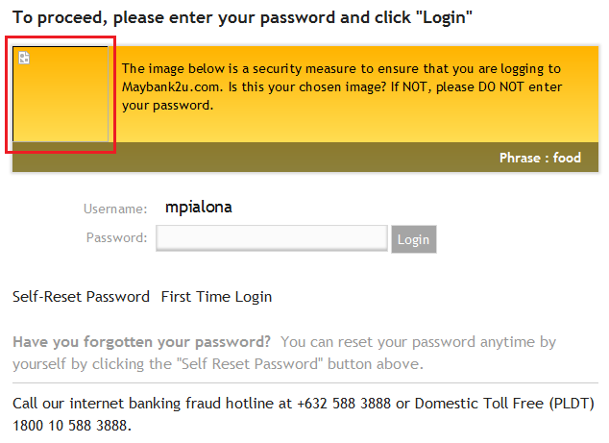

**IE 9**

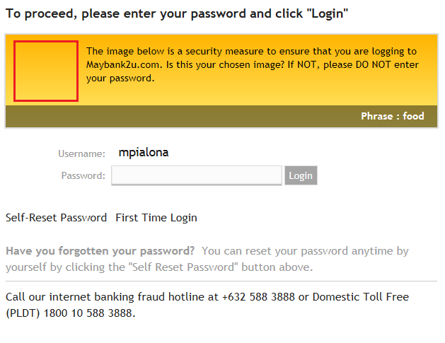

1. **Firefox 25 – Phrase row display on top after being idle for 2 minutes**

