MPI Business Requirement

Module 3: Account Inquiry



By M2U Product Management
Virtual Banking
Sept 2010

Version 1.0

Document Control

Author

Revision History

Rev# | Date | Description | Author
1.0 | 1/09/10 | First Draft | Faizul Hamdan

Copyright

MBB,VB – M2U Product Management

Business Requirement Background

Background
This module will elaborate the business requirement on Account Inquiry services for MPI Internet Banking.

High level description
- Transaction will display in Philippine Peso Currency only.
- There will be four types of services will be offered under Account Inquiry:-
- Account Summary
- Account Details
- Transaction History
- Internet Transaction History

Objective/Justification
- To allow customer view their account via respective Internet Banking

Requirement at M2U

Account Summary
- Customer able to view their account summary via MPI Internet Banking.
- System will display all account hold by the user.
- Below is the Field that to be display on the Account Summary screen

- Refer Appendix 1 – Sample of Account Summary Screen

Account Details
- Customer able to view Account Details for each account link to their access no.
- System will display in details of account info.
- Below is the Fields that to be display on Account Details Screen :
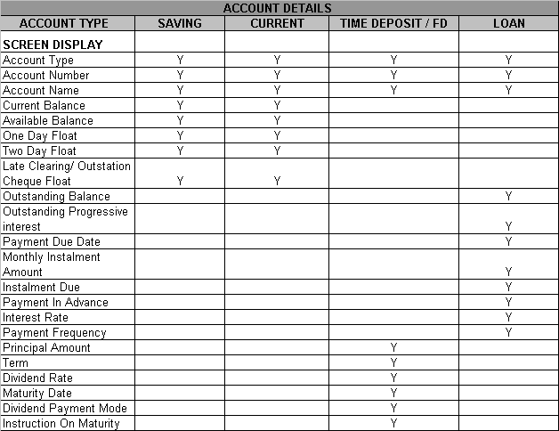

- Refer Appendix 2 – Sample for Account Detail Screen

Today Transaction
- Today Transaction is only for Saving Account.
- It only display today transaction for Saving Account
- Below is the Fields that to be display on Account Details Screen:

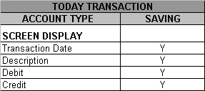
- Refer Appendix 3 – Sample for Today Transaction Screen

Recent Transaction
- Recent Transaction is only for Current account.
- It will display today and yesterday transaction for Current account
- Below is fields that to be display on Recent Transaction Screen

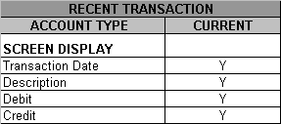

- Refer Appendix 4 – Sample Recent Transaction Screen

Transaction History
- Customer to view the transaction history from respective Saving, Current and Loan Account
- Customer can view the account activity for today and past transaction.
- Customer able to view the transaction up to 90 days (3 Months)
- Below is the field that to be display on Transaction History.

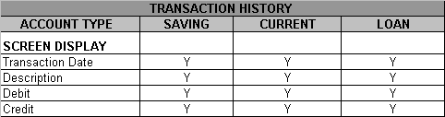

- Refer Appendix 5 – Sample Transaction History Screen

Internet Transaction History
- Customer can view all transaction done via internet.
- Customer will be able to view the transaction up to 30 days
- Below is the field that to be display on Internet Transaction History

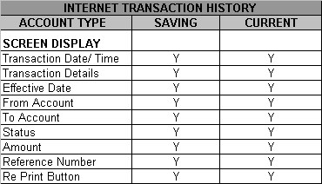
- Refer Appendix 6 – Sample Internet Transaction History Screen

Appendix 1 – Sample of A/C Summary Screen

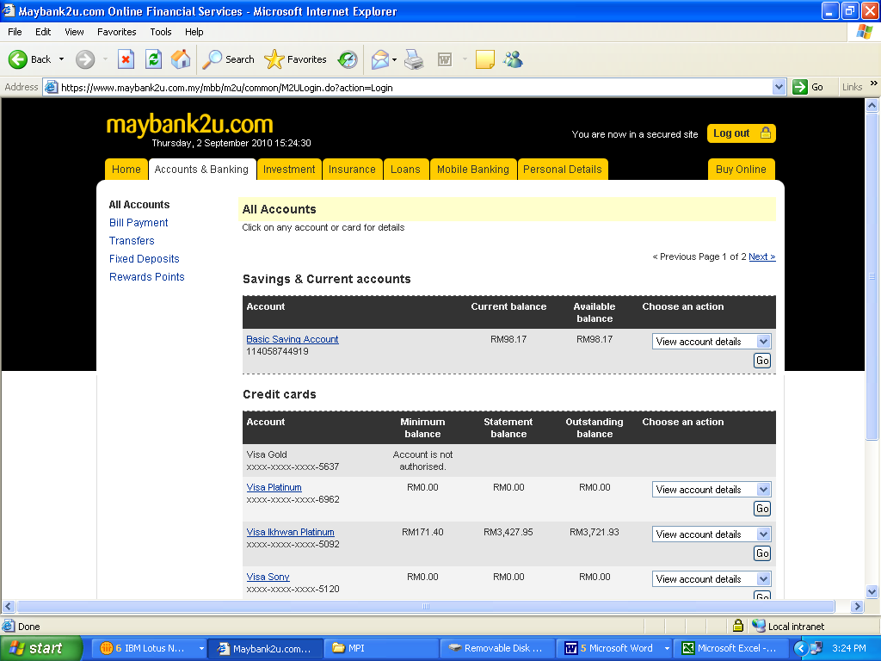

Appendix 2 – Sample of A/C Detail Screen
- Saving Account

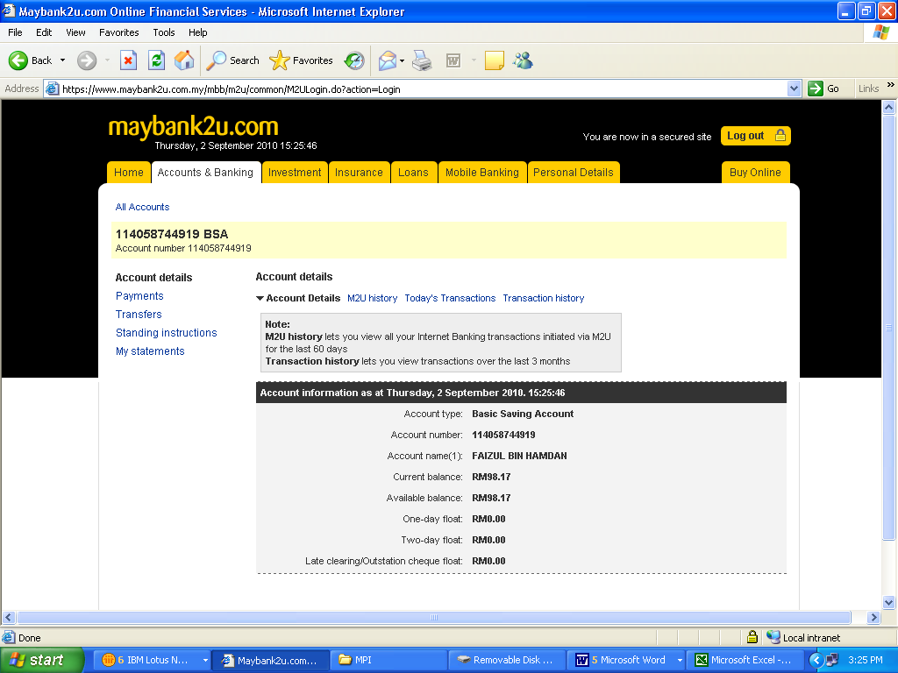

- Current Account

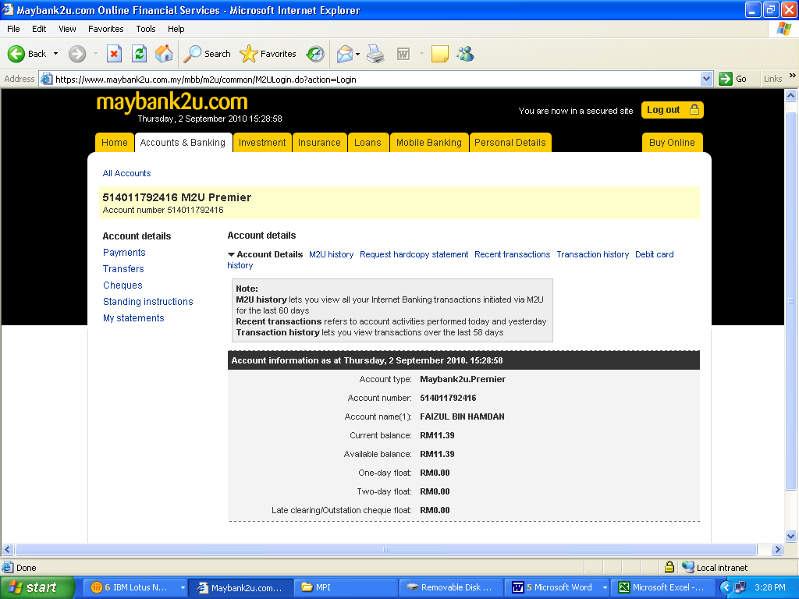
- Time Deposit Account / FD Account

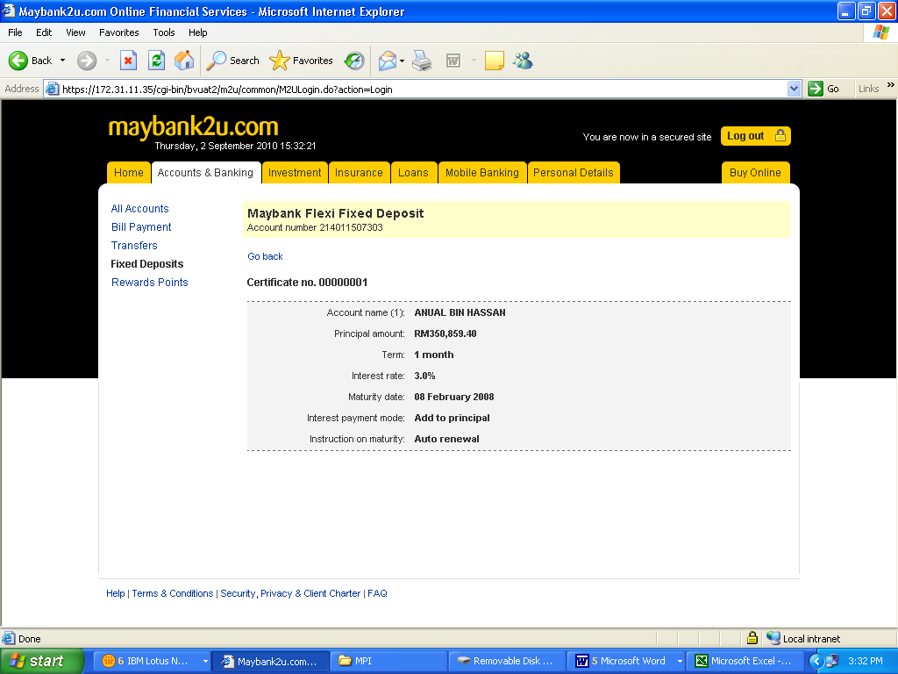

- Loan Account

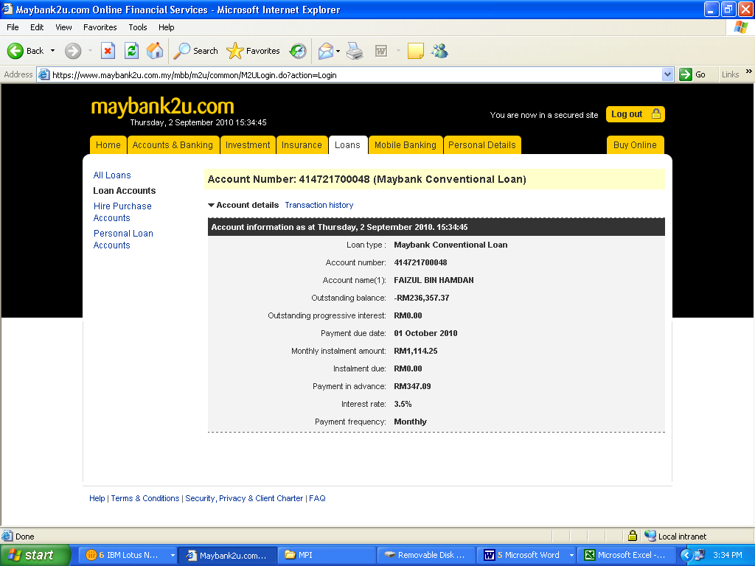

Appendix 3 – Sample of Today Transaction Screen
- Saving Account

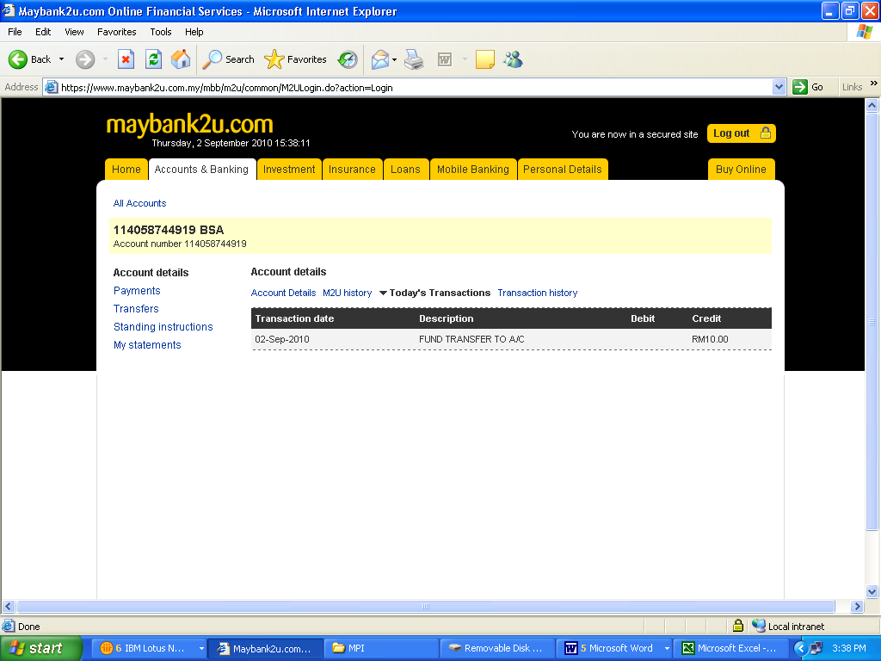

Appendix 4 – Sample of Recent Transaction Screen
- Current Account

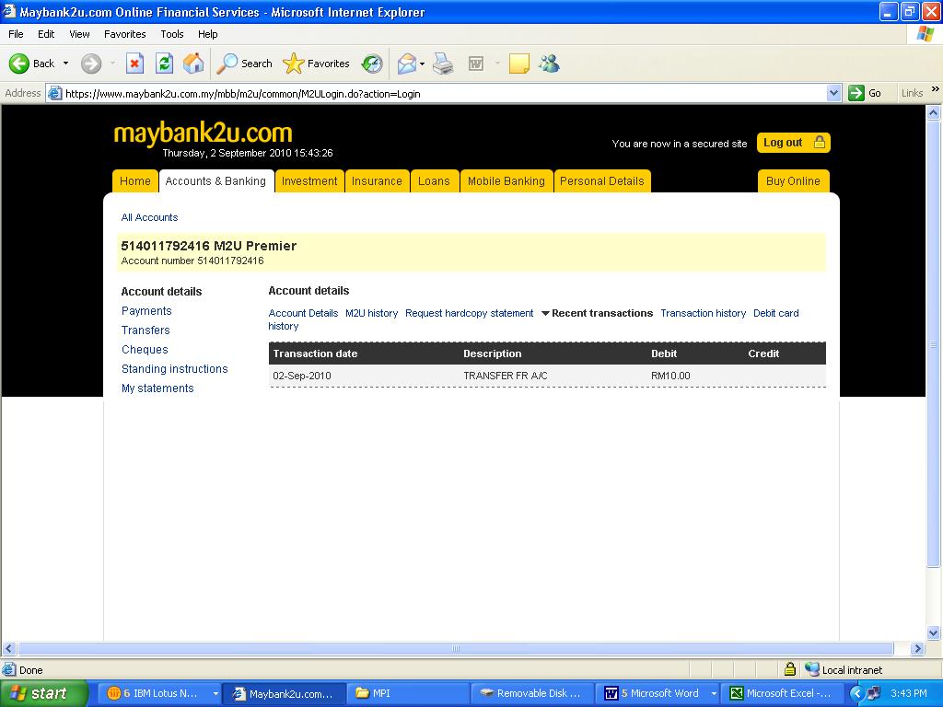

Appendix 5 – Sample of Transaction History Screen
- Saving Account

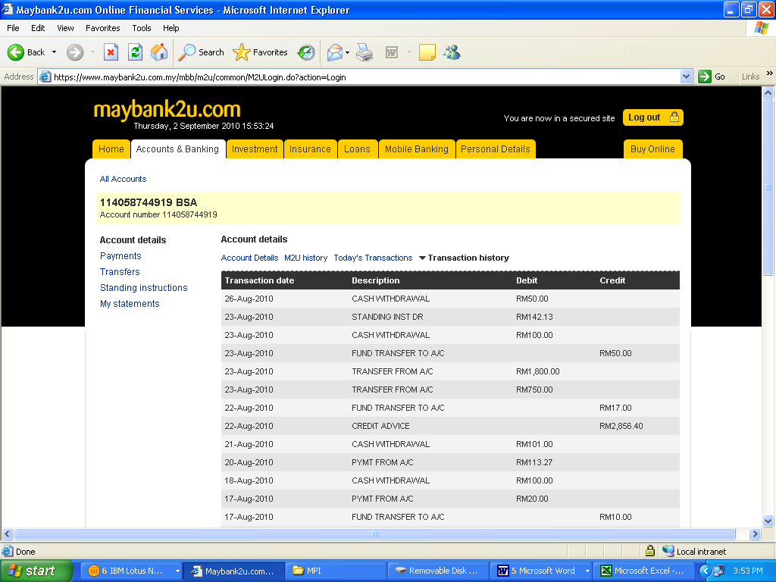

- Current Account
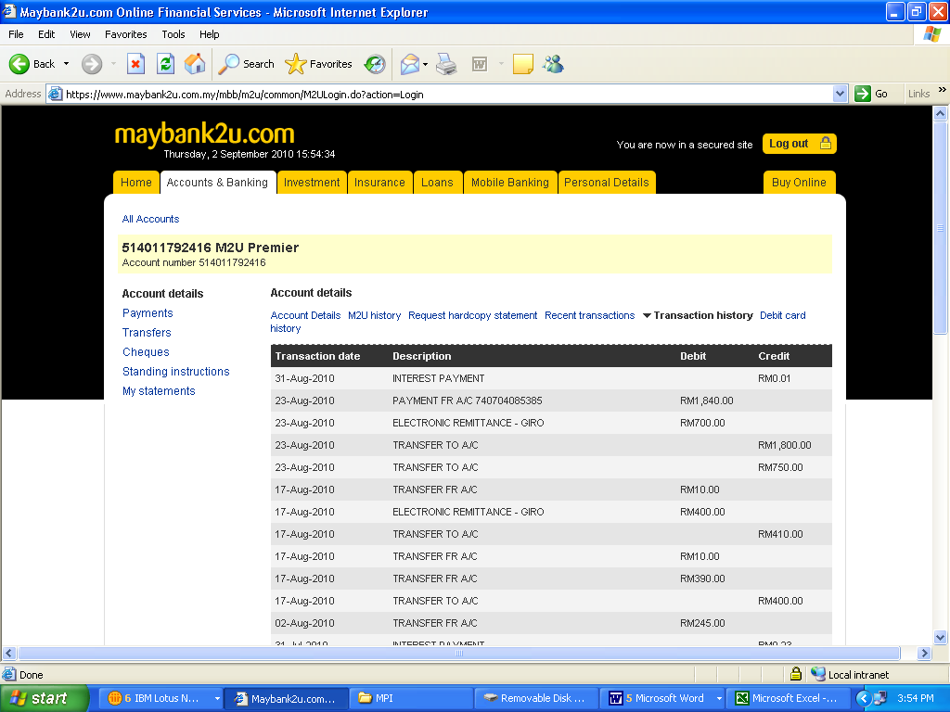

- Loan Account
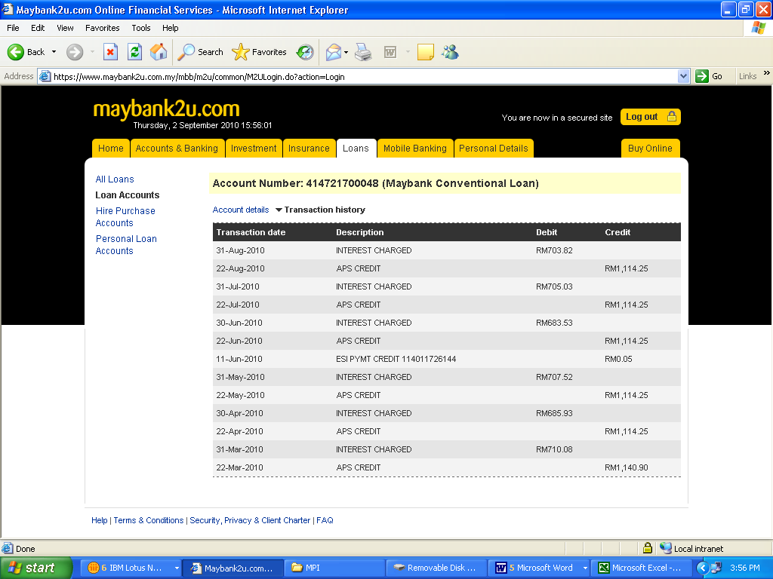

Appendix 6 – Sample of Internet Transaction History Screen
- Saving Account

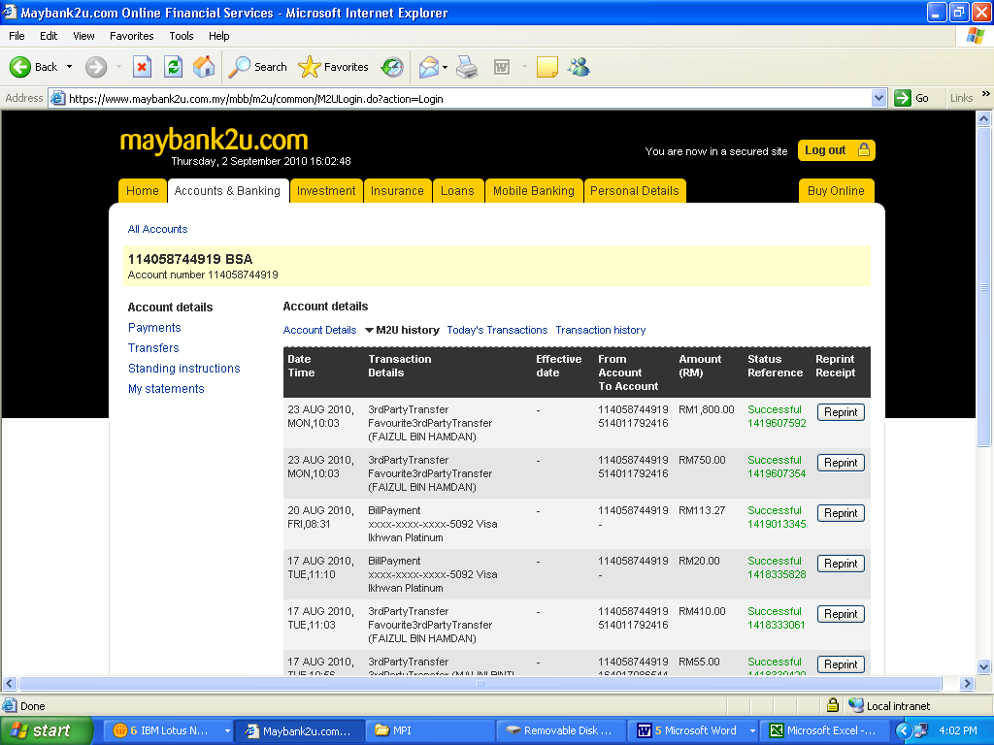

- Current Account

