Bugs# 3999
Test Title: |  | PILOT_BIB: Unable to Perform First Time Login for Corporate Admin with User Status "UNLOCKED"  - Account locked during 1st trial input SMS Pin number.
Test Description: |  | To ensure BIB Corporate Admin with status “New” and “Unlocked” able to perform 1st Time Login
Test Functionality: |  | IBAM>BIB>Company Enquiry – User Maintenance  BIB>1st Time Login
Test Procedure: |  | - Create Company Corporate Admin  - Status “NEW”  - Perform FTL with/out send SMS Pin  - Unlocked Company Corporate Admin still not perform FTL  - Status “Unlocked”  - Perform FTL with/out send SMS Pin
Response Message:
- IBAM
  - NEW – successful create New Corporate Admin
  - UNLOCKED – successful unlocked Corporate Admin
- BIB
  - Go to result page with message successful perform FTL
Test Result: | Pass: Fail: |  | Tested by: | Norhaidah Md Dasuki (QA Manager)
Reason for Failure:
Remarks: |  | Test Item 1: Create New Company Corporate Admin and perform FTL with/out send SMS Pin  Result:  IBAM – Successful create new Corporate Admin  User Status: NEW  Maker create new Corporate Admin.  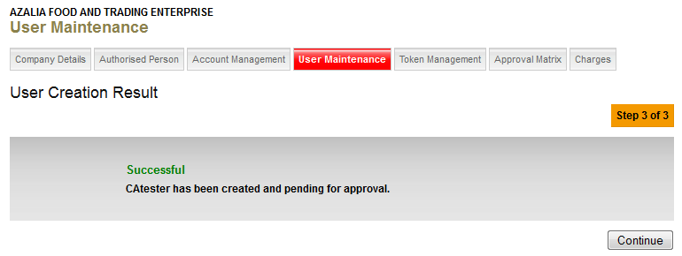  Checker approved creation of new Corporate Admin.  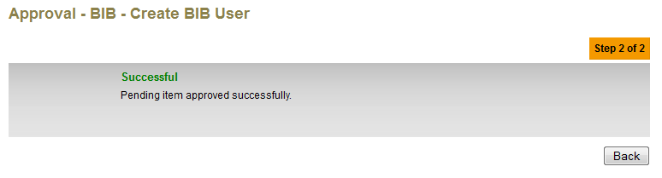  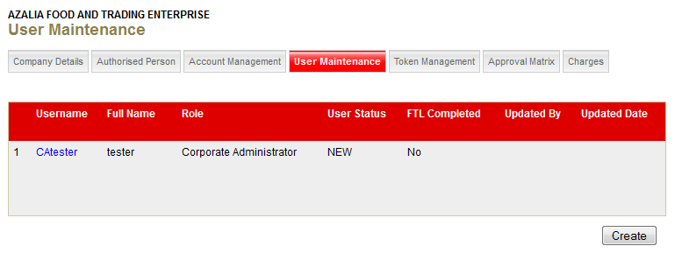  - BIB – Corporate Admin perform 1st Time Login without SMS Pin send.  Test Data: Enter Invalid “Pin” no.  Result: Account Locked on the 1st trial enter invalid PIN number.  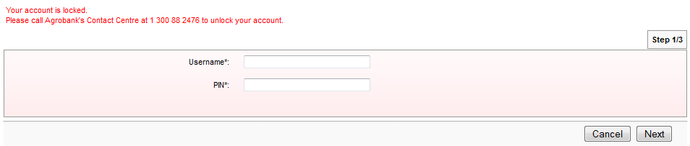  - BIB – Corporate Admin perform 1st Time Login with SMS Pin send.  Test Data: Enter Invalid “Pin” no.  Result: 1st trial enter invalid PIN number – Error Message: Username or PIN is invalid  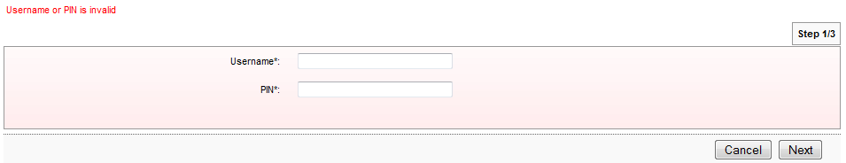  Result: 2nd trial enter invalid PIN number – Error Message: Username or PIN is invalid  Result: 3rd trial enter invalid PIN number – Error Message: Username or PIN is invalid  Result: 4th trial enter invalid PIN number – Error Message: Your account is locked. Please call Agrobank's Contact Centre at 1 300 88 2476 to unlock your account.  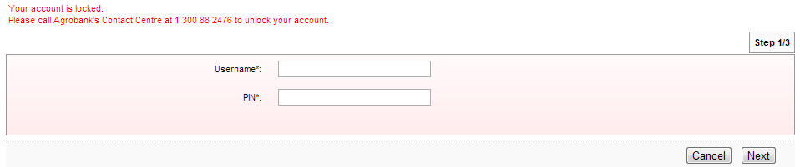  Test Data: Enter valid “Pin” no received via SMS.  Result: Successful go to FTL New Password entry page.  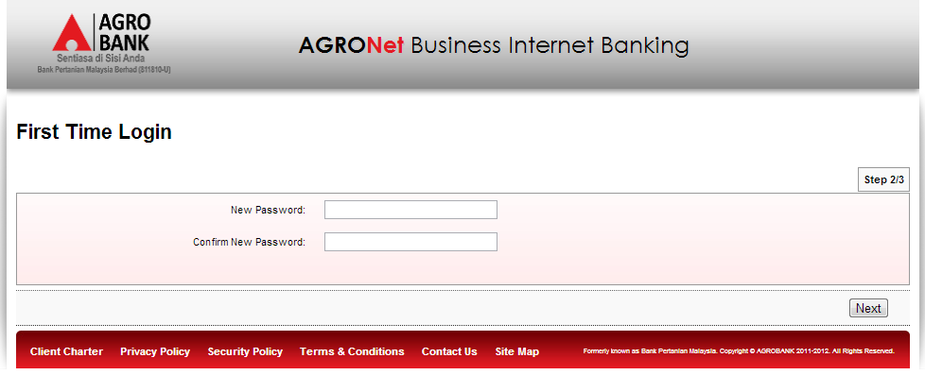
Test Item 2: Unlocked Company Corporate Admin and perform FTL with/out send SMS Pin
Result:
IBAM – Successful updated Corporate Admin status
User Status: UNLOCKED

User Status in IBAM shows LOCKED
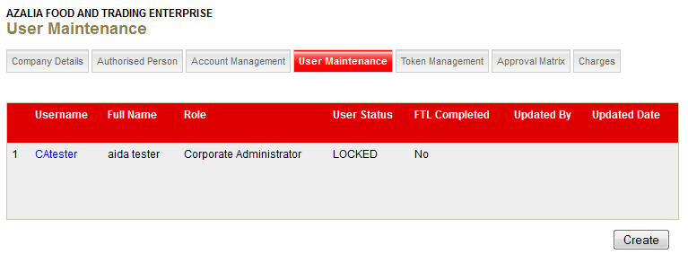
Maker unlocked Corporate Admin
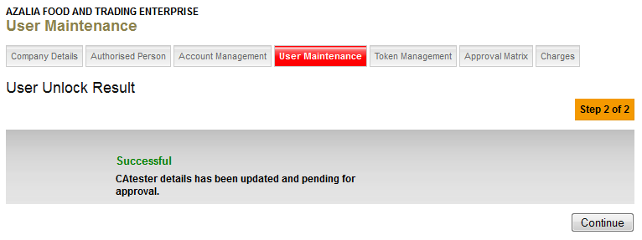

Checker approved transaction to unlock Corporate Admin
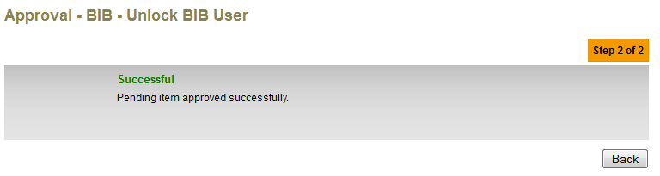
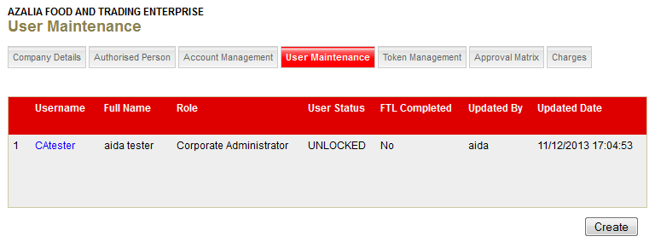

- BIB – Corporate Admin with status UNLOCKED perform 1st Time Login without SMS Pin send.
Test Data: Enter Invalid “Pin” no.
Result: 1st trial enter invalid PIN number – Error Message: Username or PIN is invalid

Result: 2nd trial enter invalid PIN number – Error Message: Username or PIN is invalid

Result: 3rd trial enter invalid PIN number – Error Message: Username or PIN is invalid

Result: 4th trial enter invalid PIN number – Error Message: Your account is locked. Please call Agrobank's Contact Centre at 1 300 88 2476 to unlock your account.

- BIB – Corporate Admin with status UNLOCKED perform 1st Time Login with SMS Pin send.
Result: 1st trial enter invalid PIN number – Error Message: Username or PIN is invalid

Result: 2nd trial enter invalid PIN number – Error Message: Username or PIN is invalid

Result: 3rd trial enter invalid PIN number – Error Message: Username or PIN is invalid

Result: 4th trial enter invalid PIN number – Error Message: Your account is locked. Please call Agrobank's Contact Centre at 1 300 88 2476 to unlock your account.

Test Data: Enter valid “Pin” no received via SMS.
Result: Successful go to FTL New Password entry page.

