Task ID# 4059
Test Title: |  | BIB - Corporate Admin Login with TAC
Test Description: |  | To enhance the security level for BIB User with Corporate Admin Role. System will send a TAC to CA after authentication and prompt for TAC validation before allowing CA to successfully login.
Test Functionality: |  | BIB > Login
Test Procedure: |  | - Did not fill in TAC field.  - Fill in TAC with other than numeric.  - Fill in TAC less than 6 digits.  - Fill invalid TAC  - Reach maximum length of attempt.
Response Message:
IB will authenticate Username & Password and TAC will automatically send to the CA phone Number.
IB will log the message to DB and there will be a scheduler to update and send the SMS accordingly.
Test Result: | Pass: Fail: |  | Tested by: | Siti Norahayu Binti Mohd Desa (QA Engineer)
Reason for Failure:
Remarks: |  | CORPORATE ADMIN LOGIN  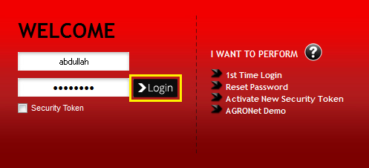  Figure 1: BIB Login Screen  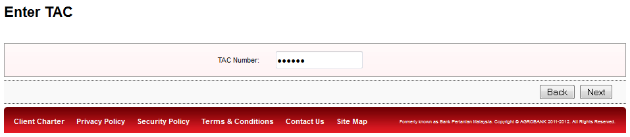  Figure 2: Login - Enter TAC Screen  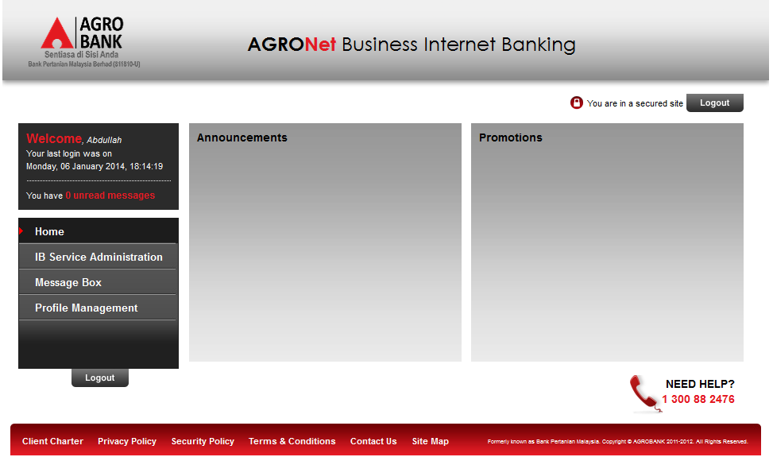  Figure 3: BIB - Corporate Admin Landing screen  Test Item 1: BIB User did not fill in TAC field  Result:  System will display error message “TAC is required”  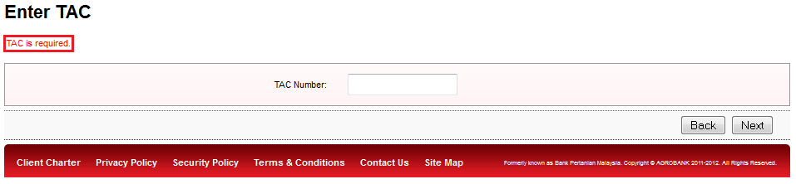  Figure 4: Login - Enter TAC Screen  Test Item 2: BIB User fill in TAC field with other than numeric  Result:  System will display error message “TAC must be numeric”  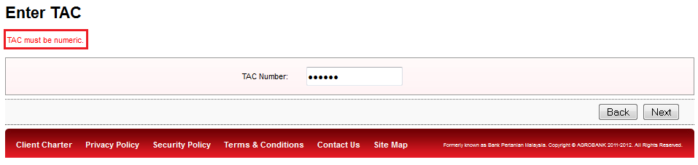  Figure 5: Login - Enter TAC Screen  Test Item 3: BIB User fill in TAC field less than 6 digits  Result:  System will display error message “TAC must consist of 6 digits”  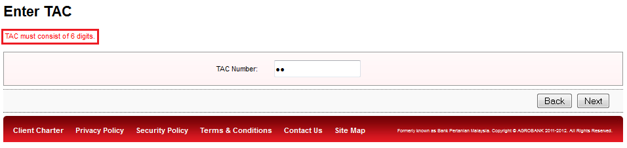  Figure 6: Login - Enter TAC Screen  Test Item 4: BIB User fill in TAC field invalid number  Result:  System will display error message “Invalid TAC”  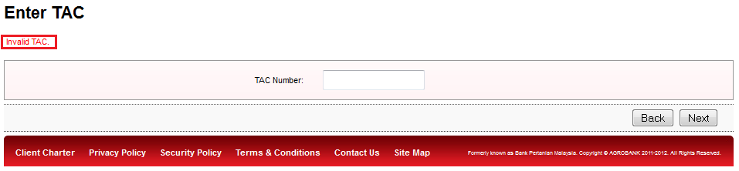  Figure 7: Login - Enter TAC Screen  Test Item 2: BIB User fill in invalid TAC reach maximum length of attempt  Result:  System will display error message “Your account is locked. Please call Agrobank’s Contact Centre at 1 300 88 2476 to unlock your account.”  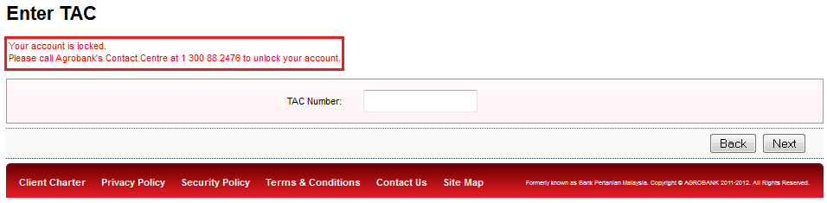 Figure 8: Login - Enter TAC Screen

