CR#EB120051_Rev3 - BAHTNET ENHANCEMENT

# Additional Fields for Bahtnet Issuance

Add additional fields, From Account Name to Bahtnet Issuance detail page (Step 1).

1. Field, “From Account Name” will be updated with value retrieved from Host based on selected From Account in the drop-down list[1]. User is allowed to update value in this field and the field can cater up to 80 characters.
2. Extend Beneficiary Account Name length to 80 characters.
3. All fields must be in English (alphanumeric only).

Subsequent pages, Confirm and Result page will use the value from Detail page. All values from text input fields (From Account Name & Beneficiary Account Name) will be capitalized. The process for subsequent steps remains unchanged.

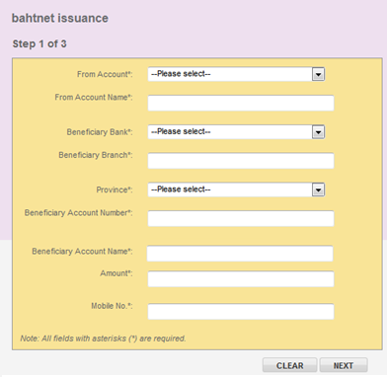

# Add new fields in the Approver authorization screen.

Add 4 new fields in the Approver Result Page

1. Transaction Date
2. Transaction Time
3. Amount
4. Charges

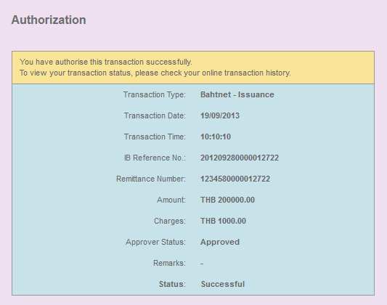

# Additional Feature in IBAM – Bahtnet Settlement Module

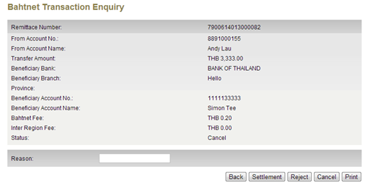

## Print Function

Add ‘Print’ function in Bahtnet Transaction Enquiry – Detail Page. The print function will be utilizing the default Browser Print function and print the detail page as it is. No special handling or formatting will be added into the Print function.

## Extend field Reason to be 80 characters.

Increase the maximum length for field Reason to accept up to 80 characters.

# Email Notification

## Targeted Email Recipient

To include filter that only send email notification to users that is directly involved in the Bahtnet transaction i.e. to the initiator who initiated the transaction and to the approver(s) who approved to the transaction. Do not send to all initiators and/or approver in the company.

This filtering only applies to email notification for Bahtnet Settlement from IBAM only.

## Update of Email Templates

1. Change email contents to English. See Appendix below for email templates.
2. Add new email notification for Cancelled transaction

## To send email (bcc) to bank’s user after settlement. (The receipt email)

1. Add bank user’s email in properties file.
2. Send email (BCC) to email set in properties file after settlement.

# Change labels & add field, Transaction Time in Print Receipt and Re-Print Receipt

1. Field, Transaction Time will be added after Transaction Date in the Print Receipt.
2. Label changes as below:

|  |  |
| --- | --- |
| **From** | **To** |
| A/C No | Receiver’s A/C No |
| Receiver’s / A/C Name | Receiver’s Name |
| Receiver’s Name | Receiving Bank |
| Other | Other Fee |

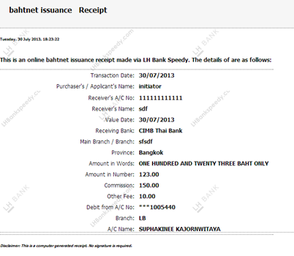

|  |  |
| --- | --- |
| Effort(man-days) |  |
| 1. Additional Fields for Bahtnet Issuance | 1.5 |
| 1. Add new fields in the Approver Authorization Screen | 1.5 |
| 1. Additional Feature in IBAM – Bahtnet Settlement Module | 1.5 |
| 1. Email Notification (4.2 & 4.3) (4.1 is FOC) | 5 |
| 1. Change Labels in Print Receipt & Re-print Receipt | 0.5 |
|  |  |
| TOTAL MAN-DAYS | **10** |
| Affected Area | IBAM  BIB  User Manual –IBAM  User Manual –BIB |

# Appendix: Email Templates

1. Email send to Bank office upon Bahtnet approval

|  |
| --- |
| **AUTOMATIC ALERT: FUND TRANSFER VIA BAHTNET**  TO: CASH OPERATION AND BAHTNET DIVISION  LH BANK SPEEDY TRANSACTION FOR FUND TRANSFER VIA BAHTNET WITH DETAIL AS FOLLOWS:  INITIATOR : A ONE CO.,LTD REFERENCE NO. : 201307290000011100 TRANSACTION DATE/TIME : 29 Jul 2013, 16:14:53  AMOUNT : THB X,XXX.XX  REMITTANCE NO. : XXXXXXXXXXXX STATUS : **IN PROCESS** |

1. Email send to customer upon settlement

|  |
| --- |
| **AUTOMATIC ALERT: FUND TRANSFER VIA BAHTNET**  TO : LH BANK SPEEDY MEMBER (INITIATOR & APPROVER)  LH BANK SPEEDY TRANSACTION FOR FUND TRANSFER VIA BAHTNET WITH DETAIL AS FOLLOWS:  INITIATOR : A ONE CO.,LTD. REFERENCE NO. : 201307290000011100 TRNASACTION DATE/TIME : 29 Jul 2013, 16:15:30  AMOUNT : THB X,XXX.XX  REMITTANCE NO. : XXXXXXXXXXXX STATUS : **SUCCESSFUL** |

1. Email send to customer upon Reject

|  |
| --- |
| **AUTOMATIC ALERT: FUND TRANSFER VIA BAHTNET**  TO : LH BANK SPEEDY MEMBER (INITIATOR & APPROVER)  LH BANK SPEEDY TRANSACTION FOR FUND TRANSFER VIA BAHTNET WITH DETAIL AS FOLLOWS:  INITIATOR : A ONE CO.,LTD.  REFERENCE NO. : 201307290000011100  TRANSACTION DATE/TIME : 29 Jul 2013, 16:15:30  AMOUNT : THB X,XXX.XX  REMITTANCE NO. : XXXXXXXXXXXX  STATUS : **REJECTED**  REASON : Account number is incorrect. |

1. Email send to customer upon cancellation **(New)**

|  |
| --- |
| **AUTOMATIC ALERT: FUND TRANSFER VIA BAHTNET**  TO : LH BANK SPEEDY MEMBER (INITIATOR & APPROVER)  LH BANK SPEEDY TRANSACTION FOR FUND TRANSFER VIA BAHTNET WITH DETAIL AS FOLLOWS:  INITIATOR : A ONE CO.,LTD. REFERENCE NO. : 201307290000011100 TRNASACTION DATE/TIME : 29 Jul 2013, 16:15:30  AMOUNT : THB X,XXX.XX  REMITTANCE NO.: XXXXXXXXXXXX STATUS : **CANCELLED** |

1. Any modifications to From Account Name will be discarded when user changes From Account. The page will be refreshed and From Account Name will be updated with new value retrieved from Host.