***Issue Form (PROD)***

|  |  |
| --- | --- |
| **Originator's Name:** Chooi So Fun  **Project:** Internet Banking  **Project Manager:** Malarvili  **Module : BVMC**  **Date Raised: 16.01.14**  **Phase :** Phase 2 – Internet Banking  **Functional Area : IBG RFI W1** | **Issue ID Number: HD00014716**  **Related Issue ID Number:**  **Classification:**  **Priority:** Critical/High/Medium/Low  **Assigned to: Vendor / IT / PMO SA / UPA**  **Actual Closed Date:** |
| **Status:** Open/Assigned/Investigated/Resolved/Approved/Deferred/No Action  *(Circle one)* | |
| **Description :**  There is 1 RFI W1 transaction failed to return in OFI W2.  The transaction was rejected due to “unable to locate residency of beneficiary” and having “Credit Error” status.  *Please refer to file attached for further details.* | **Impact:** |
| **Findings/Root Caused (Description):** | **Resolution:** |
| **Estimated Impact :** |  |
| **Recommendation:** | |
| **Accepted :**  **(Vendor / IT / PMO SA / UPA)**  **Date:** | **Accepted (KFHMB Tester):**  **Date:** |

**Email Notification RFI W1 Crediting**

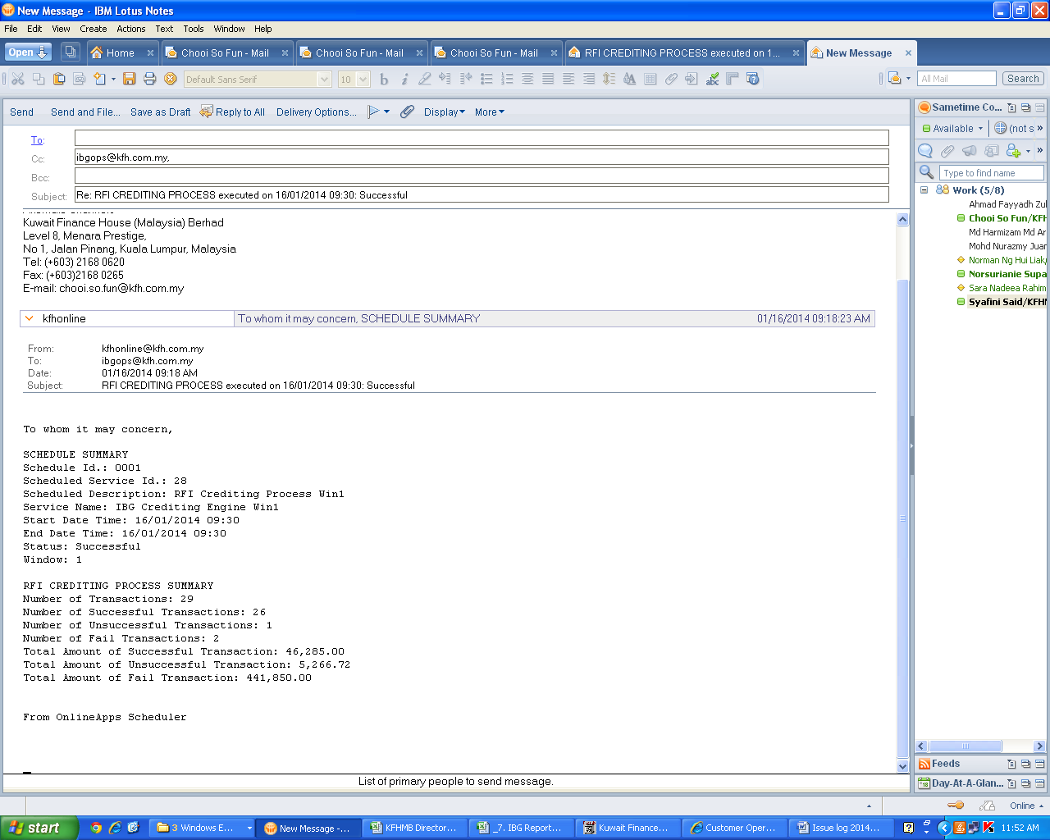

**Email Notification OFI W3**

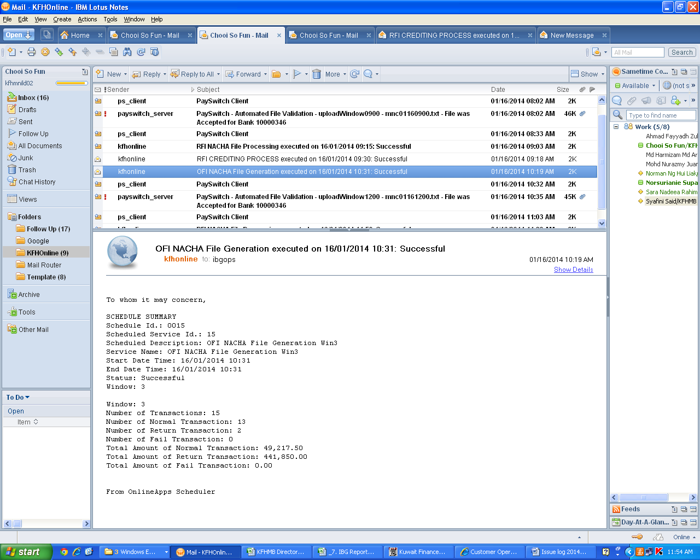

**CORUS – RFI Enquiry**

