General View of ESB Data Flow

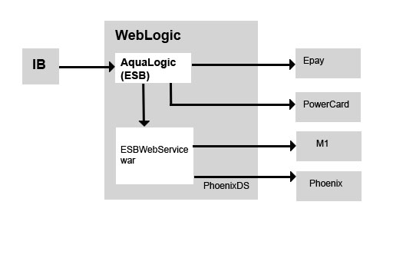

**Figure 1**

Closer View on the AquaLogic (ESB)

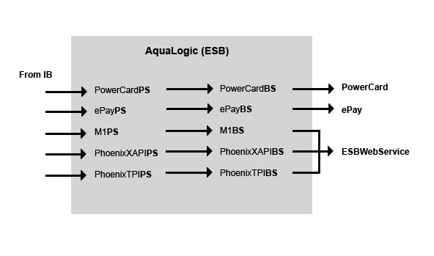

**Figure 2**

**ESB Flow on 3 different environments**

**ESB**

**DR**

IB

**ESB**

**M1**

**PowerCard_DEV**

**Phoenix_DEV**

**Phoenix_PROD**

**PowerCard_PROD**

**ESB**

**PROD**

**EPAY**

IB

IB

**DEV**