**Proposal of Favorite Standing Instruction Migration from Existing IBS to M2U v1.0**

**Introduction:**

During phase 1, IBS does not return the list of Standing Instruction in its webservice and Favourite SI was not migrated to the M2U. This issue was brought up by the business user during the meeting on 23rd October 2013.

**Action to take:**

* to migrate Favorite Standing Instruction from IBS to M2U
* there are 2 scenarios that we need to cater
  + Scenario A - users already migrated to M2U
  + Scenario B – users not yet migrated to M2U

**Affected module:**

1. Login page
   1. cater for existing user migration process
   2. cater for new user migration process
   3. add new function to direct register favourite SI to the new SI Engine
2. User profile table

**Problem observed:**

For Scenario 1, user ‘s password in M2U is not the same as IBS will not able to migrate to M2U because M2U is not able to login to IBS to get the existing Favourite SI list.

**Propose Solution for the above issue:**

**Solution 1:**

Since there is only 55 users being migrated to M2U and all of them are bank staffs, do not perform Favourite SI migration for those existing M2U users. Request the user to recreate the SI again in M2U. The impact is minimum if compare the 55 users to the 40 thousand active IBS users, the impact ration is 55/40000=0.00137.

**Solution 2:**

IBS introduces new webservice method to bypass IBS password. Meaning M2U just need to send the User ID to retrieve the Favourite SI and also to inform IBS that the migration status. This method is not in favour due to possible security breach without password.

**Scenario A**

User A has been migrated from IBS to m2u during phase 1, but their Favorite SI list is not being migrated.

**Proposed solution:**

1. IT change the ‘Favorite SI’ migration flag from database
2. When user A login, M2U will prompt a Favorite SI to be migrated to M2U
3. Upon the final submission (result page), the flag will be reset back, so next time user A login, he/she will not see this page again.

**Impact:**

* Number of user affected = 55

**Step 1:**

1. IT team changes the flag of “favorite SI migration“of user A via database.

**Step 2:**

1. User A login to m2u.
2. IBS checks whether this user exist or not (IBS requires to provide this service). If user existed, then pull the Favorite SI list without using password to IBS.

**Step 3:**

1. User A selects which SI would like to be migrated.
2. User A shall key in the termination date for transaction with occurrences.

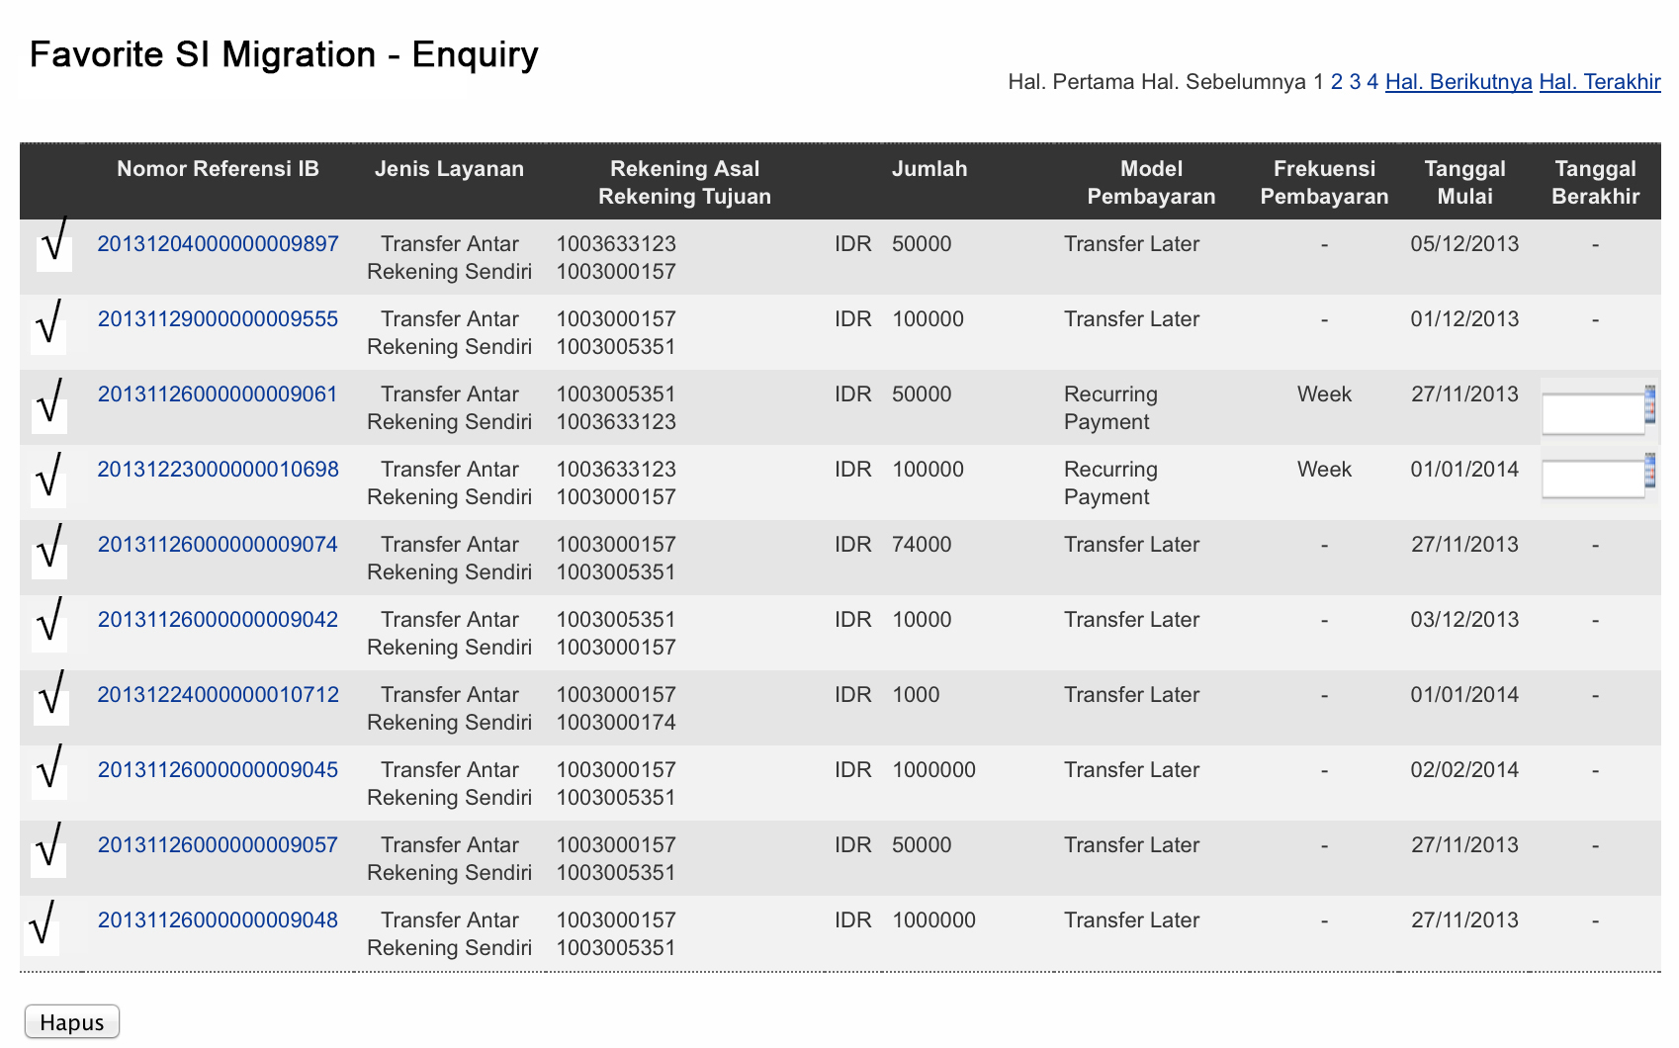

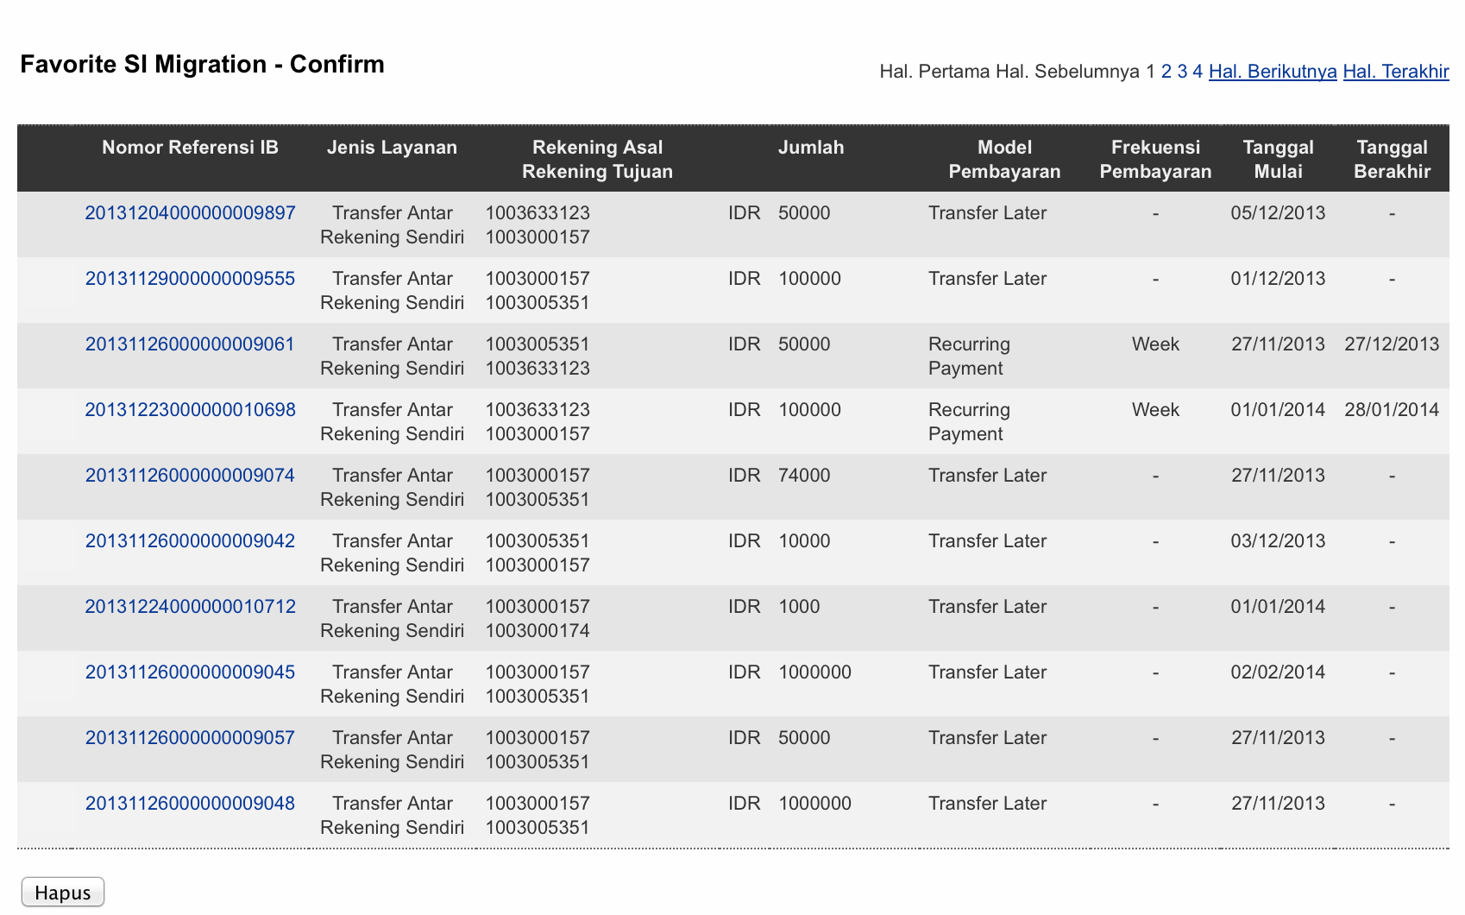

**Step 4:**

1. M2U registers all preferred SIs selected.
2. M2U keeps the SI record in m2u database.
3. M2U unregister the SI record in IBS database by calling its webservice.

<wsdl:operation name="getMigrationConfirmation">

<soap:operation soapAction="" style="document"/>

<wsdl:input name="getMigrationConfirmation">

<soap:body use="literal"/>

</wsdl:input>

<wsdl:output name="getMigrationConfirmationResponse">

<soap:body use="literal"/>

</wsdl:output>

</wsdl:operation>

**Scenario B**

User B is an existing IBS user and doing the very first time login to M2U. M2U system will migrate user accounts and the entire favorite list from IBS to M2U.

**Proposed solution:**

1. User B login to M2U via M2U login screen
2. M2U pulls favorite SI list from IBS

**Impact:**

- Number of user affected = 40K Users with around 70K SI records

**Step 1:**

1. User B login to M2U with current IBS Username and Password,
2. If user existed, then pull the Favorite SI list.

**Step 2:**

1. User B selects which SI would like to be migrated.
2. User B shall key in the termination date for transaction with occurrences.





**Step 3:**

1. M2U registers all selected preferred SIs.
2. M2U keeps the SI record in M2U database.
3. M2U unregister the SI record in IBS database by calling IBS webservice.
4. M2U register SI to new SI Engine via webservice

**Overall Risk:**

If migration SI data for the existing M2U users is compulsory, it will require IBS to provide 2 new webservice APIs that does not require user password and require more integration and testing effort.

**Mitigation:**

Do not migrate the SI for existing M2U users. Concentrate on the process and logic to migrate the 40k users rather than spend majority of the effort to solve the 55 users issue and caused project delay again.

**Fallback Plan:**

There is no fall back once user migrated to M2U. Any issue need to resolve at the M2U. At that moment, IBS and M2U are not synchronized. Fall back will cause more data integrity issue.