***Issue Form (PROD)***

|  |  |
| --- | --- |
| **Originator's Name:** Chooi So Fun  **Project:** Internet Banking  **Project Manager:** Malarvili  **Module : CORUS**  **Date Raised: 18.03.2014**  **Phase :** Internet Banking  **Functional Area : CMS Registration** | **Issue ID Number: HD00014955**  **Related Issue ID Number:**  **Classification:**  **Priority:** Critical/High/Medium/Low  **Assigned to: Vendor / IT / PMO SA / UPA**  **Actual Closed Date:** |
| **Status:** Open/Assigned/Investigated/Resolved/Approved/Deferred/No Action  *(Circle one)* | |
| **Description :**  Corus CMS Registration - Encountered error when want to approve pending item for “Zetro Services Sdn Bhd”  *Please refer to file attached for further details.* | **Impact:** |
| **Findings/Root Caused (Description):** | **Resolution:** |
| **Estimated Impact :** |  |
| **Recommendation:** | |
| **Accepted :**  **(Vendor / IT / PMO SA / UPA)**  **Date:** | **Accepted (KFHMB Tester):**  **Date:** |

**Click on Authorizatio**

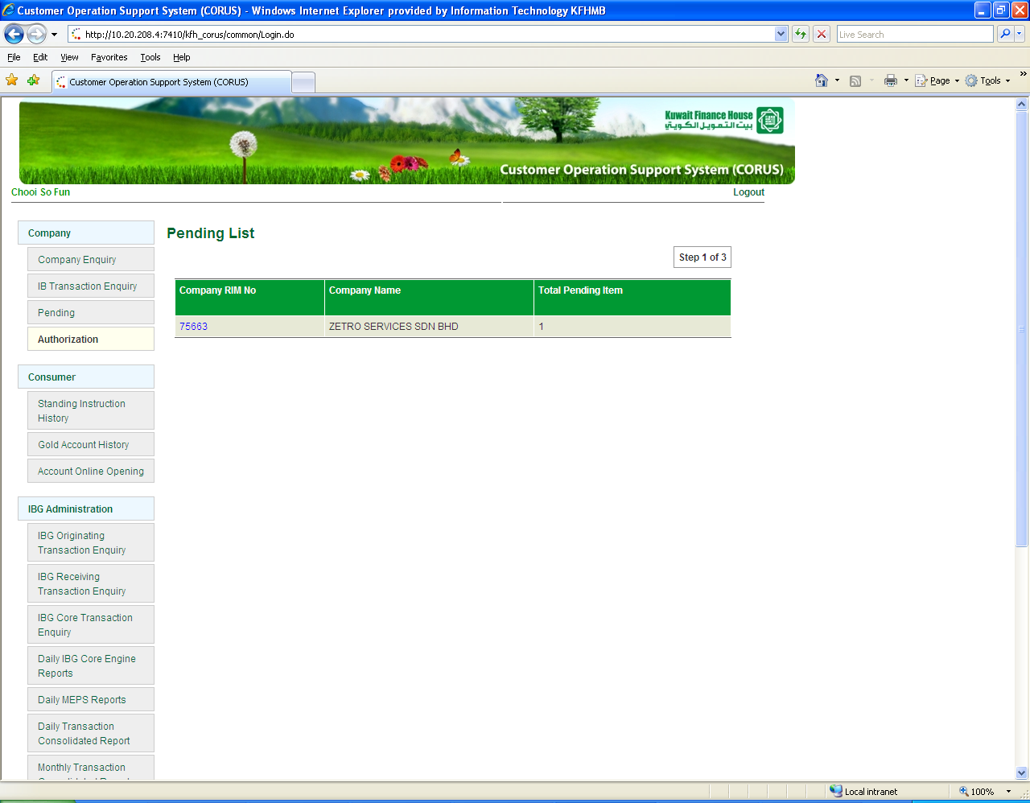

**Click on “Company RIM No. 75663”**

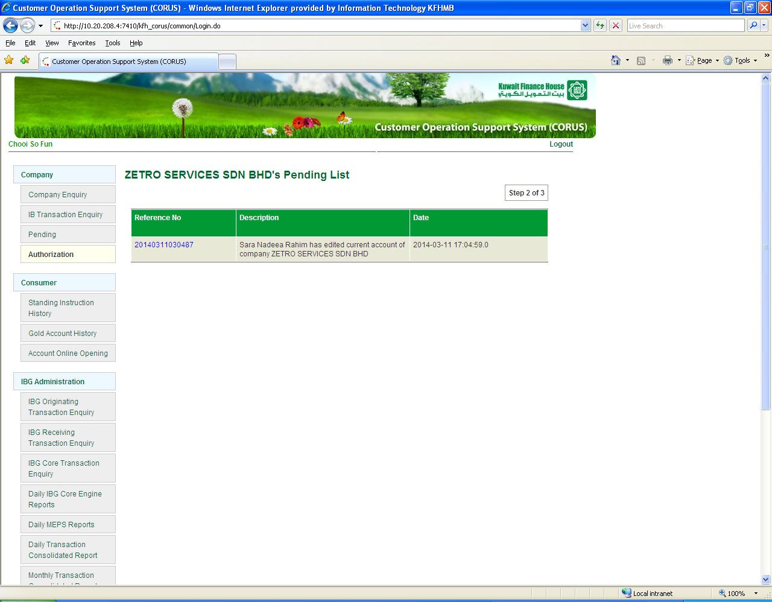

**Click on “Reference No” 🡪 Obtain error message**

