**21/3/2014 - IBAM SETUP**

**IBAM > CONTENT > PAYEE > BILL PAYMENT > EDUCATION LOAN**

|  |  |
| --- | --- |
| Channel: | **Host** |
|  | Payee Code: | **704** |
|  | Payee Product Code: | **-** |
|  | ePay Product Code: | **-** |
|  | Full Name (EN): | **PerbadananTabungPendidikanTinggiNasional (PTPTN)** |
|  | Short Name (EN): | **PTPTN** |
|  | Payee Account Number: | **1002021000019446** |
|  | Commission Account Number: | **-** |
|  | Commission Amount: | **0.00** |
|  | Customer Charges: | **0.50** |
|  | Status: | **Online** |
|  | Online Payment: | **Yes** |
|  | Favorite Register Indicator: | **No** |
|  | Effective Date: | **No** |
|  | Minimum Payment: | **No** |
|  | Minimum Payment Amount: | **0.00** |
|  | Maximum Payment: | **No** |
|  | Maximum Payment Amount: | **0.00** |
|  | RIB Trancode for Saving Account: | **0104** |
|  | RIB Trancode for Current Account: | **0105** |
|  | BIB Trancode for Saving Account: | **0000** |
|  | BIB Trancode for Current Account: | **0000** |
|  | Payee Type: | **-** |
|  | Zakat Commission in percent: | **0.00 %** |
|  | | |

|  |  |  |
| --- | --- | --- |
|  | | |
|  | Bill Account Number Required: | **No** |
|  | Check Digit for Bill Account Number Required: | **No** |
|  | Bill Account Display Name Required: | **No** |
|  | Bill Account Display Name (EN): | **-** |
|  | Bill Account Image Required: | **No** |
|  | Bill Account Image: | **-** |
|  | Validation Rule: | **-** |
|  | | |

|  |  |  |
| --- | --- | --- |
|  | | |
|  | Reference No. Required: | **Yes** |
|  | Reference No. Mandatory Flag: | **Yes** |
|  | Bill Reference Name Required: | **Yes** |
|  | Bill Reference Name Display (EN): | **Customer Offer Letter Number** |
|  | Payment Type: | **-** |
|  | Validation Rule: | **-** |
|  | | |

|  |  |  |
| --- | --- | --- |
|  | | |
|  | 1st Bill Reference Requirement: | **Yes** |
|  | Check Digit for Bill Reference Number 1 Required: | **No** |
|  | 1st Bill Reference Display Name Requirement: | **Yes** |
|  | 1st Bill Reference Display Name (EN): | **Customer Name** |
|  | 1st Bill Reference Mandatory Flag: | **Yes** |
|  | 1st Bill Reference Host Field: | **CUSTOMER_NAME** |
|  | 1st Payee Image Reference Requirement: | **No** |
|  | 1st Payee Image URL: | **-** |
|  | Validation Rule: | **-** |
|  | | |

|  |  |  |
| --- | --- | --- |
|  | | |
|  | 2nd Bill Reference Requirement: | **Yes** |
|  | Check Digit for Bill Reference Number 2 Required: | **No** |
|  | 2nd Bill Reference Display Name Requirement: | **Yes** |
|  | 2nd Bill Reference Display Name (EN): | **Customer IC/ID No** |
|  | 2nd Bill Reference Mandatory Flag: | **Yes** |
|  | 2nd Bill Reference Host Field: | **CUSTOMER_IC_ID_NUMBER** |
|  | 2nd Payee Image Reference Requirement: | **No** |
|  | 2nd Payee Image URL: | **-** |
|  | Validation Rule: | **-** |
|  | | |

|  |  |  |
| --- | --- | --- |
|  | | |
|  | Merchant: | **No** |
|  | Merchant Authorization Code: | **-** |
|  | Merchant Authorization Sub Code: | **-** |
|  | Recharge Code Indicator: | **No** |
|  | Recharge Code Name (EN): | **-** |
|  | Serial No. Indicator: | **No** |
|  | Serial No. Name (EN): | **-** |
|  | Bill Payment Allow Indicator: | **No** |
|  | Debit Engine Allow Indicator: | **No** |
|  | Programs Linked: | **-** |
|  | Payment Description: | **-** |
|  | Amount Type: | **Free Input** |
|  | Fix Amount: | **0.00** |
|  | | |

|  |  |  |
| --- | --- | --- |
|  | | |
|  | Note 1 (EN): | **-** |
|  | Note 2 (EN): | **-** |
|  | Note 3 (EN): | **-** |

**21/3/2014 - RIB – New Bill Payment**

**Issue :   
1. Receipt Payment – should wrap Payee Display Name.**

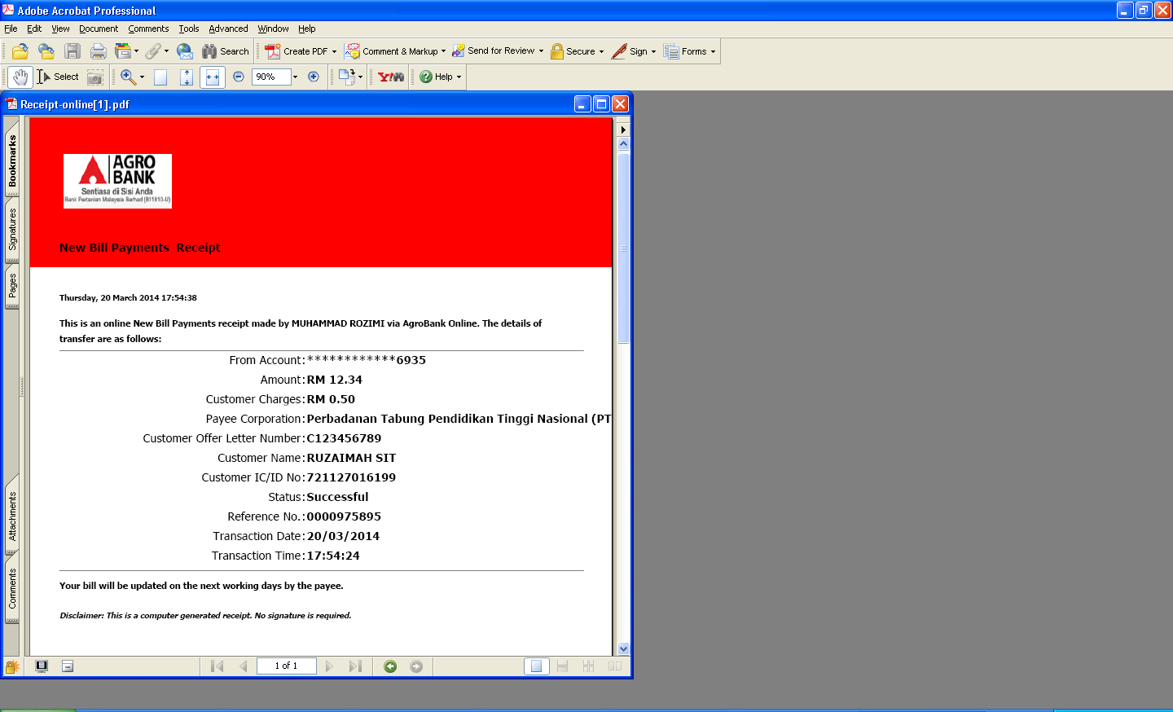

**21/3/2014 - RIB – Add fav**

**Issue :**

1. **Entry Screen - Should add fav for customer name, ic& offer letter (mandatory field)**
2. **Entry Screen - Bill Account Holder name should be equal to customer name**

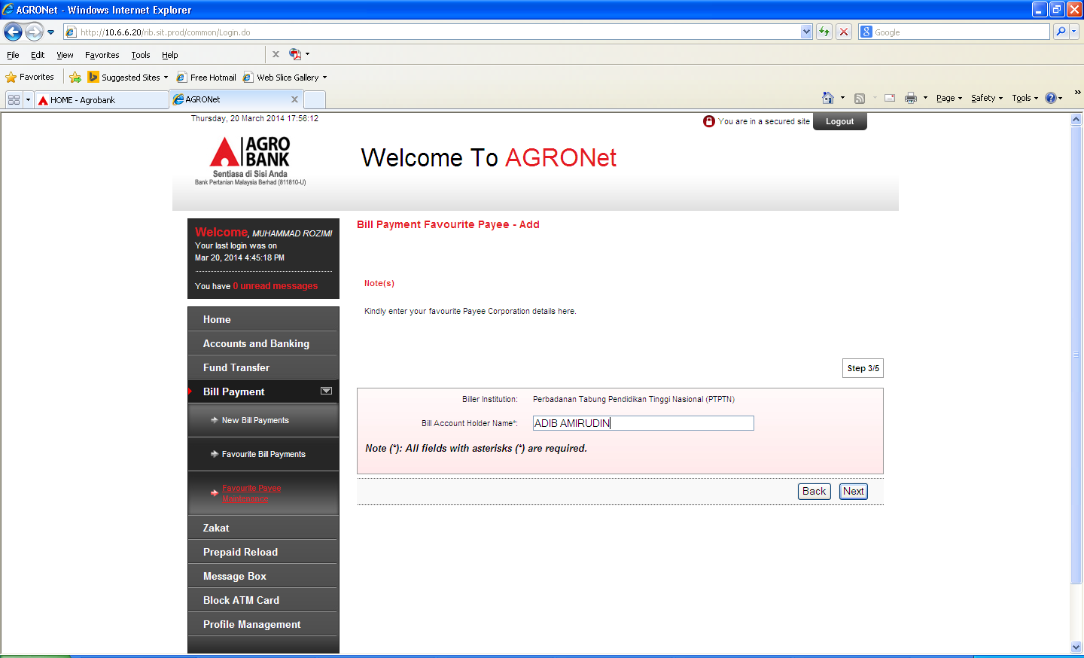

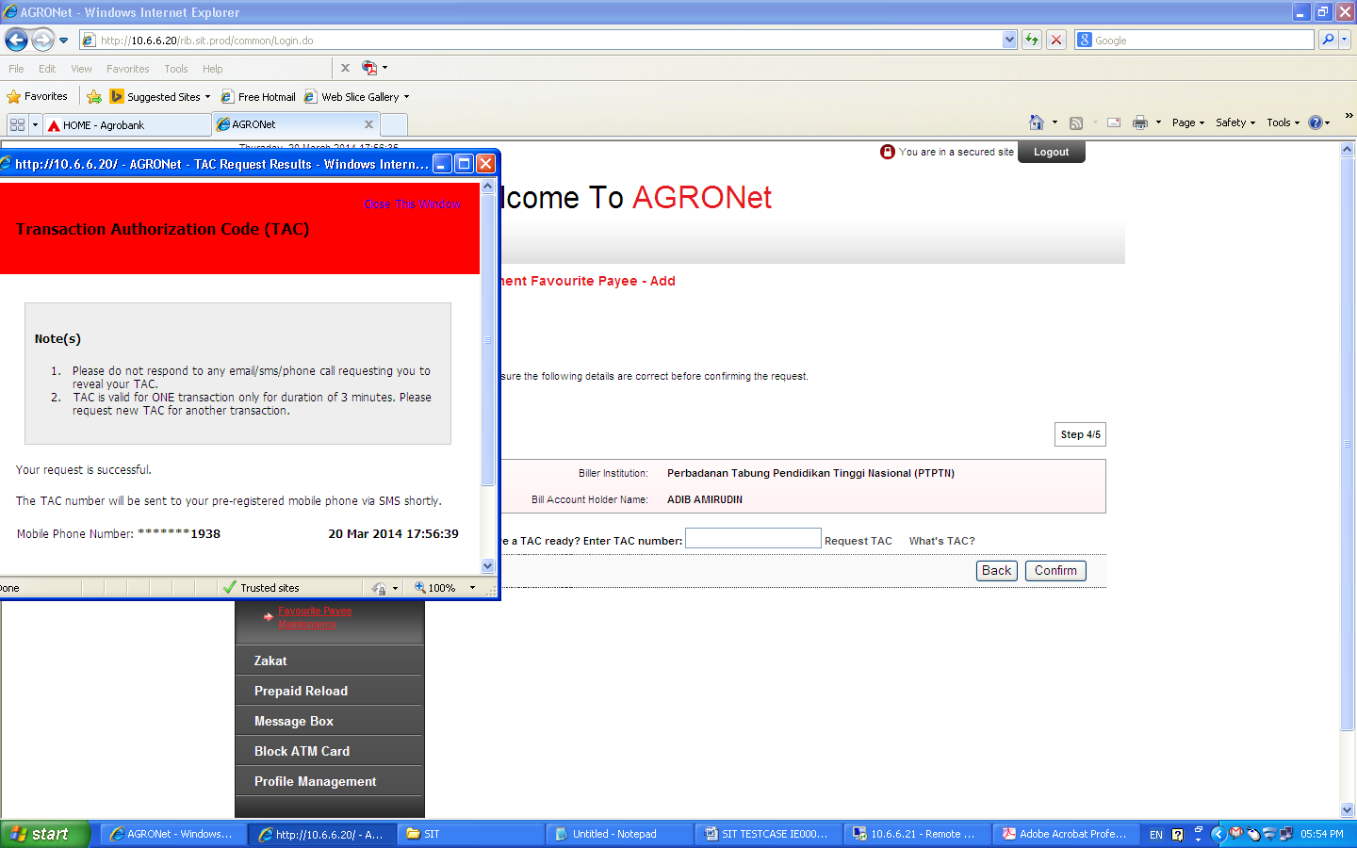

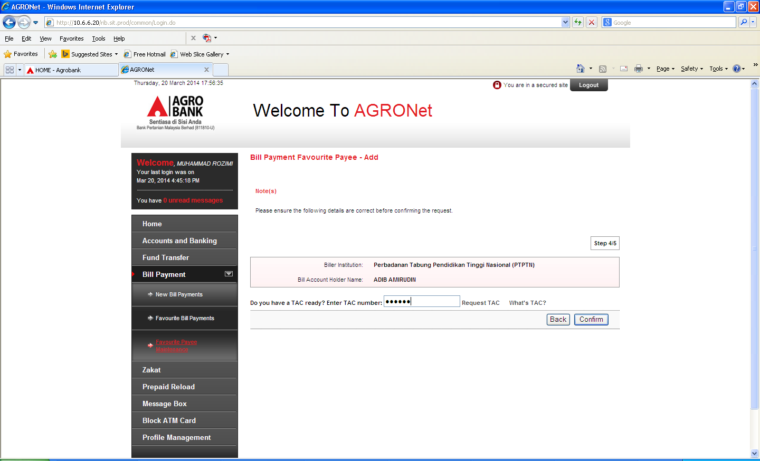

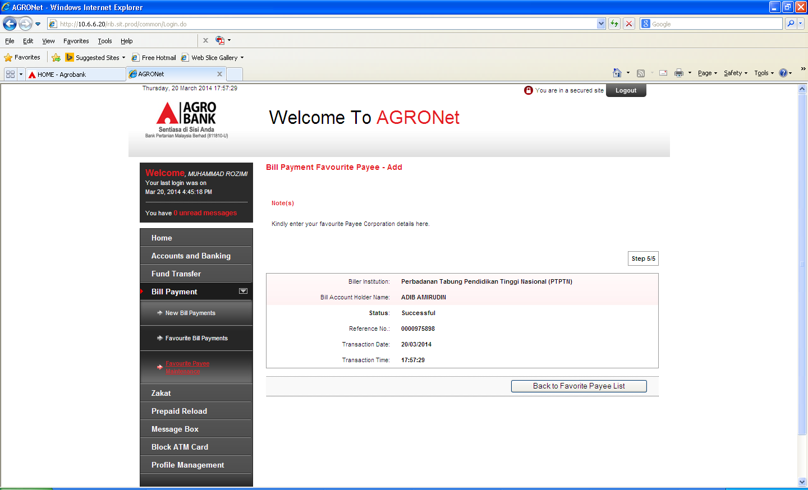

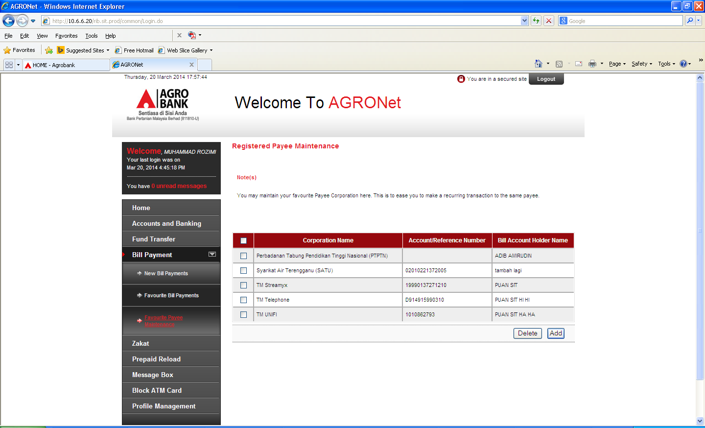

**21/3/2014 - RIB – Fav Bill Payment**

**Issue :**

1. **Entry Screen - Should not key in customer name, ic& offer letter. Details should be retrieve from registered fav.**
2. **Entry Screen - Bill Account Holder name should be equal to customer name**
3. **Receipt Payment – should wrap Payee Display Name.**
4. **Receipt Payment – Bill Account Holder name should be equal to customer name**

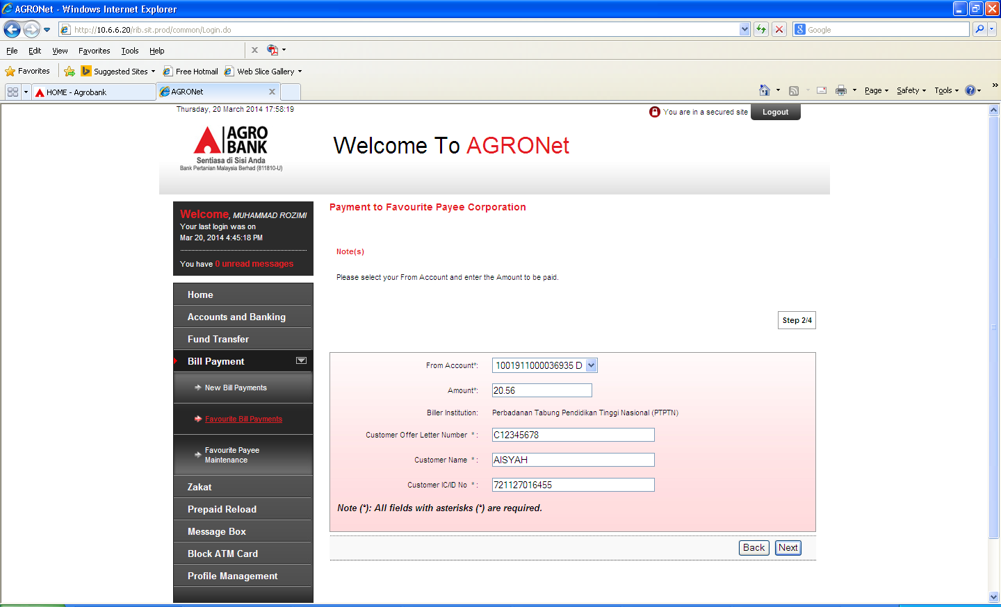

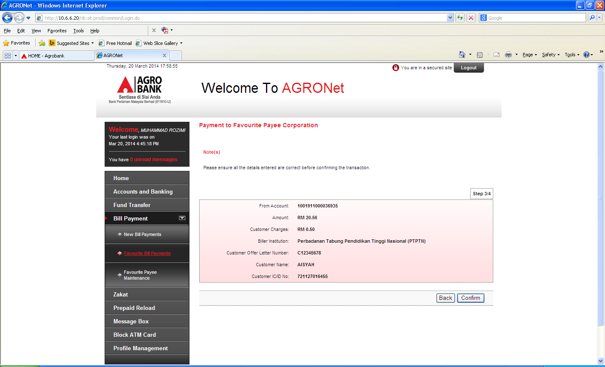

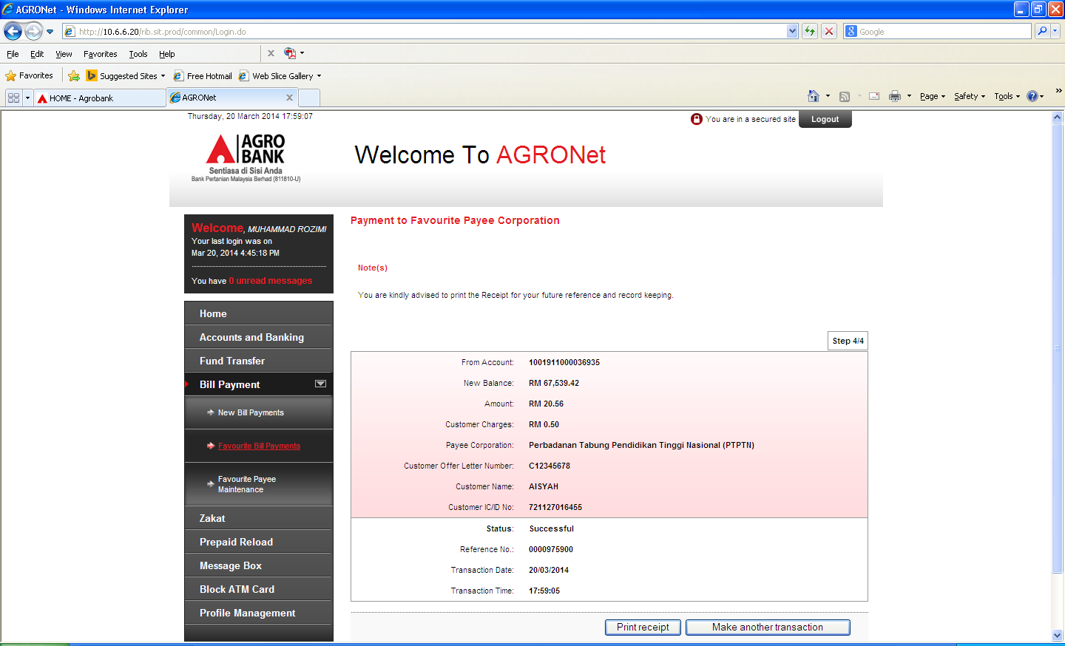

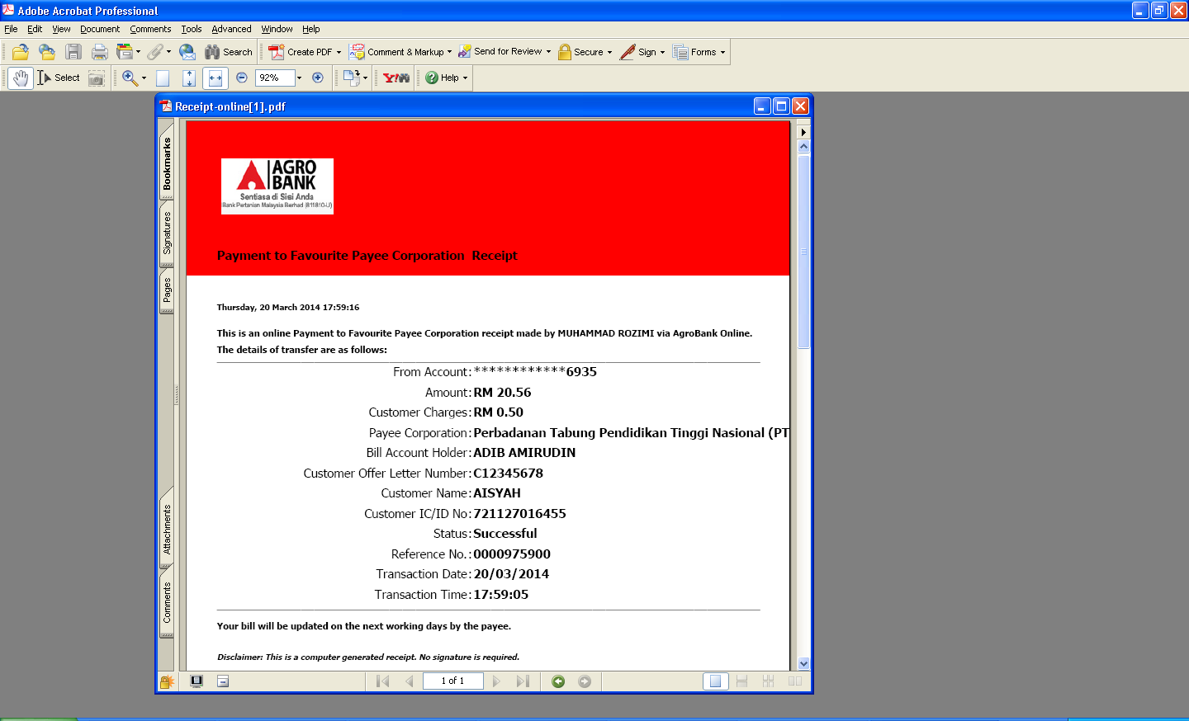

**24/3/2014 - RIB – Agronet History - Fav Bill Payment**

**Issue :**

1. **Receipt Payment – Bill Account Holder name should be equal to customer name**

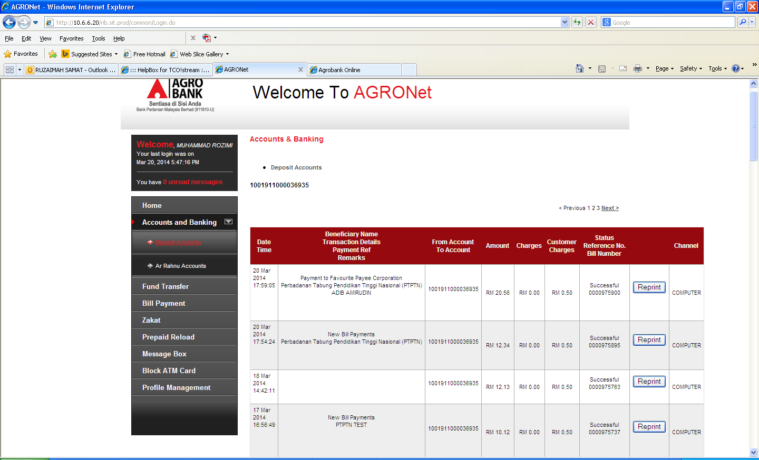

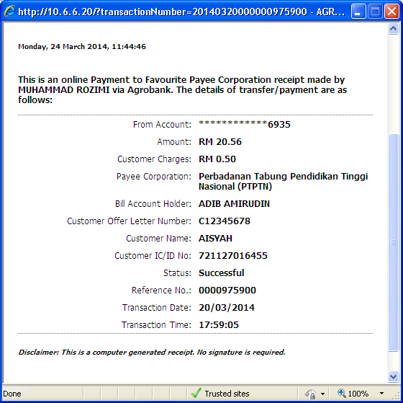

**24/3/2014 - IBAM – RIB TranxHsitory – New Bill Payment**

**Issue :**

1. **Labelling for Bill Ref No, Bill Ref1 & Bill Ref 2 should follow display name (Offer letter, Name & IC)**

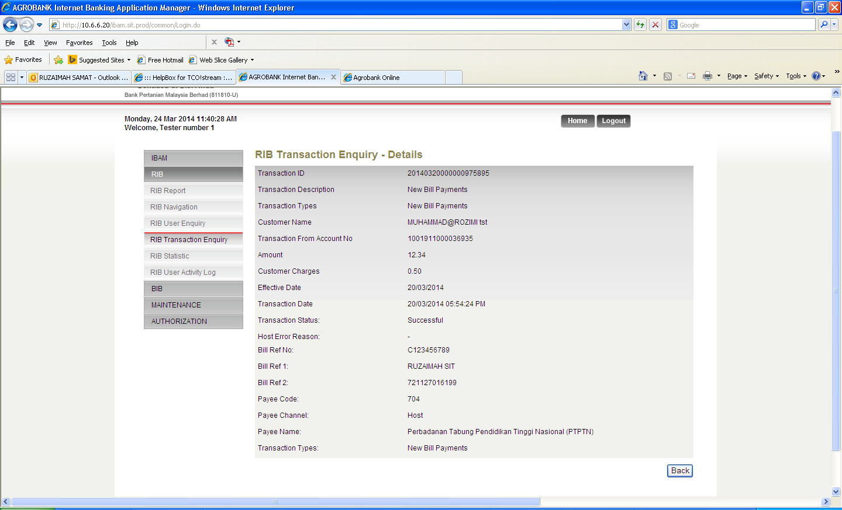

**24/3/2014 - IBAM – RIB TranxHsitory – Fav Bill Payment**

**Issue :**

1. **Labelling for Bill Ref No, Bill Ref1 & Bill Ref 2 should follow display name (Offer letter, Name & IC)**

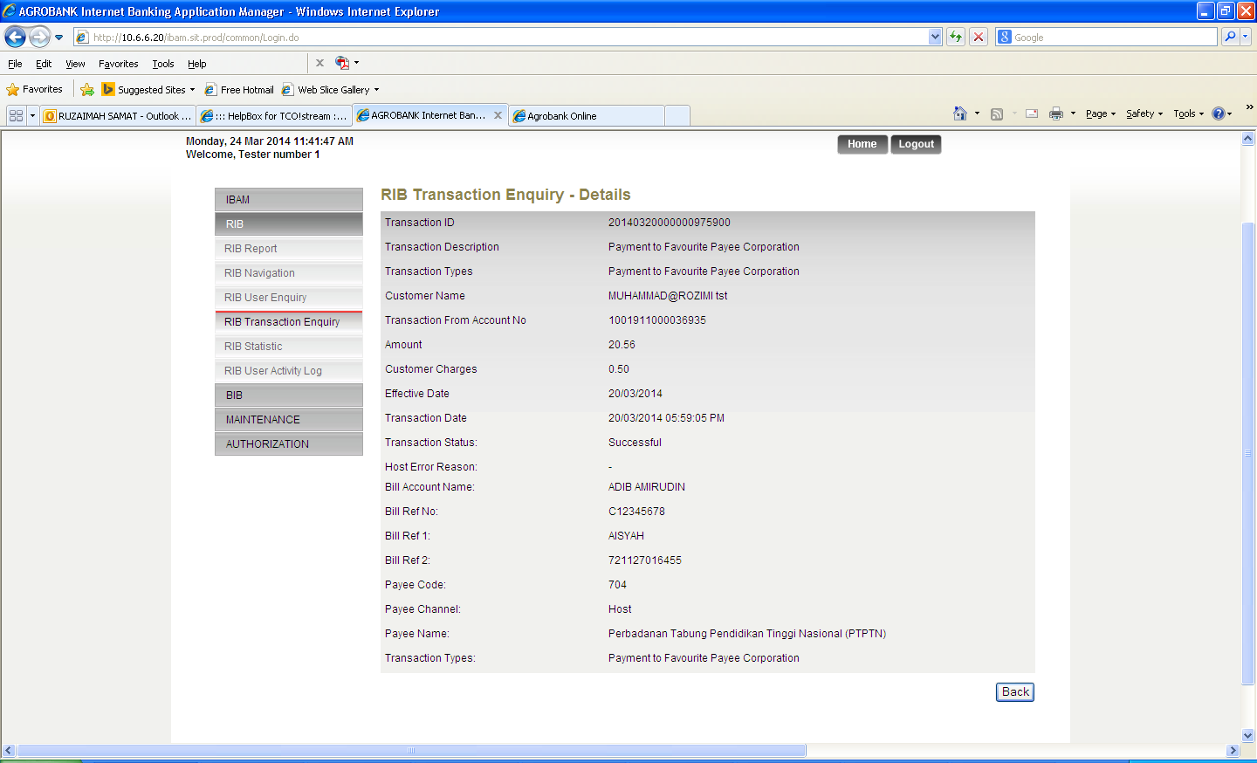

**24/3/2014 HOST Report – DDAT10P – RIB**

**Issue :**

1. **Customer Offer Letter not displayed. Check in Filler04, IB didn’t send the data.**

