Originator's Name: Chooi So Fun  Project: Banker’s Chq & Demand Draft  Project Manager: Malarvily Muniandy / Christopher Gunn  Owner: PDM / RCB  Date Raised: 05.10.10  Phase/Process:  Functional Area: Consumer | Issue ID Number: BCA-DDA-UAT-C028  Related ID Number:  Priority: High / Medium / Low  Assigned to:  Target Resolution Date:  Actual Closed Date:
Status : Open / Investigate / Retest / Re-Open / Closed / Sign-Off (Circle one)
Category : Bugs / Set-up / Clarification / Repeated / Internal CR / CR (Circle one)
Description:
Daily & Monthly Consolidated Transaction Report:
- Demand Draft with Foreign Currency KWD is not reflected in report (Text and CSV Format)

- In Text Format: Alignment for no. of rec and amt column

- In CSV Format:
- For Banker’s Cheque Application row: Shown invalid format for no. of rec. field
- For Demand Draft Application row: values are shown in invalid format

Note: Ensure to reflect the changes to Monthly Conso Trx Rpt as well.

(Refer to sample screen attached below for further details)
Impact:

Investigation (Description):

Action:

Estimated Impact:

Recommendation:

Accepted (PENRIL/SA/IT):  Date: | Accepted (KFHMB):  Date:
Associated Risk Report: | Risk Report Accepted Date:
Associated Change Request Form: | Change Control Accepted on:

Remittance Application Enquiry:
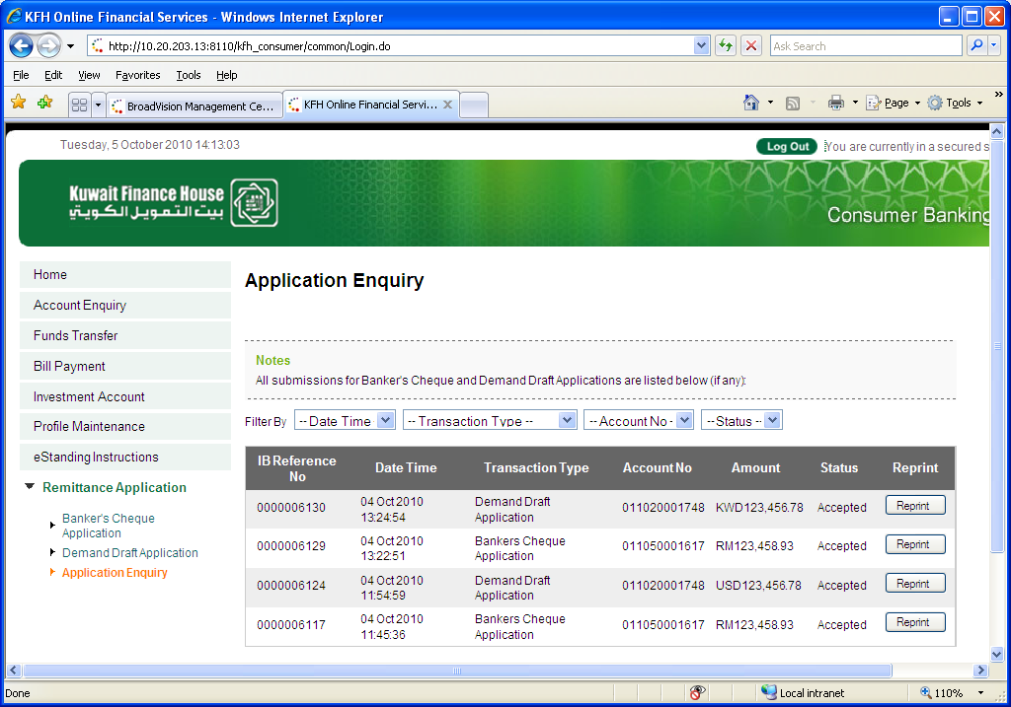
Daily Consolidated Transaction Report in TEXT Format:
KWD column
is missing
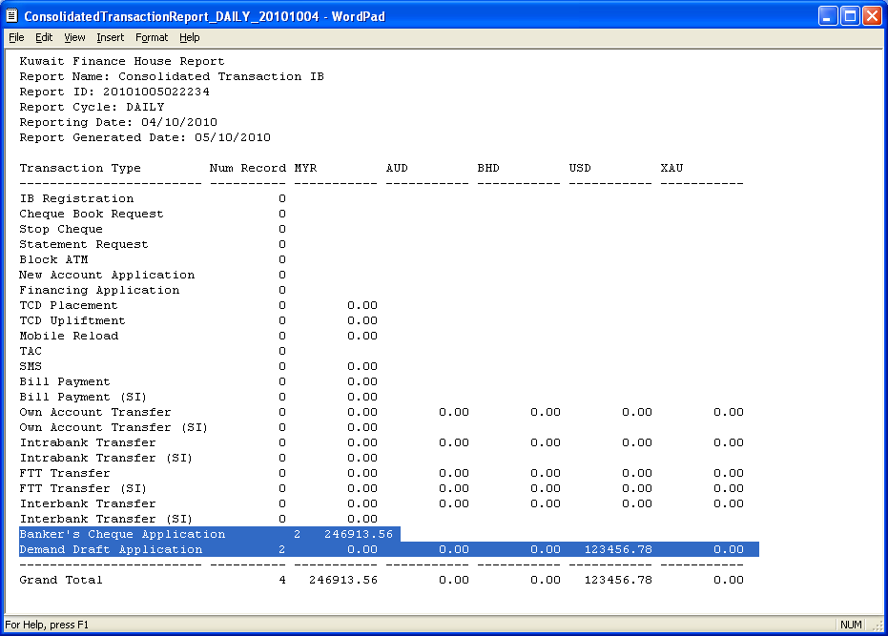
Alignment

Daily Consolidated Transaction Report in CSV Format:
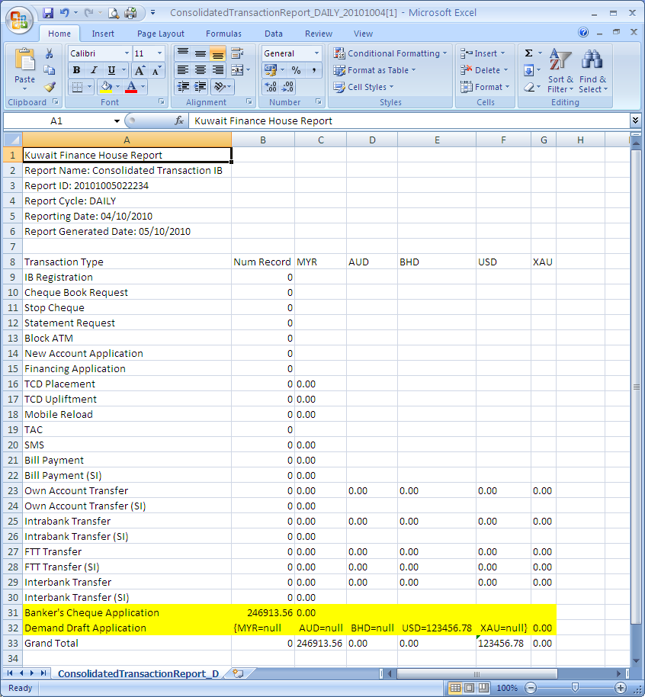
KWD column
is missing
Invalid format
Should reflect # of rec i/o amt

