1. Bind token from RCMS successful

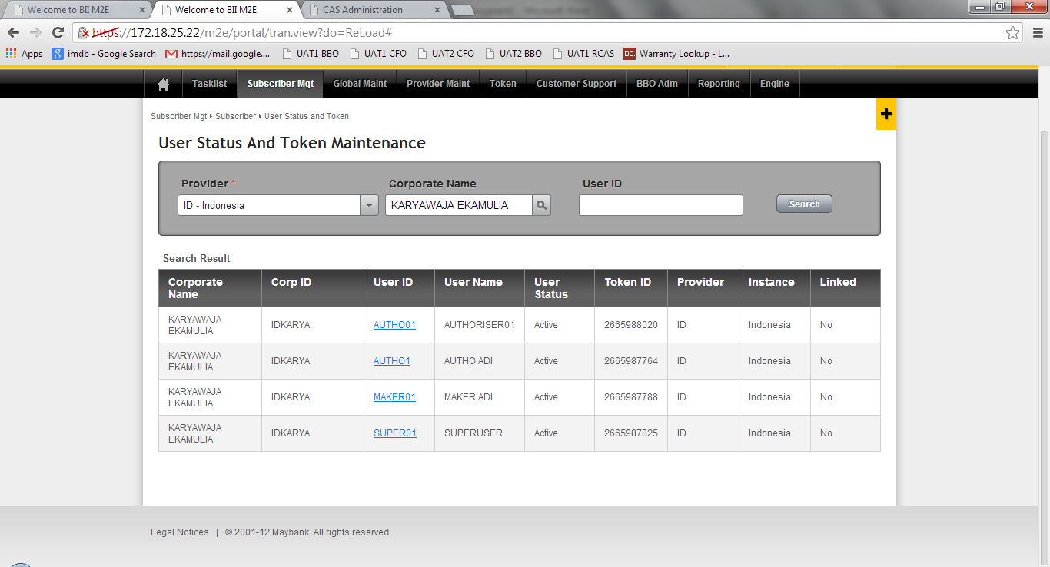

1. Check at RCAS also successful binded.

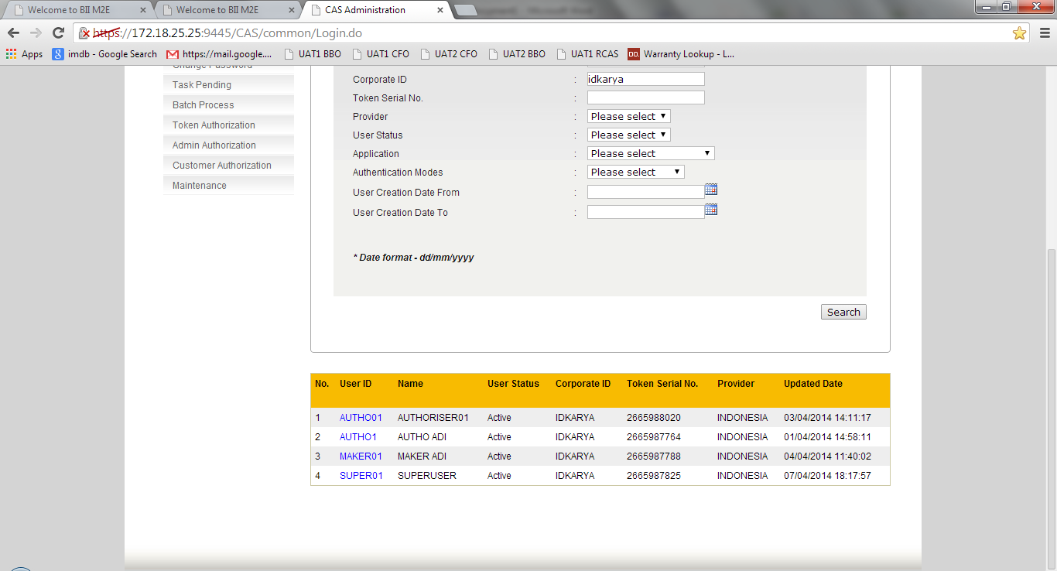

1. Why I can’t found the token no in the token listing searh by provider, only found at global without User ID, User Name & Corp ID information.

