- Assign qualifier to user ib report
- Login at Staging Server
i – Search user ib report and view user detail
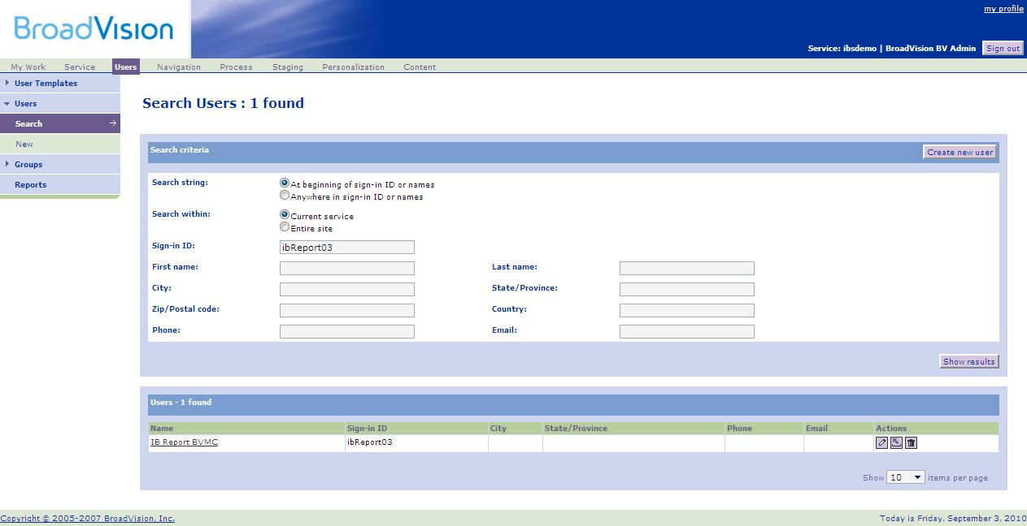
3
1
2

ii – Click on the ‘Qualifiers’ tab
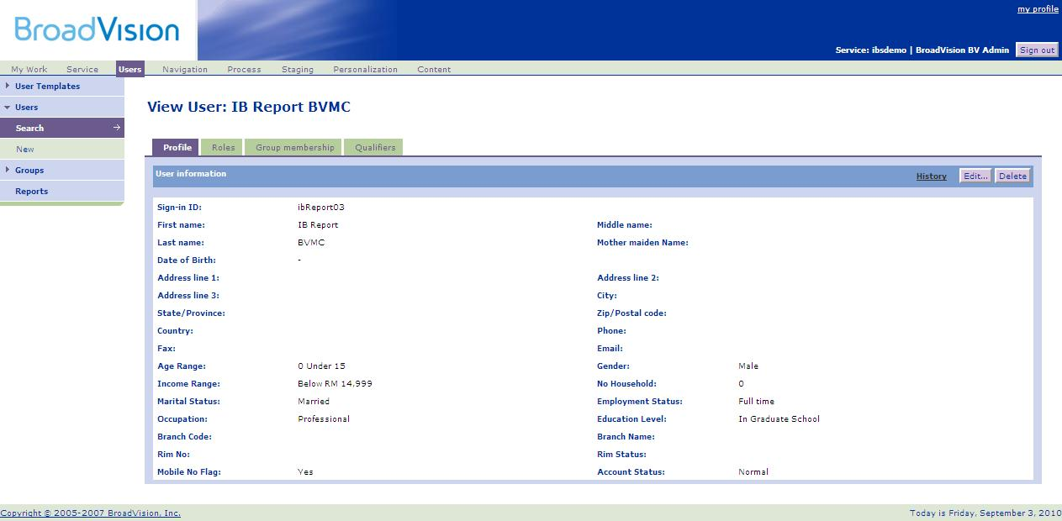

Before that, check whether these qualifier already assigned to user or not. You Just need to add qualifier which is not yet assign to user.

- Bankers Cheque Application.BRANCH
- Bankers Cheque Report.BRANCH
- Demand Draft Application.BRANCH
- Demand Draft Report.BRANCH
- REPORTTYPE > Demand Draft Application
- REPORTTYPE > Demand Draft Report
- REPORTTYPE > Bankers Cheque Application
- REPORTTYPE > Bankers Cheque Report
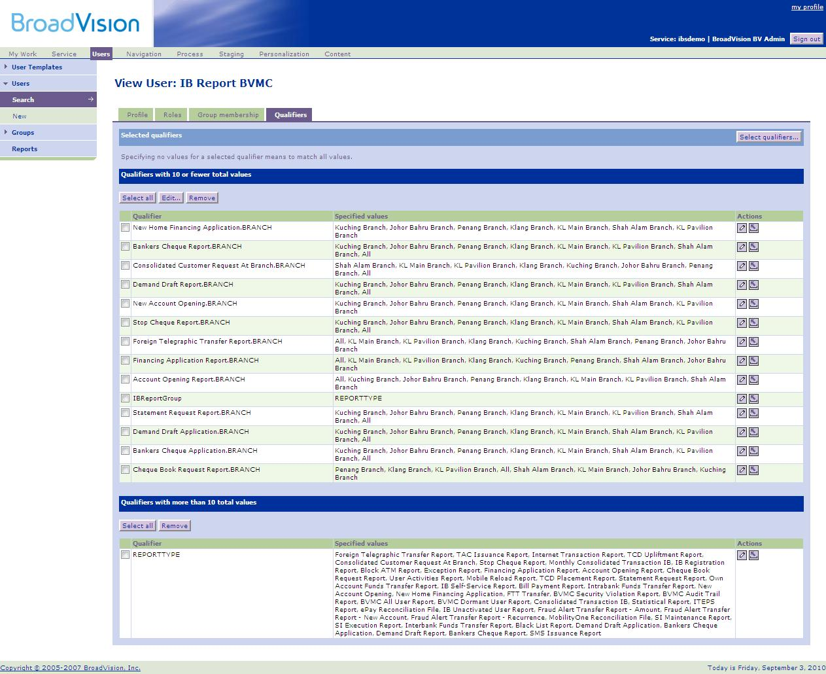

iii – Click on ‘Select qualifiers…’ button

Iv – It would pop up a new window. Click on ‘Go’ button then change the value of ‘items per page’ to `100’ to view all available values.
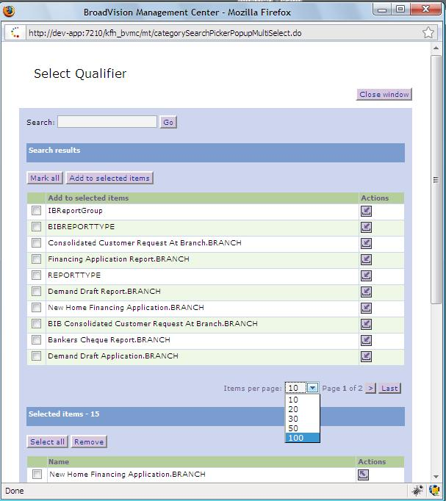
2
1

V – Tick on this value and then click on ‘Add to selected items’ button:
Bankers Cheque Application.BRANCH
Bankers Cheque Report.BRANCH
Demand Draft Application.BRANCH
Demand Draft Report.BRANCH
Vi – Then click button ‘Update’
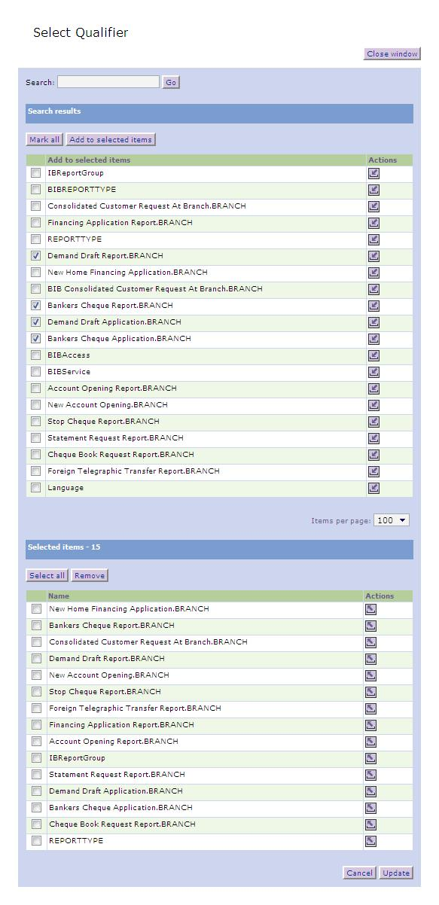
4
3
2
1

Vii – You’ll get like the screen below. Click button edit to add specified values.
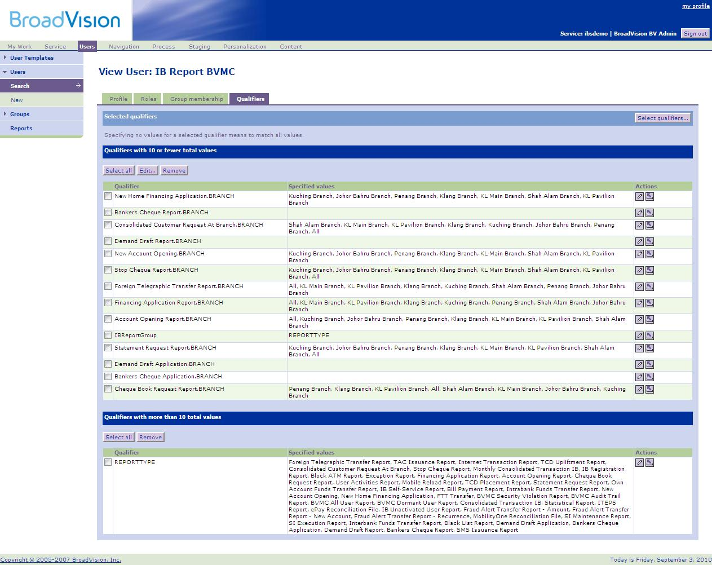

Viii – Click on ‘Add all available values’ then click ‘Save’ button
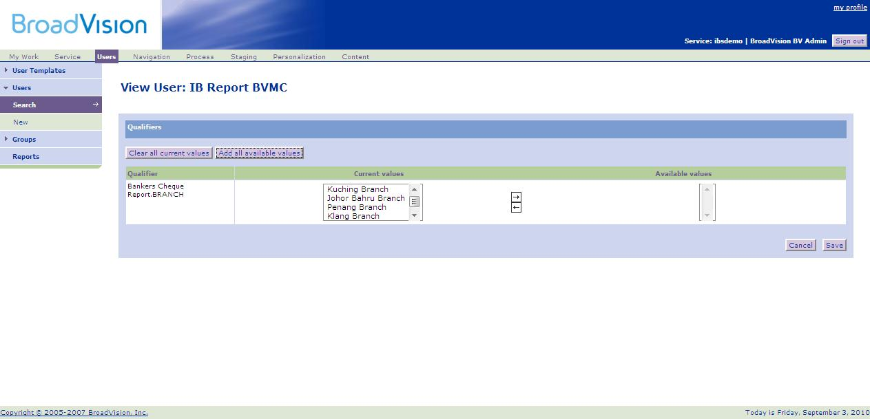
2
1

Ix – Click on edit button at REPORTTYPE qualifier

X – It would pop up a new window. Click on ‘Go’ button then change the value of ‘items per page’ to `100’ to view all available values.
2
1

Xi – kjjjj
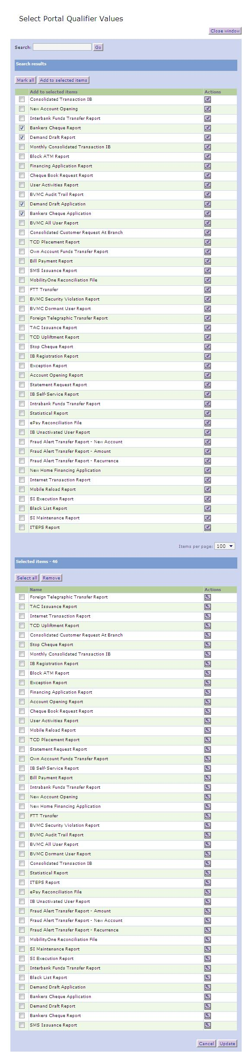
4
2
1
3

