***Issue Form (PROD)***

|  |  |
| --- | --- |
| **Originator's Name:** Chooi So Fun  **Project:** Internet Banking  **Project Manager:** Malarvili  **Module : IBG-OTC**  **Date Raised: 08.04.14**  **Phase :** Internet Banking  **Functional Area : IBG-OTC** | **Issue ID Number:**  **Related Issue ID Number:** **HD00015019**  **Classification:**  **Priority:** Critical/High/Medium/Low  **Assigned to: Vendor / IT / PMO SA / UPA**  **Actual Closed Date:** |
| **Status:** Open/Assigned/Investigated/Resolved/Approved/Deferred/No Action  *(Circle one)* | |
| **Description :**  According to JB branch, there’s only 1 successful IBG-OTC trx of RM100k (Ref# 065604) initiated but at Corus it was reflected as 2 successful entries (Ref# 065604 & 065603) & 1 failed entries (Ref# 065605). However, customer’s account only debited as 1 time only.  *Please refer to file attached for further details.* | **Impact:** |
| **Findings/Root Caused (Description):** | **Resolution:** |
| **Estimated Impact :** |  |
| **Recommendation:** | |
| **Accepted :**  **(Vendor / IT / PMO SA / UPA)**  **Date:** | **Accepted (KFHMB Tester):**  **Date:** |

**Customer’s account debited once only.**

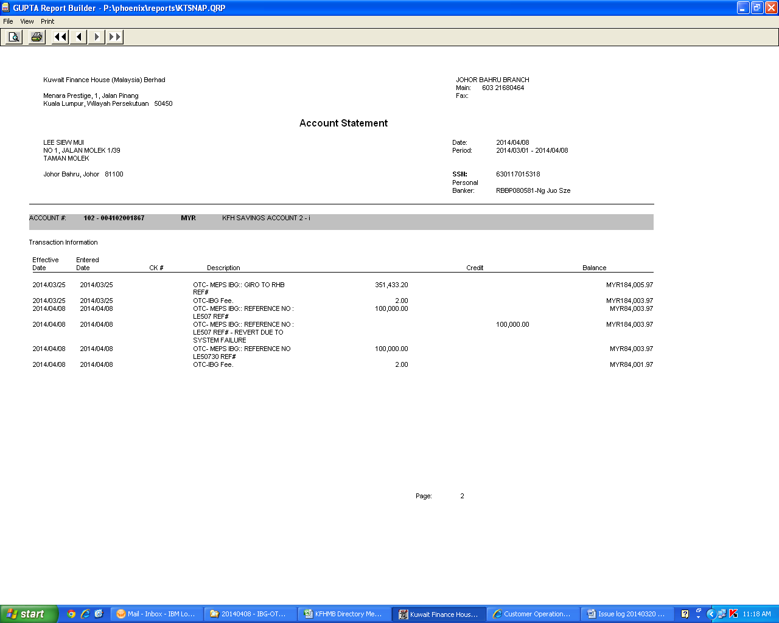

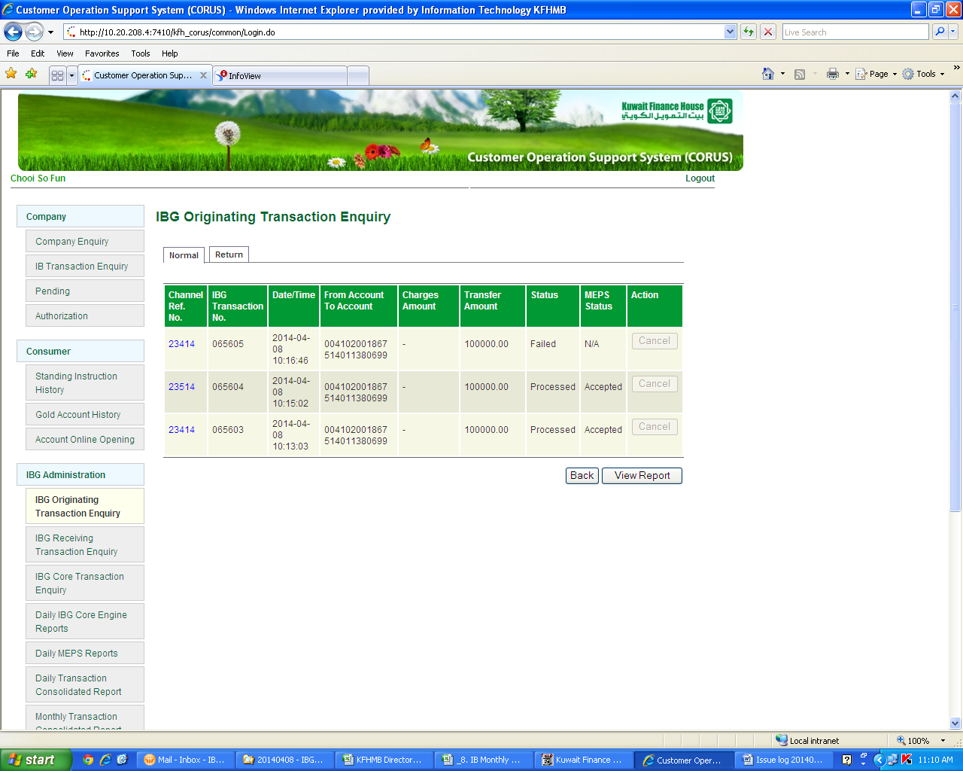

**Ref# 065603 – This is the 1st transaction performs by branch at 10.13am which supposed to be unsuccessful at CORUS as they encountered system hang when performing overwrite. Customer’s account has been reversed due to system failure but in CORUS it is still reflected as successful.**

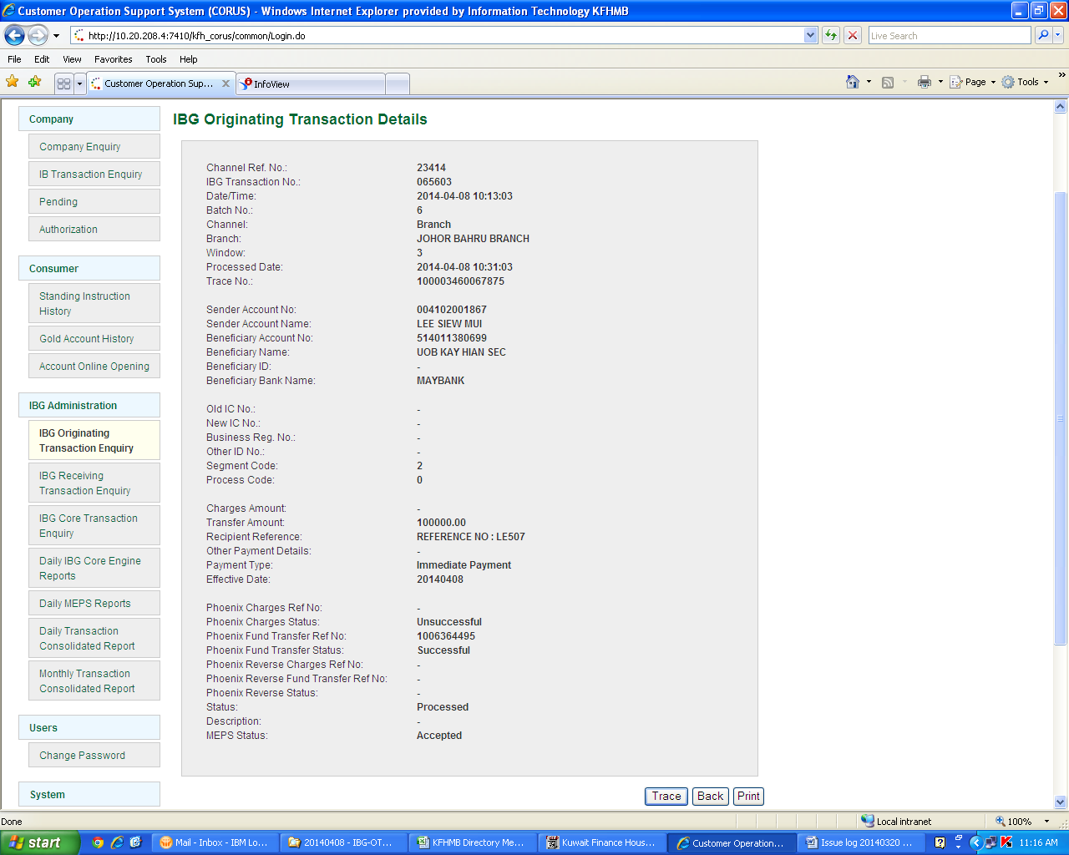

**Ref# 065604 – This is the 2nd transaction which were successfully process at 10.15am**

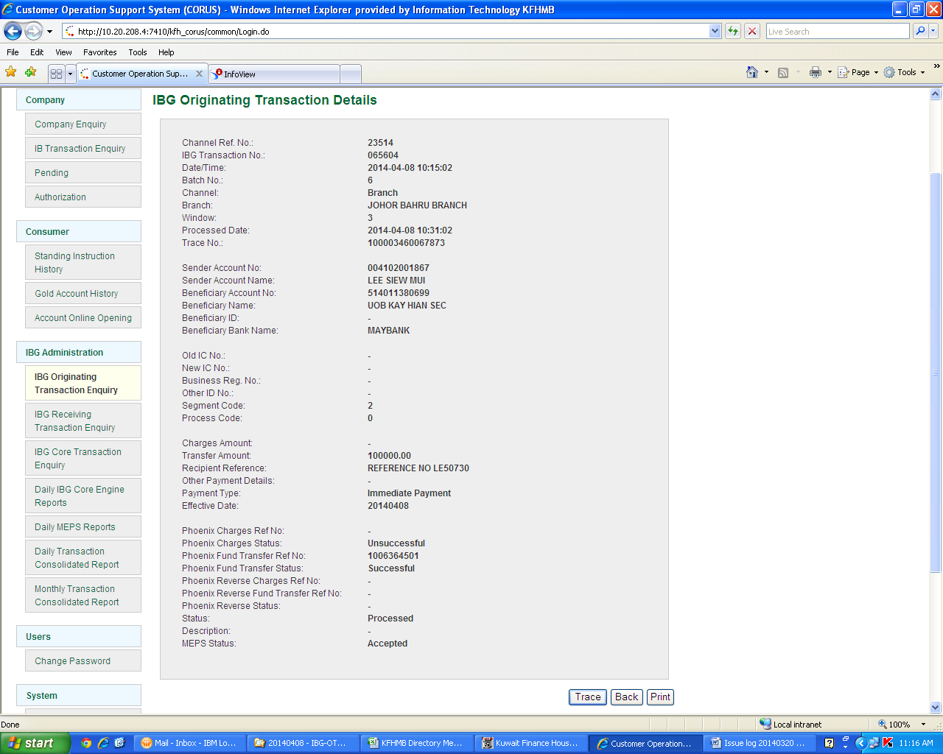

**Ref# 065605 – Why there’s additional 1 more entries created has branch claimed that they didn’t perform any more transaction.**

