# Shipping Remittance Branch qualifier BVMC data to STG

* Login to the BVMC Development Server to ship the data to STG Server.

1. Portal Qualifier Values
2. Click on the ‘Staging’ tab.
3. On the Destination field at the **Current Order** box choose ‘kfhib10:8110’
4. Then click button ‘Create new’

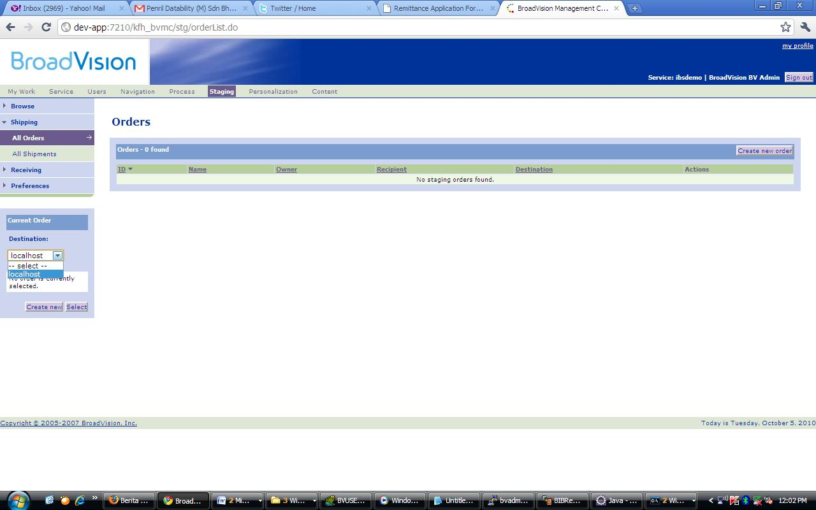

**3**

**2**

**1**

1. Put value for the fields as below:

Name: Remittance Branch Qualifier

Destination: kfhib10:8110

Recipient: bvadmin

Owner: bvadmin

Service: kfhmb

Receive Option & Shipment Options: follow as the picture.

1. Then click ‘Save’ button.

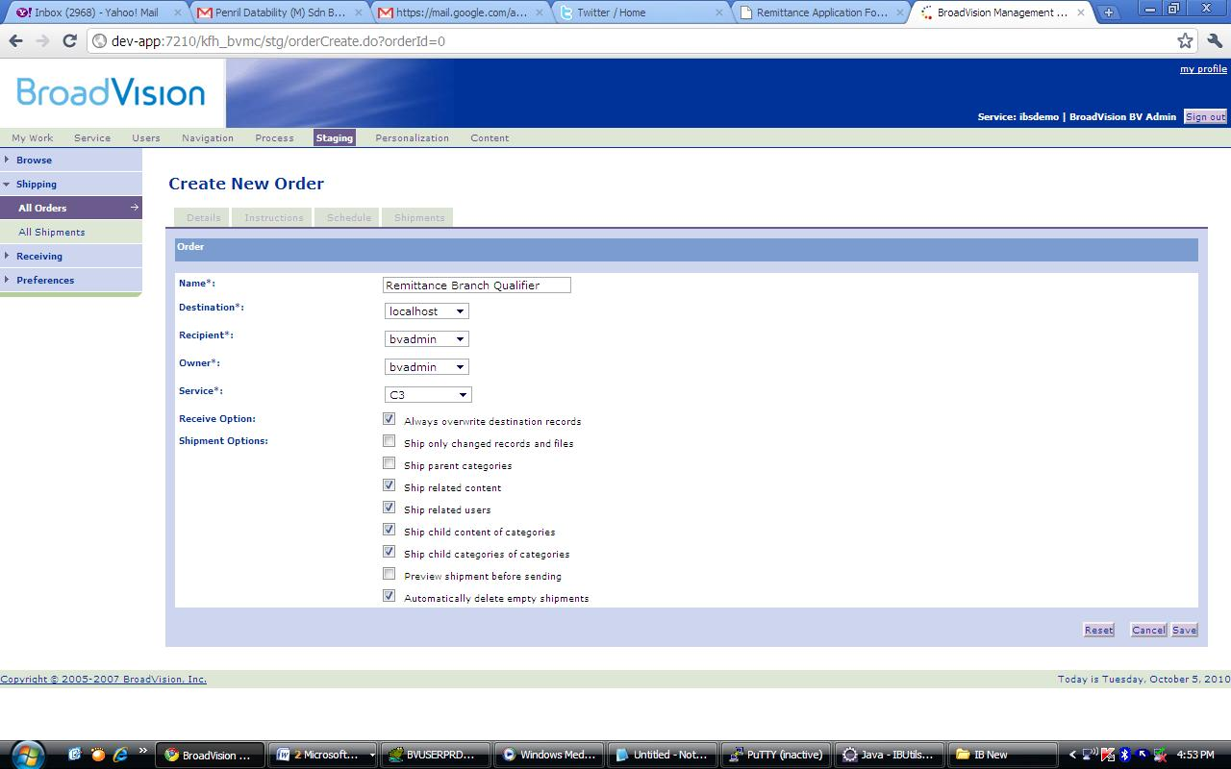

5

4

1. Click on the order no. link as following:

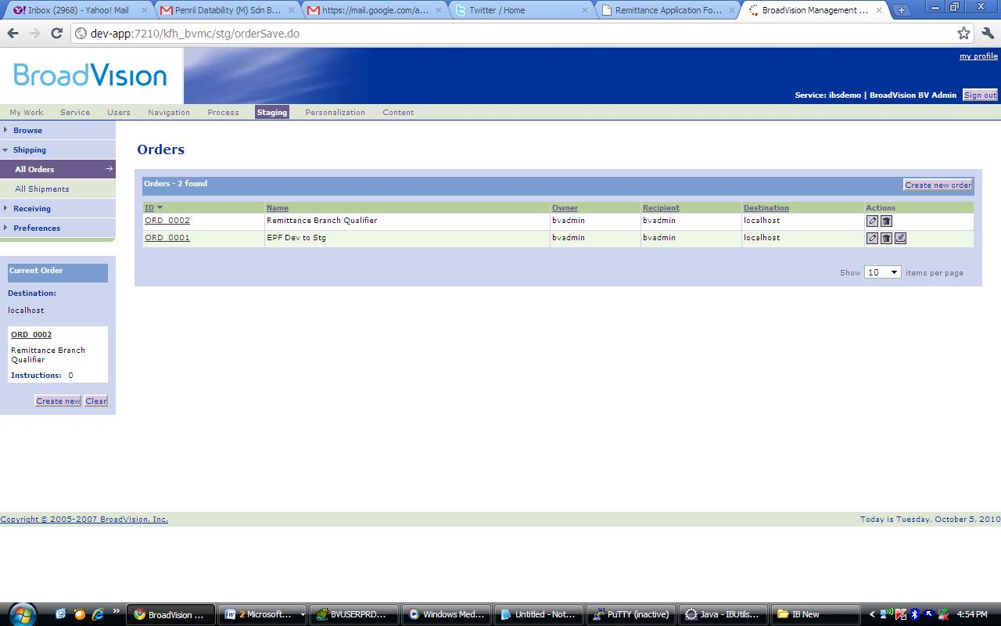

1. Then, click button ‘Add’

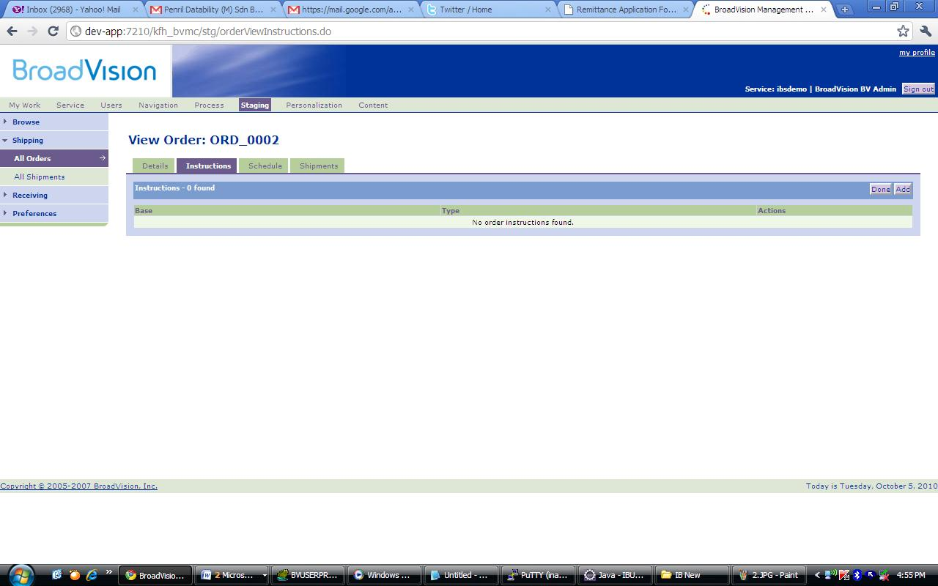

1. At the **Content Type** dropdown, choose ‘Portal Qualifier Values’

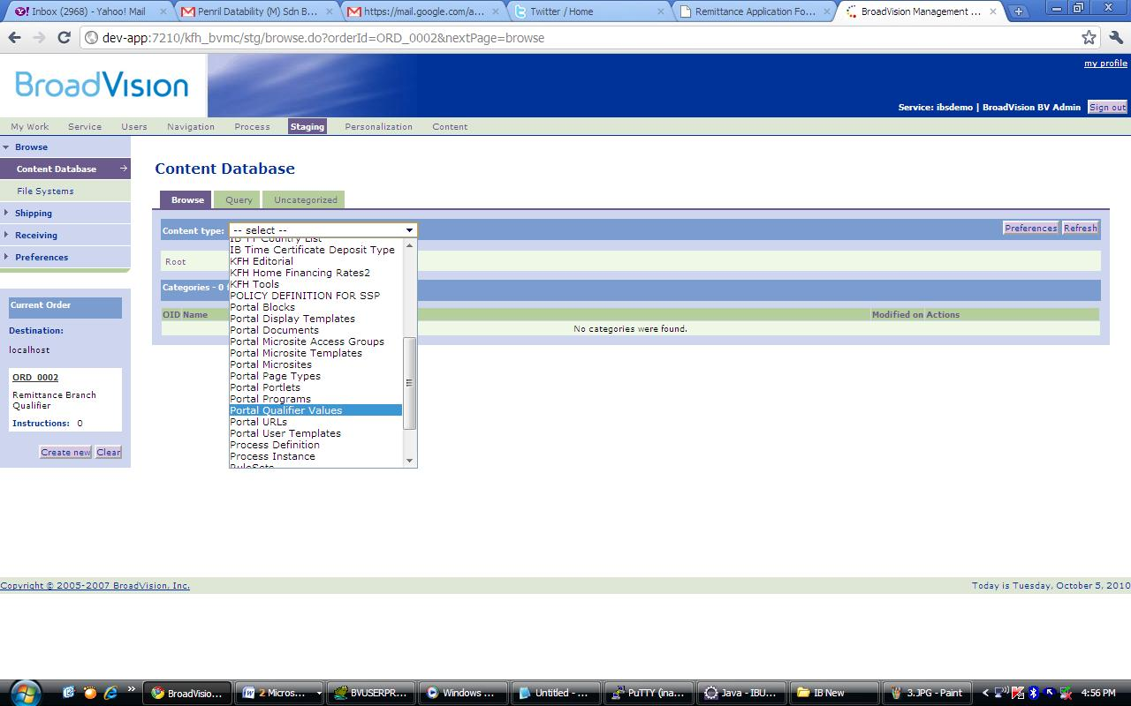

1. Change the **Show** no. to ‘100’ items per page

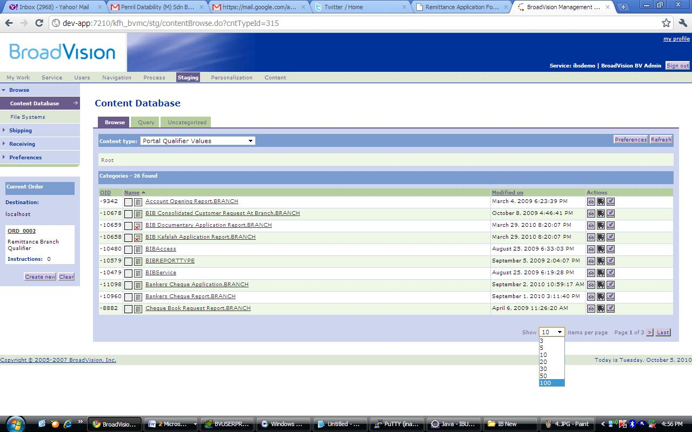

1. Click button ‘Add To Order’ for ‘Bankers Cheque Application.BRANCH'’ name link

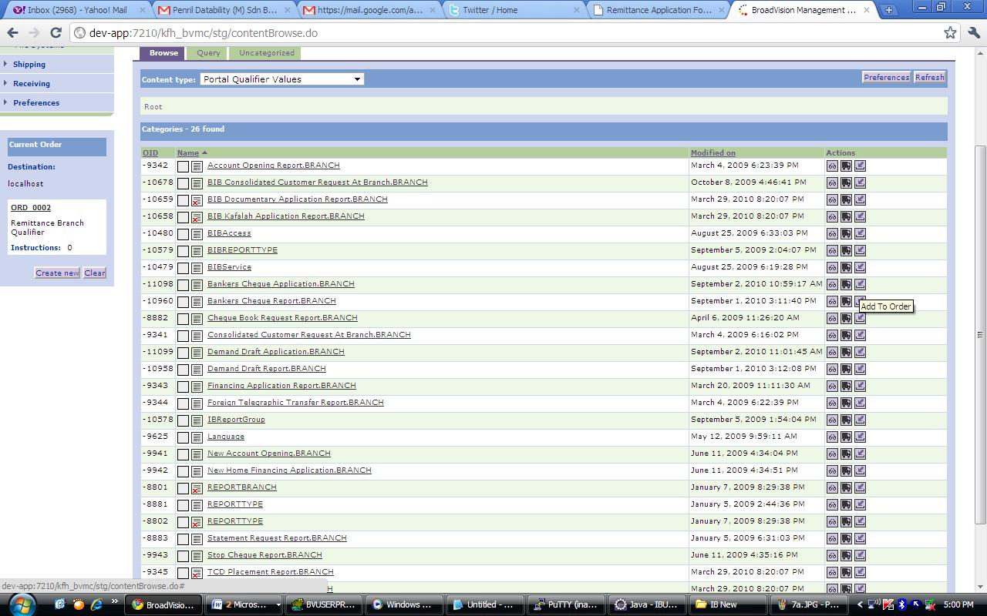

Click on this button

1. Make sure the **Instruction Base**: EP_QUAL_VALUE:/Bankers CHeque Application.BRANCH is correct, then Click button ‘Done’

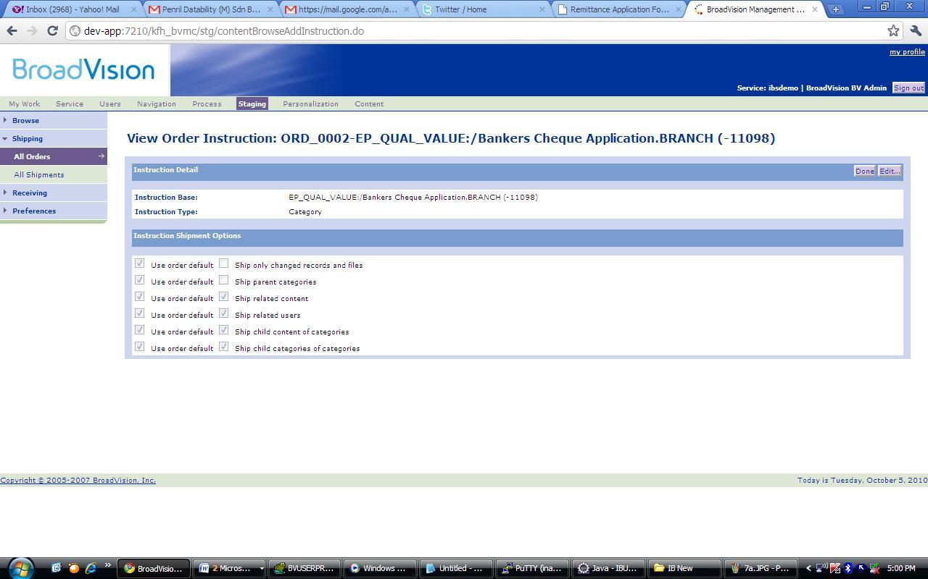

1. Repeat step 10 & 11 above to ship ‘Bankers Cheque Report.BRANCH’, ‘Demand Draft Application.BRANCH’ and‘Demand Draft Report.BRANCH’



1. Click on ‘REPORTTYPE’ link at **Name** column



1. Change the **Show** no. to ‘100’ items per page

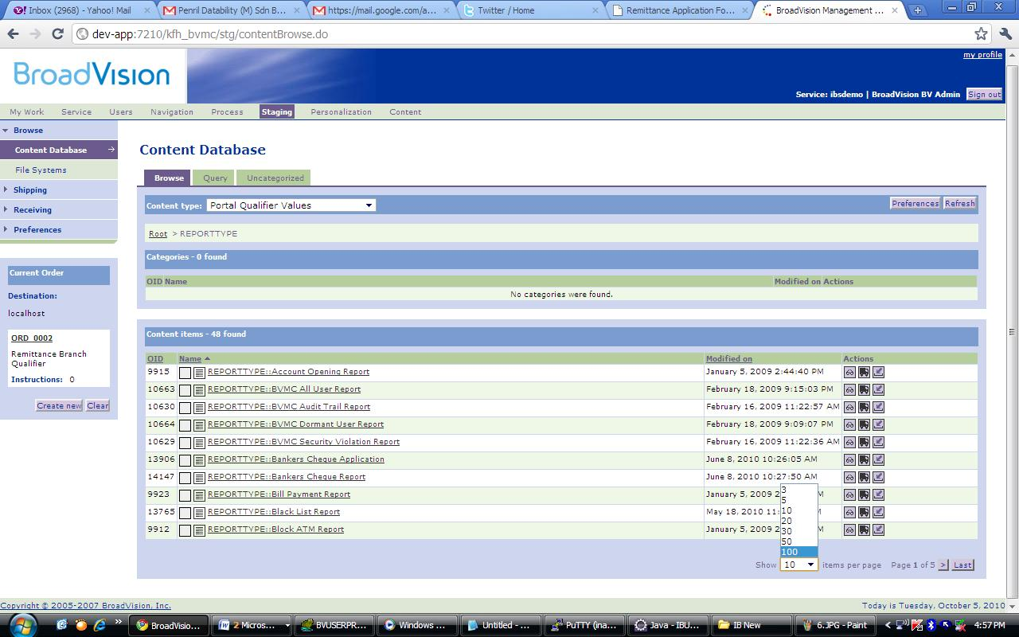

1. Click button ‘Add To Order’ for ‘REPORTTYPE::Bankers Cheque Application’ name link

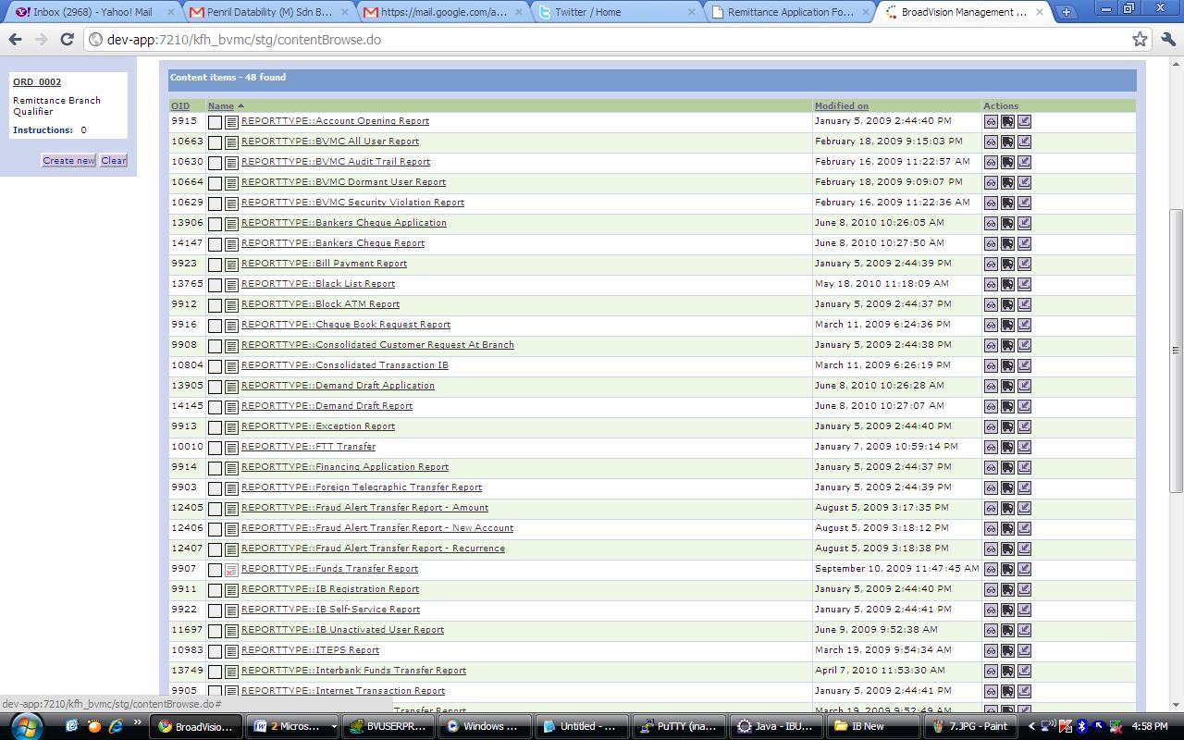

Click on this button

1. Make sure the **Instruction Base**: EP_QUAL_VALUE:xxxxx:REPORTTYPE::Bankers Cheque Application is correct, then Click button ‘Done’

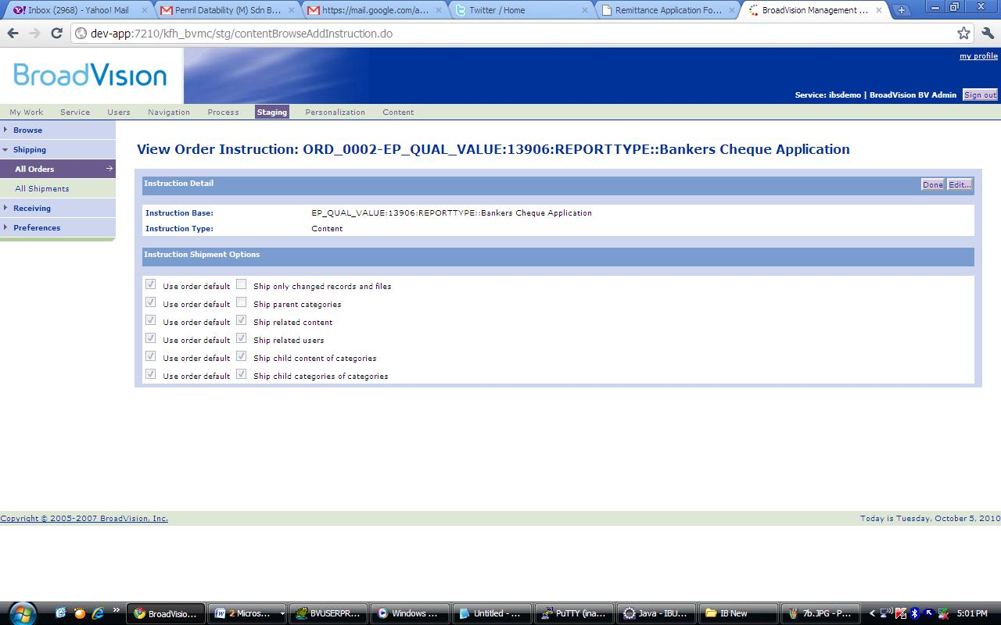

1. Repeat step 15 & 16 above to ship ‘REPORTTYPE::Bankers Cheque Report’, ‘REPORTTYPE::Demand Draft Application’ and ‘REPORTTYPE::Demand Draft Report’



1. Then, Click on the order no. link as following:



1. Double check the shipments, then when confirm, click button ‘Ship now!’

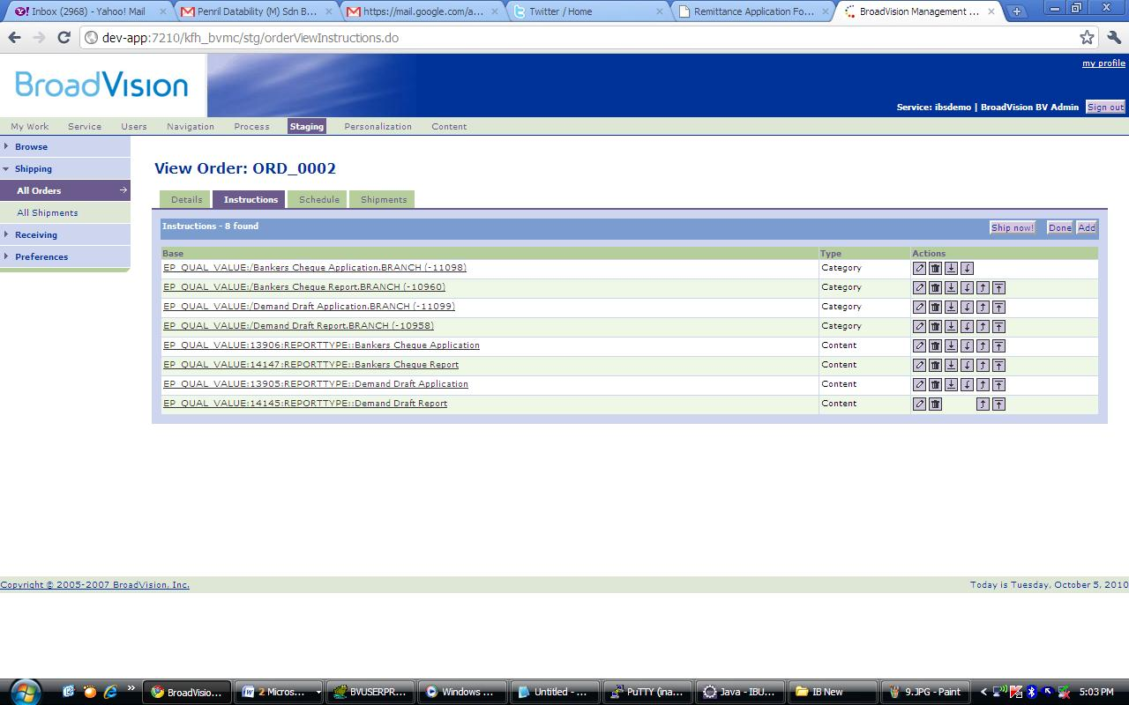

1. You’ll get the screen with ‘Creating’ status as the following.
2. Keep clicking on ‘Refresh’ button to get the Status changed to ‘Sent’

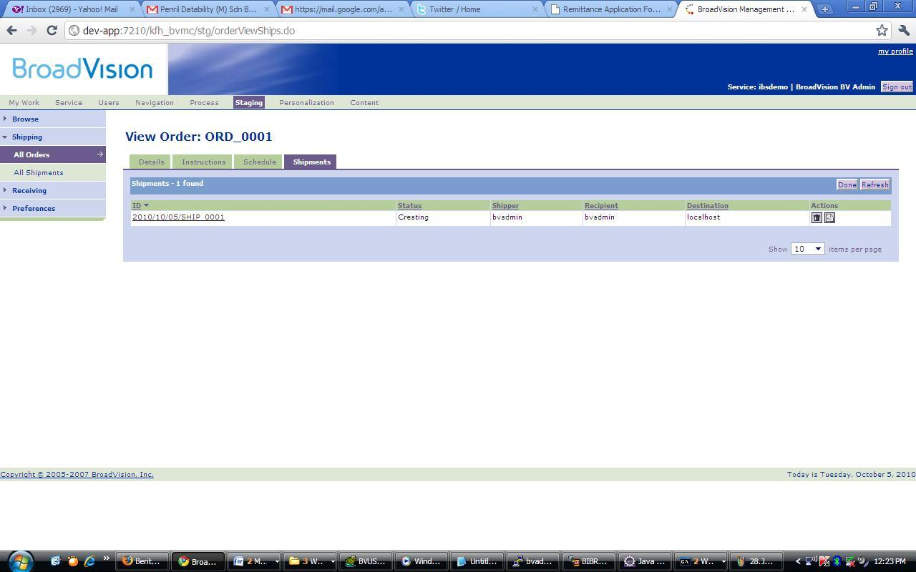

1. When the status changed to ‘Sent’ you successfully sent the shipment to the destination server.

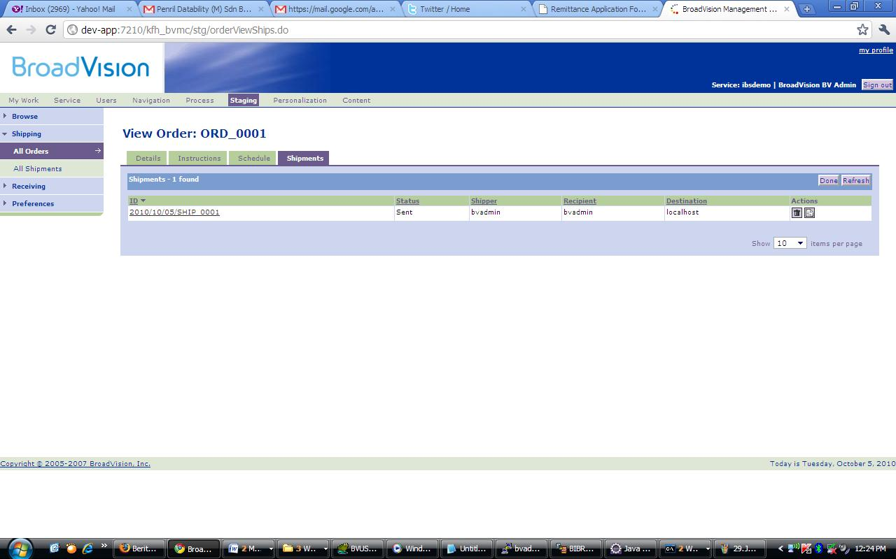

* Then, login to the BVMC Staging server to accept all the shipment made from development.

1. Click on ‘Staging’ tab
2. Then, click on ‘Receiving’ side menu

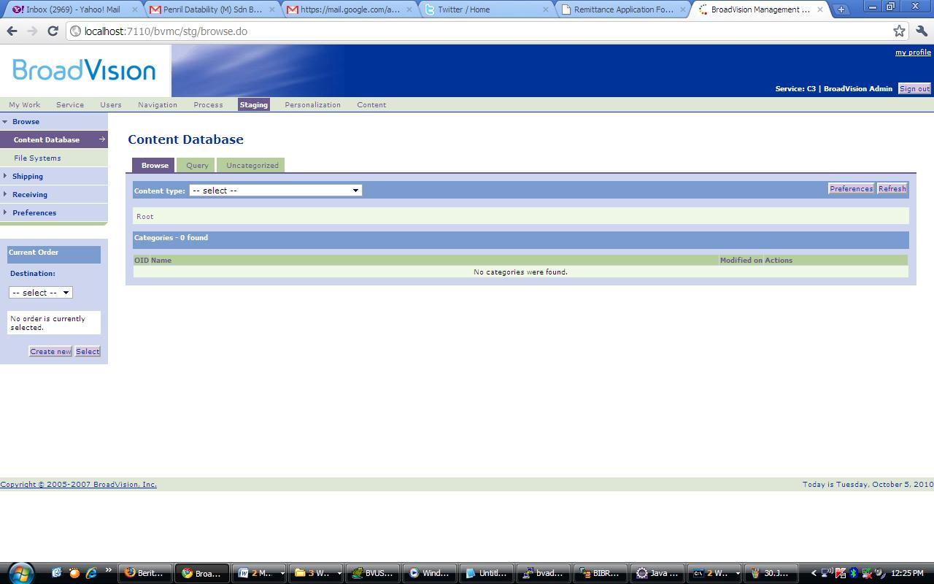

**2**

**1**

1. Click button ‘Accept shipment’ for the correct shipment date sent by checking ‘ID’ column and status is ‘Wait for review’

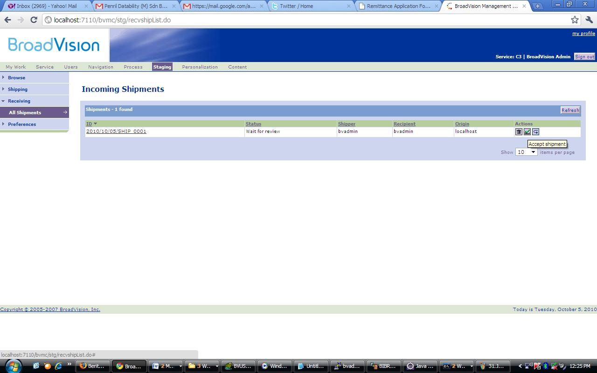

1. Then you have done accepting the shipment