Task ID#1230
Test Title: | SI Staff Fee Waiver
Test Description: | To ensure Standing Instruction transaction for staff not chargeable.
Test Functionality: | CIB > Own Account Transfer  CIB >eStanding Instruction > Own Account Transfer  Corus > Consumer > Standing Instruction History  CIB > Account Enquiry > Transaction History
Test Procedure: | - Initiate Standing Instruction transaction for staff salary account
Test Result: | Pass: Fail: | Tested by: | Siti Norahayu Binti Mohd Desa (QA Engineer)
Reason for Failure:
Remarks: | - OWN ACCOUNT TRANSFER  eSTANDING INSTRUCTIONS  CIB >eStanding Instructions  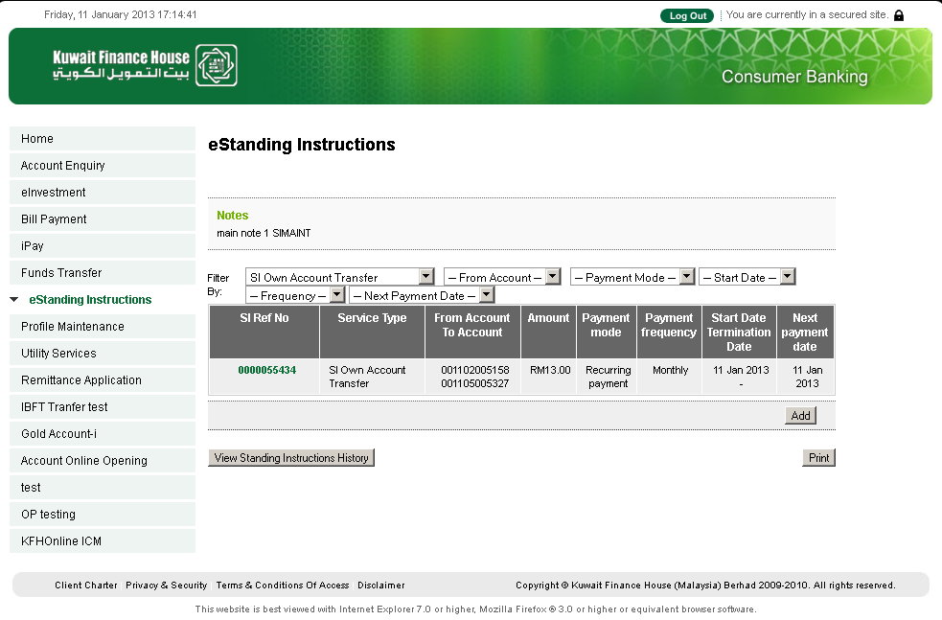  Figure 1: CIB - SI Maintenance List Screen  IB TRANSACTION ENQUIRY  CORUS > CONSUMER>Standing Instruction History  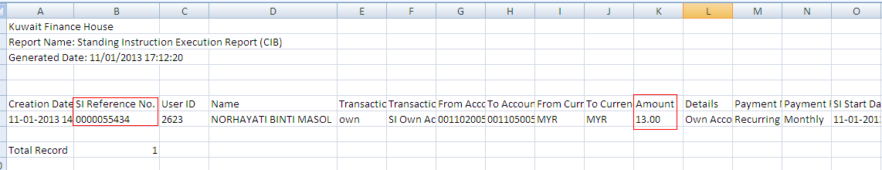  Figure 2: CORUS - Today’sSI Execution Report  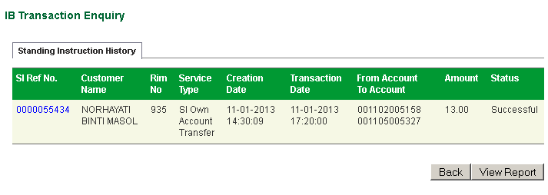  Figure 3: CORUS - SI Transaction History Enquiry Screen  eSTANDING INSTRUCTIONS  CIB >eStanding Instructions  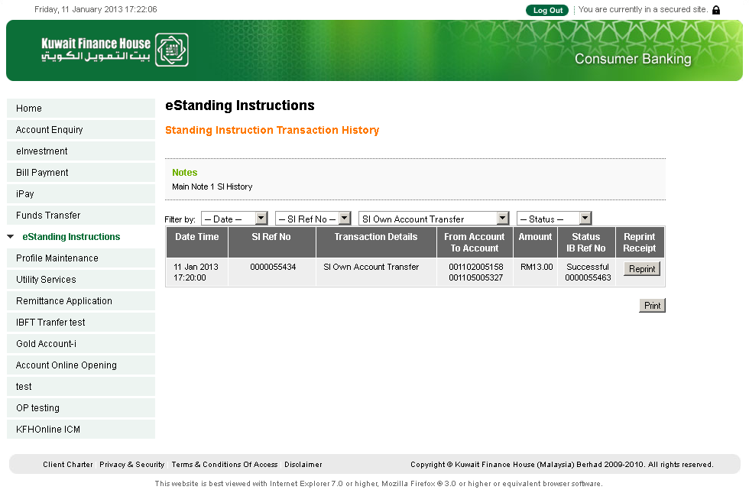  Figure 4: CIB - SI Transaction History Screen  TRANSACTION HISTORY  CIB >Account Enquiry > Transaction History  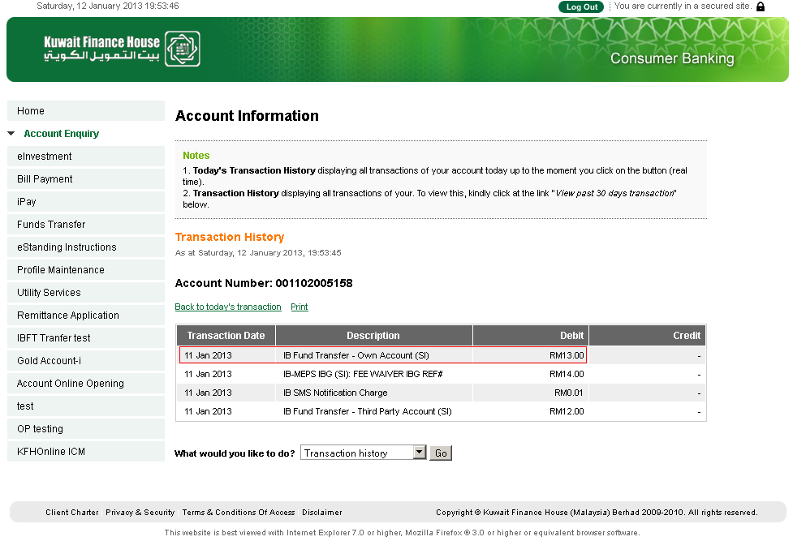  Figure 5: CIB – Transaction History Screen  SCHEDULED SERVICES  CORUS > System > Scheduled Services Maintenance > Consumer SI Engine  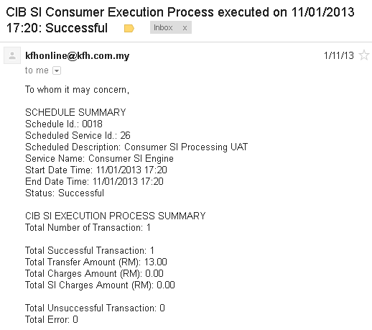  Figure 6: SI Execution Summary Email Notification Screen

Test Title: | SI Staff Fee Waiver
Test Description: | To ensure that Standing Instruction transaction for staff not chargeable.
Test Functionality: | CIB > Open 3rd Party Transfer or  CIB >eStanding Instruction > Open 3rd Party Transfer  Corus > Consumer > Standing Instruction History  CIB > Account Enquiry > Transaction History
Test Procedure: | - Initiate Standing Instruction transaction for staff salary account
Test Result: | Pass: Fail: | Tested by: | Siti Norahayu Binti Mohd Desa (QA Engineer)
Reason for Failure:
Remarks: | - OPEN 3rd PARTY TRANSFER  eSTANDING INSTRUCTIONS  CIB >eStanding Instructions  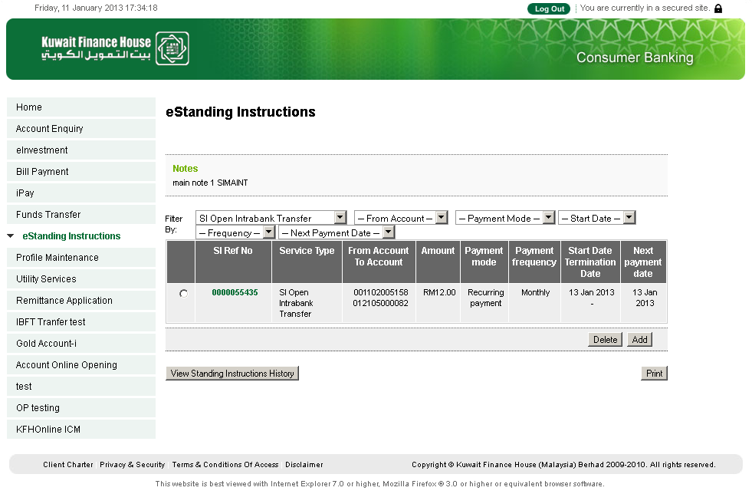  Figure 1: CIB - SI Maintenance List Screen  IB TRANSACTION ENQUIRY  CORUS > CONSUMER>Standing Instruction History  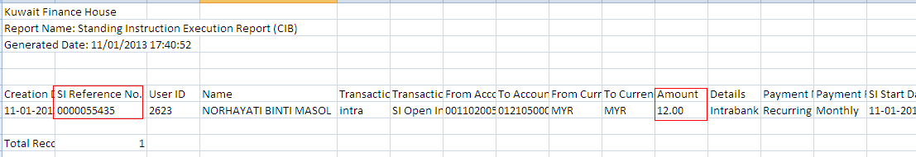  Figure 2: CORUS - Today’s SI Execution Report  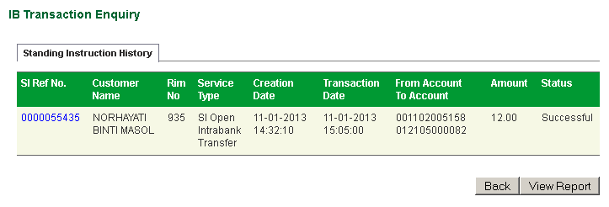  Figure 3: CORUS - SI Transaction History Enquiry Screen  eSTANDING INSTRUCTIONS  CIB >eStanding Instructions  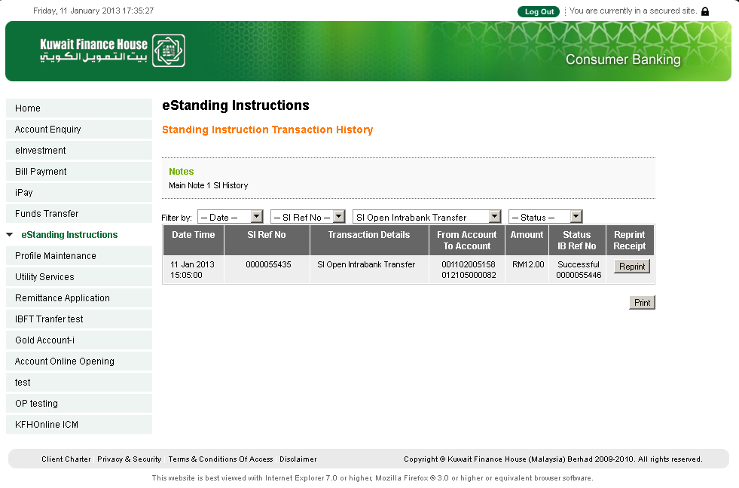  Figure 4: CIB - SI Transaction History Screen  TRANSACTION HISTORY  CIB >Account Enquiry > Transaction History  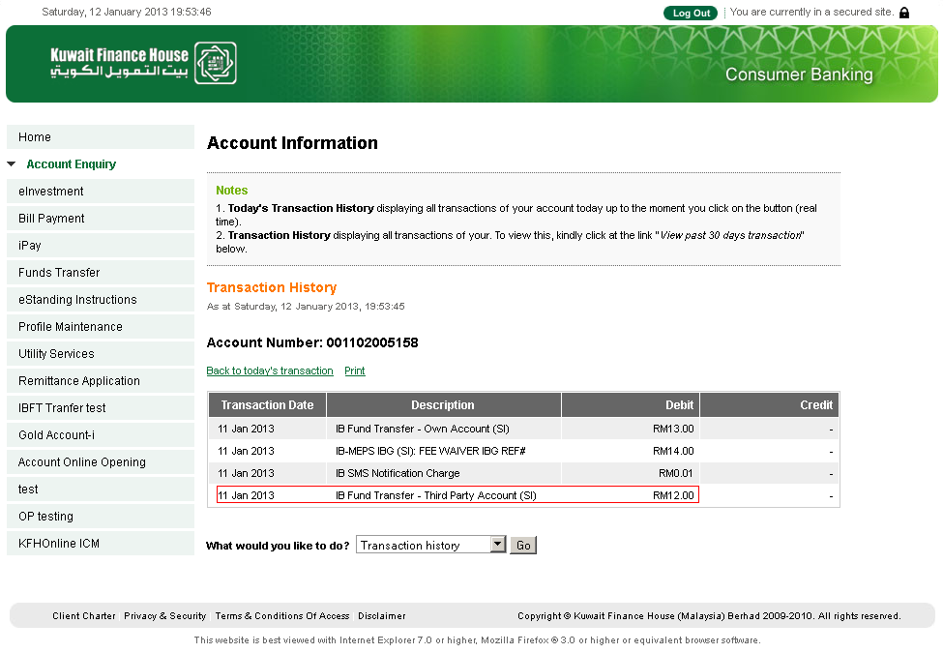  Figure 5: CIB – Transaction History Screen  SCHEDULED SERVICES  CORUS > System > Scheduled Services Maintenance > Consumer SI Engine  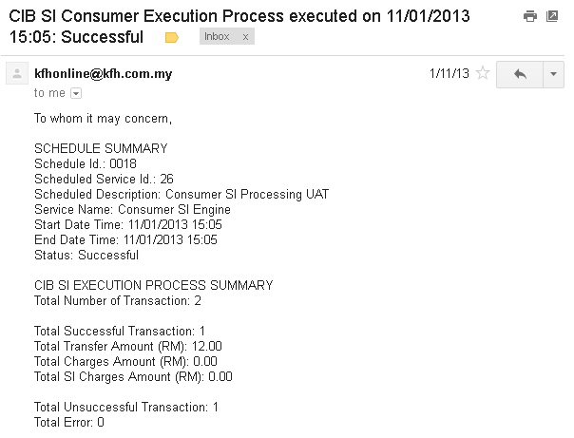  Figure 6: SI Execution Summary Email Notification Screen

Test Title: | SI Staff Fee Waiver
Test Description: | To ensure that Standing Instruction transaction for staff not chargeable.
Test Functionality: | CIB > Open Interbank GIRO Transfer or  CIB >eStanding Instruction > Open Interbank GIRO Transfer  Corus > Consumer > Standing Instruction History  CIB > Account Enquiry > Transaction History
Test Procedure: | - Initiate Standing Instruction transaction for staff salary account
Test Result: | Pass: Fail: | Tested by: | Siti Norahayu Binti Mohd Desa (QA Engineer)
Reason for Failure:
Remarks: | - OPEN INTERBANK GIRO TRANSFER  eSTANDING INSTRUCTIONS  CIB >eStanding Instructions  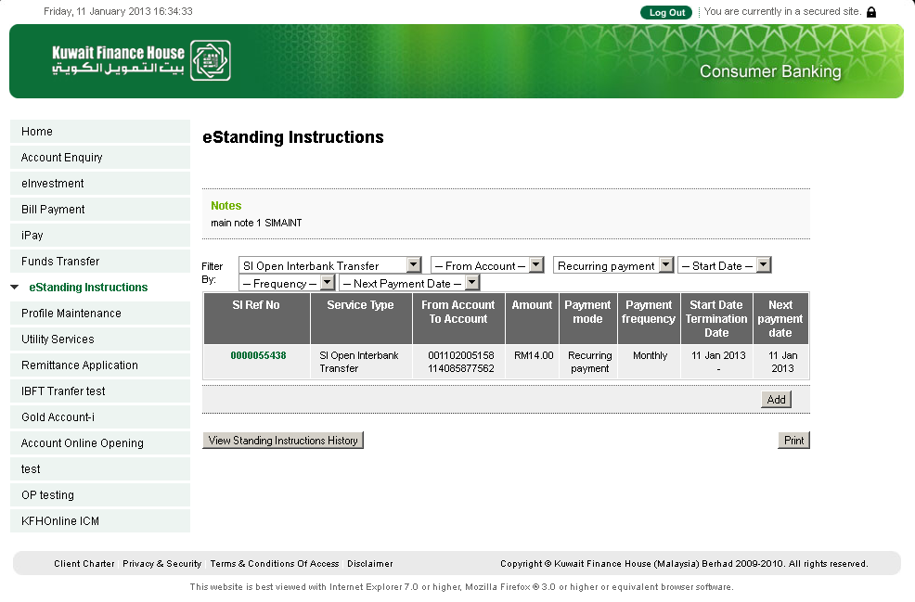  Figure 1: CIB - SI Maintenance List Screen  IB TRANSACTION ENQUIRY  CORUS > CONSUMER>Standing Instruction History  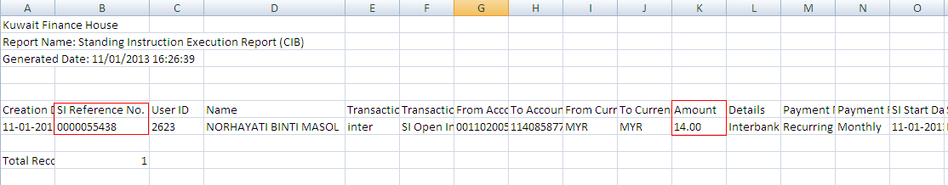  Figure 2: CORUS - Today’sSI Execution Report  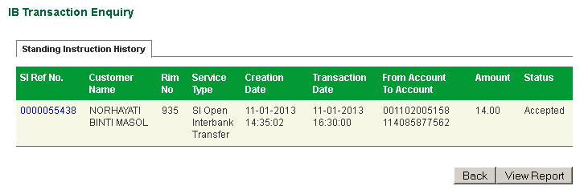  Figure 3: CORUS - SI Transaction History Enquiry Screen  eSTANDING INSTRUCTIONS  CIB >eStanding Instructions  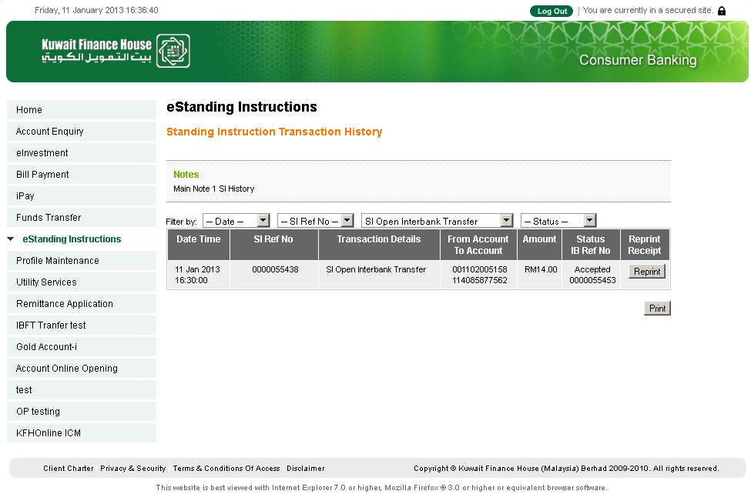  Figure 4: CIB - SI Transaction History Screen  TRANSACTION HISTORY  CIB >Account Enquiry > Transaction History  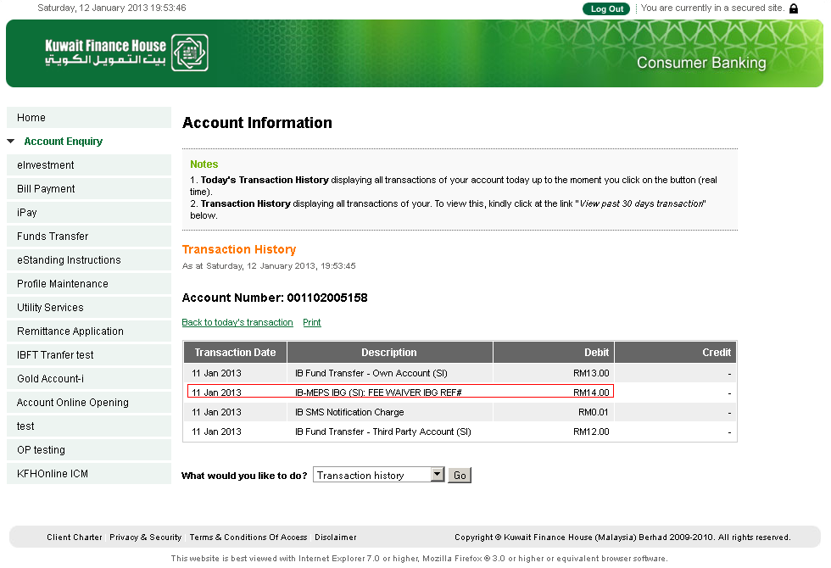  Figure 5: CIB – Transaction History Screen  SCHEDULED SERVICES  CORUS > System > Scheduled Services Maintenance > Consumer SI Engine  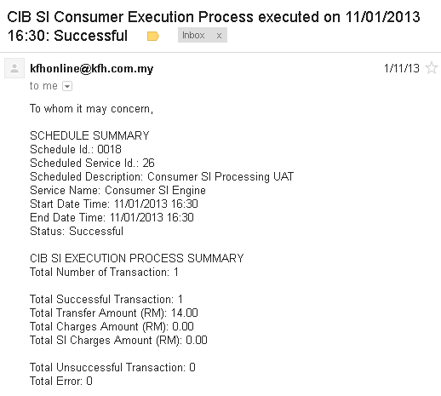  Figure 6: SI Execution Summary Email Notification Screen

Test Title: | SI Staff Fee Waiver
Test Description: | To ensure that Standing Instruction transaction for staff not chargeable.
Test Functionality: | CIB > Open Foreign Telegraphic Transfer or  CIB >eStanding Instruction > Open Foreign Telegraphic Transfer  Corus > Consumer > Standing Instruction History  CIB > Account Enquiry > Transaction History
Test Procedure: | - Initiate Standing Instruction transaction for staff salary account
Test Result: | Pass: Fail: | Tested by: | Siti Norahayu Binti Mohd Desa (QA Engineer)
Reason for Failure:
Remarks: | - OPEN FOREIGN TELEGRAPHIC TRANSFER  eSTANDING INSTRUCTIONS  CIB >eStanding Instructions  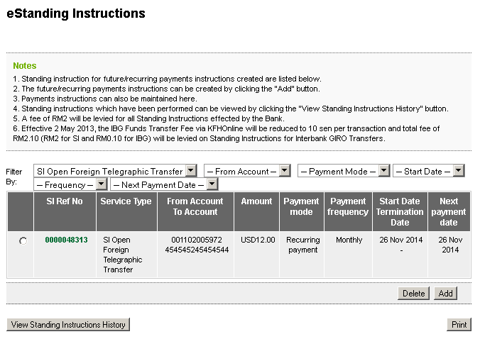  Figure 1: CIB - SI Maintenance List Screen  IB TRANSACTION ENQUIRY  CORUS > CONSUMER>Standing Instruction History  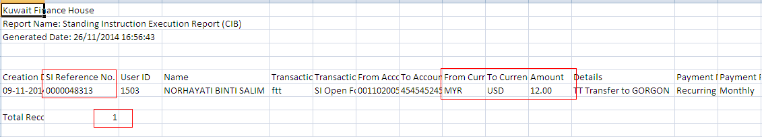  Figure 2: CORUS - Today’sSI Execution Report  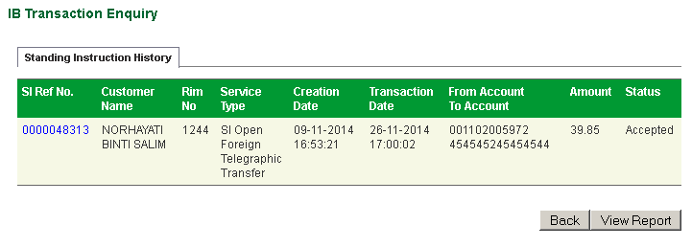  Figure 3: CORUS - SI Transaction History Enquiry Screen  eSTANDING INSTRUCTIONS  CIB >eStanding Instructions  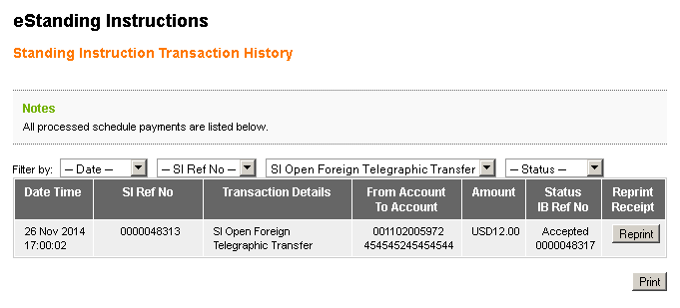  Figure 4: CIB - SI Transaction History Screen  TRANSACTION HISTORY  CIB >Account Enquiry > Transaction History  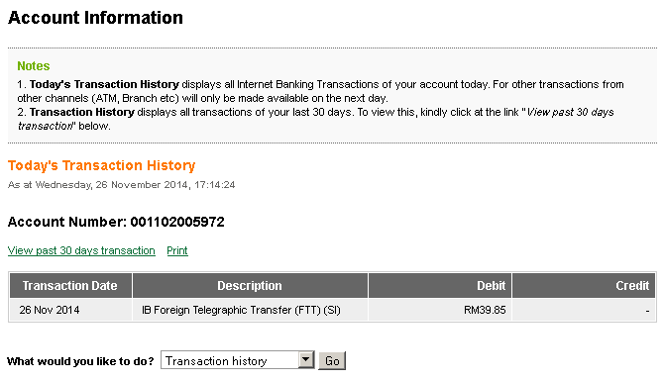  Figure 5: CIB – Transaction History Screen  SCHEDULED SERVICES  CORUS > System > Scheduled Services Maintenance > Consumer SI Engine  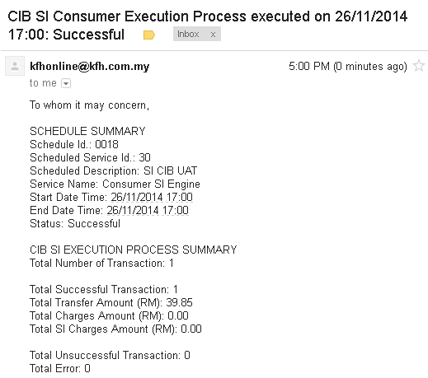  Figure 6: SI Execution Summary Email Notification Screen

