Task ID#4312
Test Title: | Adding Logger
Test Description: | To ensure logger added in DB and framework accordingly
Test Functionality: | CIB > Bill Payment > Open Bill Payment  CIB > Bill Payment > Prepaid Top Up
Test Procedure: | - To perform successful transaction and ensure the data save in the database correctly.  - To perform unsuccessful transaction and ensure the data save in the database correctly.  - To perform a transaction without unsuccessful status but system will log exception into log file
Test Result: | Pass: Fail: | Tested by: | Siti Norahayu Binti Mohd Desa (QA Engineer)
Reason for Failure:
Remarks: | BILL PAYMENT  CIB > Bill Payment > Open Bill Payment  Test Item 1: To perform successful transaction and ensure the data save in the database correctly.  Result:  Database will save all the transaction data into IB_BILL_PAYMENT, IB_TRANSACTION_HISTORY and IB_RECEIPT_DETAILS  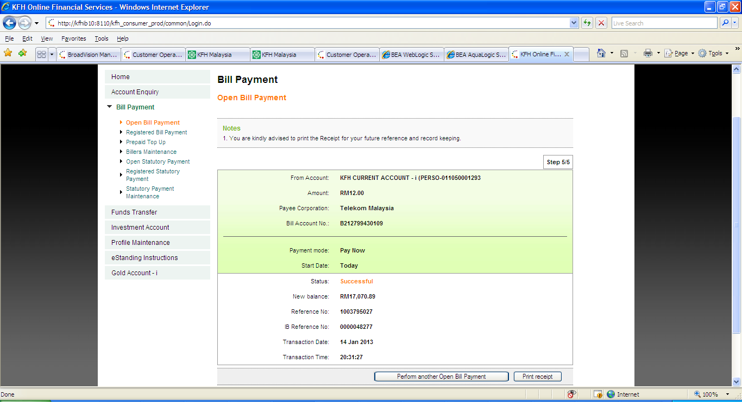  Figure 1: CIB – Open Bill Payment Result Screen  Successful log into IB_BILL_PAYMENT table  TRNX_ID 201301140000048277  TRNX_TYPE Bill Payment Open Payment  TRNX_DATE 14-JAN-2013 20:31:27 1242  USER_ID 1242  PAYEE_NAME Telekom Malaysia  BILL_ACC_NO B212799430109  BILL_ACCOUNT_NAME Bill Account No.  EFFECTIVE_DATE 14-JAN-2013 20:31:27 011050001293  FROM_ACC_NO 0110500001293  AMOUNT 12  STATUS Successful  PHX_REFERENCE_NO 1003795027  REMOTE_IP 10.20.8.124  OID 2362  PAYEE_CODE TLEKOM  PRODUCT_CODE TELEKOM  SERVICE_CODE BILLOPEN  MERCHANT_ACC_NO 01-04-133-01-03-22900502  MERCHANT Others  Table 1: IB_BILL_PAYMENT table data  Successful log into IB_TRANSACTION_HISTORY table  CREATION_DATE 14-JAN-2013 20:31:32  TRNX_ID 201301140000048277  TRNX_TYPE Bill Payment Open Payment  FROM_ACC_NO 0110500001293  AMOUNT 12  DETAILS Open Bill Payment - Telekom Malaysia  STATUS Successful  BILL_ACCTID B212799430109  REMOTE_IP 10.20.8.124  USER_ID 1242  PHX_REFERENCE_NO 1003795027  OID 2362  IB_SESSION_ID 20130114201528015202  FROM_CURRENCY MYR  TO_CURRENCY MYR  PAYMENT_MODE 01  Table 2: IB_TRANSACTION_HISTORY table data  Successful log into IB_RECEIPT_DETAILS table  TRNX_DATE TRNX_ID RECEIPT_DETAILS_NAME RECEIPT_DETAILS_VALUE SEQUENCE_ID OID  14-JAN-2013 0:00:00 201301140000048277 Transaction Type Bill Payment Open Payment 0 109924  14-JAN-2013 0:00:00 201301140000048277 From Account KFH CURRENT ACCOUNT - i (PERSO-011050001293 1 109925  14-JAN-2013 0:00:00 201301140000048277 Amount RM12.00 2 109926  14-JAN-2013 0:00:00 201301140000048277 Payee Corporation Telekom Malaysia 3 109927  14-JAN-2013 0:00:00 201301140000048277 Bill Account No. B212799430109 4 109928  14-JAN-2013 0:00:00 201301140000048277 Payment mode Pay Now 5 109929  14-JAN-2013 0:00:00 201301140000048277 Start Date Today Today 6 109930  14-JAN-2013 0:00:00 201301140000048277 Status Successful 7 109931  14-JAN-2013 0:00:00 201301140000048277 Reference No 1003795027 8 109932  14-JAN-2013 0:00:00 201301140000048277 IB Reference No 0000048277 9 109933  14-JAN-2013 0:00:00 201301140000048277 Transaction Date 14 Jan 2013 10 109934  14-JAN-2013 0:00:00 201301140000048277 Transaction Time 20:31:27 11 109935  Table 3: IB_RECEIPT_DETAILS table data  PREPAID TOP UP  CIB > Bill Payment > Prepaid Top Up  Test Item 2: To perform unsuccessful transaction and ensure the data save in the database correctly.  Result:  Database will save all the transaction data into IB_MOBILE_RELOAD, and IB_TRANSACTION_HISTORY.  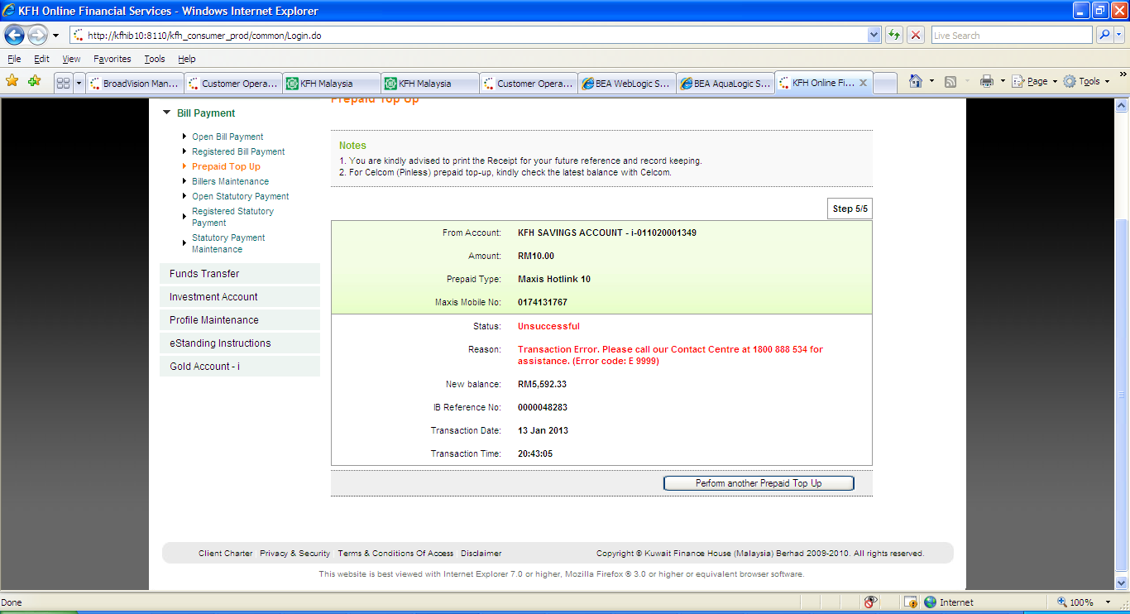  Figure 4: CIB – Prepaid Top Up Result Screen  SuccessfulLog into IB_MOBILE_RELOAD table  TRNX_ID 201301130000048283  TRNX_TYPE Bill Payment Prepaid Payment  TRNX_DATE 13-JAN-2013 20:43:05 1242  USER_ID 1242  PAYEE_CODE MXH010  PAYEE_NAME Maxis Hotlink 10  MOBILE 0174131767  AMOUNT 10  FROM_ACC_NO 011020001349  STATUS Unsuccessful  PHX_REFERENCE_NO 1003795028  REMOTE_IP 10.20.8.124  PHXREV_REF_NO 1003795030  PRODUCT_CODE MAXISHOTLINK  SERVICE_CODE BILLPRE  MERCHANT_ACC_NO 001105010843  MERCHANT ePay  OID 669  Table 4: IB_MOBILE_RELOAD table data  SuccessfulLog into IB_TRANSACTION_HISTORY table  CREATION_DATE 13-JAN-2013 20:43:10  TRNX_ID 201301130000048283  TRNX_TYPE Bill Payment Prepaid Payment  FROM_ACC_NO 011020001349  AMOUNT 10  DETAILS Prepaid Bill Payment - Maxis Hotlink 10  STATUS Unsuccessful  BILL_ACCTID 0174131767  REMOTE_IP 10.20.8.124  USER_ID 1242  RECEIPT_INDI 1  PHX_REFERENCE_NO 1003795028  OID 17622  IB_SESSION_ID 20130113204208015203  PHXREV_REF_NO 1003795030  FROM_CURRENCY MYR  TO_CURRENCY MYR  TRNX_REASON Transaction Error. Please call our Contact Centre at 1800 888 534 for assistance. (Error code: E 9999)  PAYMENT_MODE 01  Table 5: IB_TRANSACTION_HISTORY table data  SuccessfulLog into IB_RECEIPT_DETAILS table  NONE  BILL PAYMENT  CIB > Bill Payment > Open Bill Payment  Test Item 1: To perform a successful transaction status without displaying PRINT button.  Result:  System display result page without PRINT button to customer. The transaction still save into database but system will log exception into log file.  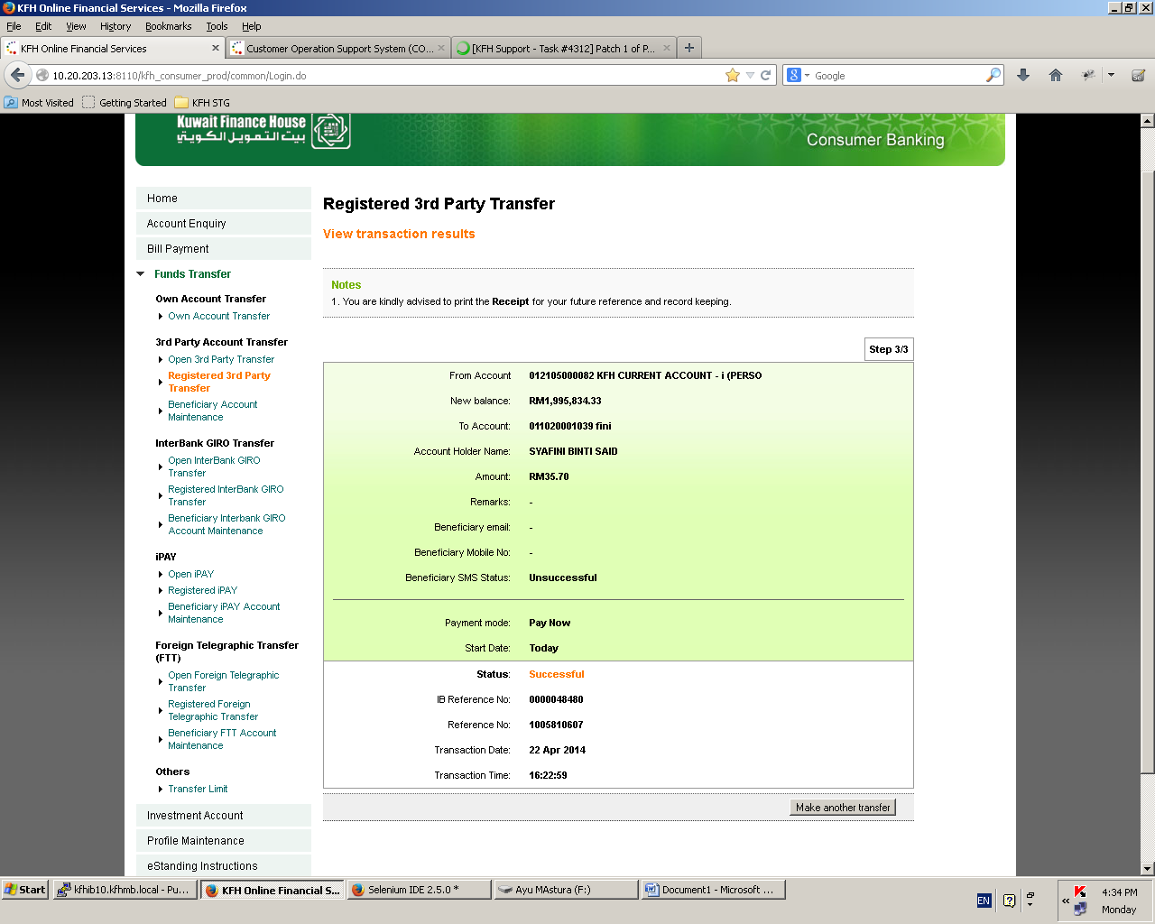  Figure 3: CIB – Open Bill Payment Result Screen  Successful log into IBSystem_bv_framework.log  2014/04/22 13:38:41:281 ERROR kfh.error.exception.IBBusinessException: [0000] Service is currently unavailable.  2014/04/22 13:48:24:813 ERROR services.ib104_fundtransfer.thirdparty.IBReg3rdPartyTransferResultsServices: Failed to Populate Receipt Map or reference no. Error message[java.lang.NullPointerException]  2014/04/22 14:38:21:933 INFO kfh.web.utils.Pagination: Constructed[my.com.kfh.web.utils.Pagination] Parameters(int,int)  2014/04/22 14:38:21:954 INFO kfh.web.utils.Pagination: Parameter Value: count[7] entriesPerPage10  2014/04/22 14:38:30:468 INFO kfh.web.utils.Pagination: Constructed[my.com.kfh.web.utils.Pagination] Parameters(int,int)  2014/04/22 14:38:30:488 INFO kfh.web.utils.Pagination: Parameter Value: count[2] entriesPerPage10  Figure 6: CIB – Open 3rd Party Transfer Confirmation Screen

