Maybank Business Requirement
Maybank2u Pay Enhancement on Mobile Application (App)



By Saber Ramli
Product Management,
Virtual Banking& Payments

Document Control

Author

Saber Ramli

Revision History

Rev# | Date | Description | Item# | Author
0.1 | 25th Feb 2014 | Initial Draft | N/A | Saber Ramli
0.2 | 2nd Mar 2014 | - Added Payment Disclosure  - Added Process Flows for Create, Delete, and Notification  - Added Reports to File  - Added Email to Seller  - Refined Global Setting Rules |  | Cheah Lu Hsun
0.3 | 3rd March 2014 |  |  | Saber Ramli
Table of Contents

1 Business Requirement Background 4
1.1 Background 4
1.2 Objective 4
1.3 High Level Requirement 4
1.4 Risks 5
2 Process Flow & Screen Design 5
2.1 Seller Menu Flow 5
2.2 Buyer Menu Flow 11
3 Host Application - MIB3 13
4 Reports 14

Business Requirement Background

Background
M2U Pay via maybank2u website was successfully launched in 2013. Currently, blog shop is using M2U pay as payment gateway to facilitate purchases at blog shops.

Objective
Now ALL M2U customers can be a seller. M2U Pay Mobile Application will allow seller ability to manage their transaction via Mobile App using Mobile phones, Ipad or Tablets.

Maybank2u Pay Mobile App creates an avenue for a hassle free selling experience. The App provides Sellers the opportunity to offer Maybank2u Pay as an option for payment to their Social Media Buyers and the convenience for Sellers to manage their business transactions.

High Level Requirement
In this mobile application, existing Maybank2u user with CASA can use this facility by downloading the app in Play Store and App Store. A link will be created in social media once seller has posted their products. These links can be posted on below social media sites:
- Facebook
- Twitter

Interested buyers will be redirect to Maybank2u Pay Payment Engine when the buyer clicks on the link posted by Sellers and make payment via M2U.

For each products posting, the seller is required to provide information such as
i. Seller Name
ii. Description
iii. Price
- No of Item
- Shipping Cost
- Email
- Mobile No

Upon creation of the short links, the mobile application will save the product information and images to the server. Seller can also track sales record for all products short links posted to the social media.
All product posted is not allowed to be edited such as duration, images, price and description.

Control measure:
- To have link in social media posting to flag for fraudster.
- Seller must be verified Maybank2U customers with CASA.
- To lock the item only for one customer if there is concurrent payment attempt from two customers for single item.
- When item sold out, the link will be unavailable.
- Seller M2U Pay Mobile App timeout is to set at 3min
- This service is only available for sole proprietor and individual.

Risks
- Customers might be calling in MGCC for refund or goods not received
- Images stored/posted could be not appropriate
- Sellers to sell illegal/inappropriate items.

Process Flow & Screen Design

Seller Menu Flow

Seller Menu Process
Step 1 to create link
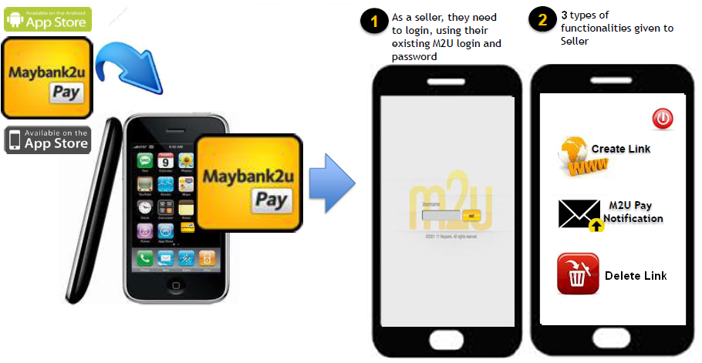
Step2 to create link
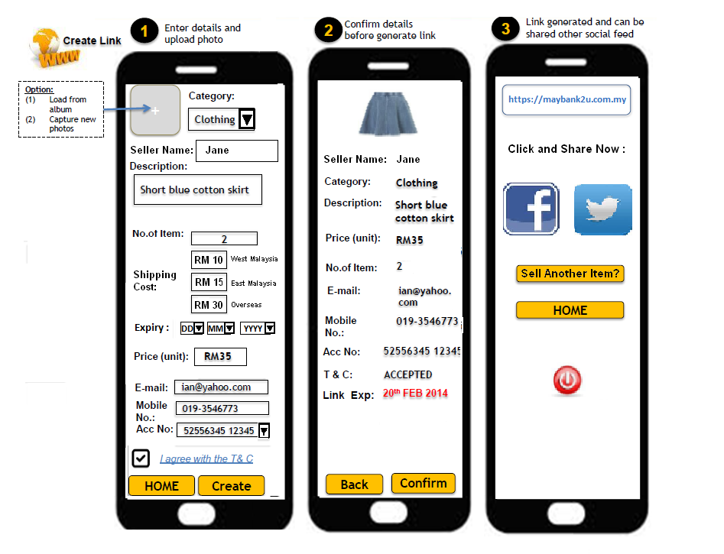
Add Expiry Box – User Entry
Fields  (exact field name) | Data Type  (e.g. Input, dropdown, Pre-populate, radio button, buttons, hyperlinks...etc) | M/O  (Mandatory / Optional) | Format  (e.g. alpha, numeric, decimals with places...etc) | Length  (Min and Max length) | Source | Validation | Remarks
Seller Name | Input | M | Alpha | 25 Digit | User | - Seller to define name to be displayed in the posting and during buyer payment engine
Category | Dropdown | M | Alpha Numeric | N/A | Predefined | - Must select at least 1 category  - In dropdown should have  1. Accessories & Clothes  2. Electronics  3. Food  4. Leisure (Music/Books)
Description | Input | M | Alpha Numeric | 250 Digit | User | -To allow user to input description of the item. No funny characters allowed.
Expiry | Pre-Populate | M | N/A | N/A |  | - To follow calendar date  -
Price | Input | M | Numeric | 7 Digit | User | - To include decimal  - Max RM 5,000 | Capping for Price is Maintainable
No of Item | Input | M | Alpha Numeric | 2 Digit | User | -Allow user to key in no of item to be sold.  - Host to update real time once stock updated by seller  - Current allowable no of item is 10 | Capping for No of Item is Maintainable
Shipping Cost | Input | O | Numeric | 5 | User | - Only numeric is allowed  - Allow decimal
Email | Input | M | Alpha Numeric | 40 | User | - Only allow a valid email address  - Must have ‘@’
Mobile No | Input | M | Numeric | 11 | User | - Only allow numeric
Account No | Input | M | Numeric | 12 Digit | User/Host | - Validate the account no whether it’s a valid MBB acc no.
Terms & Conditions | -Tick box  -hyperlinks | M |  |  | User | Customer need to tick the T&C before can continue next page.  - Once click the T&C link, will redirect to another page for T&C contain

Additional Requirement
- The link created will have expiry of 60days (maintainable/parameterized)
- To have capping to maintain the active link created (refer to). Only 20 links if allowed to be created and its parameterized.

Buyer Menu Flow

Buyer Menu Process
Step 1 – Buyer Click on Link at Social Media
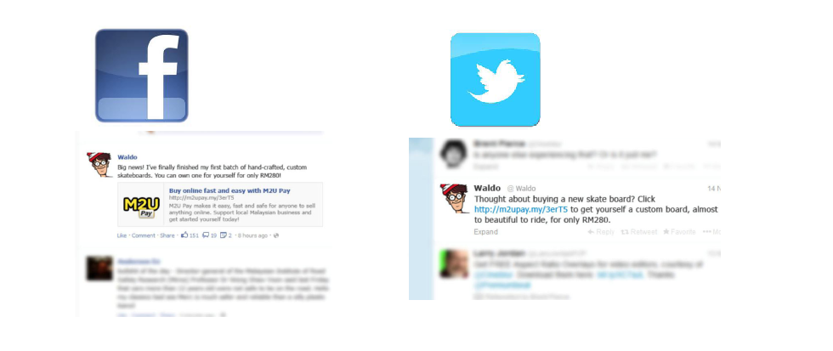
To Discuss
Report Link – Add via email.

Additional Information
- There will be also a link embedded in the Maybank2u Pay link created by Seller which allows Buyer to report any fraudulent activities. This report will be via sent to SFU team for further investigation.
- The link will be unavailable once the stock finish or expired.

Step 2 – Secure site M2U Debit Payment Engine
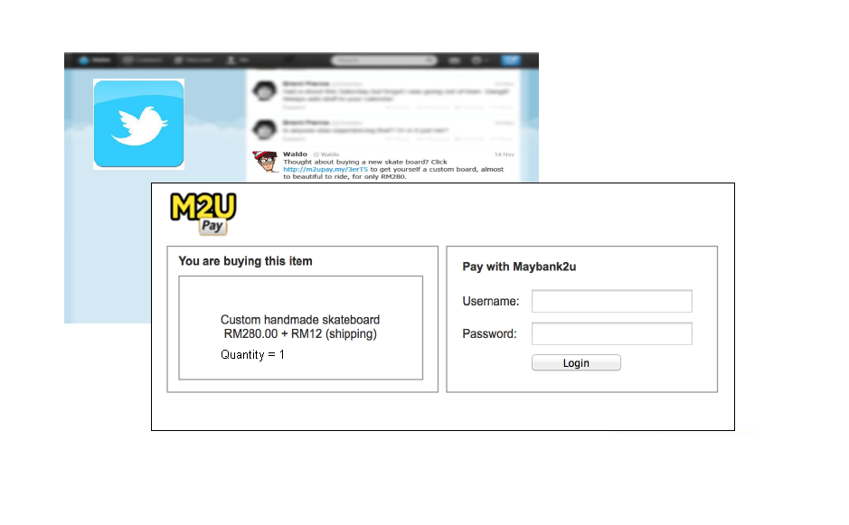
To Discuss
Step 3 – Buyer Select Bank account to be deducted and Shipping details - Step 1 of 3
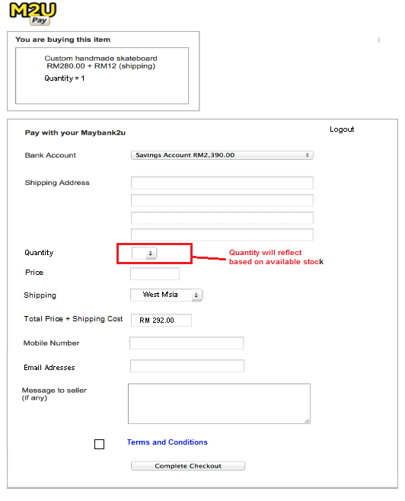
Fields  (exact field name) | Data Type  (e.g. Input, dropdown, Pre-populate, radio button, buttons, hyperlinks...etc) | M/O  (Mandatory / Optional) | Format  (e.g. alpha, numeric, decimals with places...etc) | Length  (Min and Max length) | Source | Validation | Remarks
Logout | hyperlink | N/A | Alpha | N/A | Host | - Link allow user to logout payment engine
Bank Account | Dropdown | M | Numeric | 12 Digit | Host | - To display CASA account  - Only good account to be allowed credited.  - Only display CASA account
Shipping Address1 | Input | M | Alpha Numeric | 40 Digit | User
Shipping Address2 | Input | O | Alpha Numeric | 40 Digit | User
Shipping Address3 | Input | O | Alpha Numeric | 40 Digit | User
Shipping Address4 | Input | O | Alpha Numeric | 40 Digit | User
Quantity | Dropdown | M | Numeric | 2 digit | Host | - Host to auto populate against the available seller balance stock.  - Allow buyer to select desired available quantity
Price | Pre-Populate | M | Numeric | 7 Digit | Host | - Pre-populate the price from Seller input price.  - Price increase depending in Quantity selected
Shipping | Dropdown | O | Alpha | 8 Digit | Host | - To be greyed out if Seller didn’t mentioned any shipping cost
Total Price and Shipping Cost | Pre-populate | O | Numeric | 8 Digit | Host | - To be greyed out if Seller didn’t mentioned any shipping cost
Mobile No | Input | M | Numeric | 12 Digit | User | NA
Email | Input | O | Alpha Numeric | 40 Digit | Host | - Should have @  - Email to be send to buyer on successful payment details
Message to user | Input | M | Alpha Numeric | 250 Digit | User | - Funny characters not allowed
Terms & Conditions | -Tick box  -hyperlinks | M |  |  | User | Customer need to tick the T&C before can continue next page.  - Once click the T&C link, will redirect to another page for T&C contain
Complete Checkout | Buttons | M | N/A | N/A | N/A |  | Proceed to Next Step

Additional Information
- Shipping and Total price + Shipping cost should be greyed out if Seller did not state any shipping cost.
- Quantity will be reflect based on available stock balance
Step 4 – Buyer to request and enter valid TAC- Step 2 of 3

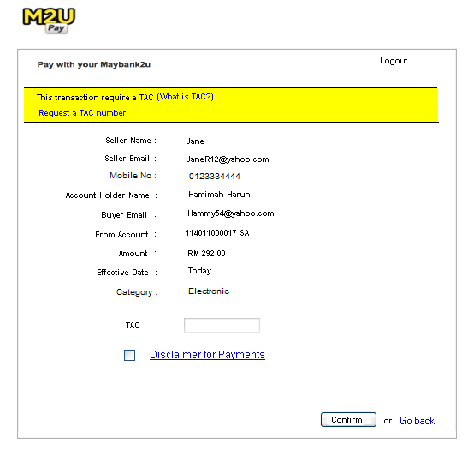

Fields  (exact field name) | Data Type  (e.g. Input, dropdown, Pre-populate, radio button, buttons, hyperlinks...etc) | M/O  (Mandatory / Optional) | Format  (e.g. alpha, numeric, decimals with places...etc) | Length  (Min and Max length) | Source | Validation | Remarks
What is TAC | hyperlink | N/A | Alpha | N/A | Host | - Should be clickable and redirect to info site
Request a TAC Number | Hyperlink | N/A | Alpha | N/A | Host | - Should be clickable  - Auto generate TAC to buyer Hand phone
Seller Name | Pre-populate | N/A | Alpha | N/A | Host | - Seller name should be the same name as seller input during post/link creation
Seller Email | Pre-populate | N/A | Alpha Numeric | N/A | Host
Account Holder Name | Pre-populate | N/A | Alpha Numeric | N/A | Host
Buyer Email | Pre-populate | N/A | Numeric | 7 digit | Host
From Account | Pre-populate | N/A | Alpha | 12 digit | Host
Amount | Pre-populate | M | Numeric | N/A | Host
Effective Date | Pre-Populate | M | Numeric | 5 Digit | Host
Category | Pre-Populate | M | Alpha | 30 Digit | Host | - Display item category  1. Accessories & Clothes  2. Electronics  3. Food  4. Leisure (Music/Books)
TAC | Input | M | Numeric | 6 Digit | User | - Only Numeric is allowed  - TAC rejection/checking as per existing
Disclaimer | CheckBox / Hyperlink | M | - |  | User | - Must be Checked To Proceed  - Hyperlink to PDF on Disclaimers
Confirm | Buttons | N/A | Alpha | N/A | N/A
Go back | hyperlink | N/A | Alpha | N/A | N/A | - Allow user to go back and revisit Step 1 of 3

Step 5 – Buyer successful payment page- Step 3 of 3

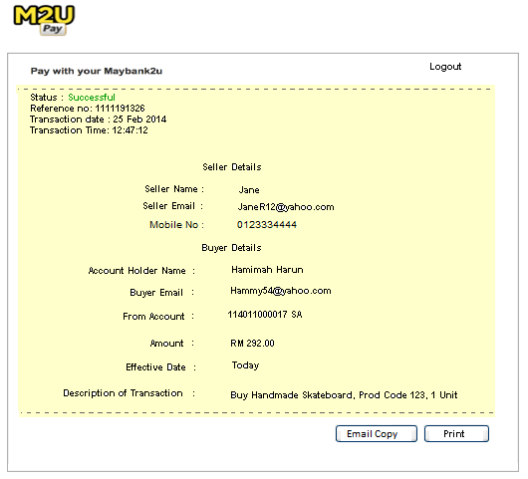

Email confirmation – Screens to be confirmed.
Fields  (exact field name) | Data Type  (e.g. Input, dropdown, Pre-populate, radio button, buttons, hyperlinks…etc) | M/O  (Mandatory / Optional) | Format  (e.g. alpha, numeric, decimals with places…etc) | Length  (Min and Max length) | Source | Validation | Remarks
Status | Pre-populate | N/A | Alphabetic | N/A | Host
Reference No | Hyperlink | N/A | Numeric | N/A | Host
Transaction Date | Pre-populate | N/A | Numeric | N/A | Host
Transaction Time | Pre-populate | N/A | Numeric | N/A | Host
Seller Name | Pre-populate | N/A | Alphabetic | N/A | Host
Seller Email | Pre-populate | N/A | Alpha Numeric | N/A | Host
Mobile No | Pre-populate | N/A | Numeric | N/A | Host
Account Holder Name | Pre-populate | N/A | Alphabetic | N/A | Host
Buyer Email | Pre-populate | N/A | Alpha Numeric | N/A | Host
From Account | Pre-populate | N/A | Numeric | N/A | Host
Amount | Pre-populate | N/A | Numeric | N/A | Host
Effective Date | Pre-Populate | N/A | Numeric | N/A | Host
Description of Transaction | Pre-Populate | N/A | Alpha Numeric | N/A | Host
Email Copy | Pre-Populate | N/A | Alpha Numeric | N/A | N/A | To discuss content and look | Realtime
Print | Buttons | N/A | Numeric | N/A | N/A

Buyer Invalid Link Display
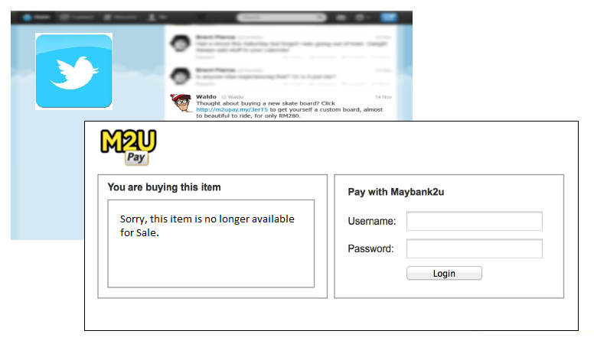
Additional Information
- Upon clicking the link from the social media link, the system will perform a check to see if the item or link is still available or valid.
  - Quantity check will display “Sorry, this item is no longer available for Sale, please the contact respective seller”
  - Link removed/disabled will display “Sorry, this item is no longer available for Sale, please the contact respective seller”

Seller M2U Pay Notification Flow

Seller M2U Pay Notification View
Step 1 – view notification
Only to display 60 days of transaction history

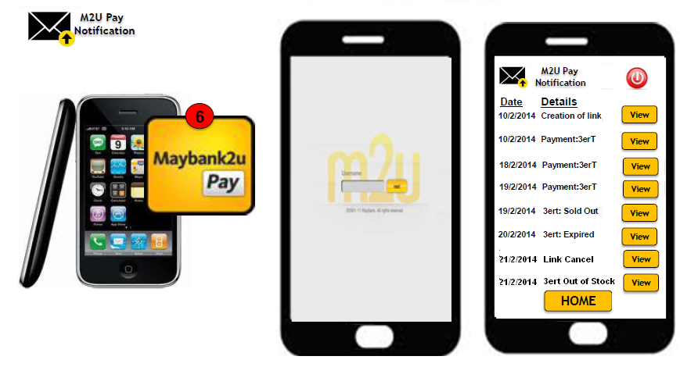
Fields  (exact field name) | Data Type  (e.g. Input, dropdown, Pre-populate, radio button, buttons, hyperlinks...etc) | M/O  (Mandatory / Optional) | Format  (e.g. alpha, numeric, decimals with places...etc) | Length  (Min and Max length) | Source | Validation | Remarks
Date | Pre-Populate | M | Numeric | As per existing | Host | NA
Details | Pre-Populate | M | Alpha Numeric | N/A | Host
View | Button | NA | Static Text | As per existing | NA | NA | To view detail of the transactions
Home | Button | NA | Static Text | As per existing | NA | NA | To homepage
Notification Transaction History | Pre-populate | M | N/A | N/A | Host | - Only to display 60 days of transaction history

Step 2 – view notification (Creation Link)
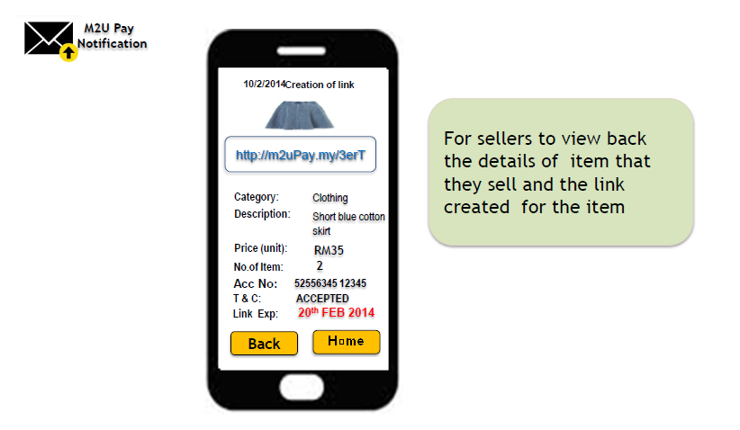
Fields  (exact field name) | Data Type  (e.g. Input, dropdown, Pre-populate, radio button, buttons, hyperlinks...etc) | M/O  (Mandatory / Optional) | Format  (e.g. alpha, numeric, decimals with places...etc) | Length  (Min and Max length) | Source | Validation | Remarks
Category | Pre-Populate | NA | Alpha | As per existing | Host
Description | Pre-Populate | NA | Alpha Numeric | N/A | Host
Price (Unit) | Pre-Populate | NA | Numeric | As per existing | Host
No of Item | Pre-Populate | NA | Numeric | As per existing | Host
Acc No | Pre-Populate | NA | Numeric | As per existing | Host
T & C | Pre-Populate | NA | Alpha | As per existing | Host
Link Expiry | Pre-Populate | NA | N/A | As per existing | Host
Back | Button | NA | Static Text | As per existing | NA | NA

Step 3 – view notification (Payment)
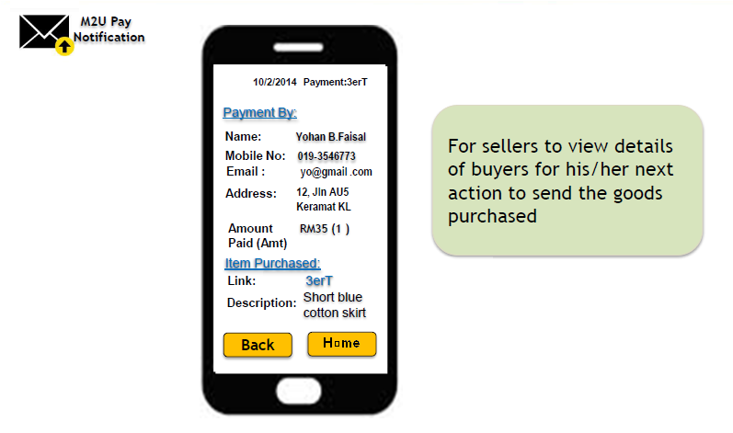
Fields  (exact field name) | Data Type  (e.g. Input, dropdown, Pre-populate, radio button, buttons, hyperlinks...etc) | M/O  (Mandatory / Optional) | Format  (e.g. alpha, numeric, decimals with places...etc) | Length  (Min and Max length) | Source | Validation | Remarks
Name | Pre-Populate | NA | Alpha | As per existing | Host
Mobile No | Pre-Populate | NA | Numeric | N/A | Host
Email | Pre-Populate | NA | Alpha Numeric | As per existing | Host | - Should have @
Address | Pre-Populate | NA | Alpha  Numeric | As per existing | Host
Amount Paid | Pre-Populate | NA | Numeric | As per existing | Host
Link | Pre-Populate | NA | AlphaNumeric | As per existing | Host
Description | Pre-Populate | NA | Alpha Numeric | As per existing | Host
Back | Button | NA | Static Text | As per existing | NA | NA

Step 4 – view notification (Sold Out)
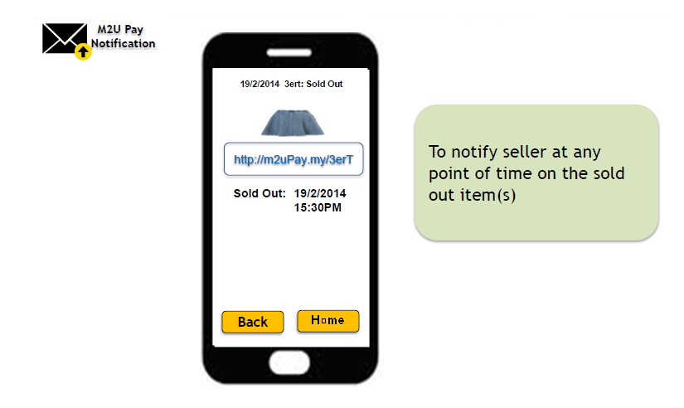

Fields  (exact field name) | Data Type  (e.g. Input, dropdown, Pre-populate, radio button, buttons, hyperlinks...etc) | M/O  (Mandatory / Optional) | Format  (e.g. alpha, numeric, decimals with places...etc) | Length  (Min and Max length) | Source | Validation | Remarks
Sold Out (Date / Time) | Pre-Populate | NA | Numeric | As per existing | Host

Step 4 – view notification (Expired)

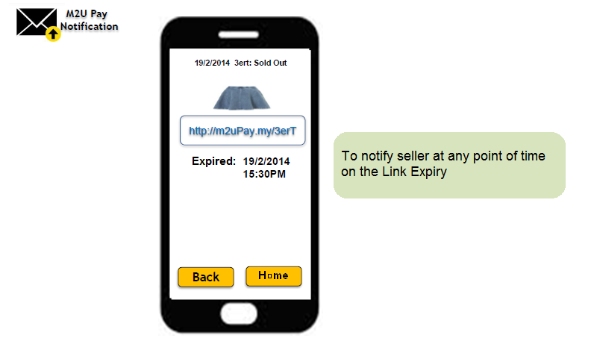

Fields  (exact field name) | Data Type  (e.g. Input, dropdown, Pre-populate, radio button, buttons, hyperlinks...etc) | M/O  (Mandatory / Optional) | Format  (e.g. alpha, numeric, decimals with places...etc) | Length  (Min and Max length) | Source | Validation | Remarks
Expired (Date / Time) | Pre-Populate | NA | Numeric | As per existing | Host

Step 4 – view notification (Link Cancel)
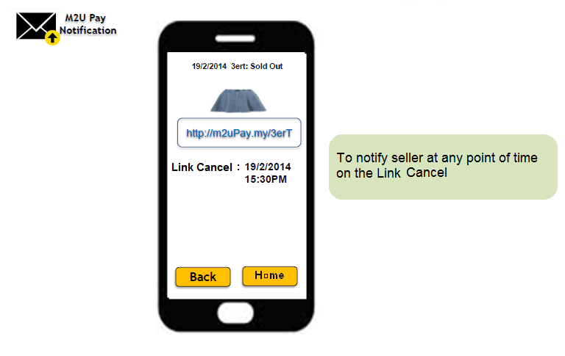

Fields  (exact field name) | Data Type  (e.g. Input, dropdown, Pre-populate, radio button, buttons, hyperlinks...etc) | M/O  (Mandatory / Optional) | Format  (e.g. alpha, numeric, decimals with places...etc) | Length  (Min and Max length) | Source | Validation | Remarks
Link Cancel (Date / Time) | Pre-Populate | NA | Numeric | As per existing | Host

Seller M2U Pay Maintenance Link Flow

Seller M2U Pay Delete Link Process
Step 1 – view Delete Link
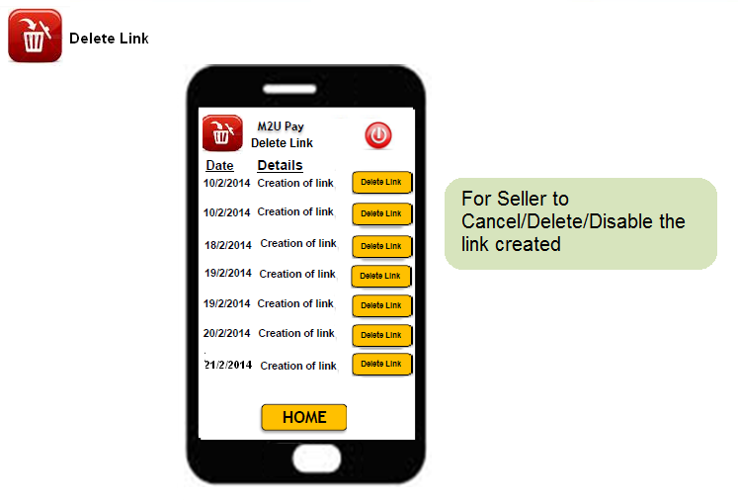

Fields  (exact field name) | Data Type  (e.g. Input, dropdown, Pre-populate, radio button, buttons, hyperlinks...etc) | M/O  (Mandatory / Optional) | Format  (e.g. alpha, numeric, decimals with places...etc) | Length  (Min and Max length) | Source | Validation | Remarks
Date | Pre-Populate | M | Numeric | As per existing | Host | NA
Details | Pre-Populate | M | Alpha Numeric | N/A | Host
Delete Link | Button | NA | Static Text | As per existing | NA | NA | To view detail of the link to be deleted/disable
Home | Button | NA | Static Text | As per existing | NA | NA | To homepage

Step 2 – view Delete Link
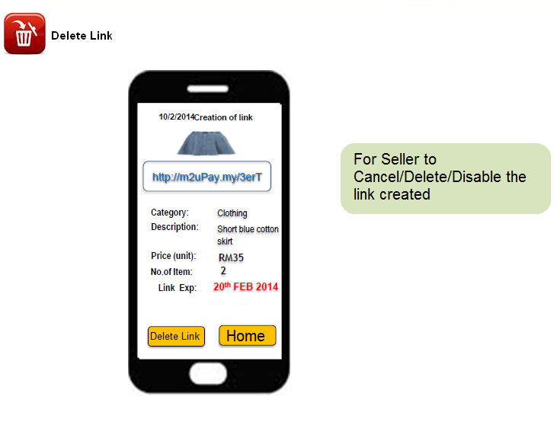

Fields  (exact field name) | Data Type  (e.g. Input, dropdown, Pre-populate, radio button, buttons, hyperlinks...etc) | M/O  (Mandatory / Optional) | Format  (e.g. alpha, numeric, decimals with places...etc) | Length  (Min and Max length) | Source | Validation | Remarks
Category | Pre-Populate | NA | Alpha | As per existing | Host
Description | Pre-Populate | NA | Alpha Numeric | N/A | Host
Price (Unit) | Pre-Populate | NA | Numeric | As per existing | Host
No of Item | Pre-Populate | NA | Numeric | As per existing | Host
Link Expiry | Pre-Populate | NA | N/A | As per existing | Host
Delete Link | Button | NA | Static Text | As per existing | NA | NA | To view detail of the link to be deleted/disable
Home | Button | NA | Static Text | As per existing | NA | NA | To homepage

Requirements for CCPP Module

M2U Pay Mobile App – Global settings – M2U Biz
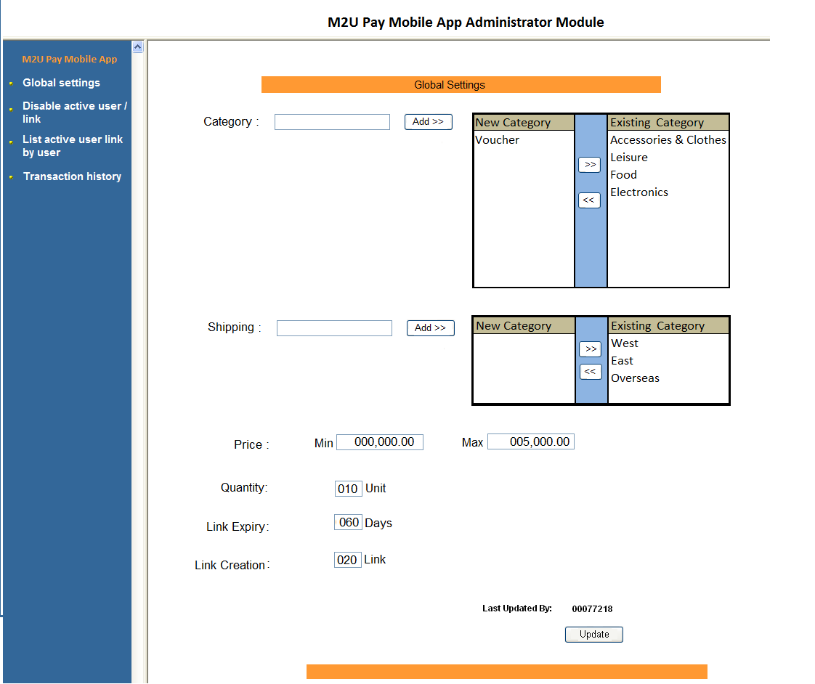

Additional Information

- Price Maximum is set to RM 5,000.00 by default, Maximum allowed is RM 9,999,999.00
- Quantity max value has been set to 10 per item, Maximum allowed is 999,999.
- Link Expiry has set to default 2 months, Maximum allowable days is 6 months.
- Maximum link creation is 20 links per Seller, Maximum allowable is 999.
- Category and Shipping is parameterized to add more options, each expandable to 999.

M2U Pay Mobile App – Disable Active User and Link

Disable Active User Flow

Disable Active User Process - SFU
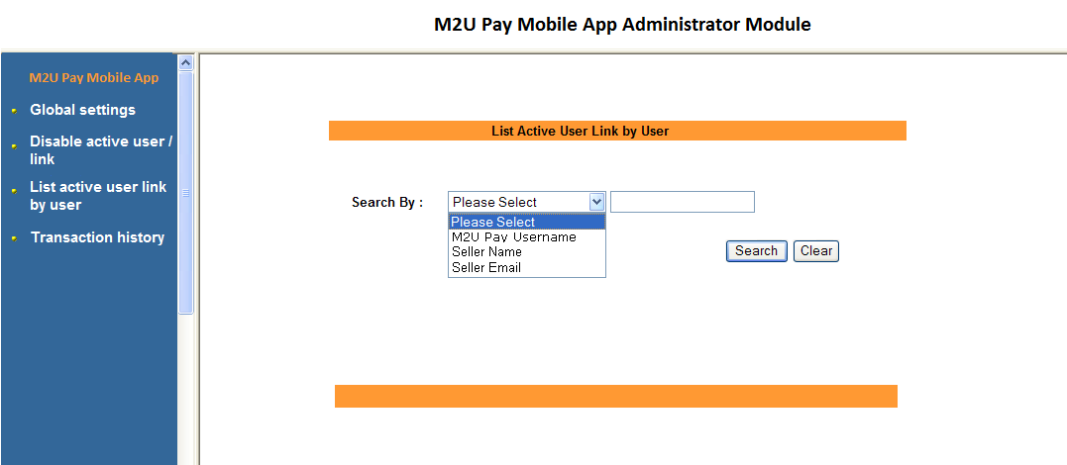

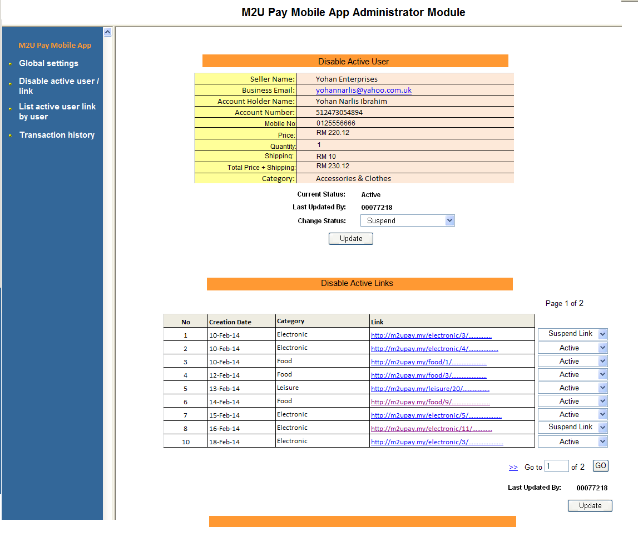

Additional Information

- If the current status is Suspend, system will block all seller activity and link until unsuspended.

M2U Pay Mobile App – List Active Link by User - CSE

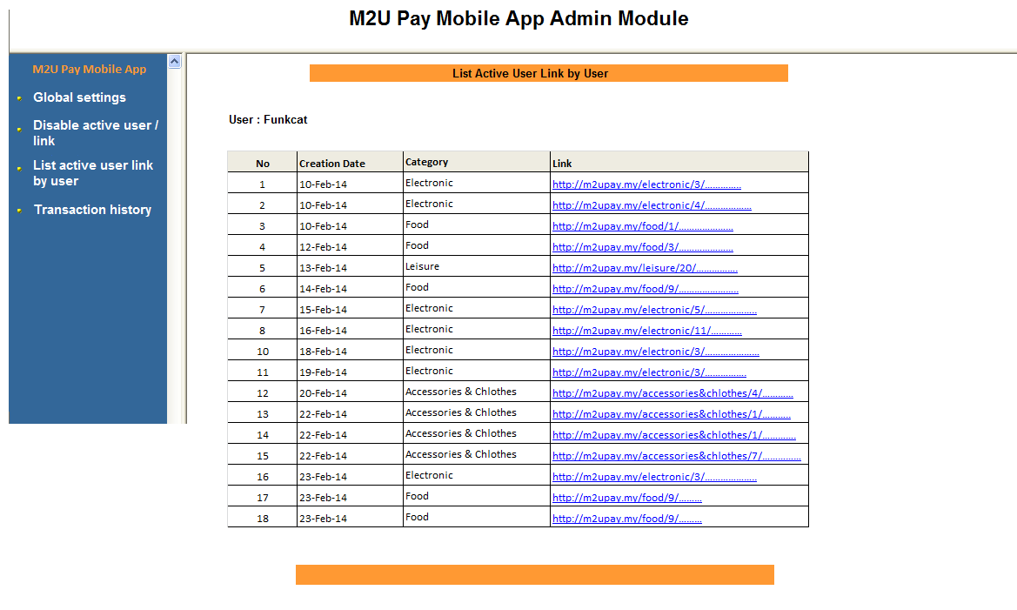
Additional Information
- List of active link will be displayed

M2u Pay Mobile App – Transaction History

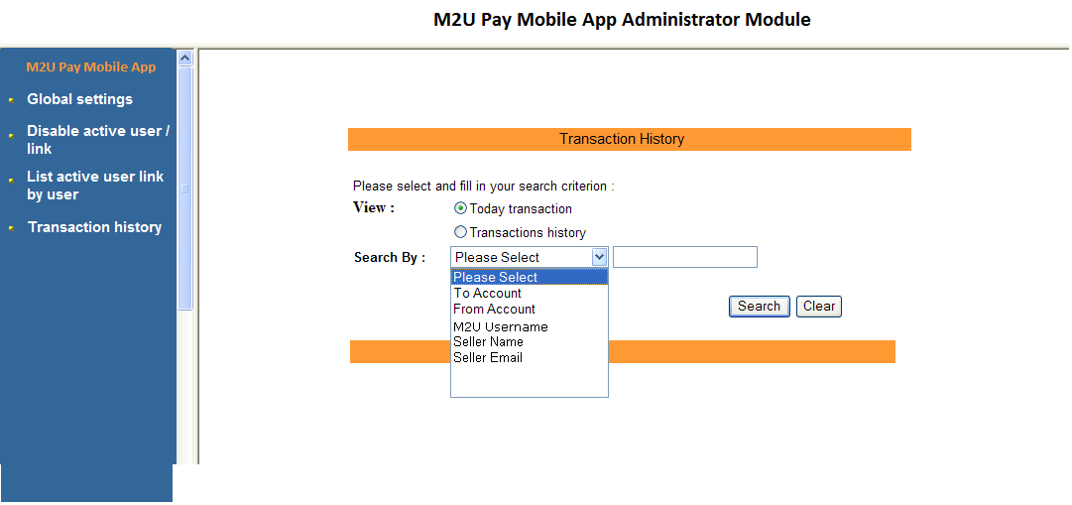

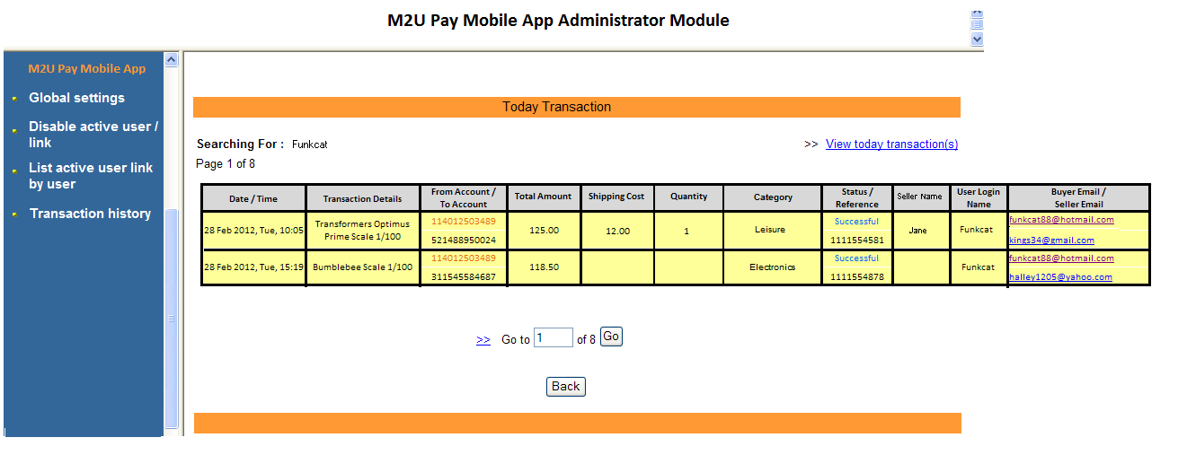
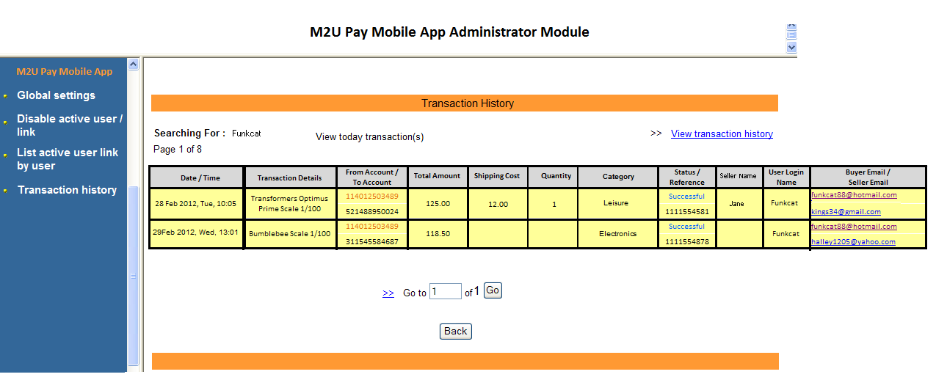

Additional Information
- To add new functionality for Helpdesk at Call Center to manage customer enquiries on transaction history.
- Able to view by Today’s Transactions or Transaction History up to 6 Months.
- Able to search Transaction’s by select To Account, From Account, M2U Username, Seller Name or Seller Email

Host Application - MIB3
- Indicator A will be used in MIB3 to indicate transaction from M2U Pay

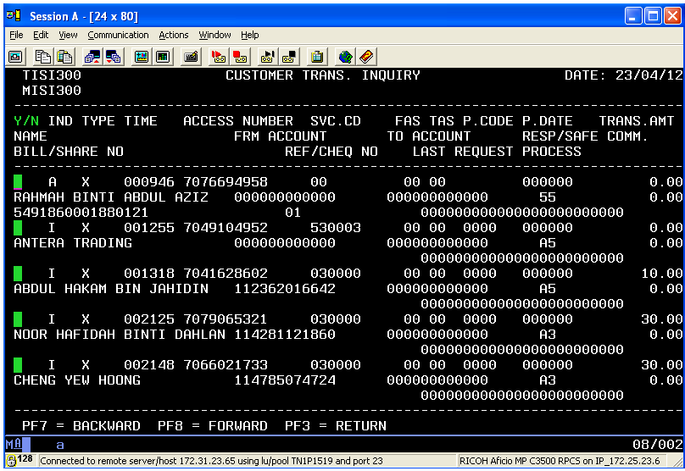
Add indicator for M2U Pay New Service Code

Reports
DMAP Report for M2U Pay Mobile App

Daily Creation or Cancel Link Report
1MAYBANK M2UPAY MOBILE TRANSACTIONS RUN DATE: 25/02/14 PAGE: 1
DEPT 100570E-CHANNEL REPORT DATE: 25/02/14 REPORT NO : DMAPXX

ACCESS NO / TIME/ MOBILE NO ACCT. NO CATEGORY CHANNEL LINK GENERATED STATUS
SELLER NAME EMAIL ADDRESS
------------------------------------------------------------------------------------------------------------------------------------------------------------------------------------------------------------------------------
7000430057 14:19:43 0163318788 114011231078 Accessories & Clothes M3G http:M2uPay.xxxxxx1 Created Jane admin@enstart.gmail.com

7000430058 15:19:43 0133318788 114011231077 Food M3G http:M2uPay.xxxxxx2 Created
Jane yahoo@enstart.gmail.com

7000430056 16:19:43 013318788 114011231077 Food M3G http:M2uPay.xxxxxx2 Cancelled Jane yahoo@enstart.gmail.com

Summary :
----------------------------------------------------------------------------------------------------------------------
Category: Accessories & Clothes
Total Link Created : 20
Total Link Cancelled : 21

Category: Leisure
Total Link Created : 20
Total Link Cancelled : 21

Category: Electronics
Total Link Created : 20
Total Link Cancelled : 21

Category: Food
Total Link Created : 20
Total Link Cancelled : 21

Fields  (exact field name) | Data Type  (e.g. Input, dropdown, Pre-populate, radio button, buttons, hyperlinks...etc) | M/O  (Mandatory / Optional) | Format  (e.g. alpha, numeric, decimals with places...etc) | Length  (Min and Max length) | Source | Validation | Remarks
Access No | Populated | M | Numeric | 10 | Host | NA | To display the Seller Information
Seller Name | Populated | M | Numeric | 20 | Host | NA | To display the Seller Information
Mobile No | Populated | M | Numeric | 12 | M2u database | NA | To display time transactions
Email Address | Populated | M | Numeric | 40 | M2u database | NA | To display an email address
Account No | Populated | M | Numeric | 12 | Host | NA | To display the acct no for payment
Category | Populated | M | alphabet | 12 | M2u database | NA | To display the category
Channel | Populated | M | alphabet | 12 | M2u Database | NA | M3G- Mobile App
Link Generated | Populated | M | Alpha | 12 | M2u Database | NA | To display link Created
Status | Populated | M | Alpha | 12 | Host | NA | To display status of link

Daily transactions M2U Pay Mobile

1MAYBANK M2UPAY MOBILE CREATION /CANCEL LINK CREATION RUN DATE: 25/02/14 PAGE: 1
DEPT 100570E-CHANNEL REPORT DATE: 25/02/14 REPORT NO : DMAPXX

ACCESS NO / TIME/ ITEM AMOUNT ACCT. NO CATEGORY CHANNEL LINK GENERATED STATUS
IC No
------------------------------------------------------------------------------------------------------------------------------------------------------------------------------------------------------------------------------
7000430057 14:19:43 2 Rm 250 114011231078 Accessories & Clothes M3G http:M2uPay.xxxxxx1 Successful :00 7701090232

7000430058 15:19:43 1 Rm 110 164011231077 Food M3G http:M2uPay.xxxxxx2 Successful:00
7701090235

7000430056 16:19:43 3 Rm 56.30 514011231077 Food M3G http:M2uPay.xxxxxx2 Failed :68
7701090236

Summary :
----------------------------------------------------------------------------------------------------------------------

Total Successful transaction By Category Item Amount

Accessories & Clothes 20 RM 800
Leisure 27 RM 900.67
Electronics 150 RM 3900.67
Food 5 RM 85

0*** END OF REPORT ***

Fields  (exact field name) | Data Type  (e.g. Input, dropdown, Pre-populate, radio button, buttons, hyperlinks...etc) | M/O  (Mandatory / Optional) | Format  (e.g. alpha, numeric, decimals with places...etc) | Length  (Min and Max length) | Source | Validation | Remarks
Access No | Populated | M | Numeric | 10 | Host | NA | To display the Buyer Information
IC No | Populated | M | Numeric | 10 | Host | NA | To display the Buyer Information
Time | Populated | M | Numeric | 8 | Host | NA | To display time transactions
Item | Populated | M | Numeric | 3 | Host | NA | To display total item buy
Amount | Populated | M | Numeric | 8 | Host | NA | To display total Amount
Account No | Populated | M | Numeric | 12 | Host | NA | To display the acct no for payment
Category | Populated | M | alphabet | 12 | Host | NA | To display the category
Channel | Populated | M | alphabet | 12 | M2u Database | NA | M3G- Mobile App
Link Generated | Populated | M | Alpha | 12 | M2u Database | NA | To display link selected for payment
Status 00 | Populated | M | alphanumeric | 00 | Host | NA | To display status of transactions with error code

