Buyer Section
Old: https://172.31.11.35/cgi-bin/bvuat5a/m2u0/index.jsp
Not meet requirement
Mobile No | Numeric | Max length | 12 Digit | User | NA
Message to user | Alpha Numeric | Max Length | 250 Digit | User | Funny characters not allowed

- Change Email labeling to Email Address
- Change Message to seller textbox to text area
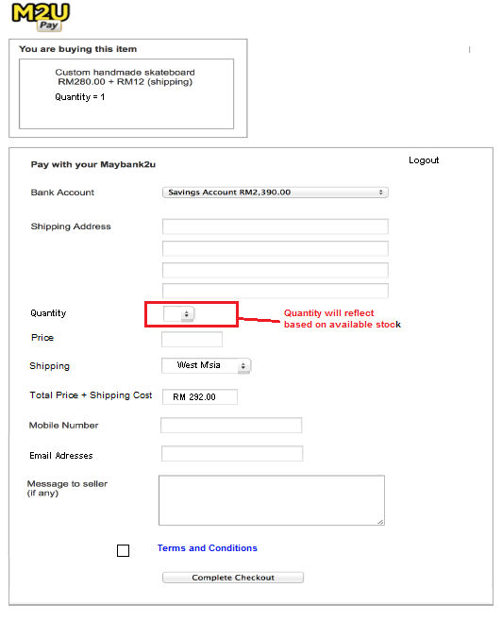 | 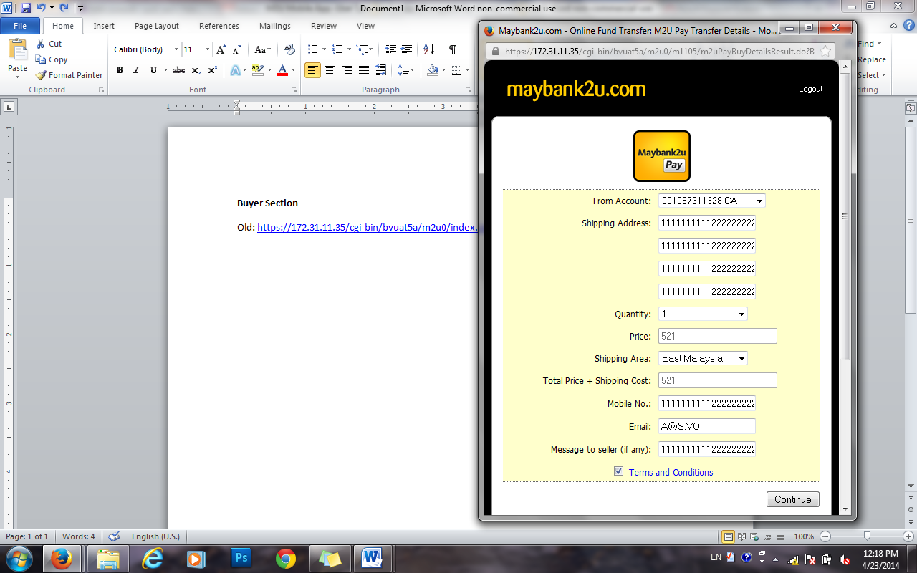
- Follow labeling from BRS. Remove Buyer Details label and do exactly from a sample.
- Add Disclaimer for Payment to Actual result
- Add validation for TAC
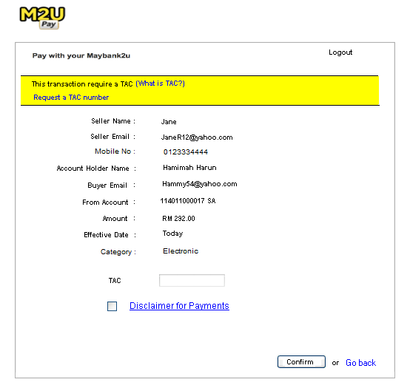 | 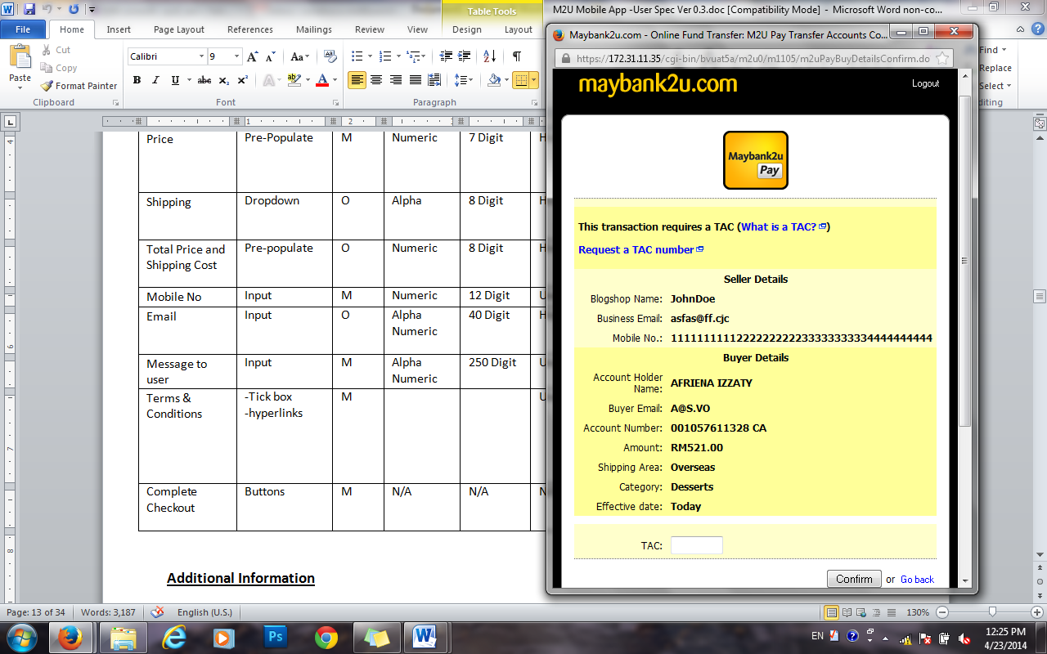

- Follow labeling from BRS given.

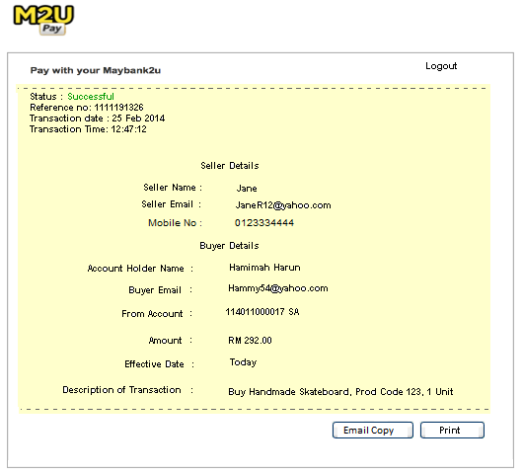 | 