**Kuwait Finance House (Malaysia) Berhad**

**KFH Online (Consumer & Business)**

**MEPS New Requirements**

**Business Requirement Specification (BRS)**

Version 1.0

**Prepared By:**

**Product Development**

**May 2010**

**Document Administration**

**Document Amendment Log**

|  |  |  |  |
| --- | --- | --- | --- |
| **Version No** | **Date Updated** | **Description of Change** | **Updated By** |
| 1.0 |  | Initial Release | Kamaruddin Damiri |
|  |  |  |  |

**Table of Contents**

1 Introduction 4

1.1 Objective 4

2 eShare Payment (ESP) 5

2.1 KFH Online (BIB): 5

2.2 IBG Core and Payswitch: 5

2.3 CORUS Report: 6

3 New 2nd Validation Specification 8

4 IBG Addenda New Specifications 9

4.1 The Requirements: 10

5 IBG Increase Limit & Fee Revision 11

5.1 BVMC 11

5.2 CORUS 11

6 AG Salary Payment 12

6.1 The Requirement 12

7 Timeline 13

# Introduction

The Interbank GIRO (IBG) payment services through KFH Online has successfully launched for customer to utilize the services. It provides convenience for customer to do fund transfer within MEPS member banks.

As to provide more convenient and enhanced services, MEPS is now providing a list of new requirements for all member banks to develop for the benefit of customers and banks as a community. The new requirements for MEPS IBG are as follows:

1. eShare Payment (ESP)
2. New 2nd Validation Specification

The document will detail out the MEPS requirement that requires KFH Online and IBG Core to handle such new enhancement. The requirement will be based on each and every modules required by MEPS.

## Objective

The objective of this document is to highlight and explain the requirement as to get the complete understanding and agreement on the following:

1. Functional specifications that will be available in KFH Online for Consumer & Business Banking.
2. Any constraints that will affect the existing KFH Online and IBG Core to adapt the new changes/requirements.

# eShare Payment (ESP)

eShare Payment (ESP) is another kind of payment that allows Brokers to pay their investors through existing MEPS IBG Platform.

## KFH Online (BIB):

Brokers transaction to pay on eShare is more referred to Business Internet Banking (BIB). BIB has the capacity to make payment in high value and volume, especially using Bulk Payment.

1. KFH Online to provide a tagging for customer to tag the transaction as eShare Payment.
2. The tagging would be similar to ID Validation using check box.
3. The tagging will also applied for BULK Payment. Customer may pay the eShare Payment in a bulk mode, thus allowing such facility to be included as well.

## IBG Core and Payswitch:

ESP requires a change in the Window 1 time and the introduction of new Segment Code, code 6. The followings are the general rules to be applied:

1. The changes in Window timing requires a change in the file processing at IBG Core. The processing time can be changed/maintained using Corus.
2. While at Payswitch, the scheduler to send file to MEPS and receive file from MEPS also requires to be amended.
3. Window 1 latest timing for OFI to send to MEPS is brought earlier to 9.15am instead of 10.00am. No extension time is allowed.
4. While for Window 1 for MEPS to make the Distribution file available for RFI is also brought earlier to 10.30am, instead of 11.15am.
5. RFI must be able to return to OFI at T+1 Window 1. Any ESP return beyond T+1 Window 1, both FIs must manage outside from the system.
6. Upon receiving Return ESP transaction, OFI is responsible to inform Brokers on the Returned status by 12.00pm.
7. The 2nd validation for ESP will only apply to Current & Savings Account only (CASA). While 2nd validation for non-ESP remain unchanged.
8. Upon receiving transaction with ESP tagging, system must be able to insert the Code 6 in the Segment Code for NACHA File OFI.
9. While for RFI case, the Code 6 received has no different/changes in processing.

**New MEPS Window 1 Timing:**

|  |  |  |  |  |
| --- | --- | --- | --- | --- |
| No | Files | Existing Time | New Time | Remarks |
| 1 | Collection File Window 1 | 10.00am | 9.15am | No extension time is allowed. |
| 2 | Collection File Window 2 | 01.00pm | - | Unchanged |
| 3 | Distribution File Window 1 | 11.15am | 10.30am | - |
| 4 | Distribution File Window 2 | 02.15pm | - | Unchanged |

**CORUS:**

|  |  |  |  |  |
| --- | --- | --- | --- | --- |
| No | Processes | Existing Time | New Time | Remarks |
| 1 | OFI Nacha File Generation Window 1 | 08.00am | 07.30am | - |
| 2 | OFI Nacha File Generation Window 2 | 12.00pm | - | Unchanged |
| 3 | RFI Nacha File Processing Window 1 | 11.45am | 11.00am | -- |
| 4 | RFI Nacha File Processing Window 2 | 02.45pm | - | Unchanged |

**Payswitch:**

|  |  |  |  |  |
| --- | --- | --- | --- | --- |
| No | Processes | Existing Time | New Time | Remarks |
| 1 | Send File (Window 1) | 08.30am | 08.30am | - |
| 2 | Send File (Window 2) | 12.30pm | - | Unchanged |
| 3 | Receive File (Window 1) | 11.30am | 10.45am | - |
| 4 | Receive File (Window 2) | 02.30pm | - | Unchanged |

## CORUS Report:

The existing Daily IBG Core reports require minor amendments as to cater for ESP.

1. As part of the requirement need the OFI to inform Brokers on any Return ESP on T+1 by 12pm, the existing “RFI Nacha File Processing Report” need to include the Segment Code.
2. With the Segment Code included, the Bank able to retrieve the report just after RFI Nacha File Processing Window 1 completed at 11.00am.

**Existing ‘RFI Nacha File Processing Report’ :**

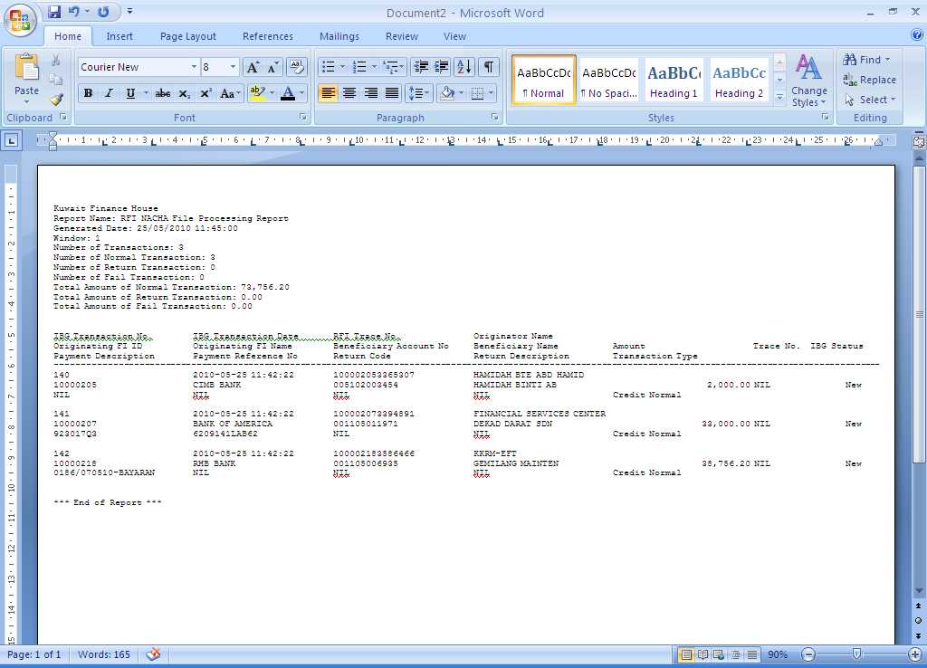

# New 2nd Validation Specification

The existing 2nd validation unable to cater another extra checking for other Segment Codes. For example, AG EFT payment that carries Code 4 cannot be added with Code 5 since the position of the code in Nacha file is at the same field.

MEPS requirement is to relocate the position of Code 5 to another field in Nacha file format.

**Existing Nacha file format:**

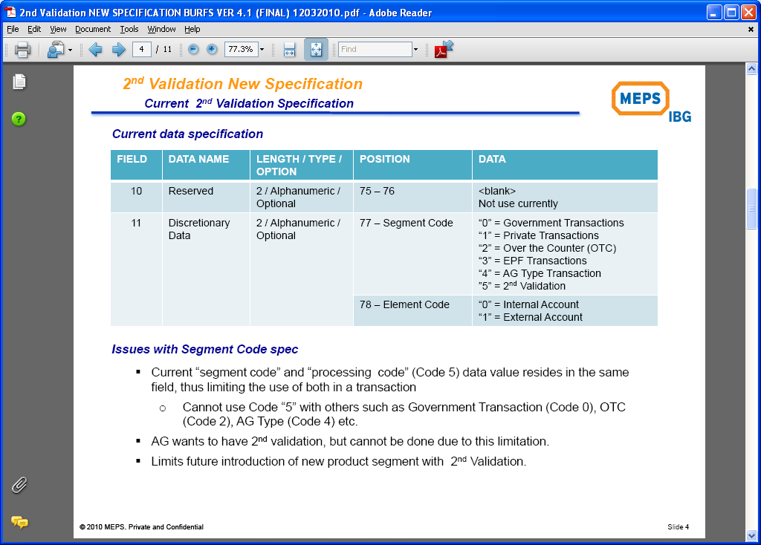

**New Revised specification:**

1. Code 5 is relocated to Position 76.
2. Code 6 (ESP) will be placed with other Segment Code at Position 77.
3. Thus it is allowing other Segment Codes to combine with Code 5. For example AG EFT transaction can now combine with 2nd validation.

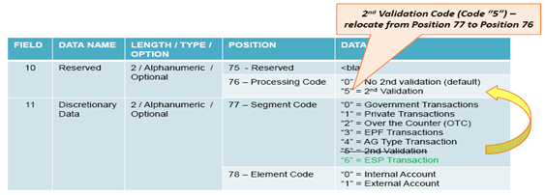

**Sample file layout:**

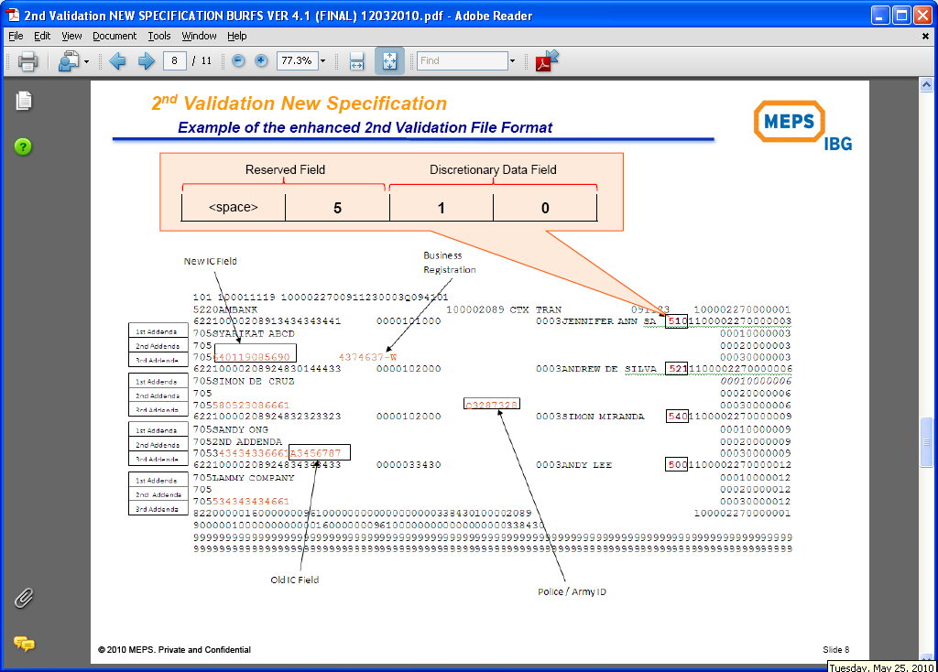

# IBG Addenda New Specifications

The IBG Addenda new specifications are meant for Payment Information and e-Dividend. Existing payment information for IBG Transaction has no sufficient information or indicators for beneficiaries to check the payment received.

The payment information referred in this requirement is those available in **Addenda 2.**

Addenda 2 consist of the following:

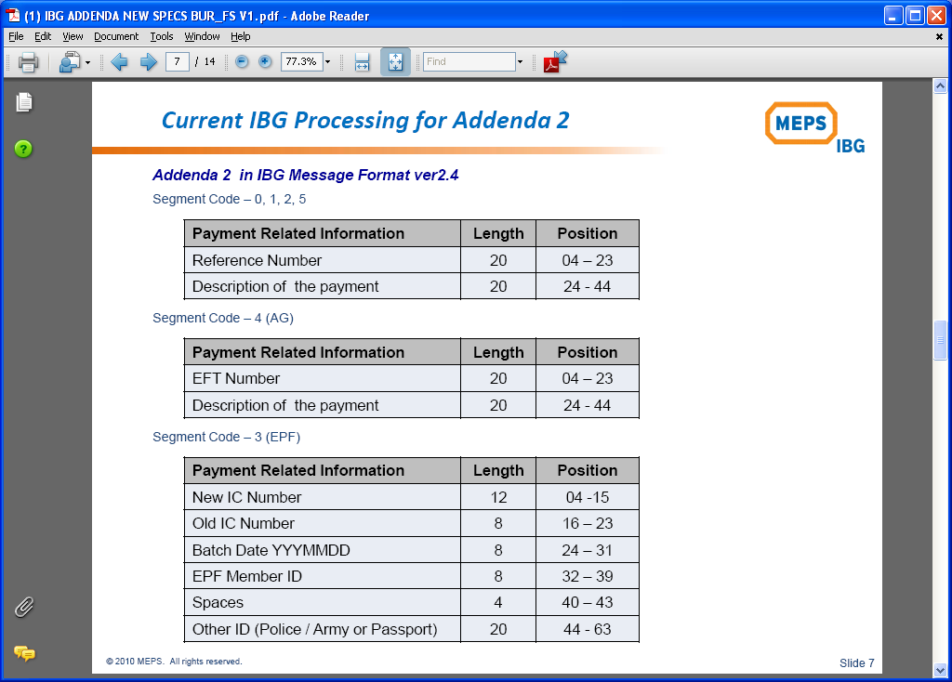

## The Requirements:

**IBG Core** is able to make sure the information available in Addenda 2 is following MEPS requirement, regardless of channel IBG transaction is created either from IB, OTC etc.

1. OFI must make sure that ADDENDA 2 is compulsory for ALL transactions, and send to MEPS.
2. In case customer does not include the information for the following fields, OFI to default the fields with the following:
3. If **Payment Description** is blank, OFI to include the following based on the Segment Code:

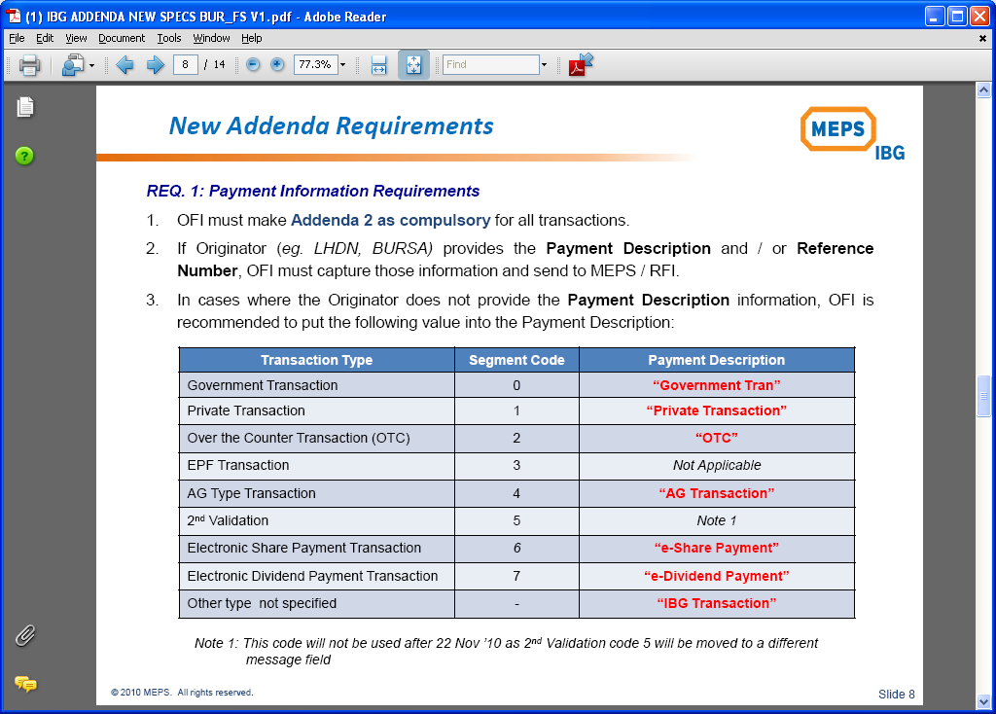

1. If **Reference Number** is blank, OFI to default it as BLANK (spaces).
2. As RFI, it is not required to validate the Payment Description and Reference Number.
3. As RFI, it is required to capture, store and made available the information to beneficiaries, especially in the Transaction Description, available in KFH Online, Phoenix and Account Statement.
4. The total length of Addenda 2 information to be displayed in the Transaction Description is **40 characters**.

# IBG Increase Limit & Fee Revision

Existing transaction limits for MEPS IBG outgoing & incoming is capped at RM100,000.00 per transaction. This limit will be increased up to RM500,000.00 per transaction.

There will be a separate transaction charges imposed to Customer, based on the transaction amount.

## BVMC

1. Standard Charges maintenance for Interbank GIRO (BIB Only) must be able to cater the 2 tier charges structure as follows:

|  |  |
| --- | --- |
| Transaction Amount | New Charges |
| Up to RM100,000 | Max RM2.00 |
| Above 100,000 | Max RM3.00 |

## CORUS

1. Customised Charges fee maintenance for **BIB Customers** must be able to have the same 2 tier charges structure as item 5.1

# AG Salary Payment

Accountant general (AG) will utilize MEPS IBG services to pay salary for government servants. It is a mandatory for the crediting banks (of salary payment) to ensure that the salary is credited on the actual pay day as instructed by AG. It is not allowed for the Bank to credit earlier or late from the specified pay day.

As Non-AG bank, KFHMB will be acting as RFI only.

## The Requirement

The AG Salary Pay Day will be denoted as **T+0.**

1. OFI will send the AG transaction on T-1 to MEPS.
2. MEPS will distribute the filke to RFI on T-1.
3. The AG Salary Payment will be included in the normal Nacha file, with other normal transaction.
4. New Segment Code, as to differentiate AG Salary Payment with other transaction, will be introduced.
5. The pay day will NOT fall on any Weekend and Public Holiday.
6. RFI to identify AG Salary Payment transaction using the Segment Code.
7. RFI to process and credit the normal transaction on T-1 as usual.
8. RFI to hold the crediting process for AG Salary Payment after midnight (T+0) and before 7.00am of the pay day.

|  |  |  |  |
| --- | --- | --- | --- |
| AG Pay Day | OFI/MEPS to send file | RFI to Credit | |
| Normal | AG Salary |
| 1. Working Day | T-1 | T-1  - As per existing | T+0  - Hold and credit at T+0 (after midnight T-1) between 0000 until 0700. |
| 2. A day after Weekend / Public Holiday | Last working day | - as per existing | - Hold and credit at T+0 between 0000 until 0700 |

***T+0*** *= AG Pay Day*

.

# Timeline

Timeline for those requirements, as given by MEPS, are as per below table. Bank is required to make sure the system readiness by the timeline as it would be a applied to all member banks.

|  |  |  |  |
| --- | --- | --- | --- |
| No | Changes | Live Date | Remark |
| 1 | eShare Payment | 21 June 2010 | No changes in the existing system as it only a setting required at CORUS. |
| 2 | Increase Limit | 01 September 2010 | For RFI to accept the payment.  For OFI is August 2011.  Fee structure for OFI to customer is subject to BNM approval. |
| 3 | 2nd Addenda:  For Payment Information and eDividend | 22 November 2010 |  |
| 4 | 2nd Validation of Code 5 | 22 November 2010 |  |
| 5 | AG Salary Payment | 1st Quarter 2011 | MEPS will confirm the finalized timeline based on all banks feedback on the development required. |