***Issue Form (PROD)***

|  |  |
| --- | --- |
| **Originator's Name:** Chooi So Fun  **Project:** Internet Banking  **Project Manager:** Malarvili  **Module : Bill Pmt**  **Date Raised: 27.5.14**  **Phase :** Internet Banking  **Functional Area : Bill Pmt** | **Issue ID Number:**  **Related Issue ID Number:** HD00015153  **Classification:**  **Priority:** Critical/High/Medium/Low  **Assigned to: Vendor / IT / PMO SA / UPA**  **Actual Closed Date:** |
| **Status:** Open/Assigned/Investigated/Resolved/Approved/Deferred/No Action  *(Circle one)* | |
| **Description :**  In Phoenix report dated 26.5.14, there was 1 failed Zakat Trx RM500 which successfully reverted however in BVMC the status still shown as successful.  *Please refer to file attached for further details.* | **Impact:** |
| **Findings/Root Caused (Description):** | **Resolution:** |
| **Estimated Impact :** |  |
| **Recommendation:** | |
| **Accepted :**  **(Vendor / IT / PMO SA / UPA)**  **Date:** | **Accepted (KFHMB Tester):**  **Date:** |

**Phoenix Report – Shown transaction failed & has been reverted**

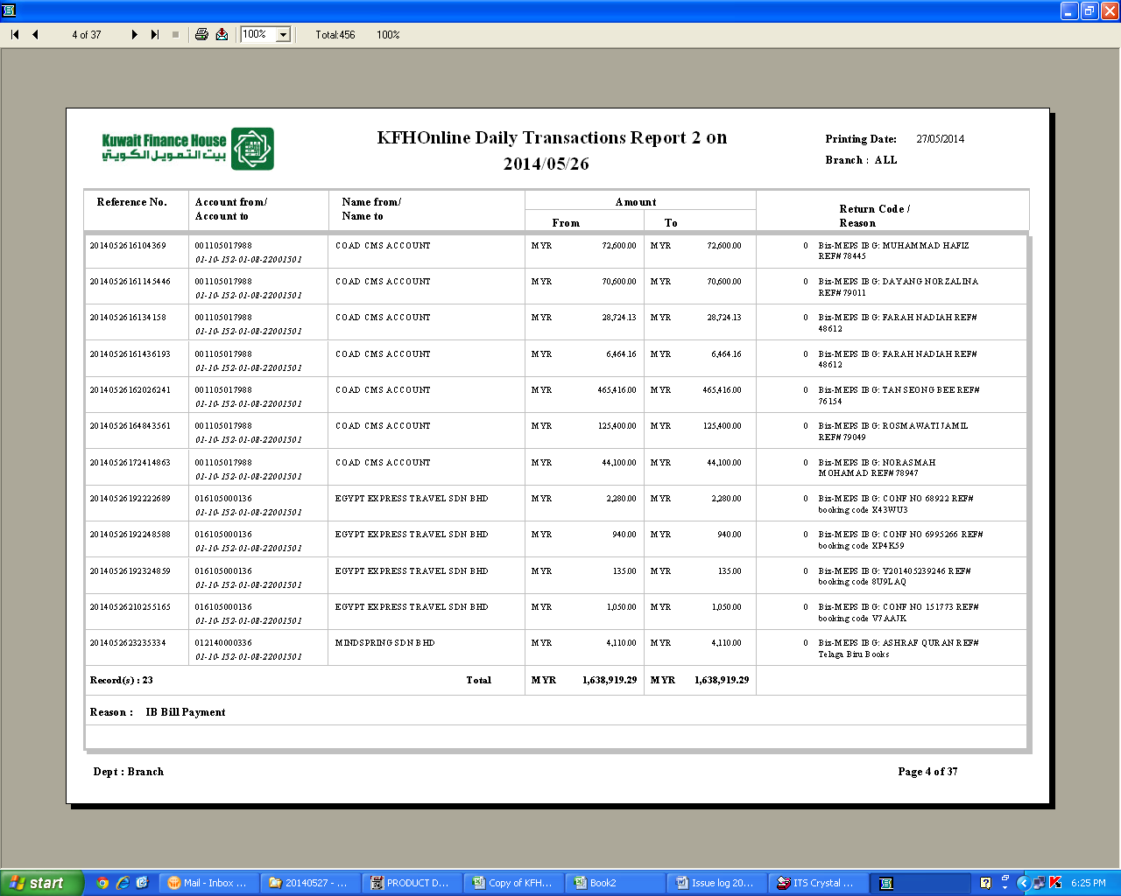

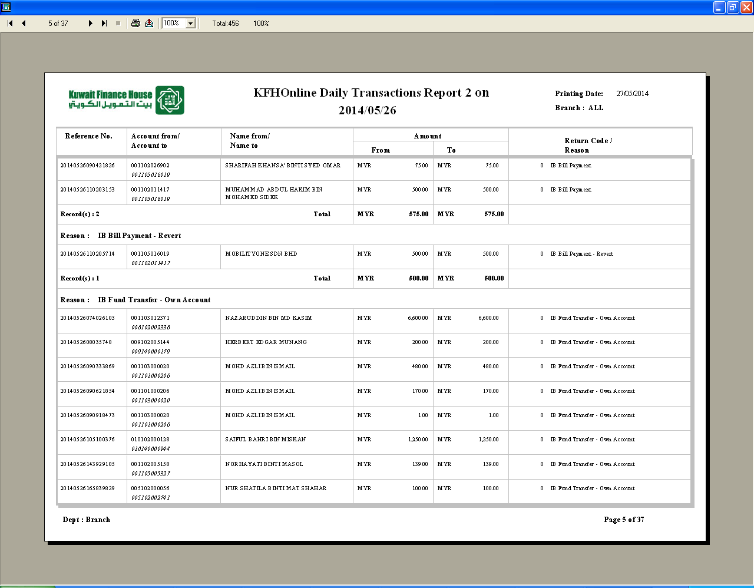

**However BVMC shown status as successful**

Internet Transaction Report

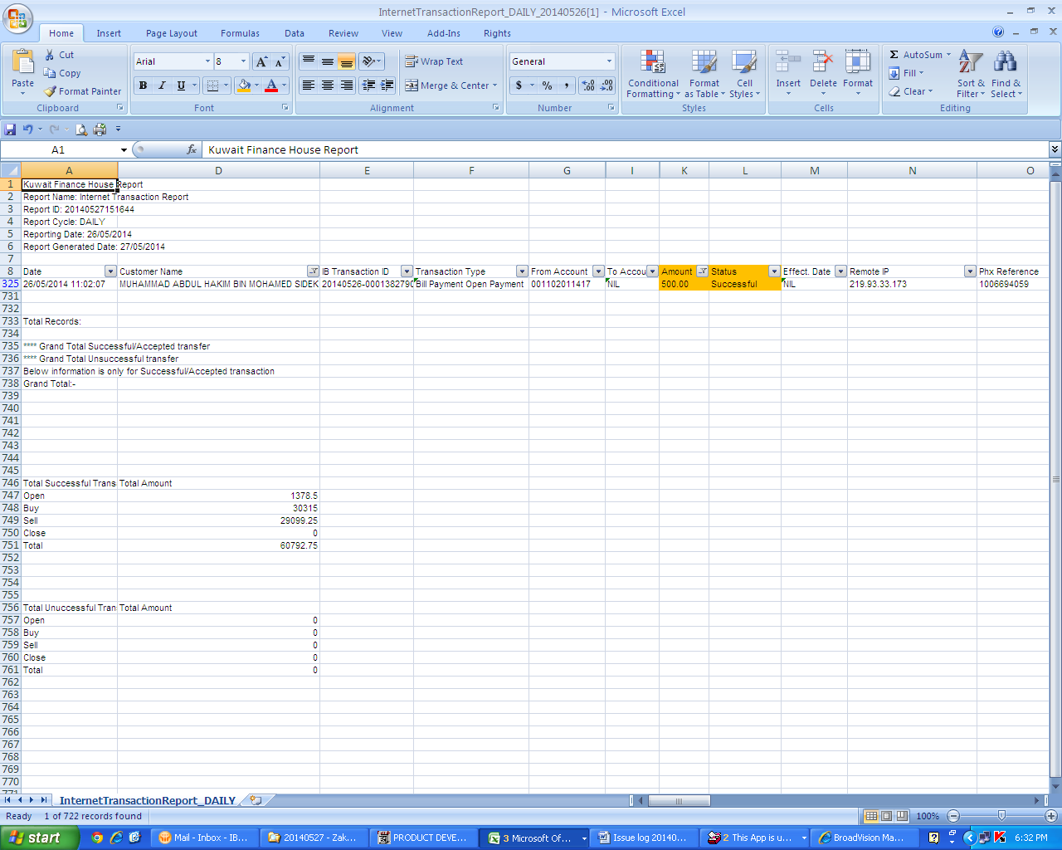

Bill Payment Report

