**Dear ASO Team,**

As highlighted yesterday, please confirm the refund status for the below transaction.

**Dear IT Team,**

Is there any update on the below issue raised yesterday? After checked at BVMC report dated 27.5.14, the transaction type was Registered IBG and it's not a SI transaction. Appended below is the details of the trx for your reference & further checking.



|  |  |
| --- | --- |
| From: | Chooi So Fun/KFHMB |
| To: | Nur Arina Mohd Arfin/KFHMB@KFHMB, Norsurianie Supatdy/KFHMB@KFHMB, Ahmad Rosli Talib/KFHMB@KFHMB, Mohd Azraf Abd Ghani/KFHMB@KFHMB, Mohd Firdaus Mohd Sofian/KFHMB@KFHMB |
| Cc: | Malarvili Muniandy/KFHMB@KFHMB, Sara Nadeea Rahim/KFHMB@KFHMB, Alternative Service Operations & Vendor Management, Zakaria Sahar/KFHMB@KFHMB, System Admin |
| Date: | 05/27/2014 11:10 AM |
| Subject: | URGENT - Prod Isse - HD00015151 - Fw: RECALCULATED (IBG PVM) - uploadWindow1200 - mnc05271200.txt 10000346 |

**Dear IT Team,**

Forwarded email refers.

Please be informed that today OFI W3 there was 1 OFI transaction initiated from CIB rejected by MyClear due to 3rd Addenda is empty.

Fyi, this is a recurring issue. Based on the last root cause given for issue log# HD00014860 was caused due to incorrect CIB-SI execution at bv_framework other than bv_framework03 which contain correct CIB-SI module.

Hence, we seek your immediate action to further check why the transaction is able to perform/go thru while the Bene ID was empty with Bene ID Verification was enable.

**Dear Arina,**

Today OFI W3, there is 1 transaction rejected by MyClear due to error for ID Validation - 3rd Addenda.

Please make the necessary refund to customer and attached the details of the transaction fya.

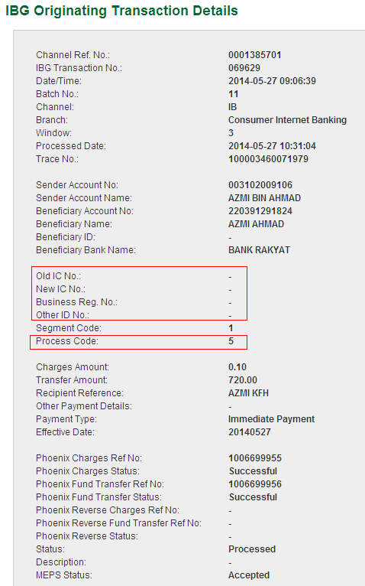

Thank you and regards,  
Chooi So Fun  
Alternate Channels  
Kuwait Finance House (Malaysia) Berhad  
Level 8, Menara Prestige,  
No 1, Jalan Pinang, Kuala Lumpur, Malaysia  
Tel: (+603) 2168 0620  
Fax: (+603)2168 0265  
E-mail: chooi.so.fun@kfh.com.my

----- Forwarded by Chooi So Fun/KFHMB on 05/27/2014 10:56 AM -----

|  |  |
| --- | --- |
| From: | <payswitch_server@myclear.org.my> |
| To: | <ibgops@kfh.com.my> |
| Date: | 05/27/2014 10:44 AM |
| Subject: | RECALCULATED (IBG PVM) - uploadWindow1200 - mnc05271200.txt 10000346 |

PAYSWITCH VALIDATION STATUS ON IBG FILE

|  |  |
| --- | --- |
| BANK NAME: | KFH |
| FILE NAME: | mnc05271200.txt |
| TRANSMISSION DATE: | 27/05/2014 10:44 |

FILE INFO

|  |  |
| --- | --- |
| IMMEDIATE ORIGIN: | 100003460 |
| IMMEDIATE DESTINATION: | 100011119 |
| CREATION DATE: | 140527 |
| CREATION TIME: | 1031 |
| FILE ID MODIFIER: | C |
| TOTAL CREDIT IN FILE: | 34,851.77 |

FILE VALIDATION STATUS

|  |  |  |  |  |
| --- | --- | --- | --- | --- |
| **Information** | **Status** | **Count** | **Amount** | **Reason** |
| File | GOOD | 1 | 34,131.77 |  |
| Batch | GOOD | 11 | 34,131.77 |  |
| Transactions | GOOD | 29 | 34,131.77 |  |
| Transactions | REJECT | 1 | 720.00 | REFER TO VALIDATION DETAILS |

|  |  |
| --- | --- |
| BANK NAME: | KFH |
| FILE NAME: | mrt05271200.txt |
| TRANSMISSION DATE: | 27/05/2014 10:44 |

TRANSMITTAL FILE VALIDATION STATUS

|  |  |  |
| --- | --- | --- |
| **Information** | **Status** | **Reason** |
| File | GOOD |  |

END OF REPORT

[attachment "ValidationStatusReport(20140527104431).pdf" deleted by Chooi So Fun/KFHMB]