MSS Concerns

1. Customer Inquiry Tab- Before migration, when you click search, MSS will load all the users since the start of enrolment. Now, it shows error while performing your request.

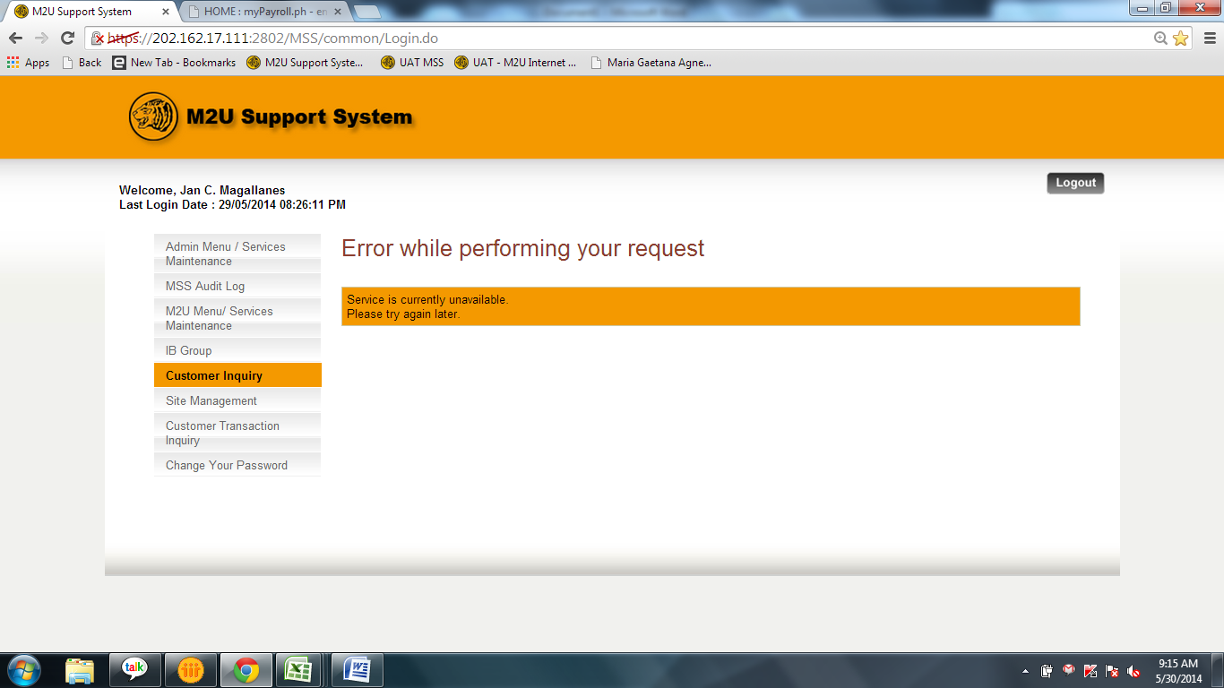

1. Customer Inquiry Tab- Before migration, you can move back the date from the beginning of M2U. Now, it’s only until May 30-31, 2012.

