KUWAIT FINANCE HOUSE
E-Banking Network Infrastructure Project

Project Handover Documentation


Table of Contents
Introduction 3
Physical Network Diagram: 3
IP Addressing Scheme: 4
Acceptence Signoff 21

Introduction

The main objective for this documentation is to descript the project of Kuwait Finance House E-Banking Network Infrastructure. This document will provide a greater visibility for the customer to look on devices installation and configuration and will help speeds up the process of troubleshooting and maintenance job in future if any problem occurs.

Physical Network Diagram:

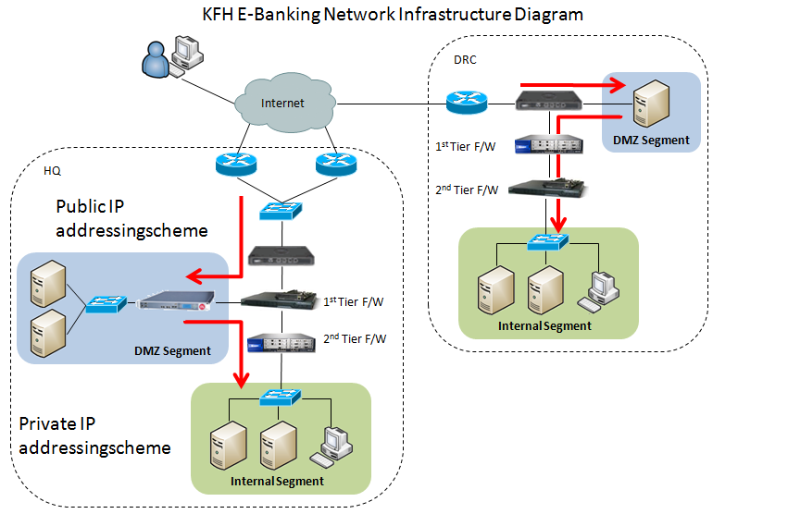

IP Addressing Scheme:

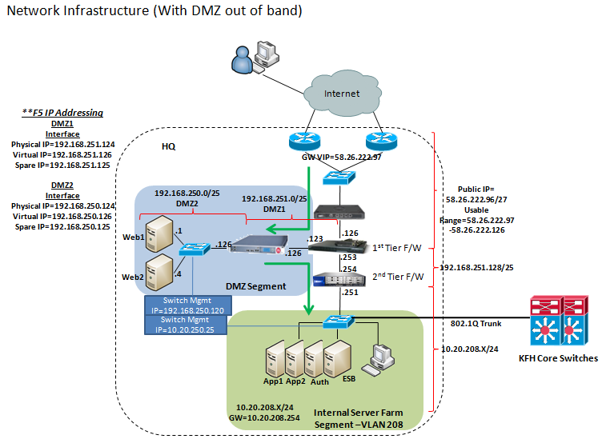

GENERAL
Public IP Address Range and Subnet Mask
58.26.222.97 – 58.26.222.126/255.255.255.224
Public IP Default Gateway
58.26.222.97
Registered URL with MyNIC used for E-Banking
Registered URL |  |  |  | Public IP Address
www.kfhonline.com.my |  |  |  | 58.26.222.100
SourceFire
FQDN Hostname
kfhwcyips01.kfhmb.local
Private IP Address Assign to this box for out-of-band Management
10.20.250.42
Existing Defence Center Software Version
4.7.0.4
Existing Defence Center IP Address
10.20.201.40
Cisco ASA Firewall
FQDN Hostname
kfhwcyfw01.kfhmb.local
Interface IP Address
Interface |  | IP Address/Subnet Mask |  |  | Gateway
Outside |  | 58.26.222.126/255.255.255.224 |  |  | 58.26.222.97
DMZ 1 |  | 192.168.251.123/255.255.255.128 |  |  | None
Inside |  | 192.168.251.253/255.255.255.128 |  |  | None
Out of Band Management |  | Not assigned |  |  | None

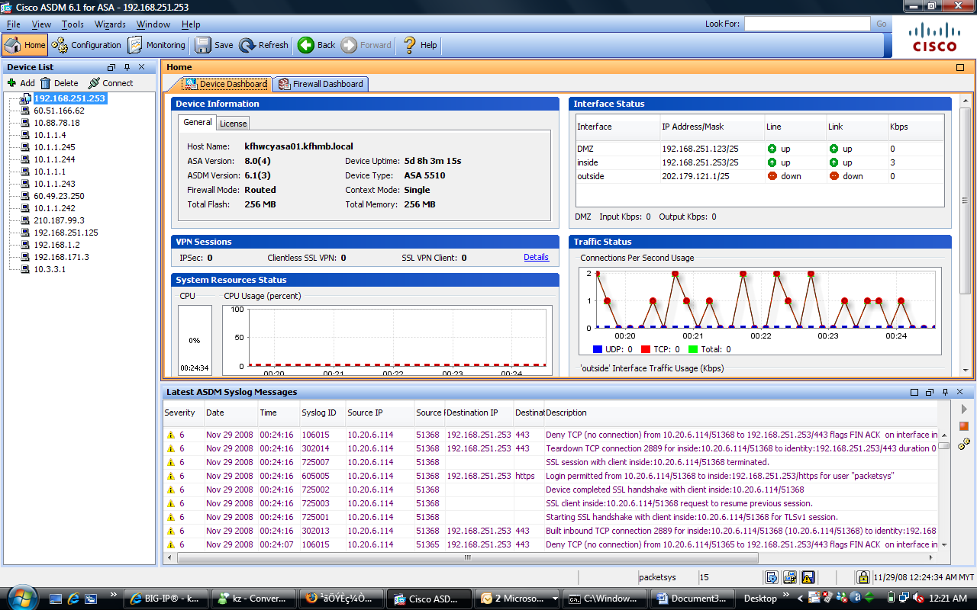
Figure 1: Homepage of Cisco ASA GUI interface

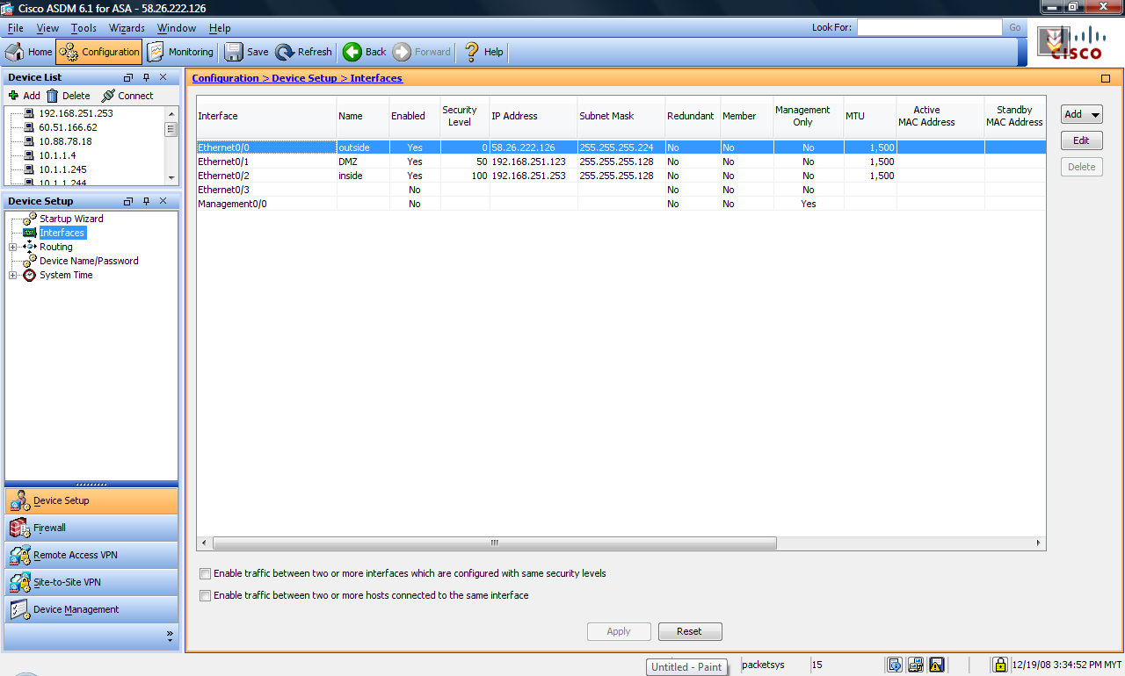
Figure 2: Cisco ASA Interfaces and IP addresses

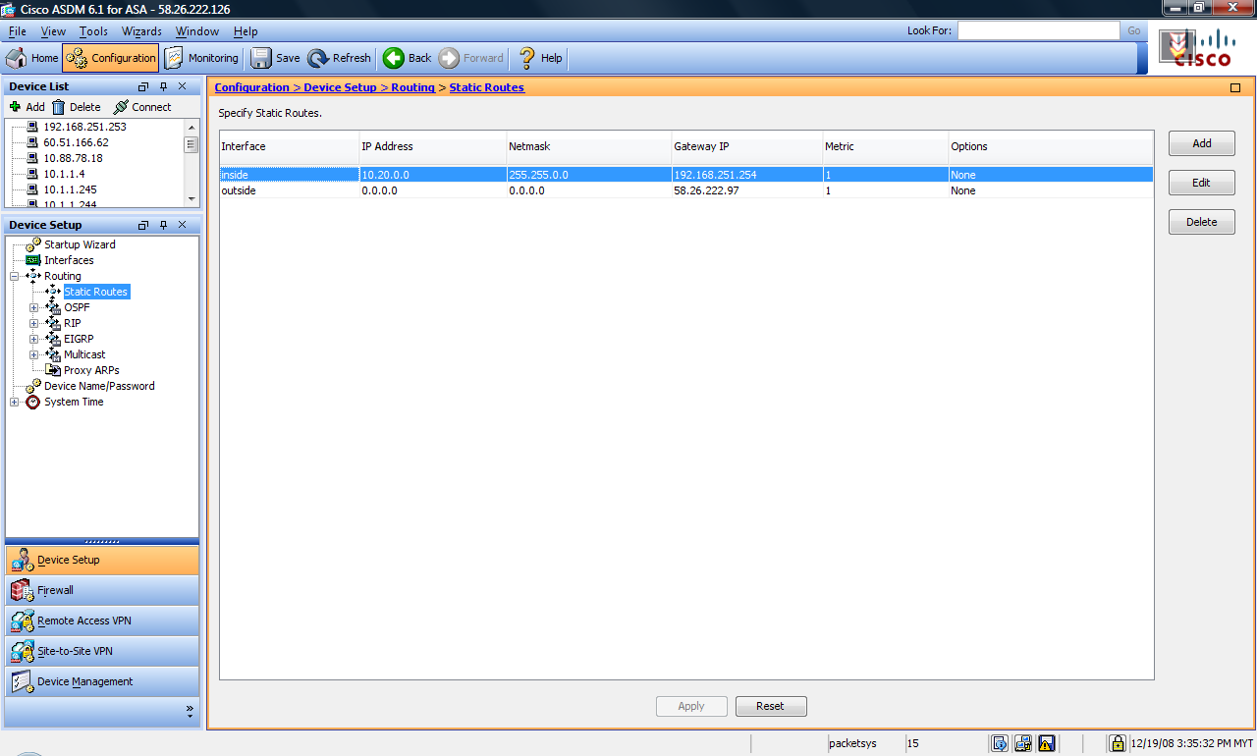
Figure 3: Cisco ASA static routing table

NAT Exemption
Source IP Address |  |  | Destination IP Address
192.168.251.0/255.255.255.128 |  |  | 10.20.208.0/255.255.255.0
192.168.251.1/255.255.255.255 |  |  | 10.20.201.55/255.255.255.255
192.168.251.4/255.255.255.255 |  |  | 10.20.201.55/255.255.255.255

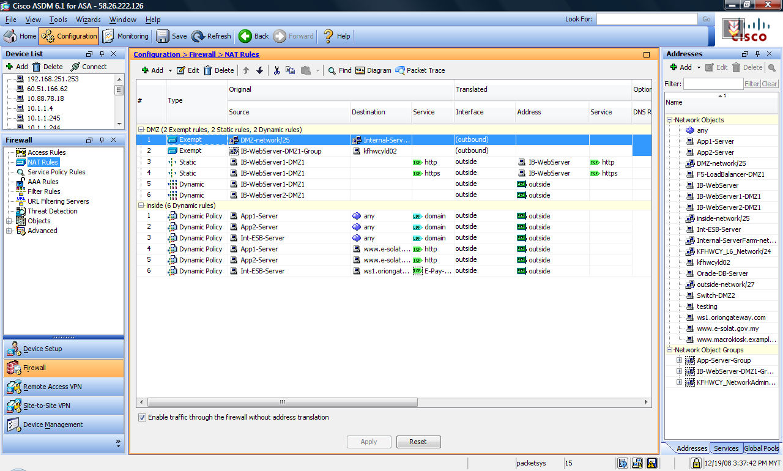
Figure 4: Cisco ASA NAT setup

Port Forwarding
Public IP Address |  |  | Internal IP Address |  |  | Services/Port Number
58.26.222.100 |  |  | 192.168.251.1 |  |  | 80
58.26.222.100 |  |  | 192.168.251.1 |  |  | 443
PAT - Dynamic Many to One NAT
Public IP Address Pool |  |  | Internal IP Segment to NAT
58.26.222.126-58.26.222.126 |  |  | 10.20.208.1
58.26.222.126-58.26.222.126 |  |  | 10.20.208.4
58.26.222.126-58.26.222.126 |  |  | 10.20.208.7
58.26.222.126-58.26.222.126 |  |  | 192.168.251.1
58.26.222.126-58.26.222.126 |  |  | 192.168.251.4

Cisco ASA Security Policy

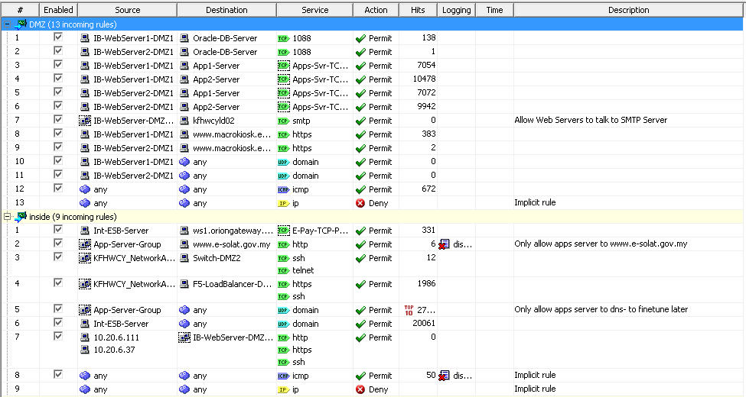
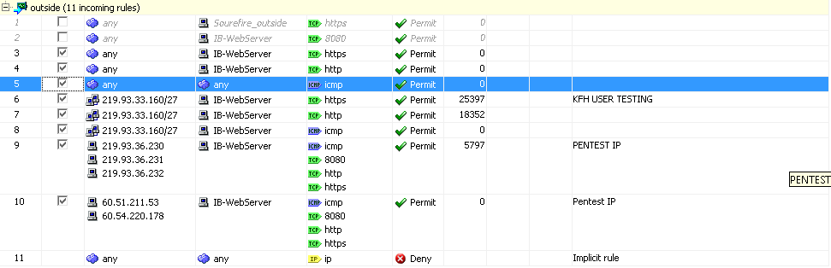

F5 Load Balancer
FQDN Hostname
kfhwcylb01.kfhmb.local
Interface IP Address
Interface |  | IP Address/Subnet Mask |  |  |  | Gateway
DMZ 1-Physical IP |  | 192.168.251.124/255.255.255.128 |  |  |  | 192.168.251.123
DMZ 1-Floating IP |  | 192.168.251.126/255.255.255.128 |  |  |  | 192.168.251.123
DMZ2-Physical IP |  | 192.168.250.124/255.255.255.128 |  |  |  | None
DMZ2-Floating IP |  | 192.168.250.126/255.255.255.128 |  |  |  | None
Device Default Gateway
192.168.251.123

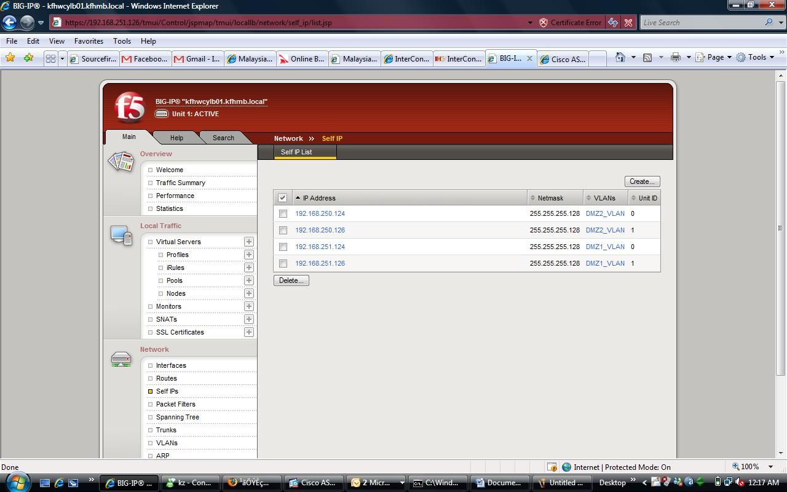
Figure 5: F5 Interface IP addressing scheme

Public IP Address | Services/Port Numbers | Device Pool IP Address for Srv Load Balance (Real IP) | Services/Port Numbers | Load Balance Method
192.168.251.1 | 80 | 192.168.250.1 | 80 | Round-robin
 |  | 192.168.250.4 | 80 | Round-robin
192.168.251.1 | 443 | 192.168.250.1 | 443 | Round-robin
 |  | 192.168.250.4 | 443 | Round-robin
192.168.251.120 | 23 | 192.168.250.120 | 23 | Round-robin
192.168.251.120 | 22 | 192.168.250.12 | 22 | Round-robin

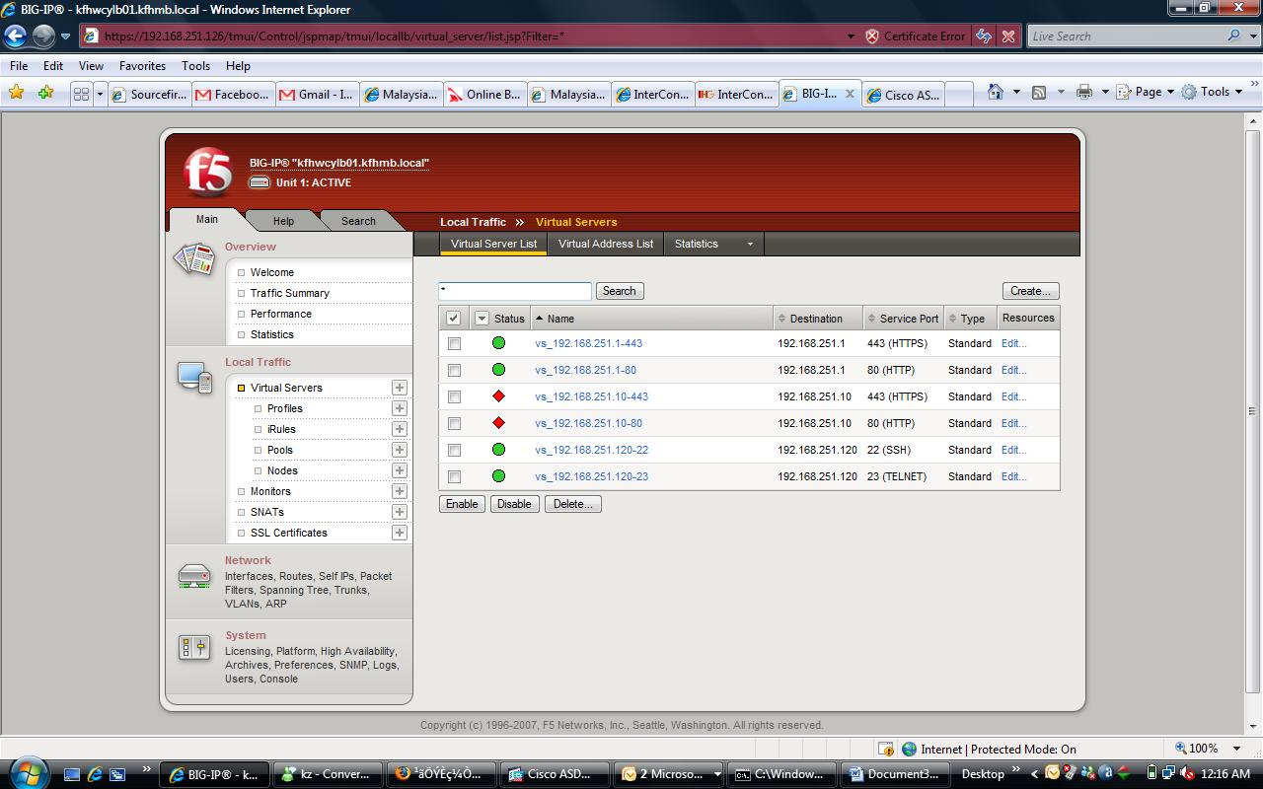
Figure 6: F5 Virtual Server setup

DMZ Cisco Catalyst 2960G Switch
DMZ Switch Management IP Address/Subnet Mask
192.168.250.120
Device Default Gateway
192.168.250.126
DMZ Switch NAT IP for Management from Internal LAN
192.168.251.120
Juniper Firewall
FQDN Hostname
kfhwcyfw02.kfhmb.local
Interface IP Address
Interface |  | IP Address/Subnet Mask |  |  | Gateway
Untrust |  | 192.168.251.254 |  |  | 192.168.251.253
Trust |  | 10.20.208.251 |  |  | 10.20.208.254

Name | IP/Netmask | Zone | Type | Link | PPPoE | Configure
ethernet0/0 | 10.20.208.251/24 | Trust | Layer3 | Up | - | Edit
ethernet0/1 | 0.0.0.0/0 | DMZ | Layer3 | Down | - | Edit
ethernet0/2 | 192.168.251.254/25 | Untrust | Layer3 | Up | - | Edit
ethernet0/3 | 0.0.0.0/0 | HA | Layer3 | Down | - | Edit
vlan1 | 0.0.0.0/0 | VLAN | Layer3 | Down | - | Edit
Figure 7: Juniper Firewall Interface and IP addresses

Juniper Firewall Policy

From Trust To Untrust, total policy: 11
ID | Source | Destination | Service | Action | Options | Configure |  |  | Enable | Move
22 | IB-Apps1-Server  IB-Apps2-Server | www.e-solat.gov.my | HTTP |  |  | Edit | Clone | Remove
13 | Int-ESB-Server | www.oriongateway.com | E-Pay TCP Ports |  |  | Edit | Clone | Remove
21 | KFHWCY_L6_Network  Server Farm-network | 192.168.251.126/32 | HTTPS  SSH |  |  | Edit | Clone | Remove
20 | KFHWCY_L6_Network  Server Farm-network | 192.168.251.120/32 | SSH  TELNET |  |  | Edit | Clone | Remove
11 | KFHWCY_L6_Network  Server Farm-network | 192.168.251.253/32 | HTTPS  SSH |  |  | Edit | Clone | Remove
14 | IB-Apps1-Server  IB-Apps2-Server  Int-ESB-Server | Any | DNS |  |  | Edit | Clone | Remove
9 | Any | Any | ICMP-ANY |  |  | Edit | Clone | Remove
8 | Any | Any | ANY |  |  | Edit | Clone | Remove
16 | IB-Apps2-Server | IB-WebServer1-DMZ1  IB-WebServer2-DMZ1 | App-Server TCP Port |  |  | Edit | Clone | Remove
15 | IB-Apps1-Server | IB-WebServer1-DMZ1  IB-WebServer2-DMZ1 | App-Server TCP Port |  |  | Edit | Clone | Remove
12 | Oracle-DB-Server | IB-WebServer1-DMZ1  IB-WebServer2-DMZ1 | SQL*Net V2 |  |  | Edit | Clone | Remove
From Untrust To Trust, total policy: 6
ID | Source | Destination | Service | Action | Options | Configure |  |  | Enable | Move
23 | IB-WebServer1-DMZ1  IB-WebServer2-DMZ1 | kfhwcyld02 | SMTP |  |  | Edit | Clone | Remove
19 | IB-WebServer1-DMZ1  IB-WebServer2-DMZ1 | Oracle-DB-Server | SQL*Net V2 |  |  | Edit | Clone | Remove
18 | IB-WebServer1-DMZ1  IB-WebServer2-DMZ1 | IB-Apps2-Server | App-Server TCP Port |  |  | Edit | Clone | Remove
17 | IB-WebServer1-DMZ1  IB-WebServer2-DMZ1 | IB-Apps1-Server | App-Server TCP Port |  |  | Edit | Clone | Remove
10 | Any | Any | ICMP-ANY |  |  | Edit | Clone | Remove
4 | Any | Any | ANY |  |  | Edit | Clone | Remove
Figure 8: Juniper Firewall Security Policy

Juniper Firewall Network Object
Name | IP/Domain Name | Comment | Configure
192.168.251.120/32 | 192.168.251.120 /32 |  | Edit | In Use
192.168.251.126/32 | 192.168.251.126 /32 |  | Edit | In Use
192.168.251.253/32 | 192.168.251.253 /32 |  | Edit | In Use
Any | 0.0.0.0 /0 | All Addr |  | In Use
Dial-Up VPN | 255.255.255.255 /32 | Dial-Up VPN Addr
DMZ1-network | 192.168.251.0 /25 |  | Edit | In Use
IB-WebServer1-DMZ1 | 192.168.251.1 /32 |  | Edit | In Use
IB-WebServer2-DMZ1 | 192.168.251.4 /32 |  | Edit | In Use
www.e-solat.gov.my | 202.190.100.60 /32 |  | Edit | In Use
www.oriongateway.com | 58.26.9.22 /32 |  | Edit | In Use
Figure 9: Juniper Firewall Untrust Network Object
Name | IP/Domain Name | Comment | Configure
Any | 0.0.0.0 /0 | All Addr |  | In Use
Dial-Up VPN | 255.255.255.255 /32 | Dial-Up VPN Addr
IB-Apps1-Server | 10.20.208.1 /24 |  | Edit | In Use
IB-Apps2-Server | 10.20.208.4 /24 |  | Edit | In Use
Int-ESB-Server | 10.20.208.7 /24 |  | Edit | In Use
KFHWCY_L6_Network | 10.20.6.0 /24 |  | Edit | Remove
Oracle-DB-Server | 10.20.208.10 /24 |  | Edit | In Use
Server Farm-network | 10.20.208.0 /24 |  | Edit | In Use
Figure 10: Juniper Firewall Trust Network Object

Name | Transport Protocol and Parameters | Timeout (min|10sec*) | Configure
App-7213 | TCP src port: 0-65535, dst port: 7213-7213 | 30 | Edit | Remove
App-7313 | TCP src port: 0-65535, dst port: 7313-7313 | 30 | Edit | Remove
App-7413 | TCP src port: 0-65535, dst port: 7413-7413 | 30 | Edit | Remove
App-7513 | TCP src port: 0-65535, dst port: 7513-7513 | 30 | Edit | Remove
TCP_22837 | TCP src port: 0-65535, dst port: 22837-22837 | 30 | Edit | Remove
TCP_33831 | TCP src port: 0-65535, dst port: 33831-33831 | 30 | Edit | Remove
Group Name | Members | Comment | Configure
App-Server TCP Port | App-7213, App-7313, App-7413, ... | Allowed TCP Port | Edit | In Use
APPLE-ICHAT | AOL, APPLE-ICHAT-SNATMAP, DNS, .. | Apple iChat Services Group | View
E-Pay TCP Ports | HTTPS, TCP_22837, TCP_33831 |  | Edit | In Use
MGCP | MGCP-CA, MGCP-UA | Media Gateway Control Protocol | View
MS-AD | MS-AD-BR, MS-AD-DRSUAPI, ... | Microsoft Active Directory | View
MS-EXCHANGE | MS-EXCHANGE-DATABASE, ... | Microsoft Exchange | View
MS-IIS | MS-IIS-COM, MS-IIS-IMAP4, ... | Microsoft IIS Server | View
VOIP | H.323, MGCP-CA, MGCP-UA, SCCP, .. | VOIP Service Group | View
Figure 11: Juniper Firewall Custom Services Object

Internal Server Farm Cisco Catalyst 2960G Switch
Switch Management IP Address/Subnet Mask
10.20.250.25/255.255.255.0
No. of VLAN
VLAN 208 and VLAN 250
VLAN ID | Network Address/Subnet Mask |  |  |  |  | Gateway
250 | 10.20.250.0/255.255.255.0 |  |  |  |  | 10.20.250.254
208 | 10.20.208.0/255.255.255.0 |  |  |  |  | 10.20.208.254

Acceptance Signoff
Signature of this Network Acceptance Test Document by the authorized KUWAIT FINANCE HOUSE representative indicates satisfaction and acceptance of the design, implementation and deliverables for the network installation.
  
KUWAIT FINANCE HOUSE Representative |  |  |  | PACKET SYSTEMS(M) Representative
Name | : |  |  | Name | : | Soon Kok Weng
Designation | : |  |  | Designation | : | Senior Network Engineer
Time | : |  |  | Time | :
Date | : |  |  | Date | :
Signature | : |  |  | Signature | :
Company Stamp | : |  |  | Company Stamp

