RETAIL INTERNET BANKING

ELECTRONIC BANKING GROUP

Nama Proyek | Retail Internet Banking
Nomor SR
Disiapkan Oleh | Febhy Toomy Saputra | Versi

Test Case No :
Test Objectives : |  | Time Deposit - Inquiry
Step No. | Actions |  | Steps | Expected Result | Pass / Fail | Actual Result
 | Melihat listing Rekening Deposito |  | - Login dengan user : ribuser1  - Pilih Rekening dan Transaksi untuk cek Deposito  - Pilih Time Deposit Account Inquiry  - Lihat List Deposito | - Melihat detail rekening Deposito  - Tidak muncul error message “Account tidak ada” | Pass | - Ok
Remark :

Lampiran :
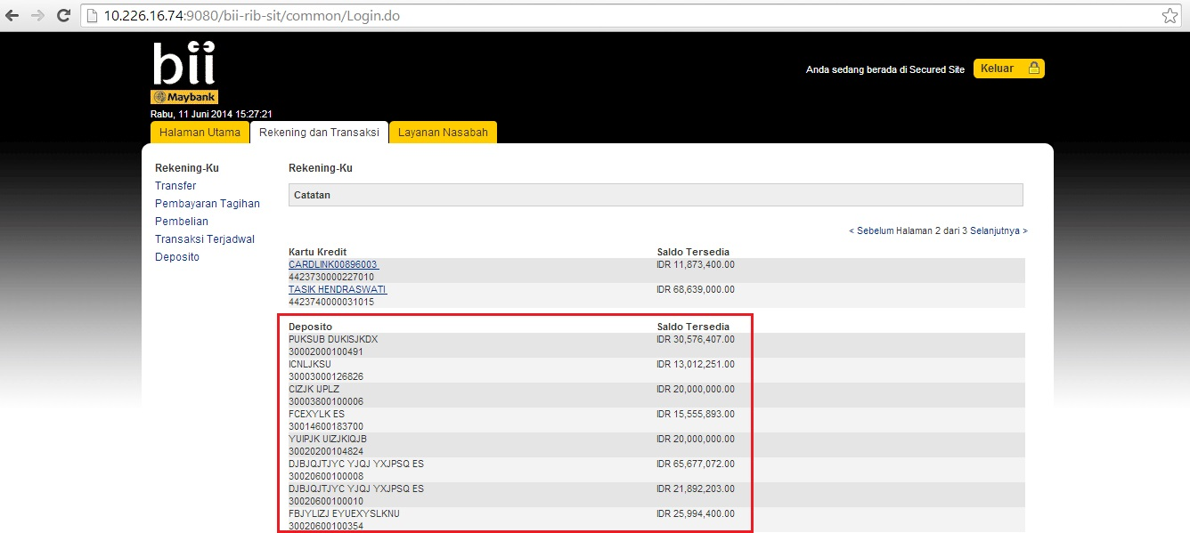

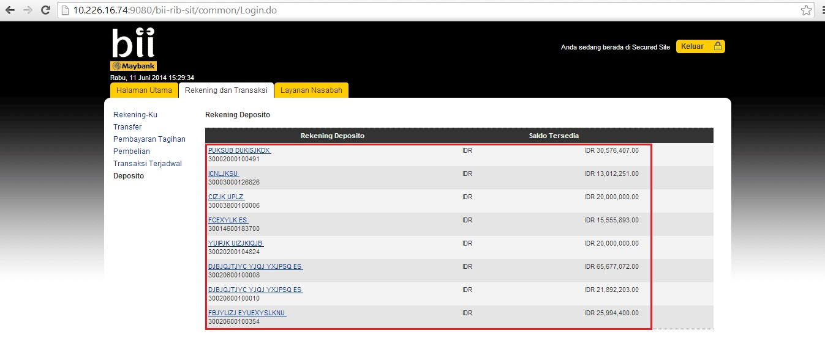

Test Case No :
Test Objectives : |  | Limit Transaction for SKN Transfer - MSS
Step No. | Actions |  | Steps | Expected Result | Pass / Fail | Actual Result
 | Merubah limit SKN per Transfer di MSS |  | - Login dengan user : administrator  - Masuk MSS -> Site Management -> Limit  - Pilih Category Name : BII  - Pilih Details : Limit SKN per Transfer  - Klik button Edit  - Input Limit Value dengan angka  - Input Limit Value dengan value yang salah seperti : koma, titik, alphabet, special karakter, spasi, dan kosong untuk munculkan validasi | - Bisa inputkan angka saja.  - Akan muncul error message “Limit value is not proper currency format” jika di input selain angka. | Pass | - Ok
Remark :

Lampiran :
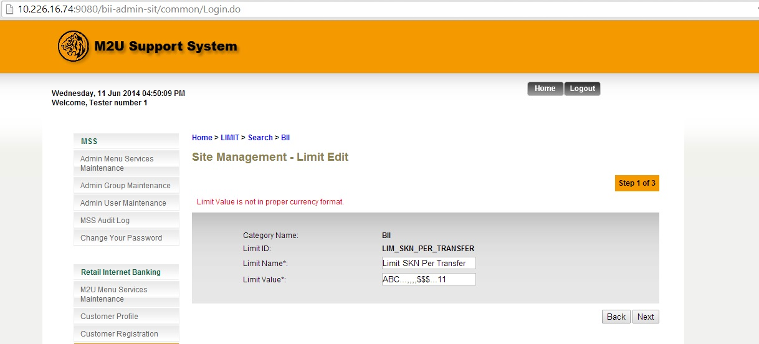

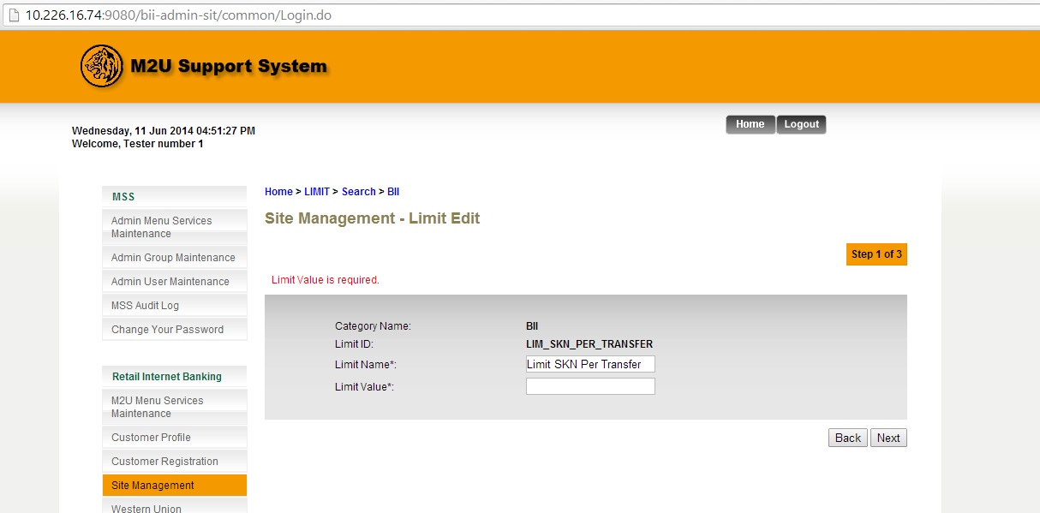

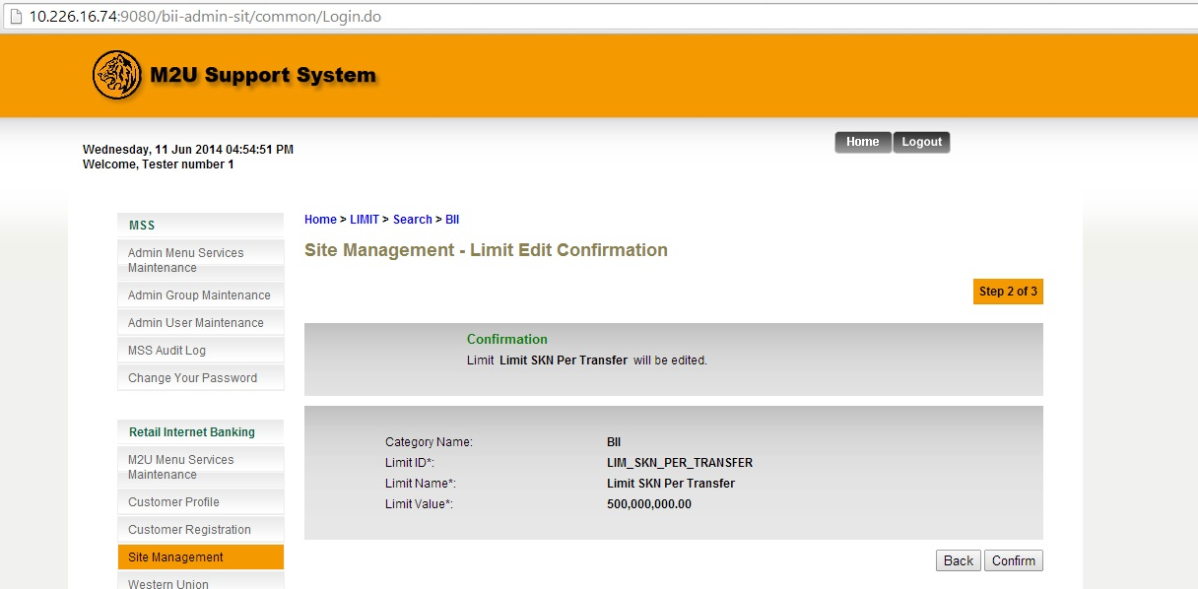

Test Case No :
Test Objectives : |  | Limit Transaction for SKN Transfer - RIB
Step No. | Actions |  | Steps | Expected Result | Pass / Fail | Actual Result
 | Melakukan transfer limit SKN per Transfer di RIB |  | - Login dengan user : ribuser1  - Masuk Login -> Transfer -> Favorite SKN/RTGS  - Input semua field  - Input field Jumlah kurang dari, sama dengan dan lebih dari 500 Juta | - Bisa inputkan kurang dari dan sama dengan 500 Juta.  - Akan muncul error message “Jumlah transaksi melebihi limit” jika di input lebih dari 500 Juta. | Pass | - Ok
Remark :

Lampiran :
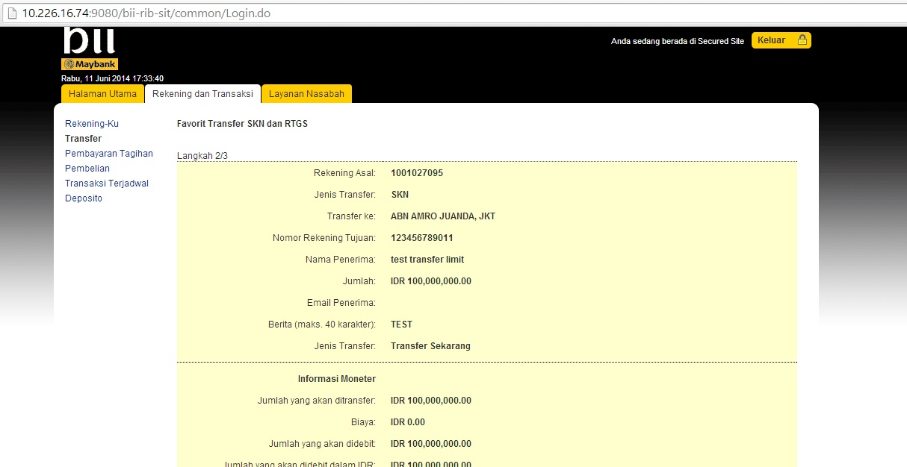

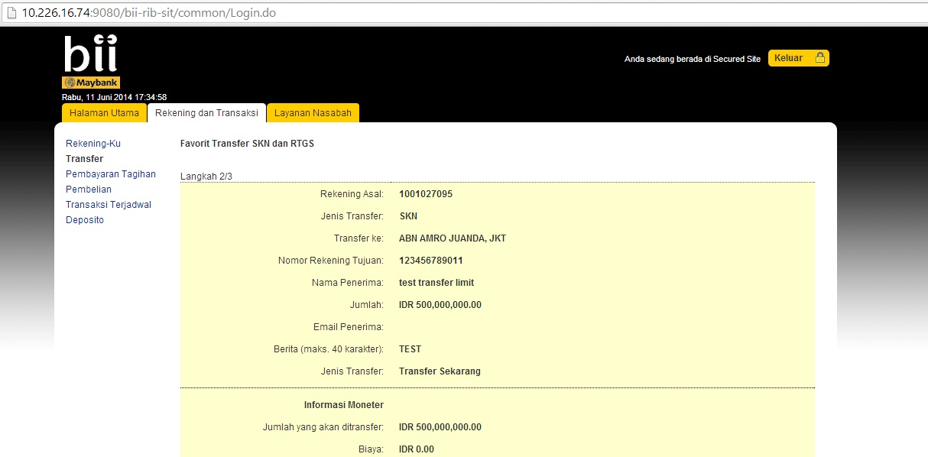

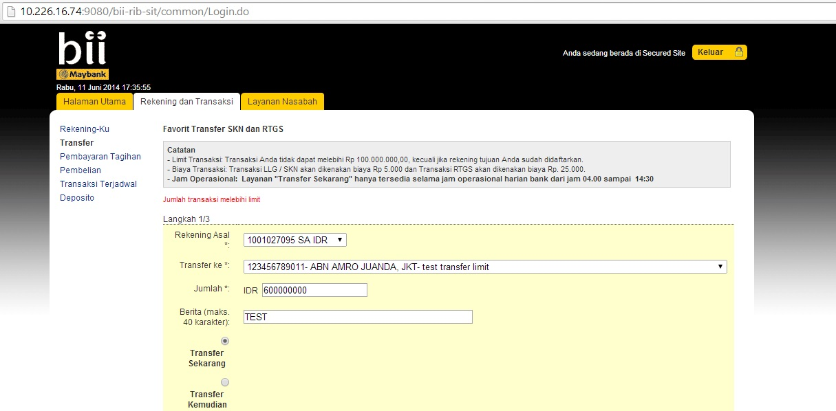

Test Case No :
Test Objectives : |  | EDW Report – Bill Payment Report
Step No. | Actions |  | Steps | Expected Result | Pass / Fail | Actual Result
 | Melihat data generate Bill Payment Report |  | - Generate Bill Payment Report  - Cek total length : 631 | - Transaction ID : length 25  - Payee Code : length 10  - Payee Name : length 70  - Bill Account Number : length 30  - Bill Account Name : length 70  - Product Code : length 25  - From Currency Code : length 10  - Local Amount : length 30  - Transaction Date Time : length 20  - Transaction Description : length 70  - User # : length 20  - From Account No. : length 25  - Amount : length 30  - Effective Date : length 20  - Remote IP Address : length 30  - Host IP Address : length 30  - User ID : length 25  - User Name : length 65  - Status : length 25  - Record’sTerminator : length 1 | Pass | - 20140612000000018420 640200 INDOVSN TOP OKE TREN 10312121212 null IDR +120000.00 20140612104206 New Bill Payments 1391 2001009682 +120000.00 20140612104206 10.110.3.166 127.0.0.1 ribuser1 CHRISTOPHER PAUL WHALEY Successful X
Remark :

Lampiran :
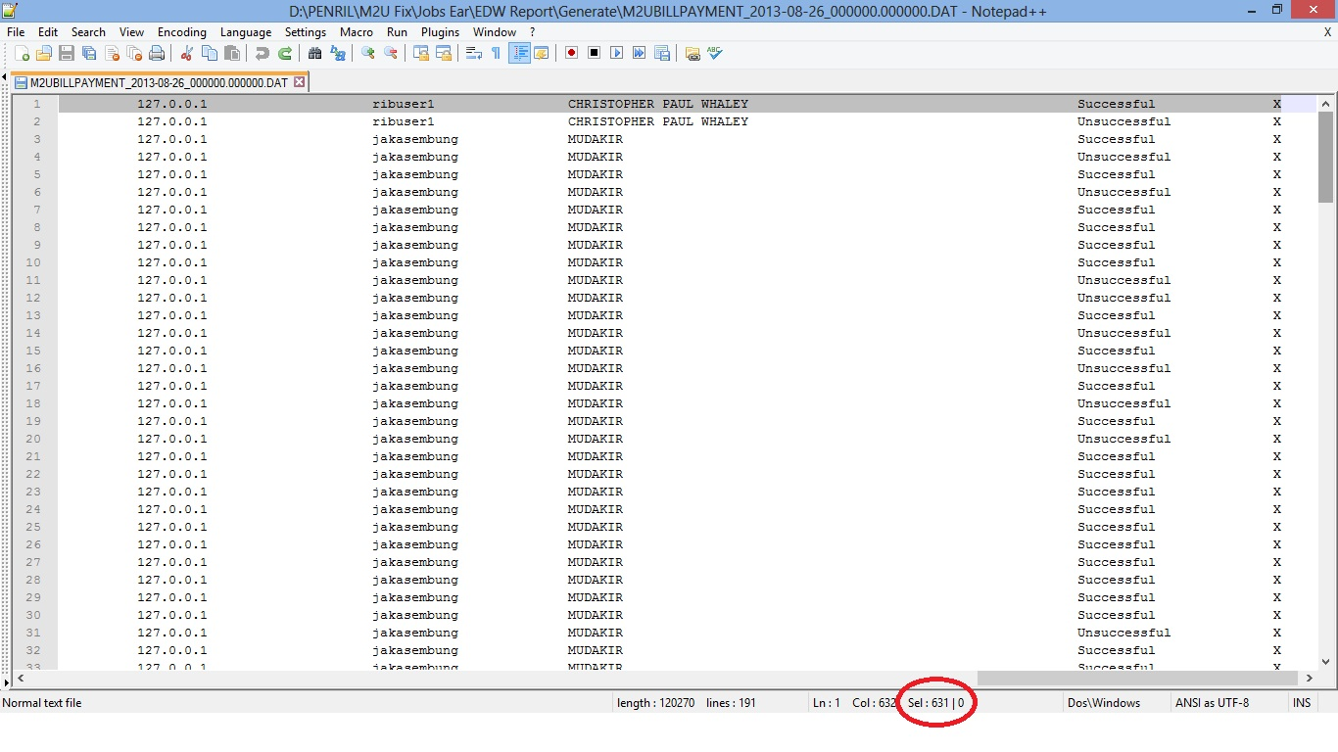

Test Case No :
Test Objectives : |  | EDW Report – Interbank Transfer Report
Step No. | Actions |  | Steps | Expected Result | Pass / Fail | Actual Result
 | Melihat data generate Interbank Transfer Report |  | - Generate Interbank Transfer Report  - Cek total length : 691 | - Transaction ID : length 25  - User ID : length 25  - User Name : length 65  - User # : length 20  - Beneficiary Name : length 70  - Beneficiary Bank Name : length 70  - Transaction Description : length 70  - Transaction Date Time : length 20  - Effective Date : length 20  - From Account No : length 25  - To Account No : length 25  - From Currency : length 10  - From Currency Rate : length 30  - To Currency : length 10  - To Currency Rate : length 30  - From Amount : length 30  - Local Amount : length 30  - Remote IP Address : length 30  - Host IP Address : length 30  - Amount : length 30  - Status : length 25  - Record’s terminator : length 1 | Pass | - 20130731000000004828 maybank SARYO 1277 NASABAH BCA B C A Transfer Interbank Online 20130731103824 20130731103824 1003632642 0651223345 IDR +1.00 IDR +1.00 +10000.00 +10000.00 10.120.19.67 127.0.0.1 +10000.00 Successful X
Remark :

Lampiran :
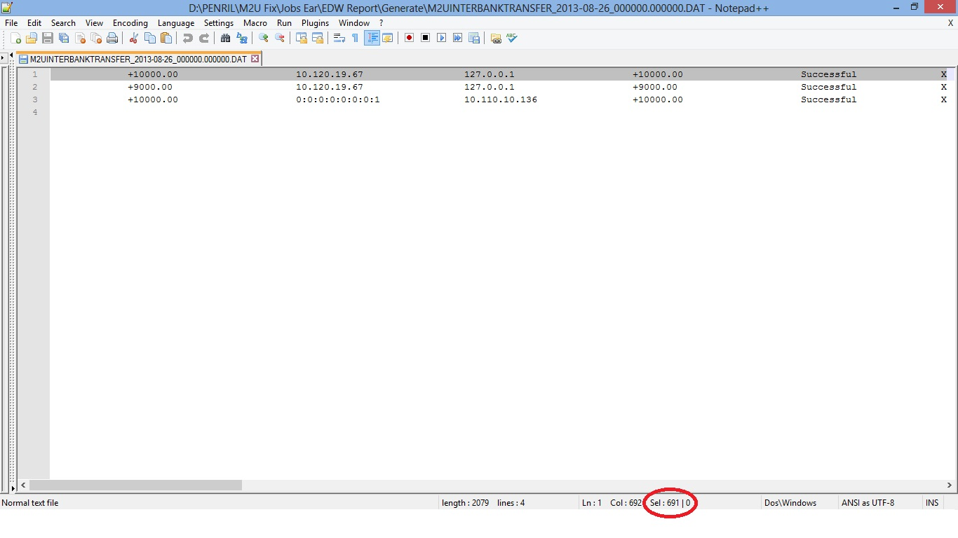

Test Case No :
Test Objectives : |  | EDW Report – Mobile Reload Report
Step No. | Actions |  | Steps | Expected Result | Pass / Fail | Actual Result
 | Melihat data generate Mobile Reload Report |  | - Generate Mobile Reload Report  - Cek total length : 464 | - Transaction ID : length 25  - User ID : length 25  - User Name : length 65  - User # : length 20  - Payee Code : length 70  - Payee Name : length 70  - Mobile No : length 18  - Transaction Date Time : length 20  - From Account No : length 25  - Remote IP Address : length 30  - Host IP Address : length 30  - From Currency Code : length 10  - Amount : length 30  - Status : length 25  - Record’s terminator : length 1 | Pass | - 20140617000000018599 ribuser1 CHRISTOPHER PAUL WHALEY 1391 105000 Kartu AS 0852112233445 20140617154425 1007555362 10.120.3.254 127.0.0.1 IDR +100000.00 X
Remark :

Lampiran :
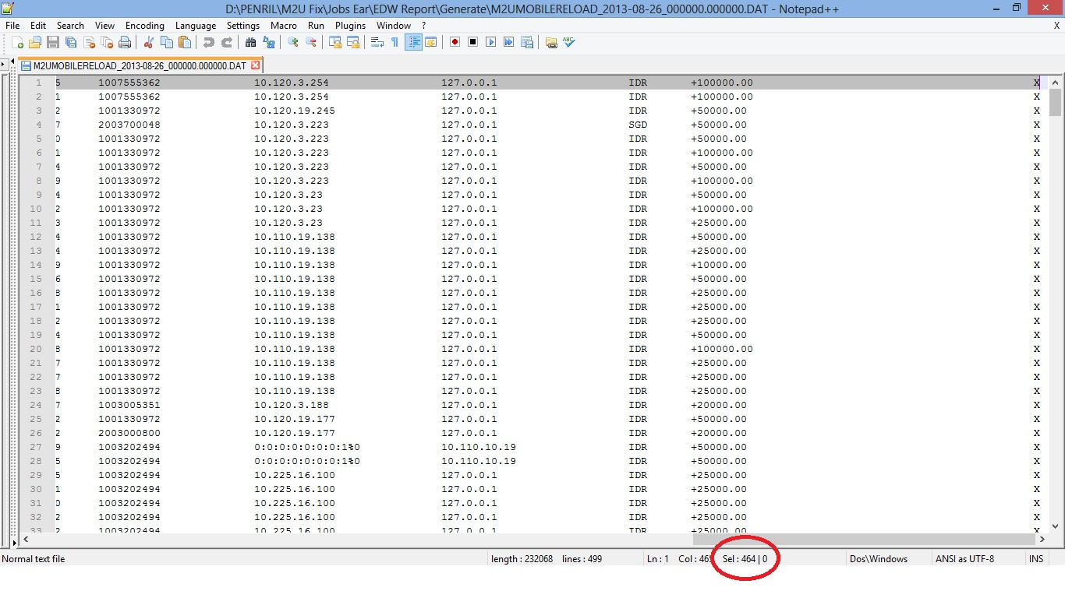

Test Case No :
Test Objectives : |  | EDW Report – Own Account Transfer Report
Step No. | Actions |  | Steps | Expected Result | Pass / Fail | Actual Result
 | Melihat data generate Own Account Transfer Report |  | - Generate Own Account Transfer Report  - Cek total length : 531 | - Transaction ID : length 25  - Account Holder Name : length 55  - User # : length 15  - User ID : length 25  - User Name : length 65  - Transaction Date Time : length 20  - Effective Date : length 20  - From Account No : length 25  - To Account No : length 25  - From Currency : length 10  - From Currency Rate : length 30  - To Currency : length 10  - To Currency Rate : length 30  - From Amount : length 30  - Local Amount : length 30  - Remote IP Address : length 30  - Host IP Address : length 30  - Amount : length 30  - Status : length 25  - Record’s terminator : length 1 | Pass | - 20140619000000018745 null 1391 ribuser1 CHRISTOPHER PAUL WHALEY 20140619152255 20140619152255 2001009682 1003000010 039 +11000.00 016 +1.00 +11.18 +123000.00 10.110.3.166 127.0.0.1 +11.18 Gagal X
Remark :

Lampiran :
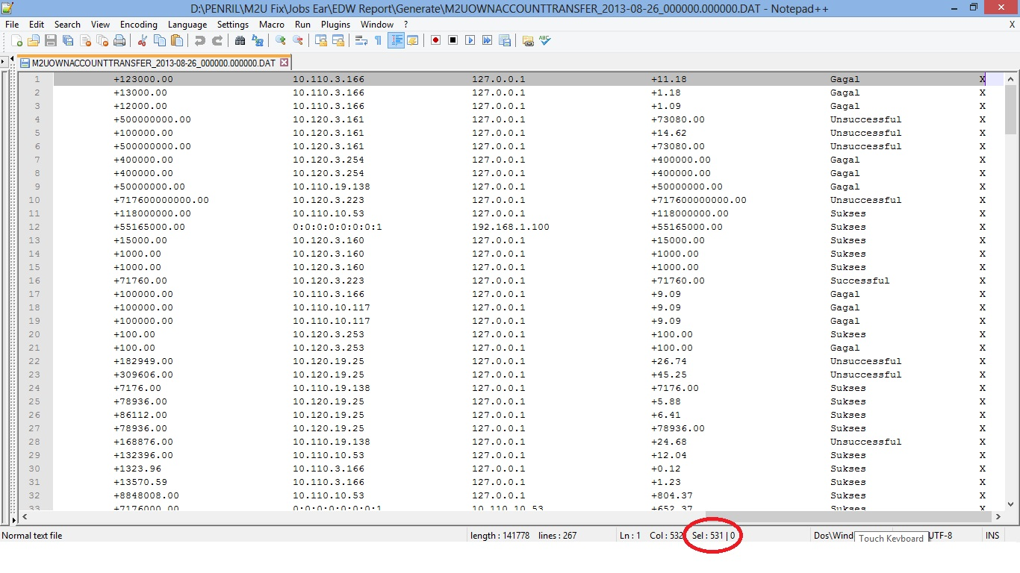

Test Case No :
Test Objectives : |  | EDW Report – Remittance Report
Step No. | Actions |  | Steps | Expected Result | Pass / Fail | Actual Result
 | Melihat data generate Remittance Report |  | - Generate Remittance Report  - Cek total length : 662 | - Transaction ID : length 25  - User ID : length 25  - User Name : length 65  - User # : length 20  - From Account No : length 70  - Destination Country : length 70  - Sender’s Name : length 205  - Charges Amount : length 20  - Charges Currency Code : length 6  - Transaction Date Time : length 20  - Effective Date : length 20  - Remote IP Address : length 30  - Host IP Address : length 30  - Amount : length 30  - Status : length 25  - Record’s terminator : length 1 | Pass | - 20140502000000016210 jakasembung MUDAKIR 1352 1001330972 China MUDAKIR KIKIR null null 20140502093139 20140502093139 10.110.19.138 127.0.0.1 +1322111.00 PROCESSING X
Remark :

Lampiran :
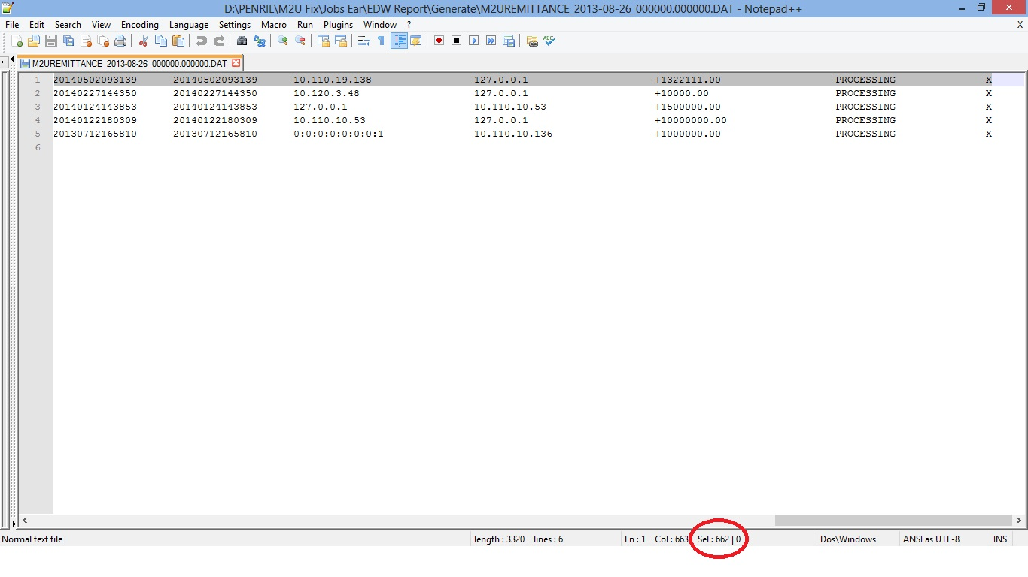

Test Case No :
Test Objectives : |  | EDW Report – Telegraphic Report
Step No. | Actions |  | Steps | Expected Result | Pass / Fail | Actual Result
 | Melihat data generate Telegraphic Report |  | - Generate Telegraphic Report  - Cek total length : 911 | - Transaction ID : length 25  - User ID : length 25  - User Name : length 65  - User # : length 20  - Beneficiary Name : length 70  - Beneficiary Bank Name : length 255  - Transaction Description : length 70  - Transaction Date Time : length 20  - Effective Date : length 20  - From Account No : length 25  - To Account No : length 50  - From Currency : length 10  - From Currency Rate : length 30  - To Currency : length 10  - To Currency Rate : length 30  - From Amount : length 30  - Local Amount : length 30  - Remote IP Address : length 30  - Host IP Address : length 30  - Amount : length 30  - Transfer Type : length 10  - Status : length 25  - Record’s terminator : length 1 | Pass | - 20140619000000018733 ribuser1 CHRISTOPHER PAUL WHALEY 1391 test THE ROYAL BANK OF SCOTLAND (CHINA) CO., LTD Transfer Valuta Asing 20140619145936 20140619145936 2001009682 987654321 USD +11000.00 JPY +110.33 +30.18 +331980.00 10.110.3.166 127.0.0.1 +18.00 Valas Successful X
Remark :

Lampiran :
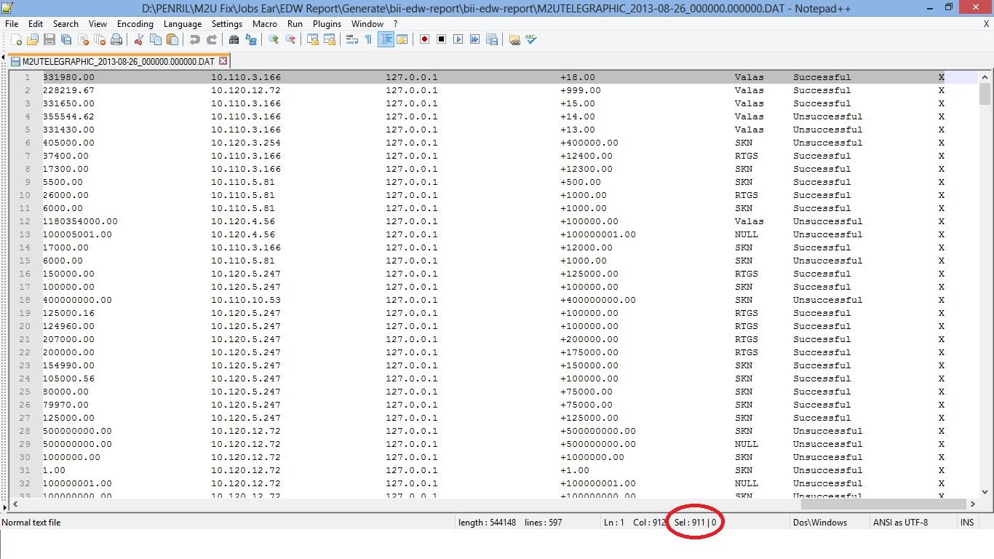

Test Case No :
Test Objectives : |  | EDW Report – Third Party Transfer Report
Step No. | Actions |  | Steps | Expected Result | Pass / Fail | Actual Result
 | Melihat data generate Third Party Transfer Report |  | - Generate Third Party Transfer Report  - Cek total length : 531 | - Transaction ID : length 25  - Account Holder Name : length 55  - User # : length 15  - User ID : length 25  - User Name : length 65  - Transaction Date Time : length 20  - Effective Date : length 20  - From Account No. : length 25  - To Account No. : length 50  - From Currency : length 10  - From Currency Rate : length 30  - To Currency : length 10  - To Currency Rate : length 30  - From Amount : length 30  - Local Amount : length 30  - Remote IP Address : length 30  - Host IP Address : length 30  - Amount : length 30  - Status : length 25  - Record’s terminator : length 1 | Pass | - 20140619000000018743 ZCNJFLY 1391 ribuser1 CHRISTOPHER PAUL WHALEY 20140619151537 20140619151537 1003000010 1001330972 016 +1.00 016 +1.00 +12000.00 +12000.00 10.110.3.166 127.0.0.1 +12000.00 Successful X
Remark :

Lampiran :
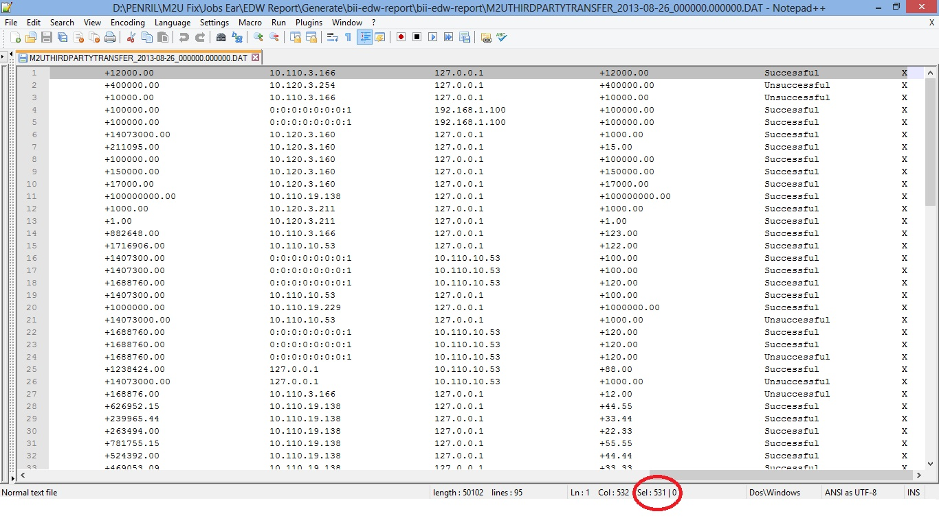

Test Case No :
Test Objectives : |  | EDW Report – Time Deposit Report
Step No. | Actions |  | Steps | Expected Result | Pass / Fail | Actual Result
 | Melihat data generate Time Deposit Report |  | - Generate Third Time Deposit Report  - Cek total length : 623 | - Transaction ID : length 25  - User ID : length 25  - User Name : length 65  - User # : length 20  - Tenure : length 70  - Maturity : length 70  - From Account No. : length 20  - From Currency : length 6  - Tcd Account No. : length 20  - Tcd Currency : length 6  - Transaction Datetime : length 20  - Effective Date : length 20  - From Currency : length 10  - From Currency Rate : length 30  - To Currency : length 10  - To Currency Rate : length 30  - From Amount : length 30  - Local Amount : length 30  - Remote IP Address : length 30  - Host IP Address : length 30  - Amount : length 30  - Status : length 25  - Record’s terminator : length 1 | Pass | - 20140520000000017338 ribuser1 CHRISTOPHER PAUL WHALEY 1391 3 Months 0 1007555362 null 39005527000055 016 20140520135824 20140520135826 +0.00 +0.00 +0.00 +0.00 10.110.3.166 127.0.0.1 +10000000.00 Unsuccessful X
Remark :

Lampiran :
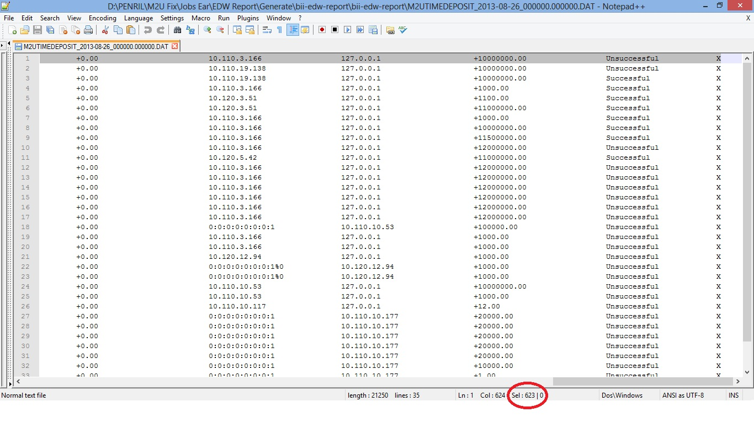

Test Case No :
Test Objectives : |  | EDW Report – Customer Profile Report
Step No. | Actions |  | Steps | Expected Result | Pass / Fail | Actual Result
 | Melihat data generate Customer Profile Report |  | - Generate Customer Profile Report  - Cek total length : 1356 | - User # : length 20  - User ID : length 20  - User Status : length 20  - Last Modified Time : length 20  - Creation Date : length 20  - Last Login Date : length 20  - Password Error Count : length 20  - Last Change Password Date : length 20  - User Full Name : length 255  - User Date Of Birth : length 10  - User Email : length 80  - User Gender : length 5  - User Home Phone Number : length 20  - User Mobile Number / TAC Number : length 20  - User Address 1 : length 80  - User Address 2 : length 80  - User Address 3 : length 80  - User Address 4 : length 80  - User Address 5 : length 80  - User Post Code : length 10  - User Display Name : length 255  - Language : length 5  - User ID No : length 20  - Salutation : length 10  - User Access No : length 20  - Updated By : length 10  - Updated Date : length 20  - Token : length 10  - Registration Reference No : length 20  - Primary Account No : length 20  - Group ID : length 5  - Record’s terminator : length 1 | Pass | - 1261 pentest 0 20130529155659 20130529155659 20130701083748 1 20130701083748 HANNAH JEANI OKTAVIA N 19761010 TWicaksono@biilab.net F 021-55764785 6228161875817 6228161875817 DURIM KEPA RT. 011/ RW. 013 KEL. DURI KEPA KEC. KBN JERUK 11510 in Nona 0006048046 0 VDP0382519130529888880004 1003000770 1 X
Remark :

Lampiran :
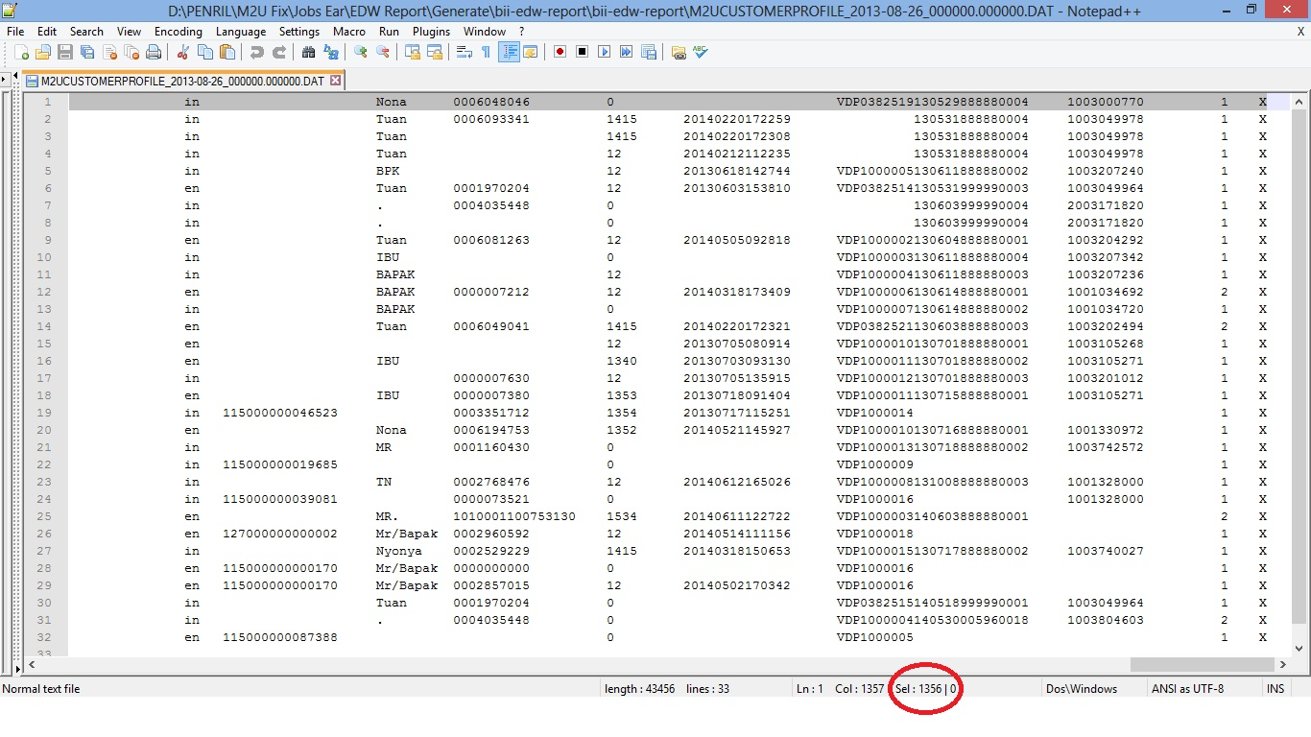

Test Case No :
Test Objectives : |  | EDW Report – Admin Profile Report
Step No. | Actions |  | Steps | Expected Result | Pass / Fail | Actual Result
 | Melihat data generate Admin Profile Report |  | - Generate Admin Profile Report  - Cek total length : 981 | - User # : length 20  - User ID : length 60  - User Status : length 20  - Last Modified Time : length 20  - Creation Date : length 20  - Last Login Date : length 20  - Password Error Count : length 20  - Last Change Password Date : length 20  - User Full Name : length 255  - User Email : length 80  - User Office Number : length 20  - User Mobile Number : length 20  - Last Login IP Address : length 40  - User Admin Role : length 20  - Group ID : length 20  - Group Name : length 70  - Group Desription : length 255  - Record’s terminator : length 1 | Pass | - 12 administrator 0 20140110145721 20101205170813 20140622023117 0 20140110145721 Tester number 1 gabbytian@penril.net 1234567890 087821954229 10.110.3.166 1 X
Remark :

Lampiran :
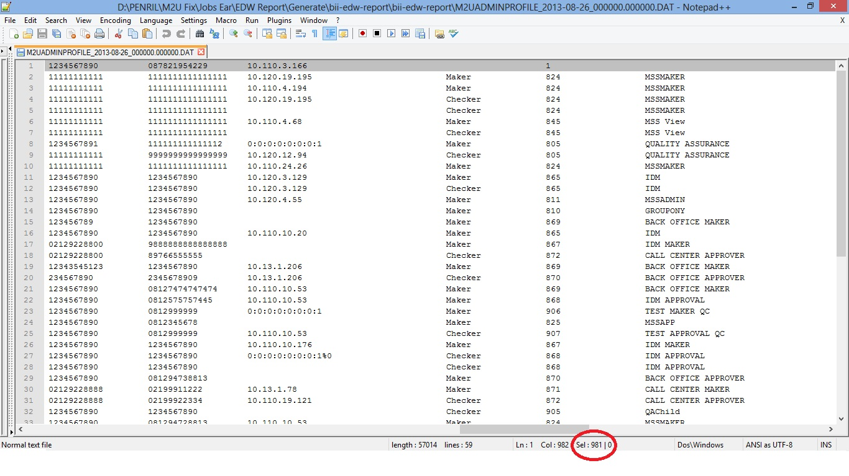

Test Case No :
Test Objectives : |  | EDW Report – Customer Activity Report
Step No. | Actions |  | Steps | Expected Result | Pass / Fail | Actual Result
 | Melihat data generate Customer Activity Report |  | - Generate Customer Activity Report  - Cek total length : 1428 | - OID : length 19  - Transaction ID : length 32  - Transaction Type : length 255  - Transaction Date : length 32  - User # : length 19  - User ID : length 50  - Activity Details : length 255  - Activity Status : length 255  - Client’s Remote IP : length 255  - User’s Browser (User Agent) : length 255  - Record’s terminator : length 1 | Pass | - 33397 20140620000000018786 Login 2014-06-20 20:58:58.517 1391 ribuser1 Successfully Login Successful 10.110.10.53 Safari537.76.4 X
Remark :

Lampiran :
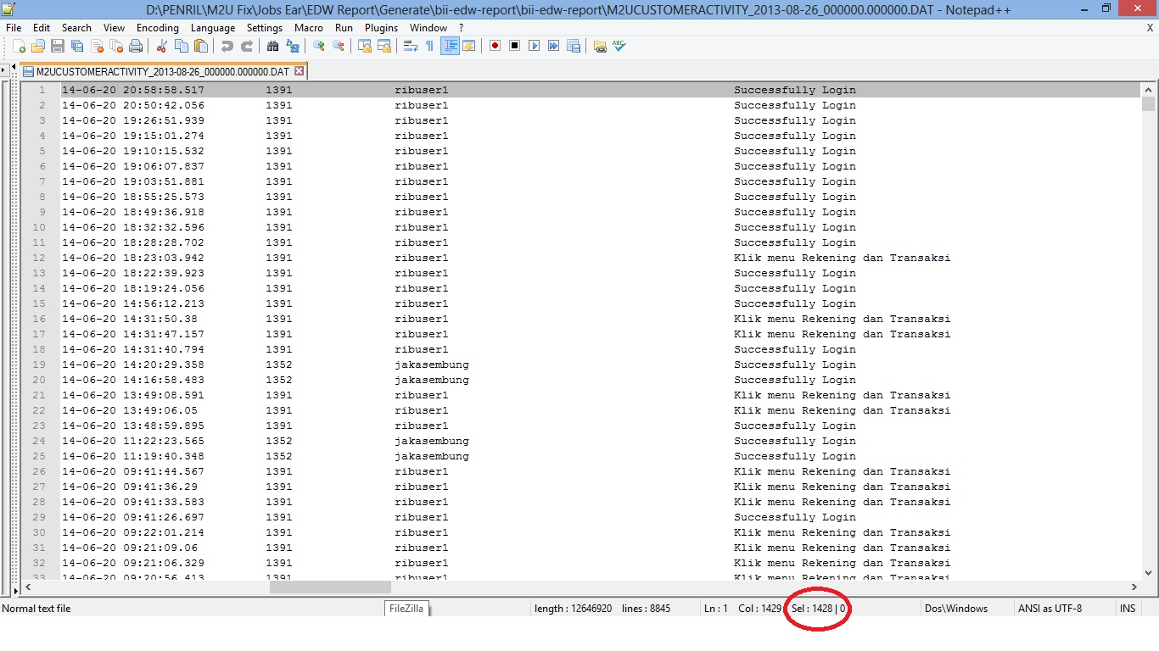

Test Case No :
Test Objectives : |  | EDW Report – EDW Statistic Report
Step No. | Actions |  | Steps | Expected Result | Pass / Fail | Actual Result
 | Melihat data generate EDW Statistic Report |  | - Generate EDW Statistic Report  - Cek total length : 161 | - Number of IB Registration via MSS : length 10  - Number of IB Registration via ATM : length 10  - Number of IB Registration via Jetsweb : length 10  - Number of Customer Login : length 10  - Number of Customer Logout : length 10  - Number of Reset Password Usage : length 10  - Number of Add Favorite Bill Payment : length 10  - Number of Delete Favorite Bill Payment : length 10  - Number of Add Favorite Mobile Reload : length 10  - Number of Delete Favorite Mobile Reload : length 10  - Number of Change Security Question : length 10  - Number of Profile Update : length 10  - Number of Time Deposit Placement : length 10  - Number of Time Deposit Upliftment : length 10  - Number of Add Favorite Foreign Currency : length 10  - Number of Delete Favorite Foreign Currency : length 10  - Record’s terminator : length 1 | Pass | - 7 22 7 5770 0 83 0 0 0 0 69 0 35 0 40 9 X
Remark :

Lampiran :
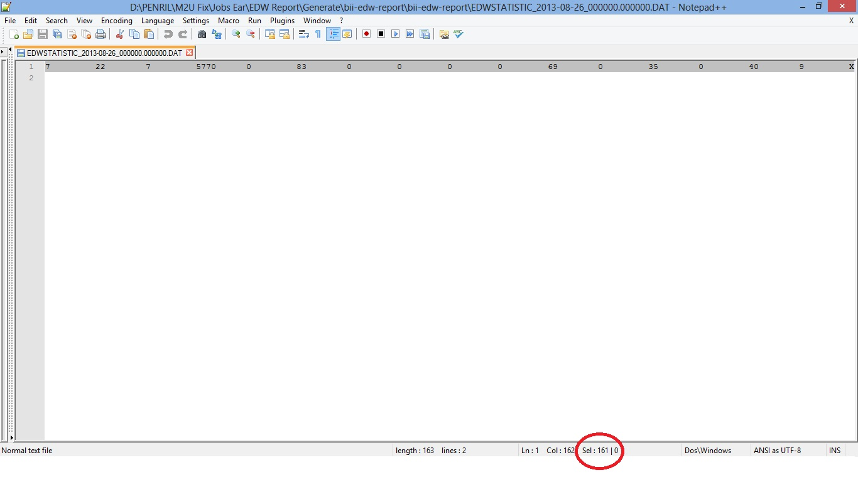

Test Case No :
Test Objectives : |  | Display Customer Name in utility bill payment
Step No. | Actions |  | Steps | Expected Result | Pass / Fail | Actual Result
 | Melihat nama customer ditampilkan pada form bill payment. |  | - Login RIB  - Username : ribuser1  - Pilih menu : Pembayaran Tagihan  - Pilih menu : Layanan Umum  - Langkah 1 :  Pilih dropdown Jenis Pembayaran : Telkom Speedy Flexi YesTV.  - Langkah 2 :  Rekening Asal : 1007555362 SA IDR.  No. Pelanggan : 0216666663.  - Langkah 3 :  Klik Button Lanjut : Tampil detail  - Langkah 4 :  Klik Button Setuju : Tampil detail dan Status Transaksi. | - Menampilkan nama customer pada form bill payment. | Pass | - OK
Remark :
Test ini menggunakan Rekening Asal : 1007555362 SA IDR dan menggunakan 3 No. Pelanggan yaitu : 0216666663, 021222222222, 112233445566

Lampiran :

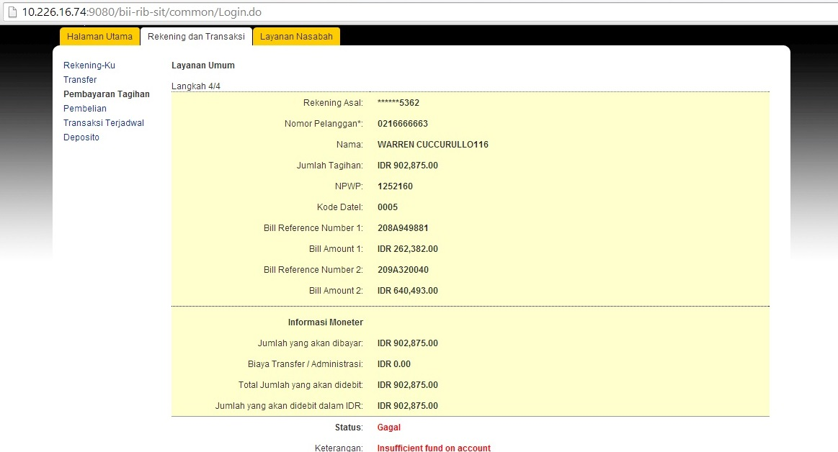

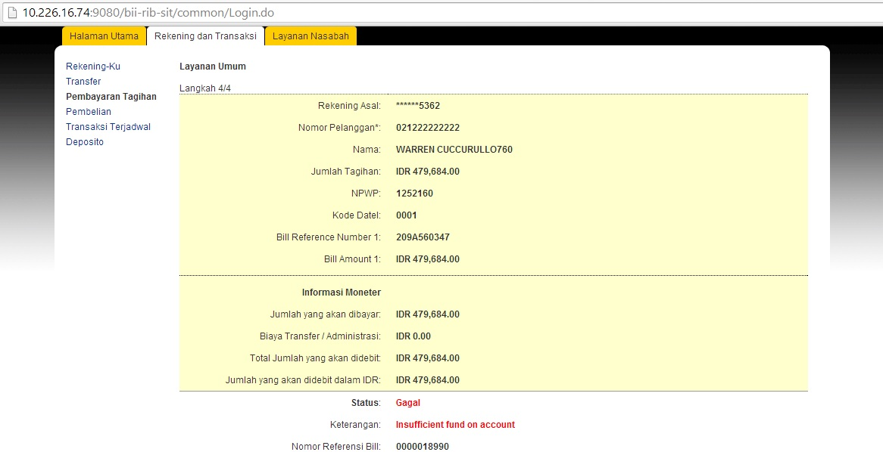

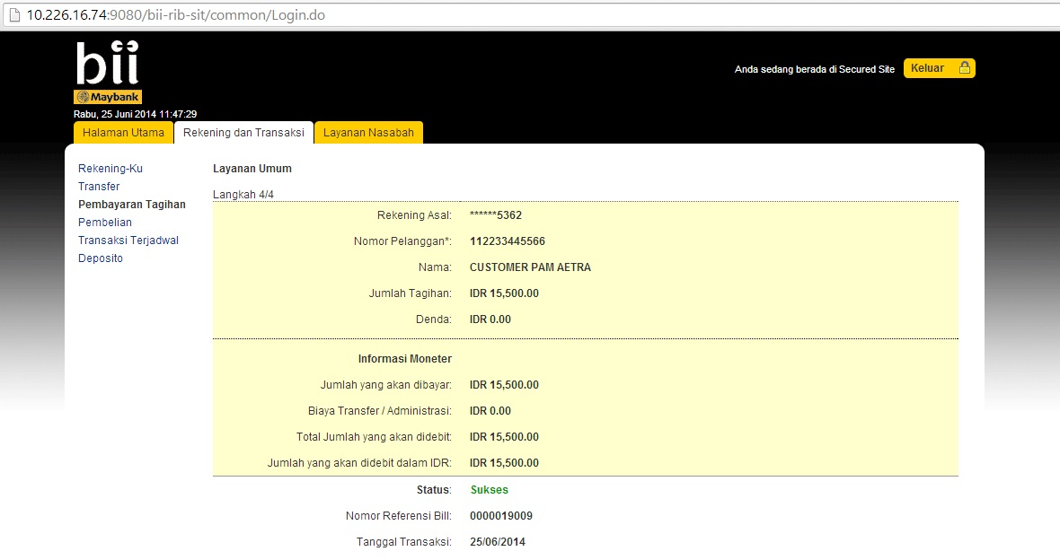

Test Case No :
Test Objectives : |  | RIB length account number on favorite valas transfer
Step No. | Actions |  | Steps | Expected Result | Pass / Fail | Actual Result
 | Cek panjang inputan nomor rekening tujuan transfer valuta asing |  | - Login RIB  - Username : ribuser1  - Pilih menu : Transfer  - Pilih menu : Valuta Asing  - Cari Swift Code  - Pilih salah satu swift code  - Masukan nomor rekening tujuan | - Inputan nomor rekening tujuan maksimal 34. | Pass | - OK  - Data Test : 0123456789012345678901234567890123
Remark :

Lampiran :
