**Disaster Recovery For Internet Banking**

**Scenario 1**

**Date: December 6th 2009**

**Scenario 1 Overview Diagram**

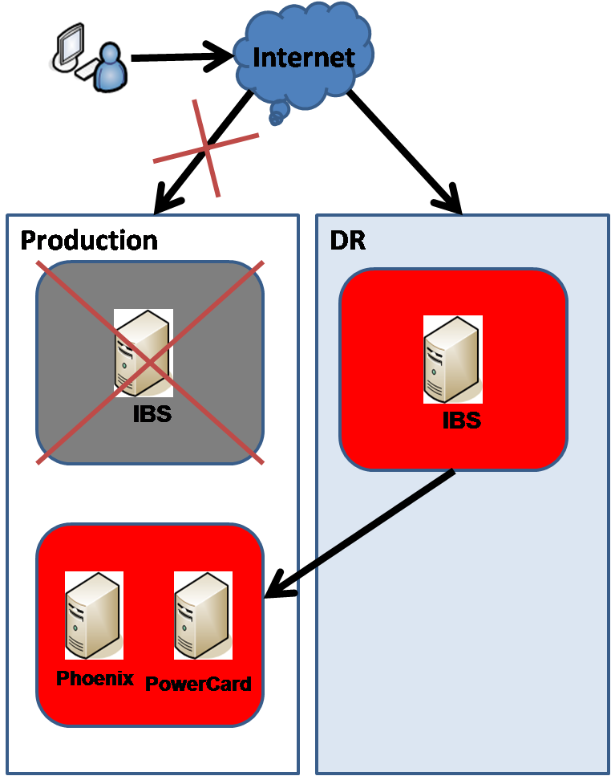

**Swing To DR Site Procedures**

**Scenario 1 - Checklist To Swing TO DR**

|  |  |  |  |
| --- | --- | --- | --- |
| ***Steps*** | ***Activities*** | ***Responsible*** | ***Remark*** |
| 1 | Activate the process to swing [www.kfhonline.com.my](http://www.kfhonline.com.my/) to DR site | IT Infra |  |
| 2 | Startup All DR Internet Banking Application | IT App |  |
| 3 | Setup DR ESB to point to Production Phoenix at primary site | IT App |  |
| 4 | DR Internet Banking Application Comfort Test | User |  |
| 5 | Open DR to public | IT Security |  |

**Activate the process to swing** [**www.kfhonline.com.my**](http://www.kfhonline.com.my/) **to DR site**

**Startup All DR Internet Banking Application**

**1.Start Up Oracle 10g Database**

|  |  |
| --- | --- |
| ***Steps*** | ***Instructions*** |
| 1 | Login to kfhib16 as oracle |
| 2 | To start the Oracle service, run the below commands:-  $sqlplus /nolog  SQL>connect / as sysdba  SQL>startup  SQL>quit |
| 3 | To start the listener, run the below command  lsnrctl start |

**2. Start Aqua Logic Service Bus (ALSB) and WebLogic Server**

|  |  |
| --- | --- |
| ***Steps*** | ***Instructions*** |
| 1 | Login to kfhib15 as esbadm |
| 2 | Change directory to  ***/export/home/esbadm*** |
| 3 | Run ./start1 |
| 4 | Wait until you see the sentence, "Server started in RUNNING mode" |
| 5 | Run ./start2 |
| 6 | Wait until you see the sentence, "Server started in RUNNING mode" |
| 7 | Go to the WebLogic console to double check the status of this service.  Go to <http://10.30.208.2:7001/console> from your browser and you should see the below screen |

**3. Start BroadVision 8.1 Service**

|  |  |
| --- | --- |
| ***Steps*** | ***Instructions*** |
| 1 | Login to kfhib14 as bvadmin |
| 2 | Delete all files and folders in “/opt/BV1TO1/JBoss/server/bv_framework0/work/jboss.web/localhost/kfh_consumer” |
| 3 | Delete all files and folders in “/opt/BV1TO1/JBoss/server/bv_framework1/work/jboss.web/localhost/kfh_consumer” |
| 4 | 1. cd /opt/BV1TO1/JBoss/server/bv_framework0 2. Run nohup ./run_BV.sh & 3. Run tail –f nohup.out and wait for it to startup completely (Successfully startup timer) |
| 5 | 1. cd /opt/BV1TO1/JBoss/server/bv_framework1 2. Run nohup ./run_BV.sh & 3. Run tail –f nohup.out and wait for it to startup completely (Successfully startup timer) |
| 6 | 1. cd /opt/BV1TO1/bin/ 2. Run ./startServers.sh -start exclude_primary |

**4. Start Up SunOne Webserver**

|  |  |
| --- | --- |
| ***Steps*** | ***Instructions*** |
| 1 | Login to kfhib13 as root |
| 2 | Run the below commands:-  ***/opt/SUNWwbsvr/https-kfhib01/start*** |
| 3 | System will prompt for password  Enter the *password*, imadmin$%^ |

**5. Start SMS Gateway Service**

|  |  |
| --- | --- |
| ***Steps*** | ***Instructions*** |
| 1 | Login to kfhib13 as smsadm |
| 2 | Run the below commands:-  cd /opt/SMSNotification  ./run.sh |
| 3 | Execute the below command to check for the service:-  ps –ef | grep SMSCron  You should see the SMSCron process is running |
| 4 | The following steps are to make ensure this process is keep on running.  Run the below command to enable Cronjob editor:-  export EDITOR=vi |
| 5 | Run the below command to go to the Unix Cronjob editor  crontab -e |
| 6 | Make sure the below command is enabled and then type “wq” to save and exit.  * * * * * /export/home/bvadmin/SMS/keepsmsalive.sh |

**Setup DR ESB to point to Production Phoenix at primary site**

**DR Scenario 1 - Modify JDBC DataSource in WebLogic Server**

**Configure JDBC Data Source To Point To Production Phoenix**

1. 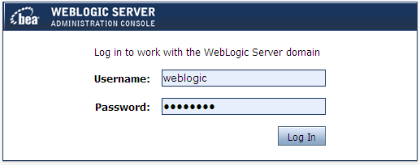Login to WebLogic Server console (**http://kfhib15:7001/console**).

Click on the Log In button to go to the landing page on step 2.

1. Select “ALSBDomain -> Services -> JDBC -> Data Sources “at left menu.

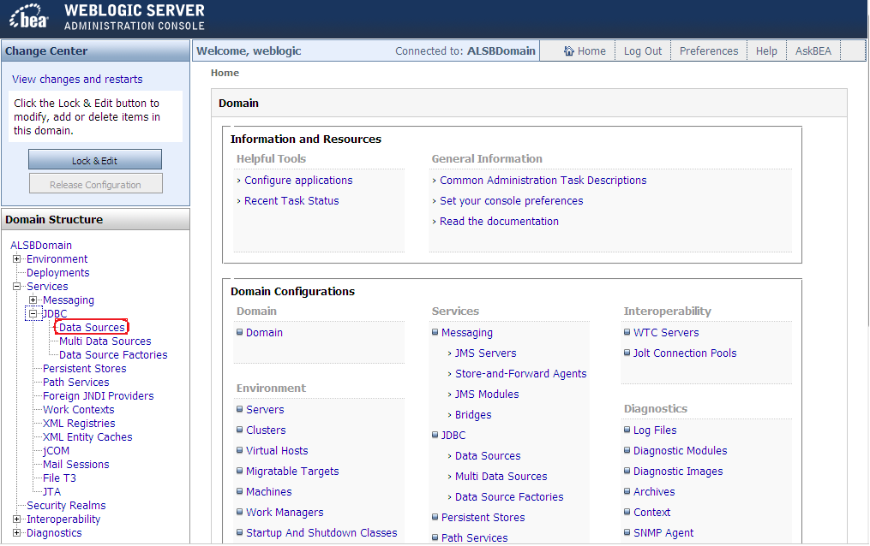

After selected the “Data Sources”, “Summary of JDBC Data Sources” page will show on the right hand side as the image on Step 4.

1. Before proceed, you need to click on “Lock & Edit” button at top left corner of WLS console.

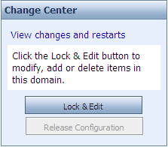

1. At the “Summary of JDBC Data Sources” panel, click on “PhoenixDS”.

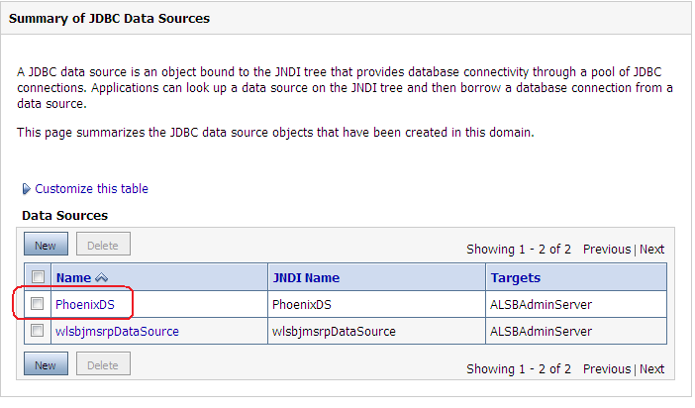

1. “Settings for PhoenixDS” panel will show. Go straight to the “Connection Pool” tab under the “Configuration” tab.

Make sure the URL is as the below:

|  |
| --- |
| **jdbc:Sybase:Tds:10.20.202.8:10001/Tds** |

The rest of the information should remains.

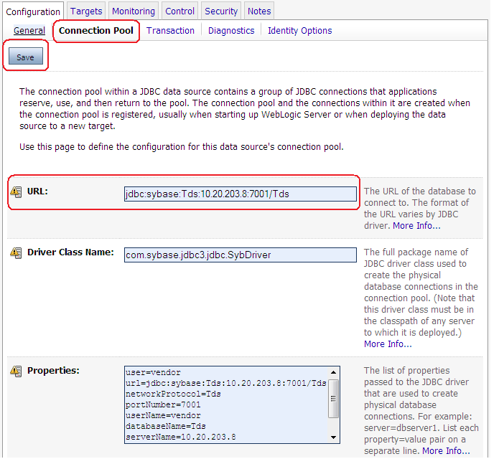

1. Click on “Save” button after make changes. Click on “Activate Changes” button on top left corner to make permanent changes.

**Setup DR ESB to point to Production PowerCard at primary site**

# Configure Endpoint URI To Point To Production PowerCard Through OC4J

1. For your information, unlike Phoenix, there is no DataSource available for OC4J in WebLogic server. Changes have to be made inside AquaLogic Service Bus.
2. Login to AquaLogic Service Bus (ALSB) console ([**http://kfhib15:7001/sbconsole**](http://kfhib15:7001/sbconsole)) as ‘weblogic’.

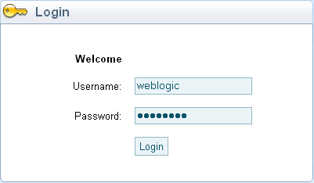

Click on the Login button to go to the landing page on step 2.

1. Select “Resource Browser” at left menu.

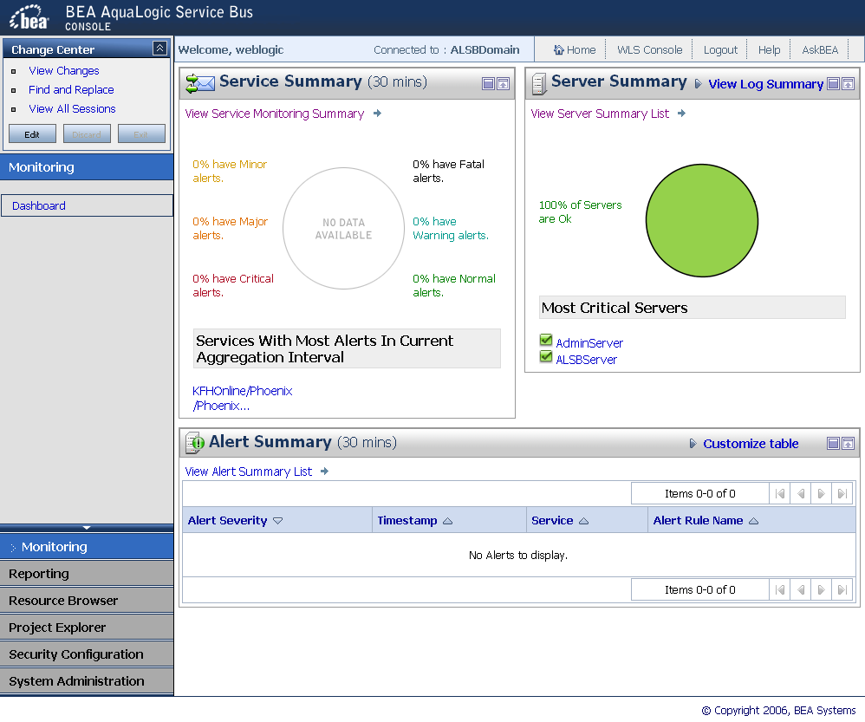

1. Select “Business Services” on the left sub menu and then click on “PowerCardBS” at the content on right side.

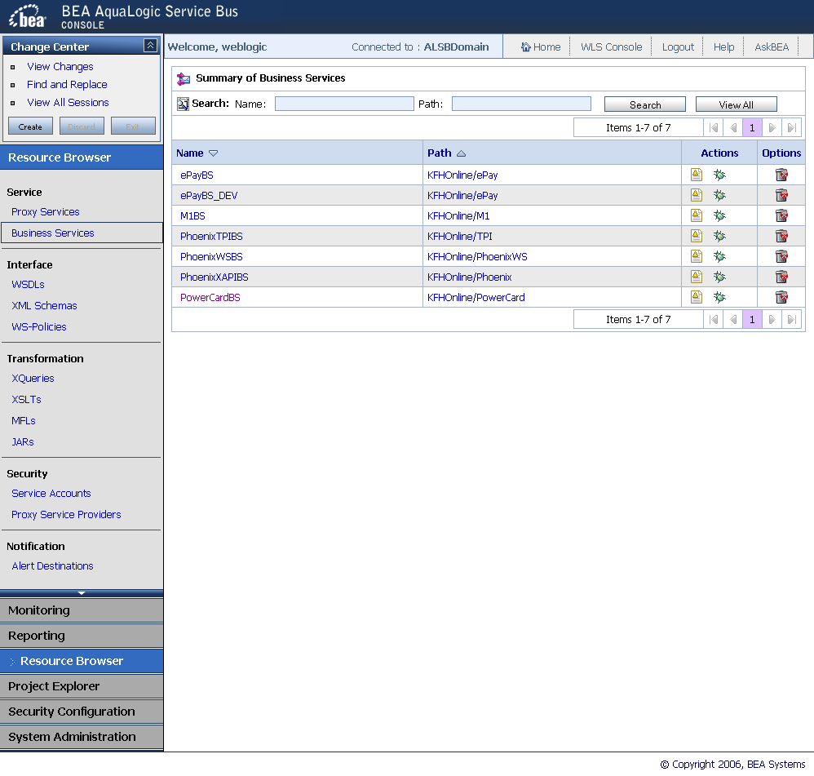

1. The below page will appear

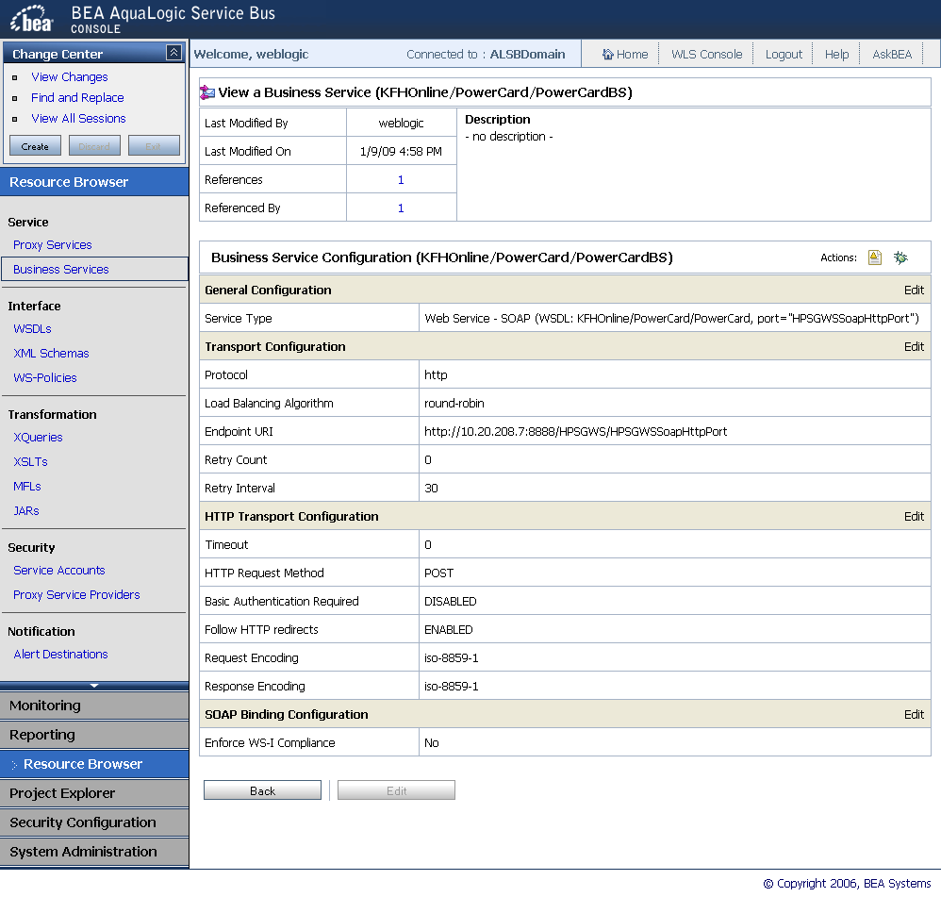

1. To edit the PowerCard to point to a new URL, click on “Create” the left top box. After that, click on “Edit” on “Transport Configuration” line at the content on the right.



1. The system will load to the below page. Click on the trash can icon below to delete the previous URL.

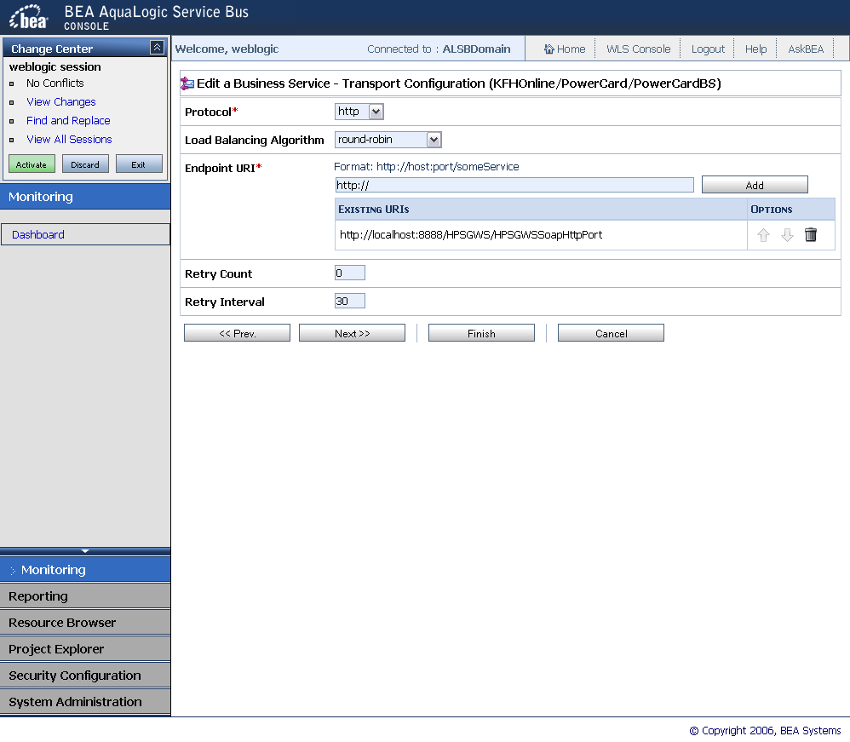

1. Enter the new URL on the “Endpoint URI” field and click “Add”



1. Click on “Finish” button.



1. The system will load to the below page. Click on “Save” button to save the modification

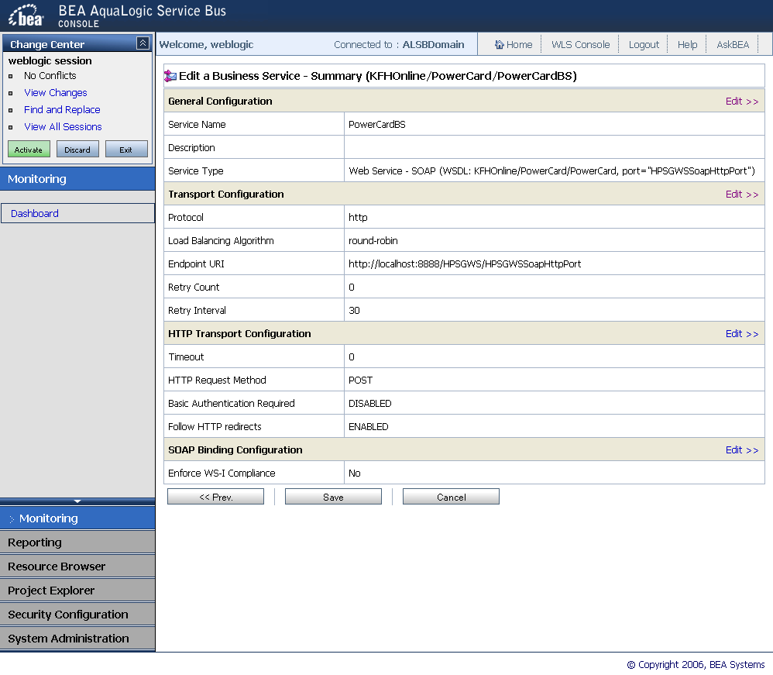

1. The message “The Service “PowerCardBS” was updated successfully” will appear on top of the page. Click on “Activate” button on the top left box to activate the changes.

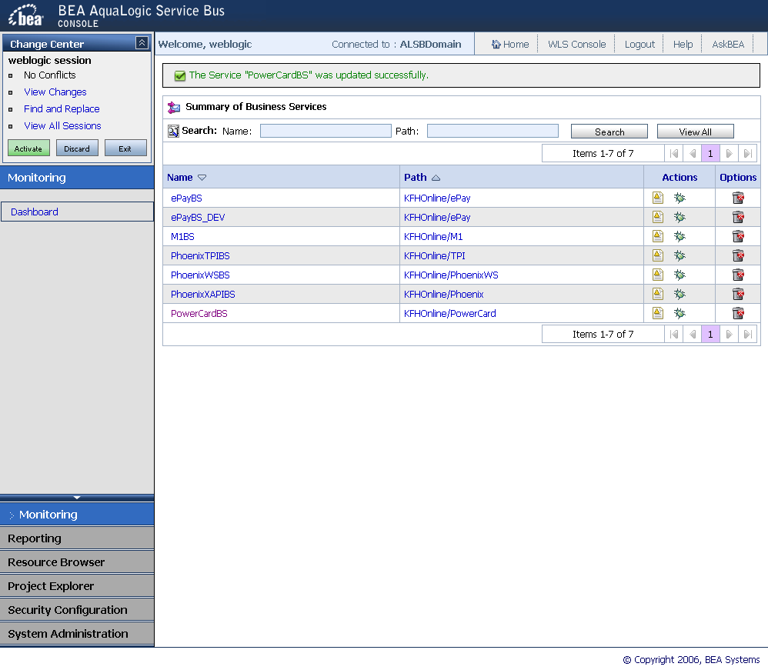

1. Enter the description for the changes or leave it blank and click “Submit” button

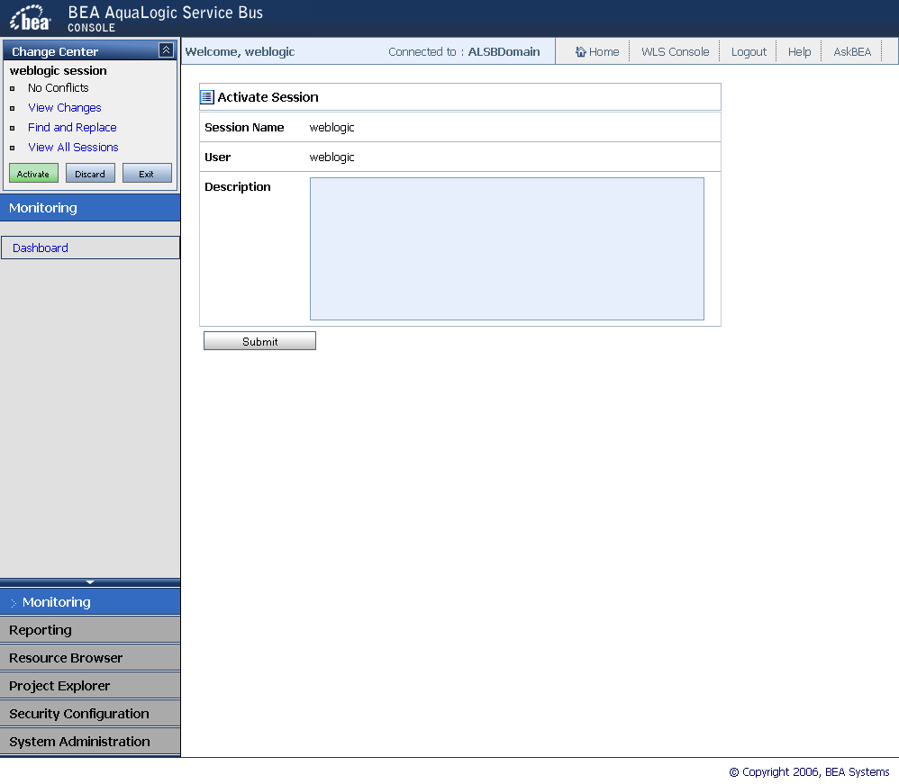

1. . Below page will appear. The URL of PowerCard is already changed

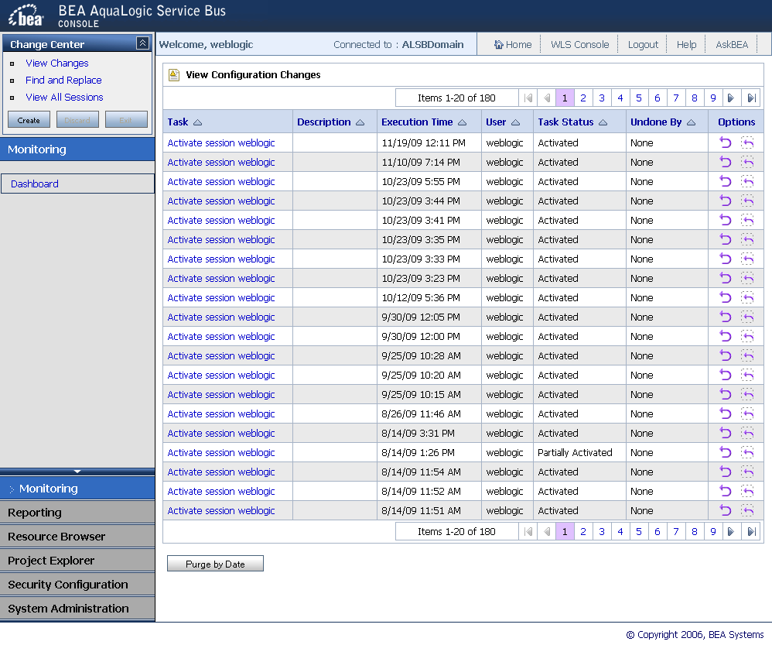

**Configure other PowerCard settings**

1. If the user are required to change the username, password or webservice, the change has to be made inside **esb.properties** in kfh_consumer(Consumer Internet Banking)
2. Below are the location for **esb.properties**:

kfhib03://opt/BV1TO1/JBoss/server/bv_framework0/esb.properties

kfhib03://opt/BV1TO1/JBoss/server/bv_framework1/esb.properties

kfhib04://opt/BV1TO1/JBoss/server/bv_framework2/esb.properties

kfhib04://opt/BV1TO1/JBoss/server/bv_framework3/esb.propertie

1. Below properties file will contain the following attribute:

**Connect to Phoenix XAPI**

esb.endpoint.phoenix.ws=xmlReceiver

esb.endpoint.phoenix=http://kfhib05:7003/PhoenixXAPIPS

**Connect to Phoenix TPI**

esb.endpoint.phoenix.tpi.ws=xmlReceiver

esb.endpoint.phoenix.tpi=http://kfhib05:7003/PhoenixTPIPS

**Connect to ePay**

esb.endpoint.epay=http://kfhib05:7003/ePayPS

esb.epay.merchant.id=608022

esb.epay.operator.id=KFH

esb.epay.terminal.id=69999979

**Connect to OC4J Webservice (PowerCard)**

esb.endpoint.powercard=http://kfhib05:7003/PowerCardPS

esb.endpoint.powercard.ws=hpsService

esb.endpoint.powercard.username=TAHIR

esb.endpoint.powercard.passwd=abc123

1. To change the power card attribute such username or password, change the current attribute to the new one. For example change the username to match the below:

esb.endpoint.powercard.username=OC4J

Note that you must change all **esb.properties** file in the mentioned above locations.

1. Restart the server. To restart, go to putty on kfhib03 and kfhib04 as “bvadmin”

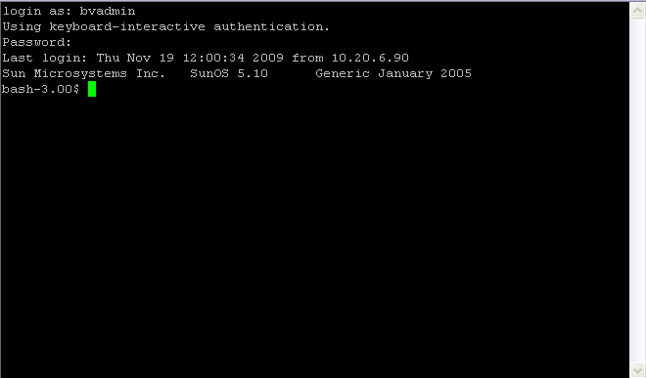

1. Execute the below command:

cd /opt/BV1TO1/bin

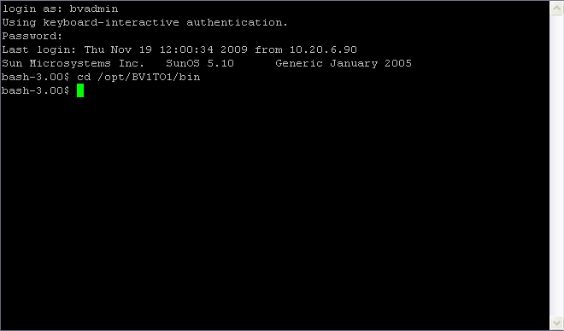

1. Then, execute the below command:

./stopServers.sh

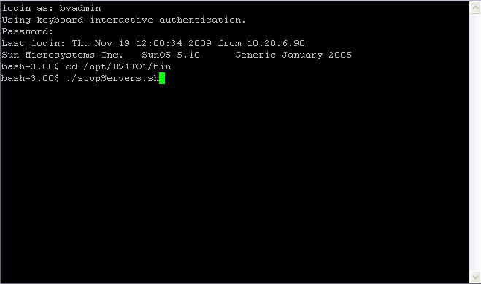

1. After done, type below command:

./startServers.sh

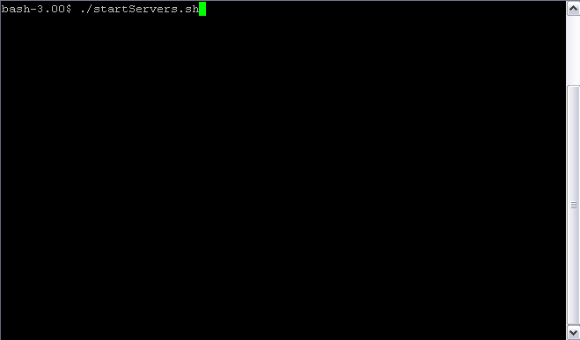

You are done.

**DR Internet Banking Application Comfort Test**

**DR SCENARIO 1 DR APPLICATIONS ACCEPTANCE TEST SCRIPT**

## Instructions

Please conduct the following tests and state whether or not the system complies with the requirements (Enter ‘Y’ for comply and ‘N’ for non-compliance). Also, upon completion of the tests, please sign and date this test script. The results of this test script should be verified by IT department personnel.

**KFHOnline.com access link for UAT:-**

**URL:** [**http://10.30.208.1:7210/kfh_consumer**](http://10.30.208.1:7210/kfh_consumer)

**URL: http://10.30.208.1:7310/kfh_consumer**

**KFH BVMC access link during DR and for UAT:-**

**URL: http://10.30.208.1:7210/kfh_bvmc**

**URL: http://10.30.208.1:7310/kfh_bvmc**

| **Item** | **Objective** | Test Action | **Expected Result** | **Remark** |
| --- | --- | --- | --- | --- |
|  | Forgot Username Test for PowerCard | 1. Go to kfh_consumer 2. Click on “Forgot my Username” 3. Fill in the following fields:    1. Account number    2. ATM card number    3. ATM pin number    4. Type the code shown 4. Click “Confirm” | The username will appear on the result page |  |
|  | Login Test for UPASS | 1. Go to kfh_consumer 2. Enter username and password similar to the ones used on production 3. Click “Login” | The page will appear where user is required to answer a security question |  |
| 1. Fill in the answer for the security question 2. Click “Next” | User will be directed to the landing page.  The landing page consists of greetings to the user and ‘What would you like to do?’ title. |  |
|  | Account Enquiry Test for Phoenix | 1. Go to kfh_consumer 2. Login until reached landing page 3. Click on ‘Account Enquiry’ on the left navigation | The page will show a list of accounts available without any error message. |  |
|  | IB Transaction History Test for Database | * 1. Go to ‘Account Enquiry’ using the above steps   2. Pick any account under ‘Current/Savings Account(s)’   3. Under the Action dropdown, select ‘KFH Online Trxn History’ and click ‘Go’ | A list of transaction history will appear on the next page for that certain account number without any error message. |  |
|  | Request TAC Test for Macrokiosk | * 1. Go the landing page using the mentioned steps above or click ‘Home’ on the left navigation after logging in.   2. Under the ‘What would you like to do?’ title, click on ‘Request TAC’. | A page will appear with a successful message. At the same time, TAC number is sent through SMS to the registered mobile number. |  |
|  | Bill Payment Zakat Test for MobilityOne | * 1. After login, click ‘Bill Payment’ on the left navigation.   2. Sub navigation will appear. Click on ‘Open Bill Payment’   3. On ‘Step1/5’, choose ‘Zakat’ for Payee Corporation category.   4. Click ‘Continue’   5. On ‘Step 2/5’ choose the desired Zakat type and click ‘Next’.   6. On ‘Step 3/5’ fill in the amount, IC number and Tahun Haul correctly.   7. Click ‘Next’   8. On ‘Step 4/5’, enter the TAC number and click ‘Confirm’ | The result page on ‘Step 5/5’ should display a successful message |  |
|  | Mobile Reload Test for ePay | * 1. After login, click ‘Bill Payment’ on the left navigation.   2. Sub navigation will appear. Click on ‘Prepaid Top Up’   3. On ‘Step 1/5’, choose prepaid type category.   4. Click ‘Continue’   5. On ‘Step 2/5’, choose prepaid type and click ‘Next’.   6. Fill in the required fields.   7. Click ‘Next’.   8. On ‘Step 4/5’, enter the TAC number and click ‘Confirm’ | The result page on ‘Step 5/5’ should display a successful message |  |
|  | Download eStatement for Shared Statement Folder | * 1. After login, click on ‘Account Enquiry’   2. Pick any account under the title ‘Current/Saving Account(s)’.   3. Under the Action dropdown, select ‘e-Statement’ and click ‘Go’   4. On the next page, select the ‘Statement Period’ dropdown according to the desired period and click ‘Go’. | A pop-up will appear where the user will able to download the e-statement file in pdf format. The pdf file should show an account statement in a proper format. |  |
|  | Request for Hardcopy Statement for Mail Server | * 1. After login, click on ‘Account Enquiry’   2. Pick any account under the title ‘Current/Saving Account(s)’.   3. Under the Action dropdown, select ‘Hardcopy Statement’ and click ‘Go’   4. On ‘Step 1/3’, select the month and year for the statement and click ‘Next’.   5. Click ‘Confirm’ on ‘step 2/3’ | A result page will appear stating that the status is successful and an email is sent to the user’s registered email.  An email should be received by the user in a proper format. |  |
|  | BVMC for Admin user Test | * 1. Go to kfh_bvmc   2. Login as ICU user with the user name and password similar to the production   3. Ensure that all users have the similar rights access as productions. | The user will successfully enter the landing page with all the admin capabilities enabled. |  |
|  | BVMC for Contact Centre user Login Test | * 1. Go to kfh_bvmc   2. Login as Contact Centre user with the user name and password similar to the production.   3. Ensure that this user still has the similar access as production. | The user will successfully enter the landing page with all the call centre capabilities enabled. |  |
|  | BVMC for Content Management Test | * 1. Go to kfh_bvmc   2. Login as Service Channel user with the user name and password similar to the production.   3. Go to ‘Content’ navigation tab at the top of the page   4. A page called ‘Browse Content’ will appear with a dropdown   5. Click on the dropdown. Make sure that the list of dropdown is similar to the one in production.   6. Click on any option of the dropdown   7. The page will be redirected to a list of category and contents for that particular content type.   8. Click into every category and content.   9. Make sure that they are accessible   10. Try to create content for testing purposes on any location. Key in any data.   11. Edit that content and then delete it. | The category and content on BVMC should be accessible and editable.  User should also be able to create, edit and delete a content successfully |  |
|  | BVMC for Report Retrieval Test | * 1. Go to kfh_bvmc   2. Login as PDM user with the user name and password similar to the production.   3. Go to ‘Content’ navigation tab at the top of the page   4. Click on ‘IB Report’ link on the left menu   5. Search for any report for testing purposes   6. Try to download the report in both CSV and TXT format | The report should be downloaded successfully in a correct form for both formats. |  |
|  | BVMC for IB Content Test | * 1. Go to kfh_bvmc   2. Login as PDM user with the user name and password similar to the production.   3. Go to ‘Content’ navigation tab at the top of the page   4. Check on the each Content Type to make sure that all contents are intact. | All Content Type are similar to production |  |

**Open DR to public**

**Swing Back To Production Site Procedures**

**Scenario 1 - Checklist To Swing Back TO Production Site**

|  |  |  |  |
| --- | --- | --- | --- |
| ***Steps*** | ***Activities*** | ***Responsible*** | ***Remark*** |
| 1 | Activate the process to swing [www.kfhonline.com.my](http://www.kfhonline.com.my/) to Production site | IT Infra |  |
| 2 | Stop All DR Internet Banking Applications | IT Infra |  |
| 3 | Backup DR Internet Banking Database | IT Infra |  |
| 4 | Stop All Production Internet Banking Application | IT App |  |
| 5 | Restore Data to Production Internet Banking Database | IT Infra |  |
| 6 | Startup All Production Internet Banking Application | IT App |  |
| 7 | Production Internet Banking Comfort Test | User |  |
| 8 | Open Production to public | IT Security |  |

**Activate the process to swing** [**www.kfhonline.com.my**](http://www.kfhonline.com.my/) **to Production site**

**Stop All DR Internet Banking Application**

**1. Stop BroadVision 8.1 Service**

|  |  |
| --- | --- |
| ***Steps*** | ***Instructions*** |
| 1 | Login to kfhib14 as bvadmin |
| 2 | 1. cd /opt/BV1TO1/bin/ 2. Run ./stopServers.sh -stop exclude_primary |
| 3 | 1. cd /opt/BV1TO1/JBoss/server/bv_framework0 2. Run ./shutdown_BV.sh |
| 4 | 1. cd /opt/BV1TO1/JBoss/server/bv_framework1 2. Run ./shutdown_BV.sh |
| 5 | 1. Run ps –ef | grep /opt/BV1TO1/jdks and make sure all running process are successfully stopped. If not kill the process(es). |

**2. Stop Aqua Logic Service Bus (ALSB) and WebLogic Server**

|  |  |
| --- | --- |
| ***Steps*** | ***Instructions*** |
| 1 | Login to kfhib15 as esbadm |
| 2 | Change directory to  ***/export/home/esbadm*** |
| 3 | Run ./stop2 |
| 4 | Wait until you see the word, "Done" |
| 5 | Run ./start1 |
| 6 | Wait until you see the sentence, "Done" |
| 7 | Please wait for at least 30 – 60 seconds to allow all services are completely stopped. Please use the command below to verify:-  1.      ps –ef | grep java  2.      Please look for the pattern of "/opt/bea/jdk150_04/bin/java" for the processes. If you do not see this process, you can proceed to next step. If the process still exists, please wait for awhile. If you have been waited too long and the process still running, please kill the process. Use the below command to kill the process:-      kill -9 <process id> |

**Backup DR Internet Banking Database**

|  |  |
| --- | --- |
| ***Steps*** | ***Instructions*** |
| 1 | Login to kfhib16 as sysdba |
| 2 | Go to /export/home/oracle/mang_backup |
| 3 | Run ./dbbackup.sh |
| Sample of the script dbbackup.sh  #!/bin/sh  DATECMD="/usr/bin/date"  DTSTR=`$DATECMD '+%Y-%m-%d-%H%M'`  DATE=`date '+%Y%m%d'`  SCRIPT_HOME_DIR="/u04/dbdump/dumpFile"  ORACLE_SID=IBSPRD  export ORACLE_SID  ORACLE_HOME=/opt/oracle/product/10.2.0/Db_1  export ORACLE_HOME  cd $SCRIPT_HOME_DIR  LOG_DIR="$SCRIPT_HOME_DIR"/"$DATE"  if [ -d $LOG_DIR ]; then  cd $LOG_DIR  else  mkdir $LOG_DIR  cd $LOG_DIR  fi  /opt/oracle/product/10.2.0/Db_1/bin/exp \'/ as sysdba\' file=$LOG_DIR/IBSPRD_$DTSTR.dmp OWNER=BVUSERPRD STATISTICS=NONE log=bvuserprd_$DTSTR.log <<EOF  exit  EOF  #/opt/oracle/product/10.2.0/Db_1/bin/exp \'/ as sysdba\' file=$LOG_DIR/IBSPRD_BIB_$DTSTR.dmp OWNER=BIB STATISTICS=NONE log=bib_$DTSTR.log <<EOF  #exit  #EOF  #/opt/oracle/product/10.2.0/Db_1/bin/exp \'/ as sysdba\' file=$LOG_DIR/fullibsprd_$DTSTR.dmp full=yes STATISTICS=NONE log=fullibsprd_$DTSTR.log <<EOF  #exit  #EOF  gzip $LOG_DIR/*.dmp | |

**Stop All Production Internet Banking Application**

**1. Stop BroadVision 8.1 Service**

|  |  |
| --- | --- |
| ***Steps*** | ***Instructions*** |
| 1 | Login to kfhib03 as bvadmin |
| 2 | 1. cd /opt/BV1TO1/bin/ 2. Run ./stopServers.sh -stop exclude_primary |
| 3 | 1. cd /opt/BV1TO1/JBoss/server/bv_framework0 2. Run ./shutdown_BV.sh |
| 4 | 1. cd /opt/BV1TO1/JBoss/server/bv_framework1 2. Run ./shutdown_BV.sh |
| 5 | 1. Run ps –ef | grep /opt/BV1TO1/jdks and make sure all running process are successfully stopped. If not kill the process(es). |
| 6 | Login to kfhib04 as bvadmin |
| 7 | 1. cd /opt/BV1TO1/bin/ 2. Run ./stopServers.sh -stop exclude_primary |
| 8 | 1. cd /opt/BV1TO1/JBoss/server/bv_framework2 2. Run ./shutdown_BV.sh |
| 9 | 1. cd /opt/BV1TO1/JBoss/server/bv_framework3 2. Run ./shutdown_BV.sh |
| 10 | 1. Run ps –ef | grep /opt/BV1TO1/jdks and make sure all running process are successfully stopped. If not kill the process(es). |

**2. Stop Aqua Logic Service Bus (ALSB) and WebLogic Server**

|  |  |
| --- | --- |
| ***Steps*** | ***Instructions*** |
| 1 | Login to kfhib05 as esbadm |
| 2 | Change directory to  ***/export/home/esbadm*** |
| 3 | Run ./stop2 |
| 4 | Wait until you see the word, "Done" |
| 5 | Run ./start1 |
| 6 | Wait until you see the sentence, "Done" |
| 7 | Please wait for at least 30 – 60 seconds to allow all services are completely stopped. Please use the command below to verify:-  1.      ps –ef | grep java  2.      Please look for the pattern of "/opt/bea/jdk150_04/bin/java" for the processes. If you do not see this process, you can proceed to next step. If the process still exists, please wait for awhile. If you have been waited too long and the process still running, please kill the process. Use the below command to kill the process:-      kill -9 <process id> |

**Restore Data to Production Internet Banking Database**

|  |  |
| --- | --- |
| ***Steps*** | ***Instructions*** |
| 1 | Login to kfhib07 as sysdba |
| 2 | Follow the below steps and command to restore data to production database   * 1. sqlplus "/as sysdba"   2. SQL> drop user bvuserprd cascade;   3. SQL> select username,created from dba_users |
| 3 | Go to the dump folder to look for the dump file. The dump file folder normally is based on the dump date “yyyyMMdd” located at “/u04/dbdump/dumpFile”  For example:-  cd /u04/dbdump/dumpFile/20091125 |
| 4 | Unzip the dmp file. The file format is IBSPRD_yyyy-MM-dd-s.dmp.gz:-  Example:-  $ gunzip IBSPRD_2009-11-25-1256.dmp.gz  Import the dmp file to database:-  $ imp bvuserprd file=IBSPRD_2009-11-25-1256.dmp log=imp_bvuserprd_26119009.log from user=bvuserprd to user=bvuserprd rows=y |

**Startup All Production Internet Banking Application**

**1. Start Aqua Logic Service Bus (ALSB) and WebLogic Server**

|  |  |
| --- | --- |
| ***Steps*** | ***Instructions*** |
| 1 | Login to kfhib05 as esbadm |
| 2 | Change directory to  ***/export/home/esbadm*** |
| 3 | Run ./start1 |
| 4 | Wait until you see the sentence, "Server started in RUNNING mode" |
| 5 | Run ./start2 |
| 6 | Wait until you see the sentence, "Server started in RUNNING mode" |
| 7 | Go to the WebLogic console to double check the status of this service.  Go to <http://kfhib05:7001/console> from your browser and you should see the below screen |

**2. Start BroadVision 8.1 Service**

|  |  |
| --- | --- |
| ***Steps*** | ***Instructions*** |
| 1 | Login to kfhib03 as bvadmin |
| 2 | Delete all files and folders in “/opt/BV1TO1/JBoss/server/bv_framework0/work/jboss.web/localhost/kfh_consumer” |
| 3 | Delete all files and folders in “/opt/BV1TO1/JBoss/server/bv_framework1/work/jboss.web/localhost/kfh_consumer” |
| 4 | 1. cd /opt/BV1TO1/JBoss/server/bv_framework0 2. Run nohup ./run_BV.sh & 3. Run tail –f nohup.out and wait for it to startup completely (Successfully startup timer) |
| 5 | 1. cd /opt/BV1TO1/JBoss/server/bv_framework1 2. Run nohup ./run_BV.sh & 3. Run tail –f nohup.out and wait for it to startup completely (Successfully startup timer) |
| 6 | 1. cd /opt/BV1TO1/bin/ 2. Run ./startServers.sh -start exclude_primary |
| 1 | Login to kfhib04 as bvadmin |
| 2 | Delete all files and folders in “/opt/BV1TO1/JBoss/server/bv_framework2/work/jboss.web/localhost/kfh_consumer” |
| 3 | Delete all files and folders in “/opt/BV1TO1/JBoss/server/bv_framework3/work/jboss.web/localhost/kfh_consumer” |
| 4 | 1. cd /opt/BV1TO1/JBoss/server/bv_framework2 2. Run nohup ./run_BV.sh & 3. Run tail –f nohup.out and wait for it to startup completely (Successfully startup timer) |
| 5 | 1. cd /opt/BV1TO1/JBoss/server/bv_framework3 2. Run nohup ./run_BV.sh & 3. Run tail –f nohup.out and wait for it to startup completely (Successfully startup timer) |
| 6 | 1. cd /opt/BV1TO1/bin/ 2. Run ./startServers.sh -start exclude_primary |

**3. Start Up SunOne Webserver**

|  |  |
| --- | --- |
| ***Steps*** | ***Instructions*** |
| 1 | Login to kfhib1 as root |
| 2 | Run the below commands:-  ***/opt/SUNWwbsvr/https-kfhib01/start*** |
| 3 | System will prompt for password  Enter the *password*, imadmin$%^ |

**4 . Start SMS Gateway Service**

|  |  |
| --- | --- |
| ***Steps*** | ***Instructions*** |
| 1 | Login to kfhib1 as smsadm |
| 2 | Run the below commands:-  cd /opt/SMSNotification  ./run.sh |
| 3 | Execute the below command to check for the service:-  ps –ef | grep SMSCron  You should see the SMSCron process is running |
| 4 | The following steps are to make ensure this process is keep on running.  Run the below command to enable Cronjob editor:-  export EDITOR=vi |
| 5 | Run the below command to go to the Unix Cronjob editor  crontab -e |
| 6 | Make sure the below command is enabled and then type “wq” to save and exit.  * * * * * /export/home/bvadmin/SMS/keepsmsalive.sh |

**Production Internet Banking Comfort Test**

**DR SCENARIO 1 PRODUCTION APPLICATIONS ACCEPTANCE TEST SCRIPT**

## Instructions

Please conduct the following tests and state whether or not the system complies with the requirements (Enter ‘Y’ for comply and ‘N’ for non-compliance). Also, upon completion of the tests, please sign and date this test script. The results of this test script should be verified by IT department personnel.

**KFHOnline.com access link for UAT:-**

**URL:** [**http://10.20.208.1:7210/kfh_consumer**](http://10.20.208.1:7210/kfh_consumer)

**URL:** [**http://10.20.208.1:7310/kfh_consumer**](http://10.20.208.1:7310/kfh_consumer)

**URL:** [**http://10.20.208.4:7410/kfh_consumer**](http://10.20.208.4:7410/kfh_consumer)

**URL:** [**http://10.20.208.4:7310/kfh_consumer**](http://10.20.208.4:7310/kfh_consumer)

**KFH BVMC access link during Production and for UAT:-**

**URL:** [**http://10.20.208.1:7210/kfh_bvmc**](http://10.20.208.1:7210/kfh_bvmc)

**URL:** [**http://10.20.208.1:7310/kfh_bvmc**](http://10.20.208.1:7310/kfh_bvmc)

**URL:** [**http://10.20.208.4:7410/kfh_bvmc**](http://10.20.208.4:7410/kfh_bvmc)

**URL:** [**http://10.20.208.4:7510/kfh_bvmc**](http://10.20.208.4:7510/kfh_bvmc)

| **Item** | **Objective** | Test Action | **Expected Result** | **Remark** |
| --- | --- | --- | --- | --- |
|  | Forgot Username Test for PowerCard | 1. Go to kfh_consumer 2. Click on “Forgot my Username” 3. Fill in the following fields:    1. Account number    2. ATM card number    3. ATM pin number    4. Type the code shown 4. Click “Confirm” | The username will appear on the result page |  |
|  | Login Test for UPASS | 1. Go to kfh_consumer 2. Enter username and password similar to the ones used on production 3. Click “Login” | The page will appear where user is required to answer a security question |  |
| 1. Fill in the answer for the security question 2. Click “Next” | User will be directed to the landing page.  The landing page consists of greetings to the user and ‘What would you like to do?’ title. |  |
|  | Account Enquiry Test for Phoenix | 1. Go to kfh_consumer 2. Login until reached landing page 3. Click on ‘Account Enquiry’ on the left navigation | The page will show a list of accounts available without any error message. |  |
|  | IB Transaction History Test for Database | * 1. Go to ‘Account Enquiry’ using the above steps   2. Pick any account under ‘Current/Savings Account(s)’   3. Under the Action dropdown, select ‘KFH Online Trxn History’ and click ‘Go’ | A list of transaction history will appear on the next page for that certain account number without any error message. |  |
|  | Request TAC Test for Macrokiosk | * 1. Go the landing page using the mentioned steps above or click ‘Home’ on the left navigation after logging in.   2. Under the ‘What would you like to do?’ title, click on ‘Request TAC’. | A page will appear with a successful message. At the same time, TAC number is sent through SMS to the registered mobile number. |  |
|  | Bill Payment Zakat Test for MobilityOne | * 1. After login, click ‘Bill Payment’ on the left navigation.   2. Sub navigation will appear. Click on ‘Open Bill Payment’   3. On ‘Step1/5’, choose ‘Zakat’ for Payee Corporation category.   4. Click ‘Continue’   5. On ‘Step 2/5’ choose the desired Zakat type and click ‘Next’.   6. On ‘Step 3/5’ fill in the amount, IC number and Tahun Haul correctly.   7. Click ‘Next’   8. On ‘Step 4/5’, enter the TAC number and click ‘Confirm’ | The result page on ‘Step 5/5’ should display a successful message |  |
|  | Mobile Reload Test for ePay | * 1. After login, click ‘Bill Payment’ on the left navigation.   2. Sub navigation will appear. Click on ‘Prepaid Top Up’   3. On ‘Step 1/5’, choose prepaid type category.   4. Click ‘Continue’   5. On ‘Step 2/5’, choose prepaid type and click ‘Next’.   6. Fill in the required fields.   7. Click ‘Next’.   8. On ‘Step 4/5’, enter the TAC number and click ‘Confirm’ | The result page on ‘Step 5/5’ should display a successful message |  |
|  | Download eStatement for Shared Statement Folder | * 1. After login, click on ‘Account Enquiry’   2. Pick any account under the title ‘Current/Saving Account(s)’.   3. Under the Action dropdown, select ‘e-Statement’ and click ‘Go’   4. On the next page, select the ‘Statement Period’ dropdown according to the desired period and click ‘Go’. | A pop-up will appear where the user will able to download the e-statement file in pdf format. The pdf file should show an account statement in a proper format. |  |
|  | Request for Hardcopy Statement for Mail Server | * 1. After login, click on ‘Account Enquiry’   2. Pick any account under the title ‘Current/Saving Account(s)’.   3. Under the Action dropdown, select ‘Hardcopy Statement’ and click ‘Go’   4. On ‘Step 1/3’, select the month and year for the statement and click ‘Next’.   5. Click ‘Confirm’ on ‘step 2/3’ | A result page will appear stating that the status is successful and an email is sent to the user’s registered email.  An email should be received by the user in a proper format. |  |
|  | BVMC for Admin user Test | * 1. Go to kfh_bvmc   2. Login as ICU user with the user name and password similar to the production   3. Ensure that all users have the similar rights access as productions. | The user will successfully enter the landing page with all the admin capabilities enabled. |  |
|  | BVMC for Contact Centre user Login Test | * 1. Go to kfh_bvmc   2. Login as Contact Centre user with the user name and password similar to the production.   3. Ensure that this user still has the similar access as production. | The user will successfully enter the landing page with all the call centre capabilities enabled. |  |
|  | BVMC for Content Management Test | * 1. Go to kfh_bvmc   2. Login as Service Channel user with the user name and password similar to the production.   3. Go to ‘Content’ navigation tab at the top of the page   4. A page called ‘Browse Content’ will appear with a dropdown   5. Click on the dropdown. Make sure that the list of dropdown is similar to the one in production.   6. Click on any option of the dropdown   7. The page will be redirected to a list of category and contents for that particular content type.   8. Click into every category and content.   9. Make sure that they are accessible   10. Try to create content for testing purposes on any location. Key in any data.   11. Edit that content and then delete it. | The category and content on BVMC should be accessible and editable.  User should also be able to create, edit and delete a content successfully |  |
|  | BVMC for Report Retrieval Test | * 1. Go to kfh_bvmc   2. Login as PDM user with the user name and password similar to the production.   3. Go to ‘Content’ navigation tab at the top of the page   4. Click on ‘IB Report’ link on the left menu   5. Search for any report for testing purposes   6. Try to download the report in both CSV and TXT format | The report should be downloaded successfully in a correct form for both formats. |  |
|  | BVMC for IB Content Test | * 1. Go to kfh_bvmc   2. Login as PDM user with the user name and password similar to the production.   3. Go to ‘Content’ navigation tab at the top of the page   4. Check on the each Content Type to make sure that all contents are intact. | All Content Type are similar to production |  |

**Open Production To Public**