Task ID# 4356
Test Title: |  | IBG Conversion
Test Description: |  | To reflects all IBG transaction in the IBG Settlement Account (Islamic)
Test Functionality: |  | - RIB  - New Interbank Transfer  - Favourite Interbank Transfer  - BIB  - New Interbank Transfer  - Favourite Interbank Transfer
Test Procedure: |  | - Make New and Favourite Interbank transaction  - Check with Host on the transcode that IB send
Response Message:
IB send new transcode = 9981

Test Result: | Pass: Fail: |  | Tested by: | Lizahwati Basirun (QA Engineer)
Reason for Failure:

Remarks: | RETAIL INTERNET BANKING (RIB)  Test Item 1: To test on New Interbank Transfer and Favourite Interbank Transfer  Result:  Host retrieve 9981 as the transcode  - New Interbank Transfer  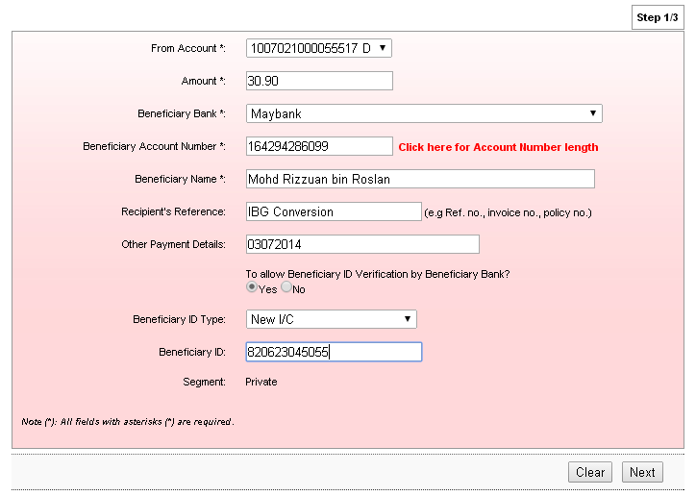  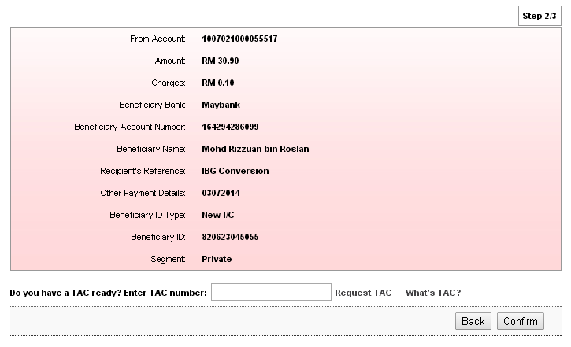  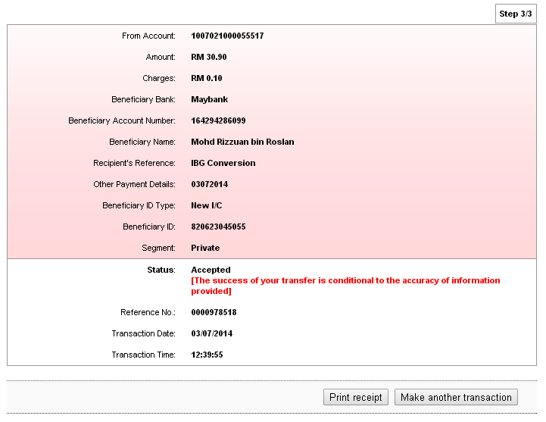  - Favourite Interbank Transfer  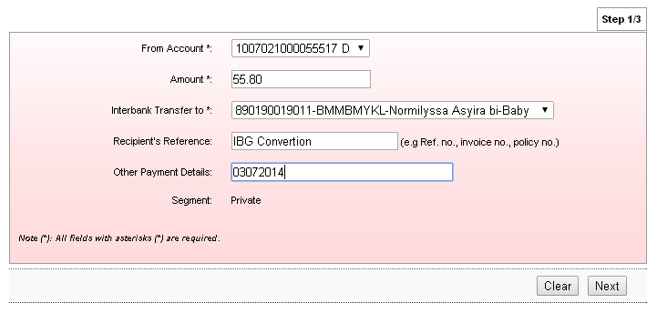  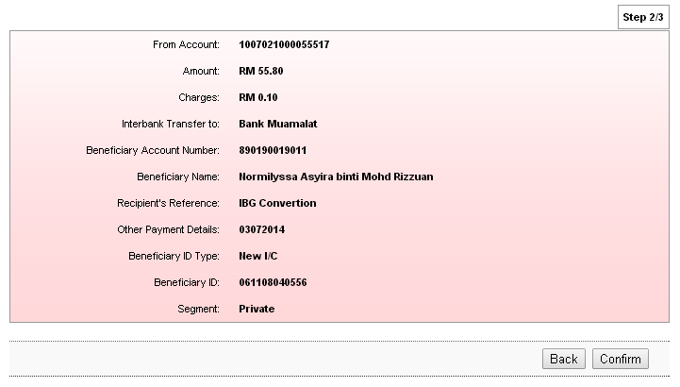  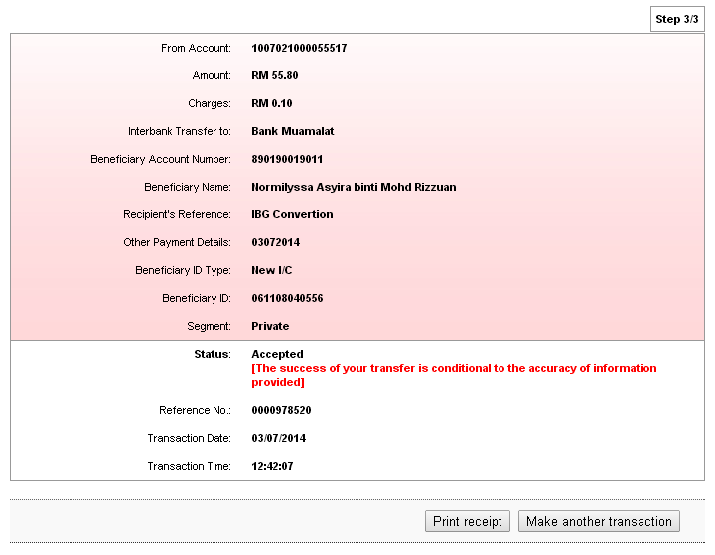  Business Internet Banking – Initiator & Approver  Test Item 1: To test on New Interbank Transfer and Favourite Interbank Transfer  Result:  Host retrieve 9981 as the transcode  - New Interbank transfer  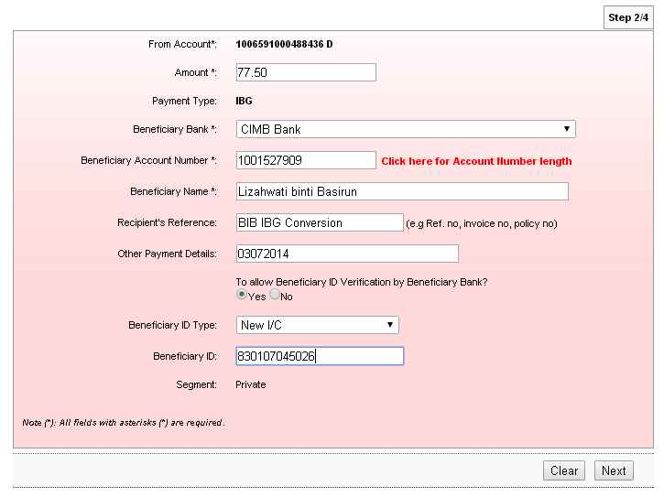  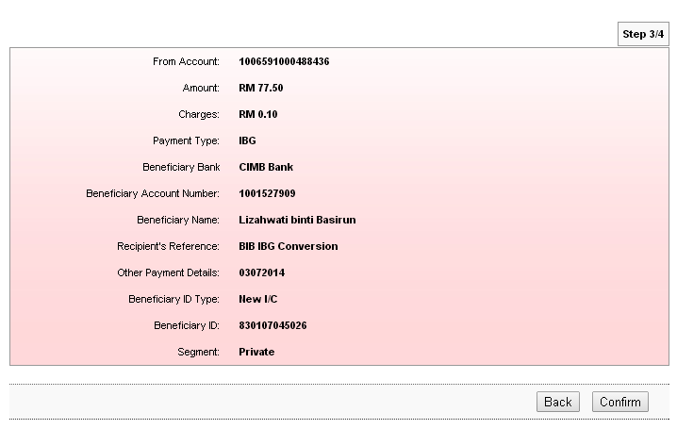  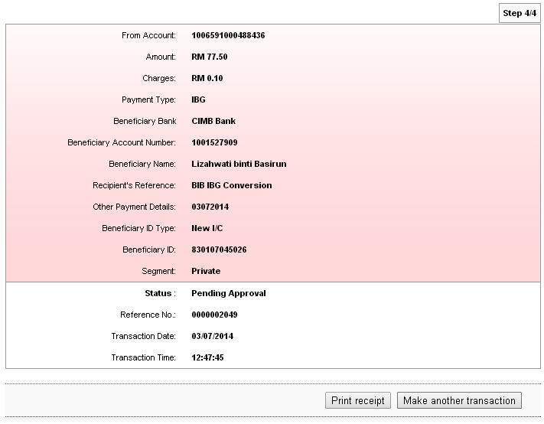  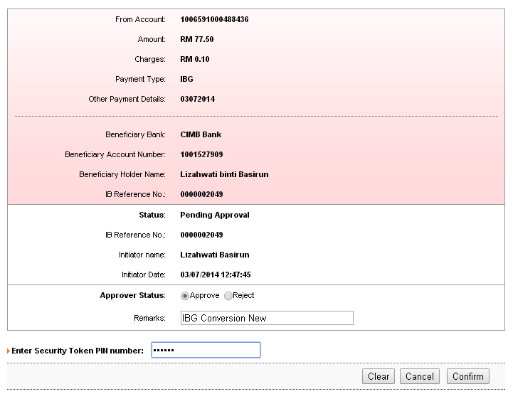  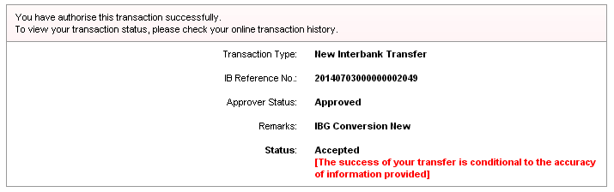  - Favourite Interbank Transfer  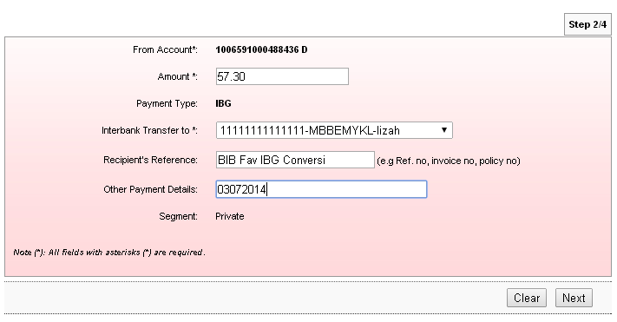  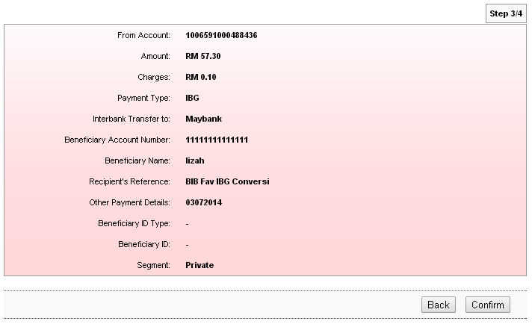  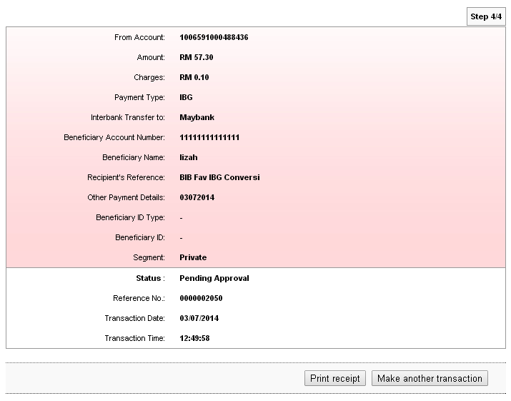  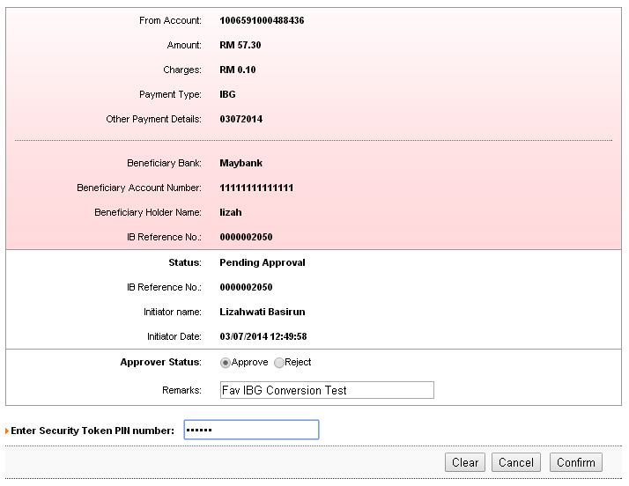  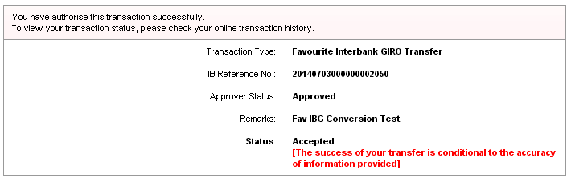  Business Internet Banking – Single User  Test Item 1: To test on New Interbank Transfer and Favourite Interbank Transfer  Result:  Host retrieve 9981 as the transcode  - New Interbank Transfer  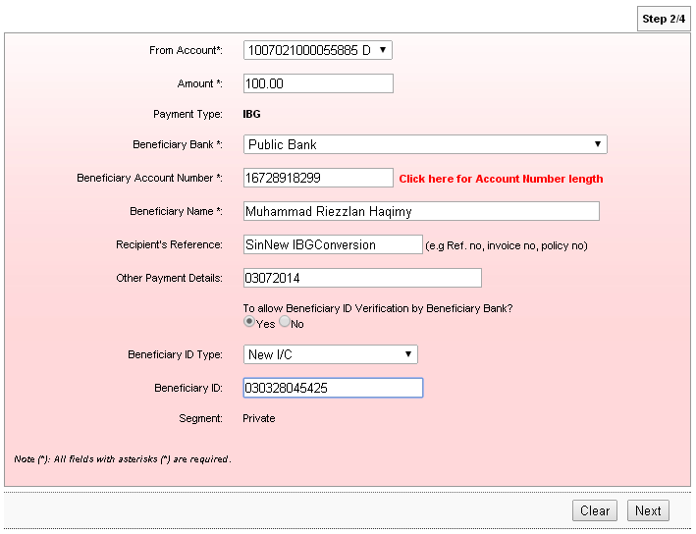  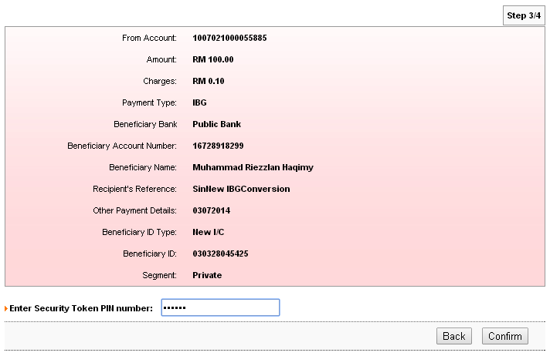  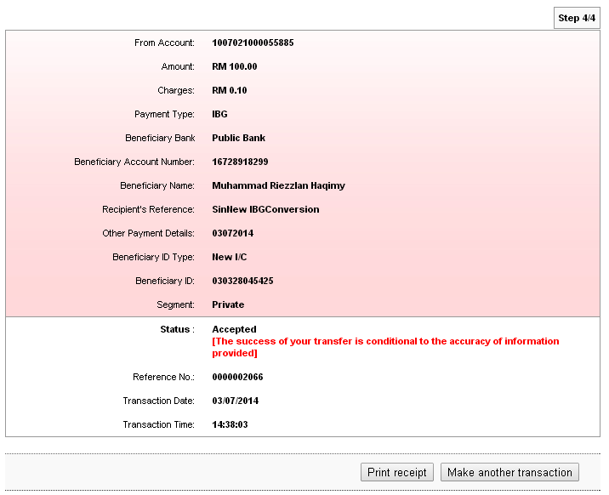  - Favourite Interbank Transfer  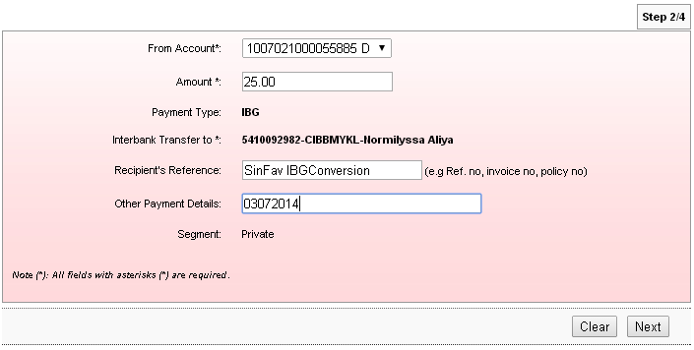  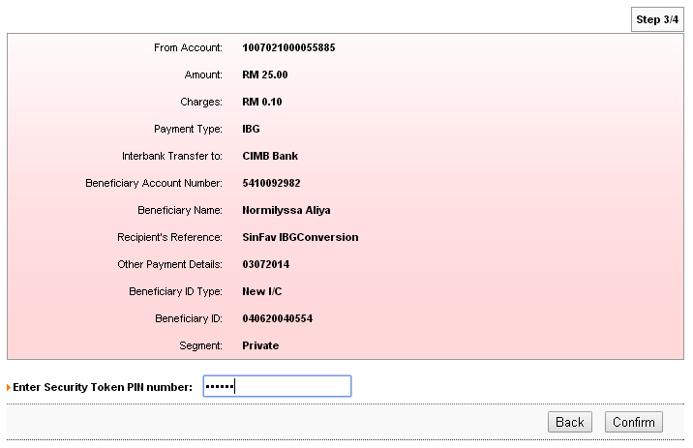  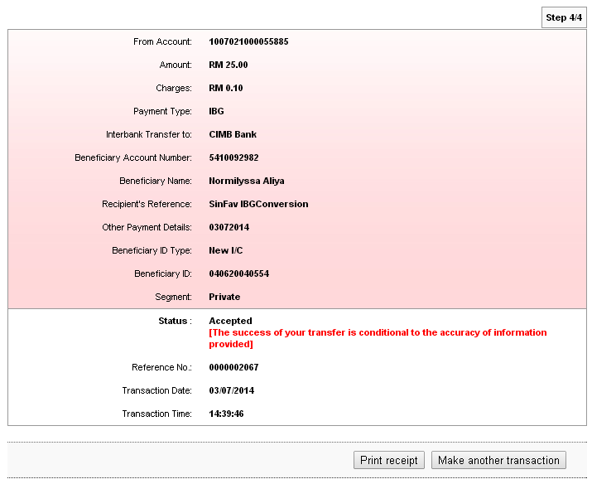  Successful - HOST retrieve as 9981 (TLBF19).