

**Malayan Banking Berhad**

**Functional Specification**

**Regional Centralized Authentication System (RCAS) Administration Modules- Production Enhancement Request (Token Cover Letter)**

2 June 2014

**Prepared By:**



Penril Datability (M) Sdn Bhd (816792-X)

Suite A-07-07 Plaza Mon’t Kiara

No. 2, Jalan Kiara, Mon’t Kiara

50480 Kuala Lumpur, Malaysia

Tel: (603) 6201 2622 Fax: (603) 6201 7622

**Document Administration**

**Document Amendment Log**

|  |  |  |  |  |  |
| --- | --- | --- | --- | --- | --- |
| **Version No** | **Date Updated** | **Description of Change** | **Updated By**  **<Name, Dept>** | **Reviewed By**  **<Name, Dept>** | **Approved By <Name, Dept>** |
| 1.0 | 2/6/14 | Initial Release- Token Cover Letter request | Yap Kah Yan  Proessional Services | Boby  Proessional Services | Tan Lee Lee  Professional Services |
|  |  |  |  |  |  |

Contents

1 Token Listing 4

1.1 To add Date Assigned From and Date Assigned To 4

1.1.1 Global Layer 4

1.1.2 Provider Layer 7

1.2 Total Token Count 10

2 Token Cover Letter 12

2.1 Print Token Cover Letter 12

2.2 Remove User from Print Queue 19

3 Token Cover Letter Reprint 22

4 Token Cover Letter Template 28

5 Appendix 30

# Token Listing

## To add Date Assigned From and Date Assigned To

The new change is to add two new date fields, **Date Assigned From** and **Date Assigned To**, in the RCAS Admin. This changes allowing RCAS administrator to search token based on the token assigned date range.

The search criteria are Batch No, Token Serial No, Status, Corporate ID, Date Assigned From, Date Assigned To.

|  |  |  |
| --- | --- | --- |
| Field | Description | Mandatory (Y/N) |
| Selection | Radio button. Choice of Global or Provider. Defaulted to Global | Y |
| Batch No | **8** characters maximum, numeric. | N |
| Token Serial No | **20** characters maximum, numeric. | N |
| Status | Dropdown list. Value: Assigned, Not Assigned. Default value is all. | N |
| Corporate ID | Alphanumeric. | N |
| Date Assigned From | If both Date Assigned From and Date Assigned To are not specified, the system will search with all existing records regardless the date. | N |
| Date Assigned To | If both Date Assigned From and Date Assigned To are not specified, the system will search with all existing records regardless the date. | N |
| Total Tokens | Display only. No input. | - |

Table 1: Token Management Search Criteria Fields

### Global Layer

**Step 1:**

RCAS administrator can access to Token Management module by clicking on the **Token Listing** tab.

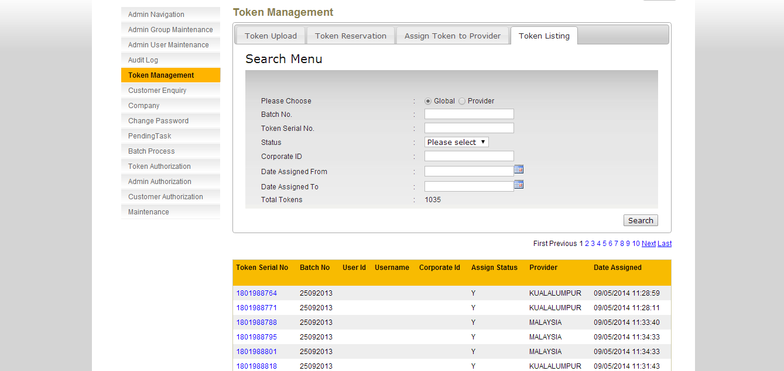

Figure 1: Token Listing Enquiry Screen (Global)

**Step 2:**

**Scenario 1:**

1. Select the **Global** option
2. Status: **Please Select** (no selection made)
3. Choose a date for **Date Assigned From**
4. Choose a date for **Date Assigned To**
5. And then click on the **Search** button
6. A list of tokens that matches search criteria will the shown

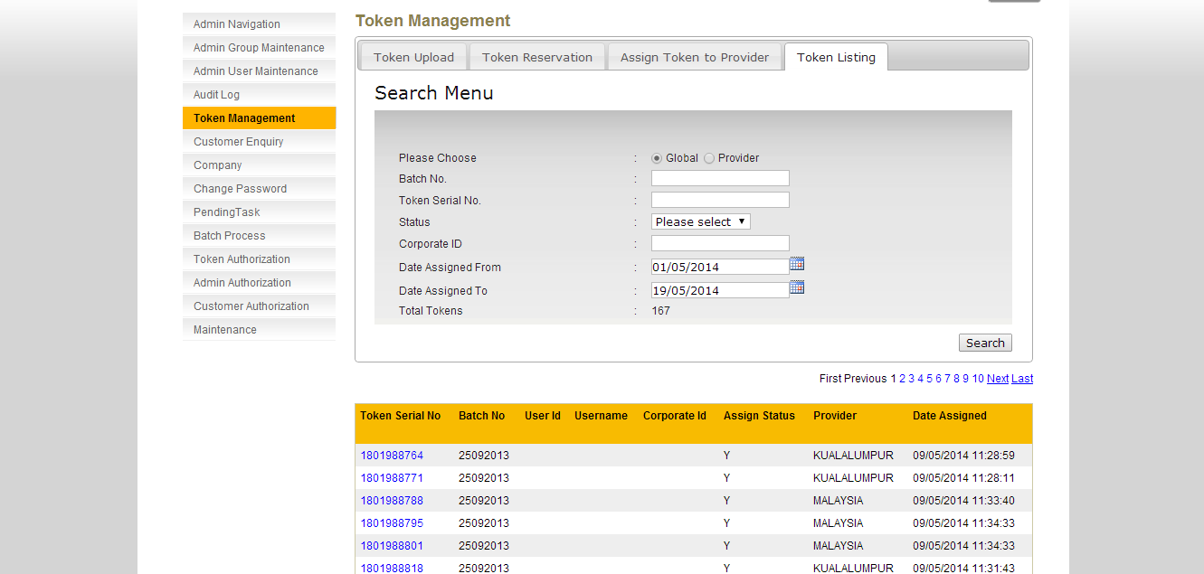

Figure 2: Token Listing Enquiry Screen (Global)

**Scenario 2:**

1. Select the **Global** option
2. Status: **Assigned**
3. Choose a date for **Date Assigned From**
4. Choose a date for **Date Assigned To**
5. And then click on the **Search** button
6. A list of tokens that matches search criteria will the shown

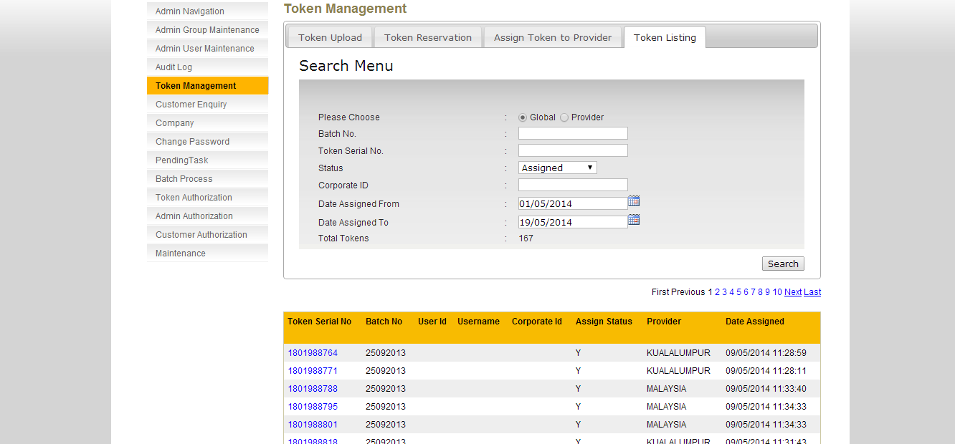

Figure 3: Token Listing Enquiry Screen (Global)

**Scenario 3:**

1. Select the **Global** option
2. Status: **Not** **Assigned**
3. And then click on the **Search** button
4. A list of tokens that matches search criteria will the shown

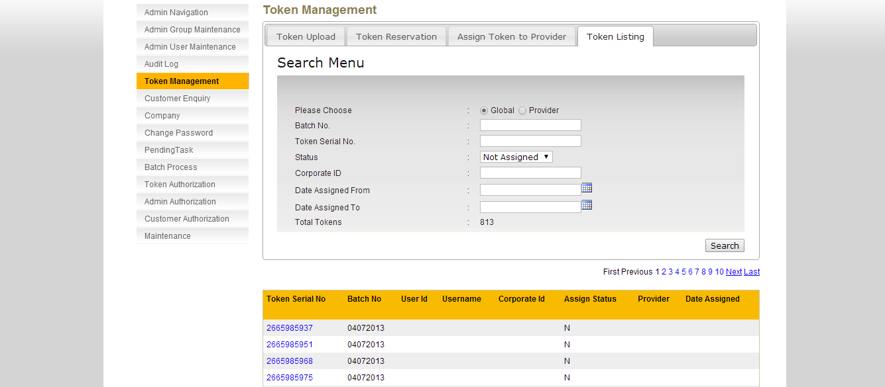

Figure 4: Token Listing Enquiry Screen (Global)

**Scenario 4:**

1. Select the **Global** option
2. Status: **Not Assigned**
3. Choose a date for **Date Assigned From**
4. Choose a date for **Date Assigned To**
5. And then click on the **Search** button
6. No matching criteria found and system will show “**No Data Available**”

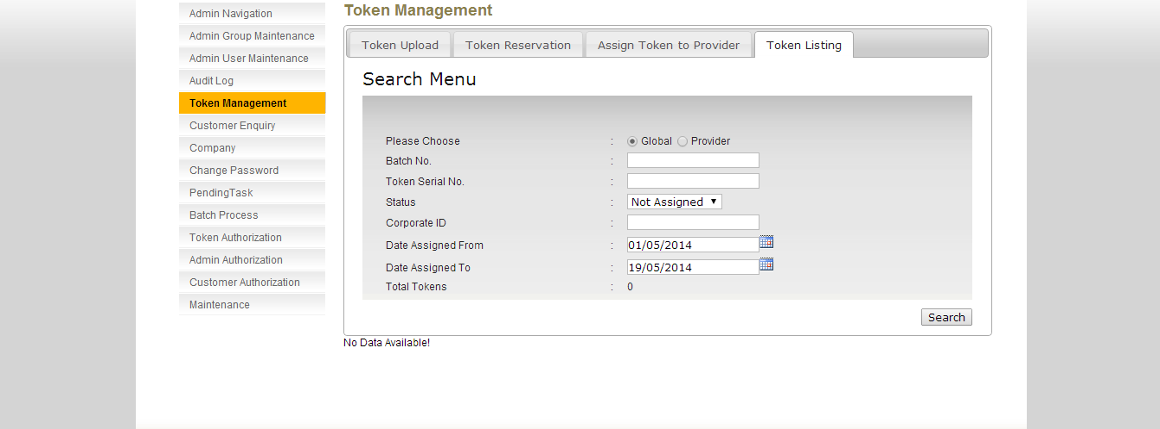

Figure 5: Token Listing Enquiry Screen (Global)

### Provider Layer

**Step 1:**

RCAS administrator can access to Token Management module by clicking on the **Token Listing** tab.

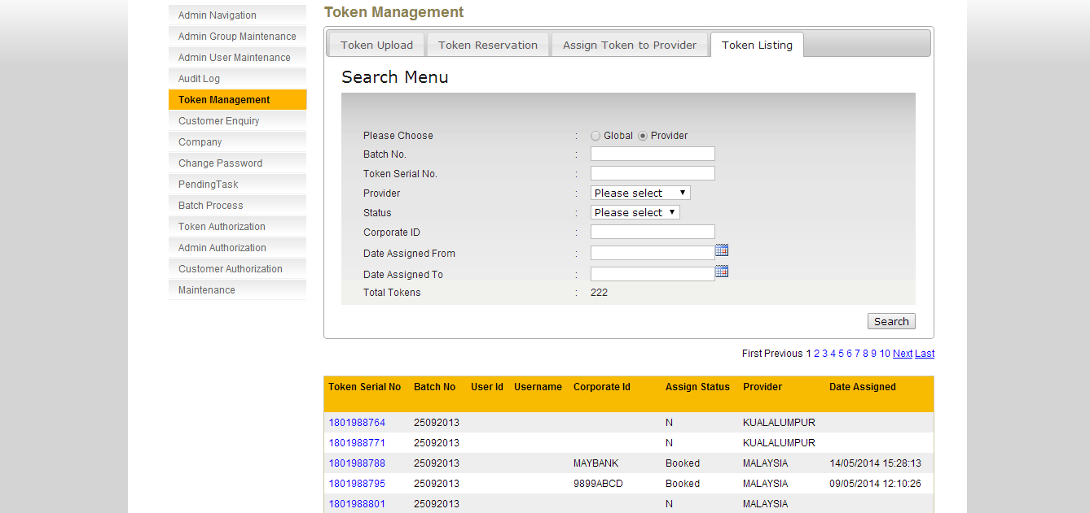

Figure 6: Token Listing Enquiry Screen (Provider)

**Step 2:**

**Scenario 1:**

1. Select the **Provider** option
2. Status: **Please Select** (no selection made)
3. Choose a date for **Date Assigned From**
4. Choose a date for **Date Assigned To**
5. And then click on the **Search** button
6. A list of tokens that matches search criteria will the shown

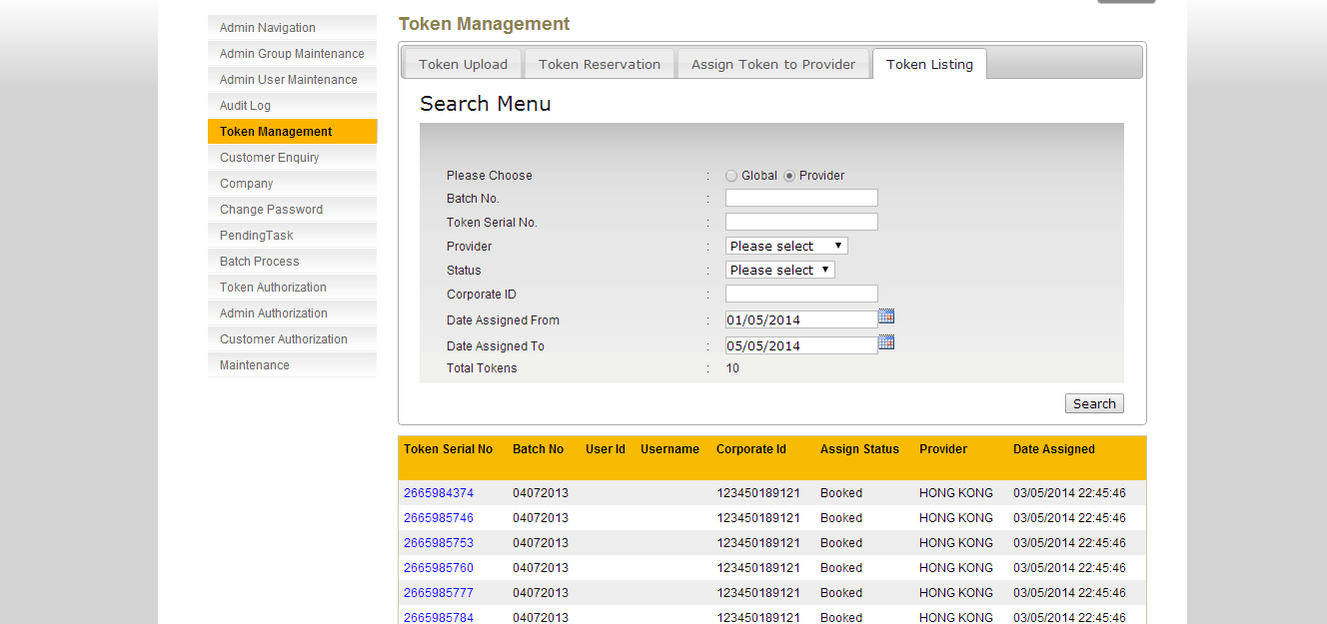

Figure 7: Token Listing Enquiry Screen (Provider)

**Scenario 2:**

1. Select the **Provider** option
2. Status: **Assigned**
3. Choose a date for **Date Assigned From**
4. Choose a date for **Date Assigned To**
5. And then click on the **Search** button
6. A list of tokens that matches search criteria will the shown

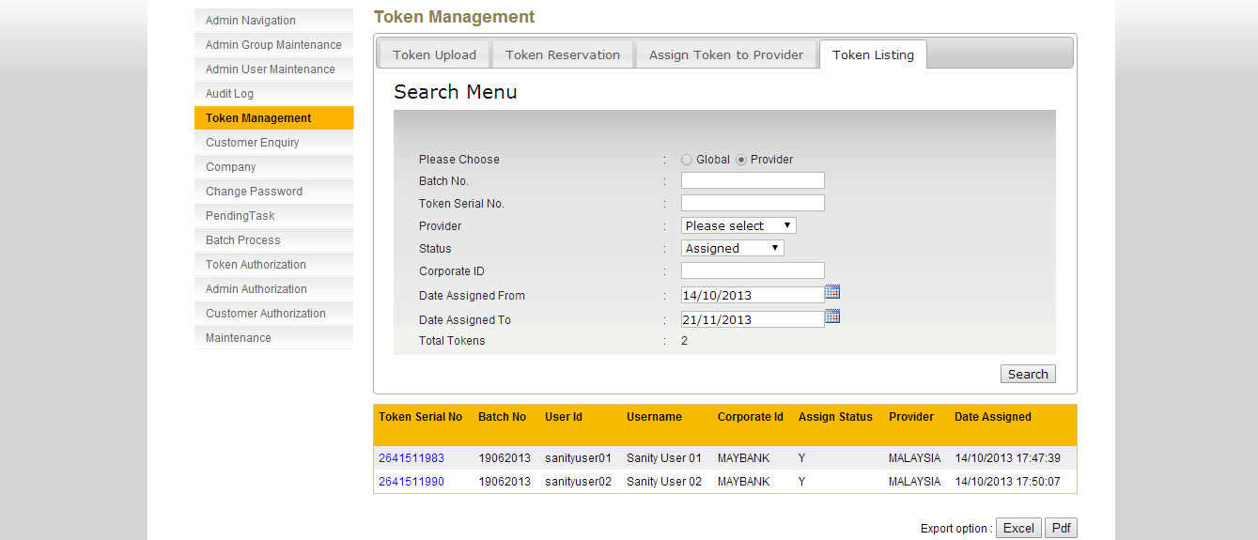

Figure 8: Token Listing Enquiry Screen (Provider)

**Scenario 3:**

1. Select the **Provider** option
2. Status: **Booked**
3. Choose a date for **Date Assigned From**
4. Choose a date for **Date Assigned To**
5. And then click on the **Search** button
6. A list of tokens that matches search criteria will the shown

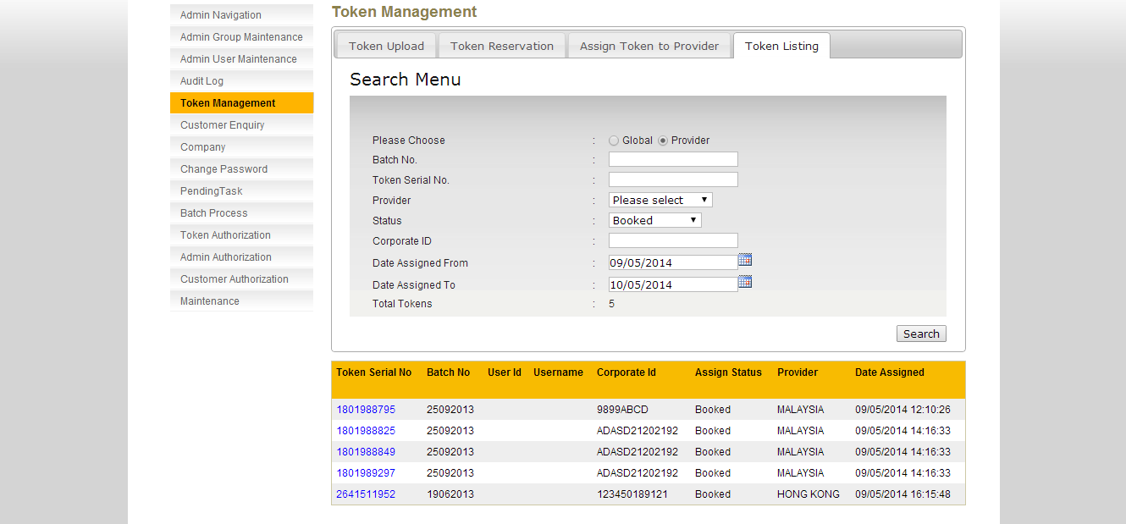

Figure 9: Token Listing Enquiry Screen (Provider)

**Scenario 4:**

1. Select the **Provider** option
2. Status: **Not Assigned**
3. And then click on the **Search** button
4. A list of tokens that matches search criteria will the shown

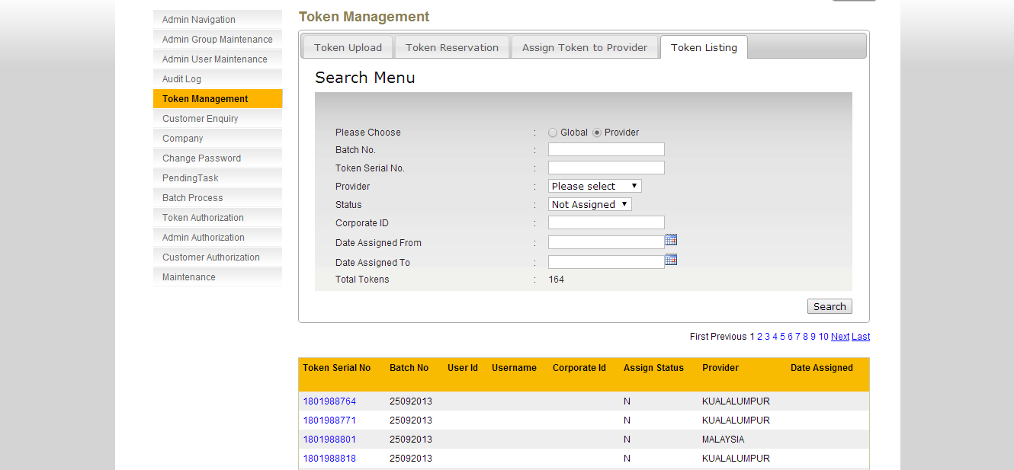

Figure 10: Token Listing Enquiry Screen (Provider)

**Scenario 5:**

1. Select the **Provider** option
2. Status: **Not Assigned**
3. Choose a date for **Date Assigned From**
4. Choose a date for **Date Assigned To**
5. And then click on the **Search** button
6. No matching criteria found and system will show “**No Data Available**”

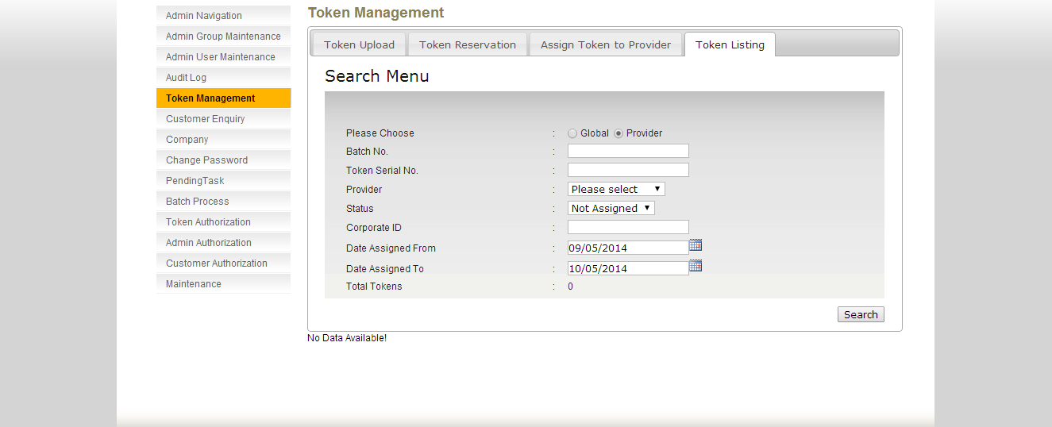

Figure 11: Token Listing Enquiry Screen (Provider)

## Total Token Count

A new total token count field is added as the search result display. RCAS administrator can now know the number of tokens that matches the search criteria. The search criteria are Global Layer or Provider Layer and detail search criteria will be Batch No, Token Serial No, Status, Corporate ID, Date Assigned From, Date Assigned To.

Please see the below screen on the Total Token field:-

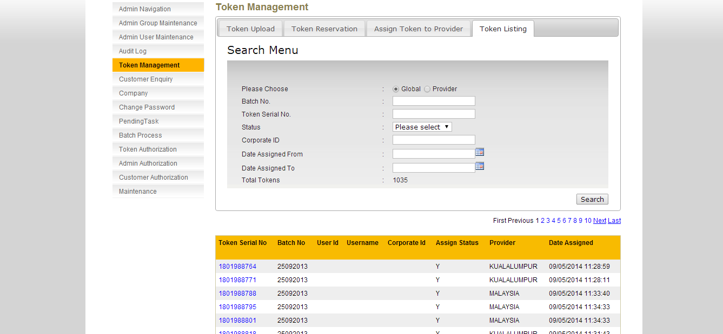

Figure 12: Token Listing Enquiry Screen (Global)

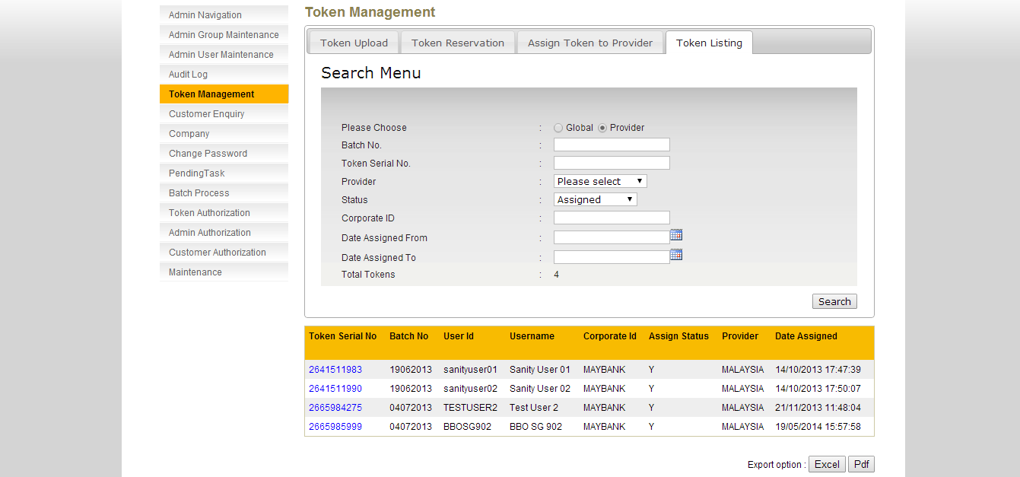

Figure 13: Token Listing Enquiry Screen (Provider)



Figure 14: Token Listing Enquiry Screen (No token found)

# Token Cover Letter

## Print Token Cover Letter

This feature shall allow RCAS Administrator to print token cover letter. The Token Cover Letter template will follow the Pin Letter format which is the variable value will follow the input from RCAS system and will only has English, no other languages as at this moment due to Maybank DB not able to support the Chinese characters. For Fix Value will be able to have English in English template or Chinese language template.

**Step 1:**

RCAS administrator can access module by clicking on the Token Cover Letter link at the navigation menu.

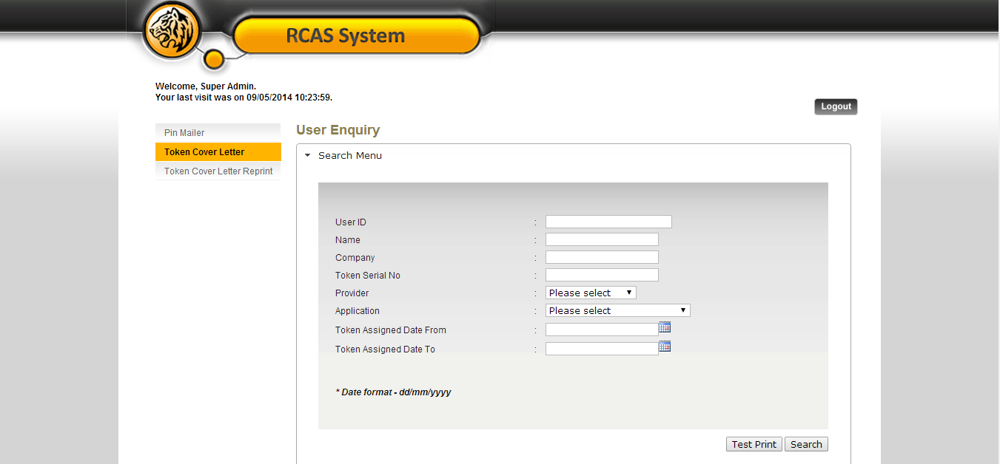

Figure 15: Token Cover Letter User Enquiry Screen

Click on **Test Print** to preview the sample format document.

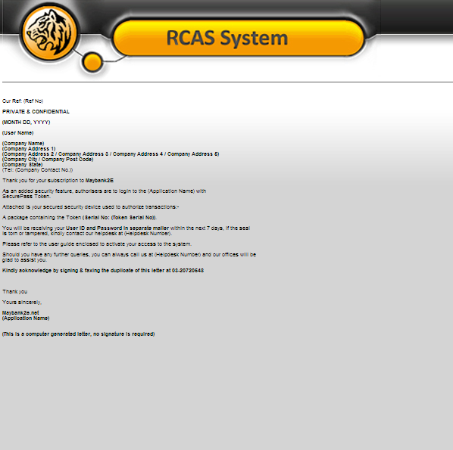

Figure 16: Token Cover Letter Test Print Popup Screen

**Step 2:**

RCAS administrator can input User ID, Name, Company, Token Serial No, Provider, Application, Token Assigned Date From and Token Assigned Date To

|  |  |
| --- | --- |
| Field | Description |
| User ID | **25** characters maximum, alphanumeric. |
| Name | User name. **40** characters maximum, alphanumeric. Could not accept special character except &'@ and space |
| Company (=Corporate ID) | **30** characters maximum, alphanumeric. |
| Token Serial No | **20** characters maximum, numeric. |
| Provider | Select provider from drop down list |
| Application | Select application from drop down list.   * **RCAS** * **e-Custody** * **e-Trade** * **RCMS** |
| Token Assigned Date From | Date format. (dd/mm/yyyy) |
| Token Assigned Date To | Date format. (dd/mm/yyyy) |

Table 2: Token Cover Letter Input Fields Format

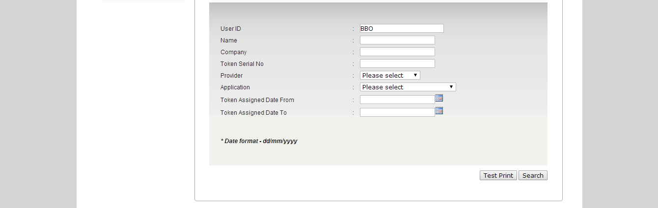

Figure 17: Token Cover Letter User Enquiry with Input

Click on **Search** button to proceed to the search result page.

**Step 3:**

The result page will show the list of the user based on the search criteria. If no fields is being input and a search is requested, RCAS will return a list of user with a pagination of 10 per page.

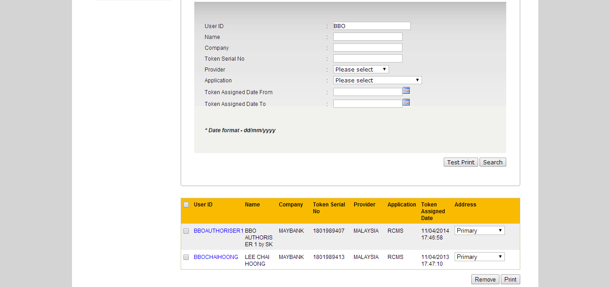

Figure 18: Token Cover Letter User Enquiry Result Page

**Step 4:**

Select the checkbox at the user enquiry result page to proceed to the printing and select either primary or correspondent address to be used. By default, RCAS will always use primary address. If the RCAS administrator selected correspondent address, RCAS will validate correspondent address1, correspondent address2 and correspondent address3, if correspondent address is empty, correspondent address will not be available for selection. Multiple prints are allowed. Click Print button

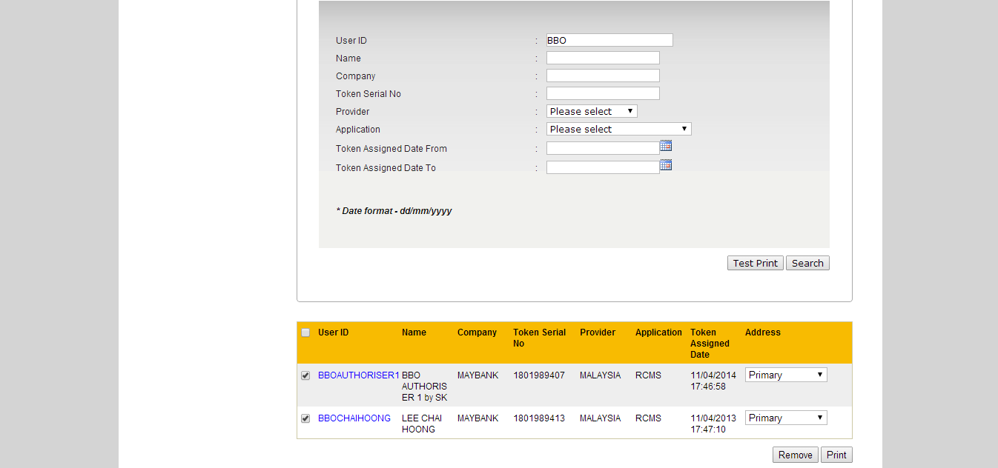

Figure 19: Select a User print

**Step 5:**

Confirmation screen shall display along with the summary of the user after printing has been completed. RCAS will generate an excel file upon the printing completion. RCAS administrator can save or cancel the excel file.

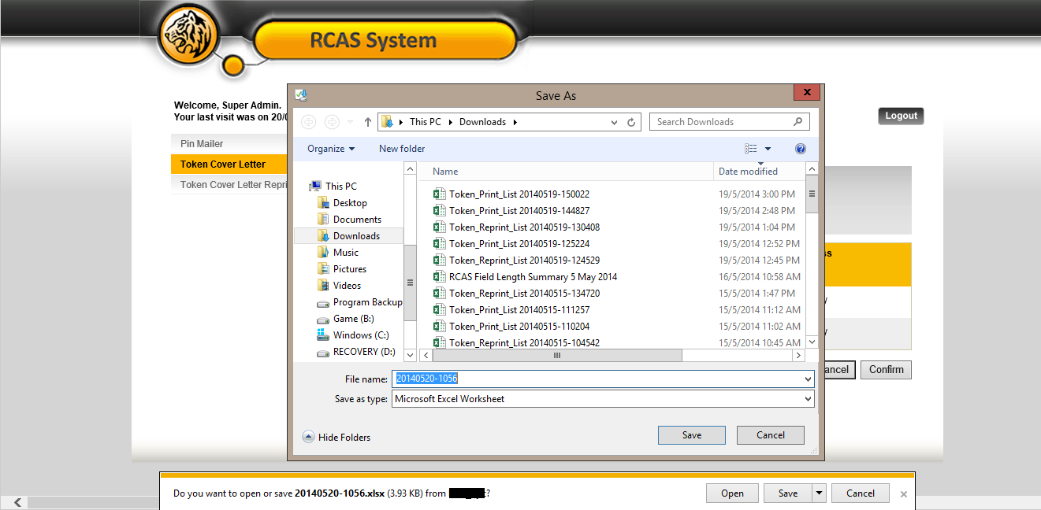

Figure 20: Download Excel File Screen (Internet Explorer 11)



Figure 21: Sample Export File

|  |  |
| --- | --- |
| Field | Description |
| User ID | User Alias |
| Attn | User Name |
| Company | Corporate ID |
| Contact No | User Mobile Number |
| Address1 | Primary Address 1 or Correspondent Address 1. Depends on selected address by RCAS administrator. |
| Address2 | Primary Address 2 or Correspondent Address 2. Depends on selected address by RCAS administrator. |
| Address3 | Primary Address 3 or Correspondent Address 3. Depends on selected address by RCAS administrator. |
| Address4 | Primary Address 4 or Correspondent Address 4. Depends on selected address by RCAS administrator. |
| Address5 | Primary Address 5 or Correspondent Address 5. Depends on selected address by RCAS administrator. |
| Postal Code | Primary Postal Code or Correspondent Postal Code. Depends on selected address by RCAS administrator. |
| City | Primary City or Correspondent City. Depends on selected address by RCAS administrator. |
| State | Primary State or Correspondent State. Depends on selected address by RCAS administrator. |
| Token No | Token Serial Number |

Table 3: Token Cover Letter Excel File Fields

**Step 6:**

Confirmation screen shall display along with the summary of the user after printing has been completed. RCAS administrator can **confirm** or **cancel** the task is completed. If **Cancel** is selected in the confirmation screen, the task in this queue will be available in enquiry page. Refer to step 8 if Cancel the task.

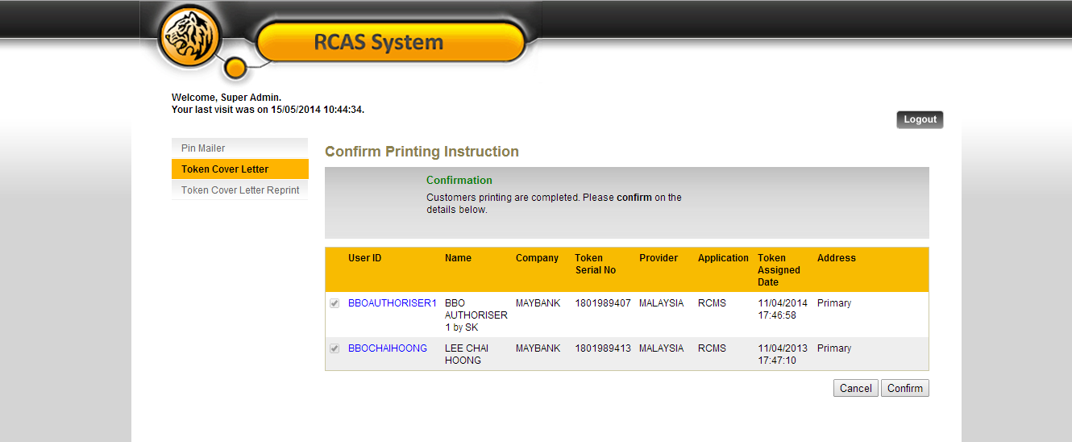

Figure 22: Print Token Cover Letter Confirmation Screen

**Step 7:**

A result page shall display the status of the request. Result page will also show the summary of the user that has been confirmed. **Confirmed** customers will be **removed** from printing **queue** and will be **queued** at **Token Cover Letter Reprint**.

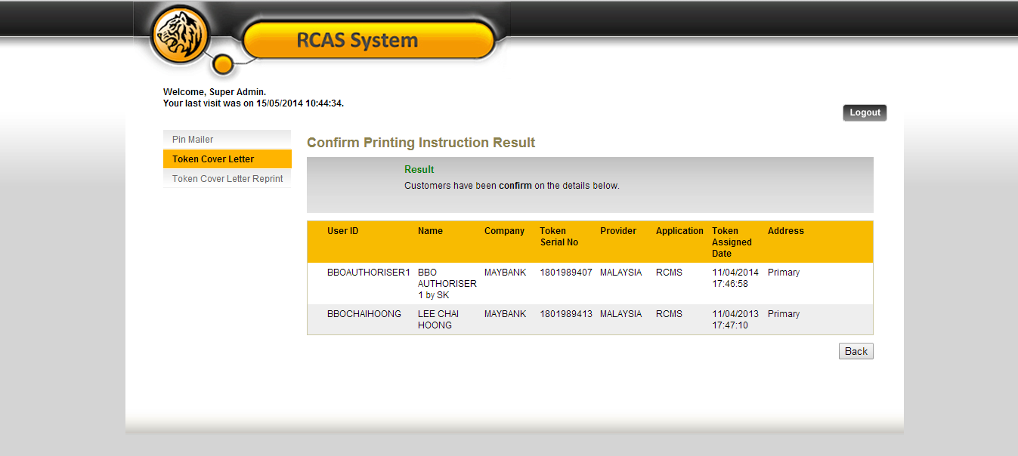

Figure 23: Print Token Cover Letter Result Screen

**Step 8:**

Confirmation screen shall display along with the summary of the user after printing has been completed. RCAS administrator can **confirm** or **cancel** the task is completed. If **Cancel** is selected in the confirmation screen, the task in this queue will be available in enquiry page. Sample screen of click Cancel the task.

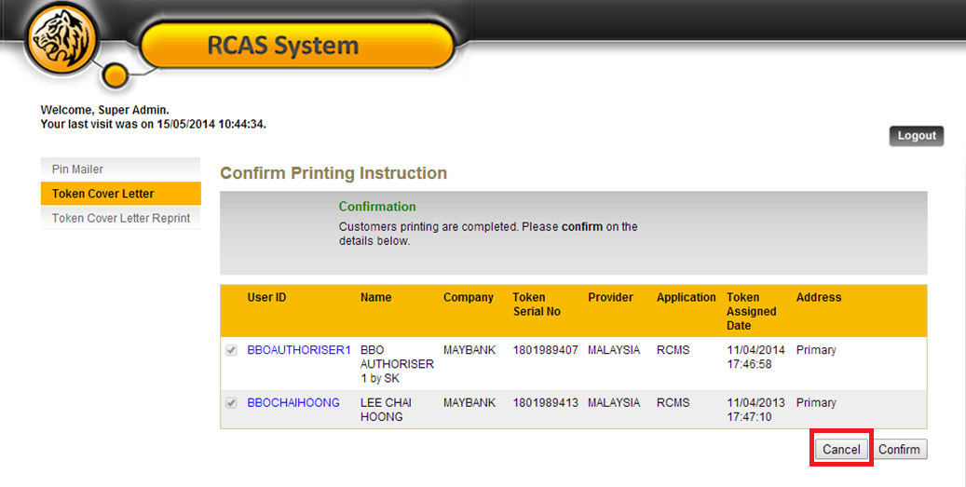

Figure 24: Print Token Cover Letter Confirmation Screen

**Step 9:**

The cancellation tasks will be return to Print Token Cover Letter Enquiry Page. It allows resubmitting the same task.



Figure 25: Print Token Cover Letter Enquiry Screen

## Remove User from Print Queue

This feature shall allow RCAS Administrator to **remove user from token cover letter print queue**.

**Step 1:**

RCAS administrator can access module by clicking on the Token Cover Letter link at the navigation menu. Click Search to enquire for the users to remove from printing queue. Select the user to be remove from printing queue by using the checkbox and click on Remove.

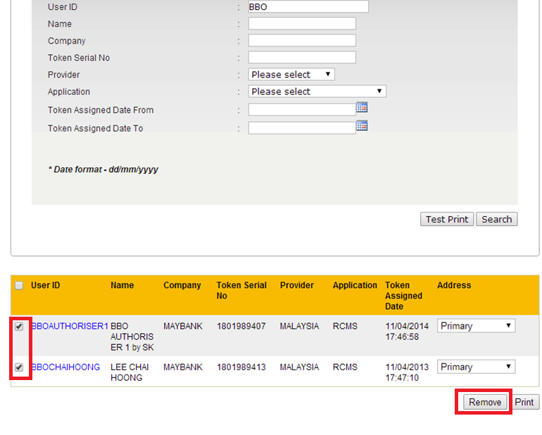

Figure 26: Print Token Cover Letter User Enquiry Screen

**Step 2:**

A confirmation screen will show the user details. Click Confirm to remove the user from printing queue or Cancel to select other user to be removed from printing queue.

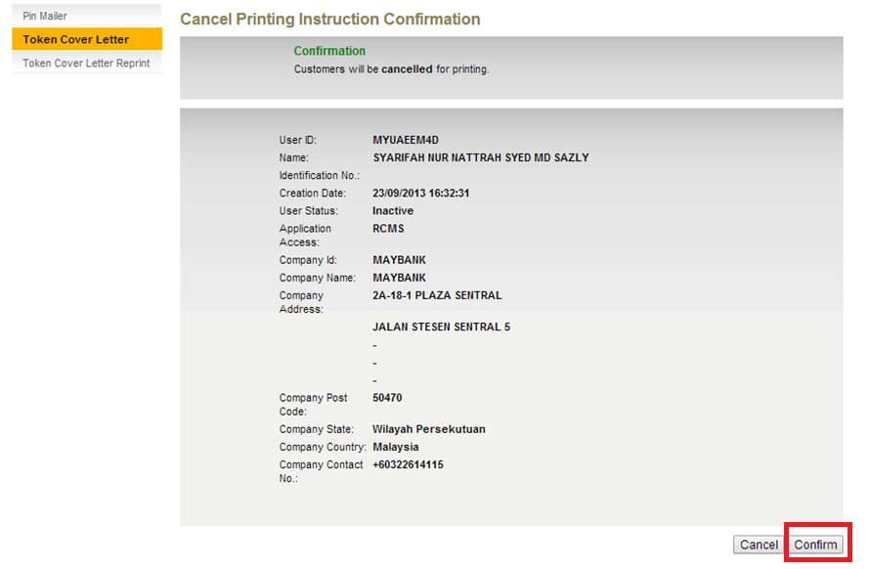

Figure 27: Remove User from Token Cover Letter Printing Queue Confirmation Screen

**Step 3:**

A result page will display the user’s details removed from printing queue. Users removed using Remove from printing queue will not be shown in Token Cover Letter Print or Token Cover Letter Reprint.

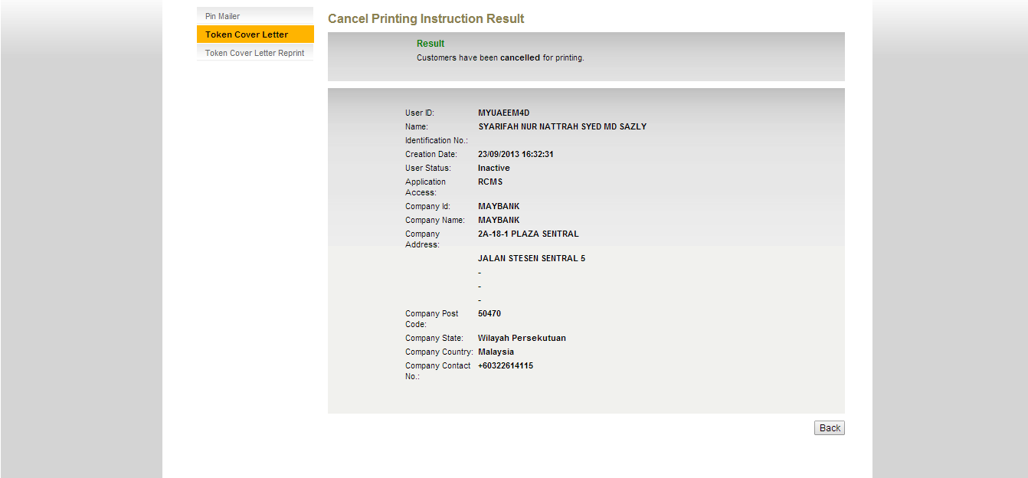

Figure 28: Remove User from Token Cover Letter Printing Queue Result Screen

# Token Cover Letter Reprint

This feature shall allow RCAS Administrator to **reprint** the customer token cover letter for those printed before. In an event that a user require to replace a new token, the RCAS Administrator will revoke and assigned new token to the user and follow through the Token Cover Letter Print process, then the existing record of the user will be deleted and replaced with this new record. Another scenario is if a token has been revoked from a user and no token replacement, then the existing record still maintains the same.

**Step 1:**

RCAS administrator can access module by clicking on the **Token Cover Letter Reprint** link at the navigation menu.

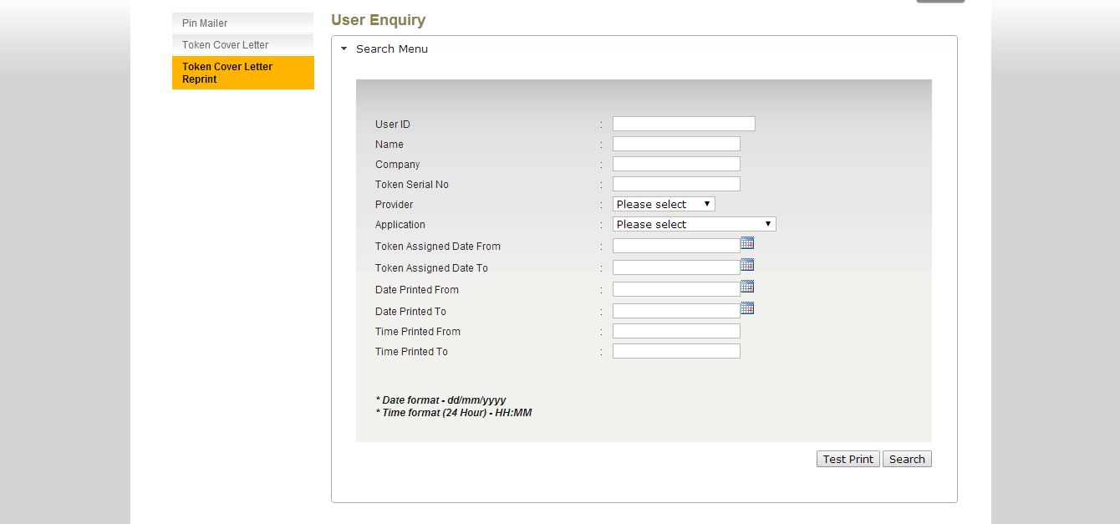

Figure 29: Token Cover Letter Reprint Enquiry Screen

**Step 2:**

RCAS administrator can input User ID, Name, Company, Token Serial No, Provider, Application, Token Assigned Date From and Token Assigned Date To

|  |  |
| --- | --- |
| Field | Description |
| User ID | **25** characters maximum, alphanumeric. |
| Name | **40** characters maximum, alphanumeric. Could not accept special character except &'@ and space |
| Company | **30** characters maximum, alphanumeric. |
| Token Serial No | **20** characters maximum, numeric. |
| Provider | Select provider from drop down list |
| Application | Select application from drop down list.   * **RCAS** * **e-Custody** * **e-Trade** * **RCMS** |
| Token Assigned Date From | Date format. (dd/MM/yyyy) |
| Token Assigned Date To | Date format. (dd/MM/yyyy) |
| Date Printed From | Date format. (dd/MM/yyyy) |
| Date Printed To | Date format. (dd/MM/yyyy) |
| Time Printed From | HHMM |
| Time Printed To | HHMM |

Table 4: Token Cover Letter Reprint Input Fields Format

Click on **Search** button to proceed to the search result page.

**Step 3:**

The search result page will show the list of the user based on the search criteria. If no fields is being input and a search is requested, RCAS will return a list of user with a pagination of 10 per page.

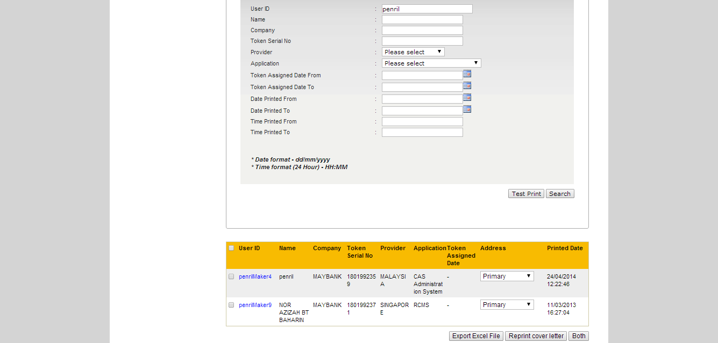

Figure 30: Token Cover Letter Reprint Enquiry Result Screen

**Step 4:**

Check on the checkbox at the user page to proceed to the printing and select either primary or correspondent address to be used. By default, RCAS will always use primary address. If RCAS administrator selects correspondent address, RCAS will validate correspondent address1, correspondent address2 and correspondent address3, if correspondent address is empty, correspondent address will not be available for selection. Multiple prints are allowed. User will be able to choose whether to reprint the token cover letter only, generate the excel file only or both.

During **Token Cover Letter Print**, if the RCAS administrator already selected correspondent address and completed the printing, then enquire the same user in reprint queue, the address is defaulted to what was selected during **Token Cover Letter Print**. However if RCAS administrator selects another address during reprint, the selected address will be defaulted in next enquiry of the user.

**Scenario 1:**

In **Token Cover Letter Print**, select correspondent address, printed with correspondent address.

In **Token Cover Letter Reprint**, will display correspondent address as default. If changed to primary address, reprinted with primary address.

Next enquiry in **Token Cover Letter Reprint**, will display primary address as default.

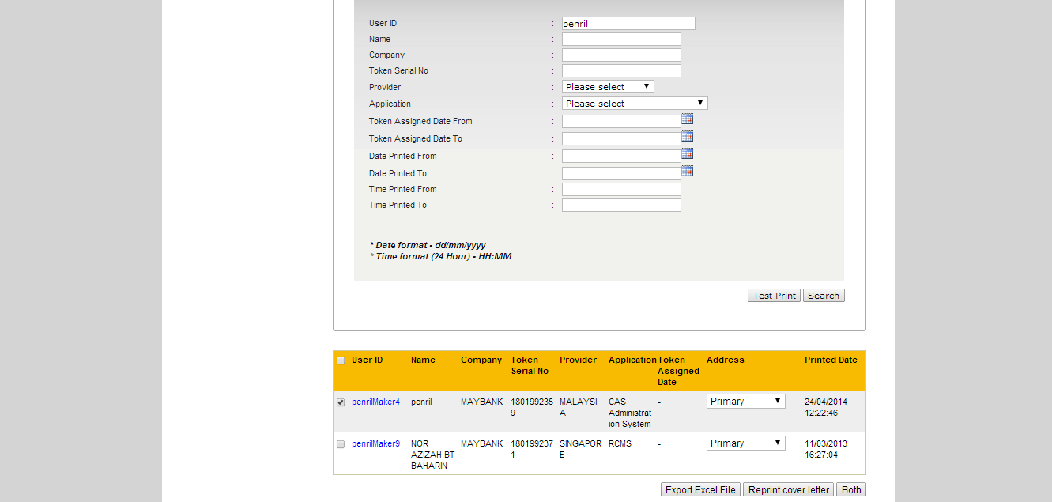

Figure 31: Select User for Token Cover Letter Reprint

**Step 5:**

* If RCAS administrator selects **Export Excel File**, an Excel file will be generating with the details of selected user. Then RCAS administrator can choose to **Reprint Cover Letter** or **Both** or navigate to other modules.
* If RCAS administrator selects **Reprint Cover Letter**, a confirmation screen will be displayed with user’s details.
* If RCAS administrator selects **Both**, token cover letter will be printed first, then an Excel file is generated. A confirmation screen will be displayed with user’s details.

In the confirmation screen, click **Confirm** to confirm the token cover letter is printed correctly. **Cancel** will allow reselecting the users for token cover letter reprint.

|  |  |
| --- | --- |
| Field | Description |
| User ID | User Alias |
| Attn | User Name |
| Company | Corporate ID |
| Contact No | User Mobile Number |
| Address1 | Primary Address 1 or Correspondent Address 1. Depends on selected address by RCAS administrator. |
| Address2 | Primary Address 2 or Correspondent Address 2. Depends on selected address by RCAS administrator. |
| Address3 | Primary Address 3 or Correspondent Address 3. Depends on selected address by RCAS administrator. |
| Address4 | Primary Address 4 or Correspondent Address 4. Depends on selected address by RCAS administrator. |
| Address5 | Primary Address 5 or Correspondent Address 5. Depends on selected address by RCAS administrator. |
| Postal Code | Primary Postal Code or Correspondent Postal Code. Depends on selected address by RCAS administrator. |
| City | Primary City or Correspondent City. Depends on selected address by RCAS administrator. |
| State | Primary State or Correspondent State. Depends on selected address by RCAS administrator. |
| Token No | Token Serial Number |

Table 5: Token Cover Letter Reprint Excel File Fields

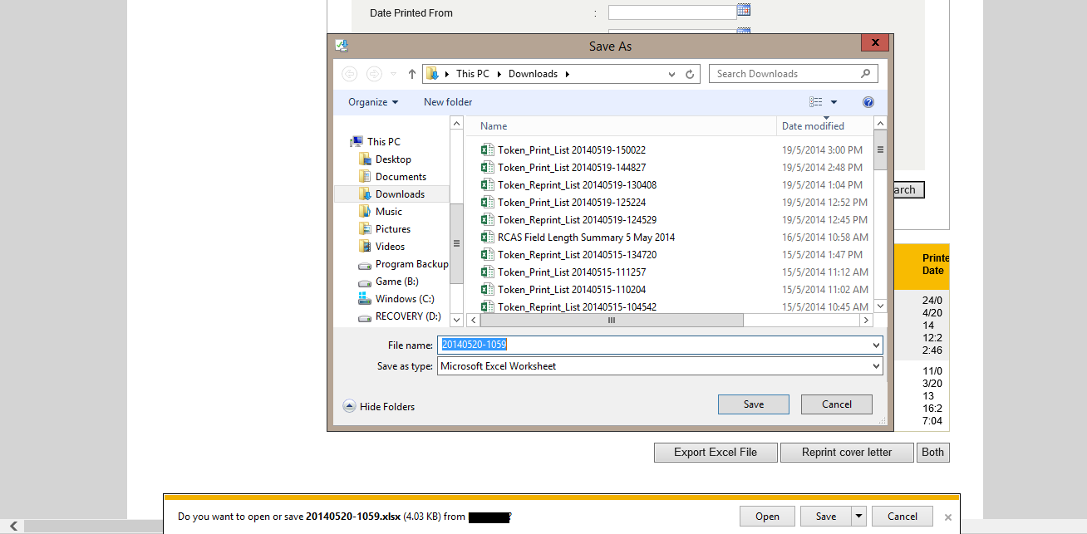

Figure 32: Download Excel File Screen (Internet Explorer 11)

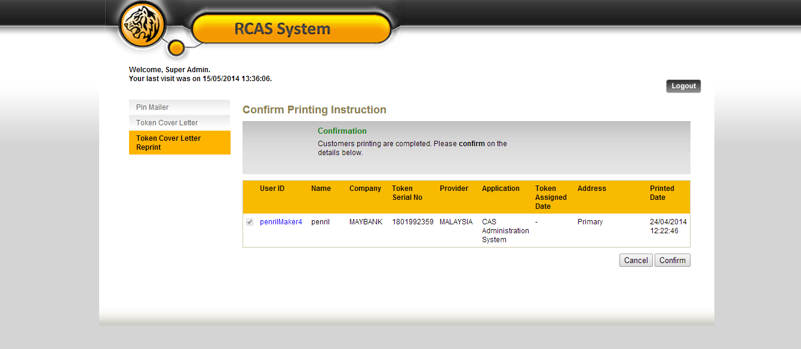

Figure 33: Token Cover Letter Reprint Confirmation Screen

**Step 6:**

A result page shall display the status of the request. Result page will also show the summary of the user that has been confirmed.

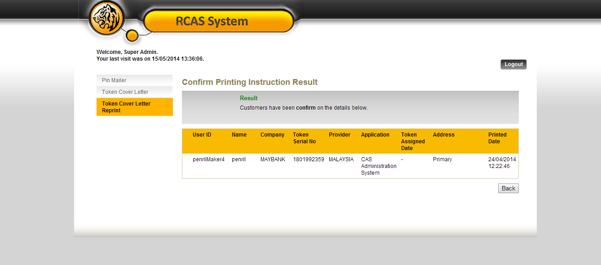

Figure 34: Token Cover Letter Reprint Result Screen

# Token Cover Letter Template

This feature shall allow RCAS Administrator to assigntoken cover letter template for different provider.

**Step 1:**

RCAS administrator can access module by clicking on **Maintenance** link at the navigation menu, click **Token Cover Letter Template** tab.

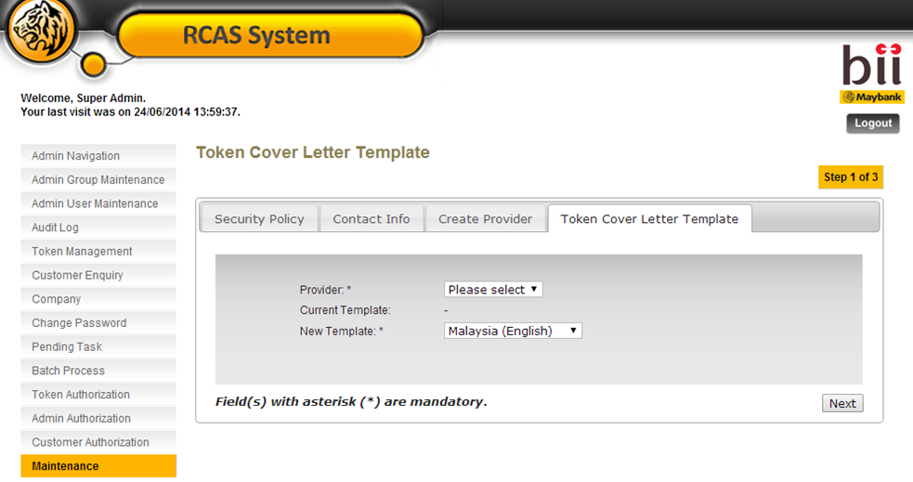

Figure 35: Token Cover Letter Template Screen

**Step 2:**

Select Provider, current template will appear that show the current template assigned to the **Provider.**

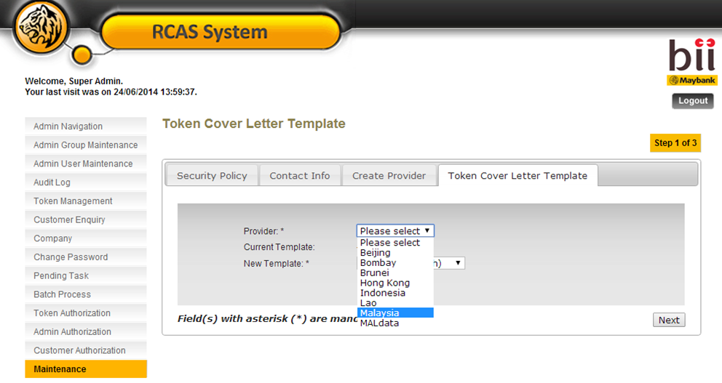

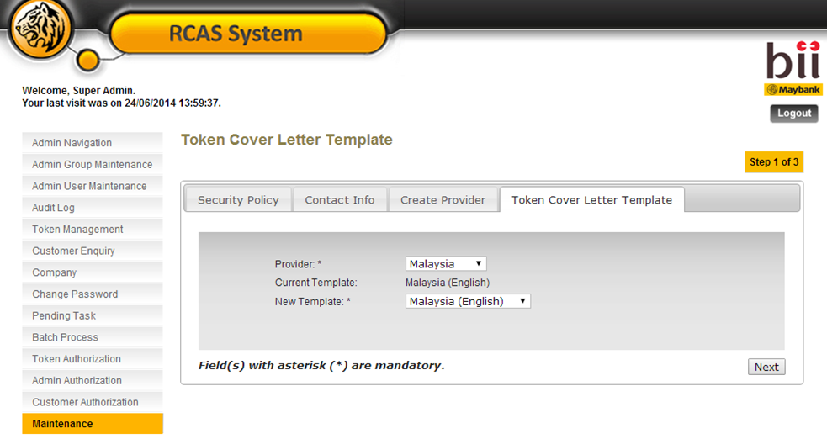

|  |  |
| --- | --- |
| Field | Description |
| Provider | Select from dropdown list. |
| Current Template | Current Template assigned to the Provider |
| New Template | Select from dropdown list to change the template. Only for 5 template.   1. Malaysia (English) 2. Singapore (English) 3. Philippines (English) 4. Indonesia (English) 5. China (Mandarin) |

Figure 36: Token Cover Letter Template Input Fields Format

**Step 3:**

Select New Template, click Next to proceed.

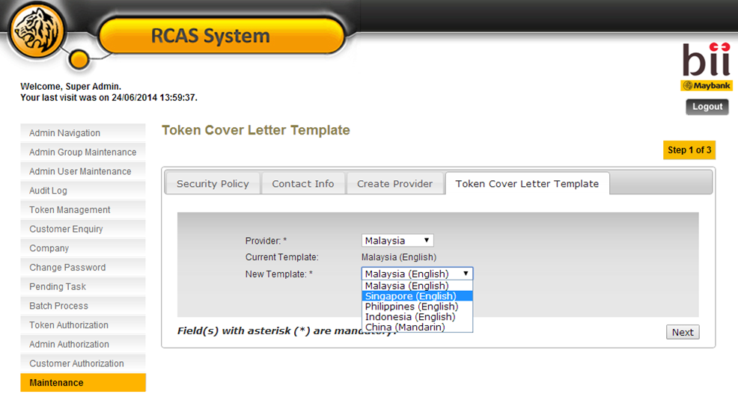

**Step 4:**

A confirmation page is displayed with the sample of the selected template. Click **Confirm** to proceed assign template to provider.

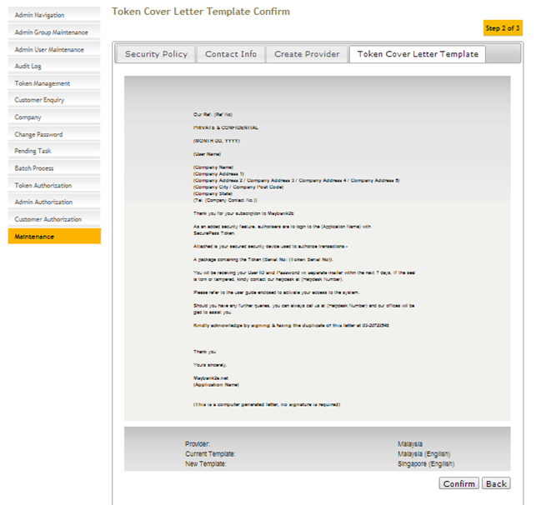

Figure 37: Token Cover Letter Template Confirmation Screen

**Step 5:**

A result page is with successful message is displayed.

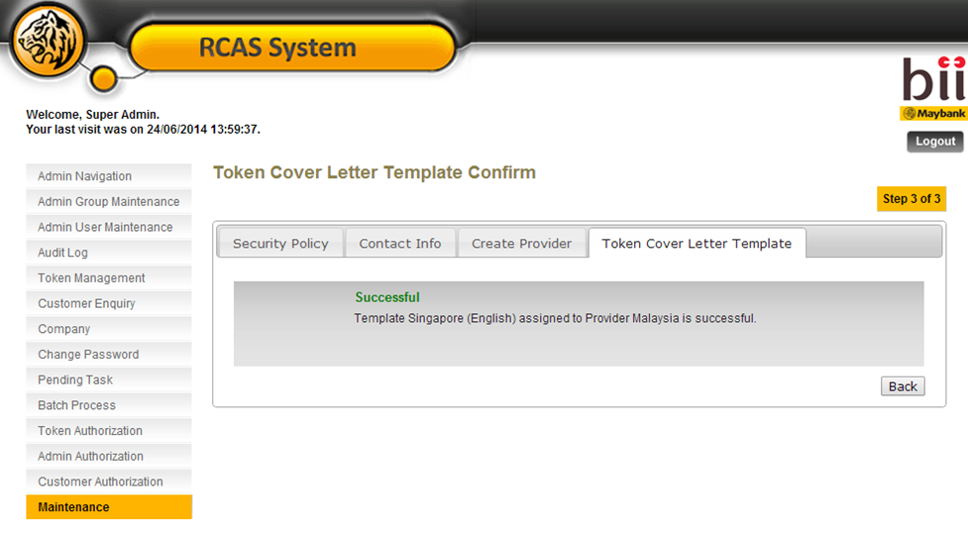

Figure 38: Token Cover Letter Template Result Screen

# Appendix

For variable value are those circles in orange color box. The rest will be fix value.

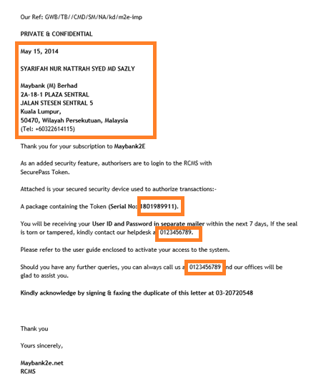

Figure 39: Sample Token Cover Letter