Installing Certificate

- First login to SUN one Web server GUI.
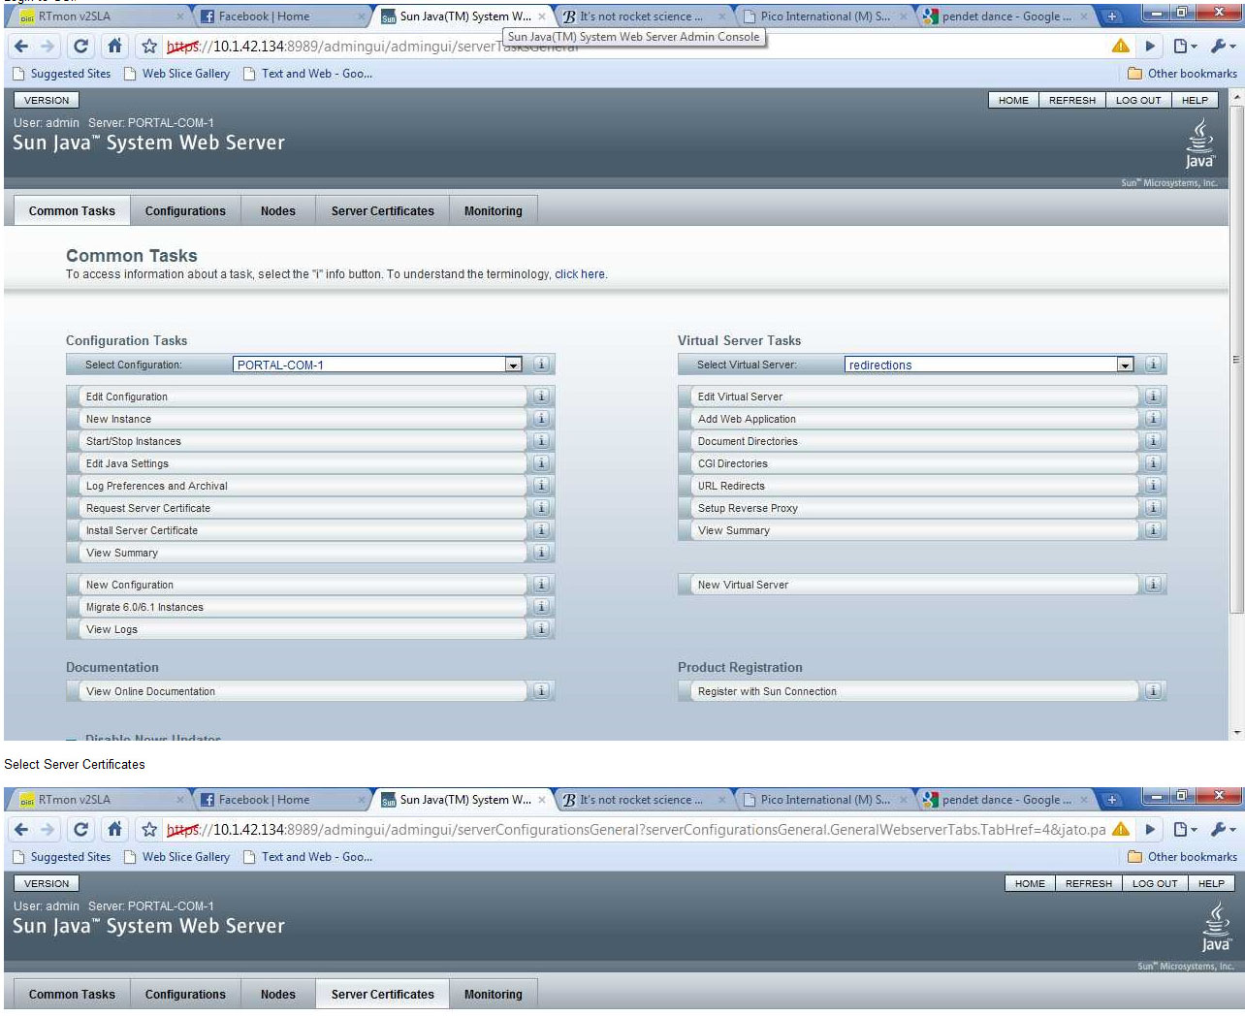

- Do select server certificate.
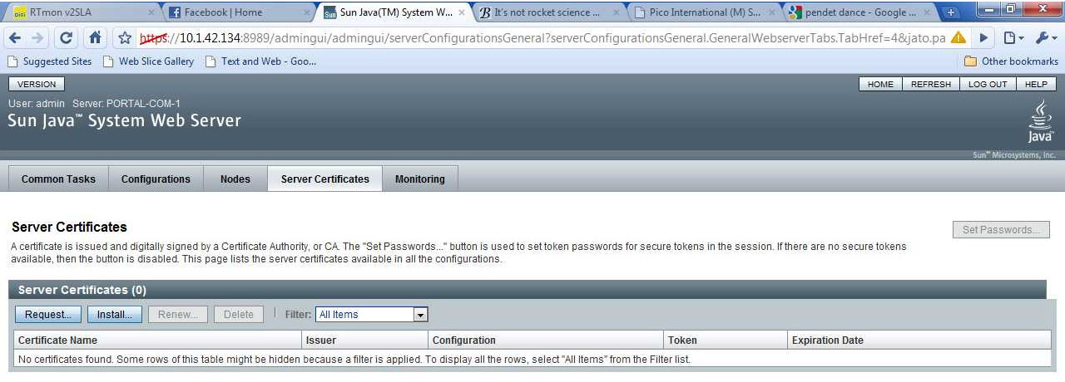

- Thirdly, click on select configuration
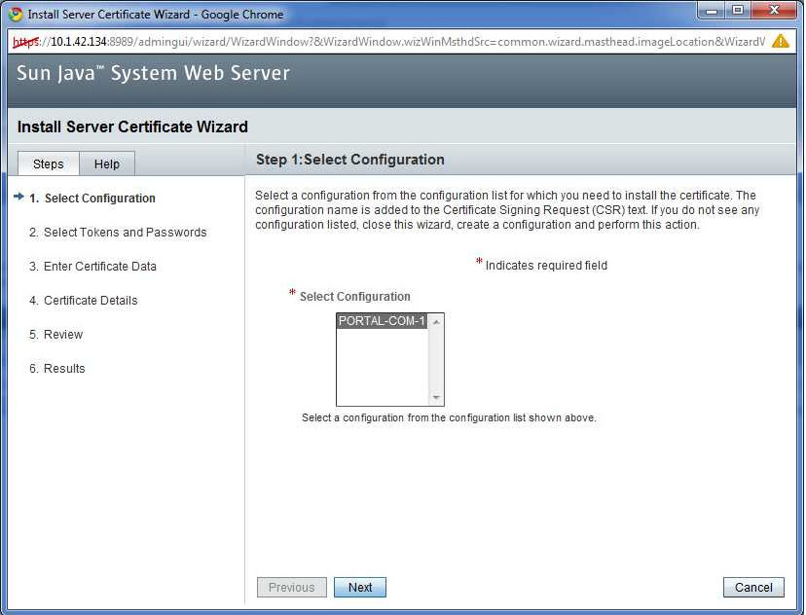

- Fourthly, the above screenshot, select that you want to install the certificate for 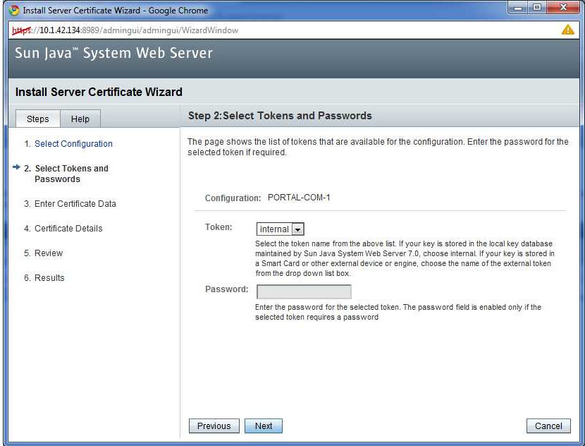

- Then enter the certificate data.
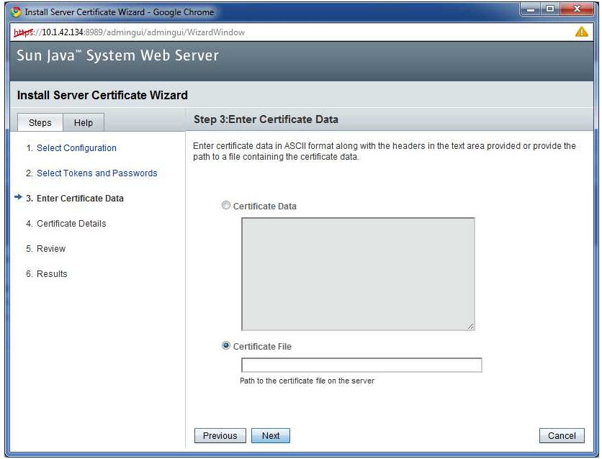

- Then , after this step ( next and agree for all the steps) proceed to the instance and ensure the https port is on ,Select the node you prefer.
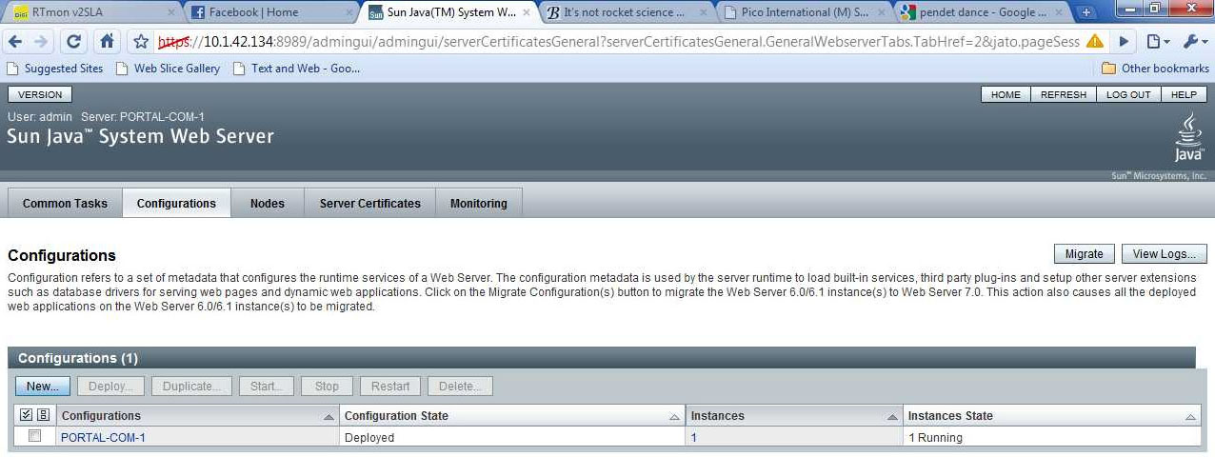

- Port 80 is usually on by default.
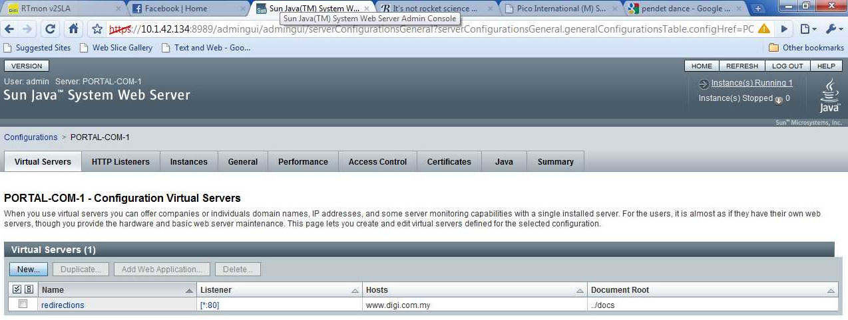

- Then click on the listener
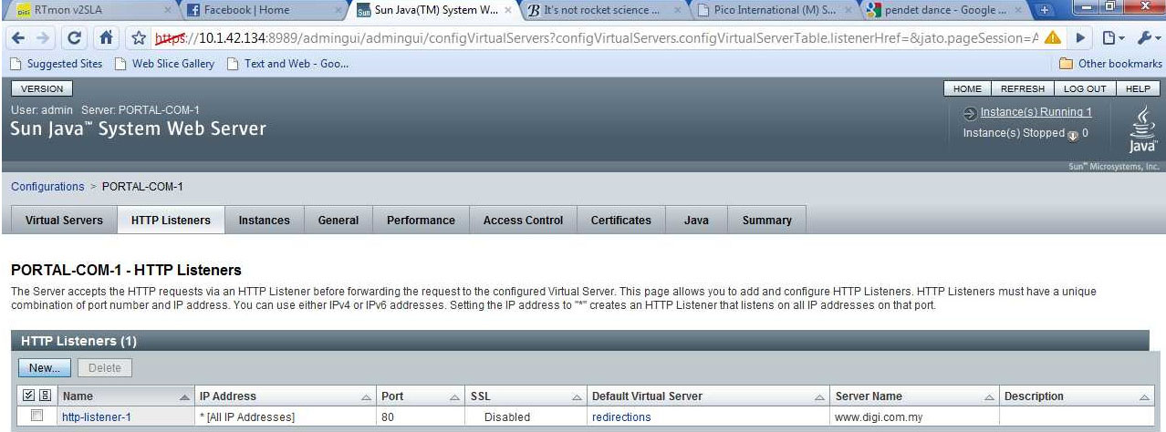
- Click new to configure a new listener
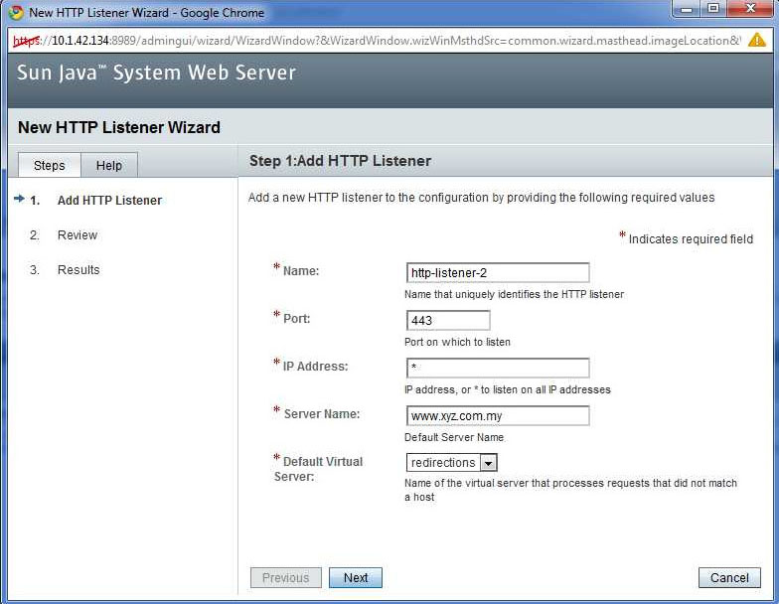

- Configure the https port and configure as below

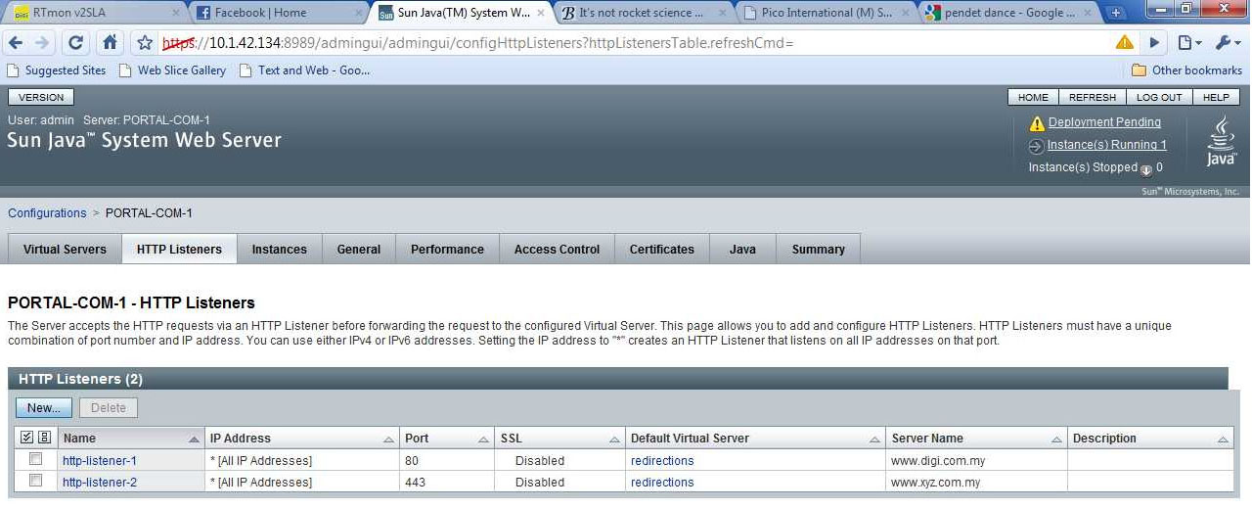

- Configure the https port and configure as below
