

**Malayan Banking Berhad**

**Functional Specification**

**Regional Centralized Authentication System (RCAS) Administration Modules- Production Enhancement Request (Token Cover Letter)**

28 May 2014

**Prepared By:**



Penril Datability (M) Sdn Bhd (816792-X)

Suite A-07-07 Plaza Mon’t Kiara

No. 2, Jalan Kiara, Mon’t Kiara

50480 Kuala Lumpur, Malaysia

Tel: (603) 6201 2622 Fax: (603) 6201 7622

**Document Administration**

**Document Amendment Log**

|  |  |  |  |  |  |
| --- | --- | --- | --- | --- | --- |
| **Version No** | **Date Updated** | **Description of Change** | **Updated By**  **<Name, Dept>** | **Reviewed By**  **<Name, Dept>** | **Approved By <Name, Dept>** |
| 1.0 | 28/5/14 | Initial Release- Token Cover Letter request | Yap Kah Yan  Proessional Services | Boby  Proessional Services | Tan Lee Lee  Professional Services |
|  |  |  |  |  |  |

Contents

1 Token Listing 4

1.1 To add Date Assigned From and Date Assigned To 4

1.1.1 Global Layer 4

1.1.2 Provider Layer 7

1.2 Add Total Token Count 11

1.2.1 Global Layer 11

1.2.2 Provider Layer 12

2 Token Cover Letter 16

2.1 Print Token Cover Letter 16

2.2 Remove User from Print Queue 23

3 Token Cover Letter Reprint 26

4 Token Cover Letter Template 32

5 Appendix 34

# Token Listing

## To add Date Assigned From and Date Assigned To

RCAS administrator allows inputting the **Date Assigned From** and **Date Assigned To** to search token.

The search criteria will include for Batch No, Token Serial No, Status, Corporate ID, Date Assigned From, Date Assigned To.

### Global Layer

**Step 1:**

RCAS administrator can access to Token Management module by clicking on the **Token Listing** tab.

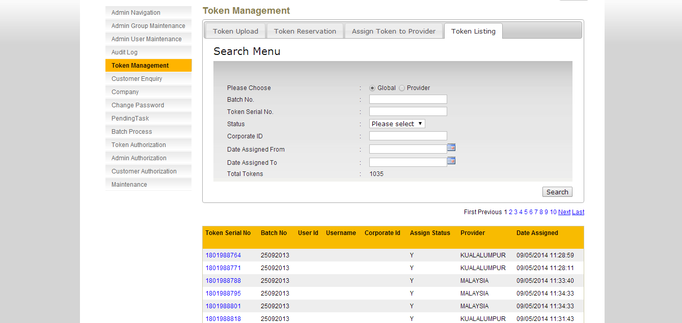

**Figure 1.1: Token Listing Enquiry Screen (Global)**

**Step 2:**

**Scenario 1:**

Select Global

Status: Please Select (Assigned + Not Assigned)

Input date for Date Assigned From

Input date for Date Assigned To

Click **Search**

Result: List tokens if matches search criteria

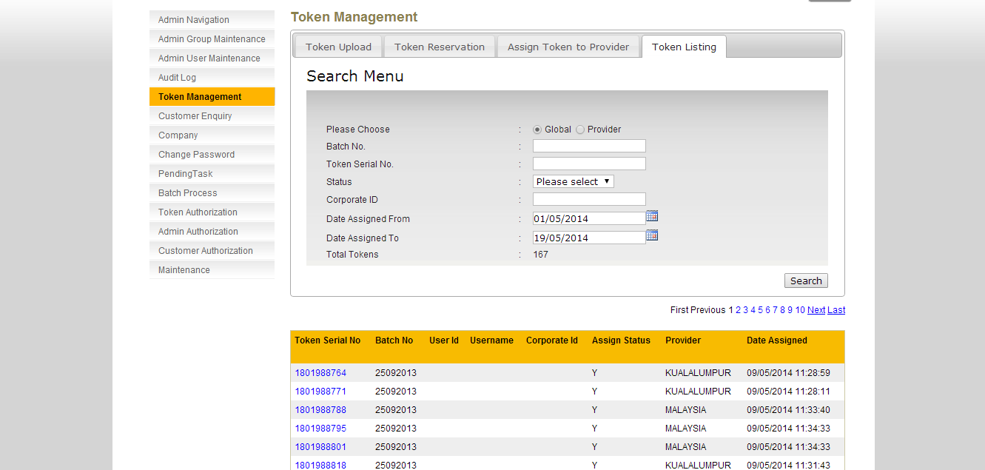

**Figure 1.2: Token Listing Enquiry Result Screen (Global)**

**Scenario 2:**

Select Global

Status: Assigned

Input date for Date Assigned From

Input date for Date Assigned To

Click **Search**

Result: List tokens if matches search criteria

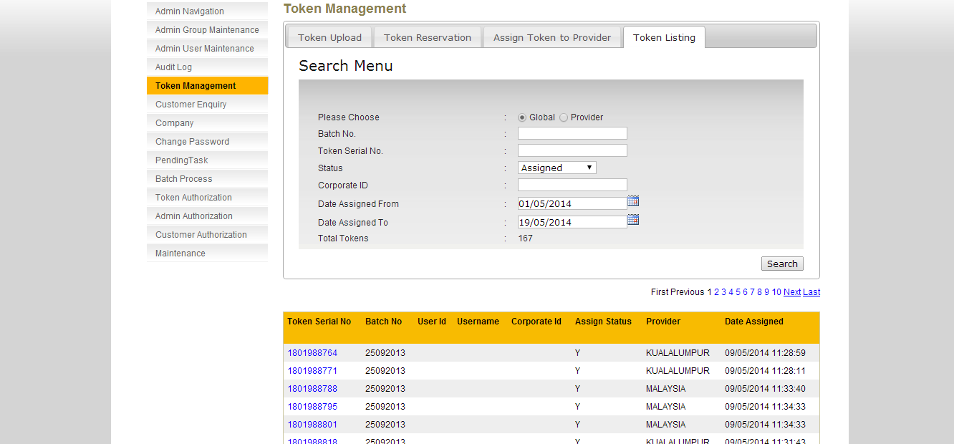

**Figure 1.3: Token Listing Enquiry Result Screen (Global)**

**Scenario 3:**

Select Global

Status: Not Assigned

Click **Search**

Result: List tokens if matches search criteria

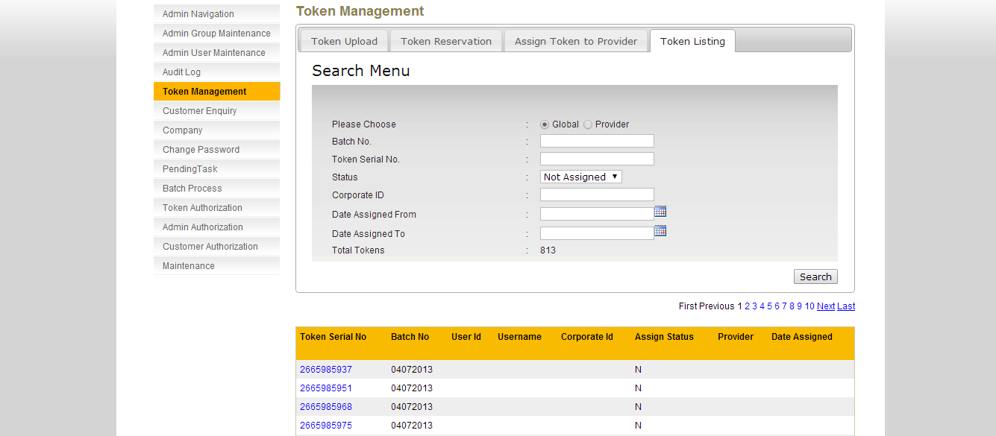

**Figure 1.4: Token Listing Enquiry Result Screen (Global)**

**Scenario 4:**

Select Global

Status: Not Assign

Input date for Date Assigned From

Input date for Date Assigned To

Click **Search**

Result: No Data Available!

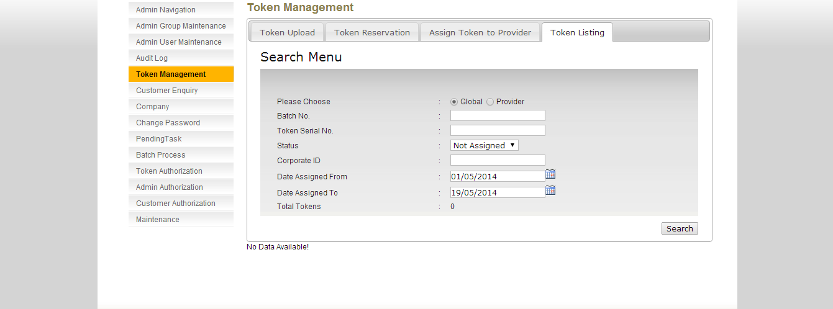

**Figure 1.5: Token Listing Enquiry Result Screen (Global)**

### Provider Layer

**Step 1:**

RCAS administrator can access to Token Management module by clicking on the **Token Listing** tab.

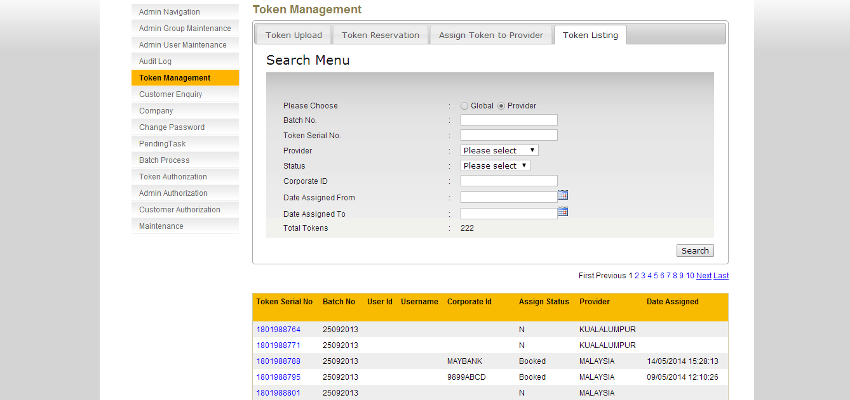

**Figure 1.6: Token Listing Enquiry Screen (Provider)**

**Step 2:**

**Scenario 1:**

Select Provider

Status: Please Select (Assigned + Not Assigned + Booked)

Input date for Date Assigned From

Input date for Date Assigned To

Click **Search**

Result: List tokens if matches search criteria

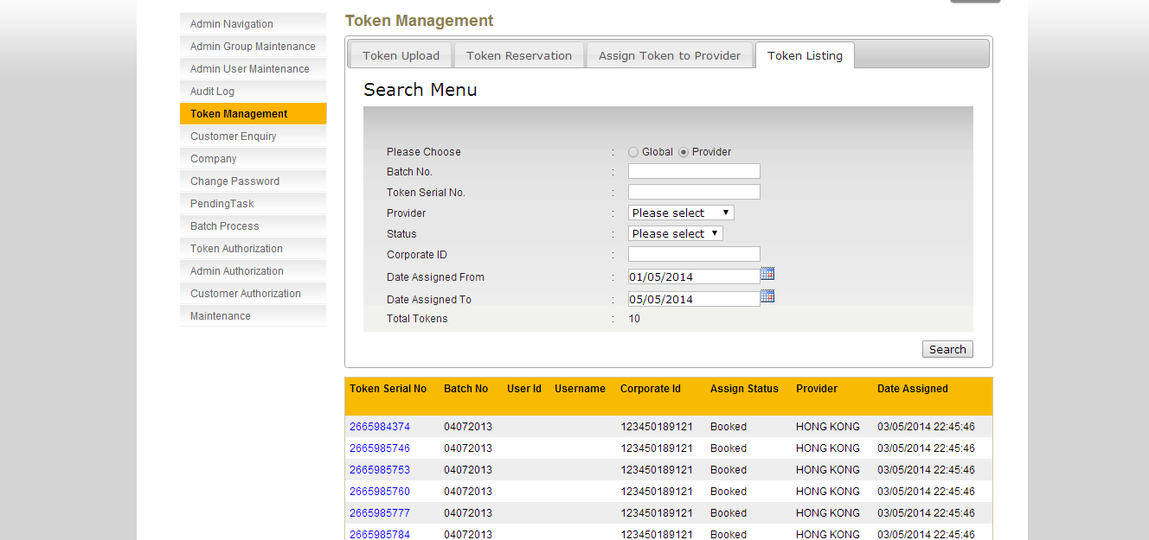

**Figure 1.7: Token Listing Enquiry Result Screen (Provider)**

**Scenario 2:**

Select Provider

Status: Assigned

Input date for Date Assigned From

Input date for Date Assigned To

Click **Search**

Result: List tokens if matches search criteria

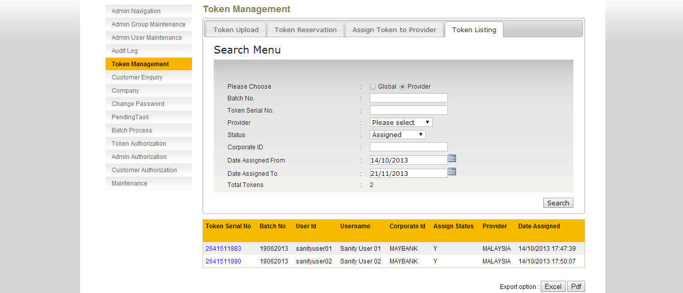

**Figure 1.8: Token Listing Enquiry Result Screen (Provider)**

**Scenario 3:**

Select Provider

Status: Booked

Input date for Date Assigned From

Input date for Date Assigned To

Click **Search**

Result: List tokens if matches search criteria

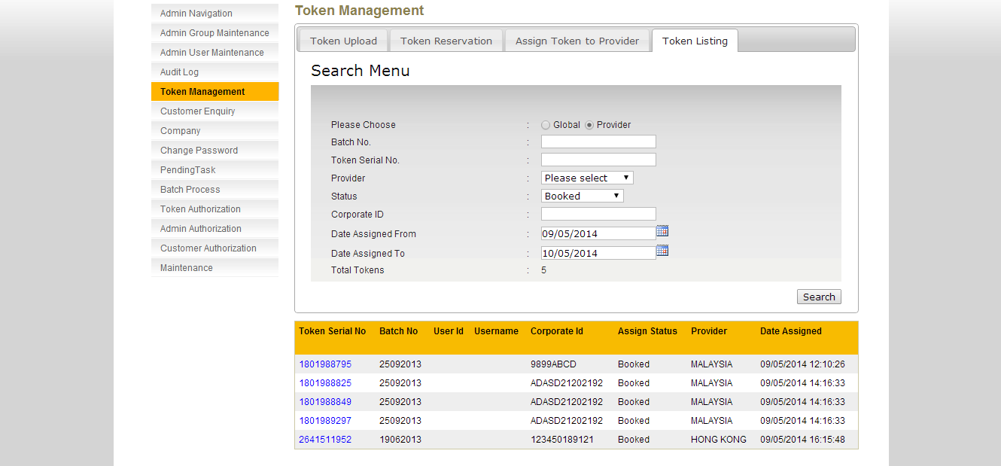

**Figure 1.9: Token Listing Enquiry Result Screen (Provider)**

**Scenario 4:**

Select Provider

Status: Not Assigned

Click **Search**

Result: List tokens if matches search criteria

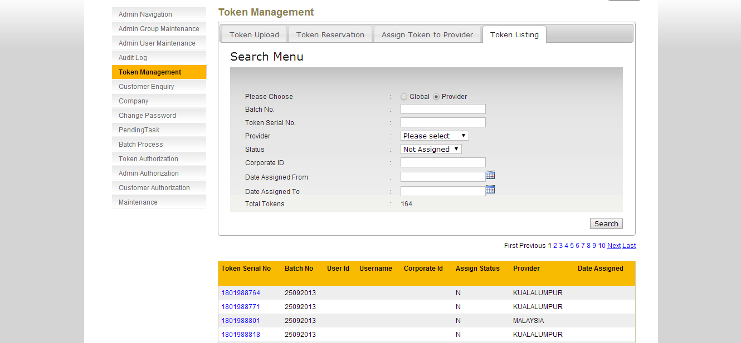

**Figure 1.10: Token Listing Enquiry Screen (Provider)**

**Scenario 5:**

Select Provider

Status: Not Assigned

Input date for Date Assigned From

Input date for Date Assigned To

Click **Search**

Result: No Data Available!

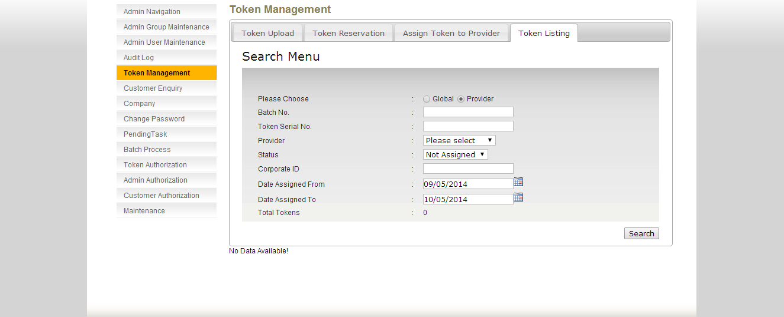

**Figure 1.11: Token Listing Enquiry Result Screen (Provider)**

## Add Total Token Count

RCAS administrator can know the number of token based on search criteria. The search criteria will include for Global Layer or Provider Layer and detail search criteria will be Batch No, Token Serial No, Status, Corporate ID, Date Assigned From, Date Assigned To.

Below is listed with some of the scenarios.

### Global Layer

RCAS administrator can know Total Token in Global Layer based on search criteria.

**Step 1:**

RCAS administrator can access to Token Management module by clicking on the **Token Listing** tab. **Global** is selected as default.

**Scenario 1:**

Select Global (default selected)

Status: Please Select (Not Assigned + Assigned) (default selected)

Result: Token count based on Status with Not Assigned and Assigned

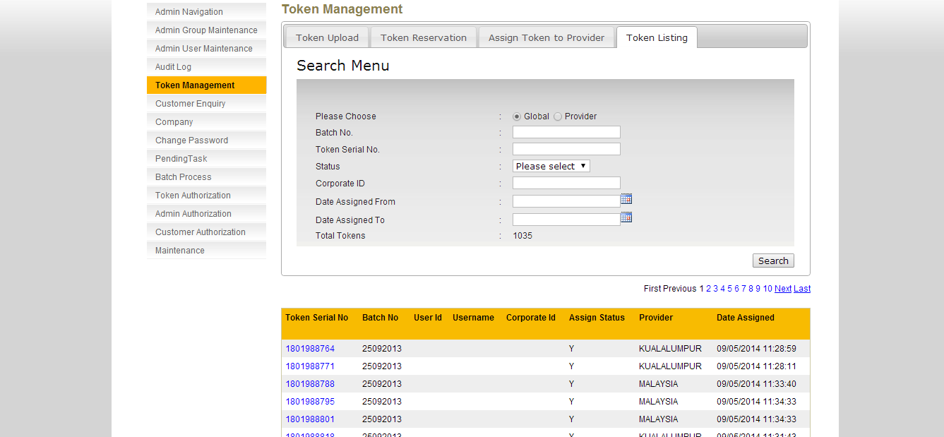

**Figure 1.12: Token Listing Enquiry Screen (Global)**

**Scenario 2:**

Select Global (default selected)

Status: Assigned

Click **Search**

Result: Token count under Global with Assigned Status

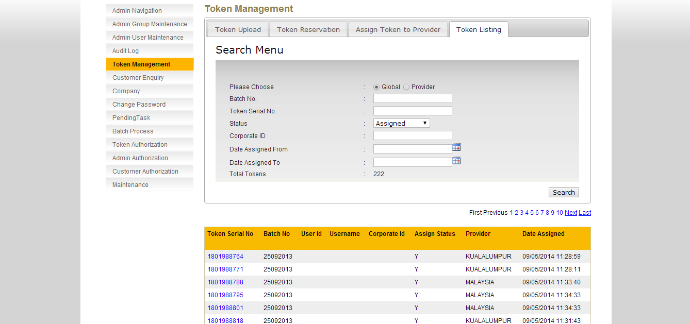

**Figure 1.13: Token Listing Enquiry Screen (Global)**

**Scenario 3:**

Select Global (default selected)

Status: Not Assigned

Click **Search**

Result: Token count with Not Assigned Status

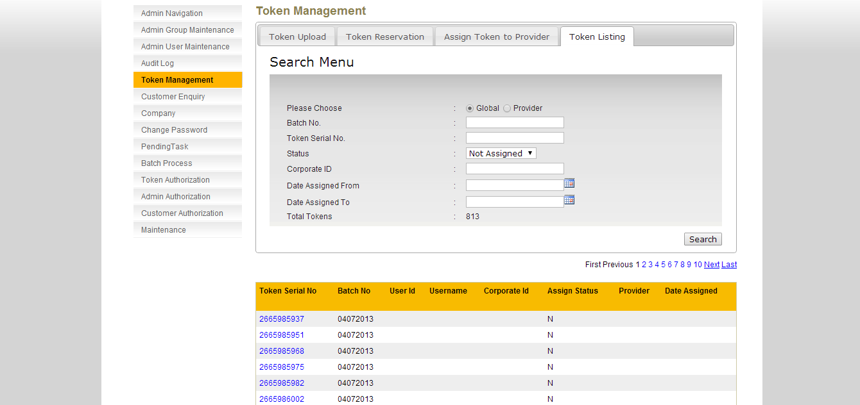

**Figure 1.14: Token Listing Enquiry Screen (Global)**

### Provider Layer

RCAS administrator can know Total Token in Provider Layer based on search criteria.

**Step 1:**

RCAS administrator can access to Token Management module by clicking on the **Token Listing** tab. Select **Provider** radio button.

**Scenario 1:**

Select Provider

Status: Please select (Not Assigned + Assigned + Booked) (default selected)

Result: Token count based on Status with Not Assigned and Assigned

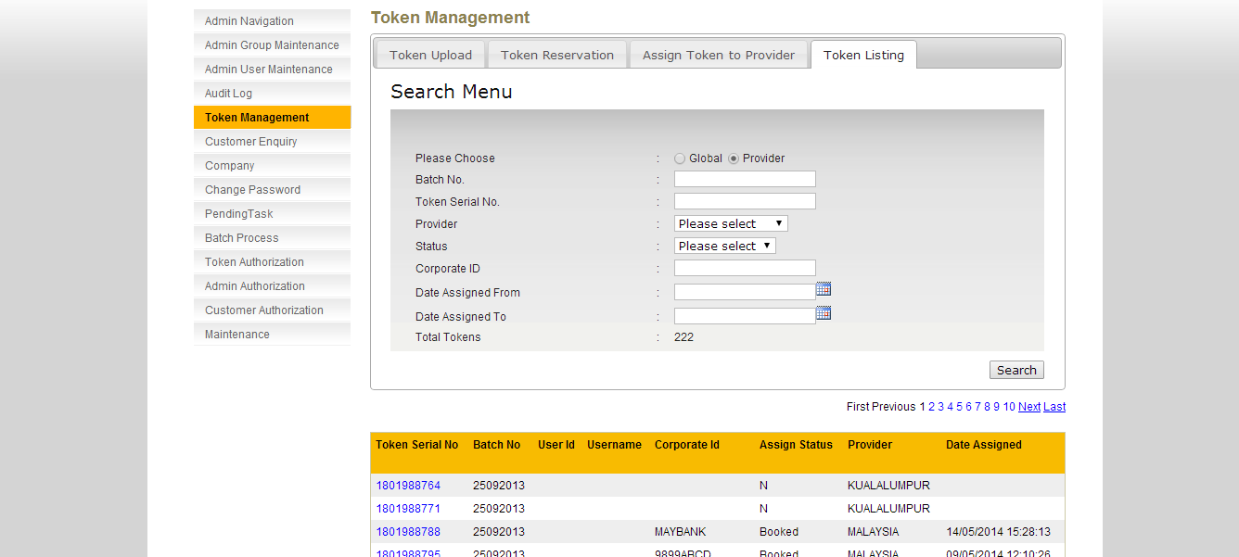

**Figure 1.15: Token Listing Enquiry Screen (Provider)**

**Scenario 2:**

Select Provider

Status: Assigned

Click **Search**

Result:Token count based on Status with Assigned

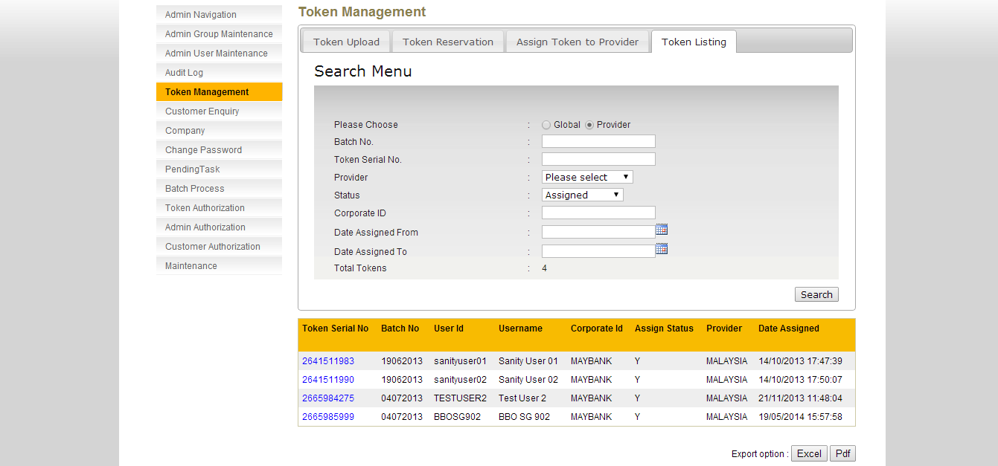

**Figure 1.16: Token Listing Enquiry Screen (Provider)**

**Scenario 3:**

Select Provider

Status: Not Assigned

Click **Search**

Result: Token count based on Status with Not Assigned

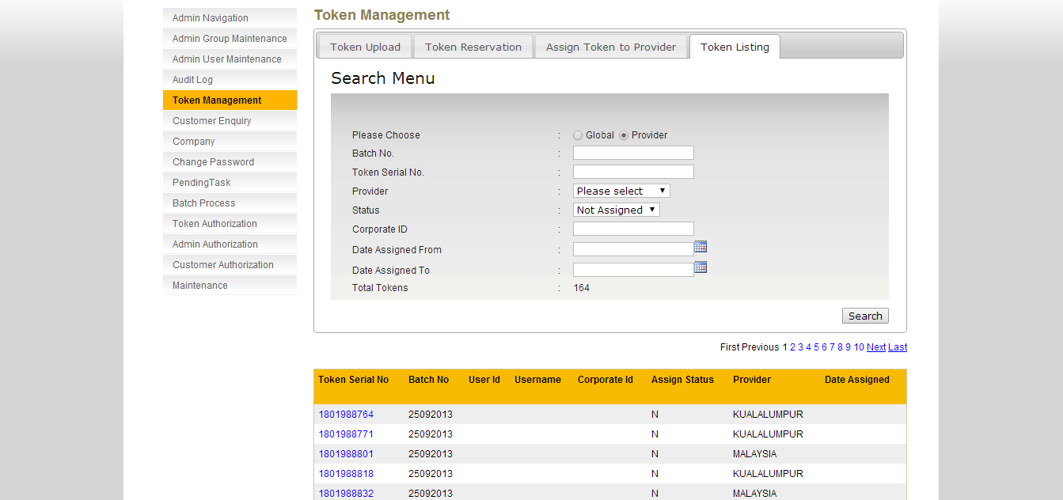

**Figure 1.17: Token Listing Enquiry Screen (Provider)**

**Scenario 4:**

Select Provider

Status: Booked

Click **Search**

Result: Token count based on Status with Booked

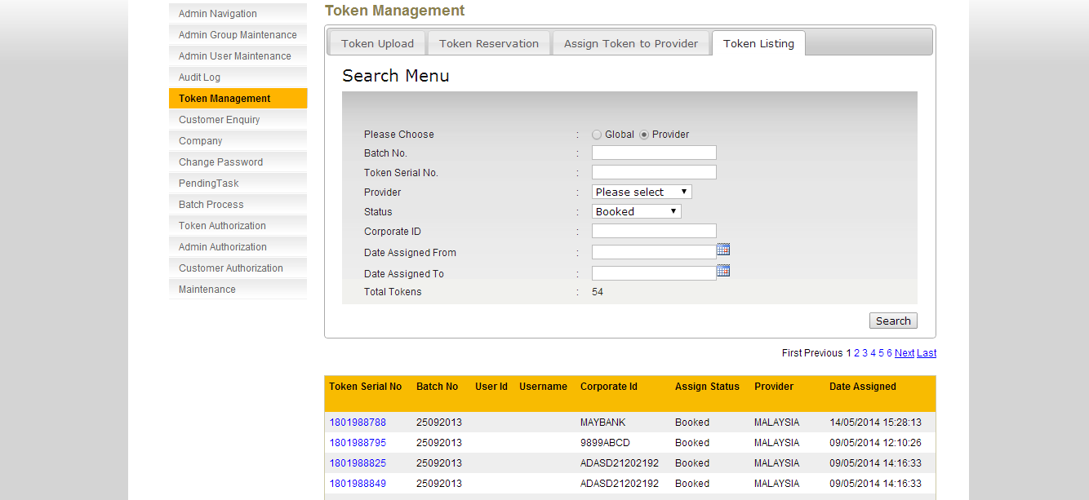

**Figure 1.18: Token Listing Enquiry Screen (Provider)**

# Token Cover Letter

## Print Token Cover Letter

This feature shall allow RCAS Administrator to print token cover letter.

**Step 1:**

RCAS administrator can access module by clicking on the Token Cover Letter link at the navigation menu.

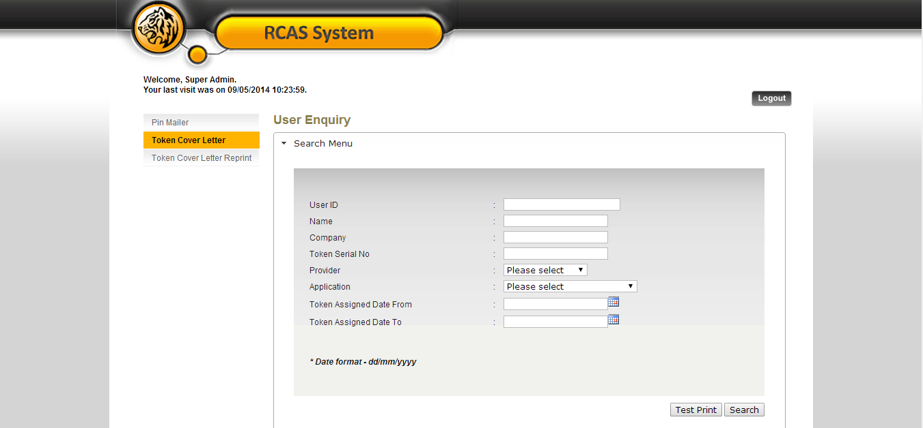

**Figure 2.1: Token Cover Letter User Enquiry Screen**

Click on **Test Print** to preview the sample format document.

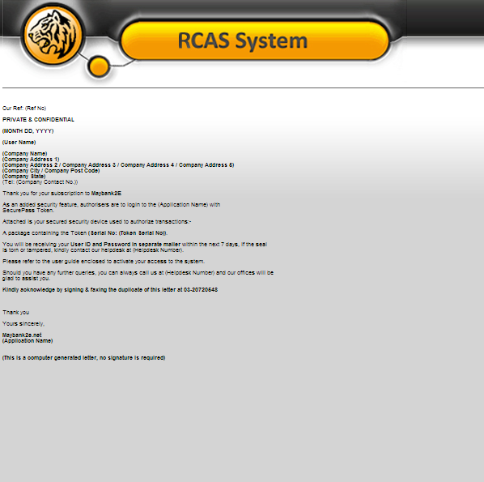

**Figure 2.2: Token Cover Letter Test Print Popup**

**Step 2:**

RCAS administrator can input User ID, Name, Company, Token Serial No, Provider, Application, Token Assigned Date From and Token Assigned Date To

|  |  |
| --- | --- |
| Field | Description |
| User ID | **25** characters maximum, alphanumeric. |
| Name | **40** characters maximum, alphanumeric. Could not accept special character except &'@ and space |
| Company | **30** characters maximum, alphanumeric. Could not accept special character except - / @ & ' . : ; |
| Token Serial No | **20** characters maximum, numeric. |
| Provider | Select provider from drop down list |
| Application | Select application from drop down list.   * **RCAS** * **e-Custody** * **e-Trade** * **RCMS** |
| Token Assigned Date From | Date format. (dd/MM/yyyy) |
| Token Assigned Date To | Date format. (dd/MM/yyyy) |

**Table 2.1: Token Cover Letter Input Fields Format**

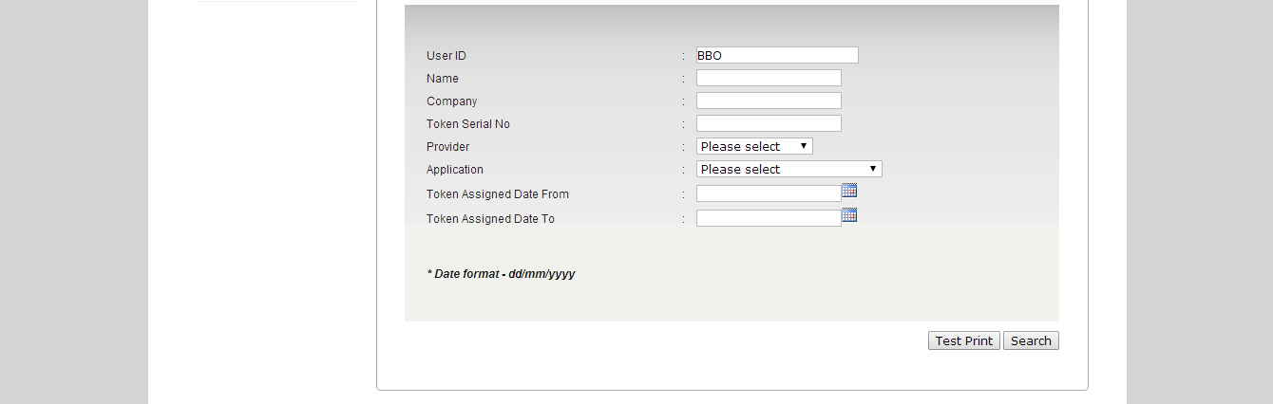

**Figure 2.3: Token Cover Letter User Enquiry with Input**

Click on **Search** button to proceed to the search result page.

**Step 3:**

The result page will show the list of the user based on the search criteria. If no fields is being input and a search is requested, RCAS will return a list of user with a pagination of 10 per page.

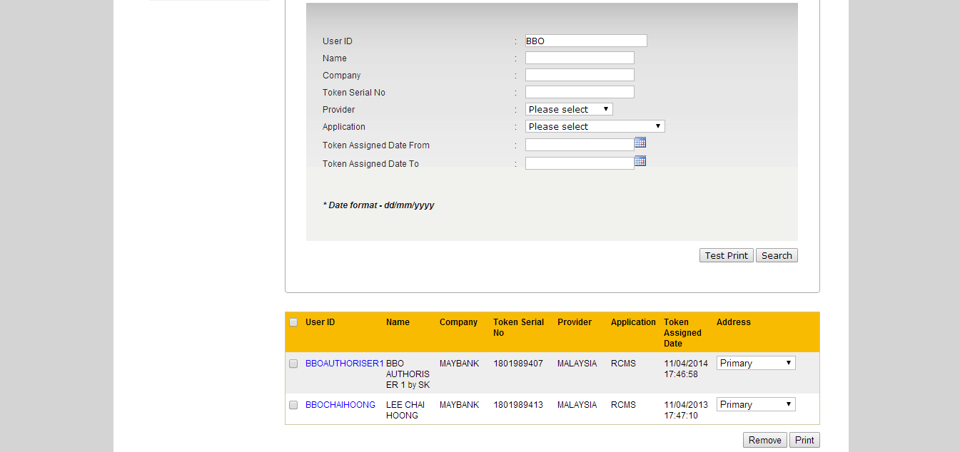

**Figure 2.4: Token Cover Letter User Enquiry Result Page**

**Step 4:**

Select the checkbox at the user enquiry result page to proceed to the printing and select either primary or correspondent address to be used. By default, RCAS will always use primary address. If the RCAS administrator selected correspondent address, RCAS will validate correspondent address1, correspondent address2 and correspondent address3, if correspondent address is empty, correspondent address will not be available for selection. Multiple prints are allowed. Click Print button

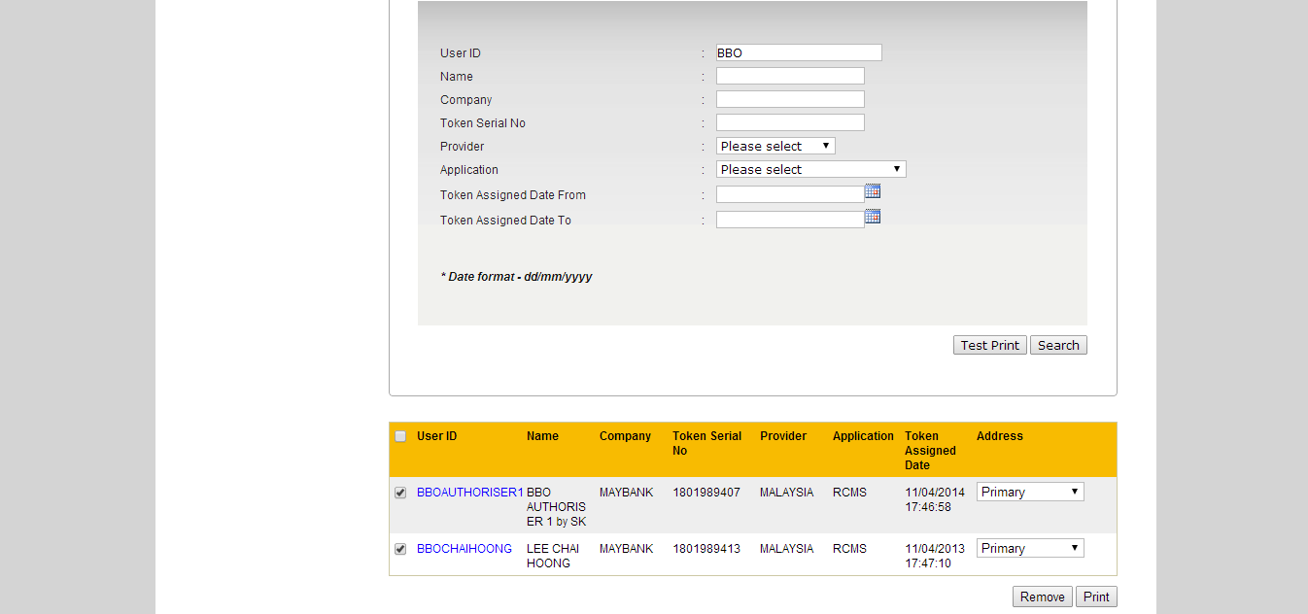

**Figure 2.5: Select User to be printed**

**Step 5:**

Confirmation screen shall display along with the summary of the user after printing has been completed. RCAS will generate an excel file upon the printing completion. RCAS administrator can save or cancel the excel file.

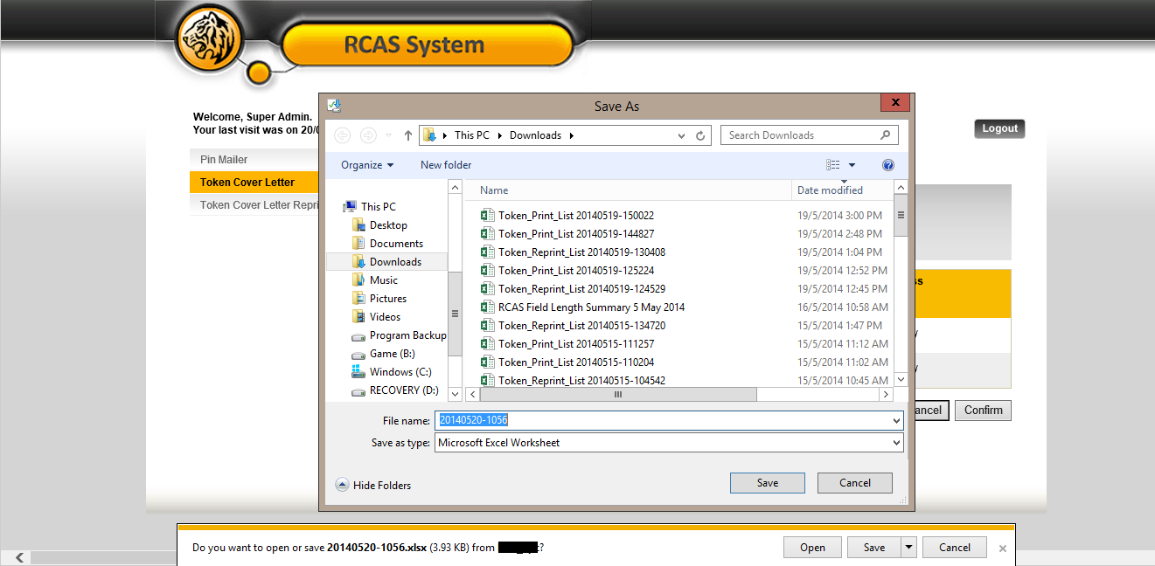

**Figure 2.6: Download Excel File Screen (Internet Explorer 11)**



**Figure 2.7: Sample Export File**

|  |  |
| --- | --- |
| Field | Description |
| User ID | User Alias |
| Attn | User Name |
| Company | Company Name |
| Contact No | User Mobile Number |
| Address1 | Primary Address 1 or Correspondent Address 1. Depends on selected address by RCAS administrator. |
| Address2 | Primary Address 2 or Correspondent Address 2. Depends on selected address by RCAS administrator. |
| Address3 | Primary Address 3 or Correspondent Address 3. Depends on selected address by RCAS administrator. |
| Address4 | Primary Address 4 or Correspondent Address 4. Depends on selected address by RCAS administrator. |
| Address5 | Primary Address 5 or Correspondent Address 5. Depends on selected address by RCAS administrator. |
| Postal Code | Primary Postal Code or Correspondent Postal Code. Depends on selected address by RCAS administrator. |
| City | Primary City or Correspondent City. Depends on selected address by RCAS administrator. |
| State | Primary State or Correspondent State. Depends on selected address by RCAS administrator. |
| Token No | Token Serial Number |

**Table 2.2: Token Cover Letter Excel File Fields**

**Step 6:**

Confirmation screen shall display along with the summary of the user after printing has been completed. RCAS administrator can **confirm** or **cancel** the task is completed. If **Cancel** is selected in the confirmation screen, the task in this queue will be available in enquiry page. Refer to step 8 if Cancel the task.

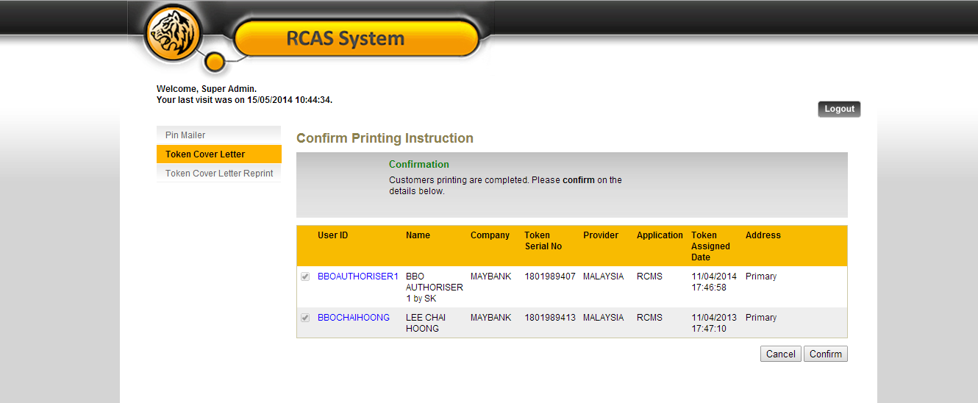

**Figure 2.8: Print Token Cover Letter Confirmation Screen**

**Step 7:**

A result page shall display the status of the request. Result page will also show the summary of the user that has been confirmed. **Confirmed** customers will be **removed** from printing **queue** and will be **queued** at **Token Cover Letter Reprint**.

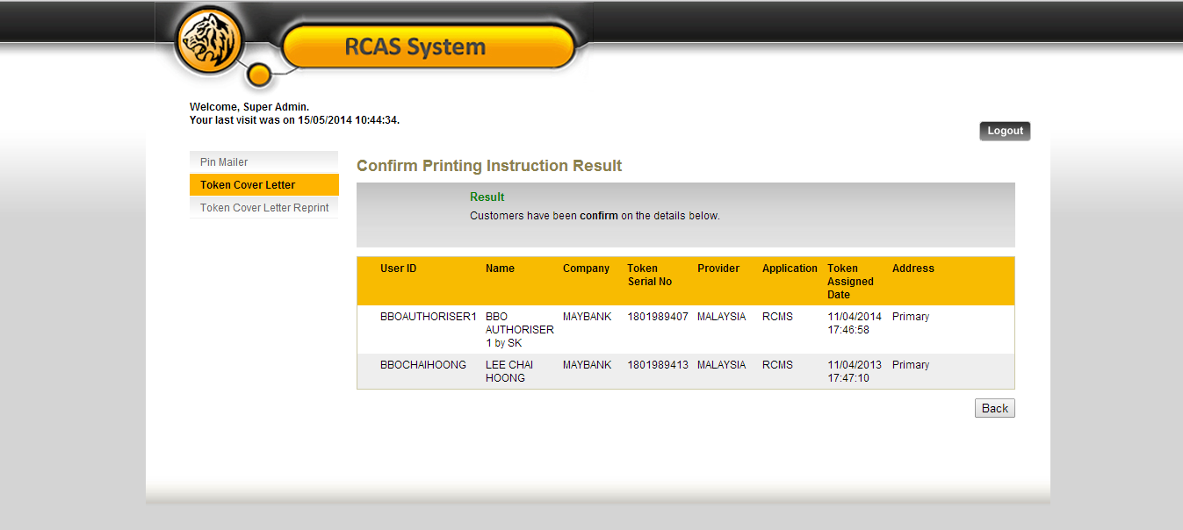

**Figure 2.9: Print Token Cover Letter Result Screen**

**Step 8:**

Confirmation screen shall display along with the summary of the user after printing has been completed. RCAS administrator can **confirm** or **cancel** the task is completed. If **Cancel** is selected in the confirmation screen, the task in this queue will be available in enquiry page. Sample screen of click Cancel the task.

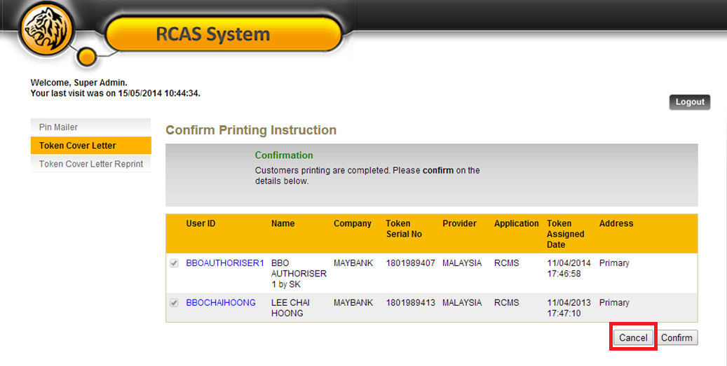

**Figure 2.10: Print Token Cover Letter Confirmation Screen**

**Step 9:**

The cancellation tasks will be return to Print Token Cover Letter Enquiry Page. It allows resubmitting the same task.



**Figure 2.111: Print Token Cover Letter enquiry page**

## Remove User from Print Queue

This feature shall allow RCAS Administrator to **remove user from token cover letter print queue**.

**Step 1:**

RCAS administrator can access module by clicking on the Token Cover Letter link at the navigation menu. Click Search to enquire for the users to remove from printing queue. Select the user to be remove from printing queue by using the checkbox and click on Remove.

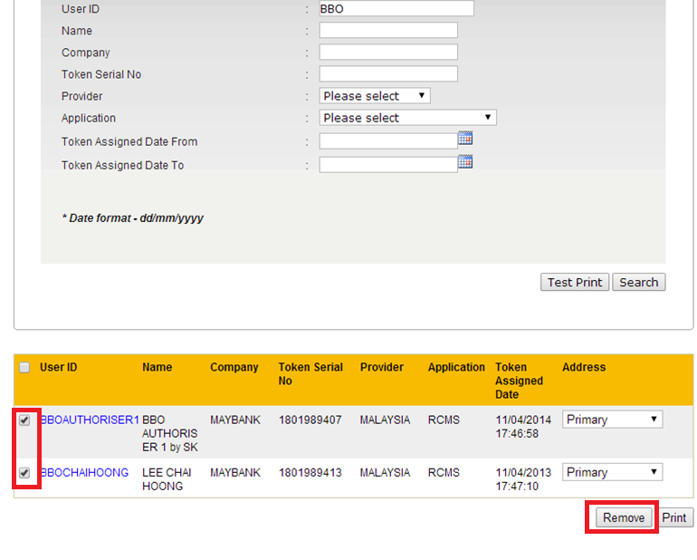

**Figure 2.12: Print Token Cover Letter User Enquiry Screen**

**Step 2:**

A confirmation screen will show the user details. Click Confirm to remove the user from printing queue or Cancel to select other user to be removed from printing queue.

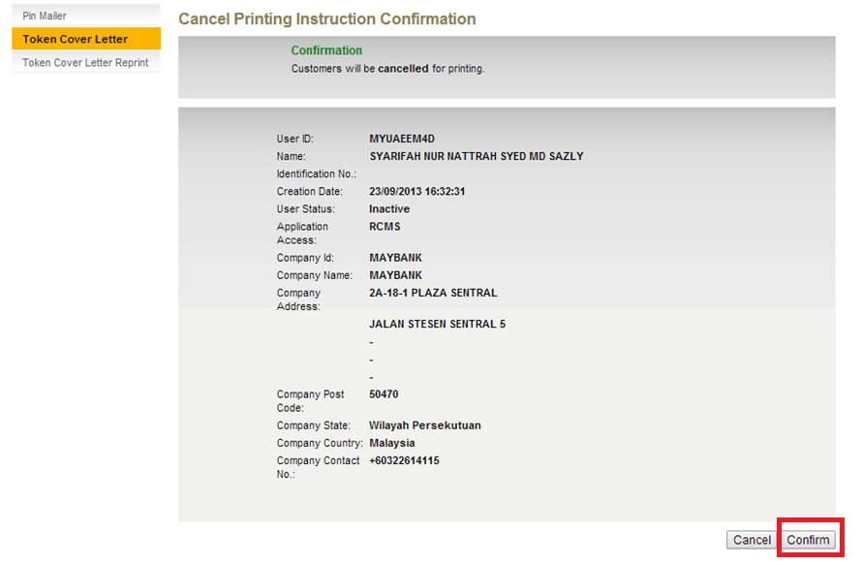

**Figure 2.13: Remove User from Token Cover Letter Printing Queue Confirmation Screen**

**Step 3:**

A result page will display the user’s details removed from printing queue. Users removed using Remove from printing queue will not be shown in Token Cover Letter Print or Token Cover Letter Reprint.

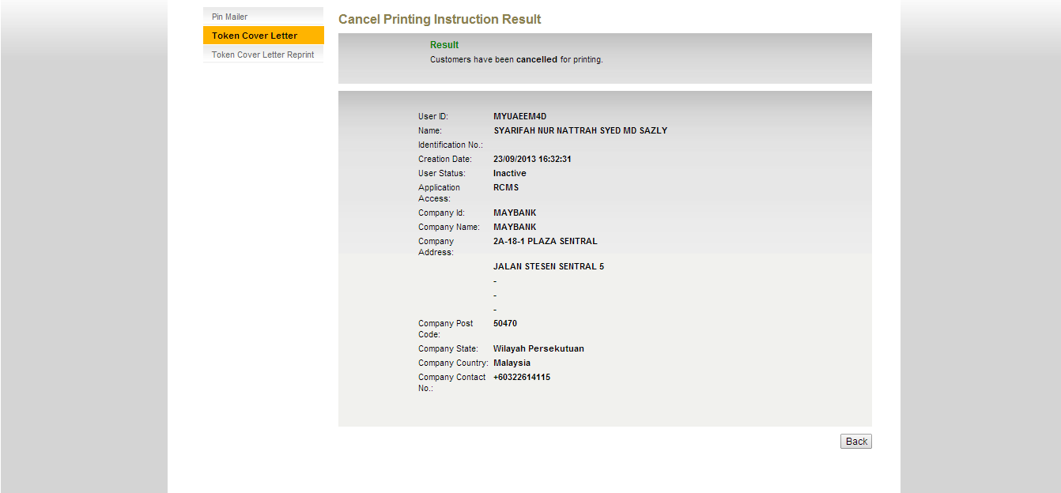

**Figure 2.14: Remove User from Token Cover Letter Printing Queue Result Screen**

# Token Cover Letter Reprint

This feature shall allow RCAS Administrator to **reprint** the customer token cover letter for those printed before.

**Step 1:**

RCAS administrator can access module by clicking on the **Token Cover Letter Reprint** link at the navigation menu.

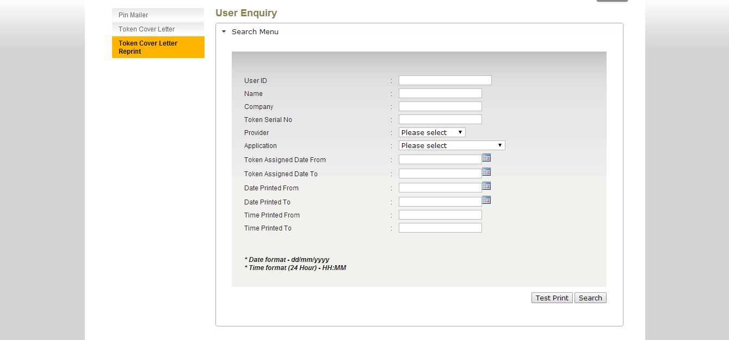

**Figure 3.1: Token Cover Letter Reprint Enquiry Screen**

**Step 2:**

RCAS administrator can input User ID, Name, Company, Token Serial No, Provider, Application, Token Assigned Date From and Token Assigned Date To

|  |  |
| --- | --- |
| Field | Description |
| User ID | **25** characters maximum, alphanumeric. |
| Name | **40** characters maximum, alphanumeric. Could not accept special character except &'@ and space |
| Company | **30** characters maximum, alphanumeric. Could not accept special character except - / @ & ' . : ; |
| Token Serial No | **20** characters maximum, numeric. |
| Provider | Select provider from drop down list |
| Application | Select application from drop down list.   * **RCAS** * **e-Custody** * **e-Trade** * **RCMS** |
| Token Assigned Date From | Date format. (dd/MM/yyyy) |
| Token Assigned Date To | Date format. (dd/MM/yyyy) |
| Date Printed From | Date format. (dd/MM/yyyy) |
| Date Printed To | Date format. (dd/MM/yyyy) |
| Time Printed From | HHMM |
| Time Printed To | HHMM |

**Table 3.1: Token Cover Letter Reprint Input Fields Format**

Click on **Search** button to proceed to the search result page.

**Step 3:**

The search result page will show the list of the user based on the search criteria. If no fields is being input and a search is requested, RCAS will return a list of user with a pagination of 10 per page. **If the token has been revoked or changed with another token, user will be removed from token reprint queue. Still checking with Keri**

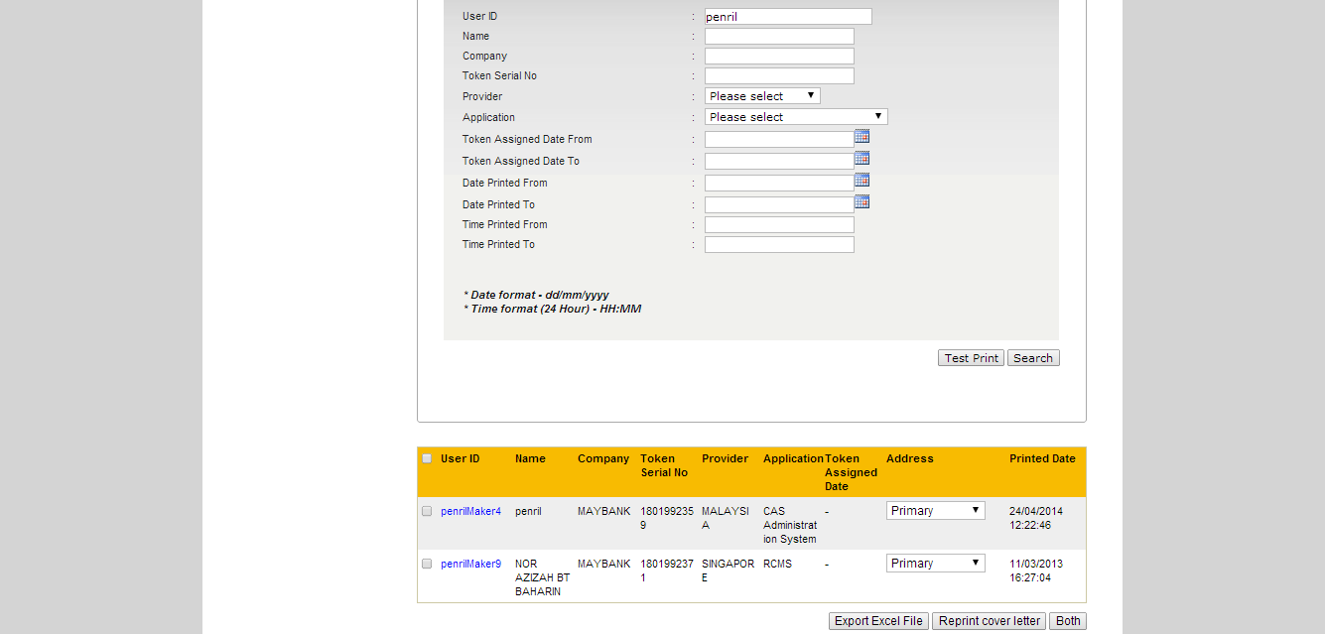

**Figure 3.2: Token Cover Letter Reprint Enquiry Result Screen**

**Step 4:**

Check on the checkbox at the user page to proceed to the printing and select either primary or correspondent address to be used. By default, RCAS will always use primary address. If RCAS administrator select correspondent address, RCAS will validate correspondent address1, correspondent address2 and correspondent address3, if correspondent address is empty, correspondent address will not be available for selection. Multiple print is allowed. User will be able to choose whether to reprint the token cover letter only, generate the excel file only or both.

During **Token Cover Letter Print**, if the RCAS administrator already selected correspondent address and completed the printing, then enquire the same user in reprint queue, the address is defaulted to what was selected during **Token Cover Letter Print**. However if RCAS administrator selects another address during reprint, the selected address will be defaulted in next enquiry of the user.

**Case 1:**

In **Token Cover Letter Print**, select correspondent address, printed with correspondent address.

In **Token Cover Letter Reprint**, will display correspondent address as default. If changed to primary address, reprinted with primary address.

Next enquiry in **Token Cover Letter Reprint**, will display primary address as default.

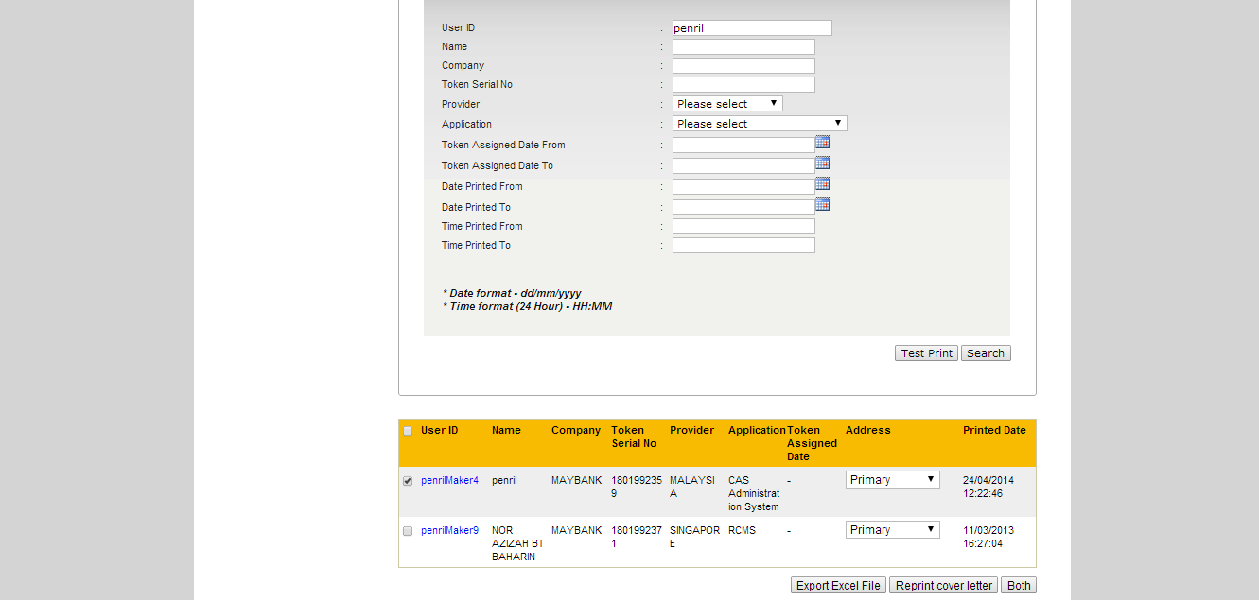

**Figure 3.3: Select User for Token Cover Letter Reprint**

**Step 5:**

* If RCAS administrator select **Export Excel File**, an Excel file will be generate with the details of selected user. Then RCAS administrator can choose to **Reprint Cover Letter** or **Both** or navigate to another modules.
* If RCAS administrator select **Reprint Cover Letter**, a confirmation screen will be displayed with user’s details.
* If RCAS administrator selects **Both**, token cover letter will be printed first, then an Excel file is generated. A confirmation screen will be displayed with user’s details.

In the confirmation screen, click **Confirm** to confirm the token cover letter is printed correctly. **Cancel** will allow to reselect the users for token cover letter reprint.

|  |  |
| --- | --- |
| Field | Description |
| User ID | User Alias |
| Attn | User Name |
| Company | Company Name |
| Contact No | User Mobile Number |
| Address1 | Primary Address 1 or Correspondent Address 1. Depends on selected address by RCAS administrator. |
| Address2 | Primary Address 2 or Correspondent Address 2. Depends on selected address by RCAS administrator. |
| Address3 | Primary Address 3 or Correspondent Address 3. Depends on selected address by RCAS administrator. |
| Address4 | Primary Address 4 or Correspondent Address 4. Depends on selected address by RCAS administrator. |
| Address5 | Primary Address 5 or Correspondent Address 5. Depends on selected address by RCAS administrator. |
| Postal Code | Primary Postal Code or Correspondent Postal Code. Depends on selected address by RCAS administrator. |
| City | Primary City or Correspondent City. Depends on selected address by RCAS administrator. |
| State | Primary State or Correspondent State. Depends on selected address by RCAS administrator. |
| Token No | Token Serial Number |

**Table 3.2: Token Cover Letter Reprint Excel File Fields**

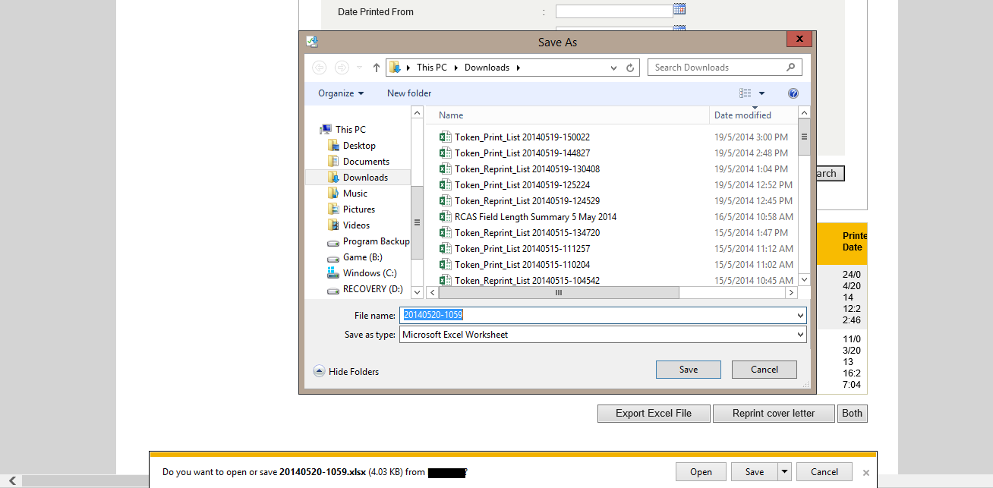

**Figure 3.4: Download Excel File Screen (Internet Explorer 11)**

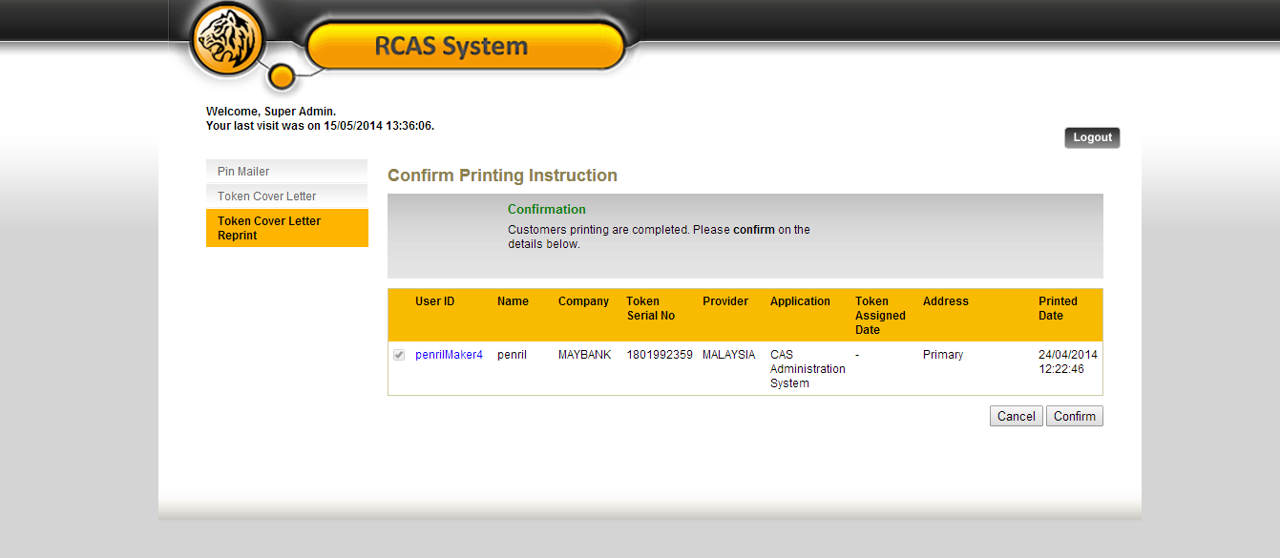

**Figure 3.5: Token Cover Letter Reprint Confirmation Screen**

**Step 6:**

A result page shall display the status of the request. Result page will also show the summary of the user that has been confirmed.

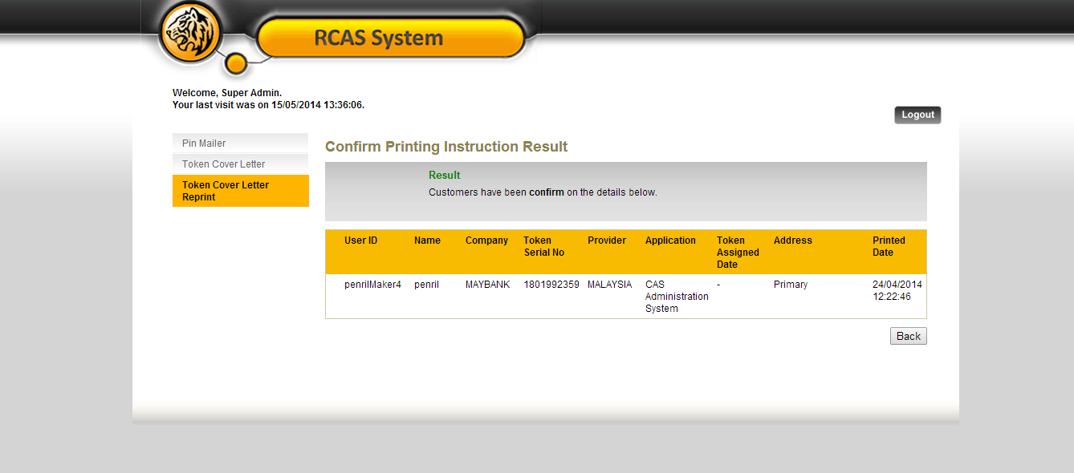

**Figure 3.6: Token Cover Letter Reprint Result Screen**

# Token Cover Letter Template

This feature shall allow RCAS Administrator to assigntoken cover letter template for different provider.

**Step 1:**

RCAS administrator can access module by clicking on **Maintenance** link at the navigation menu, click **Token Cover Letter Template** tab.

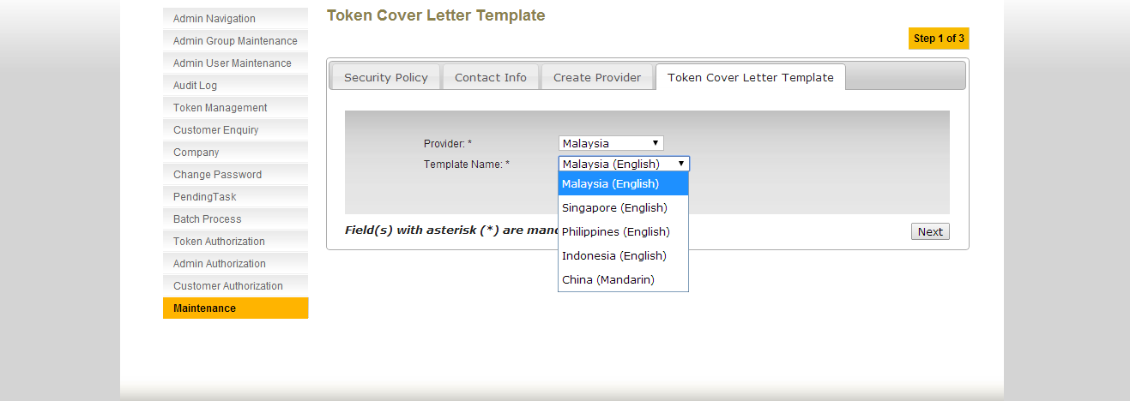

**Figure 4.1: Token Cover Letter Template Screen**

**Step 2:**

Select **Template Name** to be assigned to **Provider.** Click **Next** to proceed.

|  |  |
| --- | --- |
| Field | Description |
| Provider | Select from dropdown list. |
| Template Name | Select from dropdown list. Only for 5 template.   1. Malaysia (English) 2. Singapore (English) 3. Philippines (English) 4. Indonesia (English) 5. China (Mandarin) |

**Table 4.1: Token Cover Letter Template Input Fields Format**

**Step 3:**

A confirmation page is displayed with the sample of the selected template. Click **Confirm** to proceed assign template to provider.

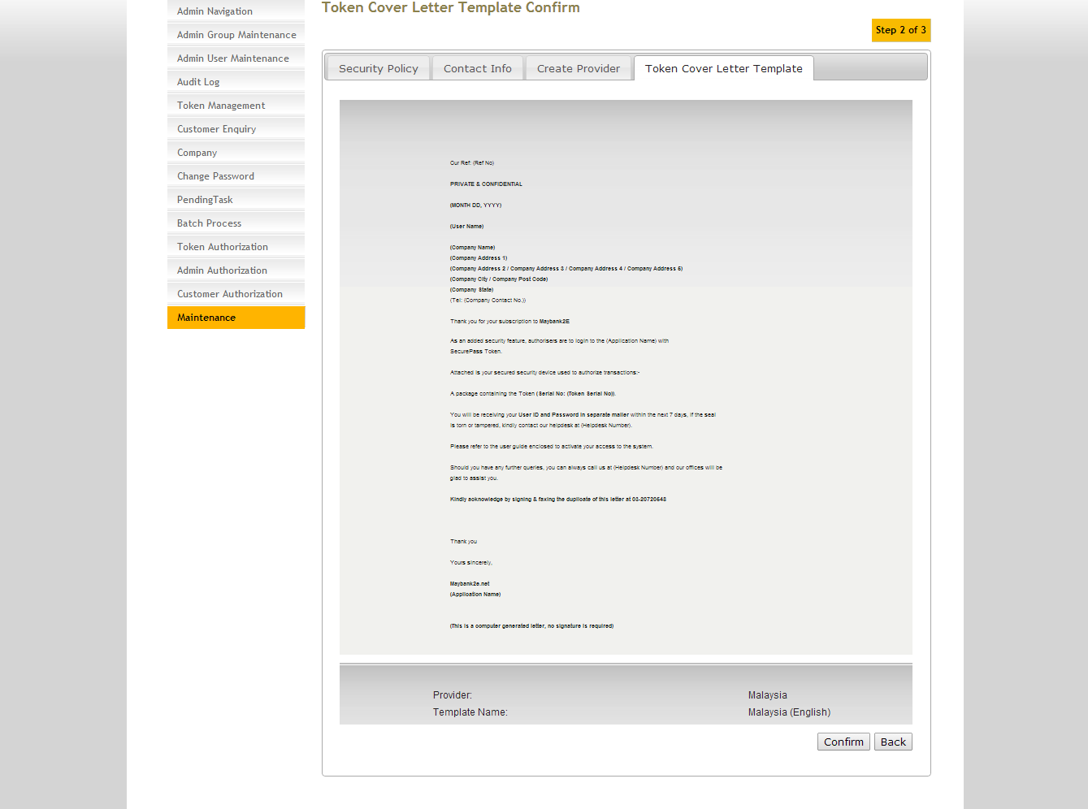

**Figure 4.2: Token Cover Letter Template Confirmation Screen**

**Step 4:**

A result page is with successful message is displayed.

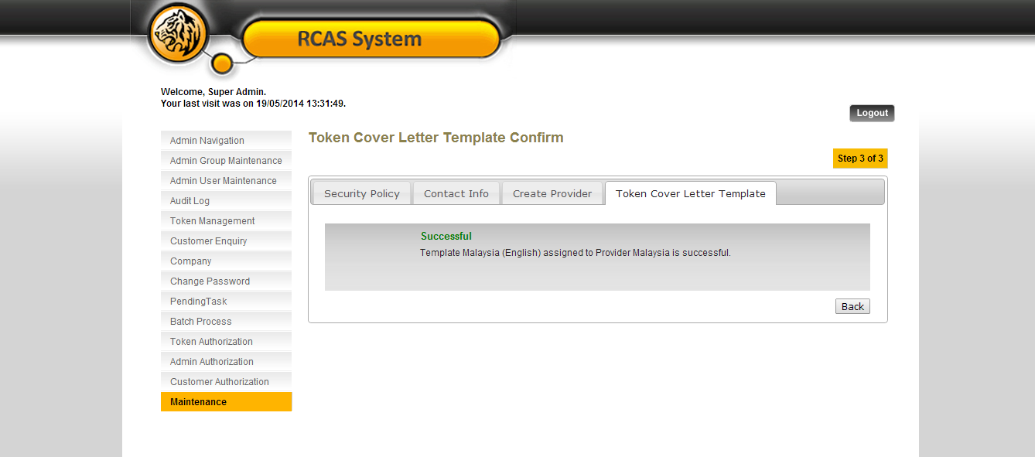

**Figure 4.3: Token Cover Letter Template Result Screen**

# Appendix

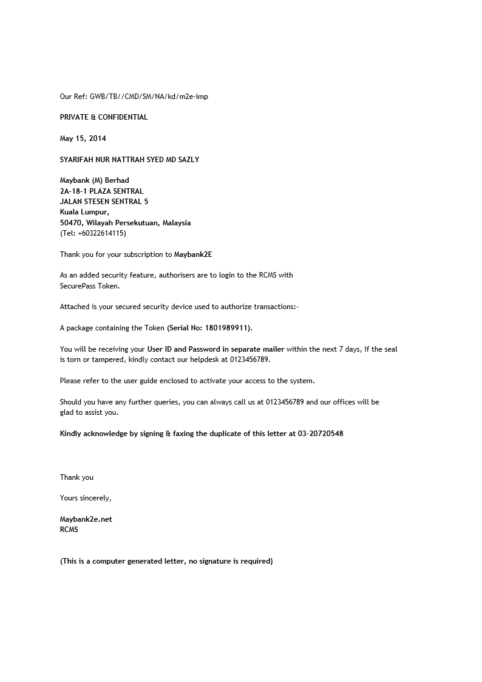

**Figure 5.1: Sample Token Cover Letter**