Task ID# 4438
Test Title: | RCAS FSD: Authorization
Test Description: | To approve / reject pending Item
Test Functionality: | - Token Authorization
Test Procedure: | - To request a Token Reservation approval
Test Result: | Pass: Fail: | Tested by: | Siti Norahayu Binti Mohd Desa (QA Engineer)
Reason for Failure:
Remarks: | TOKEN MANAGEMENT  Test Item 1: Maker request for Token Reservation  Result:  Request has been successfully send to Checker to approve or reject  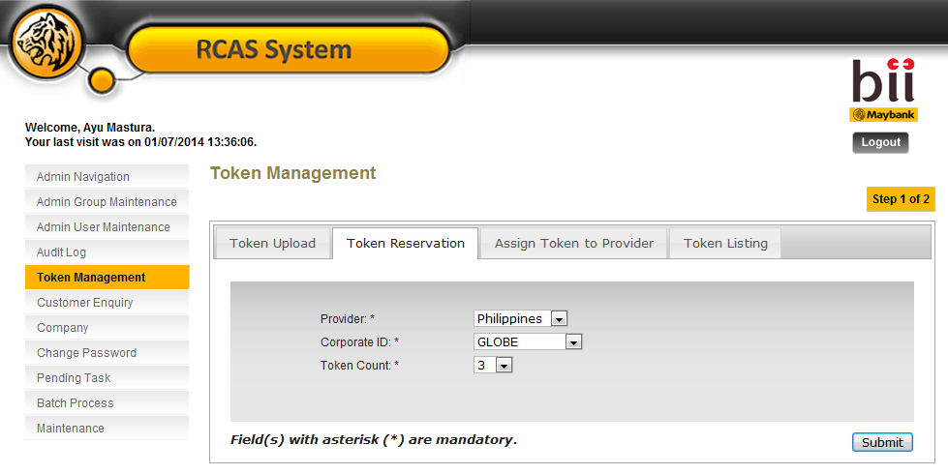  Figure 1: Token Reservation Details Screen  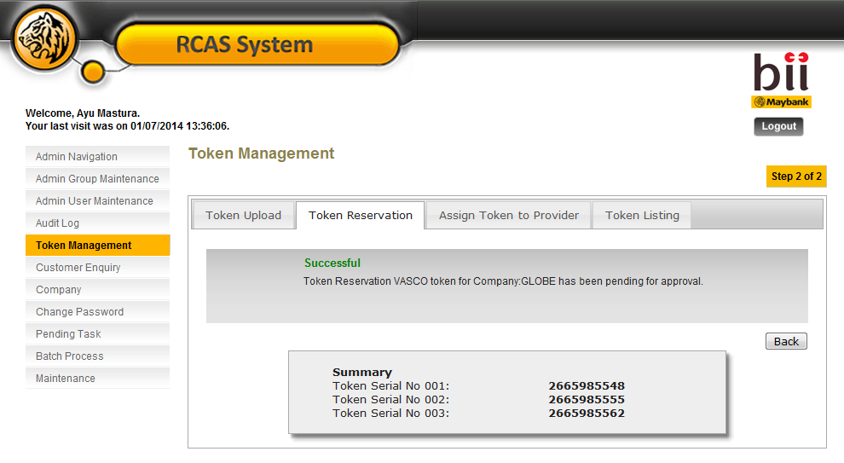  Figure 2: Token Reservation Result Screen  PENDING TASK  Test Item 2: Display Pending Item List  Result:  Successfully display Pending Item List  Figure 3: Pending item for Approval List Screen  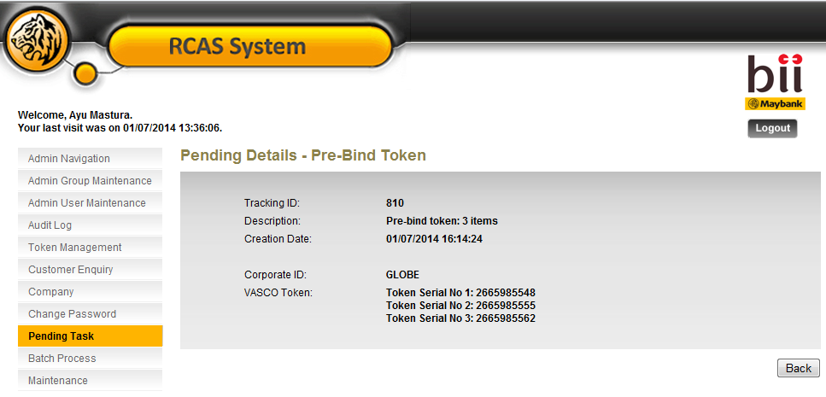  Figure 4: Pending Details Screen  TOKEN AUTHORIZATION  Test Item 3: Display Authorization Pending List  Result:  Successfully display Pending Authorization Item List  Normal Approval  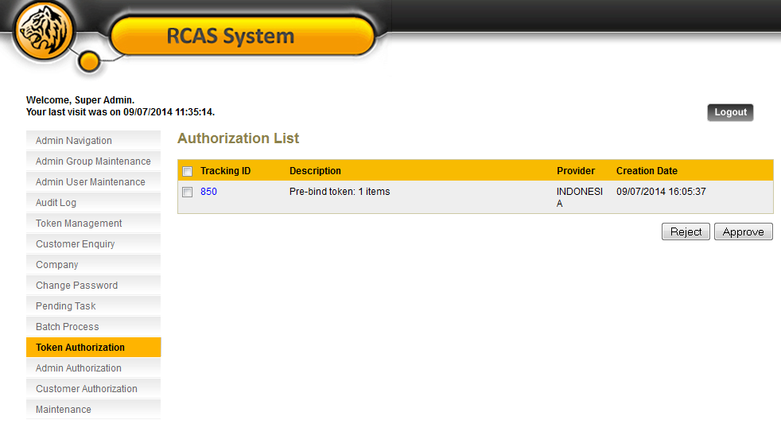  Figure 5: Token Authorization List Screen  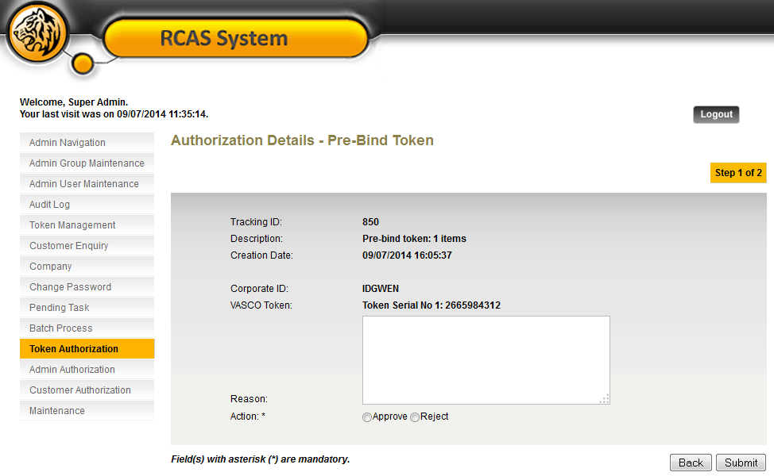  Figure 6: Token Authorization Details Screen  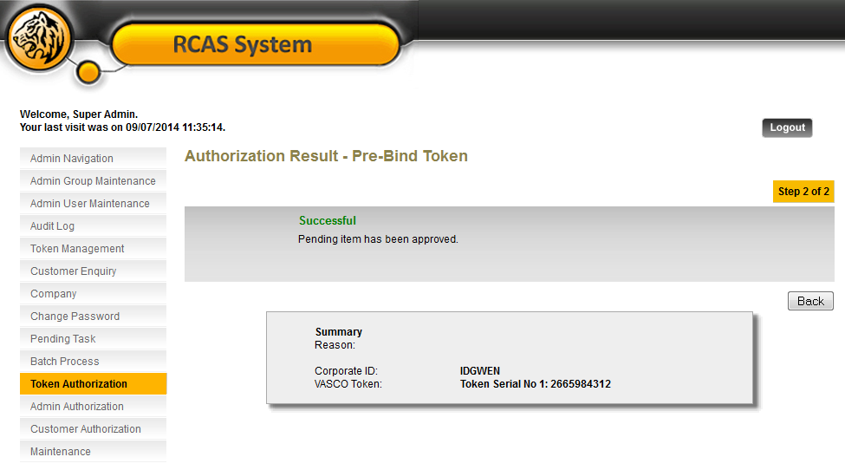  Figure 7: Token Authorization Result Screen  Single Approval  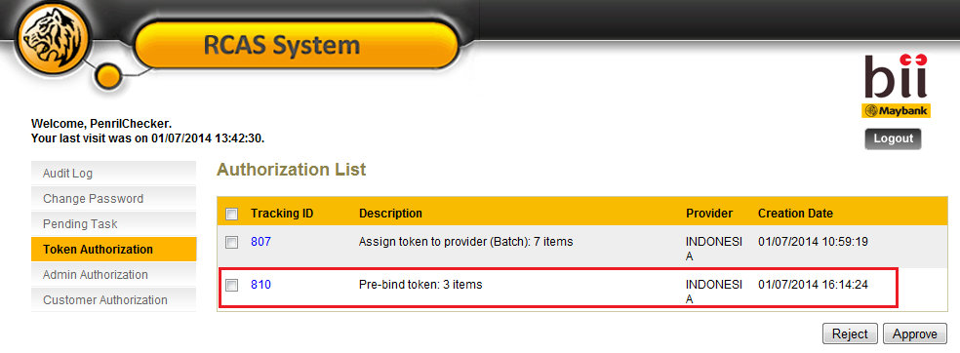  Figure 8: Token Authorization List Screen  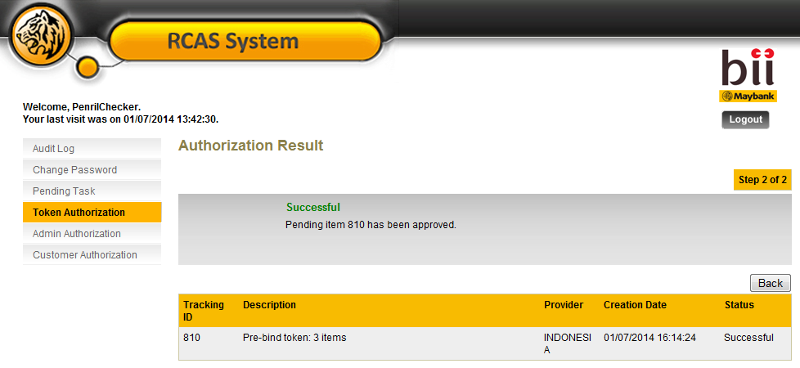  Figure 9: Token Authorization Result Screen  Multiple Approval  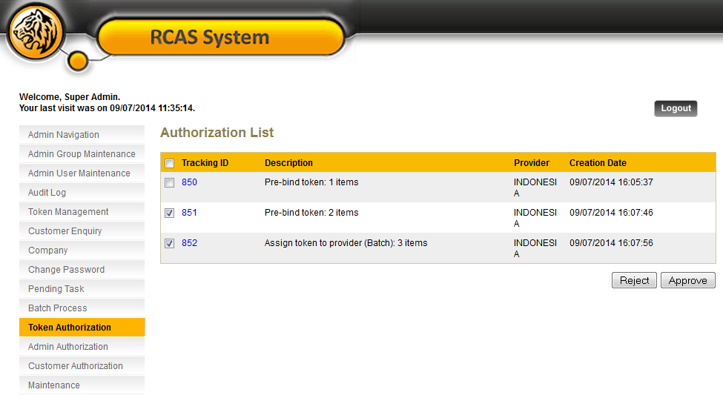  Figure 10: Token Authorization List Screen  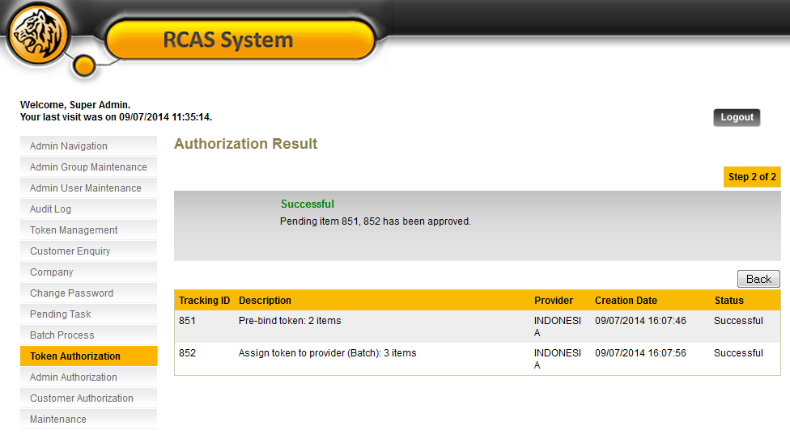  Figure 11: Token Authorization Result Screen  AUDIT TRAIL  Test Item 4: To check on the Authorization Log  Result:  Successfully display every Authorization Log  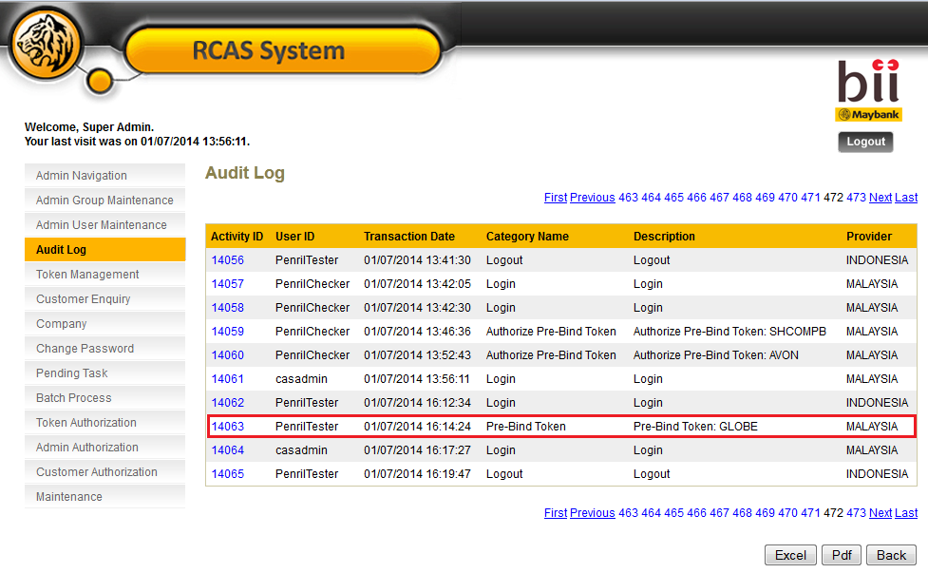  Figure 12: Audit Log List Screen (Maker)  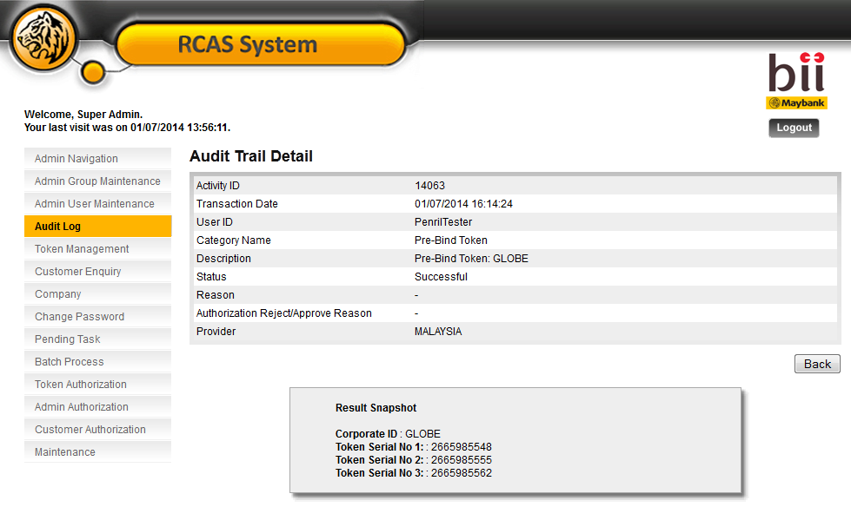  Figure 13: Audit Log Details Screen  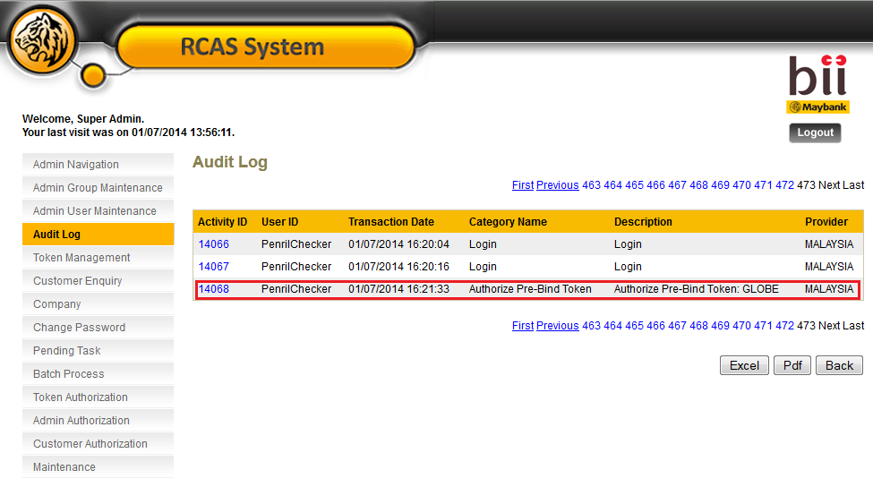  Figure 14: Audit Log List Screen (Checker)  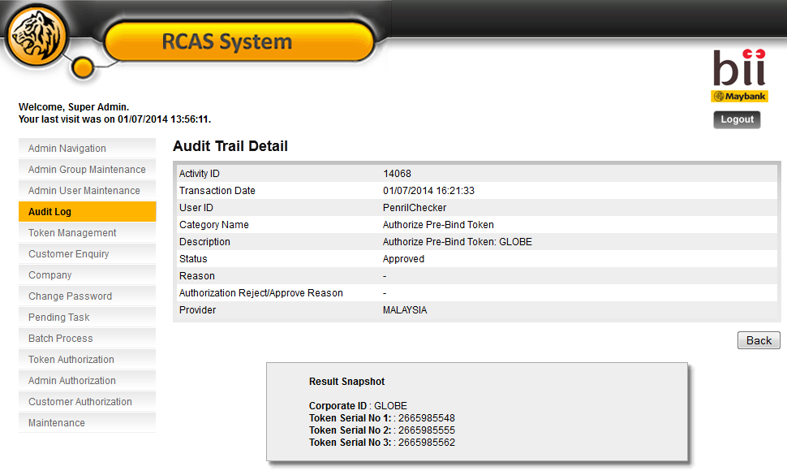  Figure 15: Audit Log Details Screen

