Task ID# 4438
Test Title: | RCAS FSD: Authorization
Test Description: | To approve / reject pending Item
Test Functionality: | - Admin Authorization
Test Procedure: | - To enable Admin User Status  - To make an Authorization with single and multiple selection.
Test Result: | Pass: Fail: | Tested by: | Siti Norahayu Binti Mohd Desa (QA Engineer)
Reason for Failure:
Remarks: | ADMIN USER MAINTENANCE  Test Item 1: Maker enable Admin User Status  Result:  Request has been successfully send to Checker to approve or reject  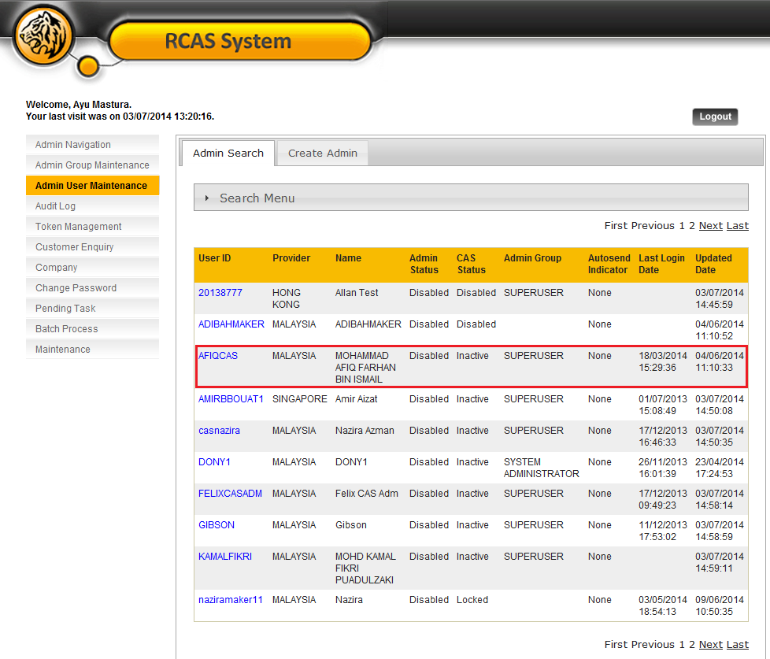  Figure 1: Admin User Maintenance List Screen  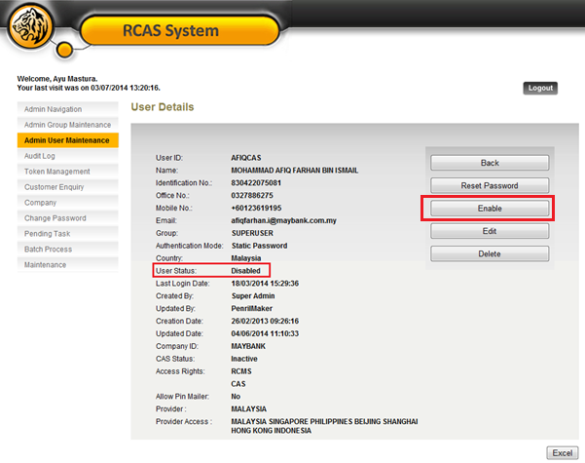  Figure 2: Admin User Maintenance Details Screen  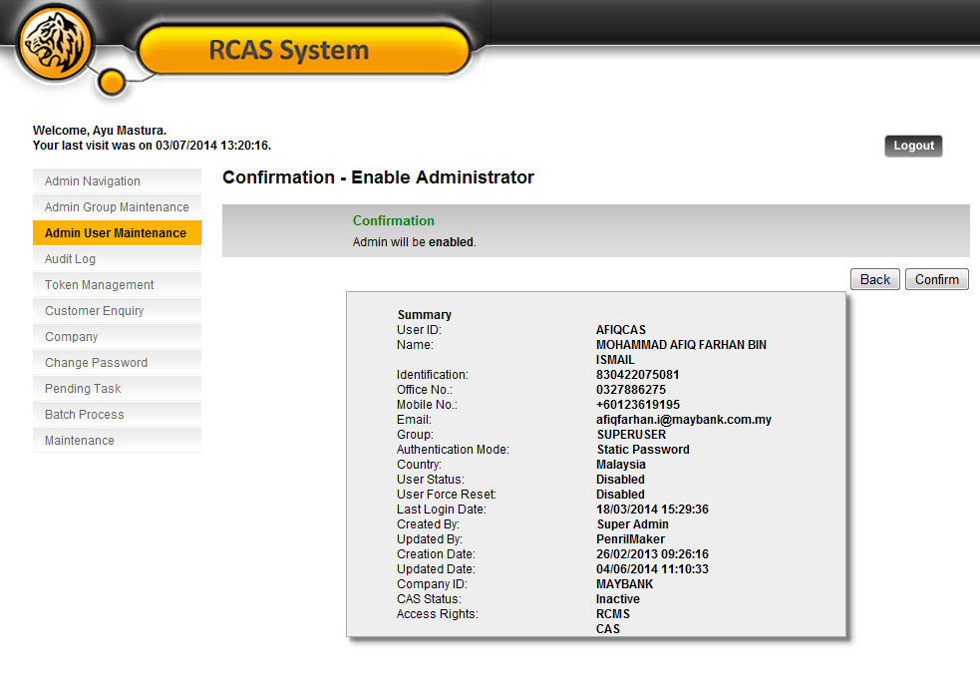  Figure 3: Admin User Maintenance Confirmation Screen  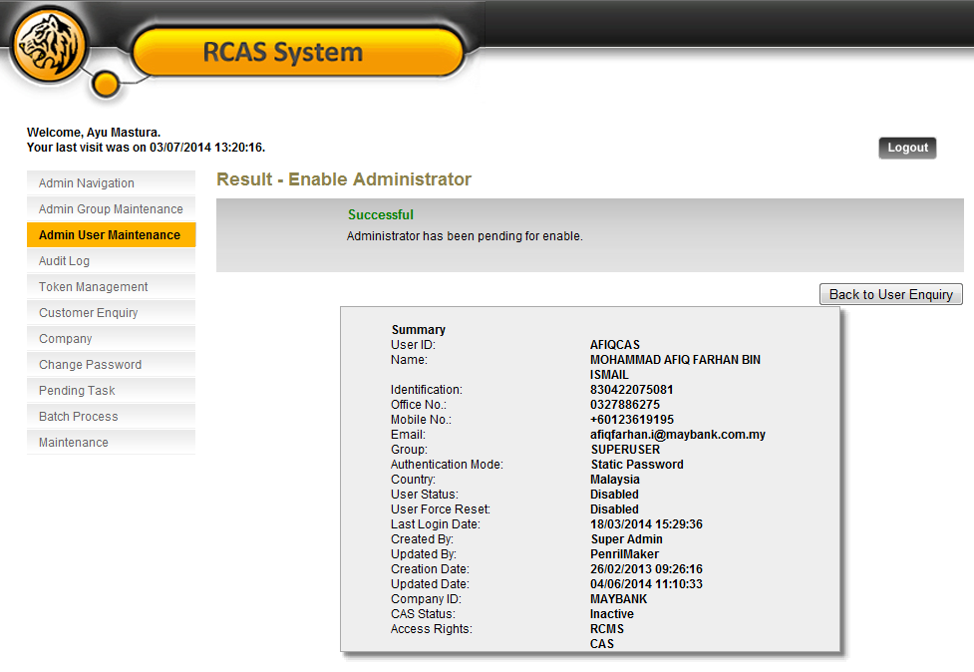  Figure 4: Admin User Maintenance Result Screen  PENDING TASK  Test Item 2: Maker performed an activity and the pending list will shown at Pending Task  Result:  Successfully display Pending Item List  Figure 5: Pending item for Approval List Screen  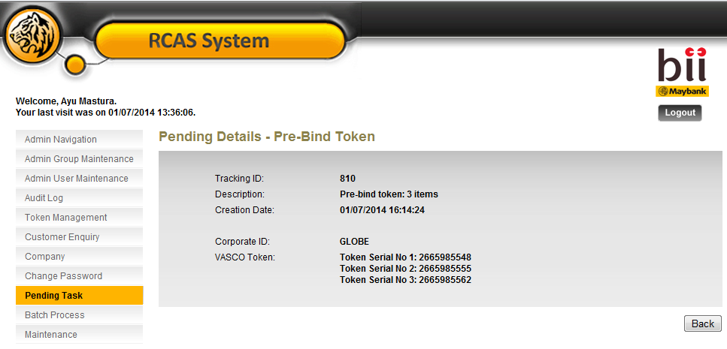  Figure 6: Pending Details Screen  ADMIN AUTHORIZATION  Test Item 3: Display Authorization Pending List with 3 method of Authorization  Result:  Successfully display Pending Authorization Item List  Normal Approval  Figure 7: Token Authorization List Screen  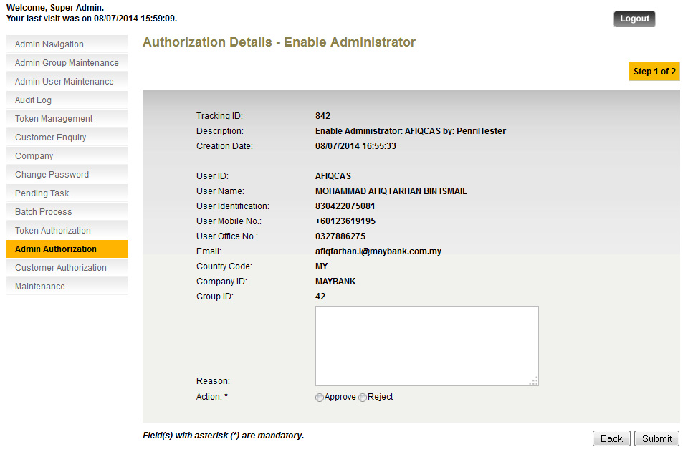  Figure 8: Token Authorization Details Screen  Single Approval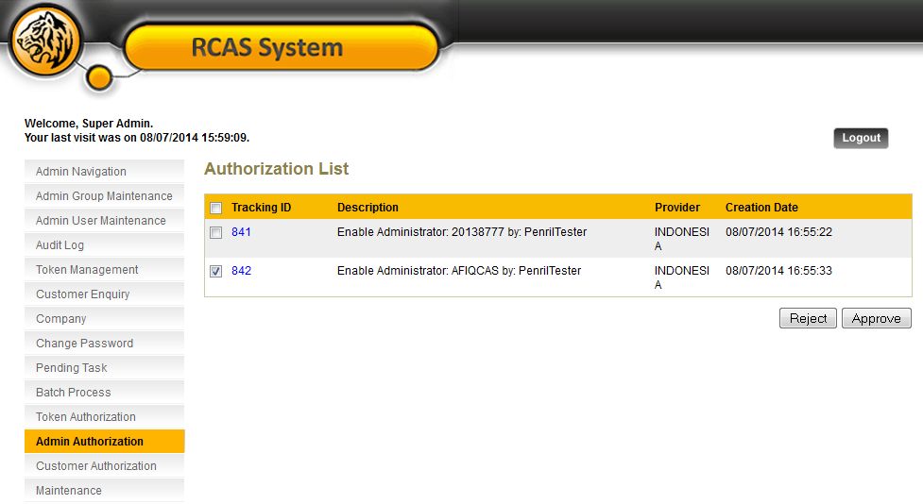  Figure 9: Token Authorization List Screen  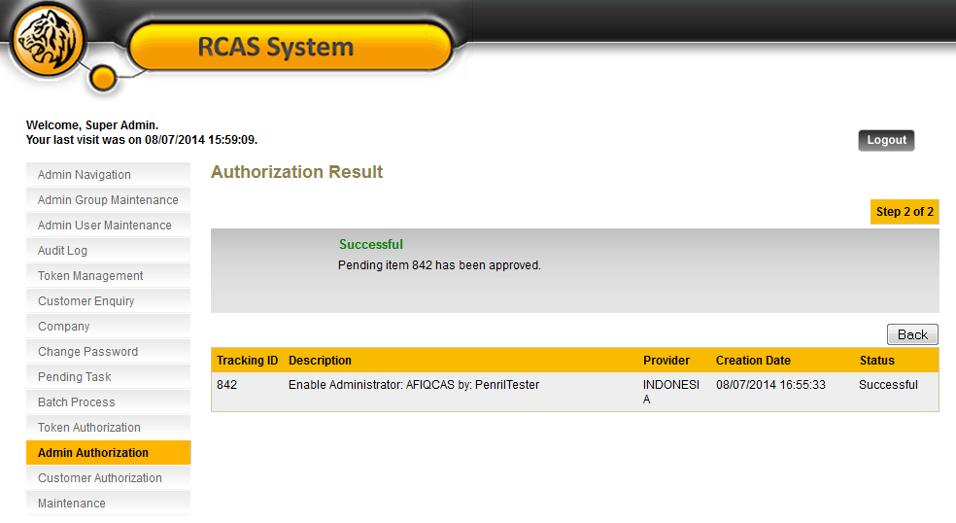  Figure 10: Token Authorization Details Screen  Multiple Approval  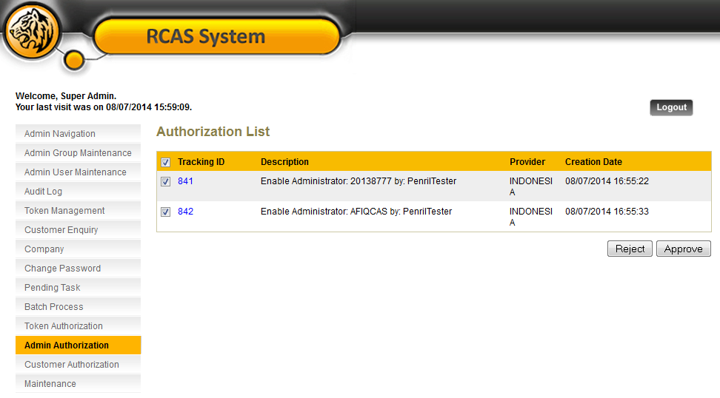  Figure 11: Token Authorization List Screen  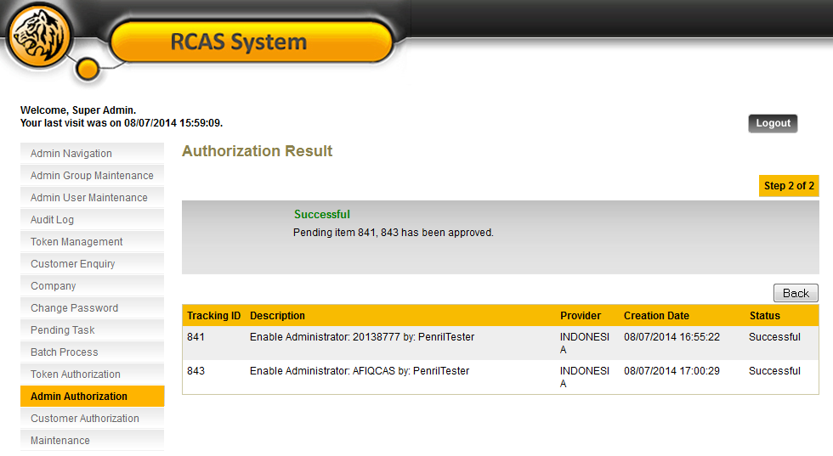  Figure 12: Token Authorization Result Screen  AUDIT TRAIL  Test Item 4: To check all activities was log in Audit Log  Result:  Successfully display every Authorization Activities Log  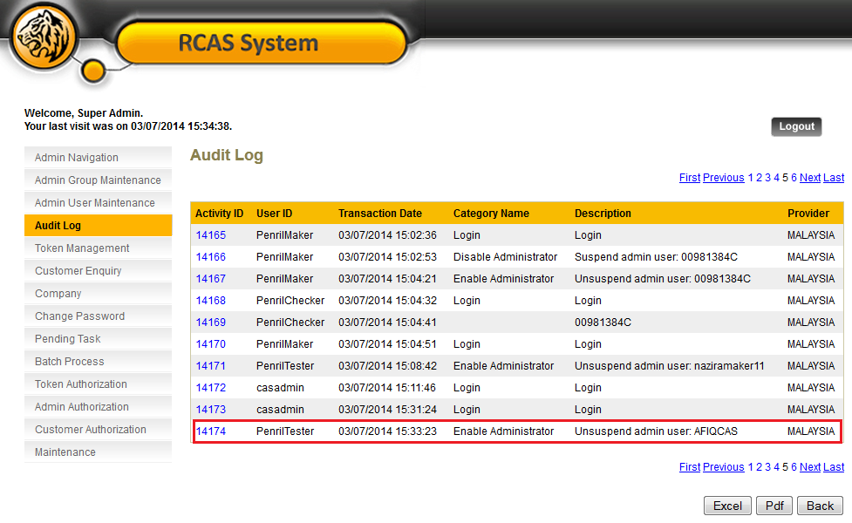  Figure 13: Audit Log List Screen (Maker)  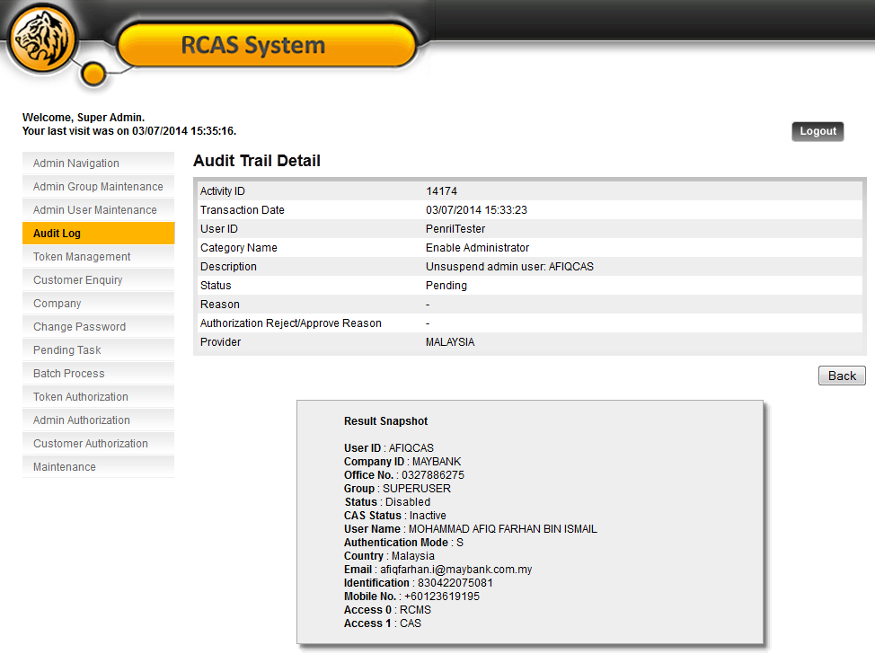  Figure 14: Audit Log Details Screen  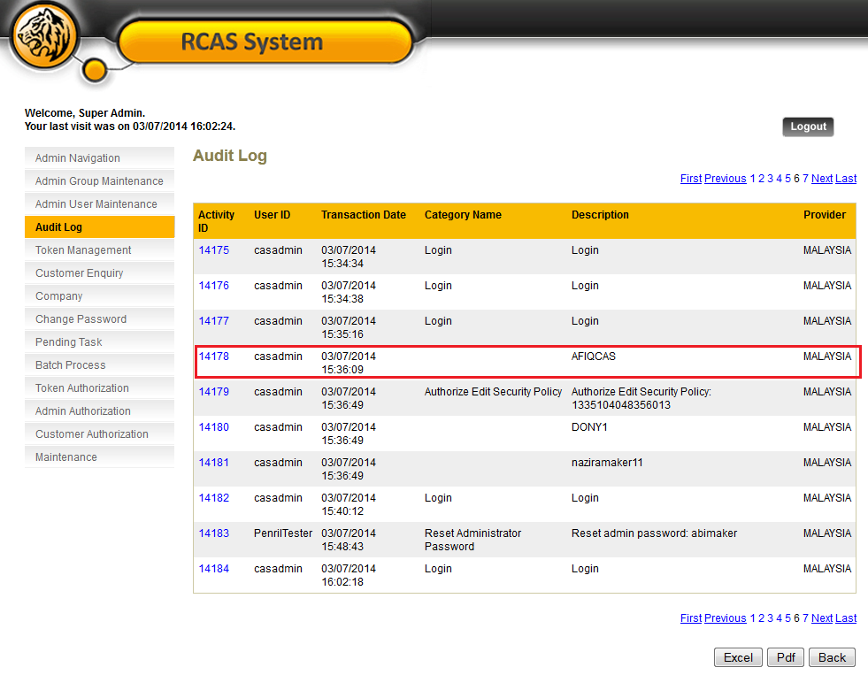  Figure 15: Audit Log List Screen (Checker)  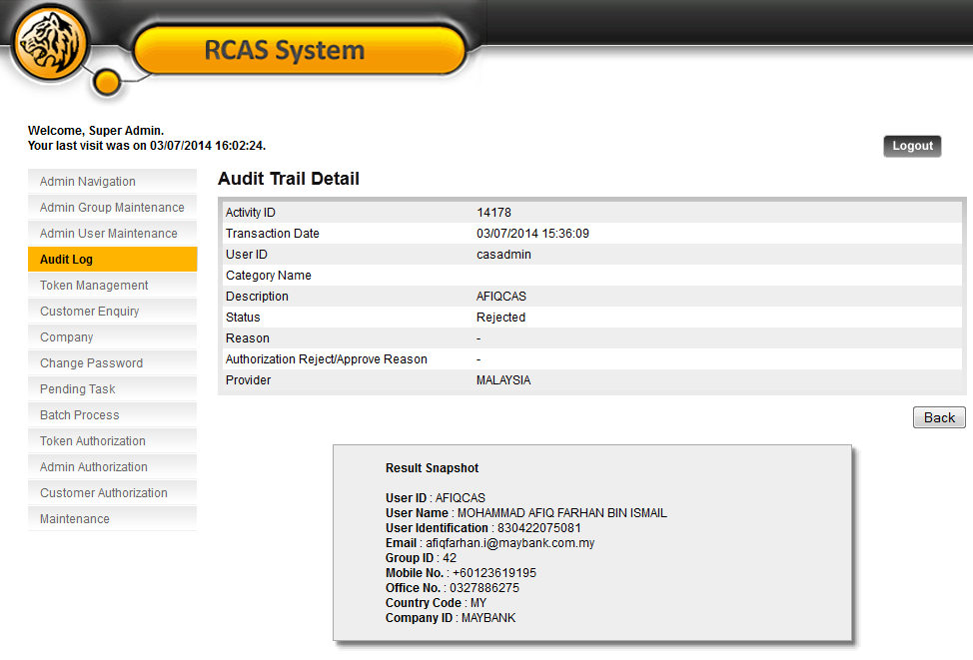  Figure 16: Audit Log Details Screen

