Task ID# 4438
Test Title: | RCAS FSD: Authorization
Test Description: | To approve / reject pending Item
Test Functionality: | - Customer Authorization
Test Procedure: | - To Delete Organization
Test Result: | Pass: Fail: | Tested by: | Siti Norahayu Binti Mohd Desa (QA Engineer)
Reason for Failure:
Remarks: | COMPANY  Test Item 1: Maker search Organization by Provider  Result:  Successfully display Search Organization details page  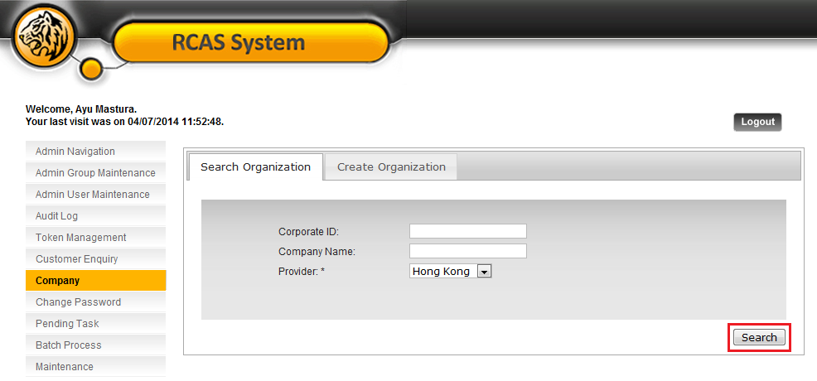  Figure 1: Search Organization Details Screen  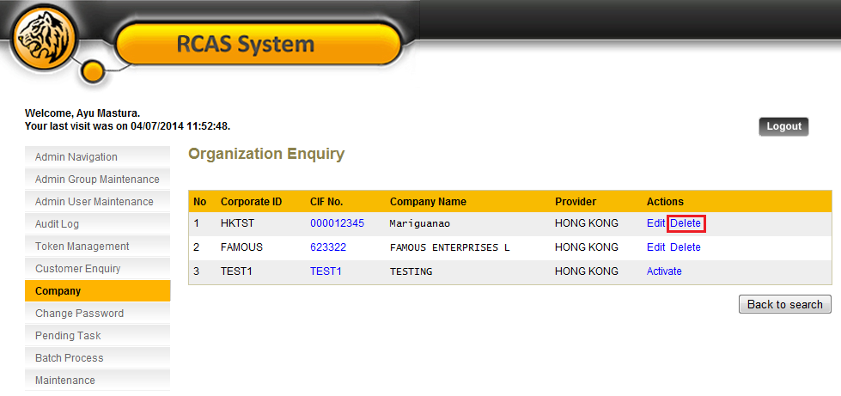  Figure 2: Organization Enquiry List Screen  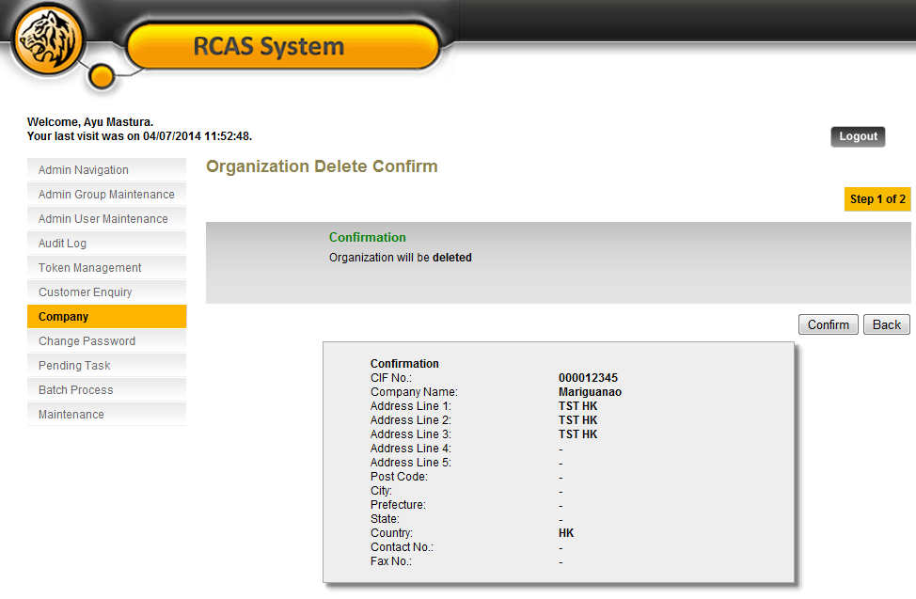  Figure 3: Organization Enquiry Confirmation Screen  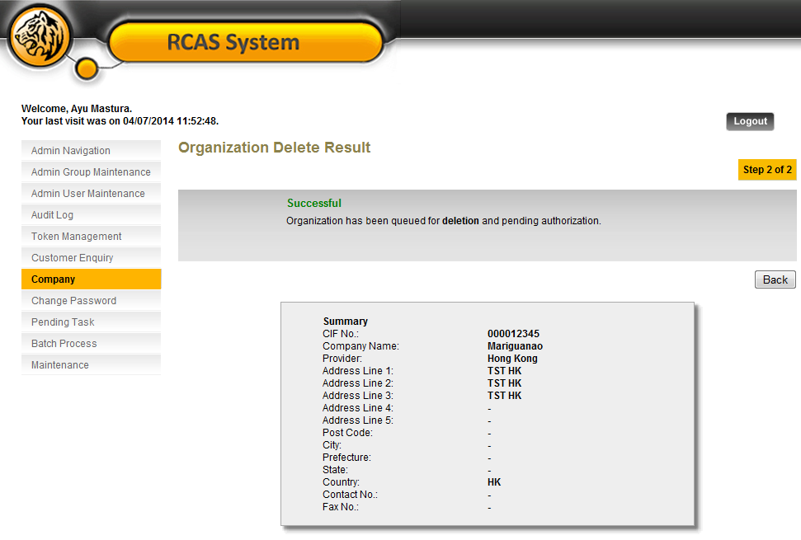  Figure 4: Organization Enquiry Result Screen  PENDING TASK  Test Item 2: Display Pending Item List  Result:  Successfully display Pending Item List  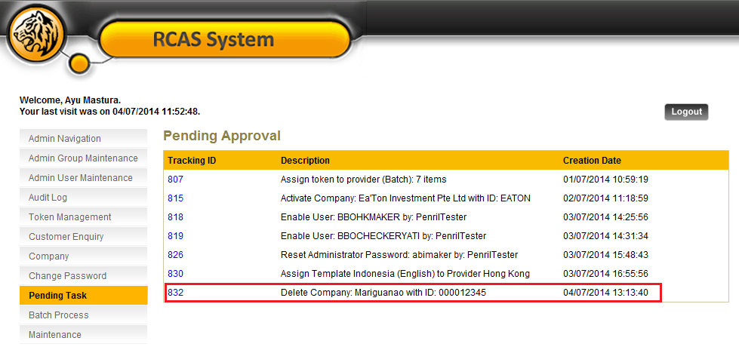  Figure 5: Pending item for Approval List Screen  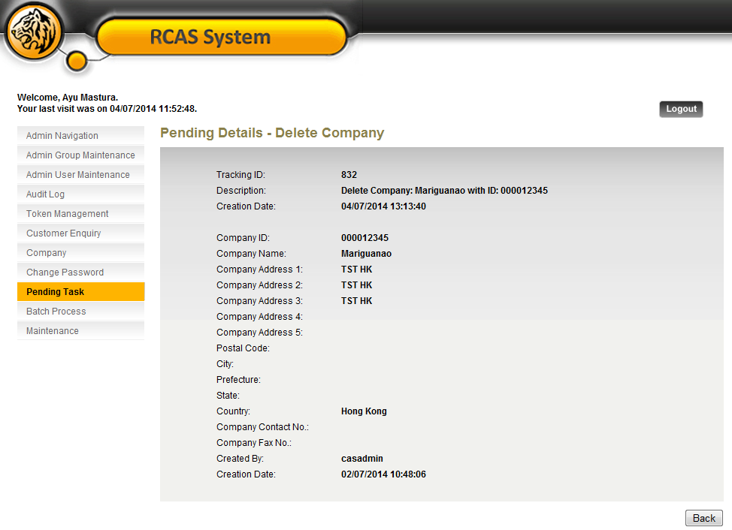  Figure 6: Pending Details Screen  CUSTOMER AUTHORIZATION  Test Item 3: Display Authorization Pending List  Result:  Successfully display Pending Authorization Item List  Normal Approval  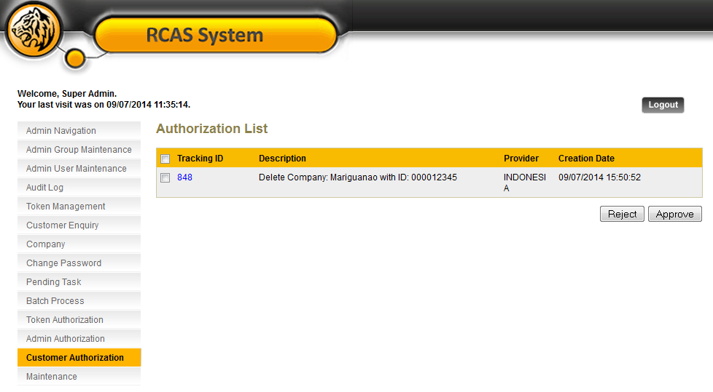  Figure 7: Customer Authorization Pending List Screen  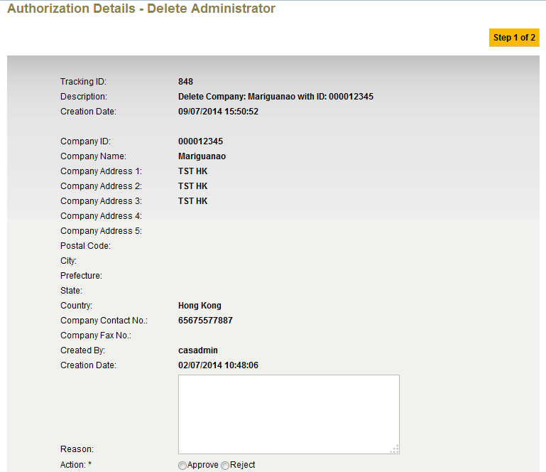  Figure 8: Customer Authorization Details Screen  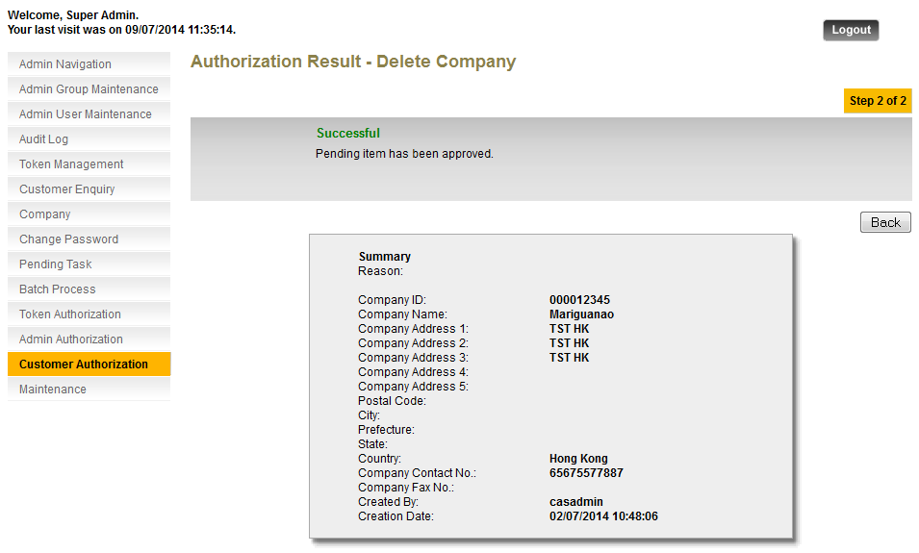  Figure 9: Customer Authorization Result Screen  Single Approval  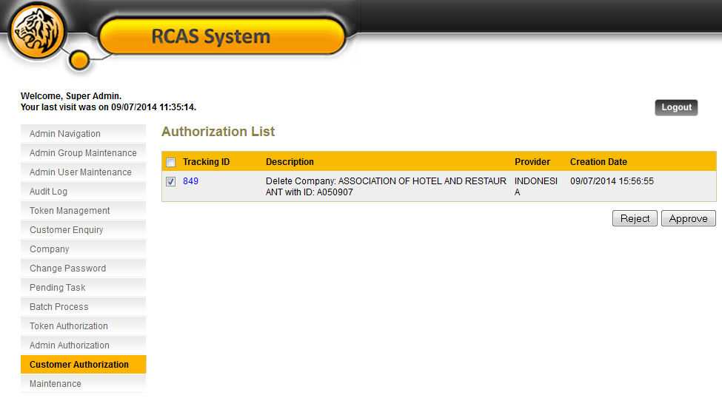  Figure 10: Customer Authorization List Screen  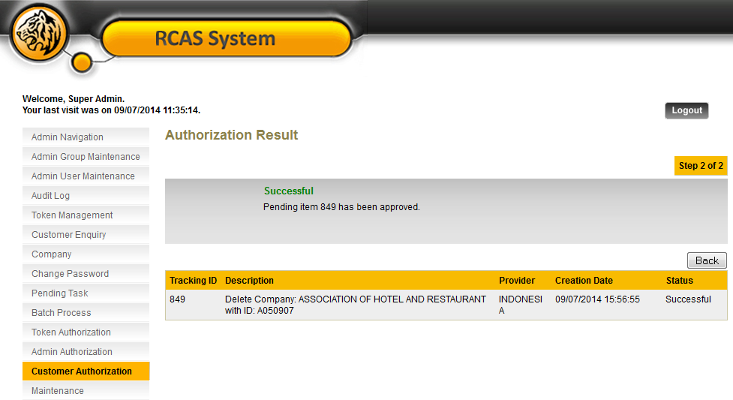  Figure 11: Customer Authorization Details Screen  Multiple Approval  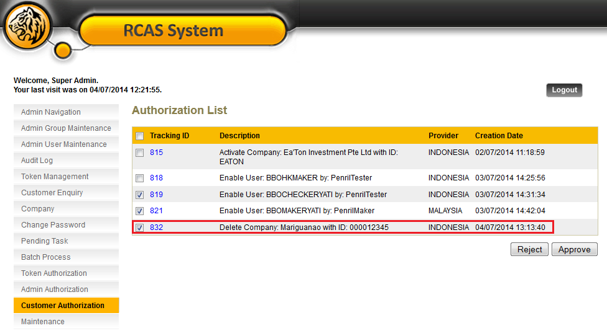  Figure 12: Customer Authorization List Screen  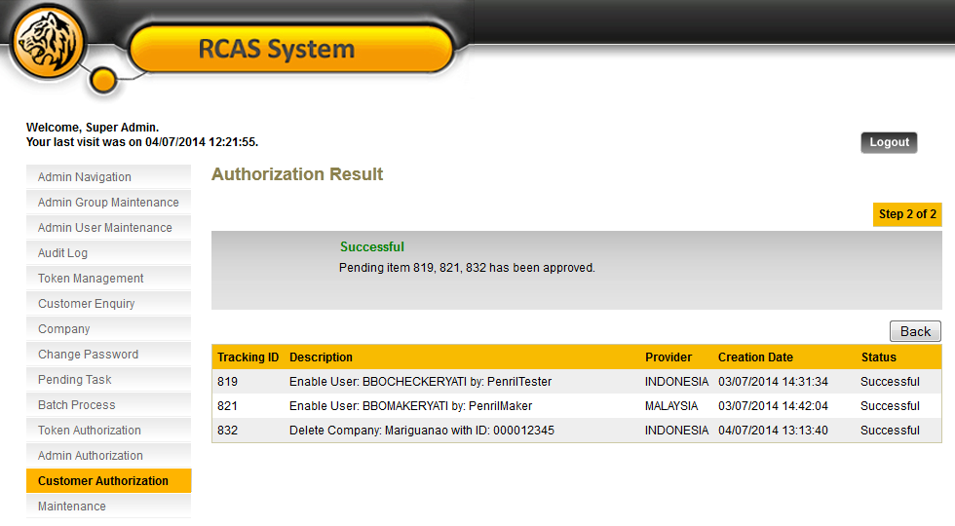  Figure 13: Customer Authorization Result Screen  AUDIT TRAIL  Test Item 4: To check on the all activities in Audit Log  Result:  Successfully display every activities in Audit Log  Figure 14: Audit Log List Screen  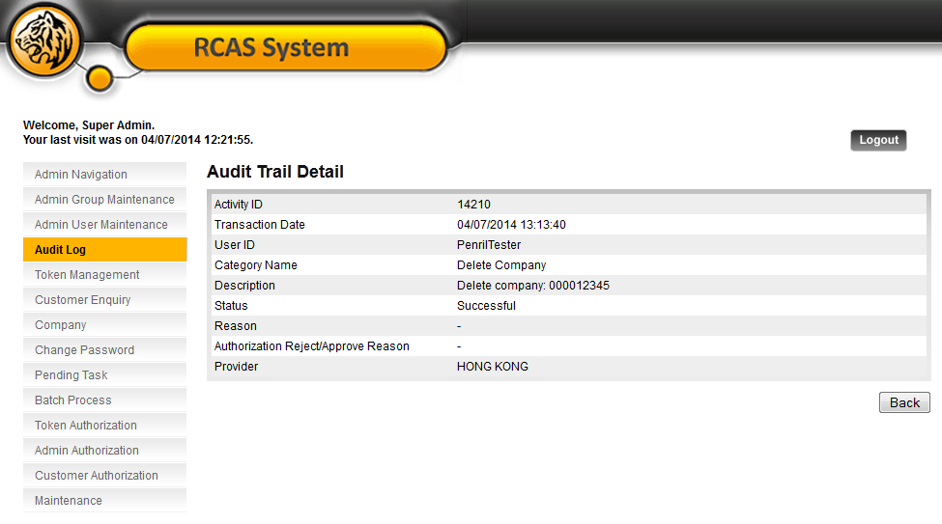  Figure 15: Audit Log Details Screen (Maker)  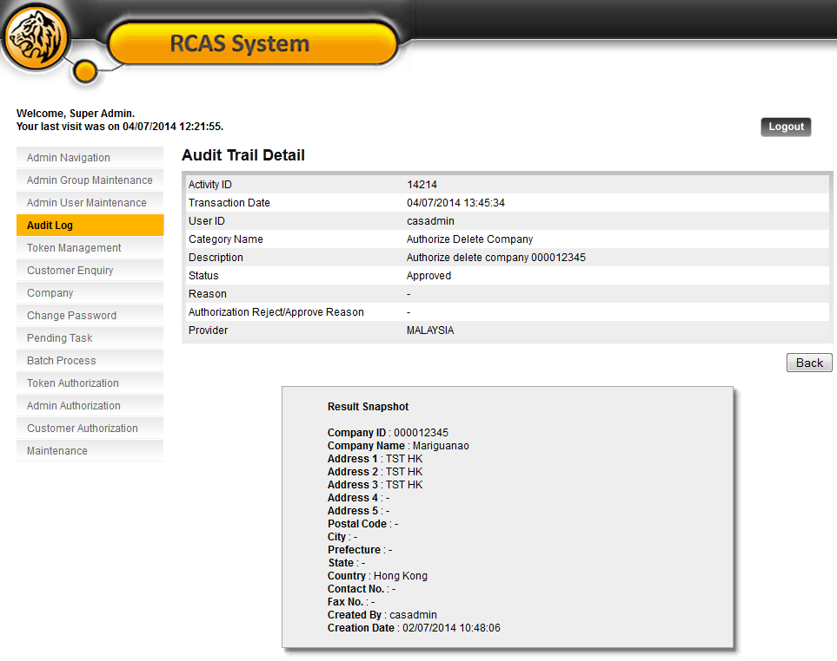  Figure 16: Audit Log Details Screen (Checker)

