Instructions

Please conduct the following tests and state whether or not the system complies with the requirements (Enter ‘Y’ for comply and ‘N’ for non-compliance). Also, upon completion of the tests, please sign and date this test script.

Item | Objective / Test | Expected Result | Comply  (Y / N) | Remark
1 | Prayer Times  Objective:  - To test the connection eSolat website  Steps:  - Use the following URL to access KFH’s to access KFH main landing page.  Test1: http:// 58.26.222.100/kfhmb/ep/  Test2: http://10.20.208.1:7210/kfhmb/ep/  Test3: http://10.20.208.1:7310/kfhmb/ep/  Test4: http://10.20.208.4:7410/kfhmb/ep/  Test5: http://10.20.208.4:7510/kfhmb/ep/  - Click on the “Prayer Time”  - Goto eSolat website – http://www.e-solat.gov.my/  - Verify the prayer information as published in KFH’s main landing page with the eSolat website’s Prayer Time. | Test1: See the landing page  Test2: See the landing page  Test3: See the landing page  Test4: See the landing page  Test5: See the landing page  Upon entering the URL, you should have successfully called up the KFH’s Main Landing page.  Upon clicking, you should have successfully called up the Prayer Time” information.  Upon entering the URL, you should have successfully called up the KFH’s Main Landing page  You should be successfully compared that the “Prayer Time” information for the 2 websites are identical based on the same date.
  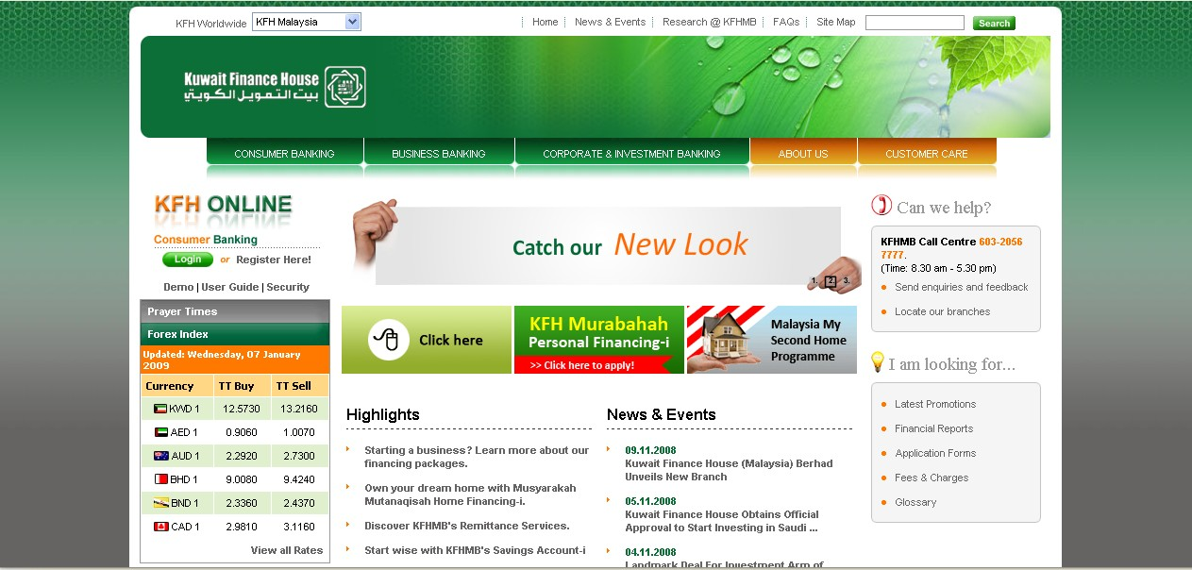
  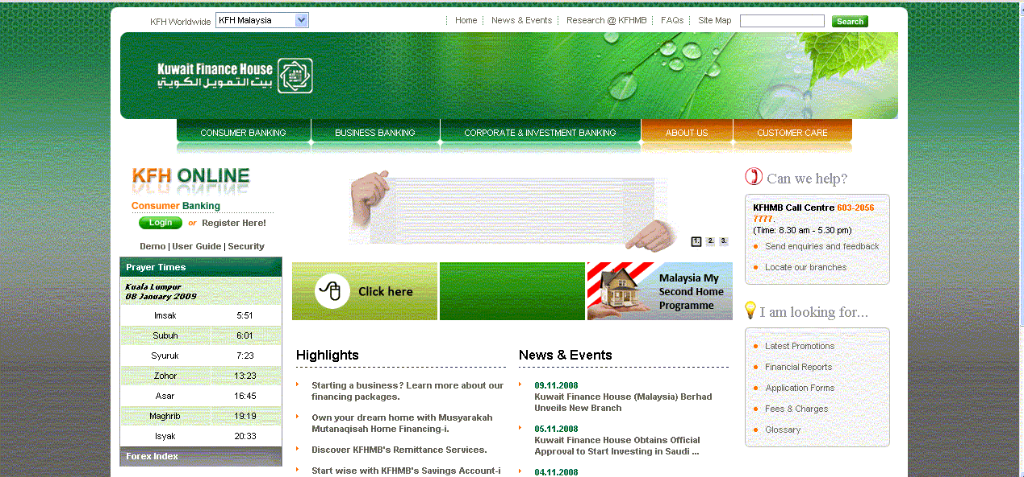
  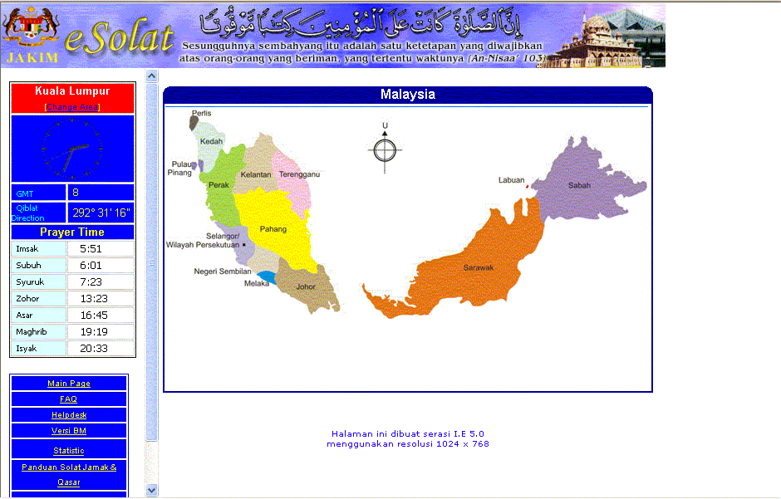
2. | Registration  Objective:  - Test the connection from kfhib01, kfhib02, kfhib03, kfhib04, kfhib05,kfhib07, OC4J(PowerCard), Phoenix XAPI  Registration  - Goto Main Landing http://58.26.222.100/kfhmb/ep/  - Click on Consumer Banking menu.  - Click on Goto Login Page – KFH Consumer Internet Banking  - Click on “Register Now”  - Click “Accept” button on “Terms & Condition” page.  - Enter the following information on Step 1 & click next.  - Account number: <12 characters>  - ATM card number:<16 digits>  - ATM pin number: <6 digits>  - Enter “Username” and should be alphanumeric format with a min 6 to max of 16 characters. It cannot contain any special characters, except for underscore.  - Enter password; alphanumeric format with a min 8 to max of 12 characters. Usage of special characters is allowed. Enter the same password for “Confirm Password” and click on “Next” button.  - Enter the security question 1 – 3. Note that you have to select different questions. Enter the answer and enter the same answer for “Confirm Answer”.  - Enter a valid mobile phone number and enter the same to “Confirm Mobile Phone Number” and click register. | Upon entering the URL, you should have successfully called up the KFH’s Main Landing page.  Upon clicking, you should have successfully called up the KFH’s Consumer Banking page.  The “KFH Online” page appears.  You would successfully called out the following pages;  Page “Step 1 / 5” of Register Now appears.  You would have successfully navigated to “Step 2 / 5 of Register Username” screen.  You would have successfully navigated to “Step 3 / 5 of Register Password” screen.  You would have successfully navigated to “Step 4 / 5 of Register Password” screen.  You would have successfully navigated to “Step 5 / 5 of Register Mobile Phone Number” screen.  You would have successfully navigated to “ Welcome Page” of Consumer Internet Banking page.
  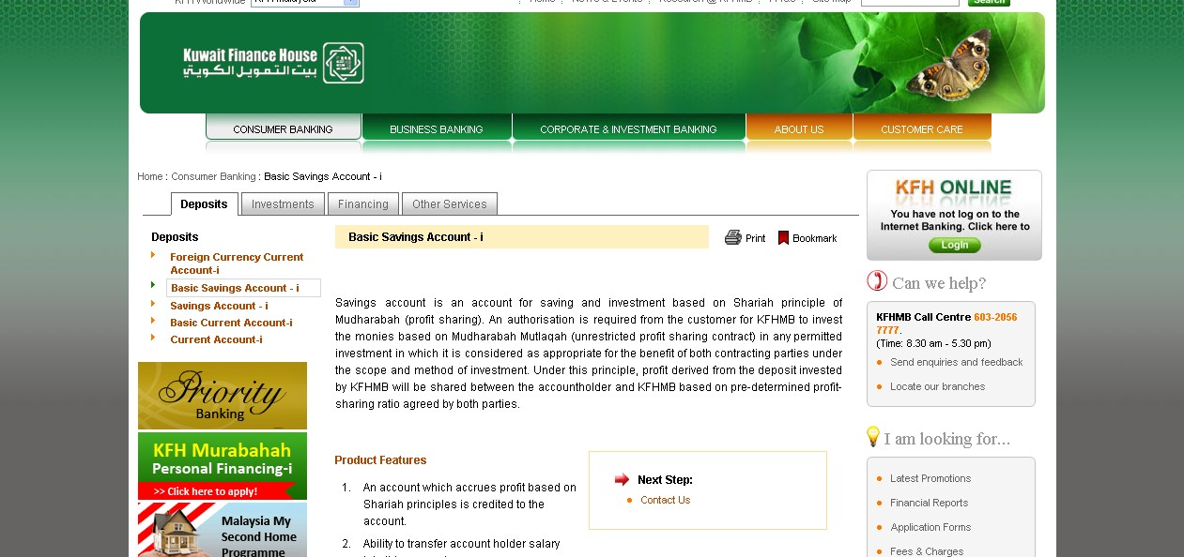
  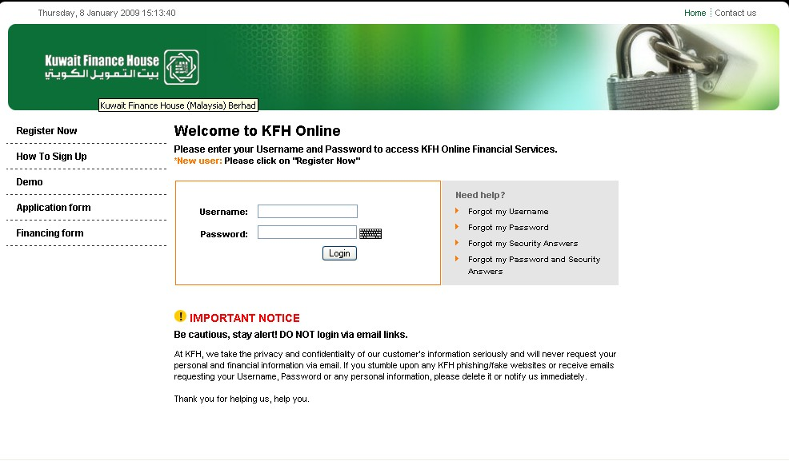
  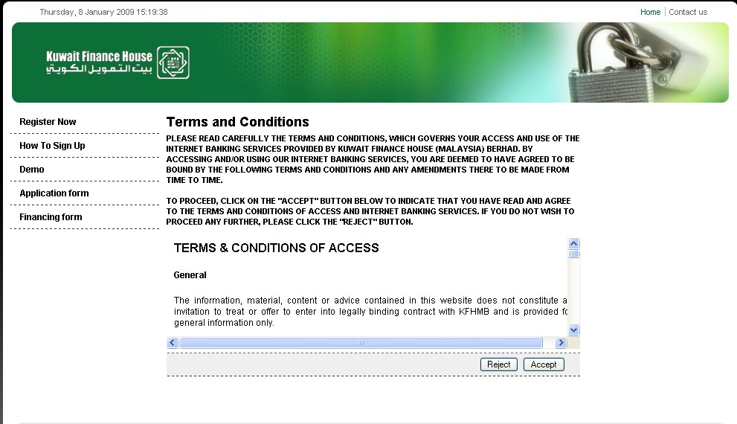
  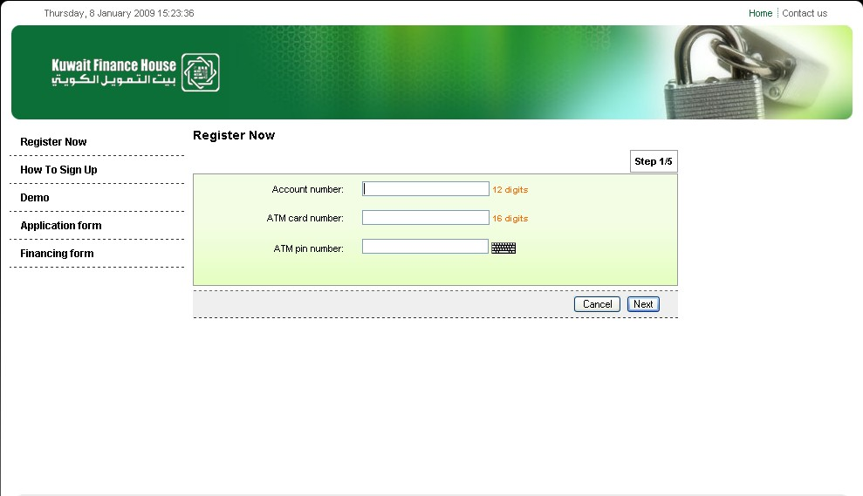
  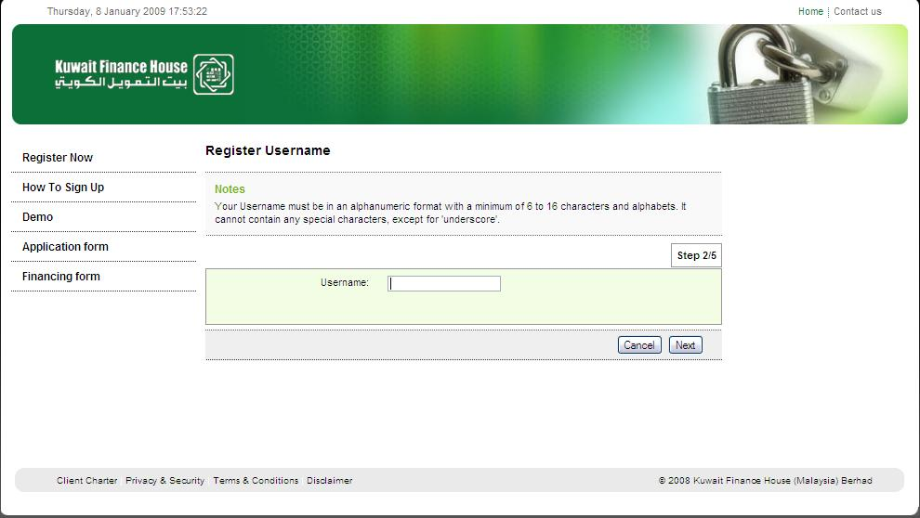
  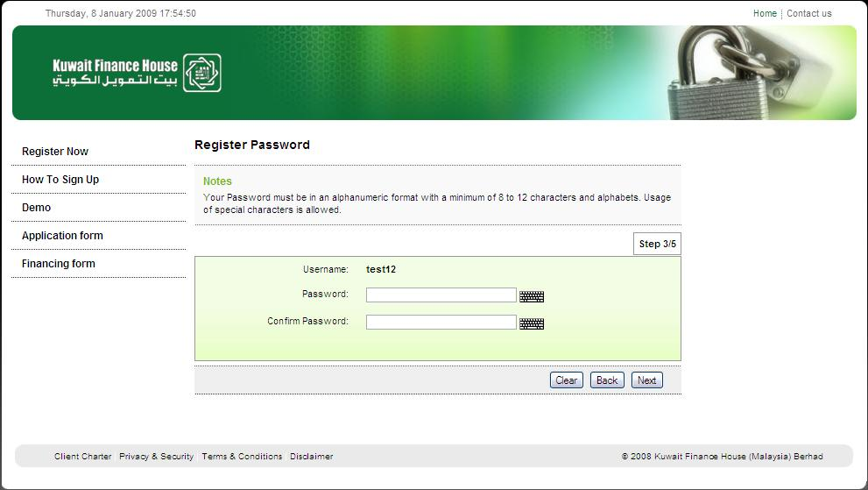
  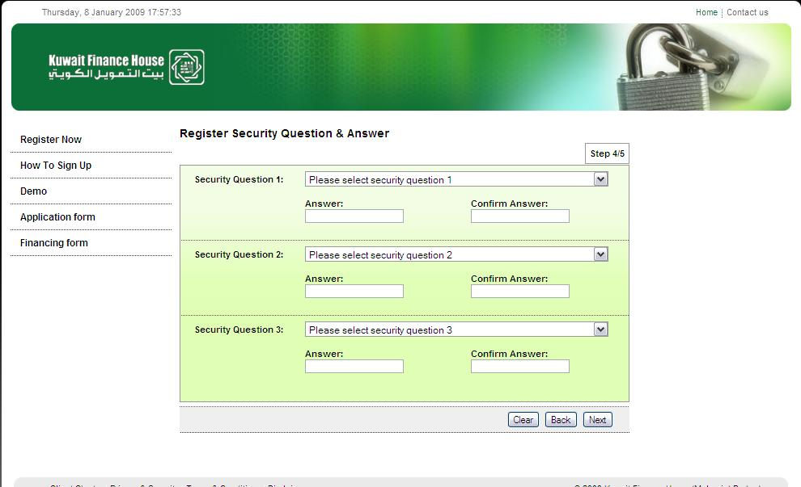
  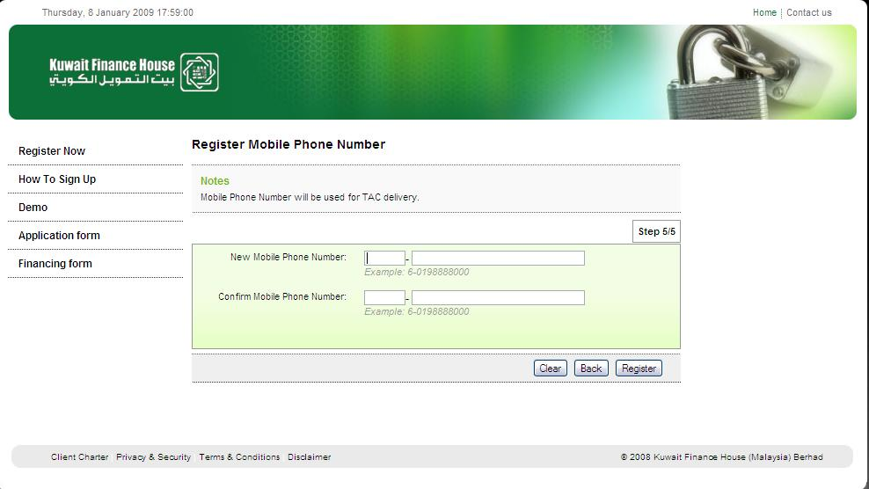
2. | Login to Consumer Internet Banking  Objective:  - Test the connection from kfhib01, kfhib02, kfhib03, kfhib04 ,kfhib07  Login  - Goto KFH’s Main Landing - http://10.20.208.1:7210/kfhmb/ep/  - Click on Consumer Banking menu.  - Click on Goto Login Page – KFH Consumer Internet Banking  - Enter “Username “and “Password” and click on “Login” button.  - Enter the answer for the “Security Question” prompted. | You would have successfully retrieved the “Login” page to Consumer Internet Banking  The “Security Question” page will appear.  You would be successfully login when the “Welcome Page” appears.
  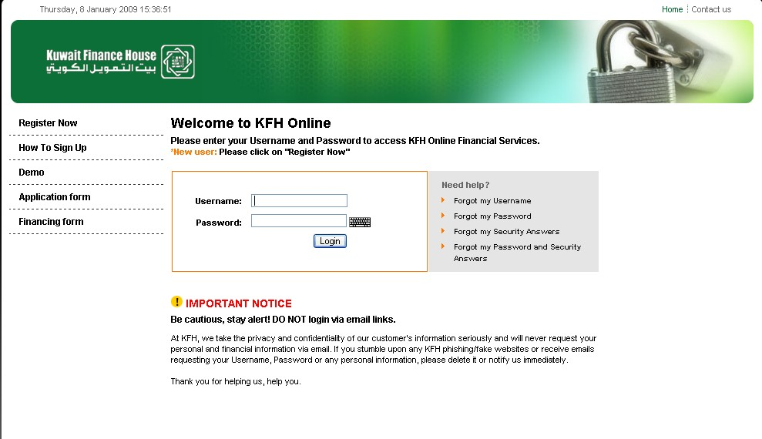
  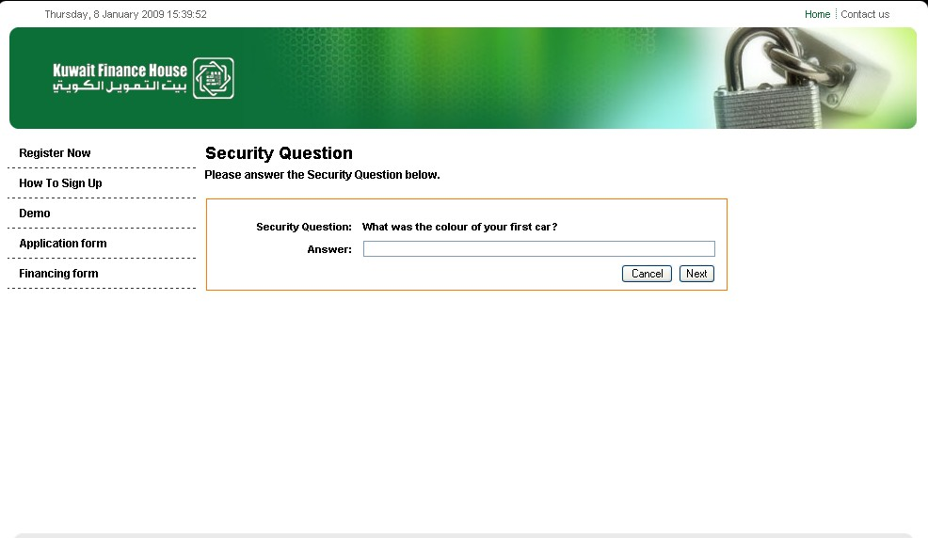
  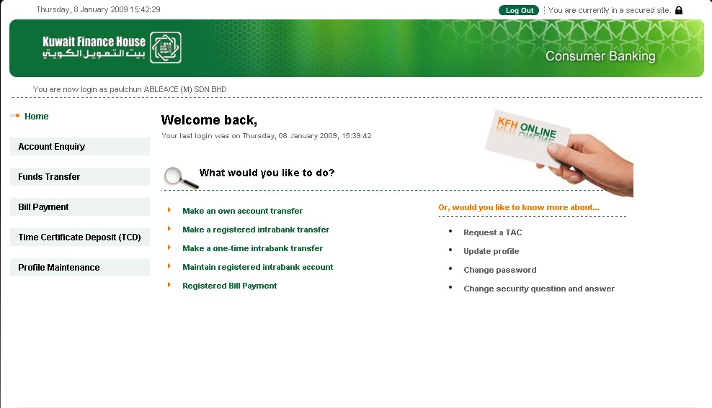
3. | Request for TAC  Objective:  - Test the connection from kfhib01, kfhib02, kfhib03, kfhib04, kfhib07, Macrokiosk Webservice  Request for TAC  - Goto Consumer Banking Main page.  - Click on “Request a TAC”  - Click on “Close” button, to exit from the pop up screen. Please note that the TAC would only be valid for 30 minutes for any transactions. | You would have successfully called out a pop-up screen on request for TAC
  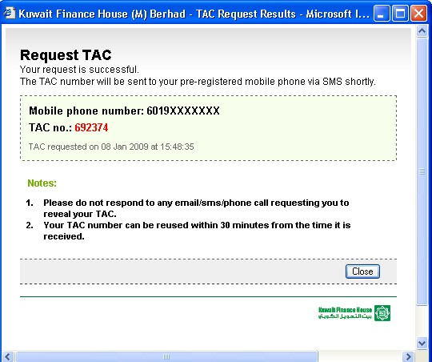
4 | Bill Payment  Objective:  - Test function on making bill payment  Bill Payment Steps;  - Login the Consumer Banking main page.  - Click on “Bill Payment” main menu.  - Under the “Bill Payment” main menu, you have the options available;  - Open Bill Payment  - Registered Bill Payment  - Prepaid Top Up  - Registered Payee Maintenance  - Click on “”Registered Bill Payment” option  - Goto “Please select a registered payee field and click on the drop down list and select a registered payee name and click “next” button.  - Enter the amount and select from the From Account Number drop down list, the account to pay from and click “Next” button.  - Enter the TAC number. You can use the existing TAC number, if available. You can use an existing “TAC” number for 30 minutes from time receiving. Else click on the “Request TAC” option. | The option for “Bill Payment” screen appears.  Bill Payment screen will appears.  The “Step 2/4” of Bill payment screen appears.  The “Step 3 /4” of Bill payment screen appears.  Page “Step 4/4 of Bill Payment” appears. You would have successfully performed a bill payment.
  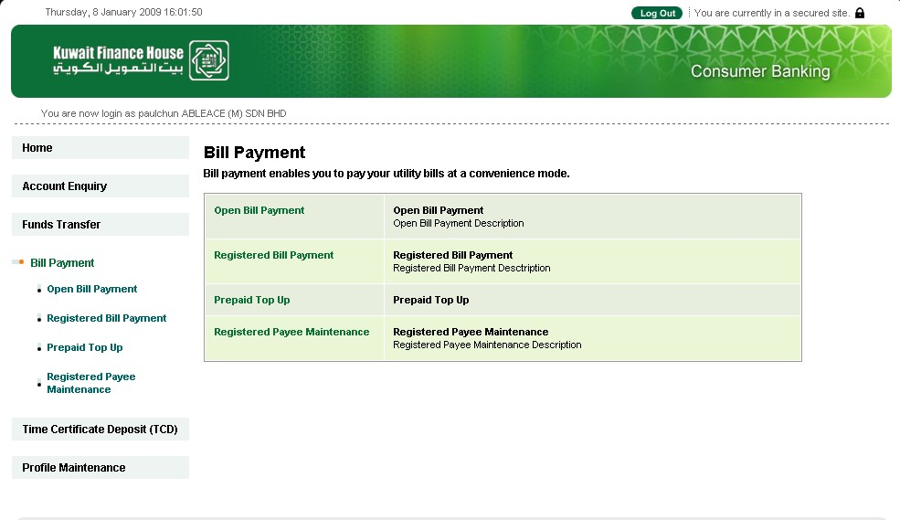
  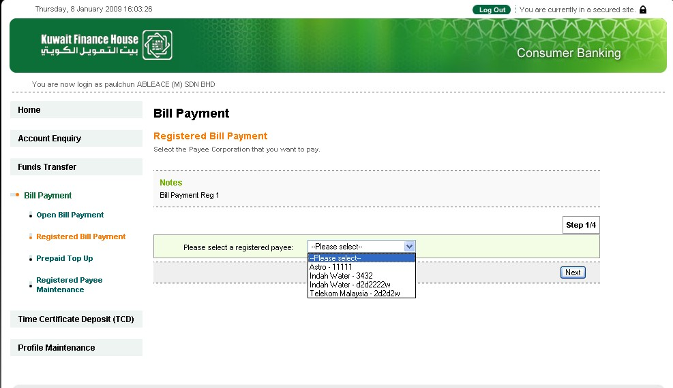
  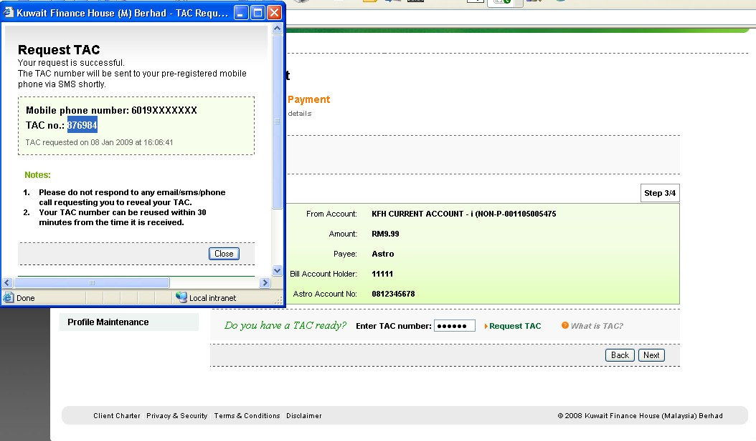
  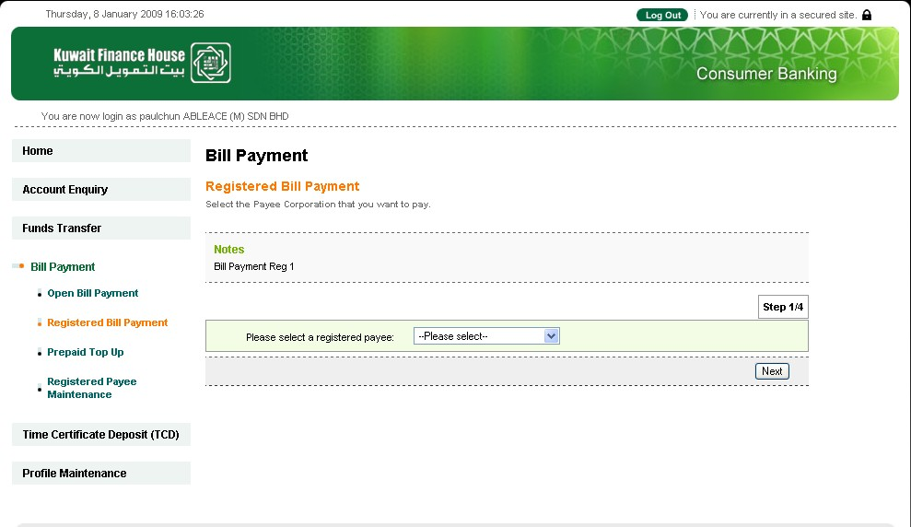
  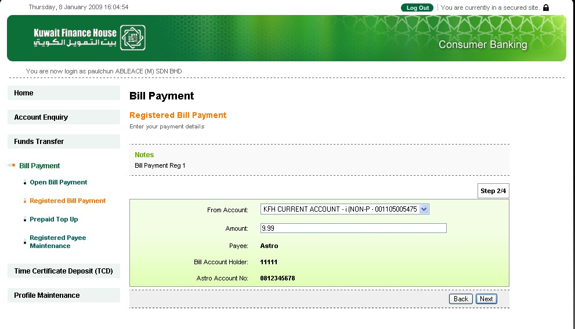
  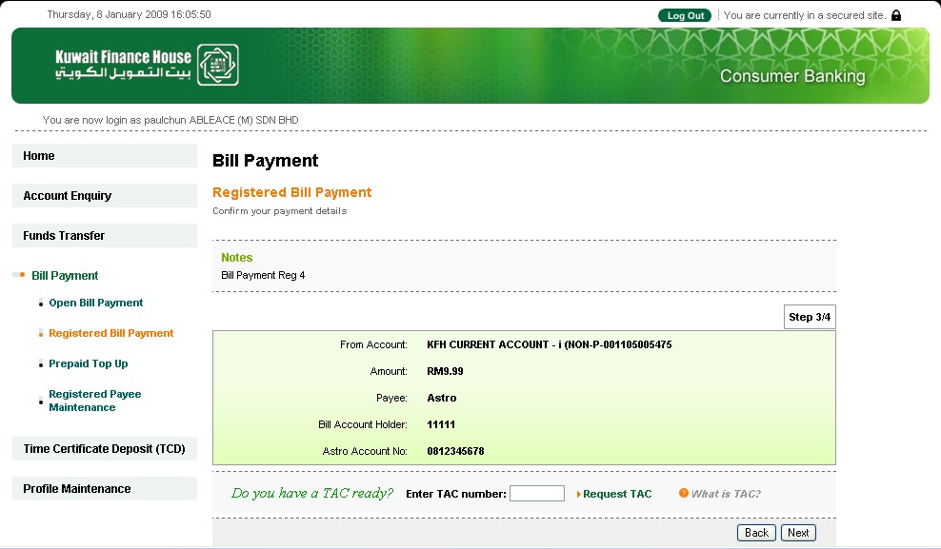
  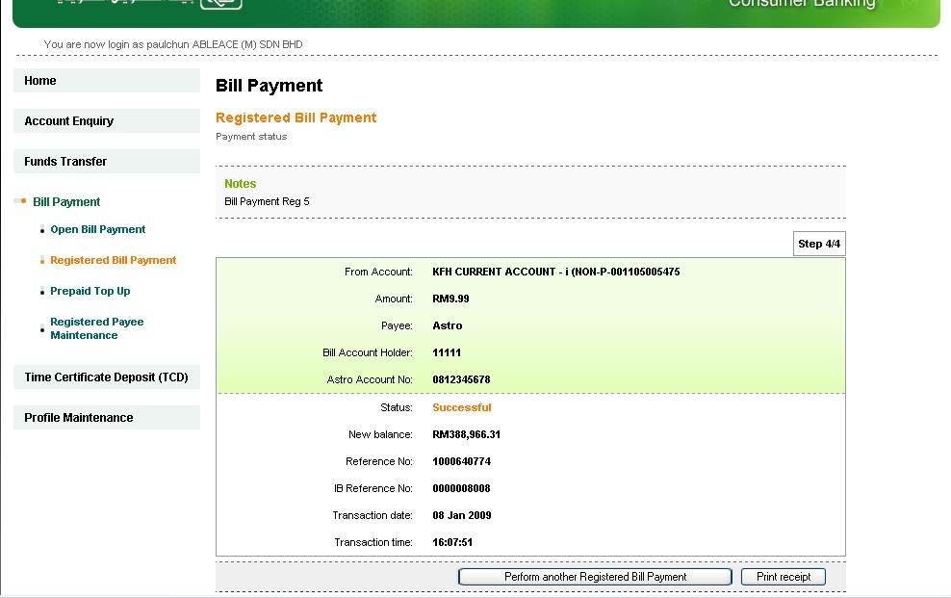
  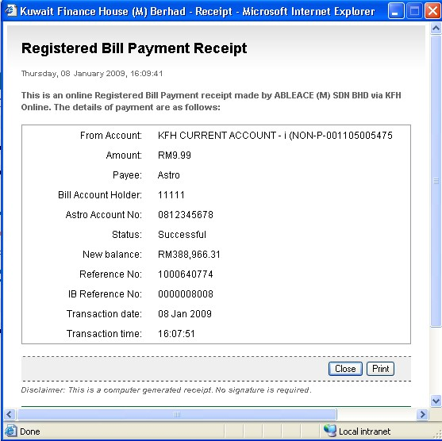
5 | Fund Transfer  Objective:  - Test the connection from kfhib01, kfhib02, kfhib03, kfhib04, kfhib05,kfhib07, Phoenix XAPI  Performed Fund Transfer Steps  - Login the Consumer Banking main page.  - Click on “Fund Transfer” main menu.  - Goto option “Intrabank Transfer” and click on “Registered Intrabank Transfer”.  - Select the drop down list for "From Account" & "To Account". Enter amount, remarks (if required) and beneficiary email address and click next.  - Click “Confirm” button. | The Fund transfer menu page appears  The “Step 1 / 3 of Registered Intrabank Transfer screen appears.  Page “Step 2 /3 of The “Step 1 / 3 of Registered Intrabank Transfer screen appears.  Page “Step 3 / 3 of Registered Intrabank Transfer screen appears.  You have successfully performed the fund transfer. The receipt can be print preview and printed.
  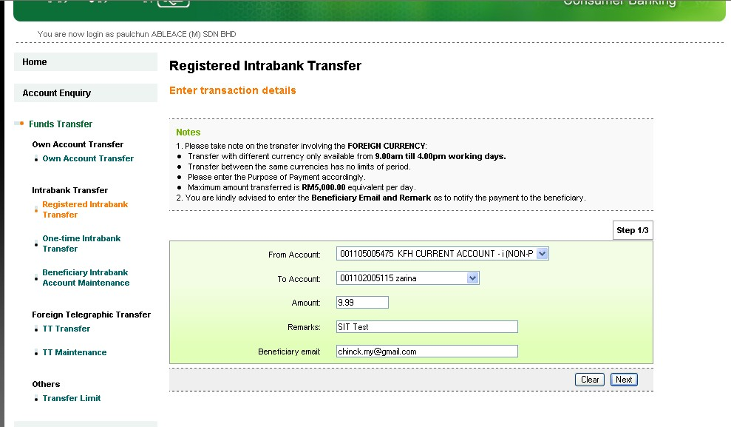
  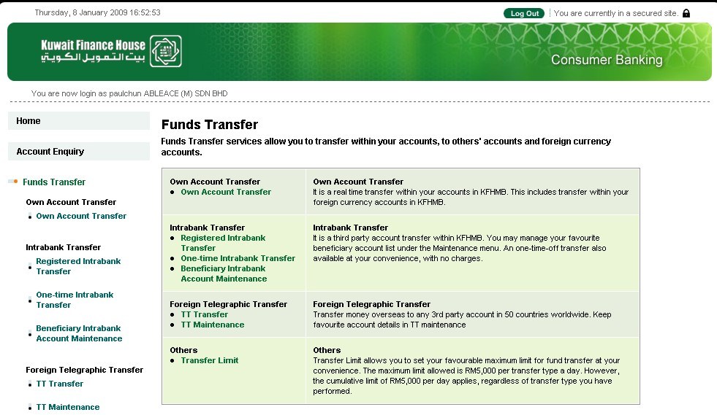
  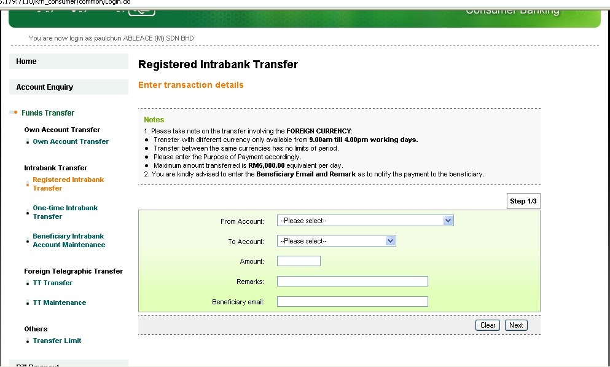
  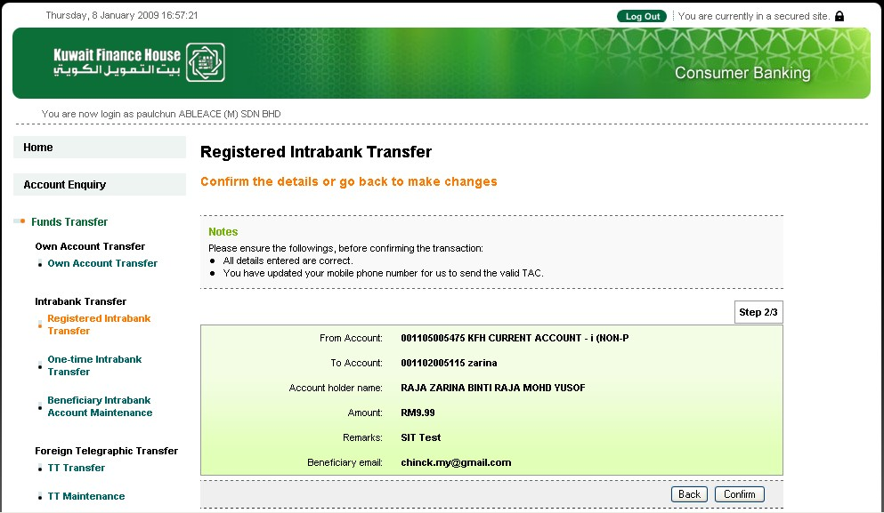
  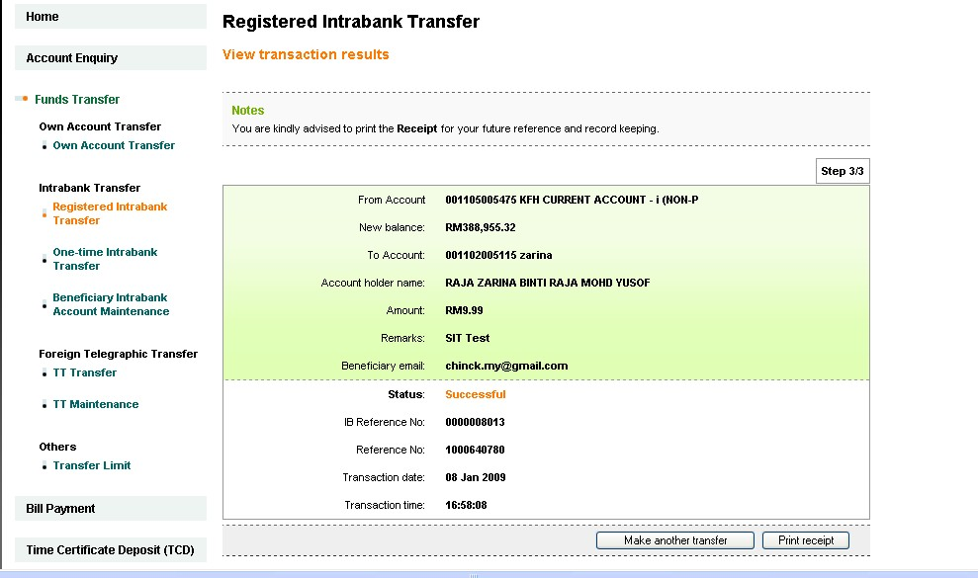
  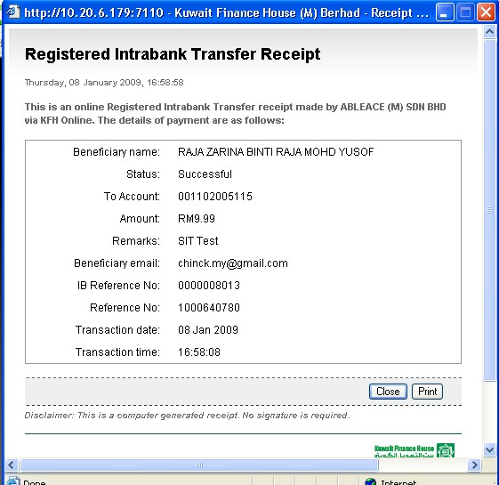
  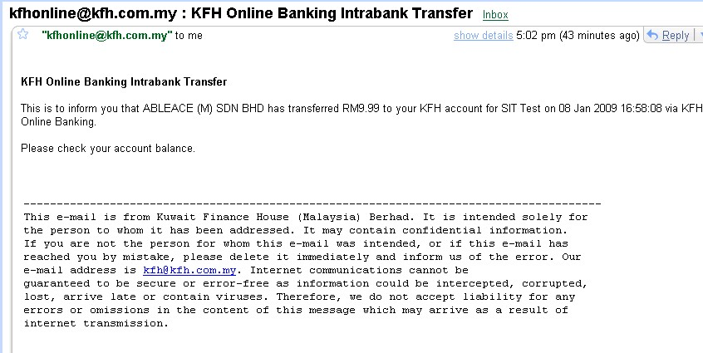

User Acceptance Test Sign Off:

Department Name: Department Name: Department Name:
Signature: Signature: Signature:

Name: Name: Name:
Designation: Designation: Designation:
Date: Date: Date:

Department Name: Department Name: Department Name:
Signature: Signature: Signature:

Name: Name: Name:
Designation: Designation: Designation:
Date: Date: Date:

