I would like to check with you a few things regarding BVMC.

1. KFH Worldwide Dropdown List



I have a url like this and when I put in kfh > About Us > AU05-KFH-Worldwide under KFH Tools,

url/action text box, the dropdown list open to an incomplete link

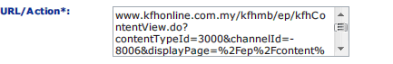

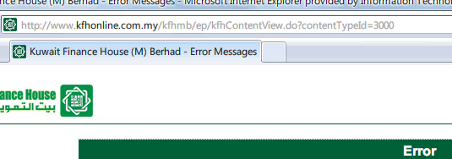

Is there a limitation for the url? Any character that cannot be put, like "&" in the url?

2. Assign User Templates to Page Types

We would like to create a new page type. Seems the select user templates button is missing.

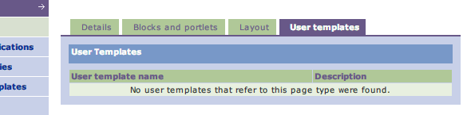

How do we go about this?