**1st CA DID ACTIVATION –> 2ND CA NOT LOCK (under normal condition)**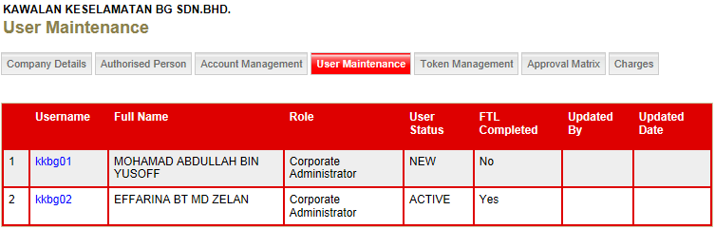

**NONE OF CAs DO ACTIVATION –> ONE OF CA HAS BEEN LOCKED**

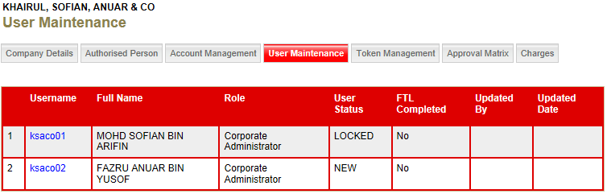

**1st CA DID ACTIVATION –> 2ND CA HAS BEEN LOCKED**

