Maybank Support System (MSS)

ELECTRONIC BANKING GROUP

Nama Proyek | Maybank Support System (MSS)
Nomor SR
Disiapkan Oleh | Febhy Toomy Saputra | Versi

Test Case No : |  | BII-MSS-SIT / Support #4762 / 2446
Test Objectives : |  | MSS – MSS inbox issue : User ID -> User No dan User Name -> User ID
Step No. | Actions |  | Steps | Expected Result | Pass / Fail | Actual Result
 | MSS inbox issue : User ID -> User No dan User Name -> User ID. |  | - Login MSS dengan user : administrator.  - Password di Bypass  - Pilih Retail Internet Banking  -> Message Box -> Notification.  - Klik button Send New Notification. | - MSS inbox issue : User ID -> User No dan User Name -> User ID | Pass | - Ok
Remark :

Lampiran :

Sebelum :

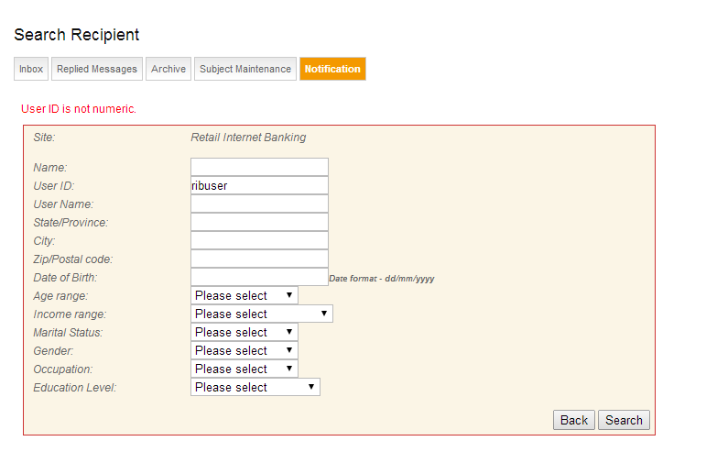

Sesudah :

