
Malayan Banking Berhad

Functional Specification
Regional Centralized Authentication System (RCAS) Administration Modules-reLocI

20 February 2014

Prepared By:



Penril Datability (M) Sdn Bhd (816792-X)
Suite A-07-07 Plaza Mon’t Kiara
No. 2, Jalan Kiara, Mon’t Kiara
50480 Kuala Lumpur, Malaysia
Tel: (603) 6201 2622 Fax: (603) 6201 7622
Document Administration

Document Amendment Log
Version No | Date Updated | Description of Change | Updated By  <Name, Dept> | Reviewed By  <Name, Dept> | Approved By <Name, Dept>
1.0 | 20/2/14 | Initial Release

Table of Contents
1 Authorization 5
1.1 Approve Pending Item 5
1.2 Reject Pending Item 8
1.3 Return Pending Item 10
2 Token Reservation for Company 16
3 Prebind Token – Boby 20
4 Maintenance – Security Policy 22
5 Company 25
5.1 Create Company 25
5.2 Edit Company 30
6 Linking user id status - Boby 35
7 Change field length 41
8 Email – Add Reference # 42
8.1 Admin User Maintenance 42
8.2 Customer Enquiry 46
8.3 Sample Email Format 57
9 Pin Mailer and Pin Letter Address 58
10 Update CFO user profile – Boby………………. 60
11 Factory ID per Application - Boby 61
12 Status Report – Boby 62

Authorization

Authorization module is separated into 3 different links in the navigation menu which are:
- Customer Authorization – Perform approval on customer related transactions
- Admin Authorization – Perform approval on admin related transactions
- Token Authorization – Perform approval on token file loading transactions.
RCAS administrator/ checker can access to the each authorization type to make approval or rejection of pending items.
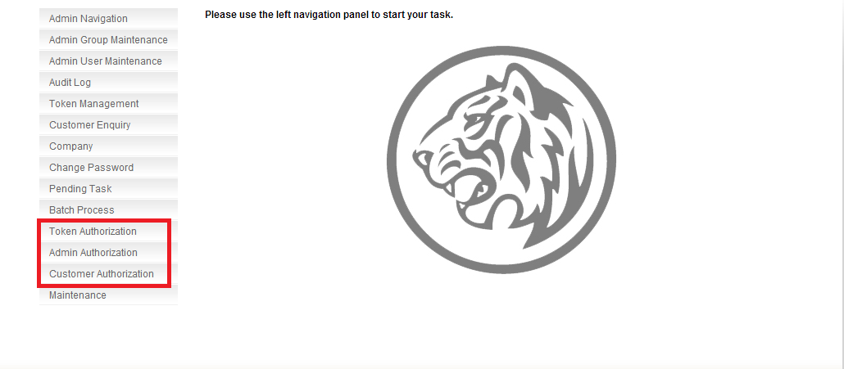

Figure 1.1: Three Different Links of Authorization Module

Approve Pending Item
This feature shall allow RCAS administrator to make an approval of pending item in a bulk or selected task without viewing the detail information for each task. This new function is added for Token Authorization, Admin Authorization and Customer Authorization.
Step 1:
RCAS administrator can access to Authorization module by clicking one of the Authorization type link at navigation menu. In this example, Token Authorization is selected.

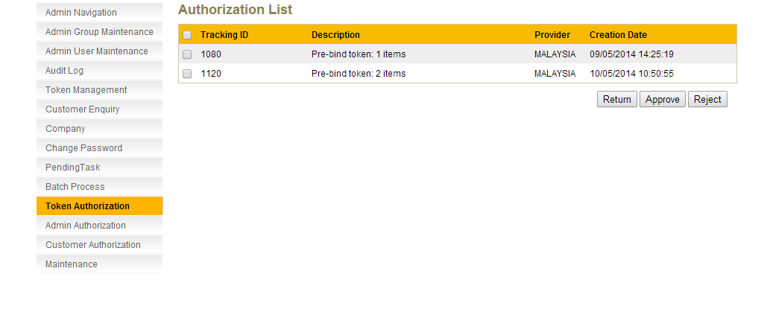
Figure 1.2: Token Authorization Module List Screen

Step 2:
RCAS will display list of pending items. Click on check box for item require for Return or Approve or Reject. If tick on the check box on the top of the label, it will select the entire task list.

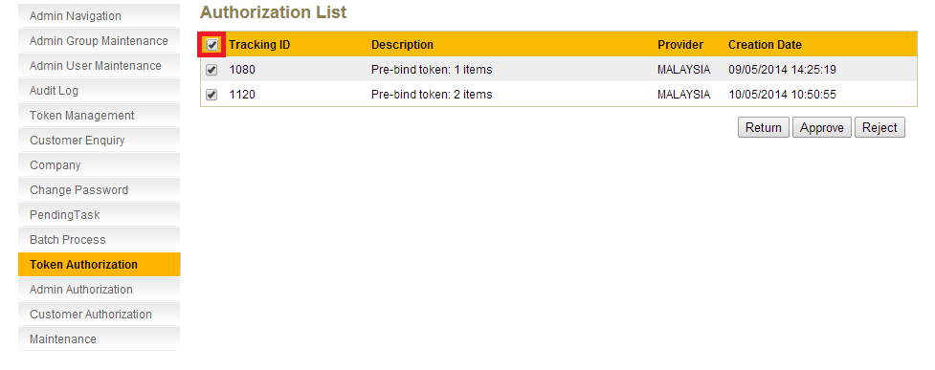
Figure 1.3: Token Authorization Module List Screen – Select All Task
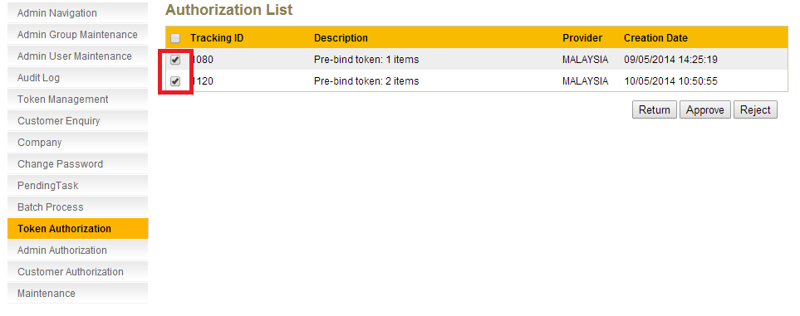
Figure 1.4: Token Authorization Module List Screen – Select Individual Task
Step 3:
Click on Approve button to approve the item.
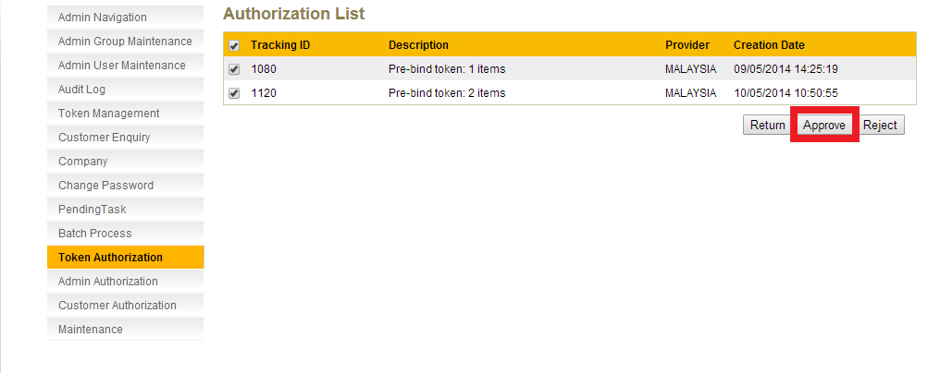
Figure 1.5: Token Authorization Module List Screen – Approve
Step 4:
A result page shall display the status of the request. Result page will also show the summary of the pending item that has been approved.
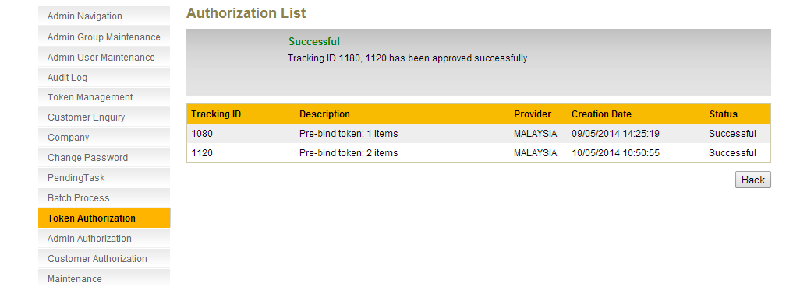
Figure 1.6: Token Authorization Module List Screen – Approve Result Screen

Reject Pending Item
This feature shall allow RCAS administrator to make a reject of pending item in a bulk or selected task without view the detail information for each task. This new function is added for Token Authorization, Admin Authorization and Customer Authorization.
Step 1:
RCAS administrator can access to Authorization module by clicking one of the Authorization type link at navigation menu. In this example, Token Authorization is selected.

Figure 1.7: Token Authorization Module List Screen
Step 2:
RCAS will display list of pending items. Click on check box for item require for Return or Approve or Reject. If tick on the check box on the top of the label, it will select the entire task list.
Figure 1.8: Token Authorization Module List Screen – Select All Task

Figure 1.9: Token Authorization Module List Screen – Select All Task
Step 3:
Click on Reject button to reject the item.

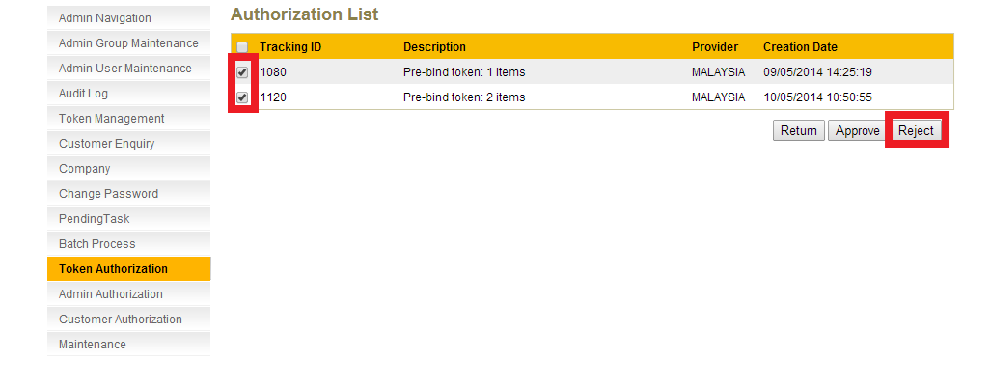
Figure 1.10: Token Authorization module List screen – Reject
Step 4:
A result page shall display the status of the request. Result page will also show the summary of the pending item that has been rejected.

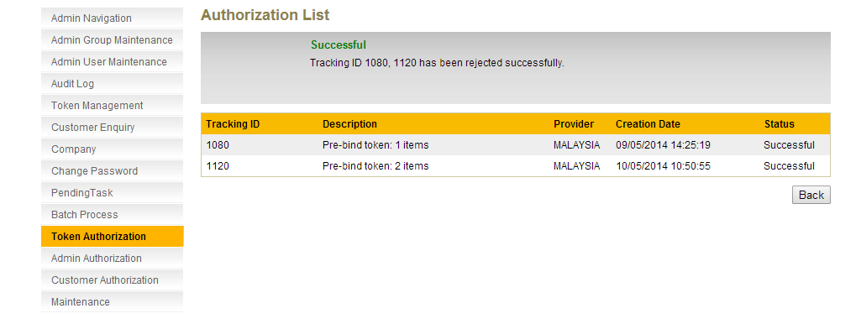
Figure 1.11: Token Authorization Module List Screen – Reject Result Screen

Return Pending Item
This feature shall allow RCAS administrator to make a return of pending item in a bulk or selected task without view the detail information for each task to Maker. This new function is added for Token Authorization, Admin Authorization and Customer Authorization.

Step 1:
RCAS administrator can access to Authorization module by clicking one of the Authorization type link at navigation menu. In this example, Token Authorization is selected.

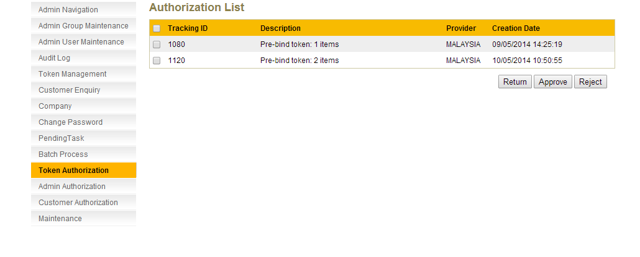
Figure 1.12: Token Authorization Module List Screen
Step 2:
RCAS will display list of pending items. Click on check box for item require for Return or Approve or Reject. If tick on the check box on the top of the label, it will select the entire task list.
Figure 1.13: Token Authorization Module List Screen – Select All Task
Figure 1.14: Token Authorization Module List Screen – Select Individual Task
Step 3:
Click on Return button to return the item to Maker.
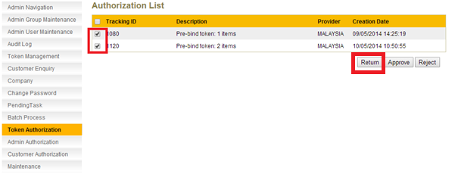
Figure 1.15: Token Authorization Module List Screen – Return
Step 4:
A result page shall display the status of the request. Result page will also show the summary of the return item that has been returned.

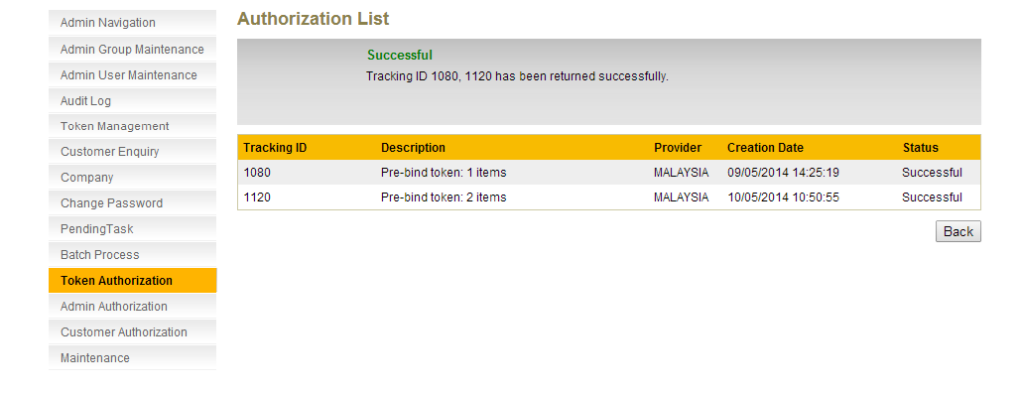
Figure 1.16: Token Authorization module List screen – Return Result Screen

Return Item - Maker view
RCAS administrator can amend or delete the return item/s from the Pending Approval module.
Kah Yan: pls add on the 31 modules list that impacted and we need to study the detail of each module which is allow to change which is not allow to amend.
Step 1:
Select Pending Task from the navigation. The list of returned items from the checker will be displayed. Click Tracking ID number.
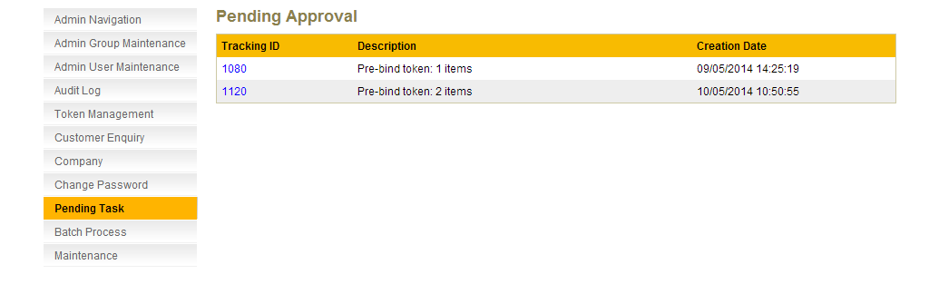
Figure 1.17: Pending Task Screen – Maker
Step 2:
Select Edit to edit the task. In this example, Pre-bind token with tracking id 1080 is selected.
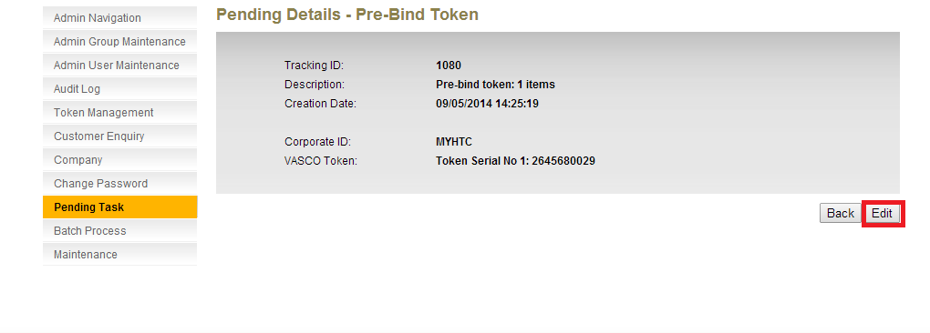
Figure 1.18: Pending Task Details Screen – Maker

Step 3:
Maker can make changes to reselect the corporate ID for the token assign. In this example, Maker changed the Corporate ID from MYHTC to MYPENRIL. Click Confirm.
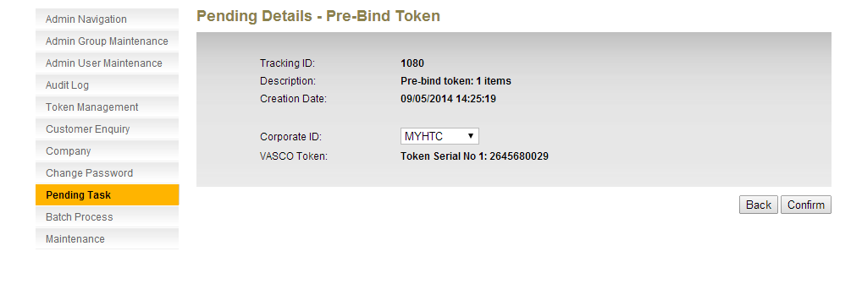
Figure 1.19: Pending Task Edit Screen – Maker

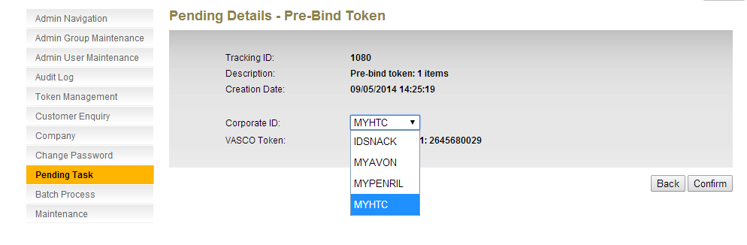
Figure 1.20: Pending Task Edit Screen with Dropdown List – Maker

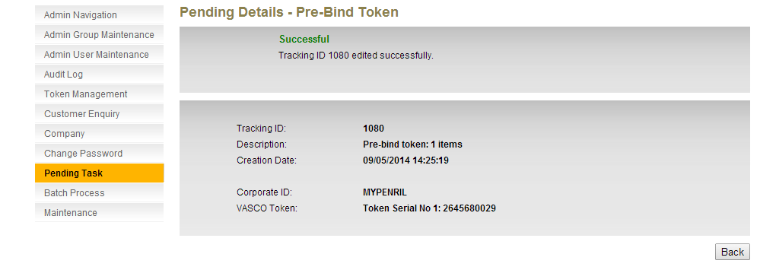
Figure 1.21: Pending Task Edit Result Screen – Maker

And make sure that items will return to maker page, pls show sample screen also.

Token Reservation for Company

This feature shall allow RCAS administrator to reserve the token(s) for the company. RCAS administrator can only pre-bind 10 tokens at once.
Step 1:
Go to the Token Management and click on “Token Reservation” tab. Choose the Provider, choose the Corporate ID and fill in the number of token to be pre-binded under this corporate. Click confirm to continue. Each process will only be limited to 10 tokens.
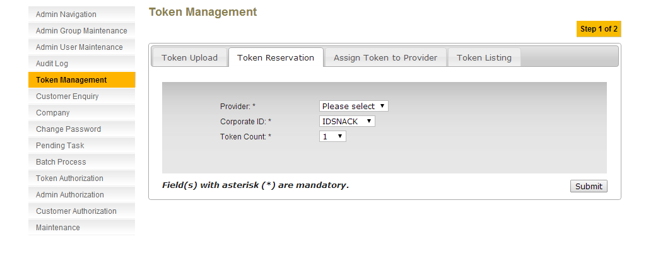
Figure 2.22: Token Reservation Main Screen

Step 2:
RCAS administrator can choose list of Provider from the dropdown list, choose list of Corporate ID from the dropdown list. RCAS administrator can choose number of token from the dropdown list as well. The number has been limited to 10.
The allowable characters and format to be input are described in the table below:
Field | Description
Provider* | - Mandatory field  Select Provider from drop down list:  - Please Select  - Malaysia  - Singapore and etc
Corporate ID* | - Mandatory field  - If Provider selected with Please Select ( it will display all the Corporate ID regardless tag to which Providers)  - If Provider selected with individual Provider, then Corporate ID will be listed those Corporate ID that tag to the particular Provider.
Token Count* | Select amount of token from drop down list  - 1  - 2  - 3  - 4  - 5  - 6  - 7  - 8  - 9  - 10
Figure 2.23: Token Reservation for Company Field Explanation
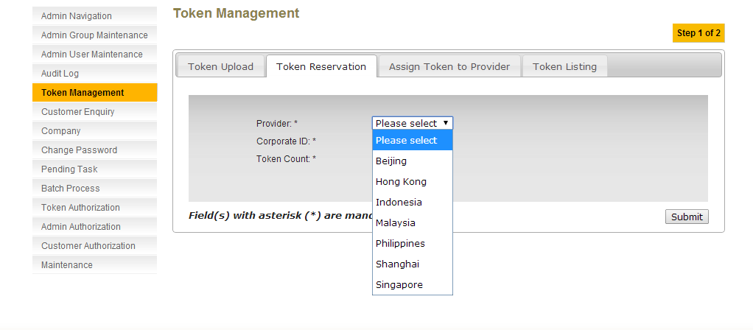
Figure 2.24: Token Reservation Screen Provider Dropdown List
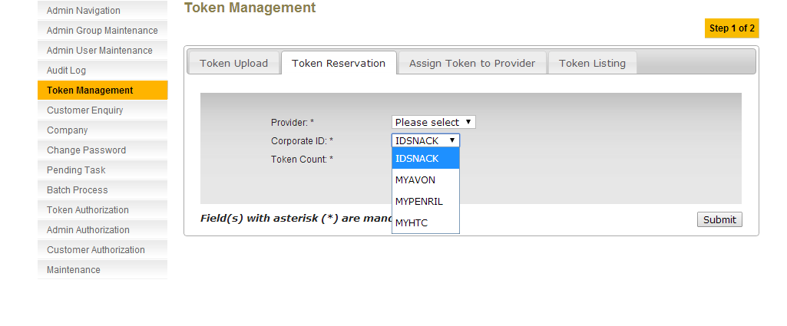
Figure 2.25: Token Reservation Screen Corporate ID Dropdown List

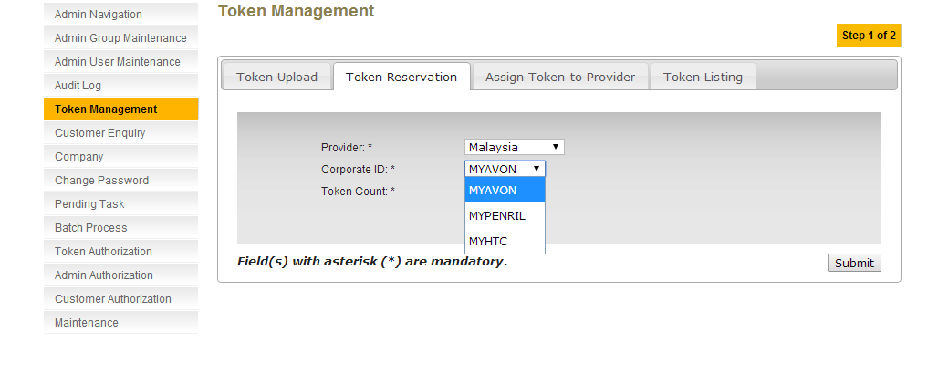
Figure 2.26: Token Reservation – Provider (Individual Provider)
Step 3:
After submit, RCAS will display the summary page.
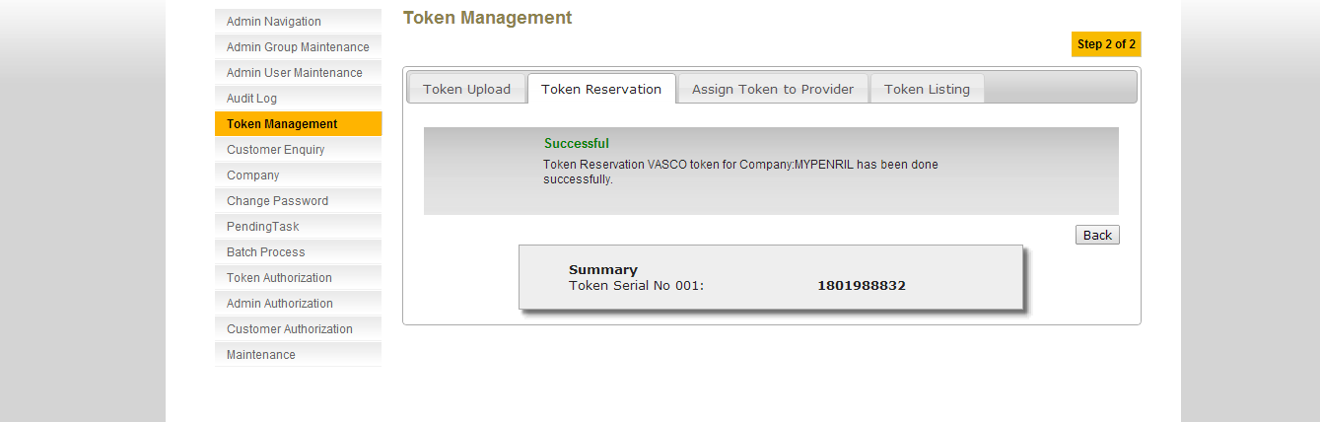
Figure: Token Reservation for Company Result Screen

Prebind Token – Boby

A new API will be provided for prebind token based on token count.
Figure 3.27: Process Flow of Prebind Token
Process:
- Channel application (eg. RCMS) will call to the API (RCAS) by sending number of token to be reserved to corporate and corporate ID.
- When RCAS receive the request, RCAS will query in the database.
  - If the database do not have the number of token requested, will return the remaining token to RCAS. RCAS then will bind the tokens to corporate. RCAS return token serial number, total request tokens (from channel application), total reserved tokens with response code partially success.
  - If the database have the number of token requested, will return the remaining token to RCAS. RCAS then will bind the tokens to corporate. RCAS return token serial number, total request tokens (from channel application), total reserved tokens with response code success.
Examples:
Case 1: Token Request less than tokens in database
Request: 100 tokens
Token in database: 500 token
Result: Return list of 100 token serial number, total request tokens (in this example is 100), total reserved tokens (in this example is 100), response code success.
Case 2: Token Request more than tokens in database
Request: 100 tokens
Token in database: 50 token
Result: Return list of 50 token serial number, total request tokens (in this example is 100), total reserved tokens (in this example is 50), response code partially success.

Maintenance – Security Policy

This feature allows RCAS Administrator to edit security policy in RCAS. It allows editing the content of Config Value only. A script to update the security policy descriptions will be provided.
Step 1:
RCAS administrator can access to this module by clicking on the Maintenance link at the navigation menu and click on Security Policy tab.
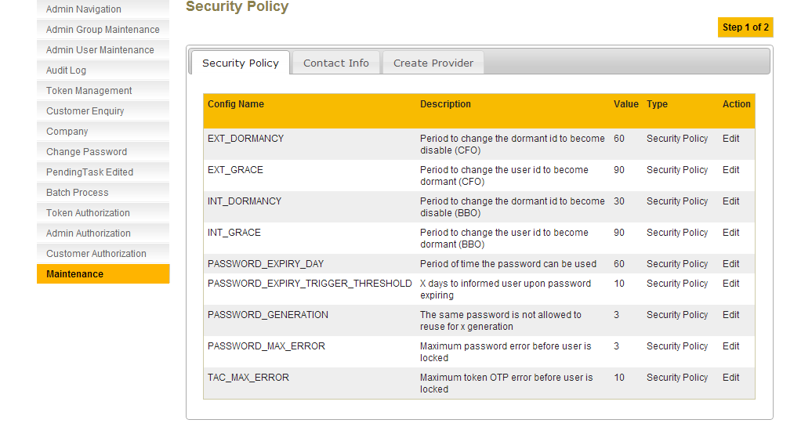
Figure 4.28: Security Policy List Screen (Before Update)

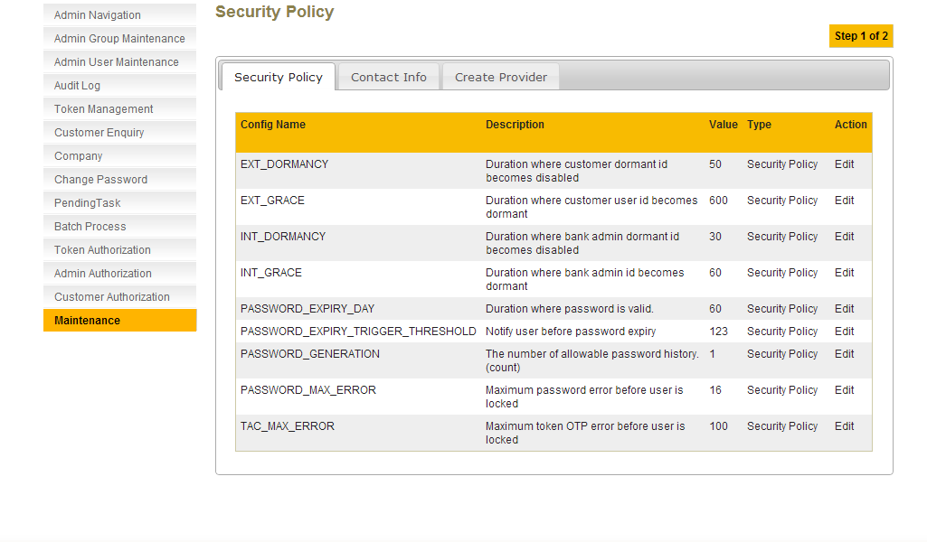
Figure 4.29: Security Policy List Screen (After Update)

Step 2:
RCAS administrator must input all the fields that are provided. The allowable characters and format to be input are described in the table below. Click on Confirm button to proceed to the result page.
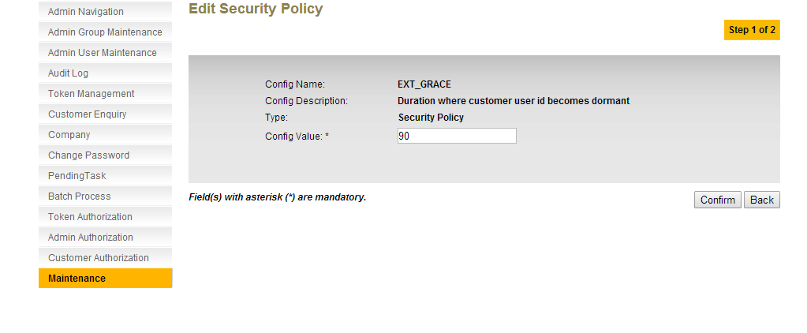
Figure 4.30: Edit Security Policy screen

Field | Description
Config Value | 3 characters maximum, numeric
Figure 4.31: Edit Security Policy field explanation
Step 3:
A result page shall display the status of the request. Result page will also show the summary of the security policy that has been edited.
If RCAS administrator (who currently logged in to this application) is a super user, the status of the request will be successful.
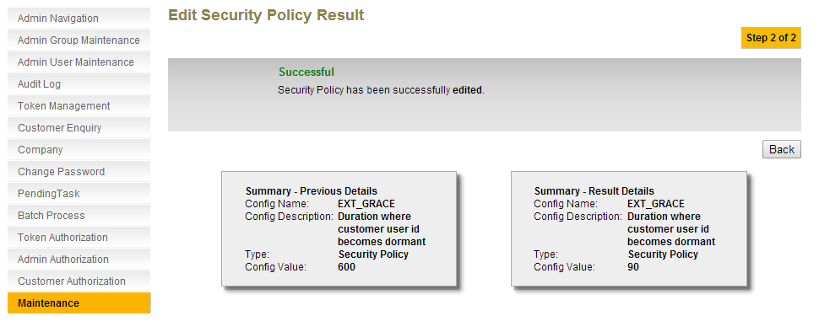
Figure 4.32: Edit Security Policy Result Screen – Super Admin
If RCAS Administrator (who currently logged in to this application) is not super user, the status of the request will be pending for approval. Pending item can be found at Admin Authorization module and it will need a Bank Admin Checker to do the authorization.
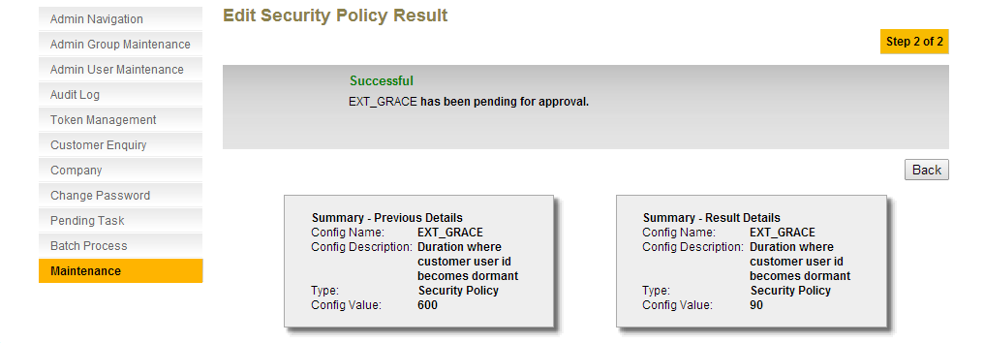
Figure 4.33: Edit Security Policy Result Screen – Maker
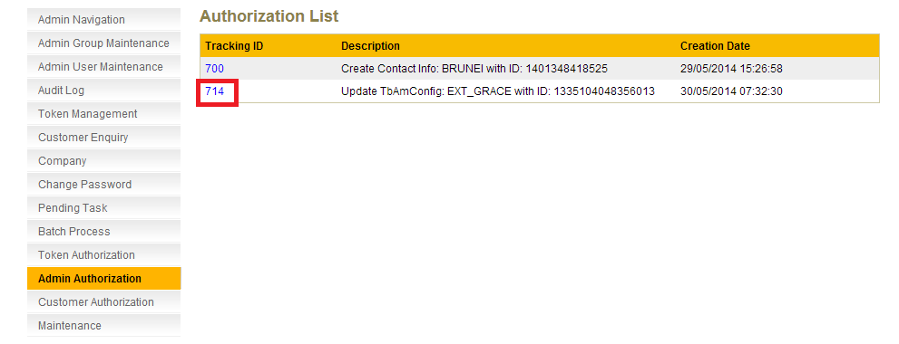
Figure 4.34: Admin Authorization List Screen – Checker
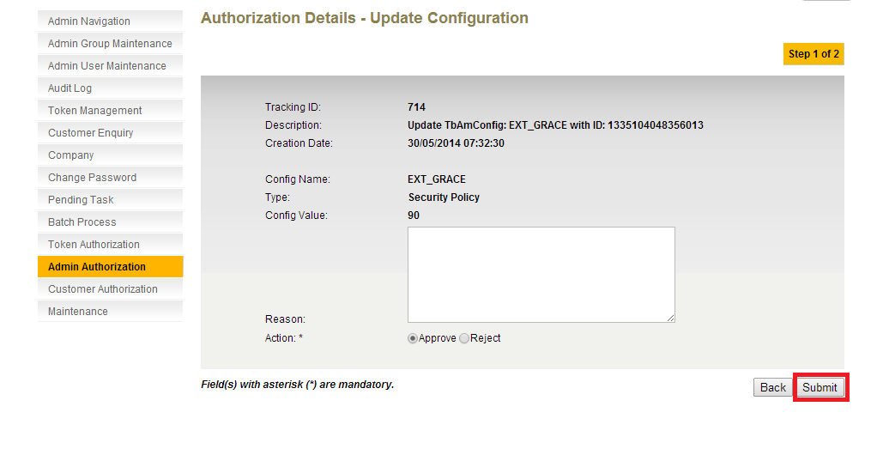Figure 4.35: Admin Authorization Details Screen – Checker

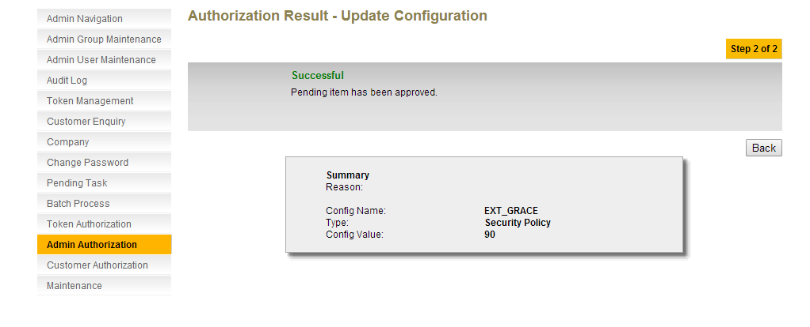
Figure 4.36: Admin Authorization Result Screen - Checker

Figure: Edit Security Policy Result Screen- Maker –pls get the correct screen shot

Company

Create Company

This feature shall allow RCAS administrator to create new company. Company ID is unique per company as no duplication of the same identifier is permitted. If administrator tried to use the same ID for other company, RCAS will prompt for a new ID. In this situation, it is recommended to perform a company enquiry on the new company to be created in order to check for its existence in RCAS prior to company creation. RCAS comes with “MAYBANK” company ID by default as all bank administrators will be created and managed under “MAYBANK” for GLOBAL instance. As for Indonesia instance, all bank administrators will be created and managed under “IDBANKBII”.
Company creation is centralized in RCAS where subsequent company creation from Integrated applications will need to query for company profiled created initially at RCAS and populate into respective application data storage.
Step 1:
RCAS administrator can access to Company module by clicking on the Company link at the navigation menu. Click on Create Organization tab to proceed to the company creation page.
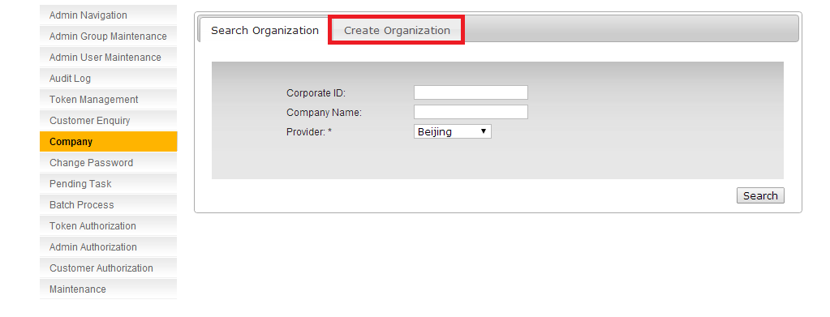
Figure 5.37: Company Enquiry Screen – Click on Create Company Tab
Step 2:
RCAS administrator has to input the provided fields for company creation. Trying to input Organization ID that already exists is not allowed, OR select via the ratio box to choice the existed Corporate ID. Note that Corporate ID by default will be converted to upper case. For example, when typing “toyota” or “Toyota” or “ToyoTa”, at company ID field, RCAS System will save it as “TOYOTA” by default (all in capital letters).
RCAS will add prefix in front of corporate Id to ensure the uniqueness of the corporate Id across instance. The prefix will be according to the provider selected by the user. For example, user creates corporate Id “TOYOTA” under Malaysia provider, the corporate Id will be MYTOYOTA.
The allowable characters and format to be input are described in the table below:
Field | Description
Corporate ID (=organization id) | 30 characters maximum, alphanumeric. Required.
Company Name | 50 characters maximum, alphanumeric. Could not accept special characters except ()'.,& and space. Required
CIF No (=Company id) | 30 characters maximum, alphanumeric. Required and Editable. Accept special characters, except “< > ( ) ' % ; + & \
Address Line 1 | 40 characters maximum, alphanumeric. Could not include special characters except #,'-./ and space. Required
Address Line 2 | 40 characters maximum, alphanumeric. Could not include special characters except #,'-./ and space. Required
Address Line 3 | 40 characters maximum, alphanumeric. Could not include special characters except #,'-./ and space. Required
Address Line 4 | 40 characters maximum, alphanumeric. Could not include special characters except #,'-./ and space.
Address Line 5 | 40 characters maximum, alphanumeric. Could not include special characters except #,'-./ and space.
City | 60 characters maximum, alphabet
Prefecture | 60 characters maximum, alphabet
Post Code | 15 characters maximum, numeric.
State | Select from drop down list. Required.
Country Code | Select from drop down list. Required.
Contact No | 16 characters maximum, numeric.
Fax No | 16 characters maximum, numeric.
Table 5.1: Create Company field explanation
Click on Submit button to proceed to the confirmation screen.
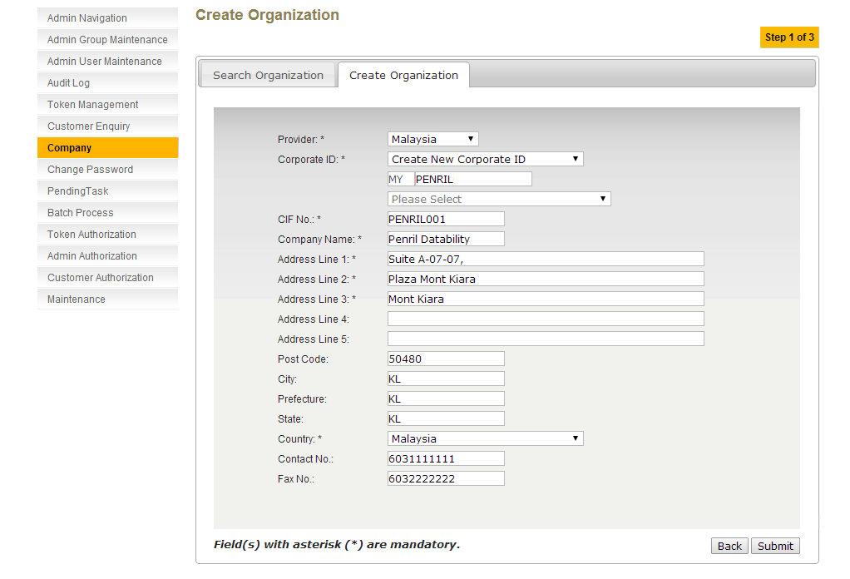
Figure 5.38: Create Company Screen with Details
Step 3:
Click on Confirm button to proceed to the result page.
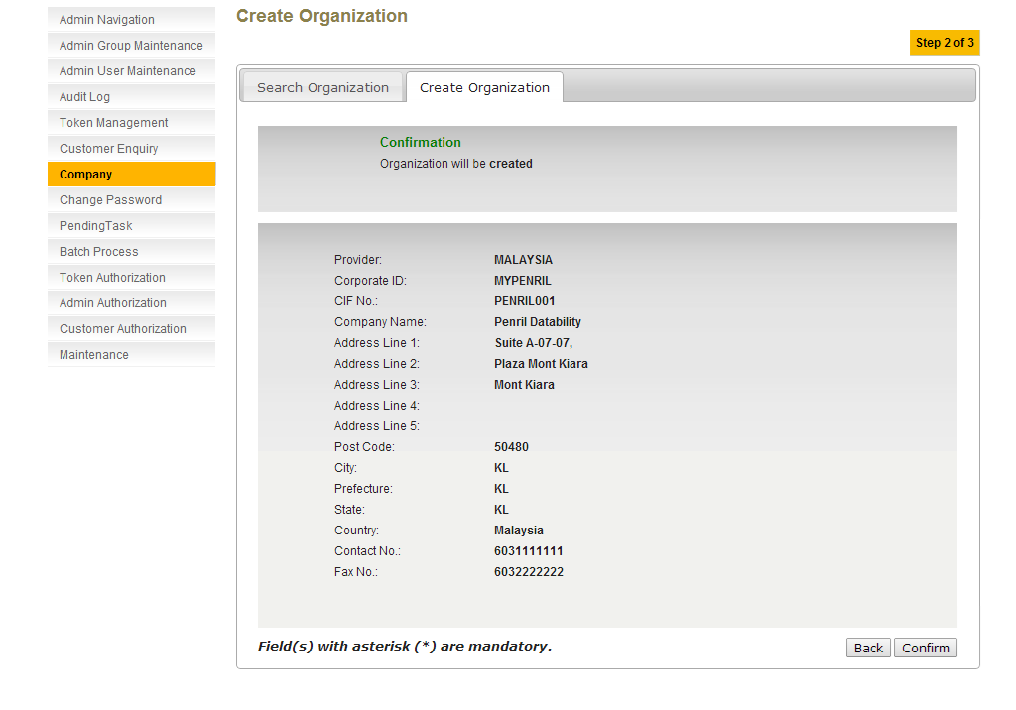
Figure 5.39: Create Company Confirmation Screen
Step 4:
A result page shall display the status of the request. The status can either be Successful or Unsuccessful. Result page will also display the summary of the company that has been created.
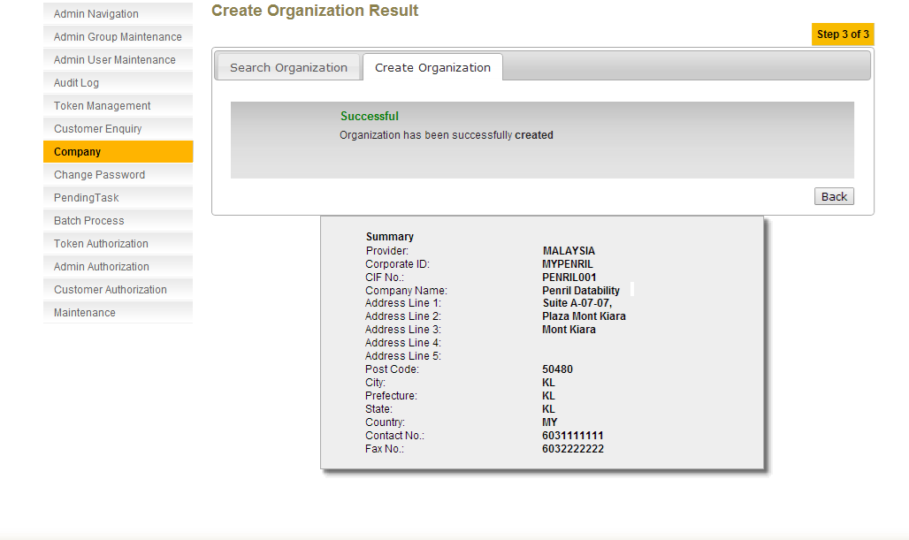
Figure 5.40: Create Company Result Screen

Edit Company
This feature shall allow RCAS administrator to edit an existing company based on organization ID and company name. Editing of company will not update/synchronize information that is being stored at integrated applications. Integrated applications are necessary to query the updated company profile and update accordingly at respective data storage.
Step 1:
RCAS administrator can access to Company module by clicking on the Company link at the navigation menu.

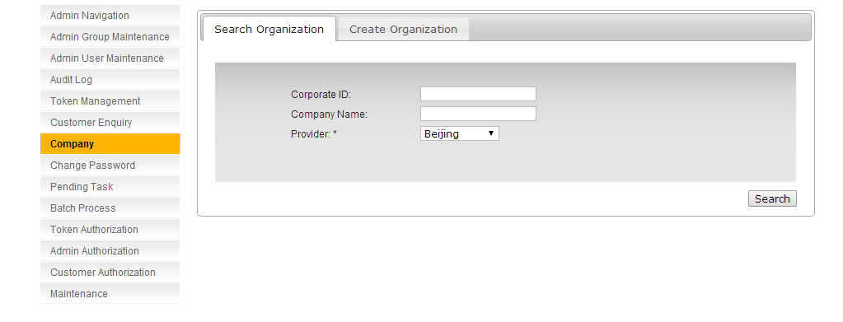
Figure 5.41: Company Enquiry Screen
Step 2:
RCAS administrator can enquire the company based on Corporate ID or Company Name, or even leave the fields blank to get the list of all companies. Click on Search button to proceed to the search result page.
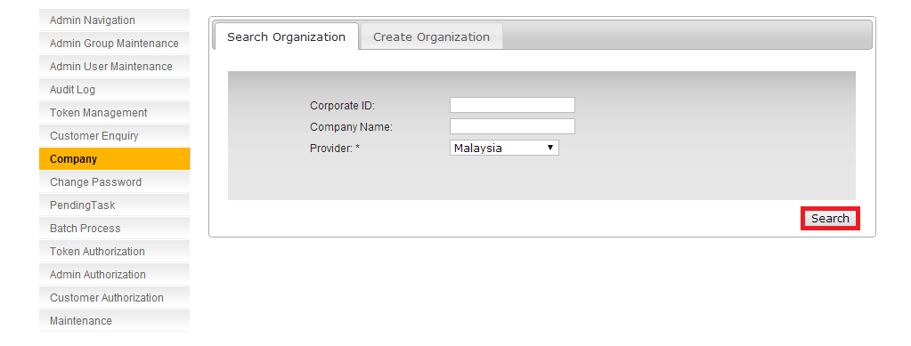
Figure 5.42: Company Enquiry Screen – Click on Search Button
Step 3:
The search result page will show the list of the company based on the search criteria. Click on Edit link that point to specific company to proceed to the company edit page.

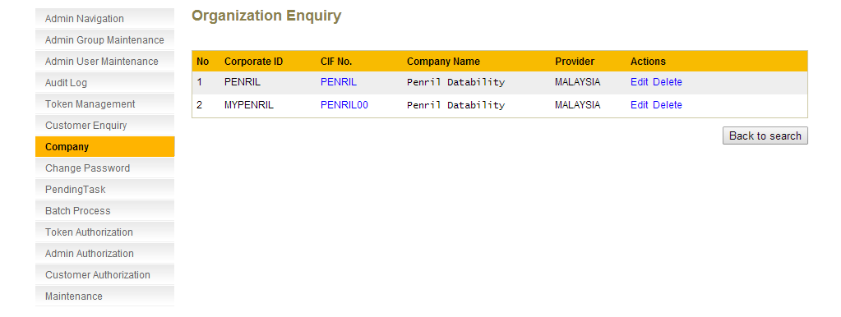
Figure 5.43: Company Enquiry Result Screen
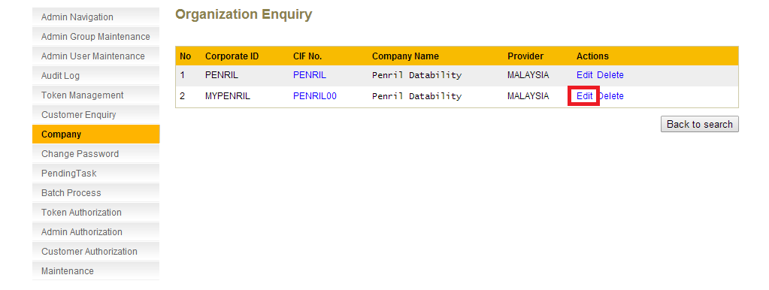
Figure 5.44: Company Enquiry Result Screen – Click on Edit Link
Step 4:
In Edit Company page, RCAS administrator can edit the company’s information details. Click on Submit to proceed to confirmation screen.
Kah Yan: pls follow the sequence based on creation. Eg: Provider, Corporate id, and etc.
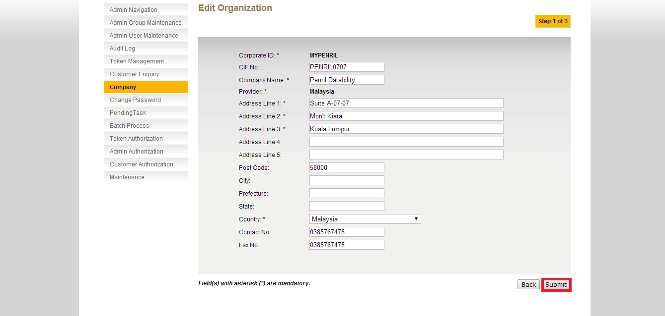
Figure 5.45: Edit Company Details Screen
Step 5:
Click on Confirm button to proceed to the result page.

Kah Yan: please follow the sequence of the creation.
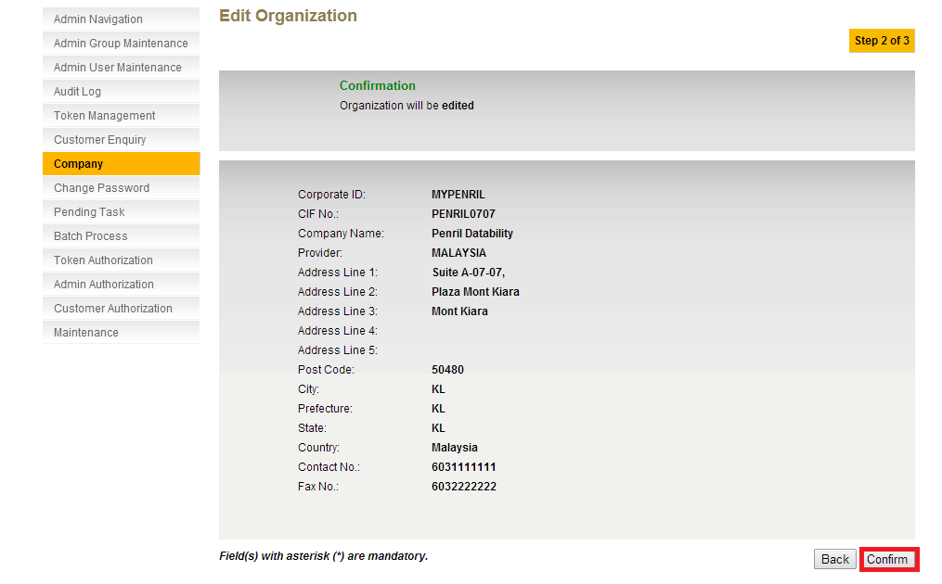
Figure 5.46: Edit Company Confirm Screen
Step 6:
A result page shall display the status of the request. The status can either be Successful or Unsuccessful. Result page will also show the summary of the company before and after it has been edited.
Kah Yan, please follow the sequence of creation.
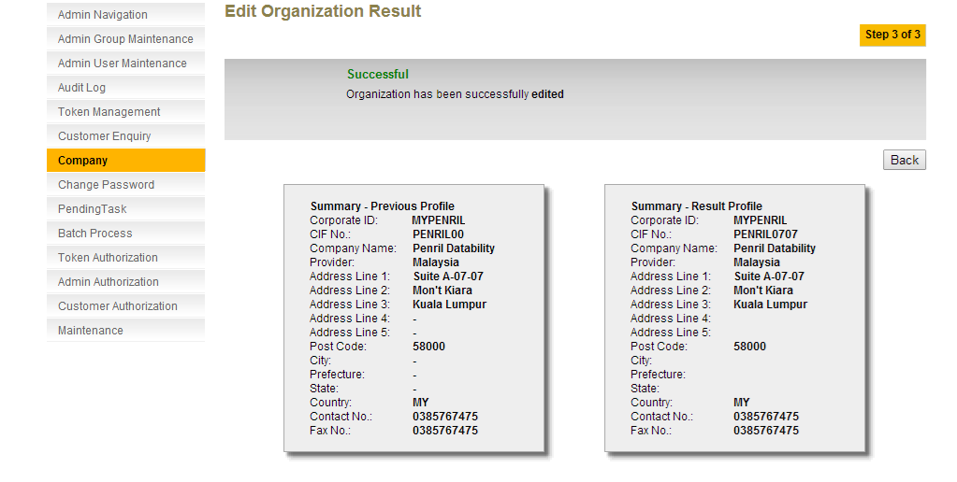
Figure 5.47: Edit Company Result Screen

Linking user id status - Boby
Main and Virtual user is consider 2 different normal user in RCAS - need to show the user linkage 'Active-Virtual' in RCAS as well.
To add 'Virtual' indicator. This virtual to be locked from all action i.e being used by other applications, cannot reset password etc.
Audit log requirement not to use the virtual user as an active user.
This indicator have integration to modify the linkage.

Step 1:
Select Customer Enquiry from the navigation list. Click Search.
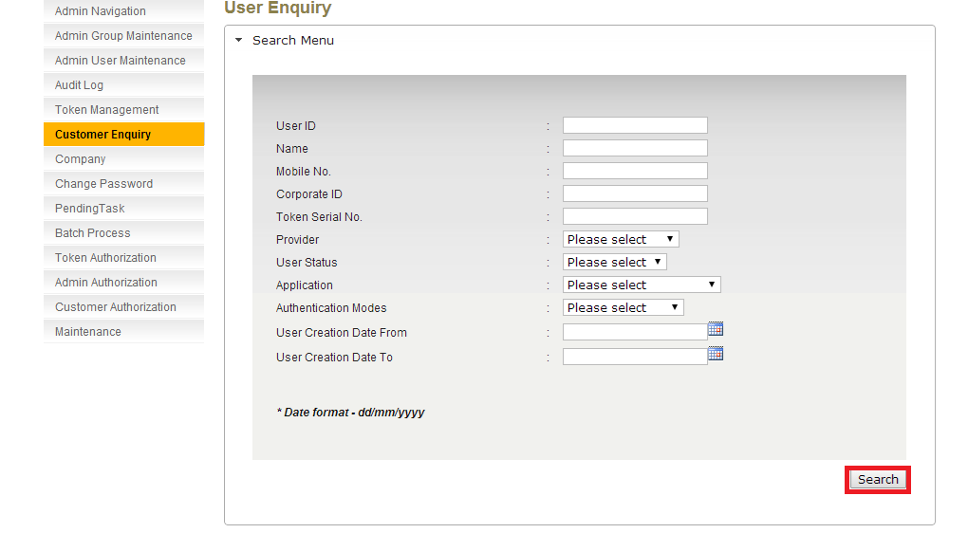
Figure 6.48: Customer Enquiry Screen
Step 2:
Select the user to view the user’s detail. Click on the selected User ID.
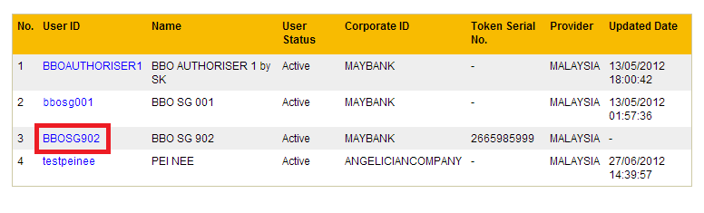
Figure 6.49: Customer Enquiry Result Screen

Step 3:
The user details is displayed with a list of functions (ie. Reset Password, Disable User, etc.). User linking information is displayed in user details. Link Indicator is the status of user linking. There is 3 possible values for Link Indicator.
- Active
- Virtual
- - (dash)
The update for user linkage will be initiated by channel application through webservice.
If the Link Indicator value is – (dash). It means that the user is not linked to other user. RCAS will treat this user as a normal user.
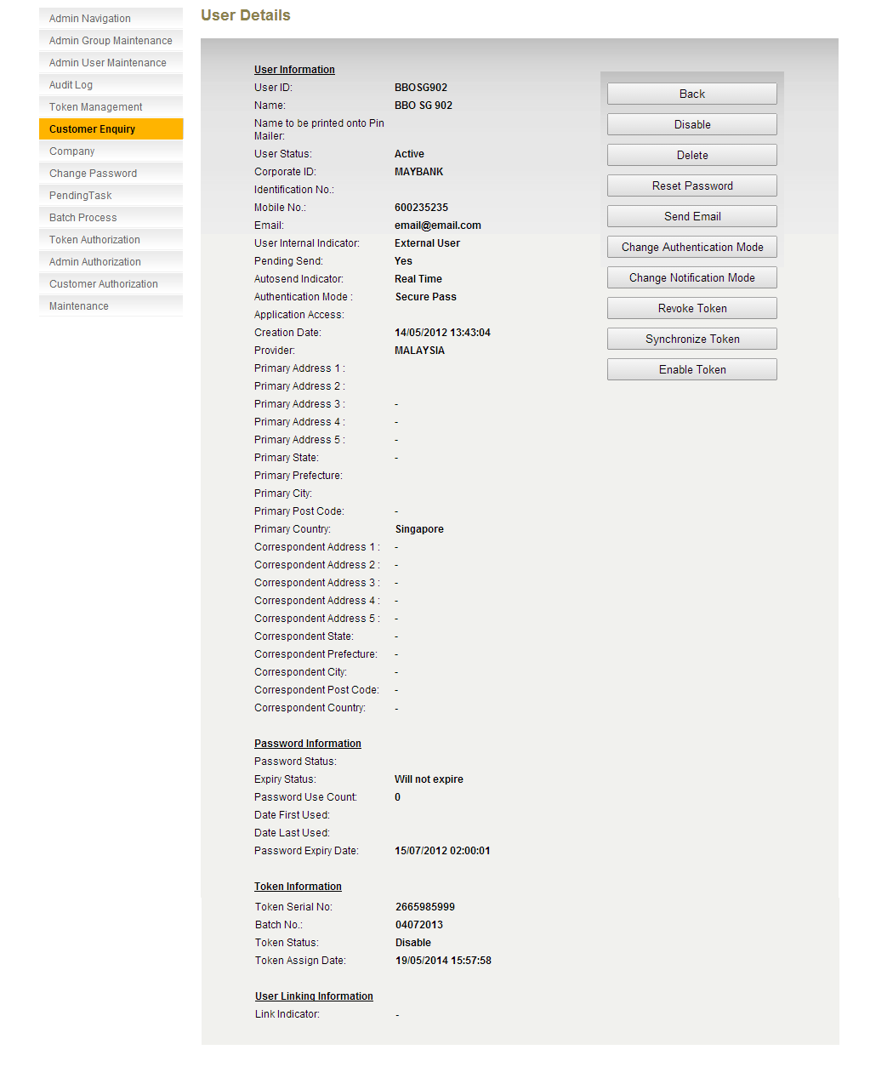
Figure 6.50: User Details Screen (No User Linking)
If the Link Indicator value is Active. It means that the user is linked to other user. RCAS will treat this user as a normal user.

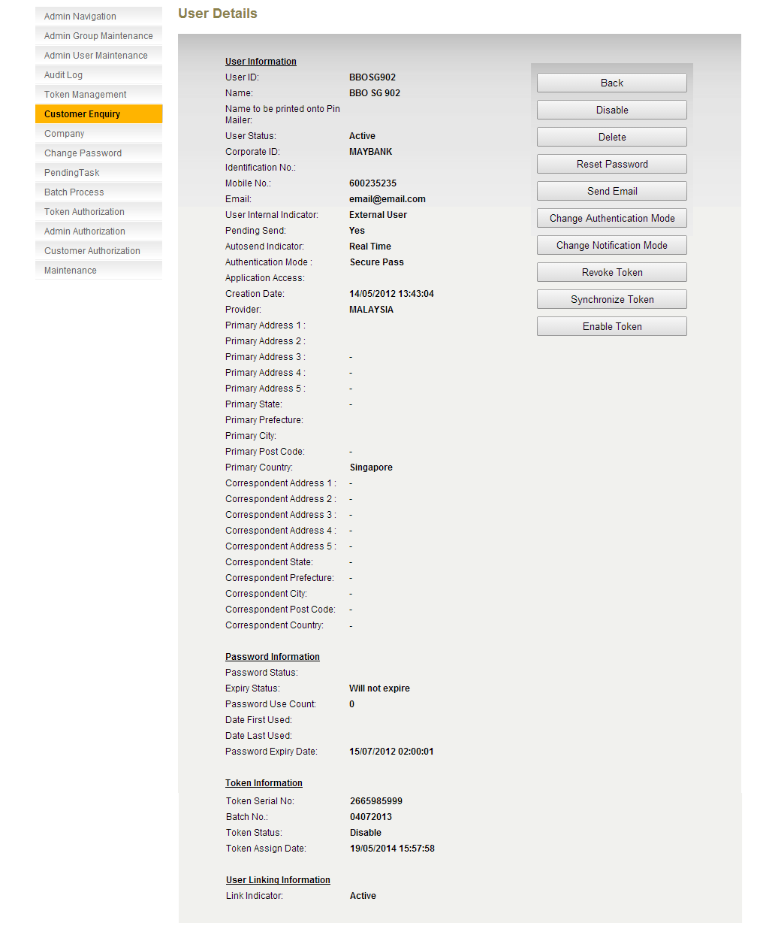
Figure 6.51: User Details Screen (Active User)

If the Link Indicator value is Virtual. It means that the user is linked to other user. RCAS will treat this user as a normal user but this user is only allowed to access certain functions. The functions available to Virtual user are:
- Assign Token
- Revoke Token
- Sync Token

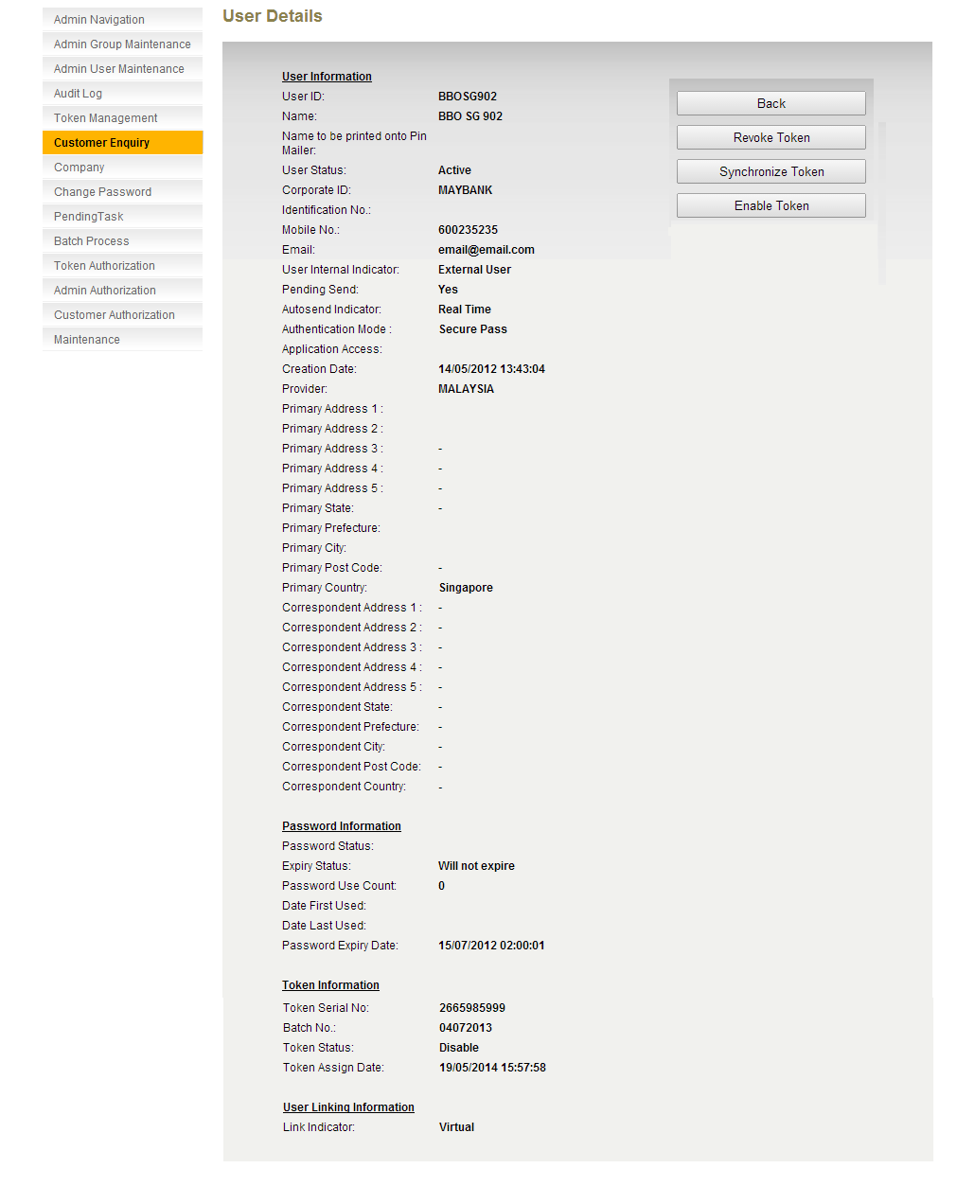
Figure 6.52: User Details Screen (Virtual User with Token)

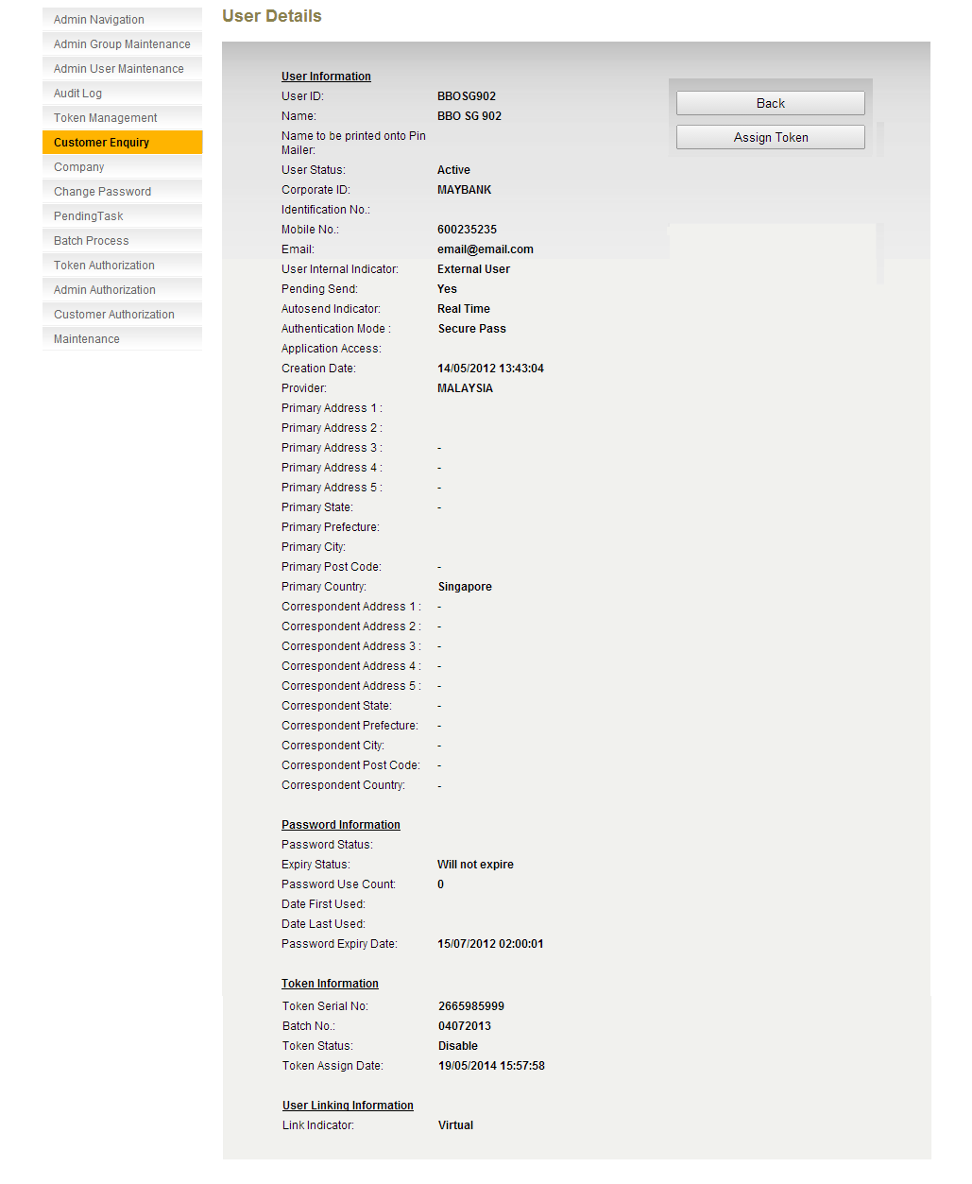
Figure 6.53: User Details Screen (Virtual User without Token)

Change field length
To change some of length from RCAS. Refer to the excel file.

Email – Add Reference #

RCAS administrator can based on the email reference # to verify with BBO or CFO user which password that they received when there has issue of receive multiple email or not able to know which password that they should use. The reason being is Maybank SMTP server may delay email delivery or any reason. By adding reference # in Reset Password for BBO and CFO user and Create BBO user id and the password notification through email should able reduce the some of the issues.
No changes on the existing RCAS Reset Password flow. There will be an additional field, Reference Number to be added in both Admin User Maintenance and Customer Enquiry.

Admin User Maintenance

Step 1:
Select Admin User Maintenance from the navigation list. Search for the administrator to reset password. Click Search.
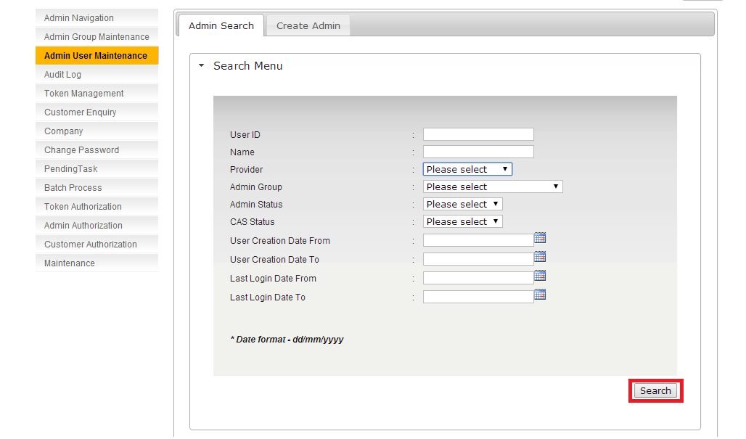
Figure 8.54: Admin User Maintenance Enquiry Screen
Step 2:
Select the user to reset password. Click on User ID
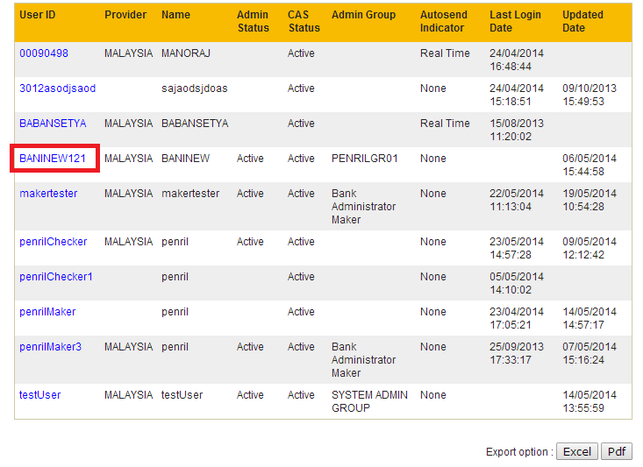
Figure 8.55: Admin User Maintenance Enquiry Result Screen

Step 3:
The user details are displayed with a list of functions (ie. Reset Password, Disable User, etc.). Click Reset Password.
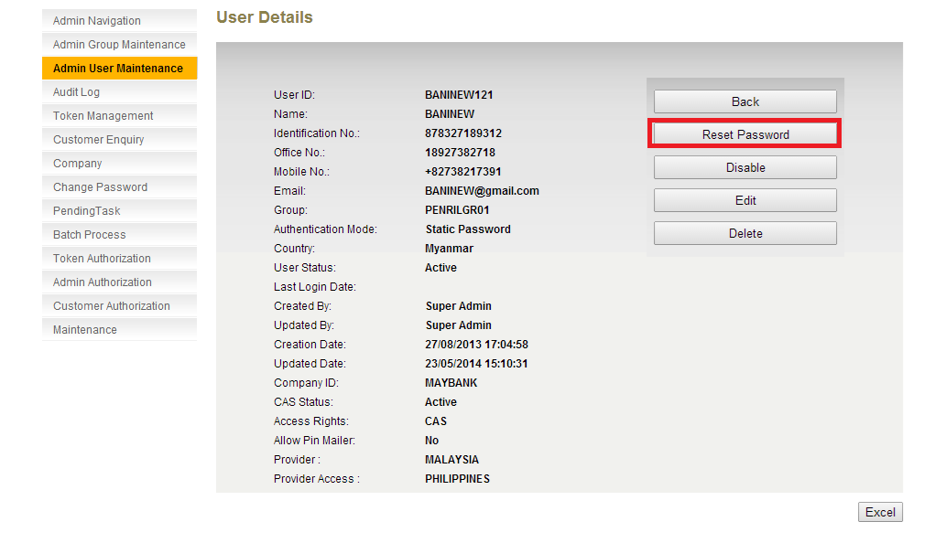
Figure 8.56: Admin User Details Screen

Step 4:
Confirmation screen will be displayed. Click on Confirm.
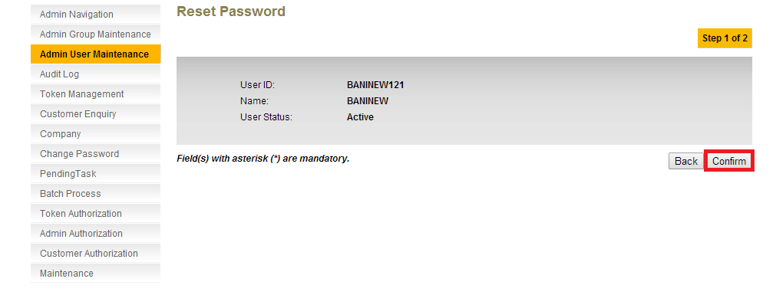
Figure 8.57: Admin User Reset Password Confirmation Screen
Step 5:
Result screen is displayed with the Reference Number in the summary details.

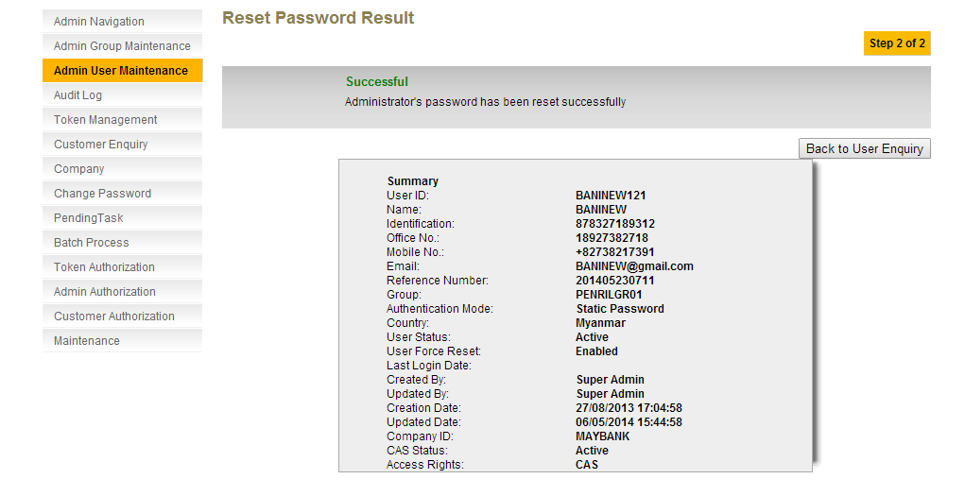
Figure 8.58: Admin User Reset Password Result Screen
Step 6:
Navigate to Audit Log, click Search to search for the record.
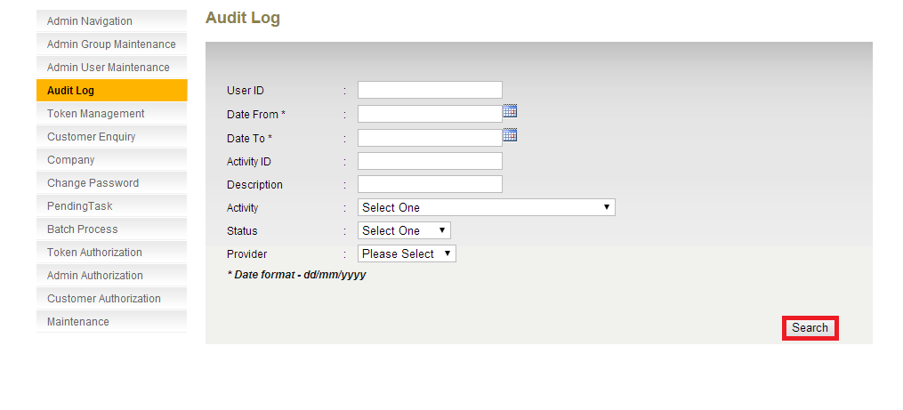
Figure 8.59: Audit Log Enquiry Screen
Step 7:
Click on Activity ID of the record.
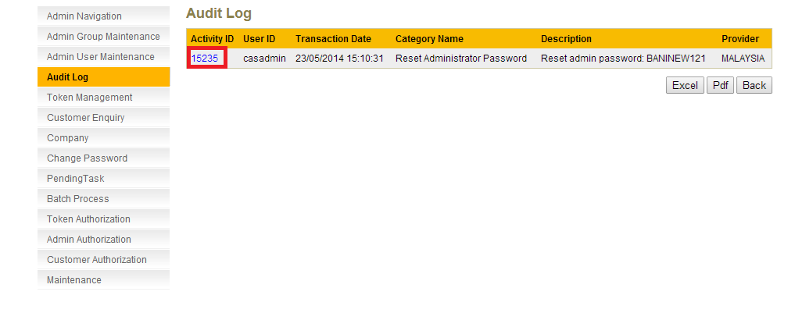
Figure 8.60: Audit Log Enquiry Result Screen
Step 8:
In Audit Log details. Reference Number is displayed in the Result Snapshot.
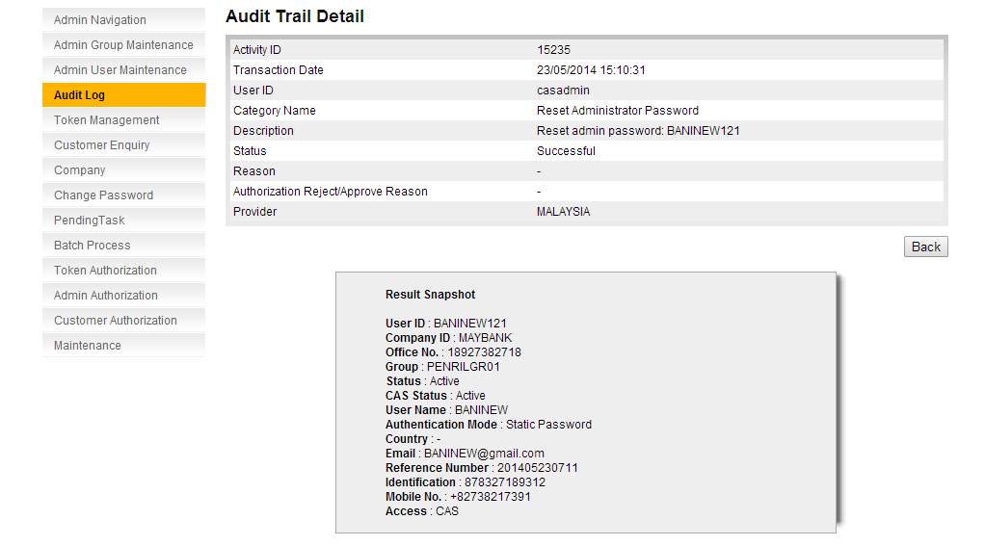
Figure 8.61: Audit Log Detail Screen

Customer Enquiry

Step 1:
Select Customer Enquiry from the navigation list. Search for the user to reset password. Click Submit.

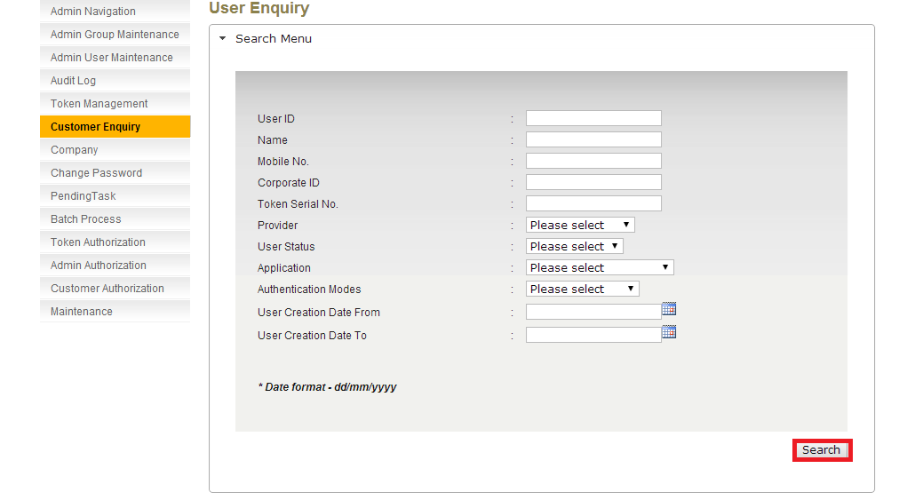
Figure 8.62: Customer Enquiry Screen
Step 2:
Select the user to reset password. Click on User ID.

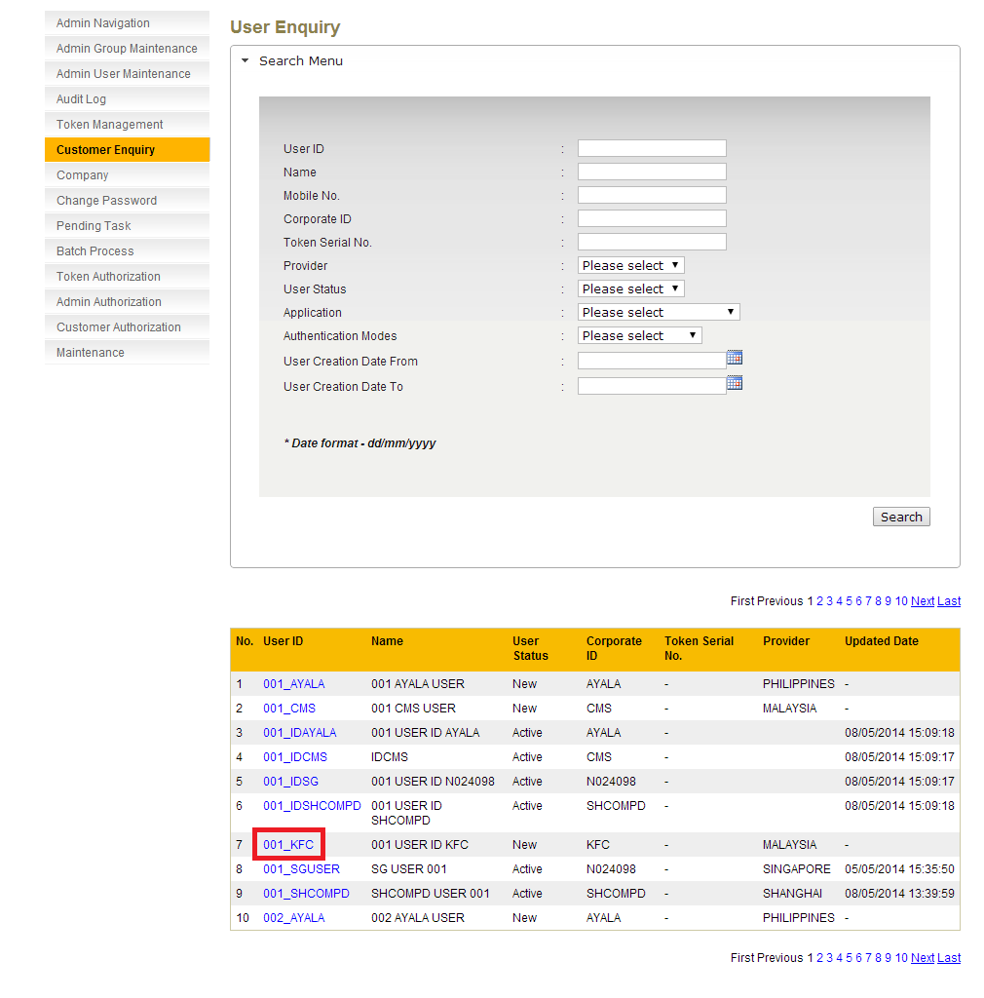
Figure 8.63: Customer Enquiry Result Screen
Step 3:
The user details are displayed with a list of functions (ie. Reset Password, Disable User, etc.). Click Reset Password.
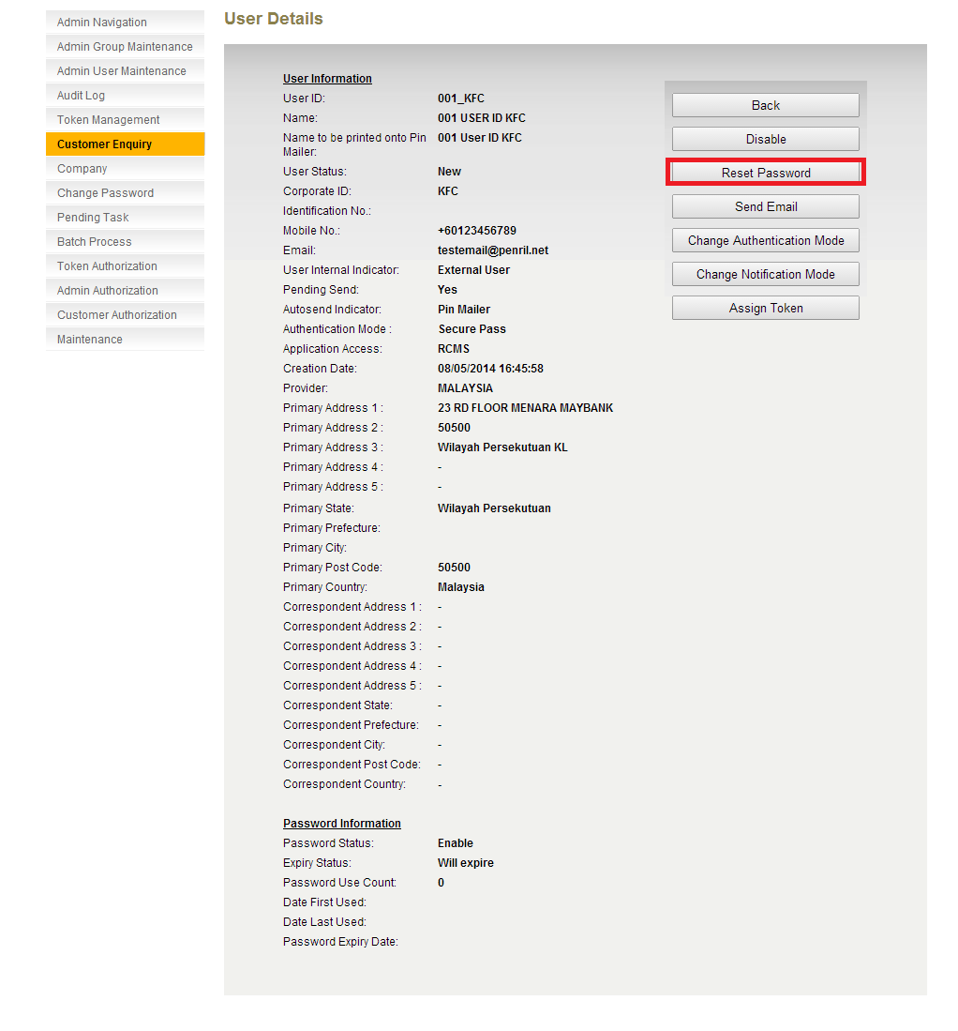
Figure 8.64: Customer Enquiry User Details Screen – Pin Mailer Autosend Indicator
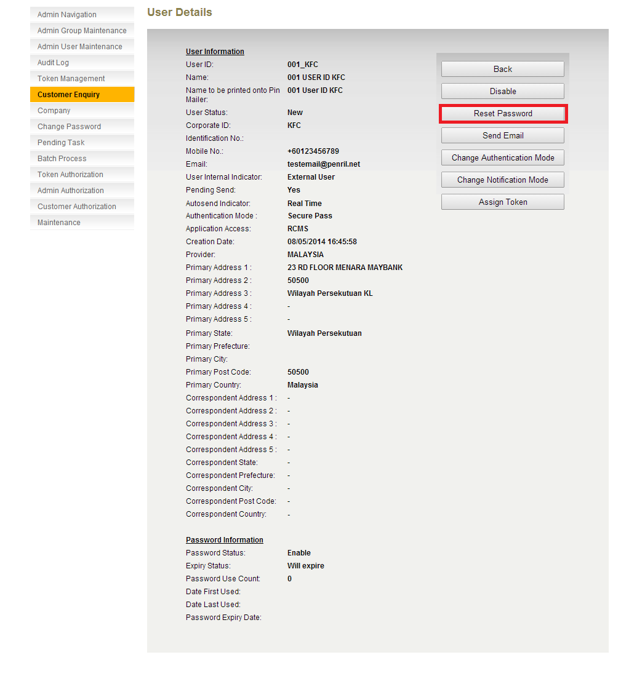
Figure 8.65: Customer Enquiry User Details Screen – Real Time Autosend Indicator
Step 4:
Confirmation screen will be displayed. Click on Confirm.
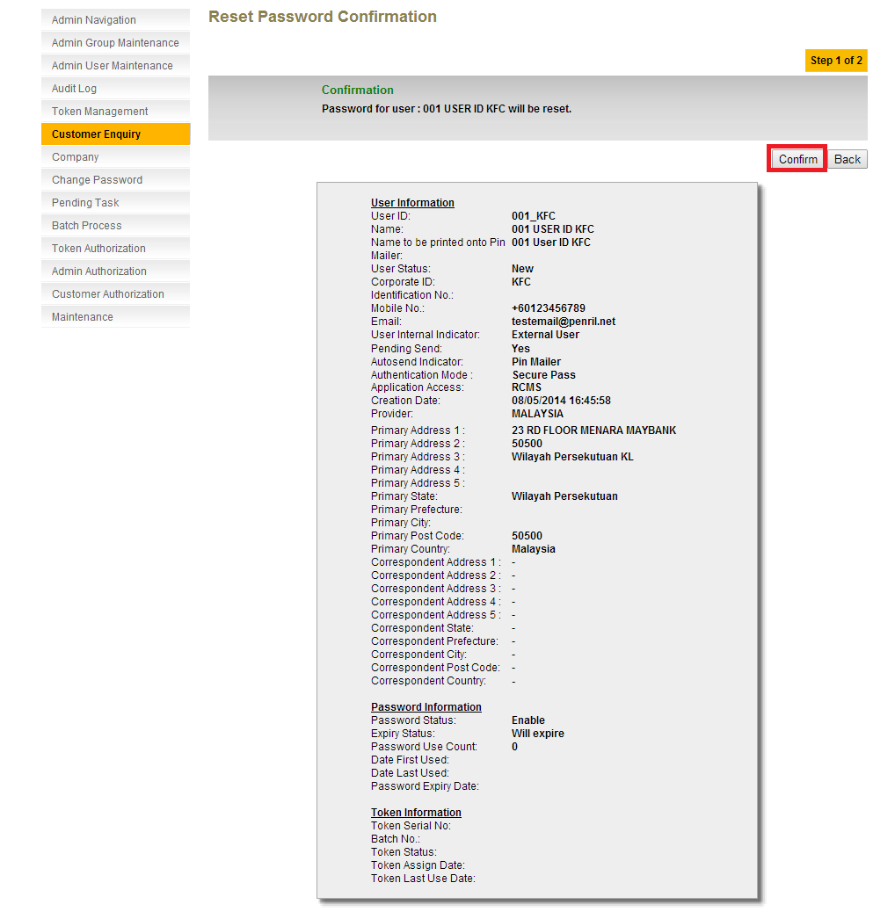
Figure 8.66: Customer Enquiry User Confirmation Screen – Pin Mailer Autosend Indicator

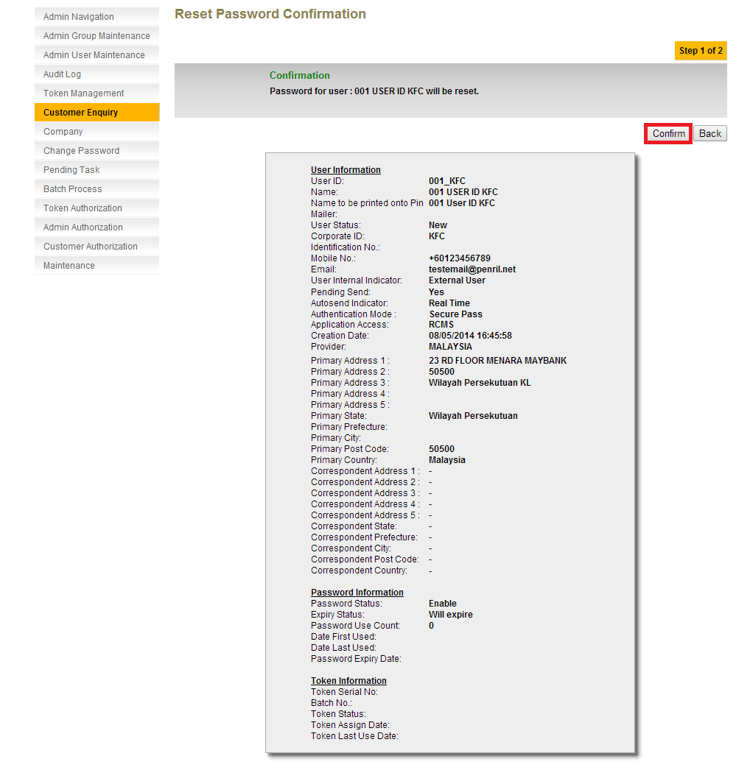
Figure 8.67: Customer Enquiry User Confirmation Screen – Real Time Autosend Indicator
Step 5:
Result screen is displayed with the Reference Number in the summary details.
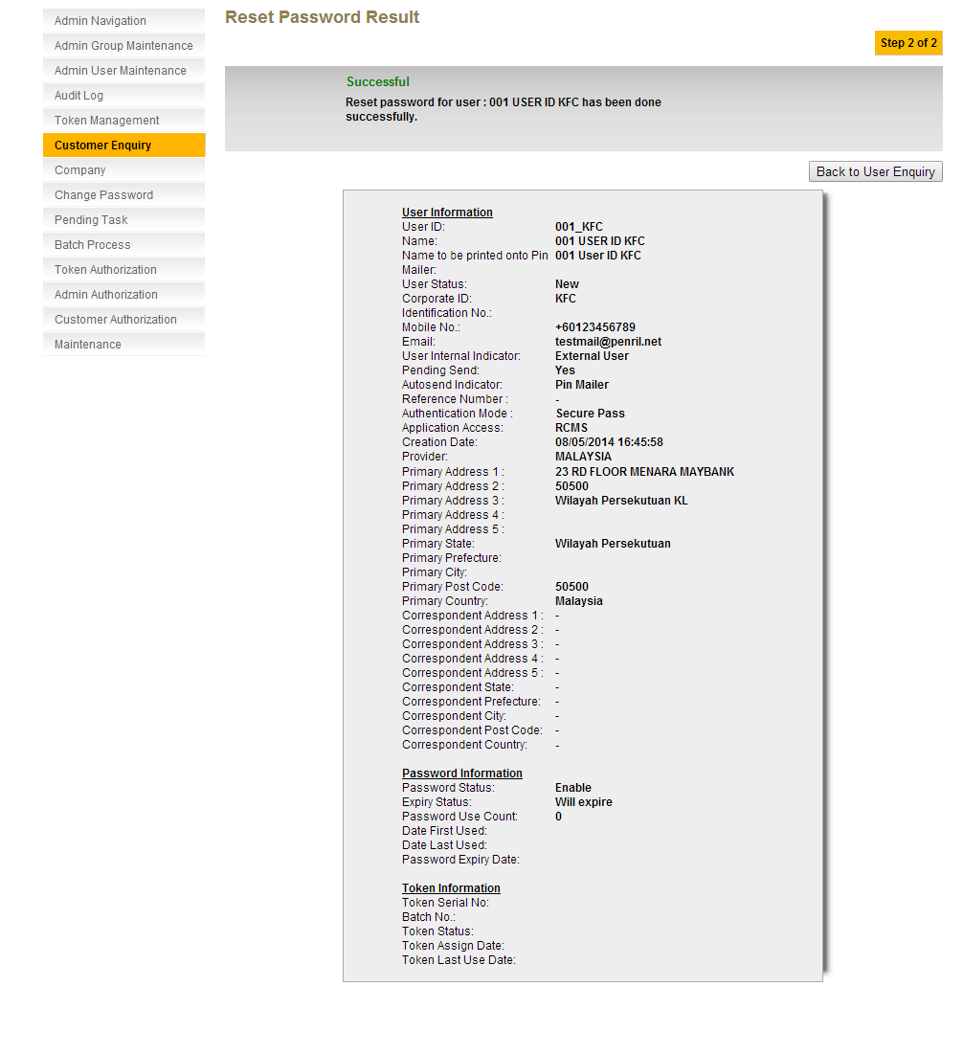
Figure 8.68: Customer Enquiry User Result Screen – Pin Mailer Autosend Indicator

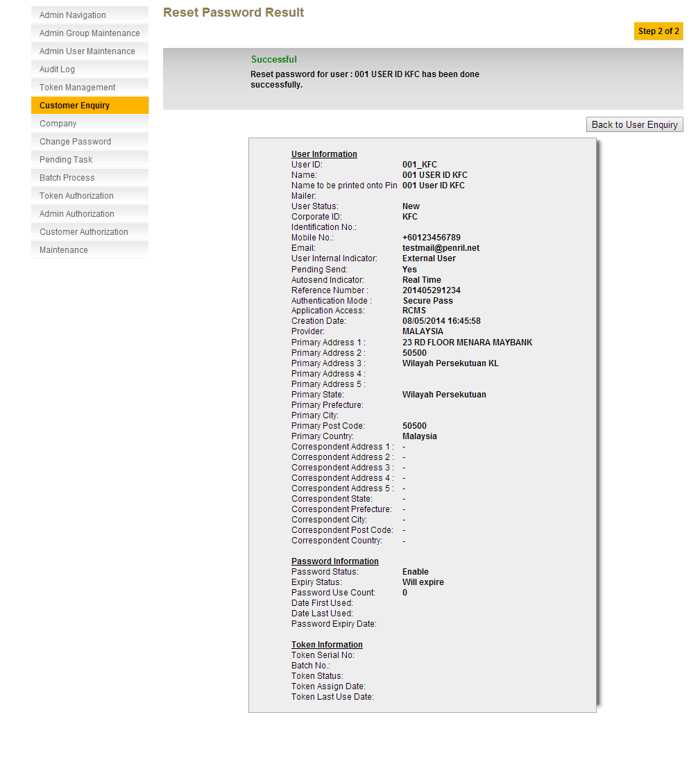
Figure 8.69: Customer Enquiry User Result Screen – Real Time Autosend Indicator
Step 6:
Navigate to Audit Log, click Search to search for the record.
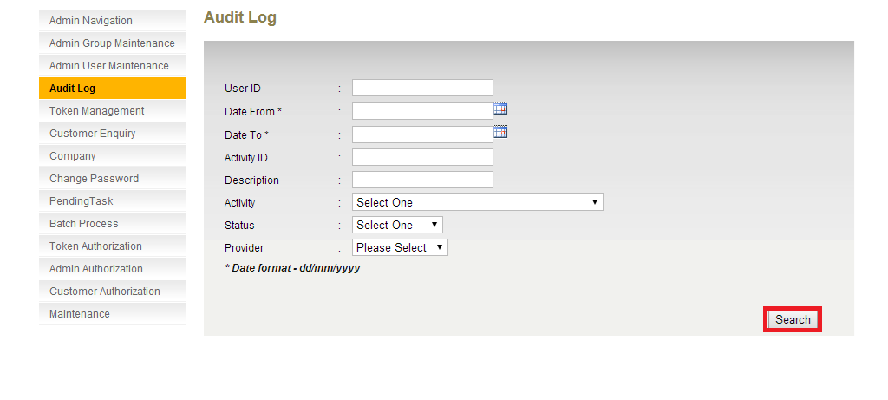
Figure 8.70: Audit Log Enquiry Screen
Step 7:
Click on Activity ID of the record.
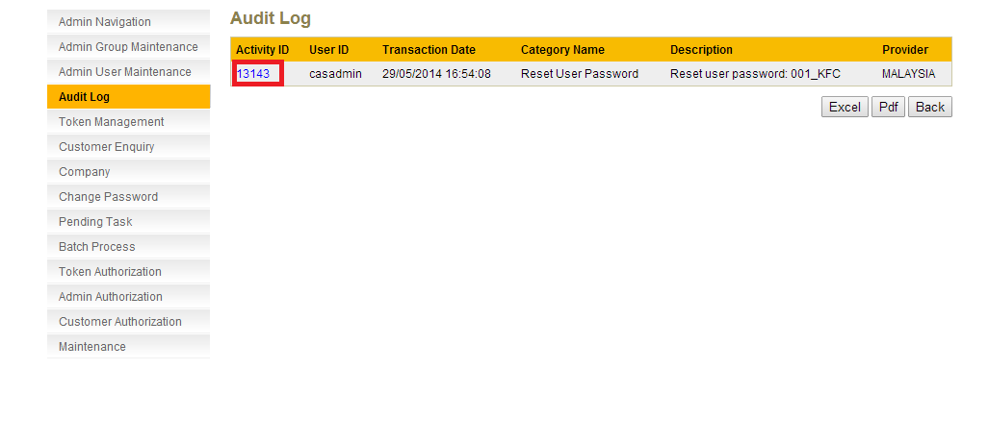

Figure 8.71: Audit Log Enquiry Result Screen
Step 8:
In Audit Log details. Reference Number is displayed in the Result Snapshot.

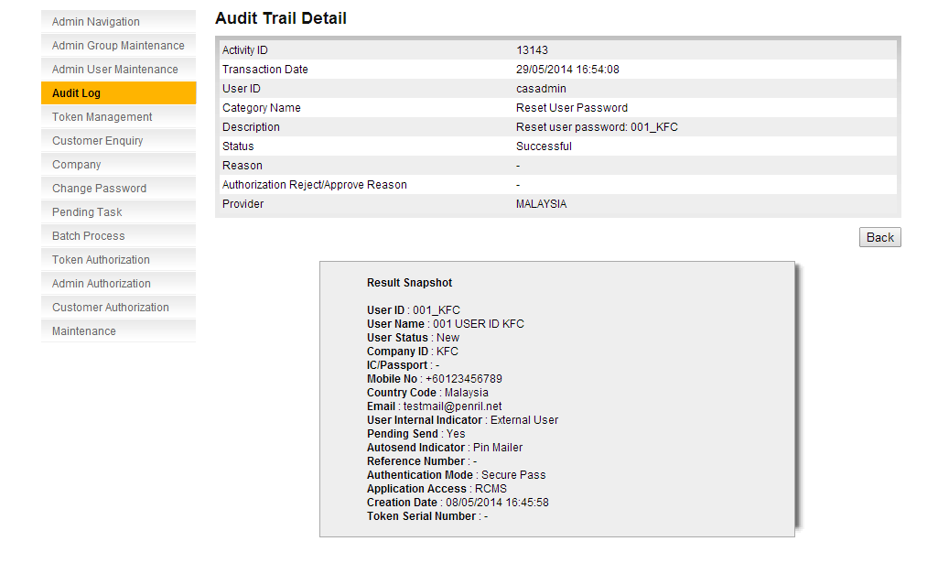

Figure 8.72: Audit Log Details Screen – Reset Password Pin Mailer Autosend Indicator

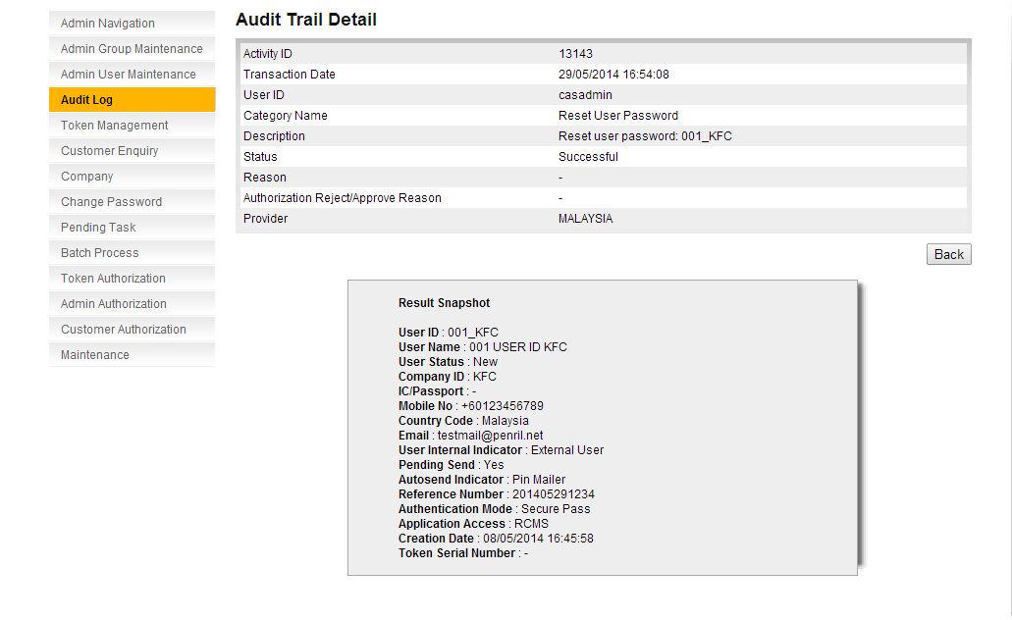
Figure 8.73: Audit Log Details Screen – Reset Password Real Time Autosend Indicator

Sample Email Format

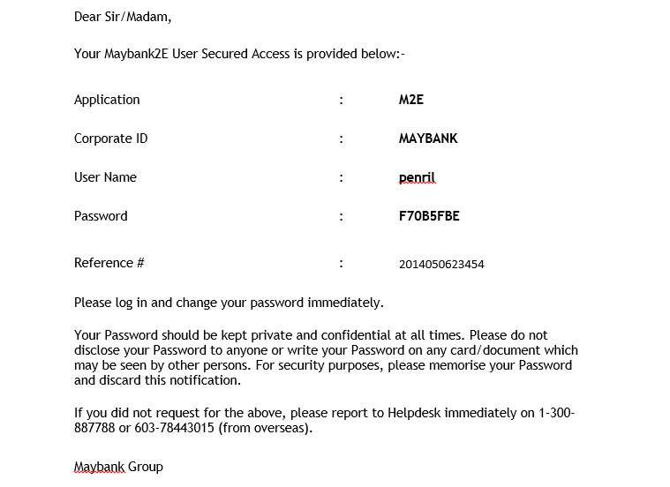
Figure 8.74: Sample Email Format

Pin Mailer and Pin Letter Address
To align the email address between the space.
Kah Yan: pls assist to add on the alignment that we use, example: address 1, address 2 in rcas is match with pin mailer or pin letter address 4 or 5 and etc….
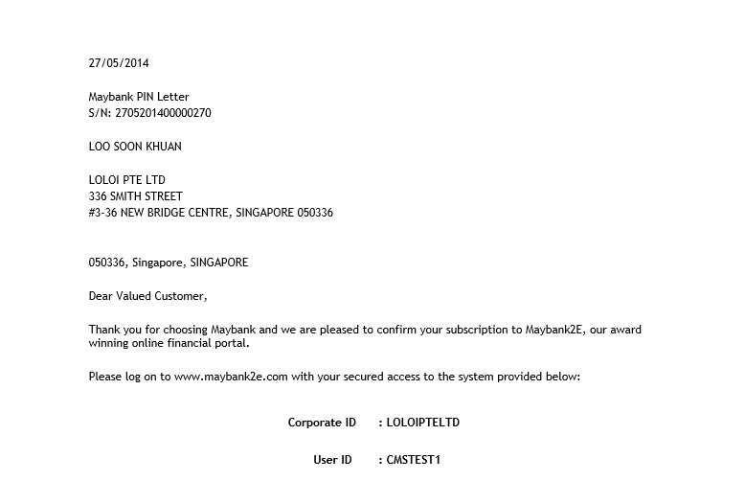
Figure 9.75: Pin Letter (Before Changes)

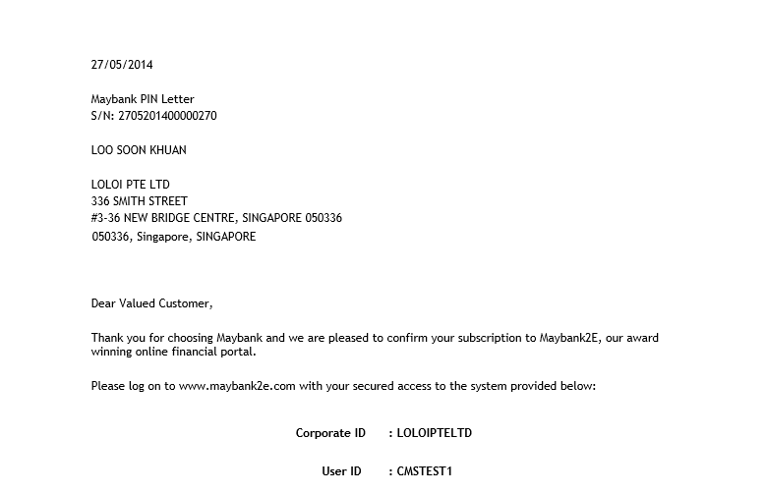
Figure 9.76: Pin Letter (After Changes)

Update CFO user profile – Boby

Current: if CFO/BBO user status is "Locked" or "Inactive", or "Disable" it not allow to update user profile
New requirement: if CFO/BBO user status is "Locked" or "Inactive", or "Disable" it allow to update user profile
Kah Yan: Edit Profile, can list down what are the profile allow to edit? Eg: Phone # or etc?
Users | User Status | Edit Profile
BBO | Locked | Not Allowed
BBO | Inactive | Not Allowed
BBO | Disabled | Not Allowed
CFO | Locked | Not Allowed
CFO | Inactive | Not Allowed
CFO | Disabled | Not Allowed
Table 10.2: Current Flow for Edit Profile

Users | User Status | Edit Profile
BBO | Locked | Allowed
BBO | Inactive | Allowed
BBO | Disabled | Allowed
CFO | Locked | Allowed
CFO | Inactive | Allowed
CFO | Disabled | Allowed
Table 10.3: New Flow for Edit Profile

Factory ID per Application - Boby
To create factory id per application.

A new API will be provided to create a factory id for each channel application.
The factory id is allowed to access the application that initiate the user creation request.
Figure 11.77: Process Flow of Factory ID Creation
Example:
Case 1:
Access Application: RCMS
Factory ID Created From: RCMS
Result: Allow to access
Case 2:
Access Application: RCSF
Factory ID Created From: RCMS
Result: Not allow to access

Status Report – Boby

This is a new module to enquire on status of all activity performed including request through webservice. The records will be stored in a new table in database. RCAS will create a file of pdf format or Excel format to be exported.
The logs will be keep in the database for a specific time (days). The number of days is parameterized and can be set in upass.cfg. Old logs will be deleted by a scheduler. There will not be any backup for the deleted logs (hard delete).
Step 1:
A new navigation Status Report will be available in RCAS. RCAS user can search for the logs. Click Search.
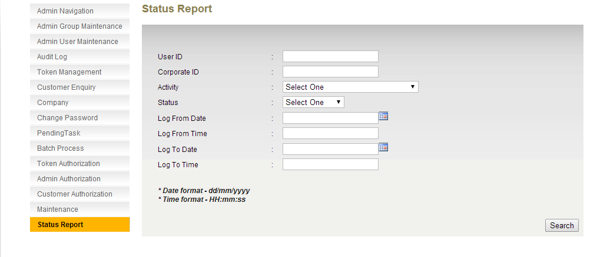
Figure 12.78: Status Report Enquiry Screen

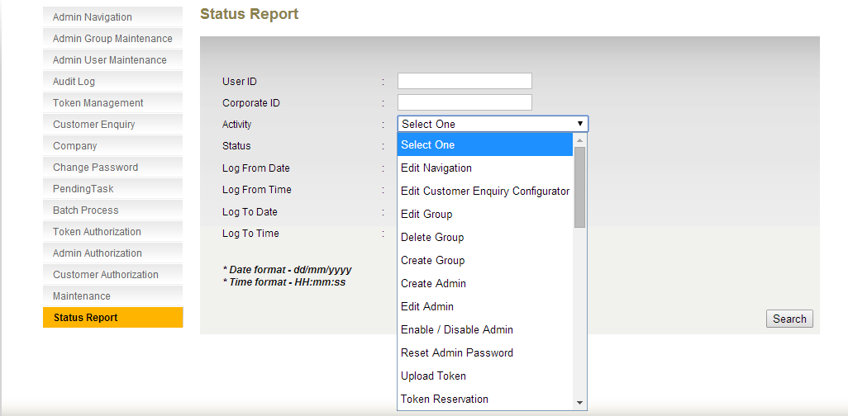
Figure 12.79: Status Report Activity Dropdown List
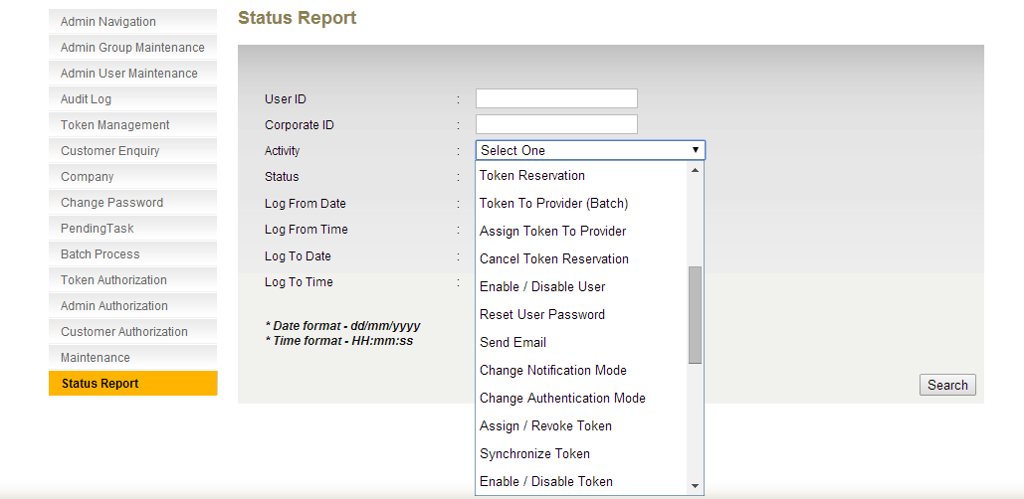
Figure 12.80: Status Report Activity Dropdown List

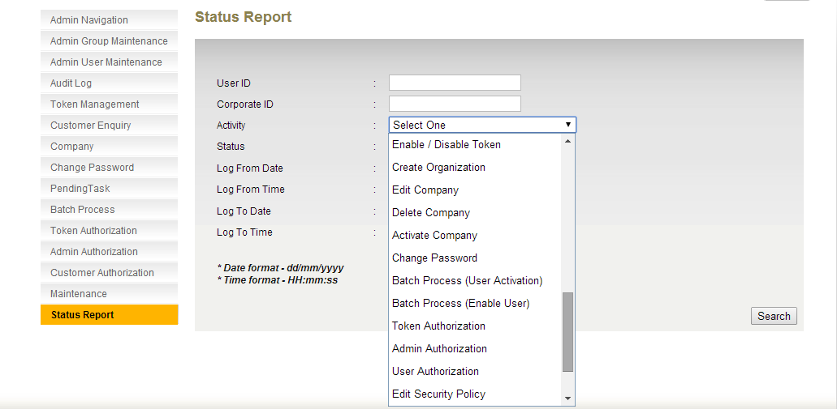
Figure 12.81: Status Report Activity Dropdown List
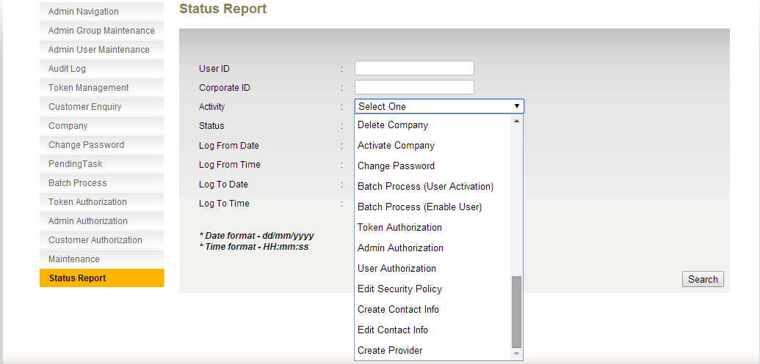
Figure 12.82: Status Report Activity Dropdown List

Field | Description
User ID | User Alias. 25 characters maximum, alphanumeric.
Corporate ID | Company ID. 30 characters maximum, alphanumeric. Not accept special character except - / @ & ' . : ;
Activity | List of activities to be stored in status report.  - Edit Navigation  - Edit Customer Enquiry Configurator  - Edit Group  - Delete Group  - Create Group  - Create Admin  - Edit Admin  - Enable / Disable Admin  - Reset Admin Password  - Upload Token  - Token Reservation  - Assign Token To Provider (Batch)  - Assign Token To Provider  - Cancel Token Reservation  - Enable / Disable User  - Reset User Password  - Send Email  - Change Notification Mode  - Change Authentication Mode  - Assign / Revoke Token  - Synchronize Token  - Enable / Disable Token  - Create Organization  - Edit Company  - Delete Company  - Activate Company  - Change Password  - Batch Process (User Activation)  - Batch Process (Enable User)  - Token Authorization  - Admin Authorization  - User Authorization  - Edit Security Policy  - Create Contact Info  - Edit Contact Info  - Create Provider
Status | Status of the request. Dropdown list
Log From Date | Creation date of the log. Format dd/MM/yyyy
Log From Time | Creation time of the log. Format hh:mm:ss
Log To Date | Creation date of the log. Format dd/MM/yyyy
Log To Time | Creation time of the log. Format hh:mm:ss
Table 12.4: Status Report Enquiry Criteria

Step 2:
A list of the records that matches the search criteria will be displayed. The list can be exported as pdf or Excel format based on RCAS user selection. Click on Log ID.
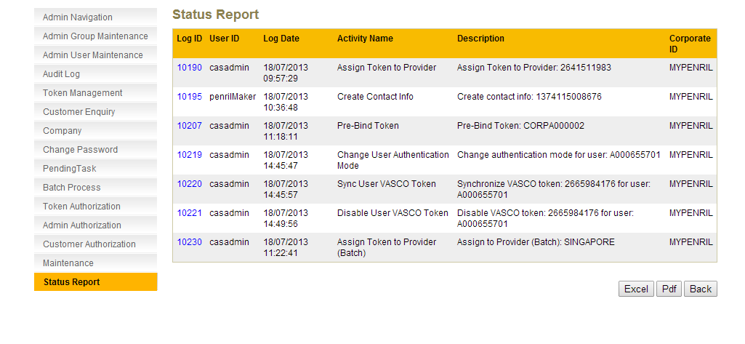
Figure 12.83: Status Report Enquiry Result Screen
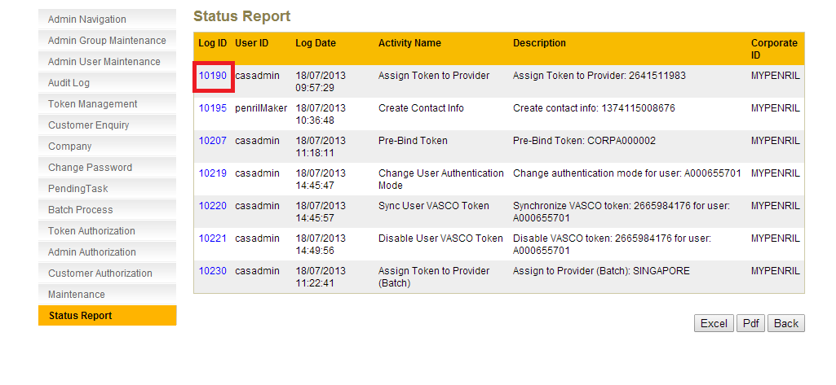
Figure 12.84: Status Report Enquiry Result Screen
Step 3:
The details of status report is displayed.
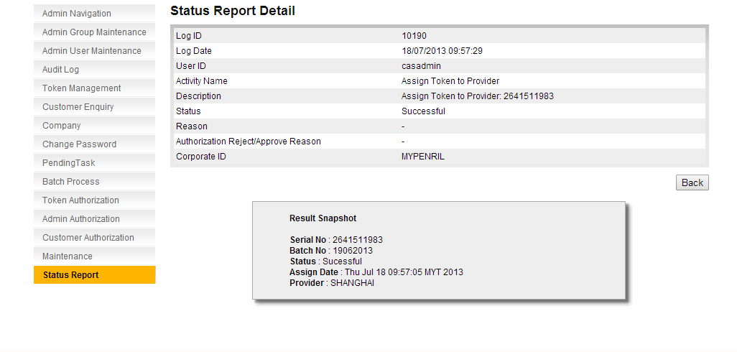
Figure 12.85: Status Report Details Screen

Field | Description
Log ID | Unique identification number for each record
Activity ID | Type of Activity (ie. Reset Password, Sync Token etc.)
Log Created By | If the request is from RCAS, will display user alias of the user id.  If the request is from webservice, will display the channel application name.
Log Date | The creation date of the log. Format dd/MM/yyyy hh:mm:ss
Log Status | Status of the log (Successful or Unsuccessful)
Reason | Root cause of Unsuccessful status.
Table 12.5: Fields to be stored in database

