
Malayan Banking Berhad

Functional Specification
Regional Centralized Authentication System (RCAS) Administration Modules- R2

26 Sept 2014

Prepared By:


Penril Datability (M) Sdn Bhd (816792-X)
Suite A-07-07 Plaza Mon’t Kiara
No. 2, Jalan Kiara, Mon’t Kiara
50480 Kuala Lumpur, Malaysia
Tel: (603) 6201 2622 Fax: (603) 6201 7622
Document Administration

Document Amendment Log
Version No | Date Updated | Description of Change | Updated By  <Name, Dept> | Reviewed By  <Name, Dept> | Approved By <Name, Dept>
1.0 | 26/9/2014 | Initial Release- R2 request | Ong Wei Kuan  Professional Services | Yap Kah Yan  Professional Services | Tan Lee Lee  Professional Services
1.1 | 10/10/2014 | Amended based on Aja feedback and add on Timezone requirement. | Ong Wei Kuan  Professional Services | Yap Kah Yan  Professional Services | Tan Lee Lee  Professional Services
1.2 | 15/10/2014 | Amended based on Aja feedback on 15 Oct and add on new requirement of differences the Server Time, Provider and Corp Provider. | Ong Wei Kuan  Professional Services | Yap Kah Yan  Professional Services | Tan Lee Lee  Professional Services

Table of Contents
1 User Linking – Virtual User ID (R2) 4
2 Active User ID Status flow (R2) 7
3 Searching criteria and Result page (R2) 8
4 Descending Order Date and Time (R2) 10
5 Create Provider (R2) 11
6 Time Zone (IndoChina) 12
6.1 Login 13
6.2 Admin Navigation 13
6.3 Admin Group Maintenance 14
6.4 Admin User Maintenance 17
6.5 Audit Log 20
6.5.1 Audit Log: List of Company Related Activity 22
6.5.2 Audit Log: List of Not Company Related Activity 23
6.6 Token Management 25
6.7 Customer Enquiry 26
6.8 Pending Task 28
6.9 Batch Process 29
6.10 Token Authorization 32
6.11 Admin Authorization 35
6.12 Customer Authorization 37
6.13 Exception Report 40
6.14 Pin Mailer 42
7 Appendix I: UTC timezone reference 49

User Linking – Virtual User ID (R2)

User Linking is process whereby user from Global RCAS instance and ID (BII) RCAS instances tied together under one global Id. For example: user1, corp1 from RCAS global tied with user2, corp2 from RCAS Indonesia under global Id global0001. Note that user linking will never be initiated from RCAS, only doable from RCMS front end. RCAS role is only to create, store and maintain the global Id via webservices. It will not be used or display in RCAS. Upon creation of global Id, RCMS will need to specify which user will be active (main user/normal user) and which user will be virtual. This only applies for CFO user only.
User will only able to perform switch or cross instance login on T+1 upon confirmation. RCAS will do batch update to other RCAS on the end of the day for all global Id created that day.
Once the users linked together, the active user will be allowed to login at both RCMS global and RCMS Indonesia. If the active user is from Global instance but login to Indonesia instance, RCAS Indonesia will send the request to RCAS Global to authenticate the user. This process will be done real-time. Beside login, change and reset password will also have similar flow, will be sent to respective instance where the user reside to perform the action.
3rd instance requirement of User Linking for below 3 scenarios:
- New user linking for 3 users from 3 different instances (1 user in 1 instance and 3 of them did not link to each other); it allows to link by identify 1 potential Active user and 2 potential Virtual User id. A global Id will be created in RCAS as per existing process. It will not allow to link for identify 2 potential Active users id and 1 potential Virtual user id.
- Existing user linking (1 Virtual user id (Global) and 1 Active user id (BII)) and wanted to link another potential Virtual user from 3rd instance. It will allow linking the 3rd Virtual user id without delink and add to existing global id.
- Existing user linking (1 Virtual user id (Global) and 1 Active user id (BII)) and wanted to link another potential Active user from 3rd instance. It will require delinking first then creating new linking between those three users. Once delink, the global Id will be deleted (soft delete) and will not be reused. A new global id will be created for the new linking.
1 global id can only consist maximum 1 user from each instance.
RCAS Audit Log did not capture all related user linking activity since the action taken is trigger from RCMS or other channel application.
Below is process of before user linking establish, user linking established and cancel of user linking (de-link).
Before User Linking establish:
Before user linking started, Bank has put in a operation process control to BBO to unbind token, RCMS has to unbind the token for identify potential virtual user id and will not allow to do the user linking if identify potential virtual user id has token. Once RCMS trigger the user linking for both user id, RCMS will send identify potential Active user id and potential Virtual User id to RCAS.
- RCAS will check the potential Active and Virtual user id whether is exist in RCAS, if both or either one user id is not found. RCAS will return error code 6: user not found. This user linking will not be establishing.
- RCAS will check the potential Active and Virtual user id whether is deleted in RCAS, if both or either one user id is deleted. RCAS will return error code 20: user has been deleted. This user linking will not be establishing.
- If both user id is exist in RCAS with user id status New/Locked/Disable/Inactive/Active. RCAS will check the potential Virtual User whether is tag to any other channel application, if yes, RCAS will return “error code 62: Potential Virtual User already tag to another application” to RCMS. RCAS will not require checking the potential Active user id whether tag to any other channel application.
- RCAS will check the potential Active and potential Virtual user id is exist in RCAS, if both or either one of the user id status is New/Active/Disable/Inactive/Locked and potential Virtual User id is tag to RCMS and did not tag with other channel application. It success to link.
After User linking established:
Once the User Linking is established successfully, below are the Virtual User id and Active status handling and impacted module to be changed.
- Behaviour of Virtual User id
  - Status from “New/Locked/Disable/Inactive/Active” will become “-“.In other words, virtual user does not hold any status.
Status | Will become | Remark
New | - | auto change
Active | - | auto change
Disable | - | auto change
Inactive | - | auto change
Locked | - | auto change

  - Virtual User will not able to login using the existing password (old password). RCAS will return “error code 61: User id is virtual.” The virtual user’s password will be removed (password become null in database) and the particular password will be updated into password history.
  - BBO RCAS is not allow do the action for function as Token Assign/Revoke Token/Sync token/Disable user id /enable user id/Reset password/Change Notification Mode/Send Email/Change Authentication Mode/Delete user id for Virtual User id. At this moment, RCAS cannot cater for future new function to be included since RCAS is not known what kind of new function will be created and require to study the requirement before can take any action.
  - Virtual User id also will not follow the security policy process. The scheduler will not check for virtual user id of password expiry, grace period, dormant period.
  - Security Policy handling of Virtual User id:
    - Creation Date – The date of user first time created is not require to change and based on first time date created.
    - Last Login Date – The last login date before Active user become Virtual user and is not require changing, based on when the user last login.
    - Password Generation Date – The password date generated is not require to change, based on when the user last reset password or the first time password generated.
    - Password Last Used Date – The password last used date is not require to change, based on when the user last login.
    - Password Generation History (in RCAS maintenance: Security Policy is Password_Generation) – The same password is not allowed to reuse for x generation is not require to change. Once the Virtual user id change back to Active user id, the password generation history will continue.
- Behaviour of Active User ID:
  - After linked, if the Active user id status is “Disable/Inactive/Locked”, this user is require to enable/activate the user id before can login. Eg: If the Active user id status is “Disable”, it require to enable it before this Active user can login.
- Below listed items are the screen with status field will be add with the new status “-“, impacted RCAS applications modules have status field with searching and search result page.
  - Customer Enquiry module: User Enquiry, Search Criteria: User Status - need to add on "-"
  - Customer Enquiry module: User Enquiry search result: User Status - need to display "-"
  - Admin User maintenance - Admin Search - Cas Status - need to add on "-"
  - Admin User maintenance - Admin Search Result page - Cas Status - need to display "-"
  - Customer Authorization (Super Admin id)- click on Tracking ID - Authorization Detail - User Status - need to display "-"
  - Customer Authorization (Checker) - click on Tracking ID - Authorization Detail - User Status - need to display "-"
  - Customer Enquiry ( Maker) - Pending Task detail - User Status - need to display "-"

De-Link user linking:
RCMS will perform the de-link user and send the global id to RCAS.
- RCAS will soft delete the global id and will not be reused after received from RCMS for de-link user.
- RCAS will change the Virtual User id status from “-“to “New”. This Virtual User id will become Active/Normal user id. This id is treated like a normal user. Follow scheduler run as per normal process. The only different is this id’s old password will no longer can be used and Bank Office needs to re-bind token to the user from RCMS.
- Once the password is reset, RCAS will change this user id status from “New” to “Active” after user login successfully. If user did not login, the status still maintain as “New” eventhough after password reset and follow the Active/Normal user id process,
Example:
- If BBO RCMS reset the password, the user id status is "New" before user login. If user still did not login after grace period, it will change from "New" to "Inactive", change from "Inactive" after grace period and change to "Disable" after dormant period.
- If BBO RCMS reset the password, the user id status will change from "New" to "Active" after user login successfully. If user did not login after grace period, it will change from "Active" to "Inactive", change from "Inactive" after grace period and change to "Disable" after dormant period.
- If BBO RCMS did not reset the password, the user id status will be "New". User also forgot to login or attempt not to use it. This id will change from "New" to "Inactive" after grace period and change to "Disabled" if after dormant period.
- RCAS will return error code (1 invalid credential) if virtual user (now become Active/Normal user) trying to login using old password. RCAS use existing error code of (1 invalid credential) for this scenario.
- RCAS will still follow existing process of using the same content of Email/SMS/Pin mailer for password reset delivery notification. Eg: If BBO RCMS reset the password and selected Email as delivery notification mode, then the content of the email will be follow the Reset Password Email content instead of New user id creation email.
- The de-link user id is possible to re-link back from channel application, and new global id will be created for the new linkage.
- Above changes will apply for RCAS Global (MY) and Bii (ID) instance.

Active User ID Status flow (R2)
Refer to the attached for the Active and Virtual User ID status flow and allowable action items.
For Active User ID:
- Allow to bind & unbind token for status with Locked/Inactive/Disable without enable it.
- Allow to remove channel application access for status with Locked/Inactive/Disable without enable it.
- For status with New, if the user did not login successfully in RCAS, the status is New eventhough RCAS BBO/RCMS BBO reset the password due to user might not receive Pin Mailer/Lost the Pin Mailer letter for the first time. However this status “New” still follows security policy process by changing to Inactive after grace period/Disable after dormant period.
Refer to excel attached for more information of Active and Virtual user id status.

Searching criteria and Result page (R2)
The result page requires being in same page of the searching criteria page, impacted 3 modules: Audit Log, Company, and Exception Report.
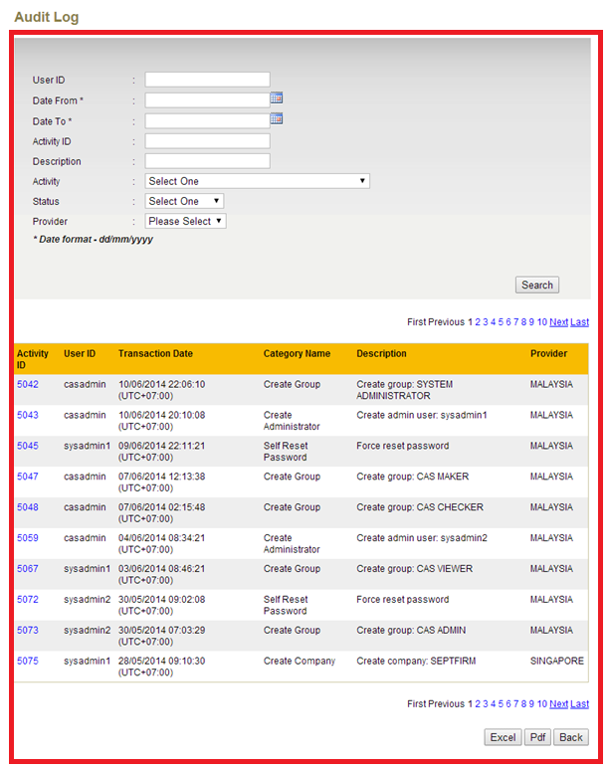
Figure 1: Audit Log – Searching criteria and result page sample
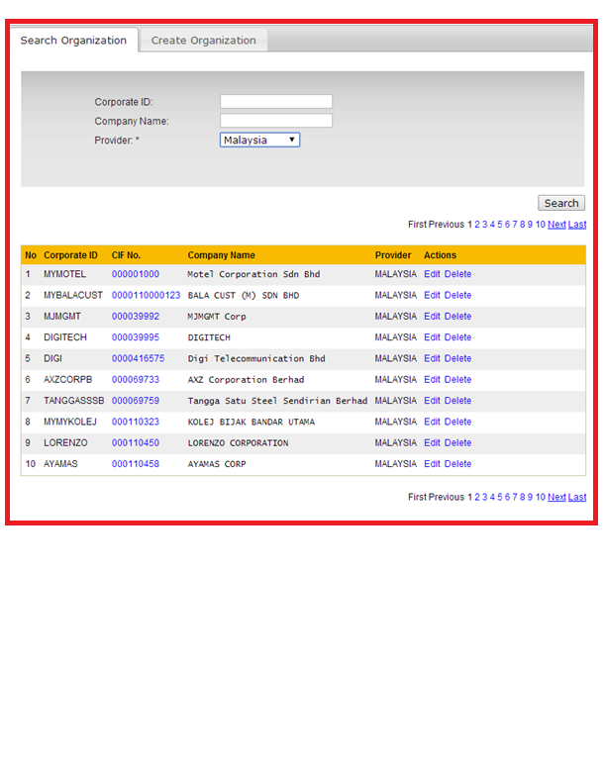
Figure 2: Company – Searching criteria and result page sample
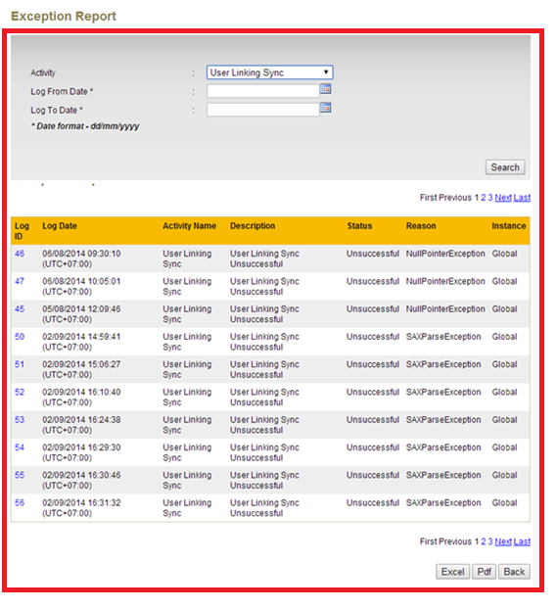
Figure 3:Exception Report – Searching criteria and result page sample

Descending Order Date and Time (R2)
There are 2 modules (Audit Log and Pin Mailer- based on Password Generated Date) involved to change the sorting based on descending order for date and time of searching result display.
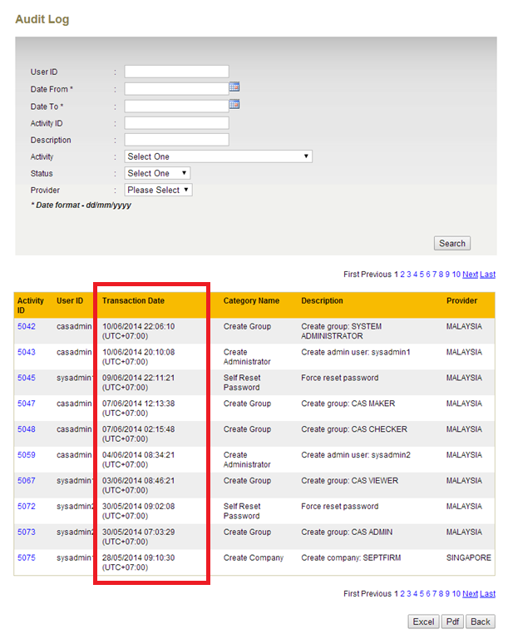
Figure 4:Audit Log – Transaction Date and time in descending order sample formatt
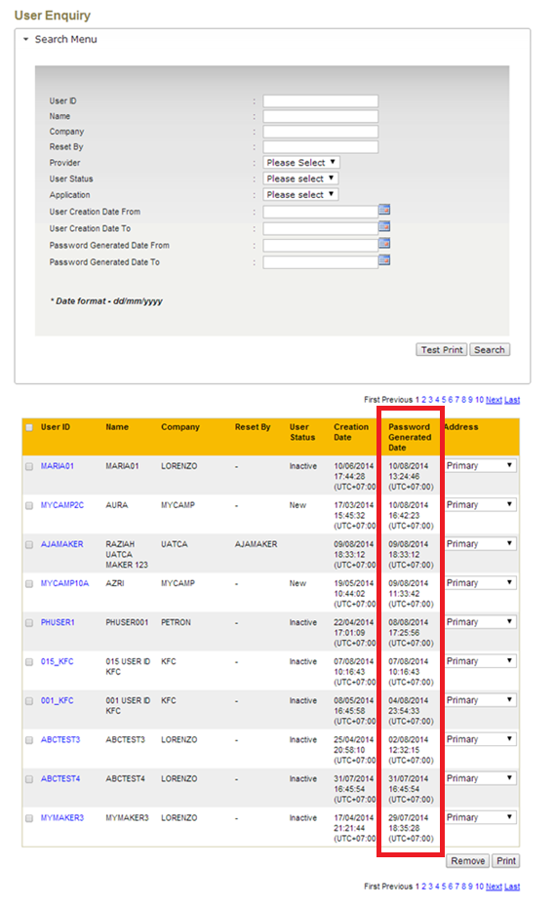
Figure 5:Pin Mailer – Password Generated Date and time and in descending order format

Create Provider (R2)
Create New Provider module: to add the Timezone for selection when create new provider under Maintenance module in order to identify the timezone of each country. Only one drop down list for all the timezone (Abbreviation and UTC Offset) when select the country. Refer to attached Appendix I for the timezone.
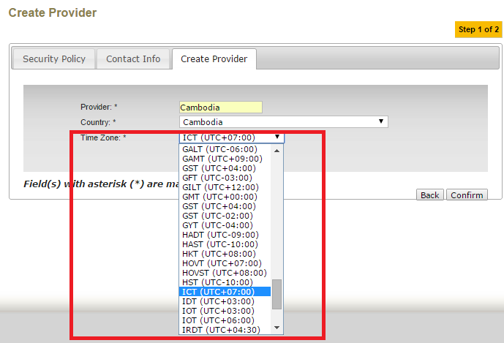
Figure 6:Create Provider – create provider page sample
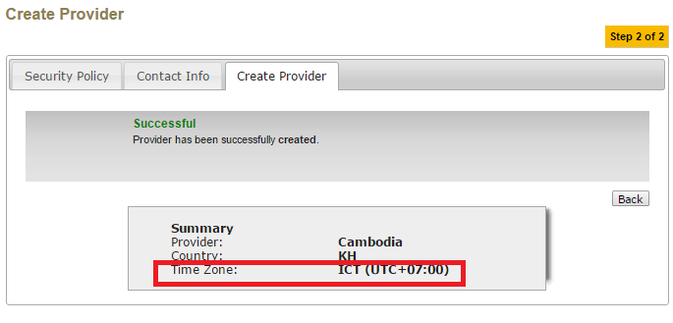
Figure 7:Create Provider – result page sample

Time Zone (IndoChina)
To support local time stamp, the local UTC time zone will be used for each country (the UTC time zone is provided by Maybank business team). RCAS determine the time zone based on the Global instance server time or BII instance server time, BBO Provider and Company Provider. Below are the enhancing items:
- System log (eg: system out.log) will be based on server time (Global instance or Bii instance).
- RCAS Scheduler (included Dormant/User Linking/Exception Report clean up) will run one time daily for all Providers.
- For searching criteria, will be based on server time if related to company activities and if non company related will be based on BBO provider time. For search result display will be based on company provider time or BBO provider time. Please refer to attached file for detail information and below screen capture for each related modules.

Login
Login: Upon BBO user login, the last login date and time will display as UTC+07:00 format.
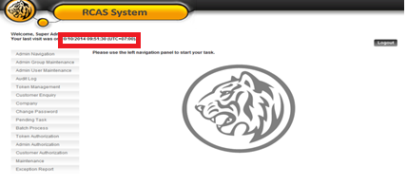
Figure 6.8: Login – Last visit date and time display based on BBO’s provider time zone

Admin Navigation
Admin Navigation Enquiry Details page:
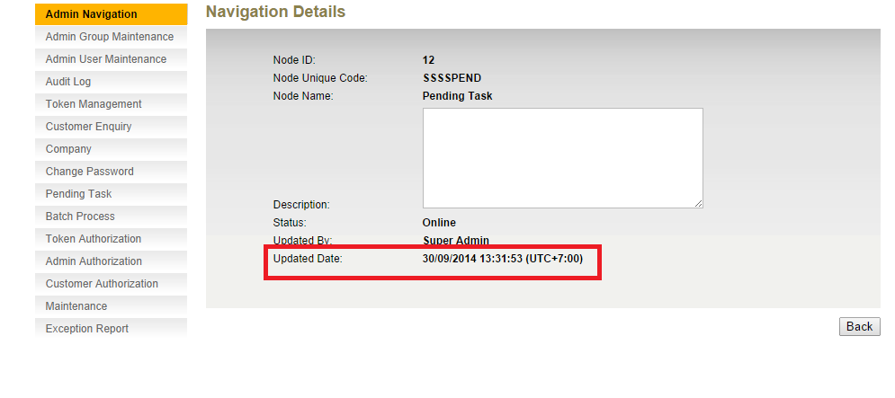
Figure 6.9: Admin Navigation Details – Updated Date display based on BBO’s provider time zone

Admin Group Maintenance
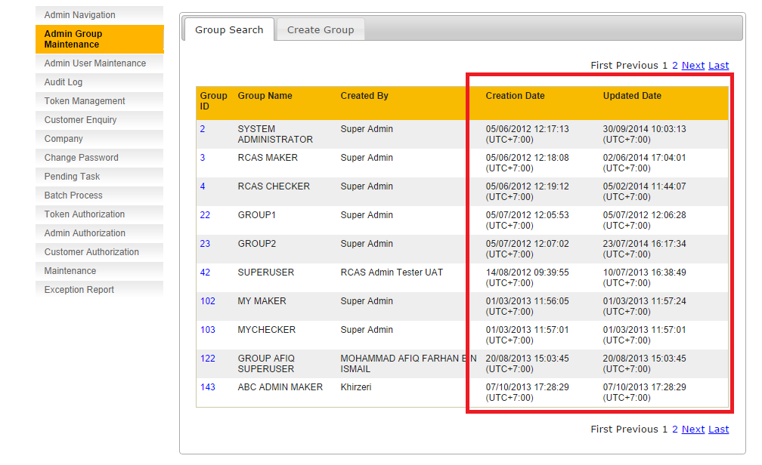
Figure 6.10: Admin Group Maintenance Group Listing – Creation Date and Updated Date display based on BBO’s provider time zone

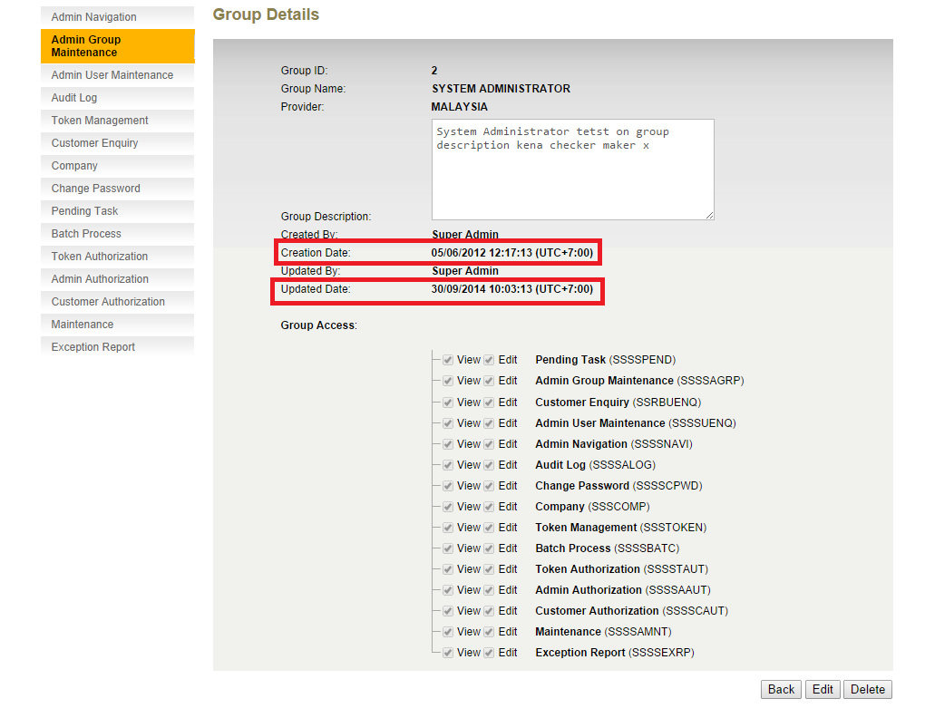
Figure 6.11: Admin Group Maintenance Details – Creation Date and Updated Date display based on BBO’s provider time zone
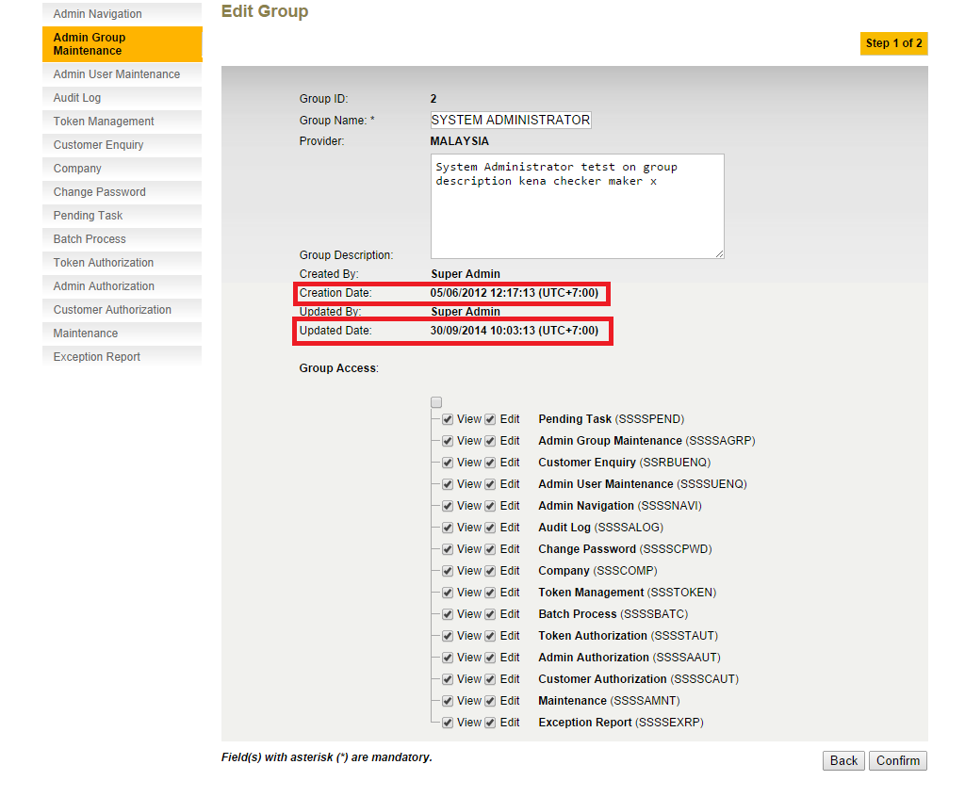
Figure 6.12: Admin Group Maintenance Edit Group – Creation Date and Updated Date display based on BBO’s provider time zone

Admin User Maintenance

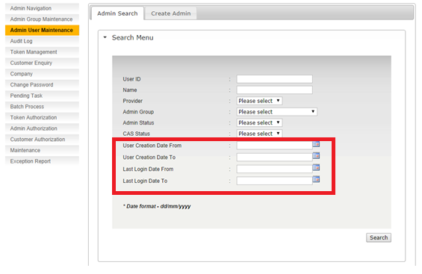
Figure 6.13: Admin User Maintenance - Admin Search criteria– User Creation Date From, User Creation Date To, Last Login Date From, Last Login Date To, will be search based on server time zone
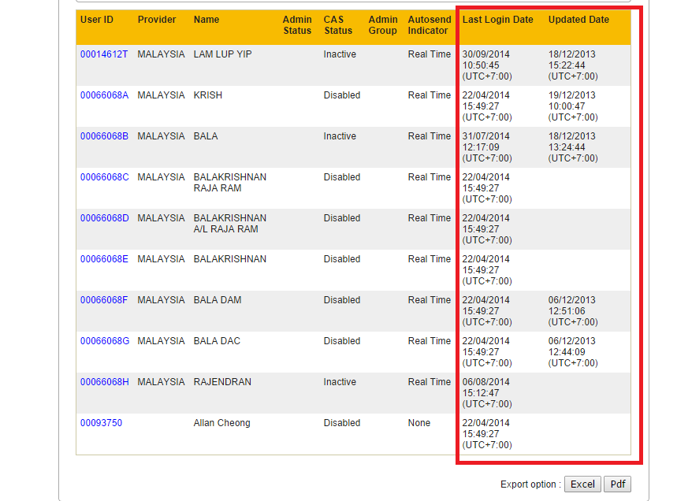
Figure 6.14: Admin User Maintenance - Admin Search Result – Last Login Date and Updated Date will be displayed based on BBO’s provider time zone. The exported files (pdf and excel) date format will also follow BBO’s provider time zone.
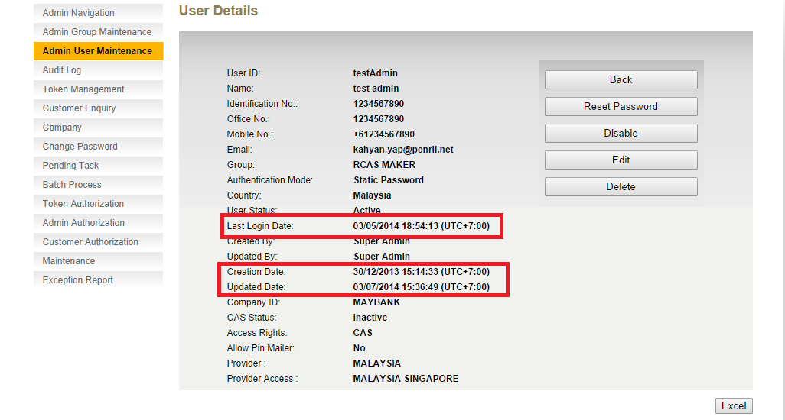
Figure 6.15: Admin User Maintenance - Admin Details – Last Login Date, Creation Date, and Updated Date will be displayed based on BBO’s provider time zone. The exported file (excel) date format will also follow BBO’s provider time zone

For Admin User maintenance function such as enable, disable, edit and delete administrator. The confirmation and result screen details is the same for all functions. Disable Administrator is used as a sample.
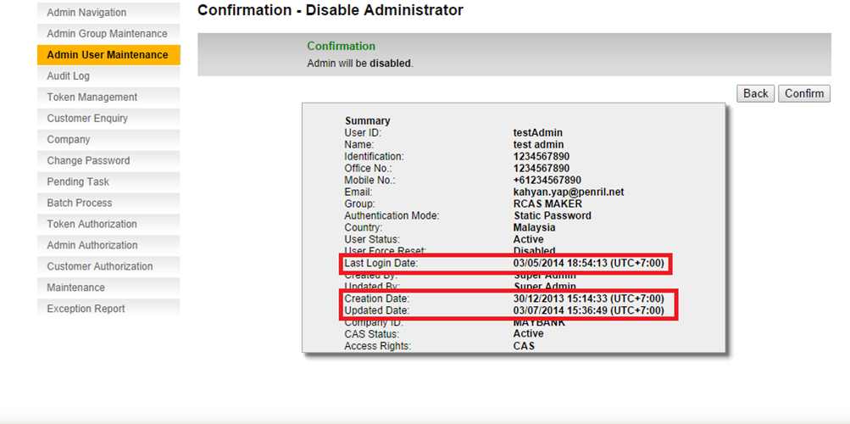
Figure 6.16: Admin User Maintenance – Disable Admin – Last Login Date, Creation Date, and Updated Date will be displayed based on BBO’s provider time zone
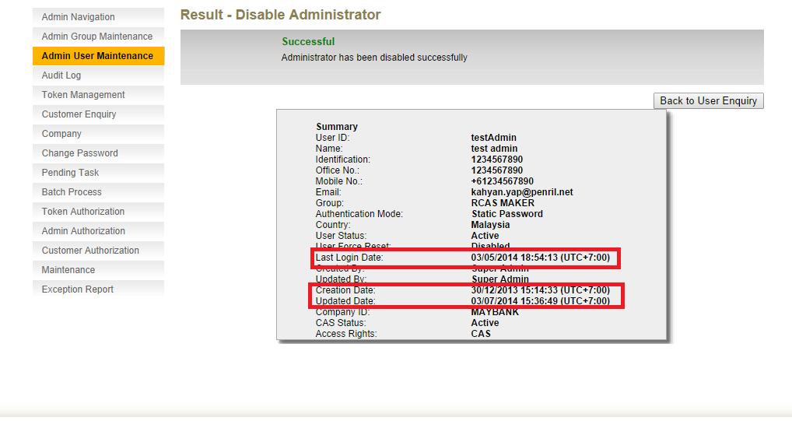
Figure 6.17: Admin User Maintenance – Disable Admin Result – Last Login Date, Creation Date, and Updated Date will be displayed based on BBO’s provider time zone.

Audit Log

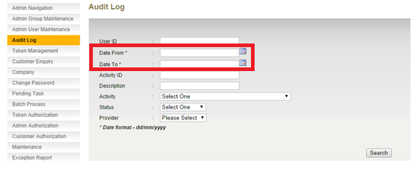
Figure 6.18: Audit Log, Search criteria: If Activity selected is related to company or there is no activity selected, Date From and Date To is based on Server time zone. If Activity selected is not related to company, Date From and Date To is based on BBO’s provider time zone

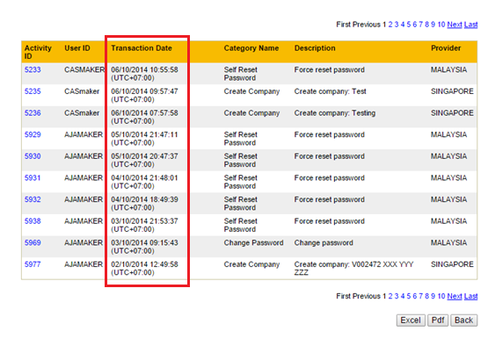
Figure 6.19: Audit Log – Search Result (for all activities) – Transaction Date will be displayed based on BBO’s provider time zone if not Company related activities, for Company related activities will be based on Company’s provider time zone. Search result will be sorted by transaction date. The exported files (pdf and excel) date format will also follow BBO’s provider time zone.

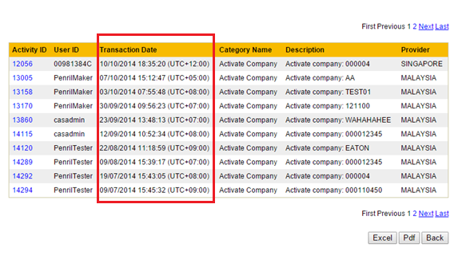
Figure 6.20: Audit Log – Search Result (for company related activities) – Transaction Date will be displayed based on company’s provider time zone. The exported files (pdf and excel) date format will also follow company’s provider time zone
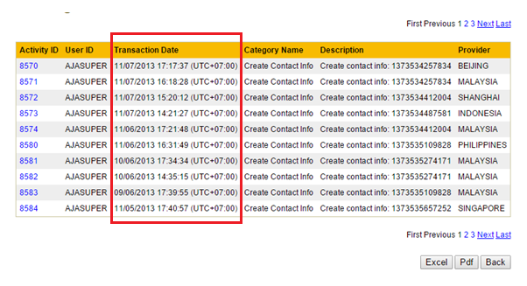
Figure 6.21: Audit Log – Search Result (for not company related activities) – Transaction Date will be displayed based on BBO’s provider time zone. The exported files (pdf and excel) date format will also follow BBO’s provider time zone.
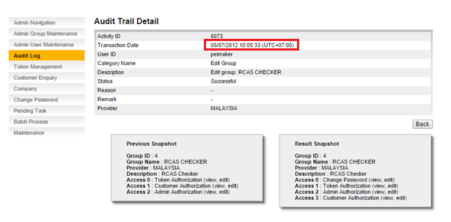
Figure 6.22: Audit Log – Audit Trail Details (for not company related activities) – Transaction Date will be displayed based on BBO’s provider time zone.
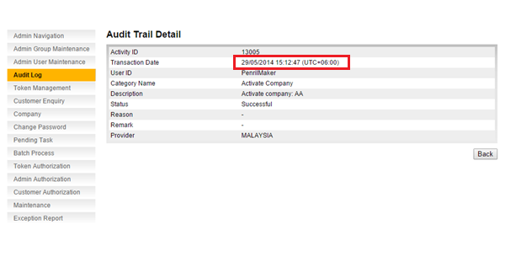
Figure 6.23: Audit Log – Audit Trail Details (for company related activities) – Transaction Date will be displayed based on company’s provider time zone.

Audit Log: List of Company Related Activity

- Change User Authentication Mode
- Change User Notification Mode
- Send Email Notification
- Batch Activate Users
- Batch Enable Users
- Authorize Delete User
- Authorize Reset User Password
- Authorize Disable User
- Authorize Enable User
- Authorize Assign User VASCO Token
- Authorize Revoke User VASCO Token
- Authorize Enable User VASCO Token
- Authorize Disable User VASCO Token
- Authorize Sync User VASCO Token
- Authorize Change User Authentication Mode
- Authorize Change User Notification Mode
- Authorize Send Email Notification
- Authorize Batch Enable User
- Authorize Delete Company
- Authorize Activate Company
- Authorize PreBind Token
- Authorize Cancel PreBind Token
- PreBind Token
- Cancel PreBind Token
- Activate Company
- Edit Company
- Create Company
- Delete Company
- Delete User
- Reset User Password
- Disable User
- Enable User
- Assign User VASCO Token
- Revoke User VASCO Token
- Enable User VASCO Token
- Disable User VASCO Token
- Sync User VASCO Token

Audit Log: List of Not Company Related Activity

- Login
- Self Reset Password
- Logout
- Change Password
- Create Group
- Edit Group
- Delete Group
- Edit Navigation
- Load VASCO Token
- Letter Printing
- Confirm Printing
- Remove Printing
- Authorize Load VASCO Token
- Authorize Edit Customer Enquiry Configurator
- Authorize Edit Security Policy
- Authorize Edit Contact Info
- Authorize Create Contact Info
- Authorize Assign Token to Provider
- Authorize Assign Token to Provider (Batch)
- Edit Customer Enquiry Configurator
- Edit Security Policy
- Edit Contact Info
- Create Contact Info
- Create Provider
- Assign Token to Provider
- Authorize Create Provider
- Create Administrator
- Edit Administrator
- Delete Administrator
- Reset Administrator Password
- Disable Administrator
- Enable Administrator

Token Management

For Global layer:

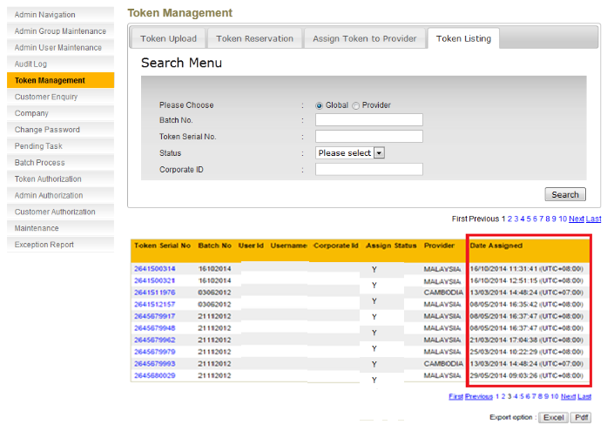
Figure 1.16: Token Management – Token Listing – Global Layer: Date Assigned will be displayed based on BBO provider time zone

For Provider Layer:
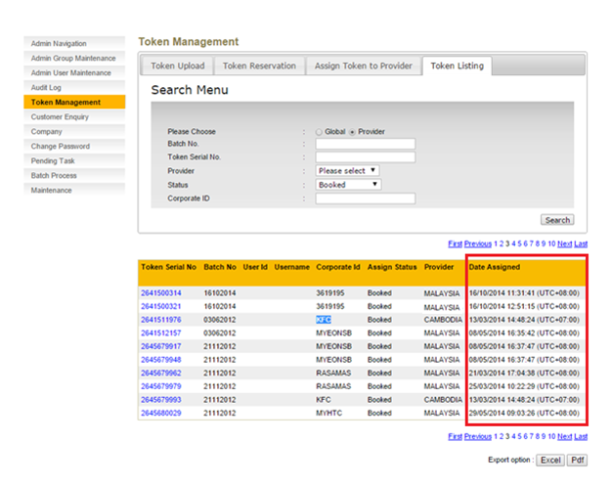
Figure 1.16: Token Management – Token Listing – Provider Layer: Date Assigned will be displayed based on company’s provider time zone

Customer Enquiry
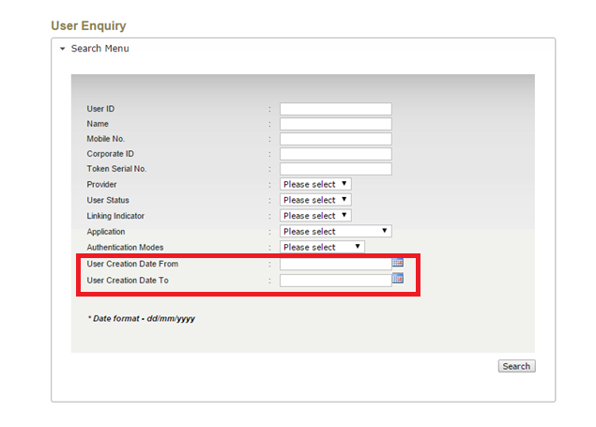
Figure 1.17: Customer Enquiry – Search Criteria – User Creation Date From and User Creation Date To will be searched based on the server time zone.

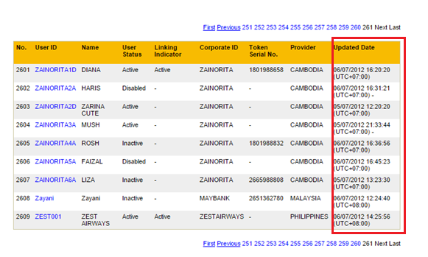
Figure 1.18: Customer Enquiry – Search Result – Updated Date will be displayed based on company’s provider time zone.
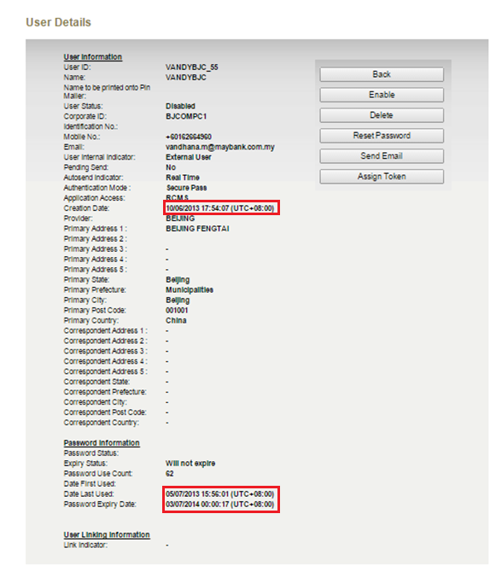
Figure 1.19: Customer Enquiry – User Details – Creation Date, Date Last Used, and Password Expiry Date will be displayed based on company’s provider time zone.

Pending Task
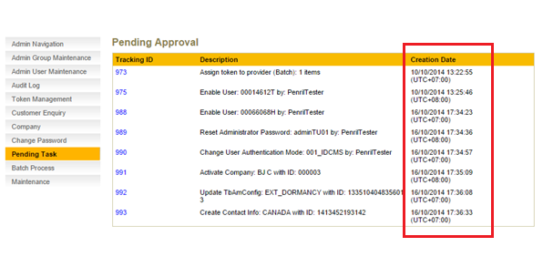
Figure 1.20: Pending Approval - If the task is related to company, Creation Date is based on company’s provider time zone. If task is not related to company, Date From and Date To is based on BBO’s provider time zone.
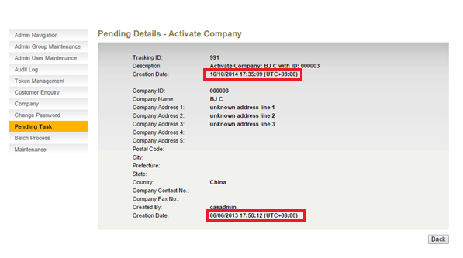
Figure 1.21: Pending Approval (for company related tasks) – All display date is based on company’s provider time zone.

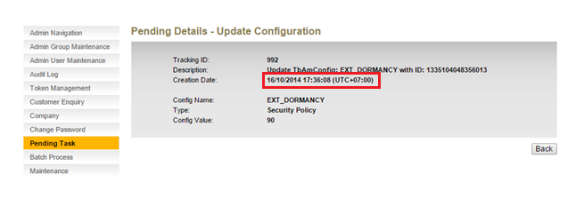
Figure 1.22: Pending Approval (for not company related activities) – All display date is based on BBO’s provider time zone.

Batch Process
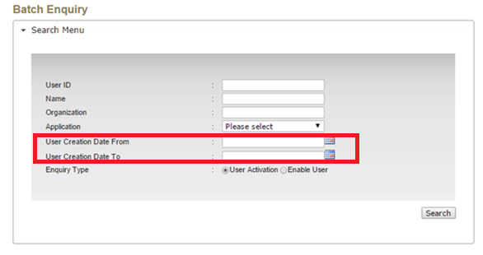
Figure 1.23: Batch Process – Search Criteria (User Activation and Enable User) – User Creation Date From and User Creation Date To will be search based on server time zone

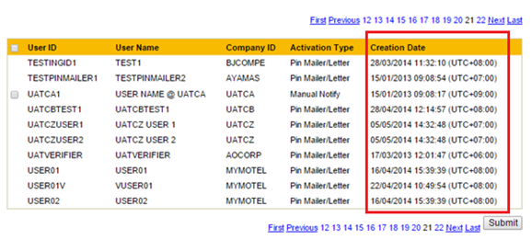
Figure 1.24: Batch Process – Search Result – Creation date is based on company’s provider time zone.
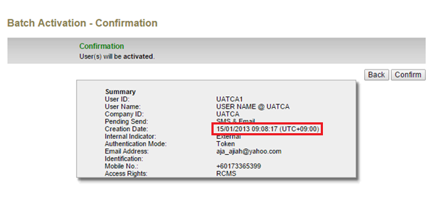
Figure 1.25: Batch Process – Confirmation Page – Creation date is based on company’s provider time zone
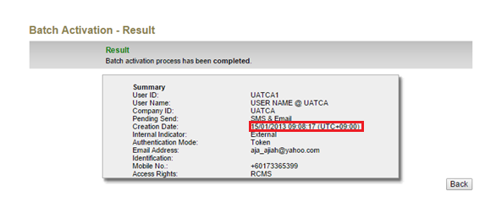
Figure 1.26: Batch Process – Result Page – Creation date is based on company’s provider time zone

Token Authorization
Below is a list on the action which will be included in Token Authorization module:
Related to company, date will display based on company’s provider timezone.
- Pre-bind Token
- Cancel Booked Token

Non-related to company, date will display based on BBO provider timezone.

- Upload Token
- Assign Token to Provider (Individual- Maker assign token to Global under Token Listing module)
- Assign Token to Provider (Batch- Maker assign token to Provider under module of Assign Token to Provider)

If action is related to company, the date displayed will be based on company’s provider time zone. If action is not related to company, the date displayed will be based on BBO’s provider time zone.
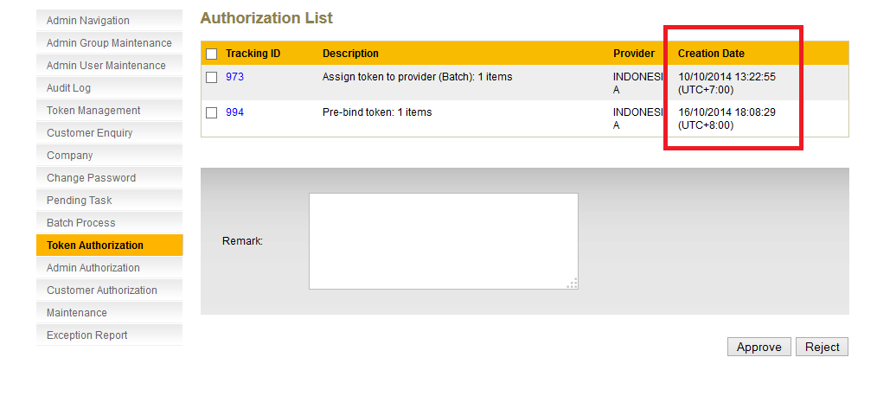
Figure 6.24: Token Authorization – Assign Token to Provider (batch) – Creation Date – is based on the BBO’s provider time zone.
Token Authorization – Pre-bind Token – Creation Date – is based on the company’s provider time zone. Company AXZCORP provider is MALAYSIA, the creation date will display as UTC+8:00

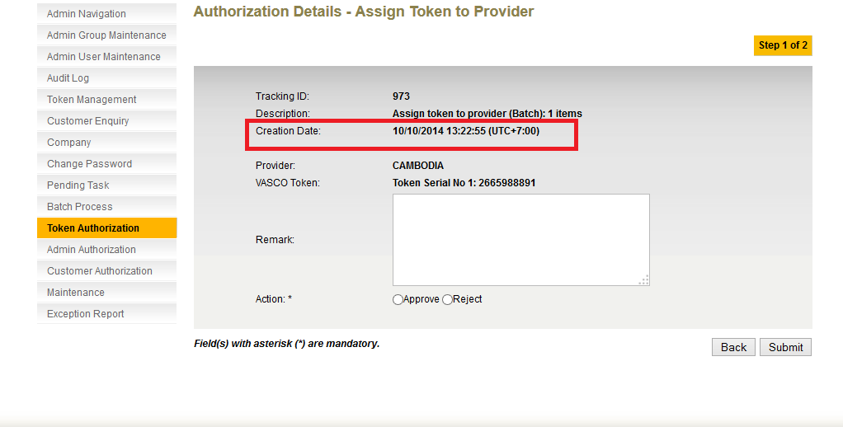
Figure 6.25: Token Authorization – Assign Token to Provider (batch) Details – Creation Date – is based on the BBO’s provider time zone.

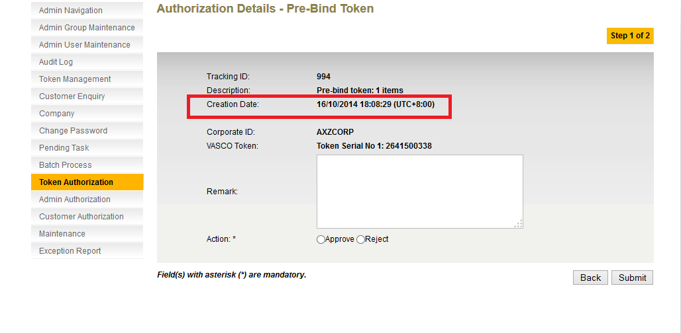
Figure 6.26: Token Authorization – Pre-bind Token Details – Creation Date – is based on the company’s provider time zone. Company AXZCORP provider is MALAYSIA, the creation date will display as UTC+8:00

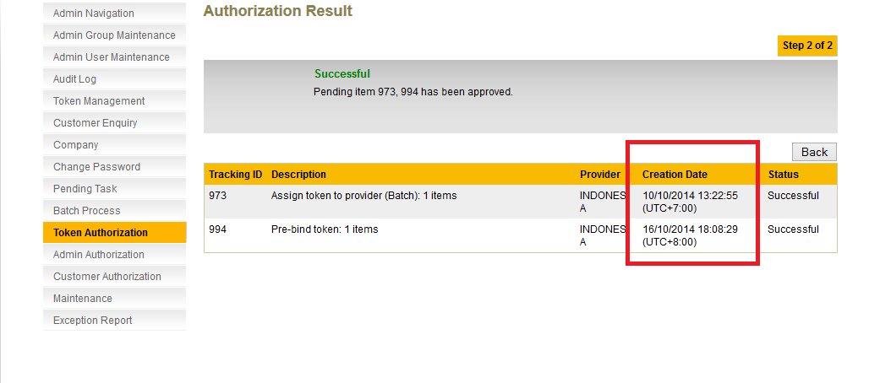
Figure 6.27: Token Authorization Bulk Authorized Result – Assign Token to Provider (batch) – Creation Date – is based on the BBO’s provider time zone.
Token Authorization – Pre-bind Token – Creation Date – is based on the company’s provider time zone. Company AXZCORP provider is MALAYSIA, the creation date will display as UTC+8:00

Admin Authorization
Below is a list on the action which will be included in Admin Authorization module:
- Reset Admin Password
- Enable Admin user
- Edit Security Policy
- Edit Contact Info
- Create Provider
- Create Contact Info

All actions date logged to admin authorization is displayed based on BBO’s provider time zone. Edit Security Policy is used as a sample.

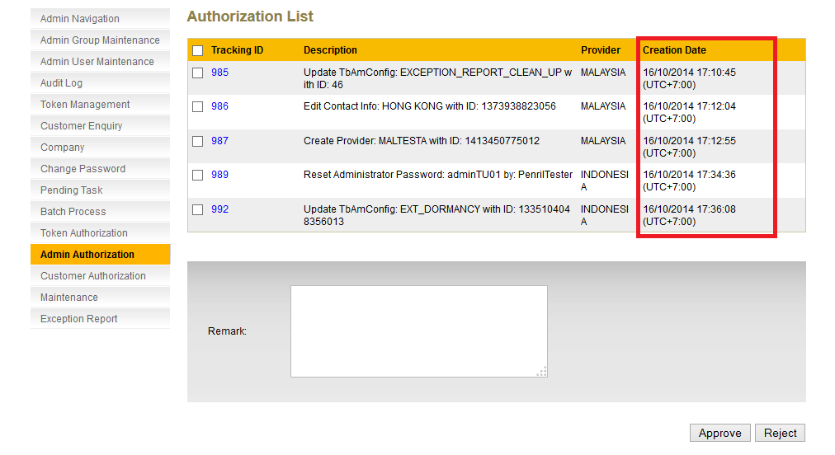
Figure 6.28: Admin Authorization – Edit Security Policy – Creation Date – is based on the BBO’s provider time zone.

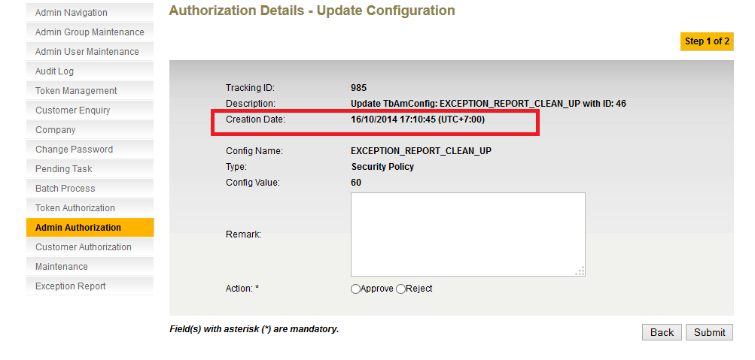
Figure 6.29: Admin Authorization – Edit Security Policy Details – Creation Date – is based on the BBO’s provider time zone.

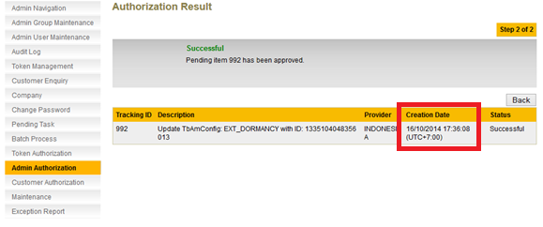
Figure 6.30: Admin Authorization Bulk Authorized Result – Edit Security Policy Result – Creation Date – is based on the BBO’s provider time zone.

Customer Authorization
Below is a list on the action which will be included in Customer Authorization module:
- Enable user
- Disable user
- Delete user
- Assign Token
- Revoke Token
- Synchronize Token
- Enable Token
- Disable Token
- Send Email
- Reset customer password
- Change Notification mode
- Change Authentication mode
- Activate company
- Delete company
- User Enablement

All actions date logged to customer authorization is displayed based on company’s provider time zone. Enable user is used as a sample.

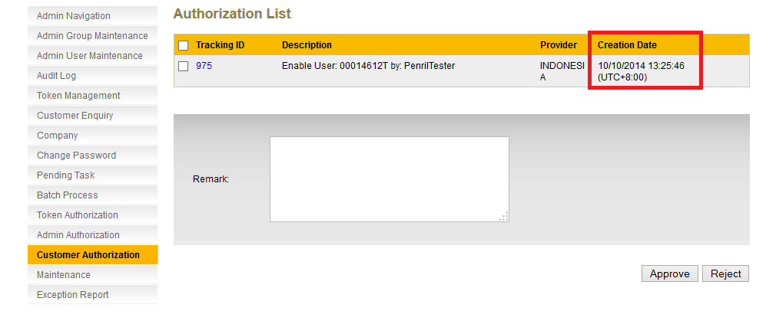
Figure 6.31: Customer Authorization – Enable User – Creation Date – is based on the company that the user belongs to. In this case, user’s 00014612T company provider is MALAYSIA, the creation date will display as UTC+8:00

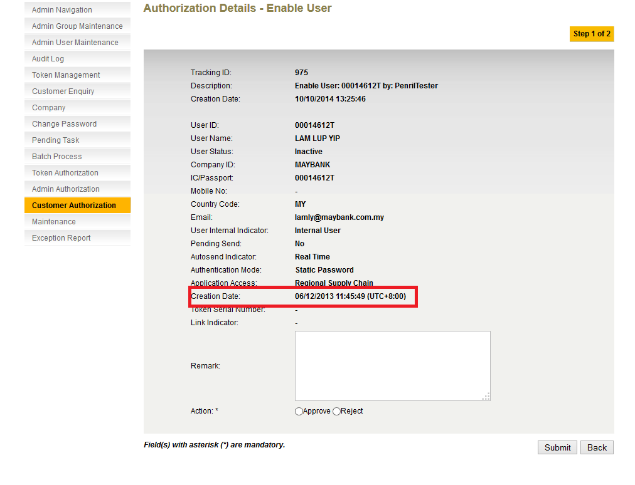
Figure 6.32: Customer Authorization – Enable User Details – Creation Date – is based on the company that the user belongs to. In this case, user’s 00014612T company provider is MALAYSIA, the creation date will display as UTC+8:00

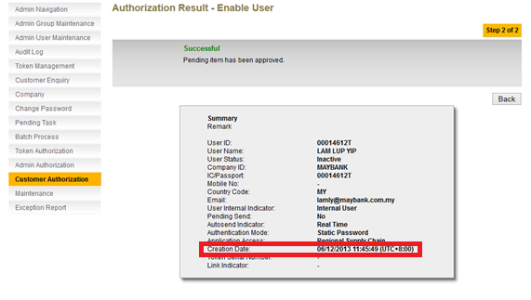
Figure 6.33: Customer Authorization – Enable User Result – Creation Date – is based on the company that the user belongs to. In this case, user’s 00014612T company provider is MALAYSIA, the creation date will display as UTC+8:00

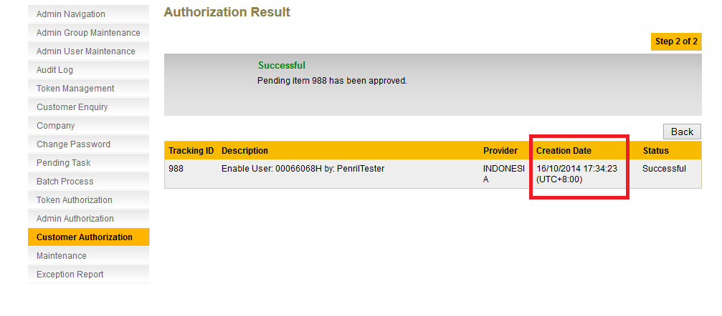
Figure 6.34: Customer Authorization – Enable User (Bulk Authorized) – Creation Date – is based on the company that the user belongs to. In this case, user’s 00066068H company provider is MALAYSIA, the creation date will display as UTC+8:00

Exception Report
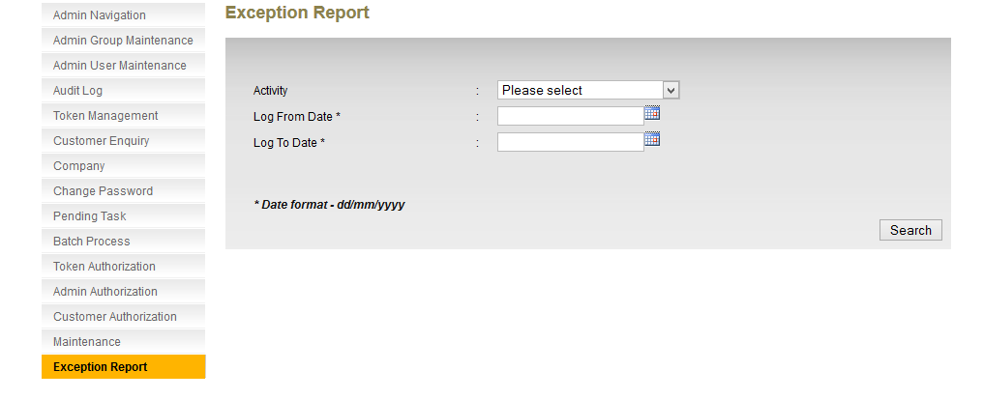
Figure 6.35: Exception Report – Search – Log From Date and Log To Date is based on server time zone.
For Exception Report, there are three activities: User Linking Sync, Dormant User Checking, and Exception Report Clean Up. User Linking Sync Exception will be used as a sample. All dates are displayed based on BBO’s provider time zone for Exception Report.
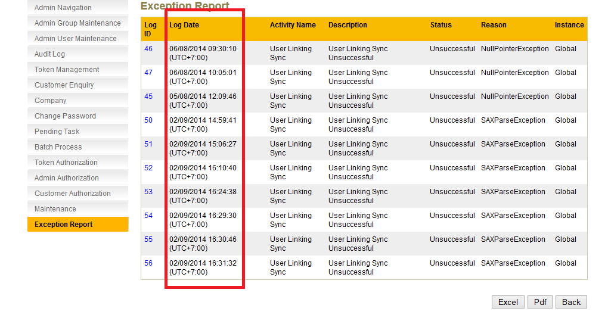
Figure 6.36: Exception Report – Search User Linking Sync Exception – Log Date is displayed based on BBO provider time zone. Export files (excel and pdf) will be based on BBO provider time zone.

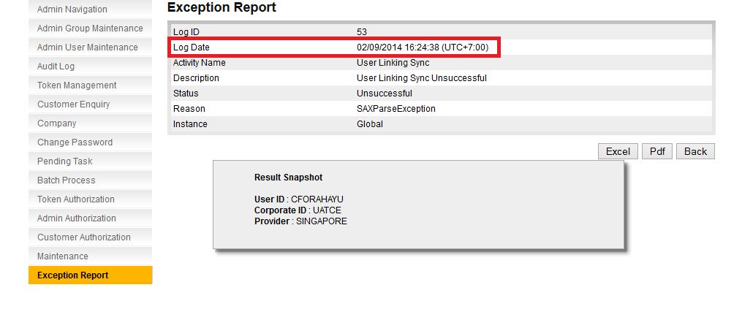
Figure 6.37: Exception Report – User Linking Sync Details – Log Date is displayed based on BBO provider time zone. Export files (excel and pdf) will be based on BBO provider time zone.

Pin Mailer

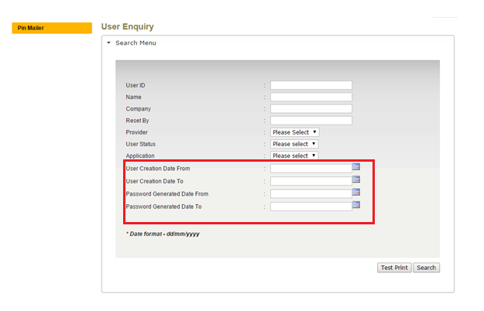
Figure 1.41: Pin Mailer – User Enquiry Search criteria– User Creation Date From, User Creation Date To, Password Generated Date From, Password Generated Date To, will be search based on server time zone
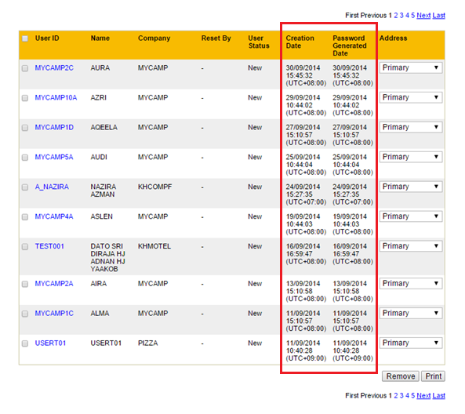
Figure 1.42: Pin Mailer – Search Result – Creation Date and Password Generated Date are displayed based on company’s provider time zone
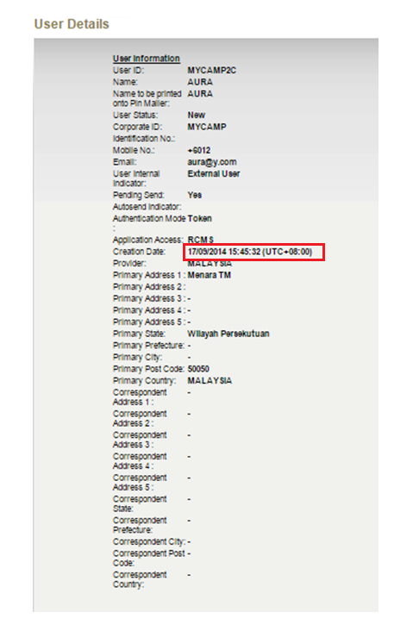
Figure 1.43: Pin Mailer – User Details – Creation Date is displayed based on company’s provider time zone
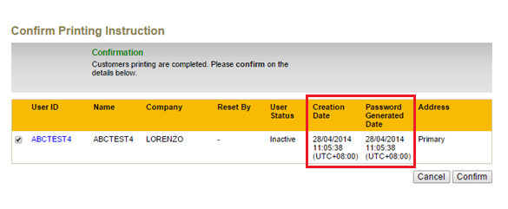
Figure 1.46: Pin Mailer – Confirm Printing – Creation Date and Password Generated Date are displayed based on company’s provider time zone
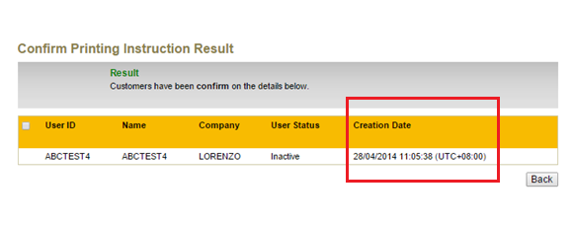
Figure 1.47: Pin Mailer – Confirm Printing Result – Creation Date is displayed based on company’s provider time zone

Remove Customer from Printing
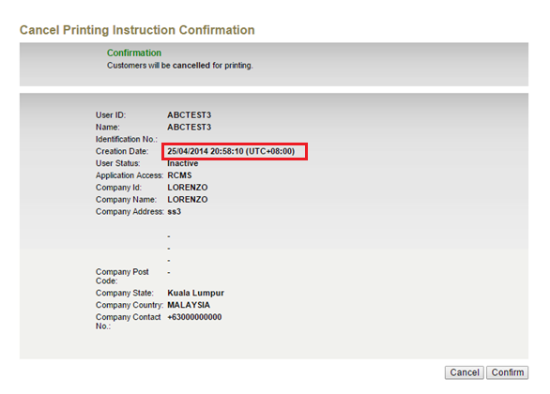
Figure 1.44: Pin Mailer – Cancel Printing Confirmation – Creation Date is displayed based on company’s provider time zone
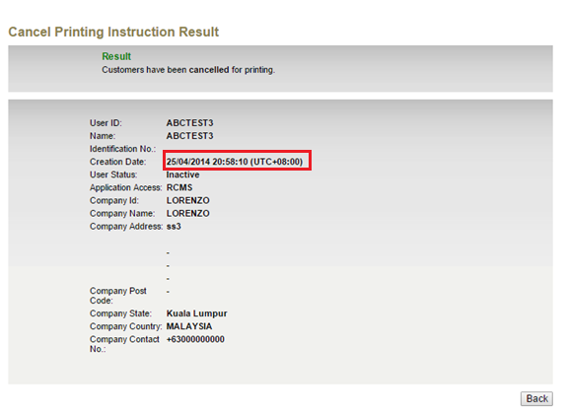
Figure 1.45: Pin Mailer – Cancel Printing Result – Creation Date is displayed based on company’s provider time zone

Pin Mailer print out:
Date and Time (on the bottom of the letter) – follow company’s provider time zone.

Pin Letter print out:
Date (on top of the letter) – follow company’s provider time zone.
Date and Time (on bottom of the letter) – follow company’s provider time zone.

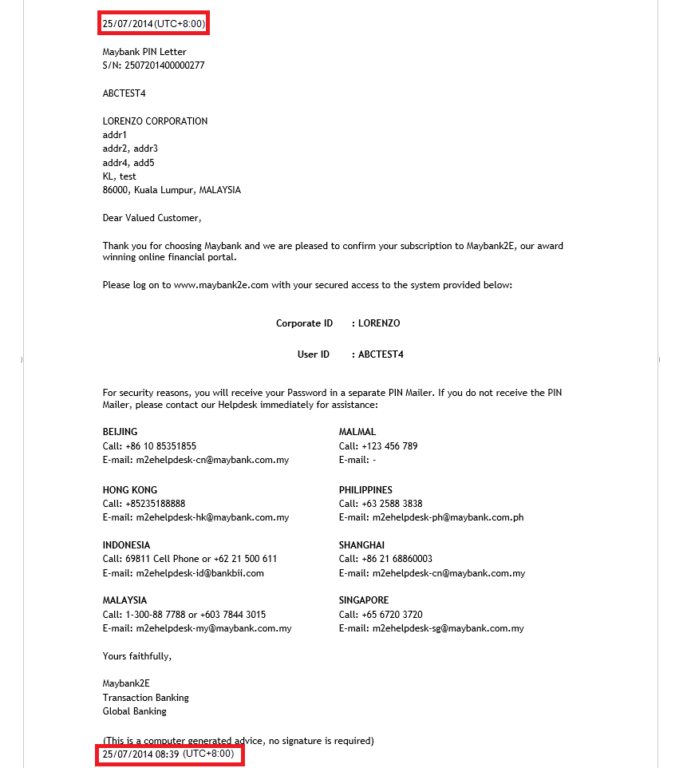

Figure 1.46: Pin Letter – Printed date and time will follow company’s provider time zone.

Appendix I: UTC timezone reference
ABBREVIATION | TIME ZONE NAME | UTC OFFSET
ACDT | AUSTRALIAN CENTRAL DAYLIGHT TIME | UTC + 10:30
ACST | AUSTRALIAN CENTRAL STANDARD TIME | UTC + 9:30
ADT | ATLANTIC DAYLIGHT TIME (Caribbean, North America) | UTC - 3
AEDT | AUSTRALIAN EASTERN DAYLIGHT TIME | UTC + 11
AEST | AUSTRALIAN EASTERN STANDARD TIME | UTC + 10
AFT | AFGHANISTAN TIME | UTC + 4:30
AKDT | ALASKA DAYLIGHT TIME | UTC - 8
AKST | ALASKA STANDARD TIME | UTC - 9
ALMT | ALMA-ATA TIME | UTC + 6
AMT | ARMENIA TIME | UTC + 4
AMT | AMAZON TIME | UTC - 4
AMST | AMAZON SUMMER TIME | UTC - 3
AMST | ARMENIA SUMMER TIME | UTC + 5
ANAT | ANADYR TIME (Russia) | UTC + 11
ANAST | ANADYR SUMMER TIME (Russia) | UTC + 12
AQTT | AQTOBE TIME (Kazakhstan) | UTC + 5
ART | ARGENTINA TIME | UTC - 3
AST | ATLANTIC STANDARD TIME (Caribbean, North America) | UTC - 4
AST | ARAB STANDARD TIME | UTC + 3
AST | ARABIA STANDARD TIME | UTC + 3
AWDT | AUSTRALIAN WESTERN DAYLIGHT TIME | UTC + 9
AWST | AUSTRALIAN WESTERN STANDARD TIME | UTC + 8
AZOT | AZORES TIME | UTC - 1
AZOST | AZORES SUMMER TIME | UTC + 0
AZT | AZERBAIJAN TIME | UTC + 4
AZST | AZERBAIJAN SUMMER TIME | UTC + 5
BNT | BRUNEI TIME | UTC + 8
BDT | BANGLADESH TIME (also see BST) | UTC + 6
BOT | BOLIVIA TIME | UTC - 4
BRT | BRASILIA TIME | UTC - 3
BRST | BRASILIA SUMMER TIME | UTC - 2
BST | BRITISH SUMMER TIME | UTC + 1
BST | BANGLADESH STANDARD TIME (also see BDT) | UTC + 6
BTT | BHUTAN TIME | UTC + 6
CAST | CASEY TIME (Antarctica) | UTC + 2
CAT | CENTRAL AFRICA TIME | UTC + 2
CCT | COCOS ISLANDS TIME | UTC + 6:30
CDT | CENTRAL DAYLIGHT TIME (Australia) | UTC + 10:30
CDT | CENTRAL DAYLIGHT TIME (North America & Caribbean) | UTC - 5
CEDT | CENTRAL EUROPEAN DAYLIGHT TIME | UTC + 2
CEST | CENTRAL EUROPEAN SUMMER TIME | UTC + 2
CET | CENTRAL EUROPEAN TIME (standard time) | UTC + 1
CHADT | CHATHAM ISLAND DAYLIGHT TIME | UTC + 13:45
CHAST | CHATHAM ISLAND STANDARD TIME | UTC + 12:45
CHOT | CHOIBALSAN TIME (Mongolia) | UTC + 8
CHOST | CHOIBALSAN SUMMER TIME (Mongolia) | UTC + 9
CHsT | CHAMORRO STANDARD TIME | UTC + 10
CIT | CENTRAL INDONESIAN TIME | UTC + 8
CKT | COOK ISLAND TIME | UTC - 10
CLST | CHILE SUMMER TIME | UTC - 3
CLT | CHILE STANDARD TIME | UTC - 4
COT | COLUMBIA TIME | UTC - 5
CST | CENTRAL STANDARD TIME (Australia) | UTC + 9:30
CST | CENTRAL STANDARD TIME (North America & Central America) | UTC - 6
CST | CUBA STANDARD TIME | UTC - 5
CST | CHINA STANDARD TIME | UTC + 8
CT | CHINA TIME (Macau) | UTC + 8
CVT | CAPE VERDE TIME | UTC - 1
CWST | CENTRAL WESTERN AUSTRALIA TIME (Eucla) | UTC + 8:45
CXT | CHRISTMAS ISLAND TIME | UTC + 7
DAVT | DAVIS TIME (Antarctica) | UTC + 7
DDUT | DUMONT D 'URVILLE TIME | UTC + 10
DST | DAYLIGHT SAVING TIME | VARIES
EASST | EASTERN ISLAND SUMMER TIME | UTC - 5
EAST | EASTERN ISLAND STANDARD TIME | UTC - 6
EAT | EAST AFRICA TIME | UTC + 3
ECT | ECUADOR TIME | UTC - 5
EDT | EASTERN DAYLIGHT TIME (Australia and Pacific) | UTC + 11
EDT | EASTERN DAYLIGHT TIME (North America and Caribbean) | UTC - 4
EEDT | EASTERN EUROPE DAYLIGHT TIME | UTC + 3
EEST | EASTERN EUROPE SUMMER TIME | UTC + 3
EET | EASTERN EUROPE TIME | UTC + 2
EGT | EASTERN GREENLAND TIME | UTC - 1
EGST | EASTERN GREENLAND SUMMER TIME | UTC + 0
EST | EASTERN STANDARD TIME (Australia and Pacific) | UTC + 10
EST | EASTERN STANDARD TIME (North America and Caribbean) | UTC - 5
EIT | EASTERN INDONESIAN TIME | UTC + 9
FJT | FIJI TIME | UTC + 12
FJST | FIJI SUMMER TIME | UTC + 13
FKST | FALKLAND ISLANDS SUMMER TIME | UTC - 3
FKT | FALKLAND ISLANDS TIME | UTC - 4
FNT | FERNANDO de NORONHA | UTC - 2
GALT | GALAPAGOS TIME | UTC - 6
GAMT | GAMBIER TIME | UTC + 9
GST | GEORGIA STANDARD TIME | UTC + 4
GFT | FRENCH GUIANA TIME | UTC - 3
GILT | GILBERT ISLAND TIME | UTC + 12
GMT | GREENWICH MEAN TIME | UTC + 0
GST | GULF STANDARD TIME | UTC + 4
GST | SOUTH GEORGIA TIME (South Georgia and the South Sandwich Islands) | UTC - 2
GYT | GUYANA TIME | UTC - 4
HADT | HAWAII-ALEUTIAN DAYLIGHT TIME | UTC - 9
HAST | HAWAII-ALEUTIAN STANDARD TIME | UTC - 10
HKT | HONG KONG TIME | UTC + 8
HOVT | HOVD TIME (Mongolia) | UTC + 7
HOVST | HOVD SUMMER TIME (Mongolia) | UTC + 8
HST | HAWAII STANDARD TIME | UTC - 10
ICT | INDOCHINA TIME | UTC + 7
IDT | ISRAEL DAYLIGHT TIME | UTC + 3
IOT | INDIAN OCEAN TIME | UTC + 3
IOT | INDIAN CHAGOS TIME (British Indian Ocean Territory) | UTC + 6
IRDT | IRAN DAYLIGHT TIME | UTC + 4:30
IRKT | IRKUTSK TIME | UTC + 8
IRKST | IRKUTSK SUMMER TIME | UTC + 9
IRST | IRAN STANDARD TIME | UTC + 3:30
IST | INDIAN STANDARD TIME | UTC + 5:30
IST | ISRAEL STANDARD TIME | UTC + 2
IST | IRISH SUMMER TIME | UTC + 1
JST | JAPAN STANDARD TIME | UTC + 9
KGT | KYRGYZSTAN TIME | UTC + 6
KOST | KOSRAE TIME (Micronesia) | UTC + 11
KRAT | KRASNOYARSK TIME | UTC + 7
KRAST | KRASNOYARSK SUMMER TIME | UTC + 8
KST | KOREA STANDARD TIME | UTC + 9
KUYT | KUYBYSHEV TIME (Samara Time as of 1991) | UTC + 4
LHDT | LORD HOWE DAYLIGHT TIME | UTC + 11
LHST | LORD HOWE STANDARD TIME | UTC + 10:30
LINT | LINE ISLANDS TIME | UTC + 14
LKT | SRI LANKA TIME | UTC + 5:30
MAGT | MAGADAN TIME | UTC + 11
MAGST | MAGADAN SUMMER TIME | UTC + 12
MART | MARQUESAS TIME | UTC - 9:30
MAWT | MAWSON STATION TIME (Antarctic) | UTC + 5
MDT | MOUNTAIN DAYLIGHT TIME (North America) | UTC - 6
MeST | METLAKATLA (Alaska Indian Community) | UTC - 8
MHT | MARSHALL ISLANDS TIME | UTC + 12
MIST | MACQUARIE ISLAND STATION TIME | UTC + 11
MMT | MYANMAR TIME | UTC + 6:30
MSD | MOSCOW SUMMER TIME | UTC + 4
MSK | MOSCOW STANDARD TIME | UTC + 3
MST | MOUNTAIN STANDARD TIME (North America) | UTC - 7
MUT | MAURITIUS TIME | UTC + 4
MVT | MALDIVES TIME | UTC + 5
MYT | MALAYSIA TIME | UTC + 8
NCT | NEW CALEDONIA TIME | UTC + 11
NDT | NEWFOUNDLAND DAYLIGHT TIME | UTC - 2:30
NFT | NORFOLK TIME | UTC + 11:30
NOVT | NOVOSIBIRSK TIME | UTC + 6
NOVST | NOVOSIBIRSK SUMMER TIME | UTC + 7
NPT | NEPAL TIME | UTC + 5:45
NRT | NAURU TIME | UTC + 12
NST | NEWFOUNDLAND STANDARD TIME | UTC - 3:30
NT | NEWFOUNDLAND TIME | UTC - 3:30
NUT | NIUE TIME | UTC - 11
NZDT | NEW ZEALAND DAYLIGHT TIME | UTC + 13
NZST | NEW ZEALAND STANDARD TIME | UTC + 12
OMST | OMSK STANDARD TIME | UTC + 6
OMSST | OMSK SUMMER TIME | UTC + 7
ORAT | ORAL TIME | UTC + 5
PDT | PACIFIC DAYLIGHT TIME (North America) | UTC - 7
PET | PERU TIME | UTC - 5
PETT | KAMCHATKA TIME | UTC + 12
PETST | KAMCHATKA SUMMER TIME | UTC + 13
PGT | PAPUA NEW GUINEA TIME | UTC + 10
PHT | PHILIPPINE TIME | UTC + 8
PHOT | PHOENIX ISLAND TIME | UTC + 13
PKT | PAKISTAN STANDARD TIME | UTC + 5
PMDT | PIERRE & MIQUELON DAYLIGHT TIME | UTC - 2
PMST | PIERRE & MIQUELON STANDARD TIME | UTC - 3
PONT | PONAPE TIME (Micronesia) | UTC+ 11
PST | PACIFIC STANDARD TIME (North America) | UTC - 8
PST | PITCAIRN TIME | UTC - 8
PWT | PALAU TIME | UTC + 9
PYT | PARAGUAY TIME | UTC - 4
PYST | PARAGUAY SUMMER TIME | UTC - 3
QYZT | QYZYLORDA TIME (Kazakhstan) | UTC +6
RET | REUNION TIME | UTC + 4
ROTT | ROTHERA (RESEARCH STATION) TIME (Antarctica) | UTC - 3
SAKT | SAKHALIN TIME | UTC + 11
SAKST | SAKHALIN SUMMER TIME | UTC + 12
SAMT | SAMARA TIME | UTC + 4
SAST | SOUTH AFRICA STANDARD TIME | UTC + 2
SBT | SOLOMON ISLANDS TIME | UTC + 11
SCT | SEYCHELLES TIME | UTC + 4
SGT | SINGAPORE TIME | UTC + 8
SRT | SURINAME TIME | UTC - 3
SLT | SRI LANKA TIME | UTC + 5:30
SST | SAMOA STANDARD TIME (American Samoa) | UTC - 11
SYOT | SYOWA (RESEARCH STATION) TIME (Antarctica) | UTC + 3
TAHT | TAHITI TIME | UTC - 10
TFT | FRENCH SOUTHERN TERRITORIES TIME | UTC + 5
TJT | TAJIKISTAN TIME | UTC + 5
TKT | TOKELAU TIME | UTC - 10
TLT | EAST TIMOR TIME (Timor-Leste Time) | UTC + 9
TMT | TURKMENISTAN TIME | UTC + 5
TOT | TONGA TIME | UTC + 13
TRUT | TRUK TIME (Micronesia) | UTC + 10
TVT | TUVALU TIME | UTC + 12
ULAT | ULAANBAATAR TIME | UTC + 8
ULAST | ULAANBAATAR SUMMER TIME | UTC + 9
UTC | COORDINATED UNIVERSAL TIME | UTC + 0
UYST | URUGUAY SUMMER TIME | UTC - 2
UYT | URUGUAY STANDARD TIME | UTC - 3
UZT | UZBEKISTAN TIME | UTC + 5
VET | VENEZUELAN STANDARD TIME | UTC - 4:30
VLAT | VLADIVOSTOK TIME | UTC + 10
VLAST | VLADIVOSTOK SUMMER TIME | UTC + 11
VOLT | VOLGOGRAD TIME | UTC + 4
VOST | VOSTOK TIME (Antarctica) | UTC + 6
VUT | VANUATU TIME | UTC + 11
WAKT | WAKE ISLAND TIME | UTC + 12
WAT | WEST AFRICA TIME | UTC + 1
WART | WEST ARGENTINA TIME | UTC - 4
WAST | WEST AFRICA SUMMER TIME | UTC + 2
WDT | WESTERN DAYLIGHT TIME (Australia) | UTC + 9
WEDT | WESTERN EUROPEAN DAYLIGHT TIME | UTC + 1
WEST | WESTERN EUROPEAN SUMMER TIME | UTC + 1
WET | WESTERN EUROPEAN TIME | UTC + 0
WFT | WALLIS AND FUTUNA TIME | UTC + 12
WGT | WESTERN GREENLAND TIME | UTC - 3
WGST | WESTERN GREENLAND SUMMER TIME | UTC - 2
WIT | WESTERN INDONESIAN TIME | UTC + 7
WST | WESTERN SAHARA TIME | UTC + 1
WST | WESTERN STANDARD TIME (Australia) | UTC + 8
WST | WESTERN SAMOA TIME (standard time) | UTC + 13
WST | WESTERN SAMOA TIME (*also used during daylight saving time) | UTC + 14
WT | WESTERN SAHARA STANDARD TIME | UTC + 0
YAKT | YAKUTSK TIME | UTC + 9
YAKST | YAKUTSK SUMMER TIME | UTC + 10
YEKT | YEKATERINBURG TIME | UTC + 5
YEKST | YEKATERINBURG SUMMER TIME | UTC + 6

