Originator's Name: Chooi So Fun  Project: SMS Notification  Project Manager: Malarvily Muniandy / Christopher Gunn  Owner: PDM / RCB  Date Raised: 15.10.10  Phase/Process:  Functional Area: Consumer | Issue ID Number: UAT-SMS005  Related ID Number:  Priority: High / Medium / Low  Assigned to:  Target Resolution Date:  Actual Closed Date:
Status : Open / Investigate / Retest / Re-Open / Closed / Sign-Off (Circle one)
Category : Bugs / Set-up / Clarification / Repeated / Internal CR / CR (Circle one)
Description:

SMS Charges for Sender and Bene (FOR ALL MODULE):
SMS Charges for Sender and Bene ARE NOT debited from account for successful transaction.

(Refer to screen attached for further details).
Impact:

Investigation (Description):

Action:

Estimated Impact:

Recommendation:

Accepted (PENRIL/SA/IT):  Date: | Accepted (KFHMB):  Date:
Associated Risk Report: | Risk Report Accepted Date:
Associated Change Request Form: | Change Control Accepted on:

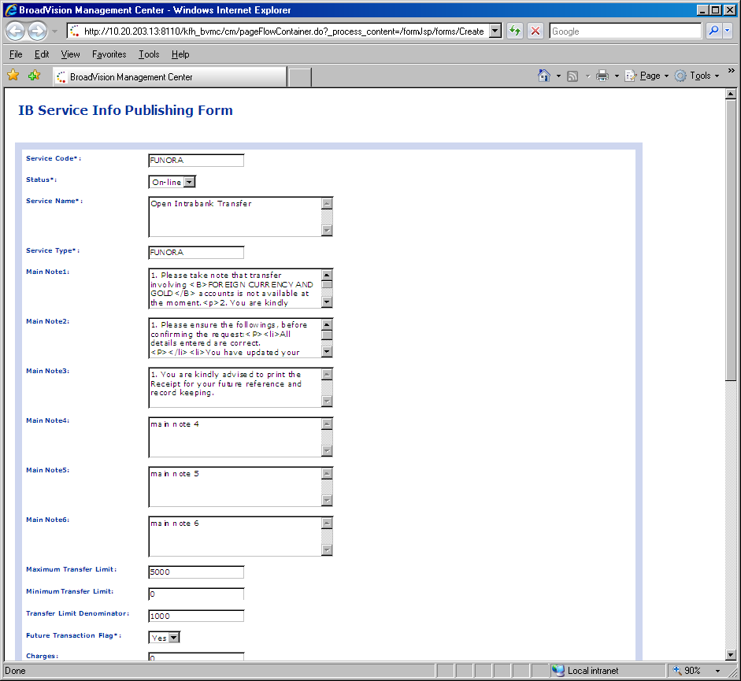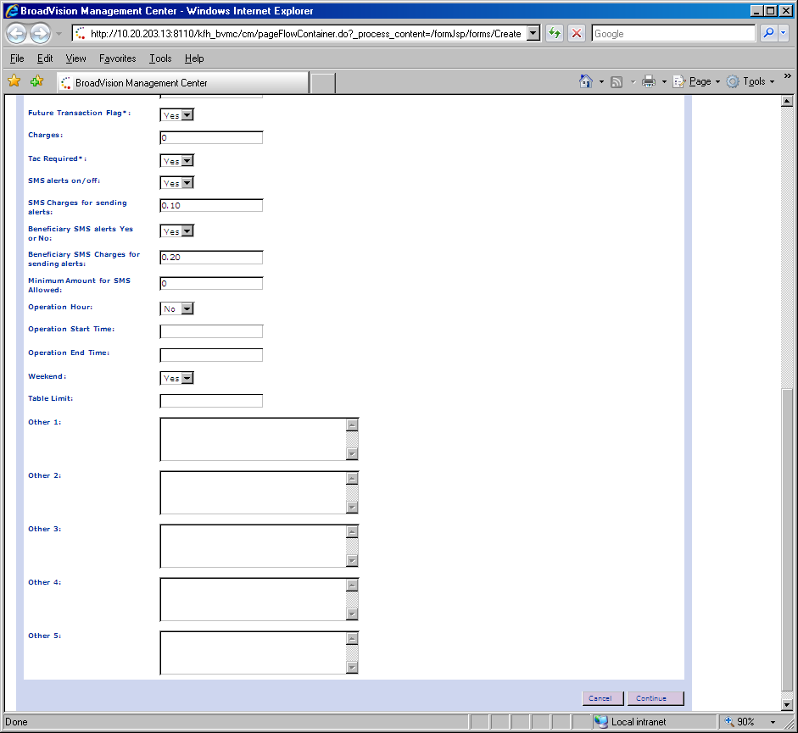
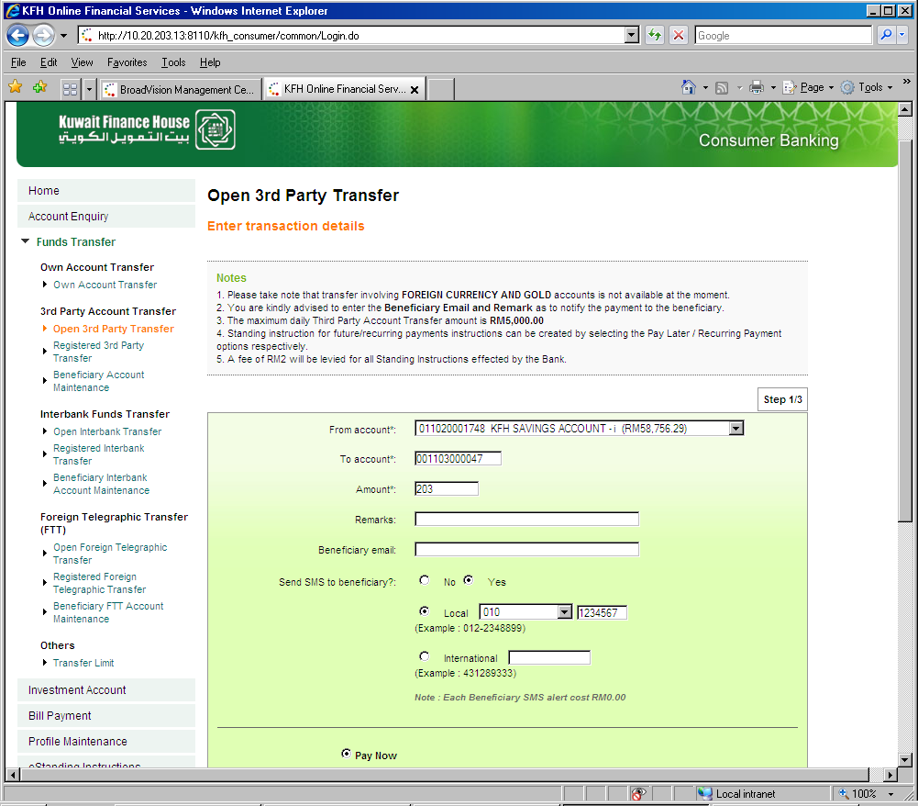

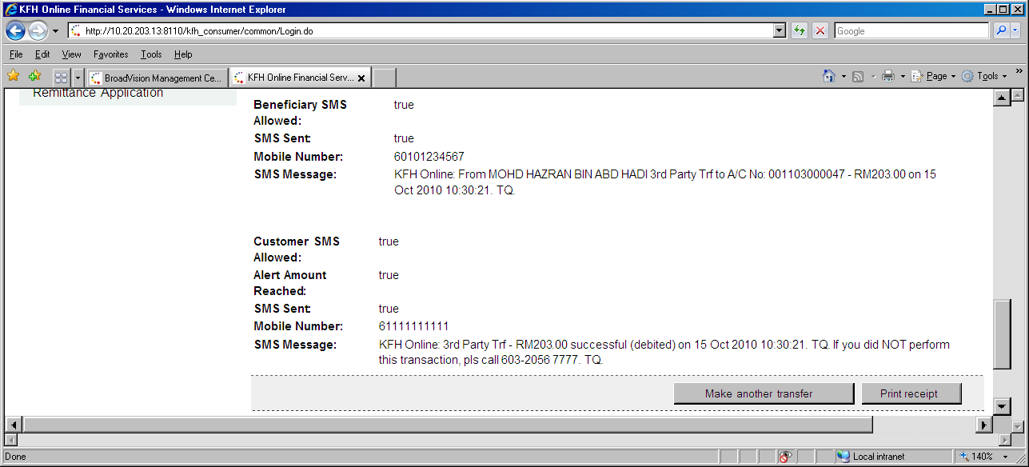
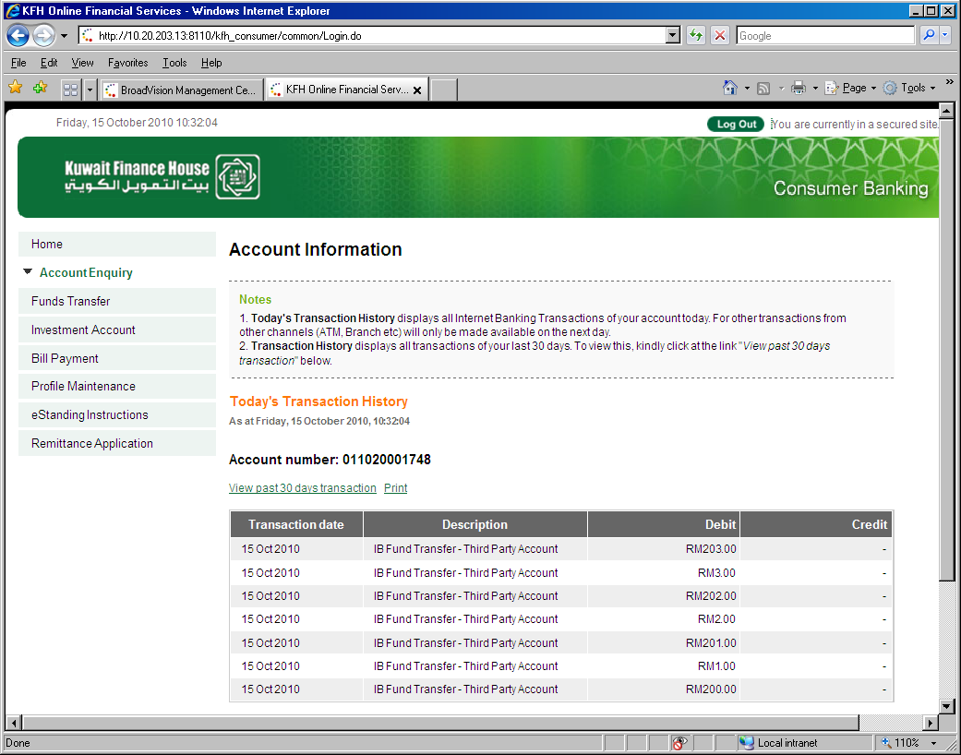
SMS Charges for Sender (0.10) & Bene (0.20) are not debited from account.

