CR# EB140093 – Extend ‘Phone Number Extension’ field length in IBAM

# Database

Modify existing tables to extend existing column length to 30 characters length.

Affected tables:

1. BIB User (OFFICE_EXT_NO)
2. BIB Company (OFFICE_PHONE_EXT_NO, OTHER_PHONE_EXT_NO)

# IBAM

Update phone extension field to allow up 30 alphanumeric characters (special characters not allowed)

1. Company Details

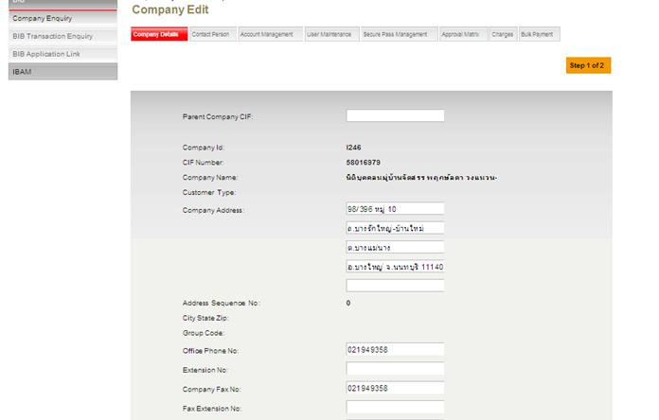

1. Contact Person

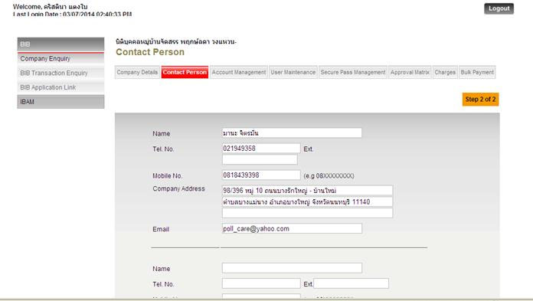

1. User Maintenance

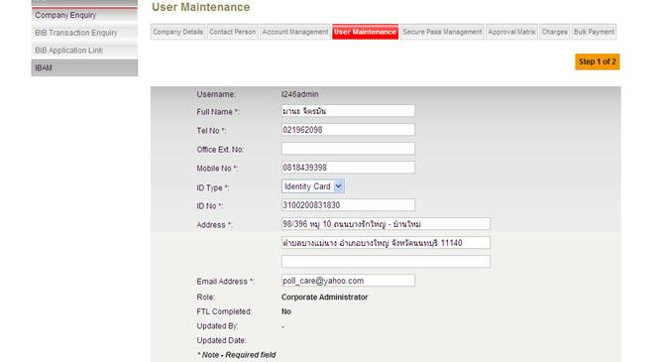

# BIB

Update “Office Ext No” field to allow up 30 alphanumeric characters (special characters not allowed). This change is applicable for Create, Edit & View User.

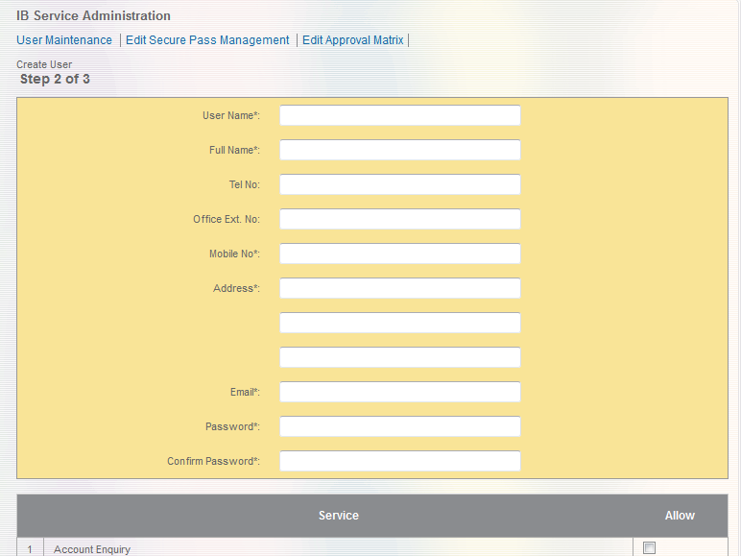

Figure Transaction History

|  |  |
| --- | --- |
| Effort(man-days) | 2 |
| Affected Area | BIB  IBAM |