# Appendix D

|  |  |  |
| --- | --- | --- |
| Service Request | | **Req. ID#.:** |
| **Description:** | **Payment Reference Standard for All Channel** | |
|  | | |

Appendix E

List of BVMC Reports and Corus Enquiry Screen and/or Reports affected.

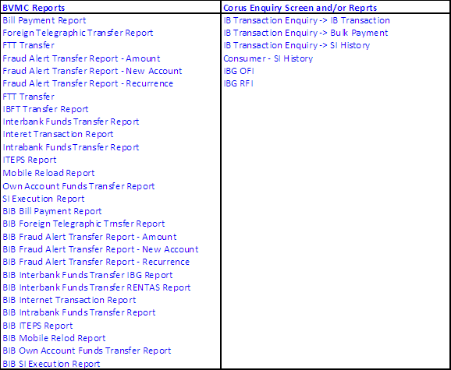

Sample of additional field required to the related report:-

