Internal testing result |  |  |  |  |  | CR-00020
Project Name: | Retail Internet Banking
Test Stage: | Unit Functionality Integration System Interface  Performance Regression Acceptance Pilot
Test Case Number: | - |  |  | Test Started Date: |  | 23/12/2014
Test Title: | JomPAY RIB transaction (CR-00020 RIB005)
Test Description: | To ensure that IB Reference No. display at Result Page & Receipt for both New JomPAY & Favourite JomPAY transactions.
Test Functionality: | RIB>JomPAY>New JomPAY  RIB> JomPAY >Favourite JomPAY
Test Procedure: | New JomPAY:  - User login to RIB and click on JomPAY and click on New JomPAY.  - User selects “From Account”.  - User enters “Biller Code”, “Ref-1”, “Ref-2” and “Amount” and click on “Next” button.  - User view the “Confirm Page”.  - User enters “TAC number” and clicks on “Confirm” button.  - User view the “Result Page”.  - User clicks on “Print Receipt” Button  - User clicks on “Account and Banking” and select AGRONet Transaction History.  - User clicks on “REPRINT” button.  Favourite JomPAY:  - User login to RIB and click on JomPAY and click on Favourite JomPAY.  - User selects Biller.  - User clicks on “Next” button.  - User select From Account, enter “Ref-1”, “Ref-2”, and “Amount” and click on “Next” button.  - User view “Confirm Page”.  - User click on “Confirm” button.  - User view “Result Page”.  - User click on Print Receipt button  - User clicks on “Account and Banking” and select AGRONet Transaction History.  - User clicks on “REPRINT” button.
Test Result: | Pass: Fail: | Tested by: |  |  | Nurul Akmal binti Yusof
Reason for Failure:
TEST DESCRIPTION
New JomPAY
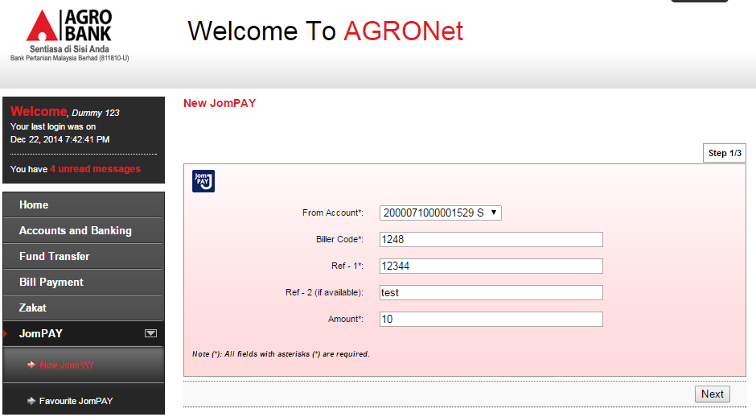

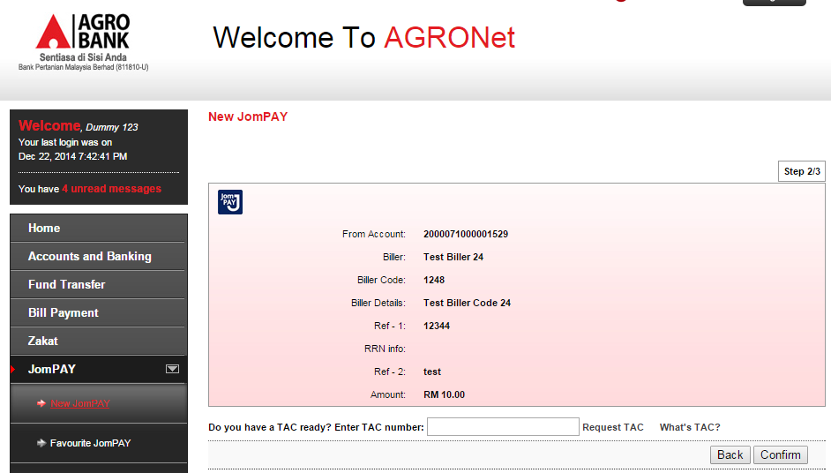

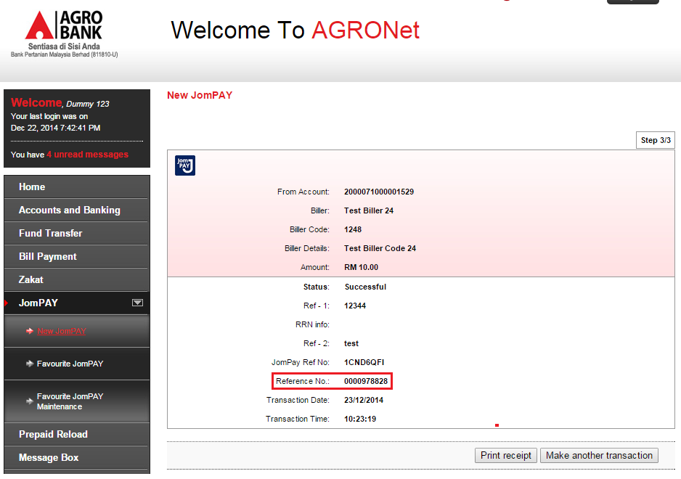

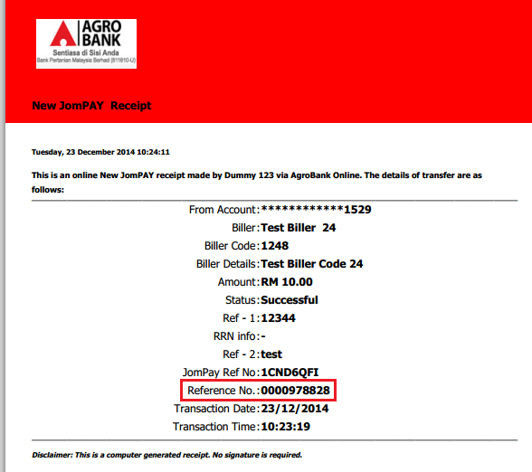

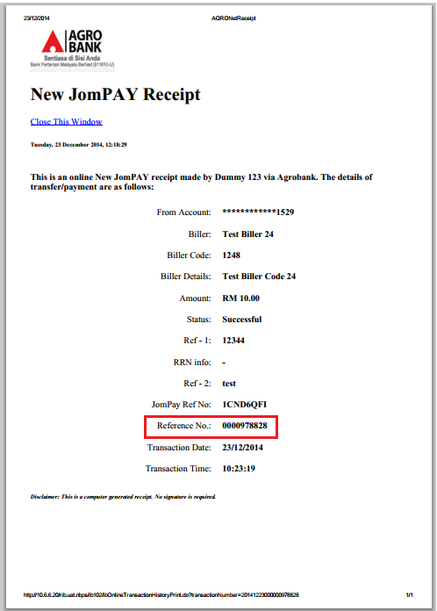

Favourite JomPAY
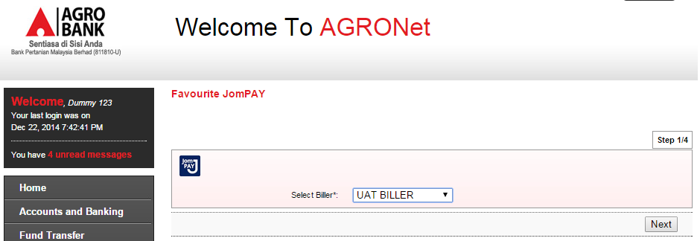

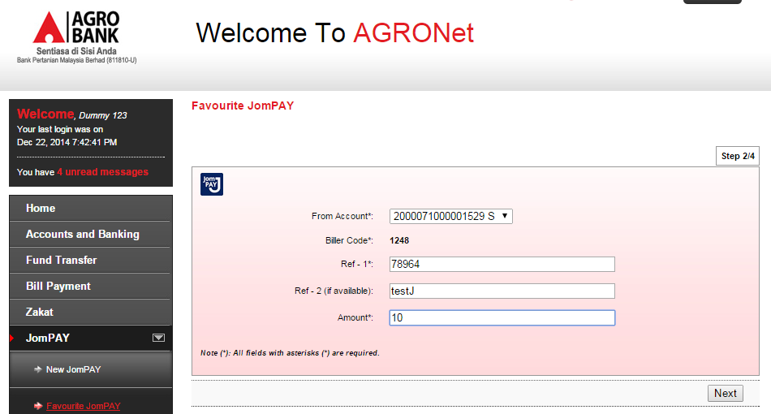

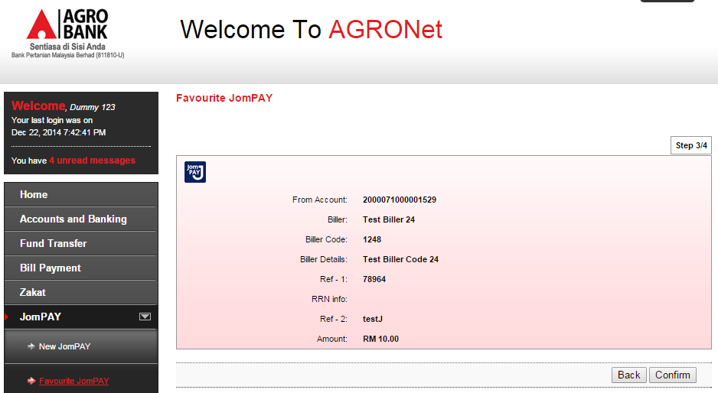
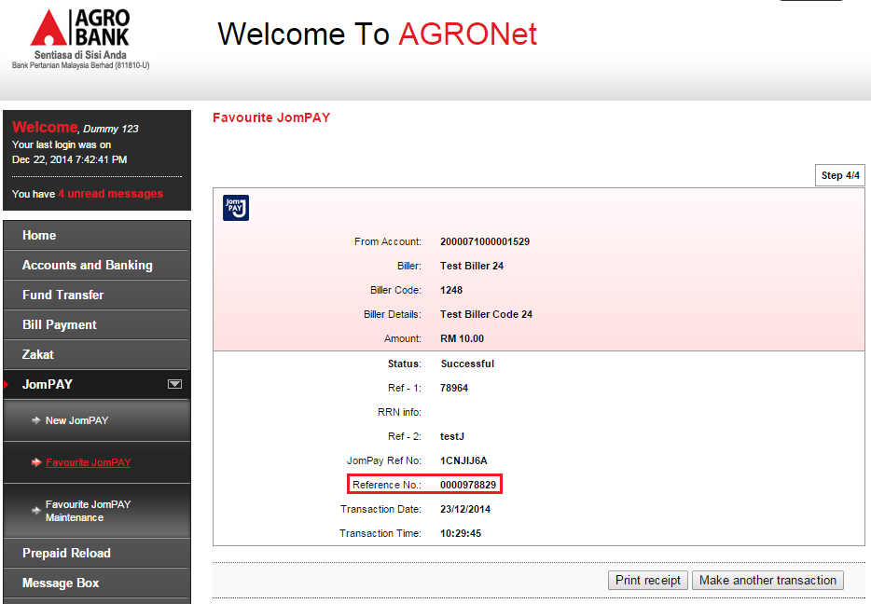

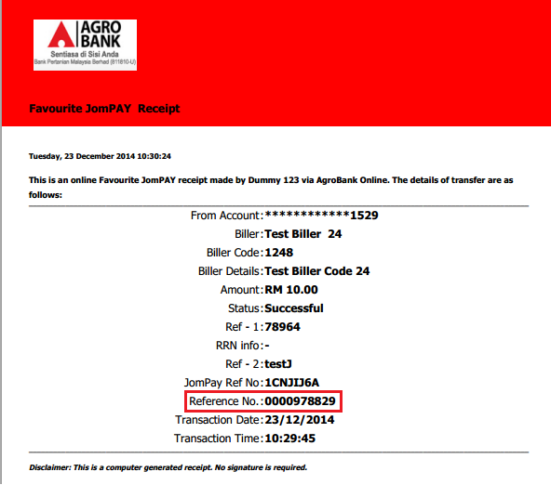

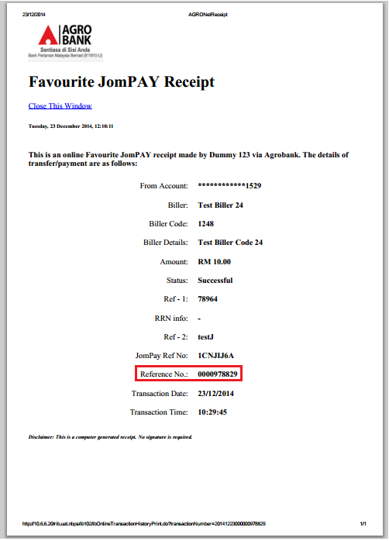
Reviewed By: (PMO
 |  |  | Name/Position : Norhaidah Binti Md Dasuki / Senior Manager, Quality Assurance and Support  Date :

