Internal testing result |  |  |  |  |  | CR-00020
Project Name: | Retail Internet Banking
Test Stage: | Unit Functionality Integration System Interface  Performance Regression Acceptance Pilot
Test Case Number: | - |  |  | Test Started Date: |  | 23/12/2014
Test Title: | JomPAY RIB transaction (CR-00020 RIB003)
Test Description: | To ensure that IB display more info at AGRONet Transaction History which are  - Ref-1  - RRN Info  - Ref-2  - JomPAY Ref No
Test Functionality: | RIB>Account and Banking>AGRONet Transaction History
Test Procedure: | JomPAY AGRONet Transaction History:  - User login to RIB and click on JomPAY and click on Account and Banking  - User select AGRONet Transaction Hsitory  - User view AGRONet Transaction History for New JomPAY & Favourite JomPAY.
Test Result: | Pass: Fail: | Tested by: |  |  | Nurul Akmal binti Yusof
Reason for Failure:
TEST DESCRIPTION
AGROnet Transaction History
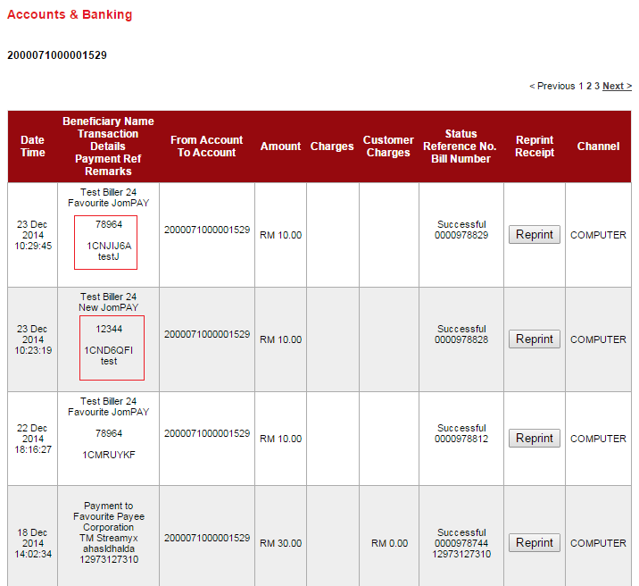

Reviewed By: (PMO
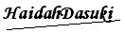 |  |  | Name/Position : Norhaidah Binti Md Dasuki / Senior Manager, Quality Assurance and Support  Date :

