Internal testing result |  |  |  |  |  | CR-00020
Project Name: | Retail Internet Banking
Test Stage: | Unit Functionality Integration System Interface  Performance Regression Acceptance Pilot
Test Case Number: | - |  |  | Test Started Date: |  | 23/12/2014
Test Title: | JomPAY RIB transaction (CR-00020 RIB002)
Test Description: | To ensure that IB display Error Message during transaction validation.
Test Functionality: | RIB>JomPAY>New JomPAY  RIB> JomPAY >Favourite JomPAY
Test Procedure: | New JomPAY:  - User login to RIB and click on JomPAY and click on New JomPAY.  - User selects “From Account”.  - User enters  a) invalid “Biller Code”, “Ref-1”, “Ref-2” and “Amount” and click on “Next” button.  b) inactive biller “Biller Code”, “Ref-1”, “Ref-2” and “Amount” and click on “Next” button.  c) inactive “Biller Code”, “Ref-1”, “Ref-2” and “Amount” and click on “Next” button.  d) “Biller Code”, invalid “Ref-1”, “Ref-2” and “Amount” and click on “Next” button.  e) “Biller Code”, “Ref-1”, “Ref-2” and “Amount” and click on “Next” button.  f) “Biller Code”, “Ref-1”, “Ref-2” and min “Amount” and click on “Next” button.  g) “Biller Code”, “Ref-1”, “Ref-2” and max “Amount” and click on “Next” button.  h) “Biller Code”, “Ref-1”, empty “Ref-2” and enter “Amount” and click on “Next” button.  i) “Biller Code”, “Ref-1”, “Ref-2” and “Amount” and click on “Next” button.  - User view “Error Message” displayed  Favourite JomPAY:  - User login to RIB and click on JomPAY and click on New JomPAY User selects Biller.  - User clicks on “Next” button.  - User select From Account,  a) enter “Ref-1”, “Ref-2”, and “Amount” and click on “Next” button.  b) enter “Ref-1”, “Ref-2”, and minimum “Amount” and click on “Next” button.  c) enter “Ref-1”, “Ref-2”, and maximum “Amount” and click on “Next” button.  d) enter “Ref-1”, empty “Ref-2”, and enter minimum “Amount” and click on “Next” button.  e) enter “Ref-1”, “Ref-2”, and minimum “Amount” and click on “Next” button.  - User view “Error Message” displayed
Test Result: | Pass: Fail: | Tested by: |  |  | Nurul Akmal binti Yusof
Reason for Failure:
TEST DESCRIPTION
a) Error 20001 - New JomPAY
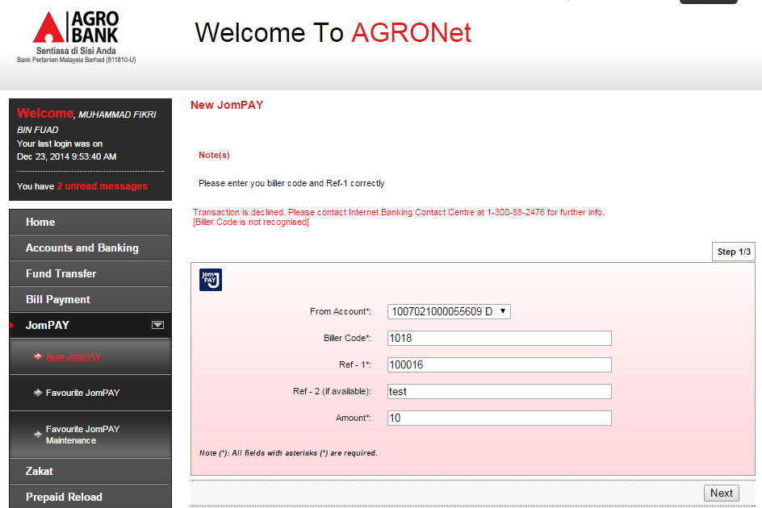

b) Error 20002 - New JomPAY

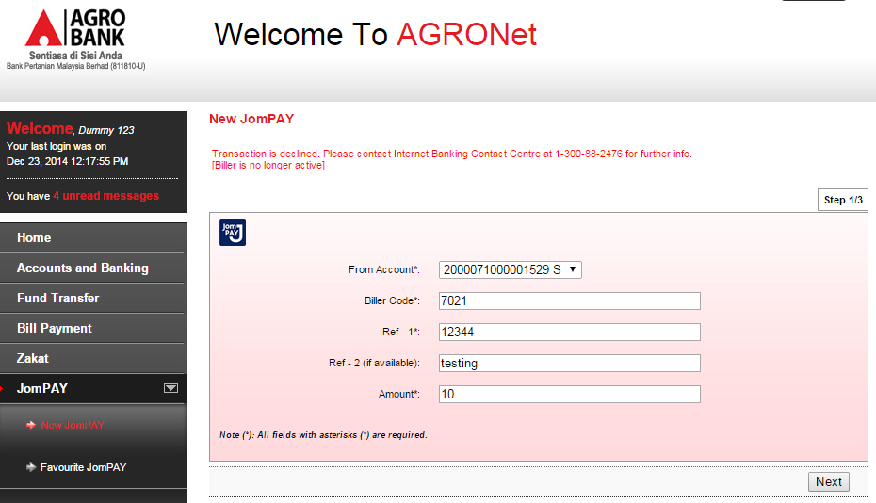
c) Error 20003 - New JomPAY
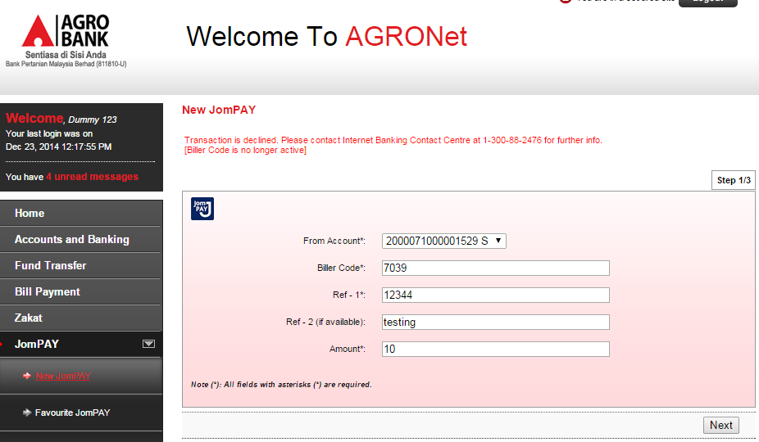

d) Error 20004 - New JomPAY
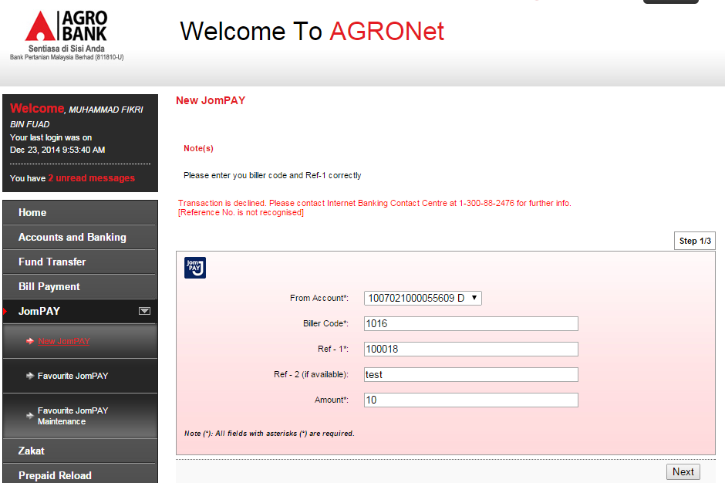
e 1) Error 20006 - New JomPAY
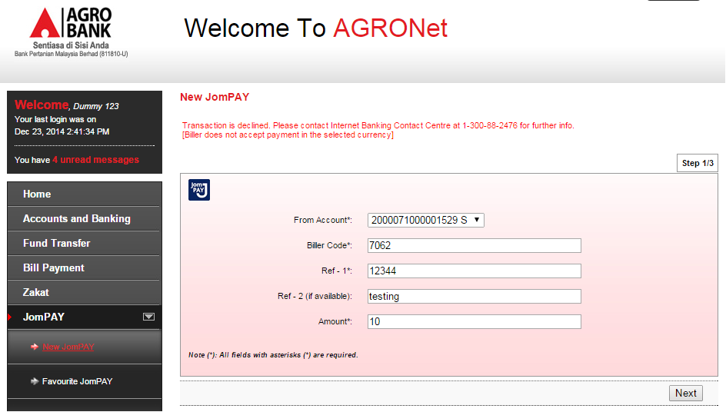
e 2) Error 20006 - Favourite JomPAY
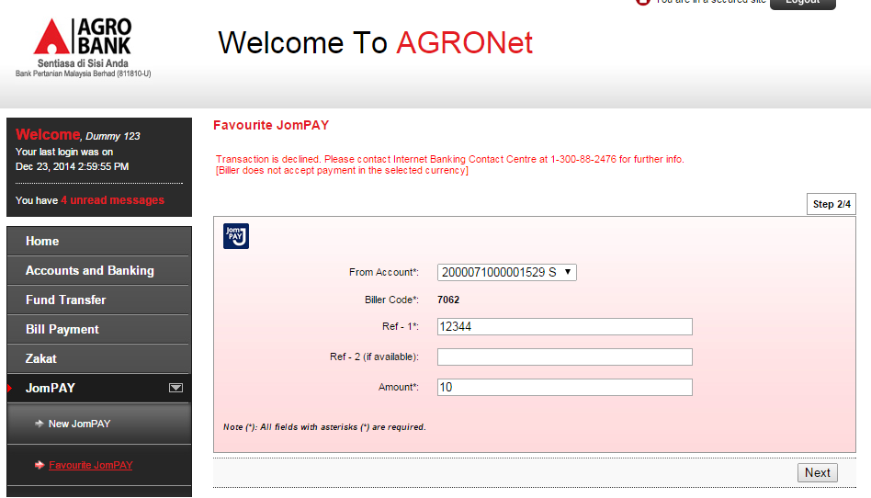

f 1) Error 20007 - New JomPAY
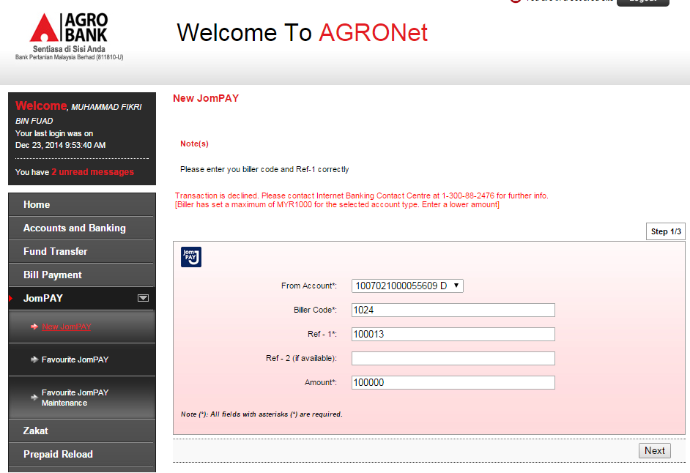
f 2) Error 20007 - Favourite JomPAY
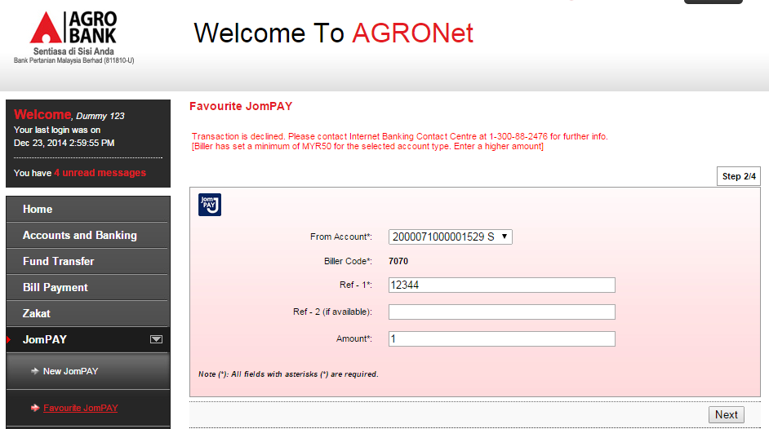

g 1) Error 20008 - New JomPAY
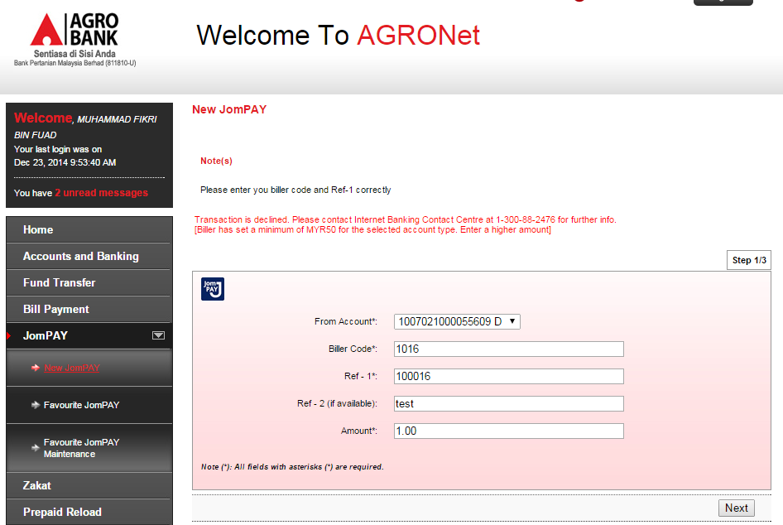
g 2) Error 20008 - Favourite JomPAY
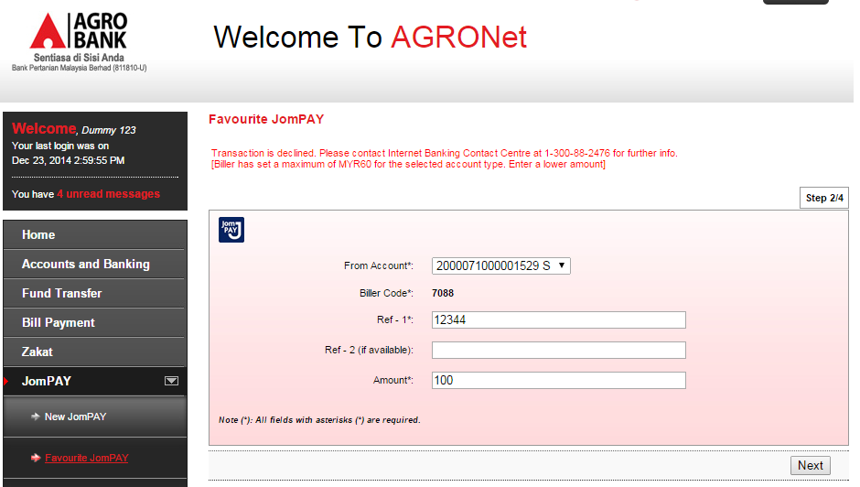

h 1) Error 20009 – New JomPAY
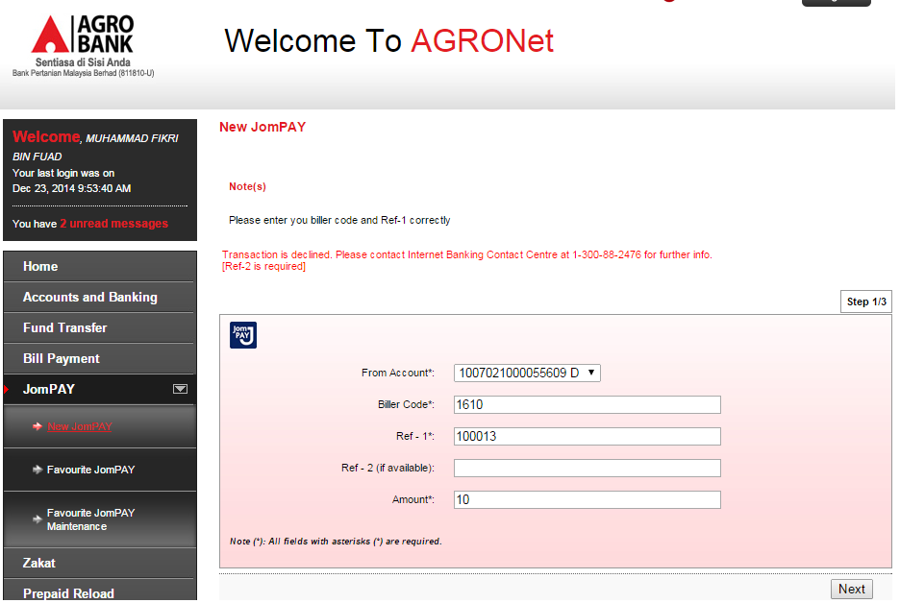

h 2) Error 20009 – Favourite JomPAY
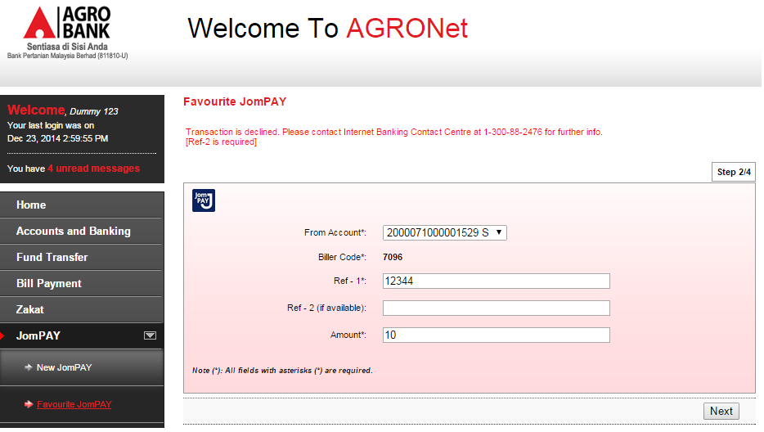

i 1) Error 20010 – New JomPAY
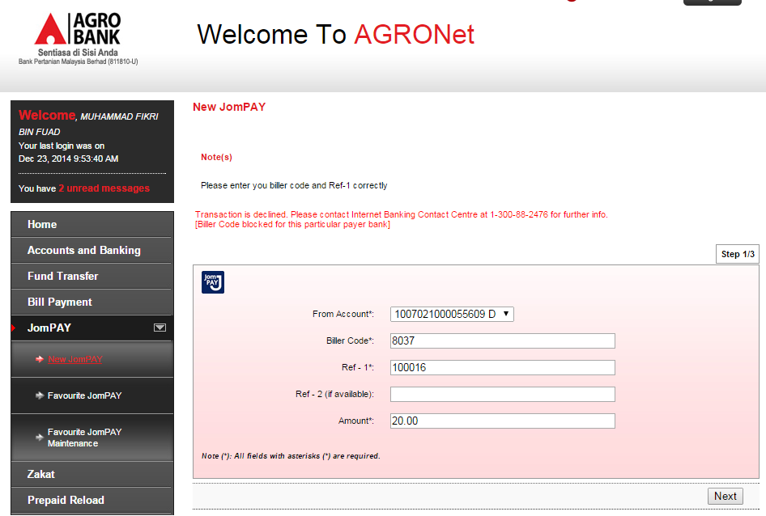
i 2) Error 20010 – Favourite JomPAY
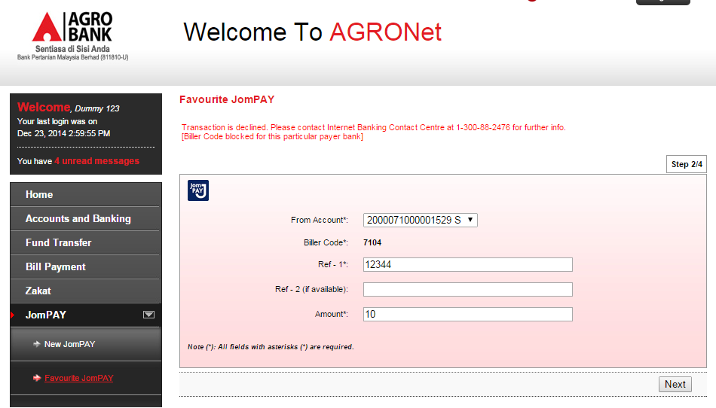

Reviewed By: (PMO
 |  |  | Name/Position : Norhaidah Binti Md Dasuki / Senior Manager, Quality Assurance and Support  Date :

