Internal testing result |  |  |  |  |  | [SCP ID :##2503##]
Project Name: | Retail Internet Banking
Test Stage: | Unit Functionality Integration System Interface  Performance Regression Acceptance Pilot
Test Case Number: | - |  |  | Test Started Date: |  | 07/01/2015
Test Title: | Favourite Interbank Maintenace – Add : Bank of China (Malaysia) Berhad
Test Description: | To ensure that user able to add Bank of China (Malaysia) Berhad as Favourite Interbank.
Test Functionality: | RIB>Favourite Interbank Maintennace
Test Procedure: | Favourite Interbank Maintenance (Add - Bank of China (Malaysia) Berhad:  - User login to RIB and click Fund Transfer.  - User clicks on Favourite Interbank Maintenance.  - User click on Add button  - Select Bank Of China as Beneficiary Bank and complete the required fields  - Click on Next button  - Enter TAC # and click on Confirm button
Test Result: | Pass: Fail: | Tested by: |  |  | Nurul Akmal binti Yusof
Reason for Failure:
TEST DESCRIPTION
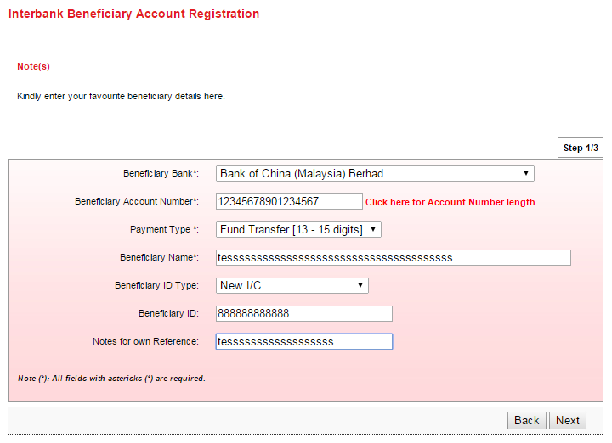

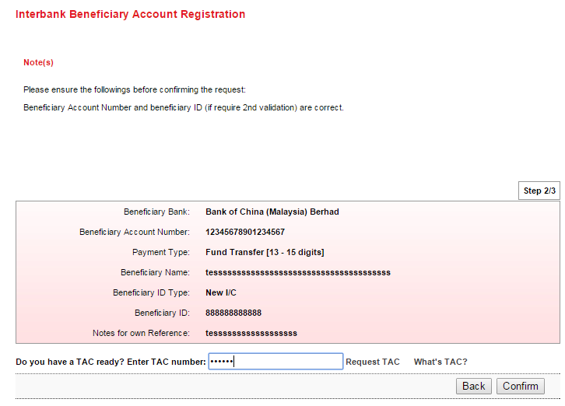

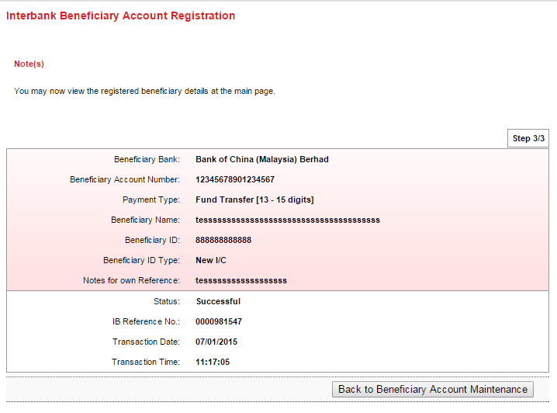

Reviewed By: (PMO
 |  |  | Name/Position : Norhaidah Binti Md Dasuki / Senior Manager, Quality Assurance and Support  Date :

