Internal testing result |  |  |  |  |  | [SCP ID :##2502##]
Project Name: | Retail Internet Banking
Test Stage: | Unit Functionality Integration System Interface  Performance Regression Acceptance Pilot
Test Case Number: | - |  |  | Test Started Date: |  | 07/01/2015
Test Title: | IBAM – Create Content: Interbank
Test Description: | To ensure that IBG & IBFT Member ID show correct value as per entered during creation.
Test Functionality: | IBAM>Content>Interbank
Test Procedure: | IBAM Create Content (Interbank):  - Login to IBAM  - Click on IBAM>Content>Interbank  - Click on Create Content  - Enter Bank Code, Bank Short Name, Bank Display Name  - Tick and enter 123456 as IBG Member ID  - Tick and enter 789012 as IBFT Member ID  - Tick the Fund Transfer and enter the Account Length and Display Name  - Click on Done button
Test Result: | Pass: Fail: | Tested by: |  |  | Nurul Akmal binti Yusof
Reason for Failure:
TEST DESCRIPTION
IBAM>Content>Interbank>Create Content
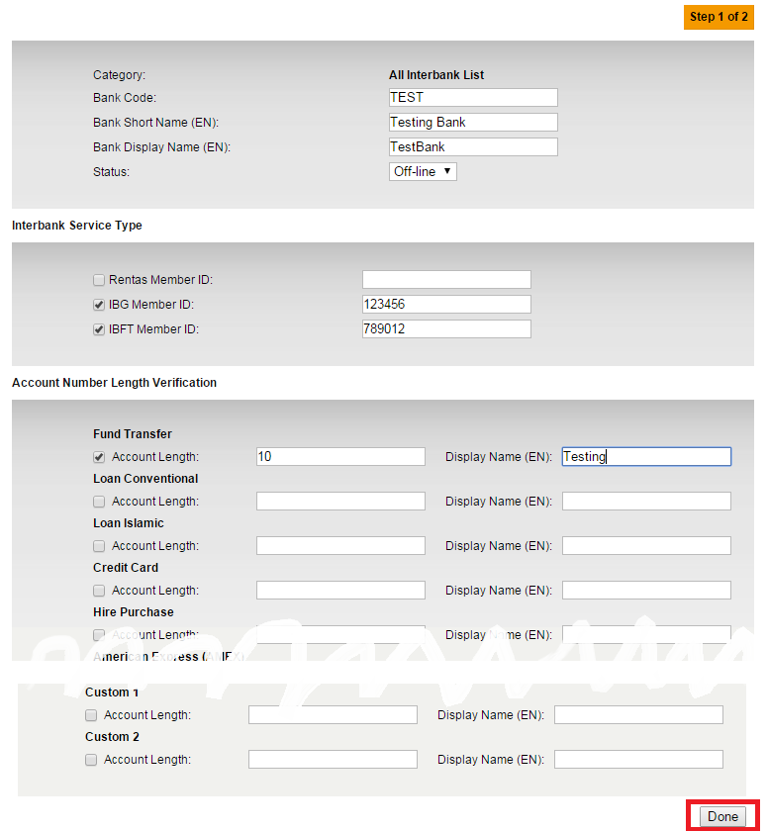
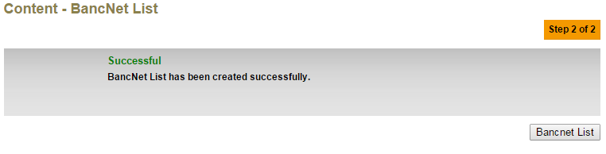

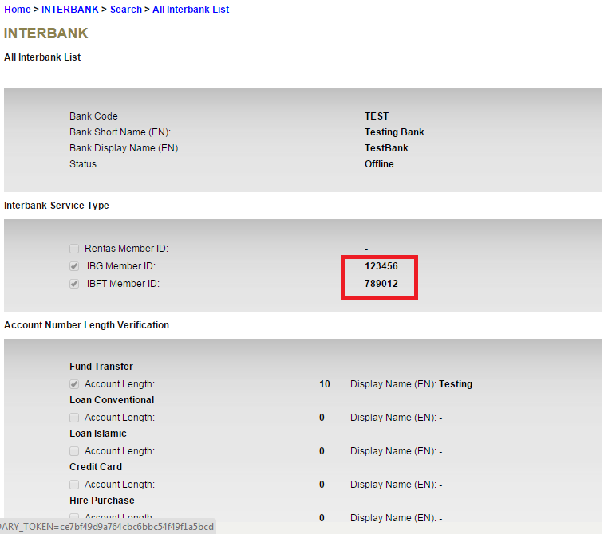

Reviewed By: (PMO
 |  |  | Name/Position : Norhaidah Binti Md Dasuki / Senior Manager, Quality Assurance and Support  Date :

