***Issue Form (PROD)***

|  |  |
| --- | --- |
| **Originator's Name:** Chooi So Fun  **Project:** Internet Banking  **Project Manager:** Malarvili  **Module : iPAY**  **Date Raised: 08.01.2014**  **Phase :** Internet Banking  **Functional Area : iPAY** | **Issue ID Number:**  **Related Issue ID Number:** HD00015730  **Classification:**  **Priority:** Critical/High/Medium/Low  **Assigned to: Vendor / IT / PMO SA / UPA**  **Actual Closed Date:** |
| **Status:** Open/Assigned/Investigated/Resolved/Approved/Deferred/No Action  *(Circle one)* | |
| **Description :**  In BVMC Rpt dated 7.1.15, 1 failed ipay transaction amounting RM825 due to reason insufficient fund was reflected as Approved in Phoenix, PowerCard and MEPS Report.  Please check why status given in BVMC was failed due toinsufficient fund.  *Please refer to file attached for further details.* | **Impact:** |
| **Findings/Root Caused (Description):** | **Resolution:** |
| **Estimated Impact :** |  |
| **Recommendation:** | |
| **Accepted :**  **(Vendor / IT / PMO SA / UPA)**  **Date:** | **Accepted (KFHMB Tester):**  **Date:** |

**Status in BVMC – IBFT Transfer Report as Unsuccessful**

|  |  |
| --- | --- |
| IB Transaction ID | 20150107-0001729741 |
| Date | 07/01/2015 16:20:42 |
| RIM # | 82453 |
| Username | BAKERSOL27 |
| Customer Name | MAZLIANA BINTI MUHAMAD TARMIZI |
| From Account | 002103014538 |
| Beneficiary Account # | 569981000751 |
| From CY | MYR |
| To CY | MYR |
| From Acct. Crt. Date | NIL |
| Amount | 825.00 |
| Local Amount | 825.00 |
| Payment Details | business |
| Beneficiary Name | BAKERS SOLUTION |
| Beneficiary Bank | MAYBANK |
| Beneficiary Bank ID | MBBEMYKL |
| Beneficiary Transaction Ref # | business |
| Beneficiary Email | mazlianatarmizi@yahoo.com |
| Description | iPAY to BAKERS SOLUTION (MAYBANK: 569981000751) |
| Effective Date | 2015-01-07 |
| **Status** | **Unsuccessful** |
| **Reason** | **Insufficient funds** |
| Host Reference | NIL |
| Remote IP | 175.136.54.227 |

**Phoenix**

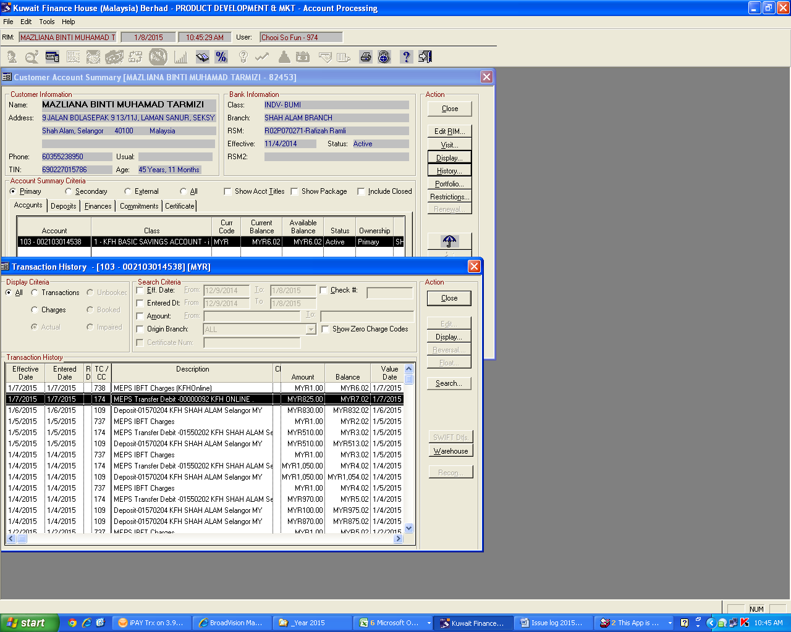

**Status in Phoenix Report as Approved:**

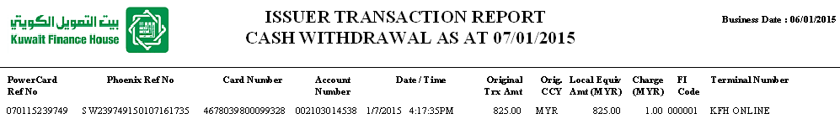

**Status in Powercard Report as Approved:**



**Status in MEPS Report as Approved**

