***Issue Form (PROD)***

|  |  |
| --- | --- |
| **Originator's Name:** Chooi So Fun  **Project:** Internet Banking  **Project Manager:** Malarvili  **Module : Bill & Prepaid**  **Date Raised: 08.01.2014**  **Phase :** Internet Banking  **Functional Area : Bill & Prepaid** | **Issue ID Number:**  **Related Issue ID Number:** HD00015734  **Classification:**  **Priority:** Critical/High/Medium/Low  **Assigned to: Vendor / IT / PMO SA / UPA**  **Actual Closed Date:** |
| **Status:** Open/Assigned/Investigated/Resolved/Approved/Deferred/No Action  *(Circle one)* | |
| **Description :**  There were total 6 extra Bill & Prepaid transactions performed on 3 Jan 2015 were successful captured at ePay. Customers’ account were debited and credited to ePay’s account accordingly. Based on customer’s feedback, they encountered system auto logged out after clicked on the confirm button.  This also resulted the transactions were not reflected in the KFHOnline Transaction History and receipt also not available for retrieval. BVMC Report also didn’t reflect these 6 transactions also.  *Please refer to file attached for further details.* | **Impact:** |
| **Findings/Root Caused (Description):** | **Resolution:** |
| **Estimated Impact :** |  |
| **Recommendation:** | |
| **Accepted :**  **(Vendor / IT / PMO SA / UPA)**  **Date:** | **Accepted (KFHMB Tester):**  **Date:** |

**The below 6 transactions performed on 3 Jan 2015 were successful where customers’ account were debited and credited to ePay’s account**

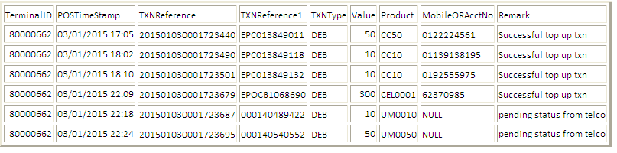

**ePay’s account - Credited**

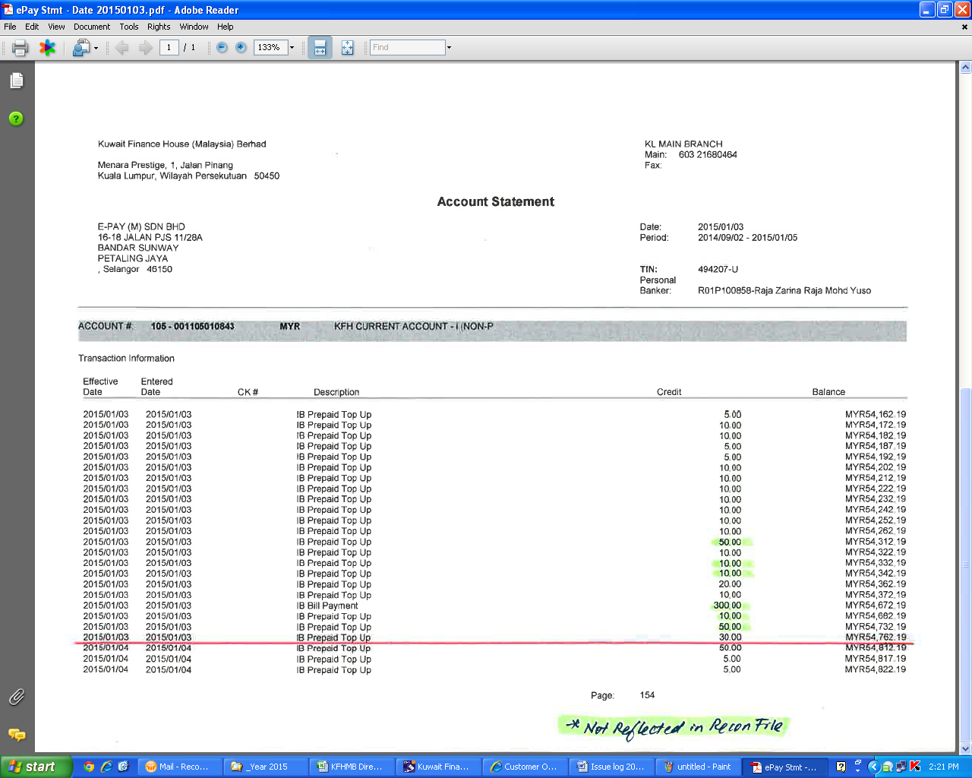

**Phoenix Report – Customers’ account Debited and Credited to ePay’s account**

