1. http://www.kfh.com.my/kfhmb/v2/programView.do?channelId=-9182&contentTypeId=3001&displayPage=/ep/common/layoutBody.jsp&field=DISPLAY_ORDER&pageTypeId=8610&programId=10768

Production

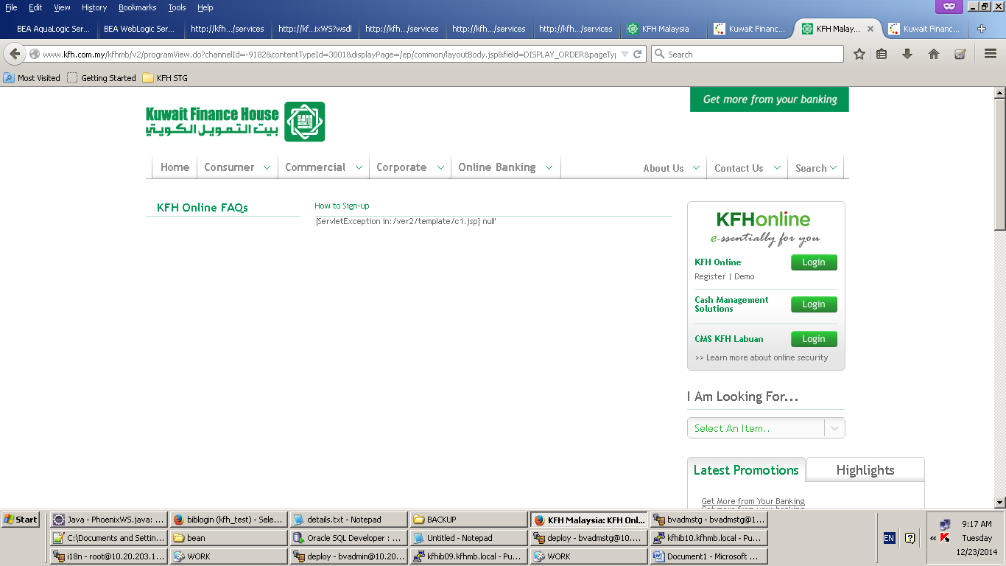

Development 7110

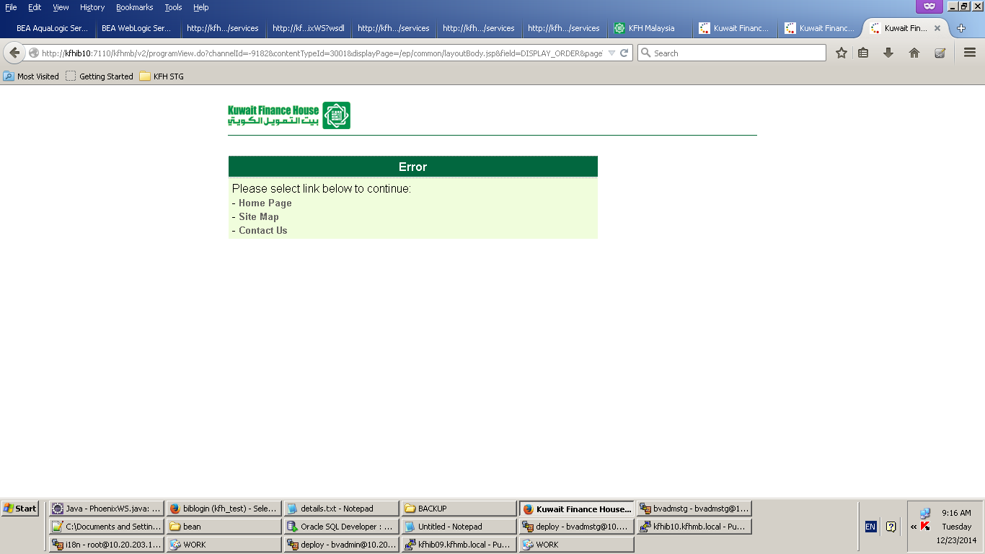

Staging 8110

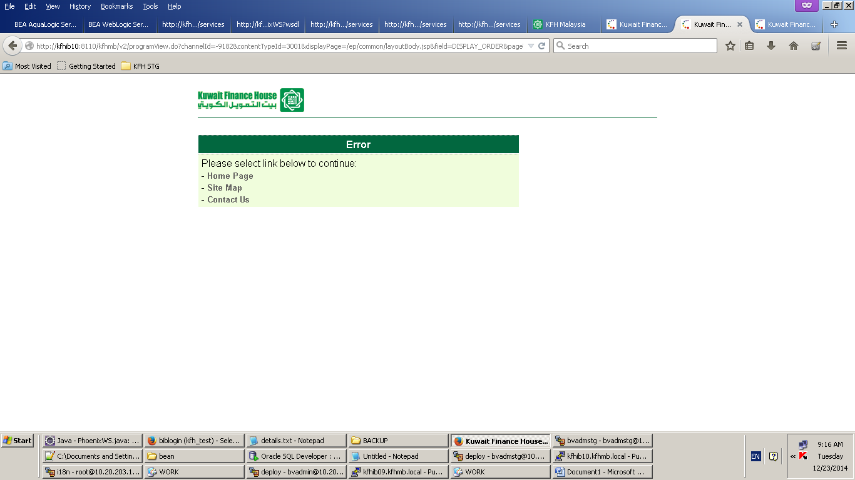

2.

http://www.kfh.com.my/kfhmb/ep/programView.do?channelId=-9182&contentTypeId=3001&displayPage=/ep/common/layoutBody.jsp&field=DISPLAY_ORDER&pageTypeId=8610&programId=10768

Production

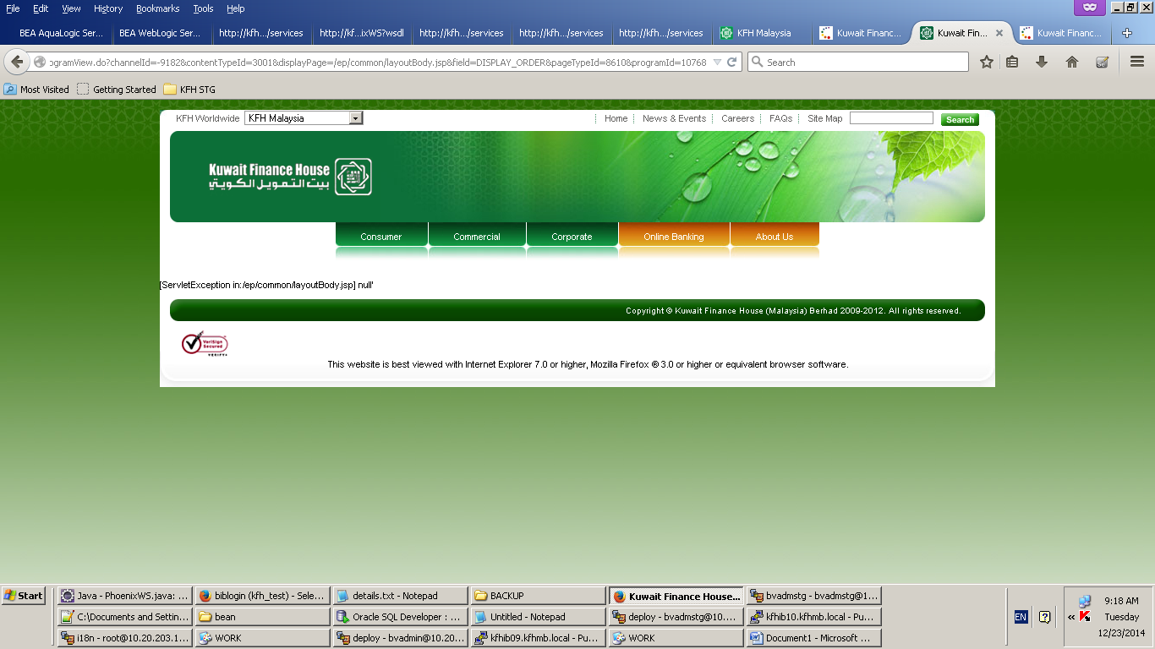

Development 7110

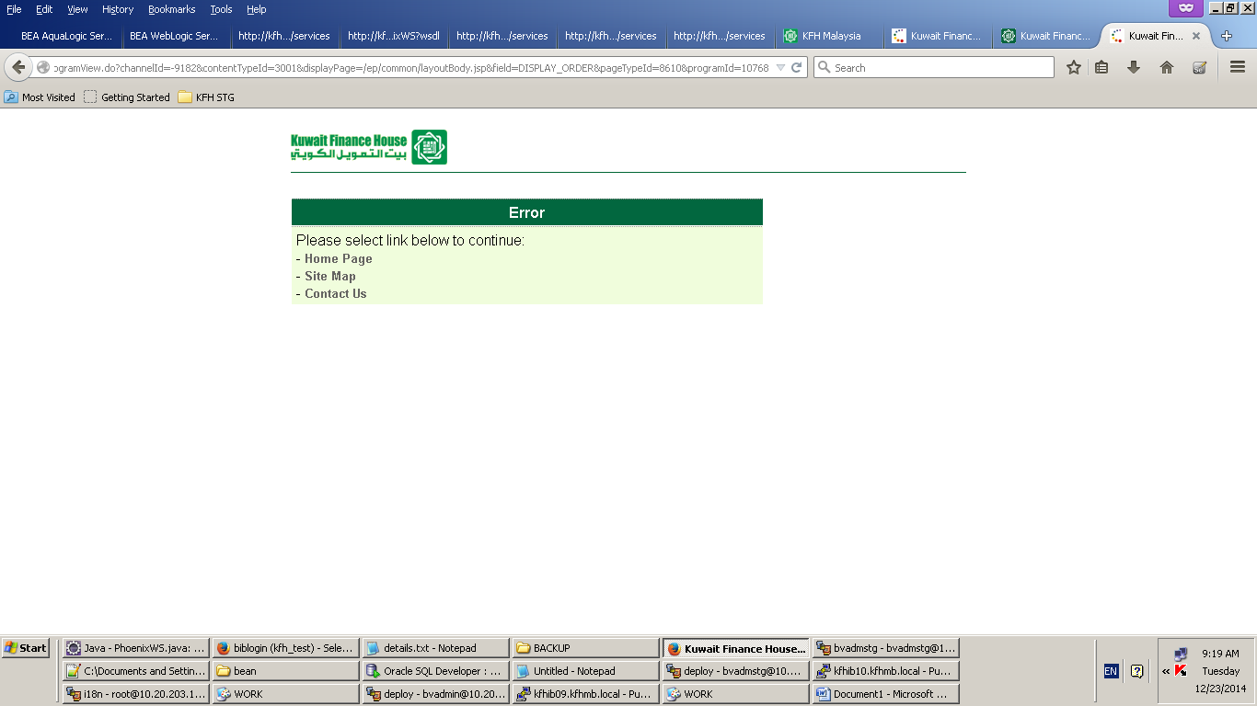

Staging 8110

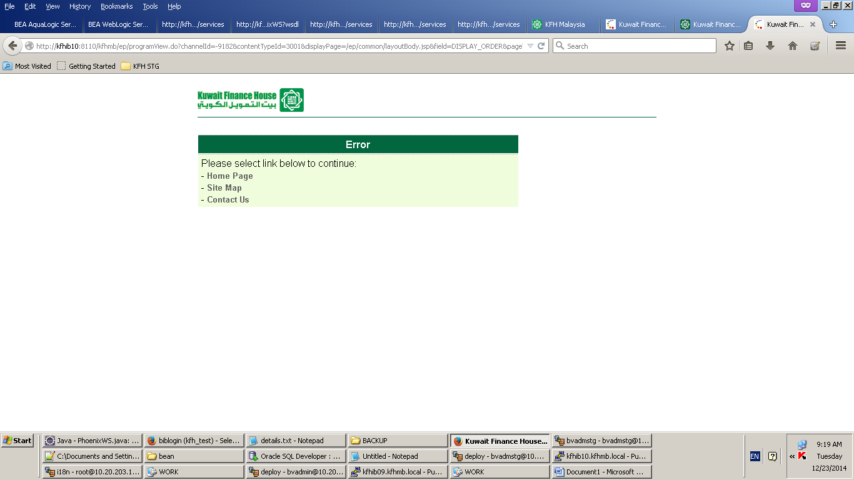

Test in dev

http://kfhib10:7110/kfhmb/v2/programView.do?contentTypeId=2&displayPage=%2Fver2%2Fprogram%2Ffeedbackform.jsp&pageTypeId=13809&channelPath=%2Fver2%2Fv2_Navigation%2FContact+Us&programName=03_CUForm

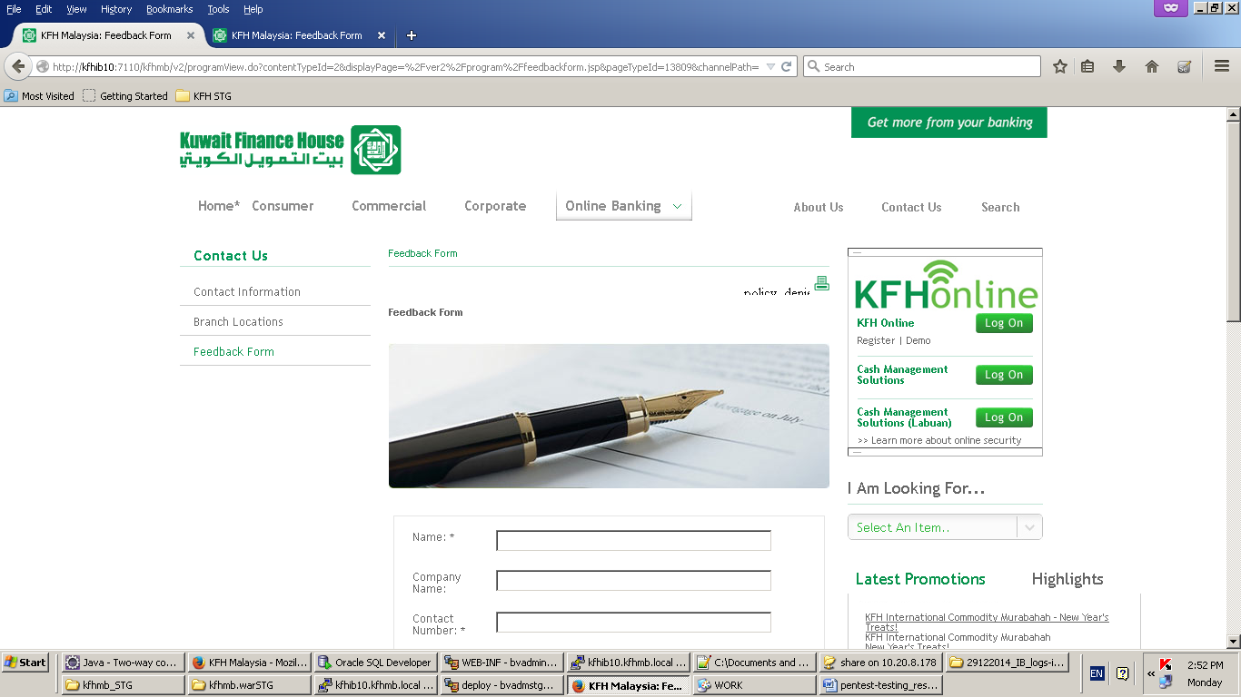

http://kfhib10:8110/kfhmb/v2/programView.do?contentTypeId=2&displayPage=%2Fver2%2Fprogram%2Ffeedbackform.jsp&channelPath=%2Fver2%2Fv2_Navigation%2FContact+Us&programName=03_CUForm&tabId=6

